Design: Last Sale From TPF

Overview

Current processing
Currently Last Sale coming from TPF is formated and published on Ticker channel. Currently the last sale message received from TPF is not checked if it is OSEQ (out of sequence). It is converted to recap message and published on recap channel.

New requirement
New fields will be received from TPF which needs to be sent to HyTS. If lastSalePrefix is not give by TPF, find out it’s value by querying MDH and applying OSEQ, LATE logic. Then publish Ticker message to Ticker channel to be consumed by COPP, CAS.

Implementation

Processing of Last Sale message from TPF (See Ticker flowdiagram below)
- LastSaleReportMessage class will be modified to handle extra information sent by TPF in last sale message
    - Use InternalDetailTickerStruct instead of InternalTickerStruct
    - Use TickerDetailConsumer instead of TickerConsumer
    - Update byte map in LastSaleReportMessage(ReportsService aService) to handle extra fields listed in TPF Last Sale Format document.
    - Update formatAndPublish and publish method to format above fields to InternalDetailTicker
    - Update in publish method to publish to TickerDetail instead of Ticker channel.

- A new event channel will be created named TickerDetail
- A new interface will be added to IDL named TickerDetailConsumer. See CMIiIDLDesign.doc
- MarketDataConsumer will extend TickerDetailConsumer.
- MarketDataServiceImpl , MarketDataConsumerQueueImpl are the only classes which implement MarketDataConsumer. These classes need to implement new mentod acceptTickerDetail.
- MarketDataServiceImpl :
Add method acceptTickerDetail
- A new class named MarketDataConsumerPrefixQueueImpl will be created which will extend MarketDataConsumerQueueImpl
acceptTickerDetail :
For input parameter internalTickerDetailStruct,
If source is TPF
processForOSEQ_LATE(internalTickerDetailStruct) – See this function in detail below.
If isDisseminated in TickerDetail from TPF is false
Convert TikerDetailStruct to TickerStruct
Get Ticker publisher and publish InternalTickerStruct using acceptTicker so that ticker is published to COPP , CAS etc. Pending issue : Need to make sure that the event published here are sent to copp bridge but should not be consumed by TpfAdapter
End-if
If source is SBT
Get Ticker publisher and publish InternalTickerStruct using acceptTicker so that ticker is published to
COPP , CAS et
End-if

For both SBT and TPF :
Call processRecapFromTicker, save to Market Data History (with new columns) and publish recap same as currently done in acceptTicker.
- MarketDataServiceHomeImpl :
- In In addConsumer, remove adding of existing MDConsumer and add code to register MDConsumerPrefixQueueImpl.
- Add getMarketDataTickerDetailConsumer {instantiate MDConsumerPrefixQueueImpl and return it}. This is for TraderService (listed here for compeleteness)

- MarketDataHistoryEntryImpl :
Add new columns (fields) listed in Database changes design document.
- MarketDataConsumnerQueueImpl :
Add method acceptTickerDetail similar to acceptTicker
Add inner class TickerDetailEntry similar to TickerEntry

processForOSEQ_LATE(internalTickerDetailStruct) {

If internalTickerDetailStrcuct.InternalTickerStruct.salePrefix is not empty
If salePrefix is not any of the (OSEQ, LATE … the list to be give by TPF team)
internalTickerDetailStruct.InternalTickerStruct.salePrefix = spaces
return;
else
Return; do not do anything.
End-if
End-if

lastSalePrefix = “”;
isLastSaleInCurrentMarket = false
didTradeOccur=false
lastSalePriceTpf = internalTickerDetailStrcuct.InternalTickerStruct.lastSalePrice
marketDataHistories = get Market Data Histories for last OSEQ_TIME_FRAME_SECONDS by calling
MarketDataHistoryHome.findByTime
For each marketDataHistory
If (marketDataHistory is a quote) && --Entry type =1 = QUOTE_ENTRY
(bidPrice <= lastSalePriceTpf >= askPrice)
isLastSaleInCurrentMarket = true
Break for loop.
End-if
If (marketDataHistory is a trade) --Entry type =2 PRICE_REPORT_ENTRY
didTradeOccur= true
End-if
End-for
If (isLastSaleInCurrentMarket) -yes quote.
lastSalePrefix = “”
ElseIf (didTradeOccur)
lastSalePrefix = “OSEQ” -no quote yes trade
Else
lastSalePrefix = “LATE” - no quote no trade
End-if

internalTickerDetailStrcuct.InternalTickerStruct.salePrefix = lastSalePrefix;
}

A database query can be made for this logic
SELECT entry_type FROM
(SELECT entry_type
FROM
(SELECT entry_type
FROM MKT_DATA_HIST
WHERE &start_time <= ENTRY_TIME
AND &end_time >= ENTRY_TIME
AND PROD_KEY = &prod_key
AND ( entry_type = 2
OR ( entry_type = 1
AND BID_PRICE <=&lastSalePrice
AND &lastSalePrice <= ASK_PRICE))
ORDER BY entry_type
and DAYOFWEEK = to_char(sysdate,'D')

)
WHERE ROWNUM <= 1

If entry_type = 1
lastSalePrefix = “”
If entry_type = 2
lastSalePrefix = “OSEQ”
If no row found
lastSalePrefix = “LATE”

Following table sumarizies additional processing for Last Sale prefix

TPF | MDH | Published on ticker | PDS
Spaces | LATE/OSEQ or spaces depending on 90 seconds look up | LATE/OSEQ or spaces depending on 90 seconds look up | blank
CMBB/CMBS | CMBB/CMBS | CMBO | S
SPDB/SPDS | SPDB/SPDS | SPRD | S
UAWB/UAWS or MMHH | UAWB/UAWS or MMHH | Blank | blank
Any other valid prefix in list | Any other prefix in list | Any other prefix in list | ??
Any other prefix | Any other Iprefix | Spaces | ??
List of Valid prefixs = CANC,CNCL,CNCO,CNOL,FXOP,FXCL,FXHI,FXLO,FXVO,LATE,OPNL,OPEN,OSEQ,REOP,AJST,SPRD,STDL,CMBO

Processing of Last Sale message from SBT (See Ticker flow diagram below)
- In TickerConsumerHomeLocalBOSessionCollectedImpl, in getPublisher, it will return TickerPublisher instead of TickerPublisherLocal
- In TradeReportImpl, it will get TickerPublisher instead of TickerPublisherLocal so that it will do only publish to ticker.
- Then in TradeReportImpl, it will call getMarketDataService.getMarketDataTickerDetailConsumer.acceptTickerDetail
- In MarketDataServiceHomeImpl add getMarketDataTickerDetailConsumer {instantiate MDConsumerPrefixQueueImpl and return it}.

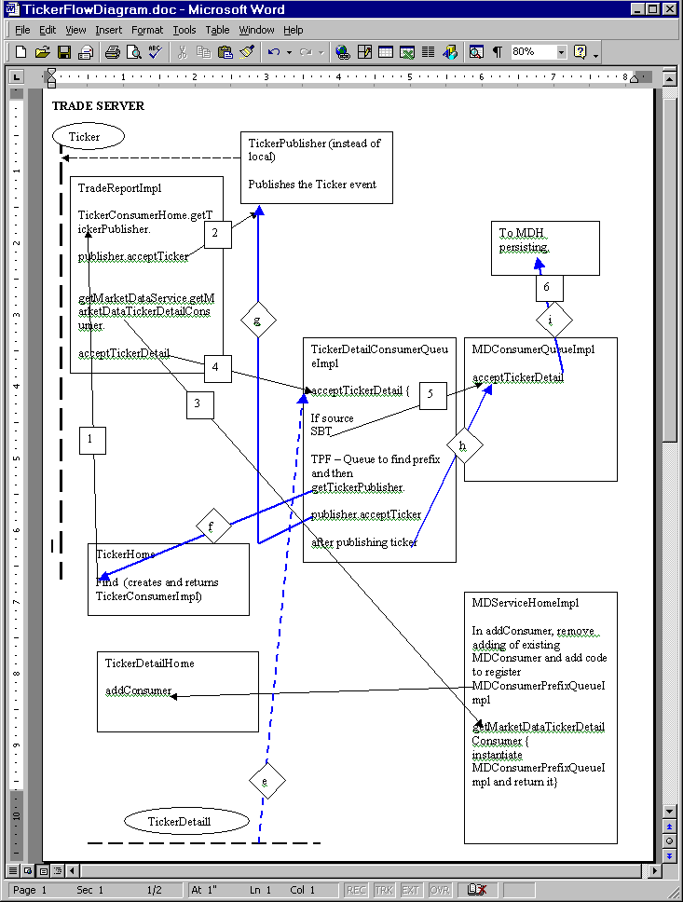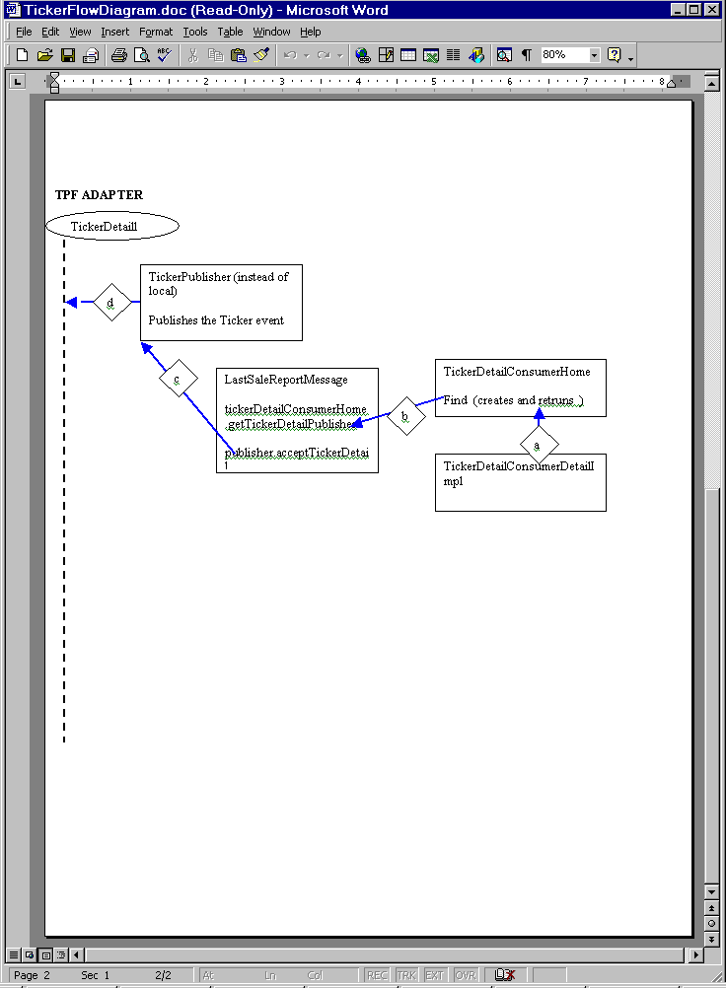

Routing Groups consideration while publishing Ticker
For Ticker messages coming form TPF , to avoid TpfAdapter getting Ticker message back when TradeServer publishes it following logic will be implemented.
After QPE
Ticker channel.
Only TradeServer publishes to Ticker Channel. And TradeServer does not listen on Ticker Channel anymore (it listens to TickerDetail). So no need for consideration for getting it’s own events.

Only TpfAdapter publishes to Ticker Detail Channel. TpfAdapter does not listen on TickerDetail.

But TradeServer publishes ticker on Ticker channle for TPF last sale (received via TickerDetail) which TpfAdapter don’t want to get again.

Following table sumarizes who should get Ticker messages published by Trade Server and when.

 | From TPF Trade  IsDesiminated = True  Publish with no groups | From TPF Trade  IsDesiminated = False  Publish with only PRODBCXX | From SBT Trade  Publish with  PRODBCXX PRODBCXXTradeServerXX
CAS | Yes | Yes | Yes
COPP |  | Yes | Yes
TPF |  |  | Yes

CAS - No filter on groups. Always gets all messgaes
COPP - Filter on remote group PRODBCXX
TFPAdapter - Filter on remote group PRODBCXXTradeServerXX

If the Ticker is published by TradeServer with PRODBCXXTradeServerXX, it indicates that it was a trade done by SBT.
If the Ticker is published by TradeServer without PRODBCXXTradeServerXX, it indicates that it was a trade not done by SBT and it acted just as pass through.

Please see diagram representing this.

CAS

Ticker Channel

PRODBCXX
PRODBCXXTradeServerXX
PRODBCXX

No Groups

COPPBridge

IsDesim
No Yes

TPFAdapter

TradeServer

TickerDetailChannel

TPF Simulator for testing Last Sale
Tpf simulator will be created, modified to receive last sale from TPF for testing.

Scripts
- add new channel TickerDetail to createSbtEC script.

Database(.5)
- New fileds will be added to MARKET_DATA_HIST table. See Database changes.doc

SetContext(.125)
- None

XML/DTD(.5)
- MarketDataService.xml : add parameter oseqTimeFrameSeconds
- More xml chnages will be needed. This list of xmls will be updated soon.
- XML re-genration required

Homes/Services(4)
- MarketDataServiceServiceImpl
- MarketDataConsumnerQueueImpl
- MarketDataHistoryEntryImpl

ImplPlan(.5)
- GC2A needs to be upgraded before any BC box as addition of TickerDetail channel cause many xml changes.
- INFRA support needs to make required changes to admin.server.xml to map TickerDetail channel.
- Create TickerDetail channel.
- There is no dependancy on GC because of this feature as all changes involved are related to BC cluster only.

PerformanceTestingProcedure(1)
- Create test procedures to prove throughput capabilities. TPF simulator can be used to drive the data.
- Run performance test with lots of last sale messages from TPF which will result in database query (listed in implementation section)for OSEQ evaluation and determine it’s impact. Heavy quoting activity should be generated at the same time last sale should be received from TPF for same product. Quoting will try to insert records in MHD table and OSEQ logic will try to read. We need to determine difference in performance with OSEQ queries running and without them. If this causes slowdown the query needs to be revisited or different approach must be taken.

TestingProcedure(1)

OSEQ testing :
- Set oseqTimeFrameSeconds to 5 minutes or more to fascilitate creating market data manually and getting last sale event from TPF
- Create several market data histories
- Receive LastSale event from Tpf with isDesiminated flag = false.
- Monitor the value of isOutOfSequence flag in the Ticker event which is sent to COPP. It should be true or false depending on market data histories created.
Test Condition 1 :
Incoming values from TPF
Last Sale prefix = OSEQ or any of the valid values : CANC,CNCL,CNCO,CNOL,FXOP,FXCL,FXHI,FXLO,FXVO,LATE,OPNL,OPEN,OSEQ,REOP,AJST,SPRD,STDL,CMBO
Last Sale price = any
In Ticker channel published by HTS
Last Sale prefix = OSEQ

Test Condition 2 :
Incoming values from TPF
Last Sale prefix = Any value other than listed in test condition 1
Last Sale price = any
In Ticker channel published by HTS
Last Sale prefix = Spaces

Test Condition 3 :
Incoming values from TPF
Last Sale prefix = Spaces
Last Sale price = 5.20
In Ticker channel published by HTS
Last Sale prefix = Spaces
During last 90 seconds (configurable, change to 5 mins for testing)
If (isLastSaleInCurrentMarket) -yes quote.
lastSalePrefix = “”
ElseIf (didTradeOccur)
lastSalePrefix = “OSEQ” -no quote yes trade
Else
lastSalePrefix = “LATE” - no quote no trade
End-if

Last Sale message from TPF :
- Receive LastSale event from Tpf by performing a trade on TPF. Take help of TPF support for this. The Last Sale message should come to SBT with isDesiminated flag= false.
- Make sure event is published on TickerDetail channel.
- Ticker message should be sent to COPP on Ticker channel. Take help of Alex who is working on Copp Bridge to verify this.
- Ticker message should be sent to CAS on Ticker channel.
- Make sure Market Data Hisotry is created in database with new fields listed in Database changes by doing a database query on MKT_DATA_HIST.
- Receive LastSale event from Tpf with isDesiminated flag= true.
- Make sure event is published on TickerDetail channel.
- Make sure Market Data Hisotry is created in database with new fields listed in Database changes.
- Make sure NO Ticker message is sent to COPP on Ticker channel.
- Ticker message should be sent to CAS on Ticker channel.

OperatorProcedure(.5)
- In case of SBT failure, operations should run some command on TPF to should start sending LastSale messgages to COPP and continue sending messages to SBT with isDesiminated = true to be queued on queue till SBT si up again.

Fallback/Failover
- In case of hybrid failover (when SBT is down), TPF will send Last Sale messages to COPP. Also, it will send Last Sale messages to SBT also. But these messages will be with isDesiminated=true. These messages will be queued untill SBT comes back up. When SBT is up, it will receive these queued messages. It will process them (persist to MDH and publish recap)but will not sent to COPP (HyTS , MarketDataService will not publish event on Ticker channel).
- TpfAdapter should be notified by SMS if HyTS is down. Then TPFAdpater will close connections with TPF so that messages will start queing up and will be processed once SBT is up again.

GUI Overview
No changes

Pending issues

Description | Resolution
How will TPF know failure of SBT? | This will be manual process
List of valid lastSalePrefix needs to be obtained from TPF group. | CANC,CNCL,CNCO,CNOL,FXOP,FXCL,FXHI,FXLO,FXVO,LATE,  OPNL,OPEN,OSEQ,REOP,AJST,SPRD,STDL,CMBO

