

SYSTEMS DIVISION

MDR DISPLAY DESIGN

Market Linkage Phase II
(WR #2042)

Draft

Prepared by:
David Tarnow

Date: 01/30/03
Last Updated: 02/05/03

Approved by:

Jim Neceda
Systems Development
Table of Contents
1. MDR Display 3
1.1 MDR Display Requirements 3
1.1.1 MDR Display request Format 3
1.1.2 Possible MDR Display Entries 3
1.1.3 New MDR Display Program 5
1.1.4 Modify Existing Program to enter new MDR processing 11
1.1.5 Modify Existing TS0HM DSECT 11
1.1.6 MDR Display Output Format 12
1.2 Test Cases 15

MDR Display

MDR Display Requirements

MDR requests will come from TNT whenever a user wants a display of Market Data Retrieval information. The request can be an initial request, a request by time and / or date, or a page up or down request. The request can also come from other platforms such as SBT as long as they have implemented the proper routines to request and accept the data.

Since it is desirable to have transactions which do not require a SPA record for processing, the client will store the record ordinal numbers which are required for paging along with the item number in the MD / MY record for the item from which the display has originated (this is the top most item on the display). This information is needed in order to directly access the MDR ‘MD’ record without having to traverse long MDR chains from the prime MDR record every time an up or down request is processed. The TC / DU Work Area (WA) records will also not be needed using this scheme.

Due to the large size of the individual MDR items, multiple block Host Gateway HGSENDs will be utilized using the same transfer scheme as was developed for Ebook Front End, where multiple data blocks are sent with a ‘D’ “Block Type” and the number of items in each block followed by an End block with an ‘E’ “Block Type”.

All of the data messages for this transaction will be sent and recieved in character format.

MDR Display request Format
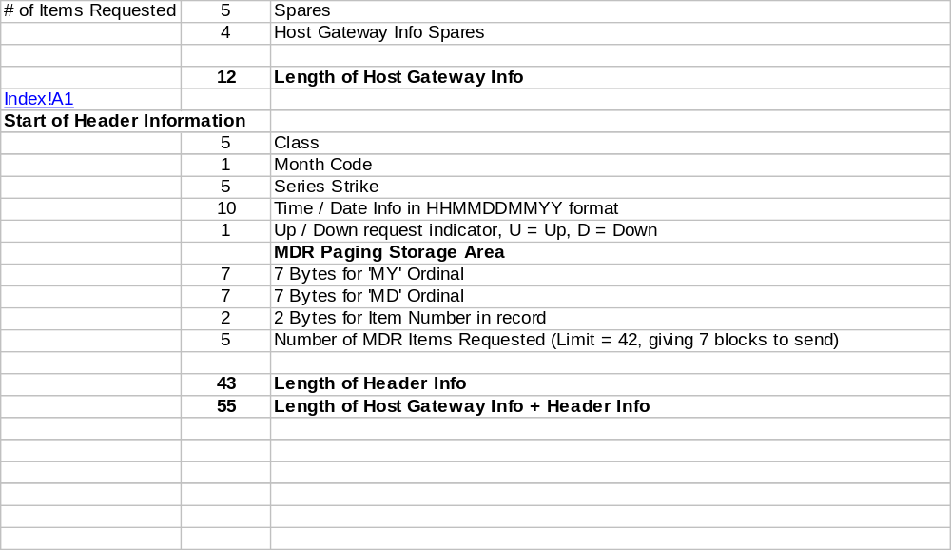

Possible MDR Display Entries

NOTE: All entries below are requesting 25 MDR Display line items. All fields with no values will be zero filled.

Sample Entry | Size (in bytes) | Sample Entry in HEX format
Initial request for IBM Jan 55 ½:  ME...........IBM__A0055128...........................000025 | 59 | D4C50000000000000000000000D0C2D44040C1F0F0F5F5F1F2F8000000000000000000000000000000000000000000000000000000F0F0F0F0F2F5
MDR requested by time for same series at 10:30  ME...........IBM__A00551281030.......................000025 | 59 | D4C50000000000000000000000D0C2D44040C1F0F0F5F5F1F2F8F1F0F3F00000000000000000000000000000000000000000000000F0F0F0F0F2F5
MDR requested by date & time for same series at 10:30:  ME...........IBM__A00551281030122502.................000025 | 59 | D4C50000000000000000000000D0C2D44040C1F0F0F5F5F1F2F8F1F0F3F0F1F2F2F5F0F20000000000000000000000000000000000F0F0F0F0F2F5
MDR requested by date for same series:  ME...........IBM__A0055128....122502.................000025 | 59 | D4C50000000000000000000000D0C2D44040C1F0F0F5F5F1F2F800000000F1F2F2F5F0F20000000000000000000000000000000000F0F0F0F0F2F5
Up request for previously displayed series:  ME...........IBM__A0055128..........U1A0FB320001A4B11000025  Notes: U=UP, 1A0FB32=MY ORDINAL, 0001A4B=MD ORDINAL, and 11 = ITEM NUMBER IN RECORD | 59 | D4C50000000000000000000000D0C2D44040C1F0F0F5F5F1F2F800000000000000000000E4F1C1F0C6C2F3F2F0F0F0F1C1F4C2F1F1F0F0F0F0F2F5

New MDR Display Program

CONVERT INPUT TO EBCDC
CONVERT FRACTION?

IF NUMBER OF ITEMS REQUESTED > 99
SENDMSG "PROCESSING ERROR" MSG # 503
EXIT PROCESSING
END IF

IF UP OR DOWN REQUESTED
VALIDATE PAGING INFO
GET MDR RECORD USING MY / MD ORDINAL
IF UP REQUESTED
SET # OF ITEMS TO MOVE UP AS ITEMS REQUESTED (VALUE FROM INPUT MSG) - 1
MOVE UP N ITEMS
BUILD AND SEND OUTPUT BLOCK
ELSE
SET # OF ITEMS TO MOVE UP AS ITEMS REQUESTED (VALUE FROM INPUT MSG) - 1
MOVE DOWN N ITEMS
BUILD AND SEND OUTPUT BLOCK
ENDIF
ELSE
IF TIME FIELD ENTERED
IF TIME FIELD INVALID FORMAT
SENDMSG "INVALID TIME - PLEASE REENTER" MSG # 222
EXIT PROCESSING
ELSE
MOVE TIME TO MDR_TIME_REQUESTED
END IF
END IF
IF DATE FIELD ENTERED
IF DATE FIELD INVALID FORMAT
SENDMSG "INVALID DATE - PLEASE REENTER" MSG # 221
EXIT PROCESSING
ELSE
IF TIME FIELD NOT ENTERED
MOVE 2359 TO MDR_TIME_REQUESTED (THIS WILL GET LAST TIME ENTRY FOR DATE REQ)
END IF
ELSE
SET DATE TO TODAY’S DATE
END IF
GET PRIME MY RECORD USING SERIES INFO
SAVE MY ORDINAL
IF NO ITEMS EXIST IN MY
IF NO BACK CHAIN EXISTS
SENDMSG "NO MDR ITEMS EXIST FOR SERIES”
ELSE
IF MDR BY TIME REQUESTED (TIME INPUT FIELD <> BLANKS OR ZEROS)
FIND MDR ITEM BY TIME & DATE
BUILD AND SEND OUTPUT BLOCK
ELSE (INITIAL DISPLAY)
GET BACK CHAINED MD RECORD
POINT TO LATEST MDR ITEM
BUILD AND SEND OUTPUT BLOCK
END IF
END IF
ELSE
IF MDR BY TIME REQUESTED (TIME INPUT FIELD <> BLANKS OR ZEROS)
FIND MDR ITEM BY TIME & DATE
BUILD AND SEND OUTPUT BLOCK
ELSE (INITIAL DISPLAY)
POINT TO LATEST MDR ITEM
BUILD AND SEND OUTPUT BLOCK
END IF
END IF
ELSE

EXITC

VALIDATE PAGING INFO (MD/MY ORDINAL & ITEM NUMBER FROM INPUT REQUEST MESSAGE)

IF ITEM NUMBER NOT NUMERIC
SENDMSG "PROCESSING ERROR” MSG # 503
ELSE
PACK, CONVERT AND STORE ITEM NUMBER
ENDIF

IF MY ORDINAL NUMBER NOT VALID HEX CHARACTERS
SENDMSG "PROCESSING ERROR” MSG # 503
ELSE
PACK, CONVERT AND STORE MY ORDINAL
ENDIF

IF MD ORDINAL NUMBER NOT VALID HEX CHARACTERS
SENDMSG "PROCESSING ERROR” MSG # 503
ELSE
PACK, CONVERT AND STORE MD ORDINAL
ENDIF

RETURN

GET PRIME MY RECORD USING SERIES INFO

CLEAR PAGING DATA (MD/MY ORDINAL FROM INPUT REQUEST MESSAGE)

IF CLASS = BLANKS
SENDMSG "NO SUCH SERIES”
ELSE IF MONTH CODE = BLANK
SENDMSG "NO SUCH SERIES”
ELSE IF STRIKE = BLANKS
SENDMSG "NO SUCH SERIES”
END IF

CHECK SERIES INFO USING PIOPT?
UPDATE INITIAL INQUIRY COUNTER
ENTRC TUSM TO GET MY RECORD FOR THIS SERIES - SET UUEDIT TO 'Y' TO SEARCH INACTIVE SERIES

IF SERIES NOT FOUND
SENDMSG "NO SUCH SERIES”
END IF

RETURN

GET MDR RECORD USING MY / MD ORDINAL (MY / MD ORDINAL)

IF MD ORDINAL <> ZEROS
SETUP FACE & FIND MD RECORD
IF SERIES INFO <> SERIES INFO SUPPLIED IN INPUT MESSAGE
CLEAR SERIES & PAGING INFO
SENDMSG "PLEASE RE-ENTER SERIES INFO" MSG
EXIT PROCESSING
END IF
ELSE IF MY ORDINAL <> ZEROS
SETUP FACE & FIND MY RECORD
IF SERIES INFO <> SERIES INFO SUPPLIED IN INPUT MESSAGE
CLEAR SERIES & PAGING INFO
SENDMSG "PLEASE RE-ENTER SERIES INFO" MSG
EXIT PROCESSING
END IF
ELSE
CLEAR SERIES & PAGING INFO
SENDMSG "PLEASE RE-ENTER SERIES INFO" MSG
EXIT PROCESSING
ENDIF

RETURN

FIND MDR ITEM BY TIME & DATE (TIME, DATE, RETURNS POINTER TO ITEM)

UPDATE GLOBAL COUNT OF MDR INQUIRIES BY TIME

IF DATE FIELD NOT ENTERED
SET DATE AS TODAY’S DATE
ELSE
MOVE DATE FROM INPUT MESSAGE
END IF

SEARCH THROUGH MDR ITEMS FOR MATCHING TIME INTERVAL (USE SEARCH ROUTINE IN TMDG)
SET # OF ITEMS TO MOVE UP = 1
MOVE UP N ITEMS
BUILD AND SEND OUTPUT BLOCK
END IF

RETURN

MOVE UP N ITEMS (# ITEMS, CURRENT ITEM NUMBER, RETURNS POINTER TO NEW ITEM)

REMAINING_UP_COUNT := UP_COUNT
COMPUTE RECS REMAINING UP
RECS REMAINING UP THIS REC := MAXITEMS – CURRENT ITEM NUMBER

IF RECS_REMAINING_UP_THIS_REC >= REMAINING_UP_COUNT
CURRENT_ITEM_NUMBER := CURRENT_ITEM_NUMBER + REMAINING_UP_COUNT
REMAINING_UP_COUNT := 0
ELSE
REMAINING_UP_COUNT := REMAINING_UP_COUNT – RECS_REMAINING_UP_THIS _REC
GET FORWARD CHAINED RECORD
SET CURRENT_ITEM_NUMBER TO 1
RECS_REMAINING_UP_THIS_REC := # ITEMS IN THIS REC
WHILE REMAINING_UP_COUNT > 0
IF RECS_REMAINING_UP_THIS_REC >= REMAINING_UP_COUNT
CURRENT_ITEM_NUMBER := CURRENT_ITEM_NUMBER + REMAINING_UP_COUNT
REMAINING_UP_COUNT := 0
ELSE
REMAINING_UP_COUNT := REMAINING_UP_COUNT – RECS_REMAINING_UP_THIS _REC
GET FORWARD CHAINED RECORD
SET CURRENT_ITEM_NUMBER TO 1
RECS_REMAINING_UP_THIS_REC := # ITEMS IN THIS REC
END IF
END WHILE
ENDIF

MOVE DOWN N ITEMS (# ITEMS, CURRENT ITEM NUMBER, RETURNS POINTER TO NEW ITEM)

REMAINING_DOWN_COUNT := DOWN_COUNT
RECS_REMAINING_DOWN_THIS_REC := CURRENT ITEM NUMBER

IF RECS_REMAINING_DOWN_THIS_REC >= REMAINING_DOWN_COUNT
CURRENT_ITEM_NUMBER := CURRENT_ITEM_NUMBER - REMAINING_DOWN_COUNT
REMAINING_DOWN_COUNT := 0
ELSE
REMAINING_DOWN_COUNT := REMAINING_DOWN_COUNT – RECS_REMAINING_DOWN_THIS _REC
GET BACKWARD CHAINED RECORD
SET CURRENT_ITEM_NUMBER TO MAXITEMS
RECS_REMAINING_DOWN_THIS_REC := MAXITEMS
WHILE REMAINING_DOWN_COUNT > 0
IF RECS_REMAINING_DOWN_THIS_REC >= REMAINING_DOWN_COUNT
CURRENT_ITEM_NUMBER := CURRENT_ITEM_NUMBER - REMAINING_DOWN_COUNT
REMAINING_DOWN_COUNT := 0
ELSE
REMAINING_DOWN_COUNT := REMAINING_DOWN_COUNT – RECS_REMAINING_DOWN_THIS _REC
GET BACKWARD CHAINED RECORD
SET CURRENT_ITEM_NUMBER TO MAXITEMS
RECS_REMAINING_DOWN_THIS_REC := MAXITEMS
END IF
END WHILE
ENDIF

BUILD AND SEND OUTPUT BLOCK (POINTER TO START ITEM, NUMBER OF ITEMS TO SEND)

GET A 1K OUTPUT BLOCK
FORMAT HEADER INFO
FORMAT MDR PAGING INFO (CONVERT PAGING INFO TO CHAR)

ITEMS LEFT TO SEND = NUMBER OF ITEMS TO SEND
POINT TO FIRST ITEM IN OUTPUT BLOCK
SET TOTAL ITEMS SENT COUNT TO 0

WHILE NOT COMPLETED (COMPLETED INDICATOR = 0)
IF ITEMS LEFT TO SEND = 0
SET COMPLETED INDICATOR (COMPLETED INDICATOR = 1)
FORMAT “NO MORE MDR ITEMS EXIST” MESSAGE IN CURRENT OUTPUT ITEM
INCREMENT TOTAL ITEMS SENT COUNT
HGSEND OUTPUT BLOCK
ELSE
FORMAT MDR ITEM INTO OUTPUT ITEM
INCREMENT TOTAL ITEMS SENT COUNT
DECREMENT ITEMS LEFT TO SEND COUNT
IF ITEMS LEFT TO SEND COUNT > 0
IF MDR ITEM IS LAST ITEM IN RECORD
IF BACKWARD CHAINED MDR RECORD ORDINAL = ZEROS
SET ITEMS LEFT TO SEND = 0
ELSE
GET BACKWARD CHAINED MDR RECORD
SET MDR ITEM POINTER TO TOP ITEM IN RECORD
END IF
ELSE
INCREMENT MDR ITEM POINTER
ENDIF
IF OUTPUT BLOCK POINTER POINTS TO LAST ITEM
HGSEND OUTPUT DATA BLOCK
GET A NEW 1K OUTPUT BLOCK
FORMAT HEADER INFO
FORMAT MDR PAGING INFO
SET OUTPUT BLOCK ITEM POINTER TO FIRST ITEM
ELSE
INCREMENT OUTPUT BLOCK ITEM POINTER
END IF
END IF
ENDIF
END WHILE

GET A NEW 1K OUTPUT BLOCK
FORMAT END BLOCK
INSERT TOTAL ITEMS SENT COUNT INTO END BLOCK
HGSEND END BLOCK

RETURN

FORMAT MDR ITEM INTO OUTPUT ITEM (POINTER TO MDR RECORD ITEM, POINTER TO OUTPUT BLOCK ITEM)

NOTE: USE TMDE AS A REFERENCE FOR FORMATTING.

MYRCTYP&S DS XL1 RECORD TYPE 1=PR, 2=RAES, 3=QR, 4=AQ, 5=MI

GET CATEGORY INDICATOR
VALIDATE MYRCTYP IS BETWEEN 1 AND 5
CONVERT ENTRY TIME & DATE TO CHAR AND MOVE TO OUTPUT ITEM
FORMAT UNDERLYING SECURITY PRICE & MOVE TO OUTPUT ITEM (GETC$)
CONVERT TERMINAL ID (TC / DU) FROM ITEM AND MOVE TO OUTPUT ITEM

IF ITEM IS A PRICE REPORT (MYRCTYP = 1)
FORMAT PRICE REPORT ITEM
ELSE
FORMAT QUOTE, AUTOQUOTE, OR MARKET INDICATOR ITEM
END IF

FORMAT NBBO QUOTE INTO OUTPUT ITEM

IF ITEM WAS A TRADE THROUGH
MOVE TRADE THROUGH INDICATOR TO OUTPUT ITEM
ELSE
MOVE A BLANK TO OUTPUT ITEM
END IF

ADDRESS GLOBAL EXCHANGE TABLE
DO FOR EVERY EXCHANGE SLOT IN THE GLOBAL EXCHANGE TABLE
IF NO MARKET INDICATOR BITS ARE SET IN THE MDR ITEM FOR THE EXCHANGE
MOVE A ‘?’ TO THE MARKET INDICATOR CORRESPONDING TO THE EXCHANGE IN THE OUTPUT ITEM
ELSE
SET THE MARKET INDICATOR IN THE OUTPUT ITEM ACCORDING TO THE EXCHANGE’S BITS
END IF
SET THE BEST BID INDICATOR IN THE OUTPUT ITEM ACCORDING TO THE CORR ITEM’S MDR BITS
SET THE BEST ASK INDICATOR IN THE OUTPUT ITEM ACCORDING TO THE CORR ITEM’S MDR BITS
END DO

RETURN

FORMAT PRICE REPORT ITEM
CONVERT VOLUME TO CHARACTER AND MOVE TO OUTPUT ITEM
CONVERT LAST SALE USING GETC$ AND MOVE TO OUTPUT ITEM
MOVE BROKER & CONTRA BROKER INITIALS TO OUTPUT ITEM
MOVE PREFIX TO OUTPUT ITEM
MOVE EXCEPTION INDICATOR TO OUTPUT ITEM

RETURN

FORMAT QUOTE, AUTOQUOTE, OR MARKET INDICATOR ITEM

FORMAT BID SIZE AND ASK SIZE USING GETC$
IF ITEM IS A MARKET INDICATOR (MYRCTYP = 5)
FORMAT MARKET INDICATOR USING ROUTINE TMDE500 FROM TMDE
ELSE
FORMAT QUOTE BID / ASK USING ROUTINE IN TMDE
MOVE PREFIX / MARKET INDICATOR TO OUTPUT ITEM
IF ITEM IS AN AUTOQUOTE (MYRCTYP = 4)
MOVE AUTOQUOTE INDICATOR TO OUTPUT ITEM
END IF
END IF

RETURN

Modify Existing Program to enter new MDR processing

HGRA – Add new message version and route new version messages to new processing.

**********************************************************************
* SET UP APPL STATS *
**********************************************************************
*
LA R14,EBHAPHD ADDRESS HEADER IN ECB
MVC MTCODE,=C'EQRU ' SHOW MDR FOR APPL STATS
MVC MTCODE+4(4),HG0AORG ADD CLIENT NAME
*
CLI HG0AVER,MDRSBTV5 NEW EXTENDED MDR? (VERSION > 5)?
BNH OLDMDR NO, PERFORM OLD MDR TRANSACTION
*
ENTNC NEWMDR NEW EXTENDED MDR TRANSACTION
OLDMDR EQU *

Modify Existing TS0HM DSECT

TS0HM – Add new message identifier “ME”.
Add fields for MDR request, output display, output message, and end blocks.

MDR Display Output Format

1.1.6.1 Response Output Host Gateway block Format

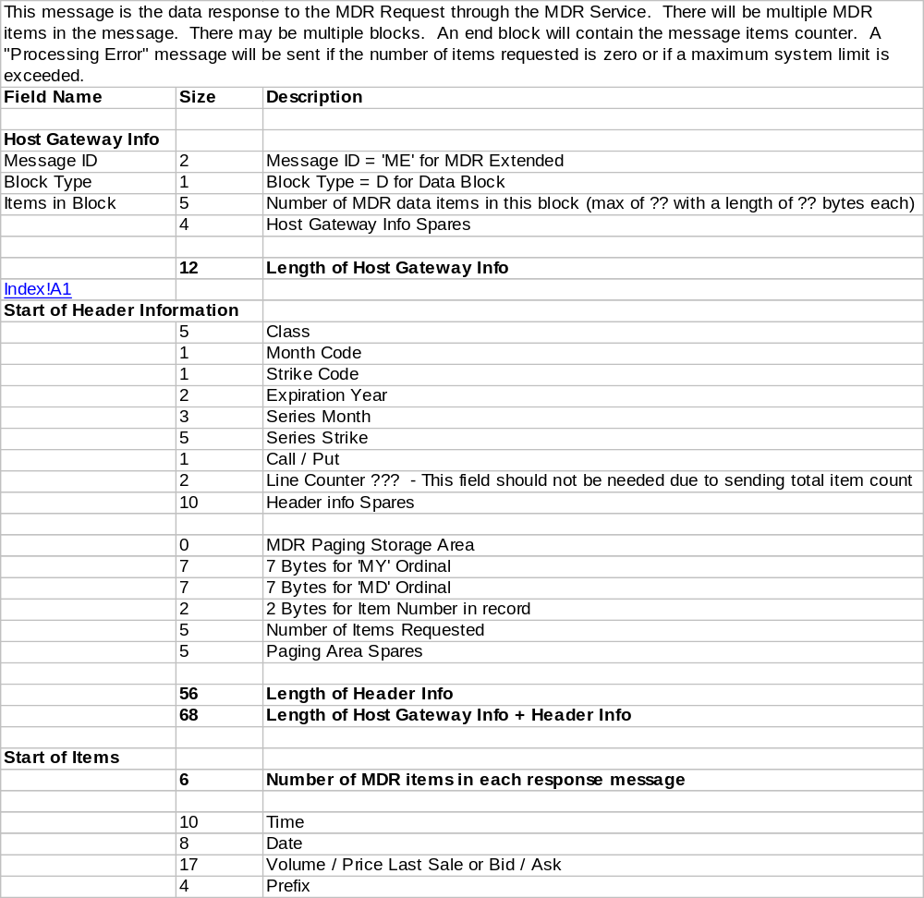

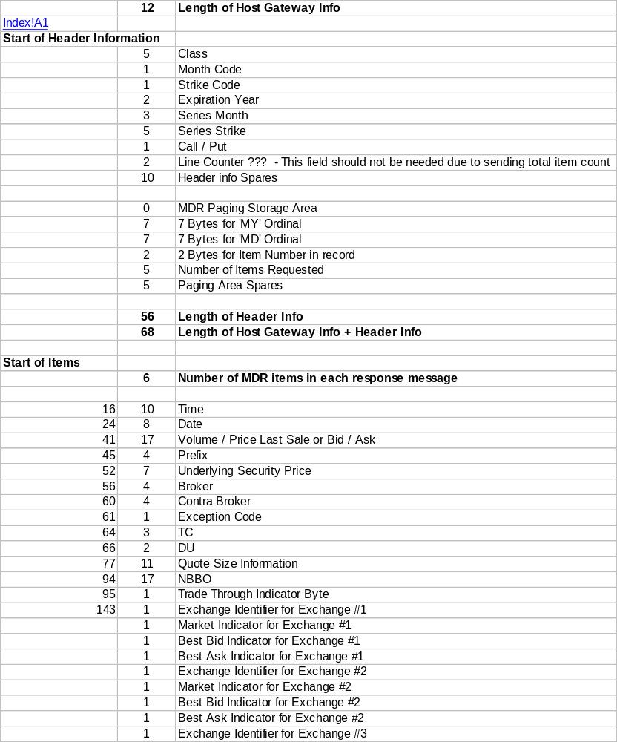
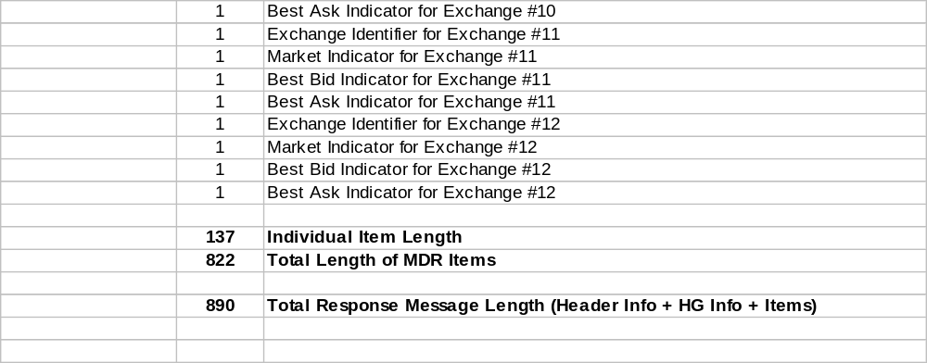

1.1.6.3 End Block Format

Field | Length | Description
Message ID | 2 |  | Message ID = ME
End Block Identifier | 1 |  | E for End Block
Total number of Items sent | 5 |  | nnnn

1.1.6.4 Output Message Format

Field | Length | Description
Message ID | 2 |  | Message ID = ME
Error Message Identifier | 1 |  | N for Error Message Identifier
Error Message Number | 6 |  | Error Message Number

1.1.6.5 Output Message Number

Message # | Text
1370 | INVALID CLASS
1371 | INVALID MONTH
1372 | INVALID STRIKE
221 | INVALID DATE
222 | INVALID TIME
410 | NO MDR ITEMS EXIST FOR SERIES
503 | PROCESSING ERROR
1615 | INVALID MESSAGE TYPE

Test Cases

- No MDR items.
- No items in MY, MD back chain exists.
- Send exactly one block of data.
- Full display of data sent.
- Less than a full display sent.
- Display last MDR page which is not a full page.
- Display a single MDR item.
- Up with no more up items.
- Down with no more down items.
- Down with no more down items and less than a page displayed.
- Up from a middle page.
- Down from a middle page.
- MDR by time.
- MDR by time where items don’t exist at that time.
- MDR for a previous day & time.
- MDR for a day & time in the future.
- MDR for inactive series
- Chained MDR records.
- Initial entry, bad class.
- Initial entry, non-existant series.
- Initial entry, bad month code.
- Initial entry, invalid time.
- Initial entry, invalid date.
- Invalid MDR paging info.

