Minimum Hybrid Quote Crossing and Locking Processing
In current CBOEDIRECT system, Quote Crossing and Locking handling is responsible for handling all the crossing or locking market created by MM quotes and quote-like orders of Hybrid products (quotes mean both real quotes and quote-like orders in this document), and send the locked market to TPF/TSS, during the lock period, only Non quote-like tradable can trade against quotes or the resting book orders.
There’s new requirement to require the system be able to trade n (n is configurable, let say 1) number of quantity between any two the quotes (of the same lock) according to price/time priority immediately when a quote lock is detected in the system before a real quote lock is created. This requirement will introduce one new trading property, “QuoteLockMinimumTrade”, so the minimum trade number n, can be configured by session name and class key (n = 0, 1, 2… m, m <= the minimum quote quantity of the two side quotes).
When n=0, means there’s no minimum trade immediately when a quote lock is detected, e.g. same as the behavior in current system (from CBOE Direct 3.0 to 3.9).
When n=1, means the system will trade 1 contract between each of the two quotes joining the quote lock, when quotes are crossed/locked with each other; and whenever a new quote coming in and join the quote lock.
When n=m, means the system will trade MIN (m, MIN (Q1 qty, Q2 qty)) contracts between each of the two quotes (let’s say Q1 and Q2) that cause the quote lock, when quotes are crossed/locked with each other; and whenever a new quote coming in and join the quote lock.
This functionality should be able to be turned off/on easily according to the configuration of n for different class and session name.

IDL Changes
A. Add new methods into TradingPropertyConsumerExt and TradingPropertyServiceExt for the new trading property QuoteLockMinimumTrade;

1) consumers.idl
interface TradingPropertyConsumerExt : TradingPropertyConsumer {
…

void acceptQuoteLockMinimumTradeQuantityUpdate ( in tradingProperty::PropertySequenceId seq, in cmiSession::TradingSessionName sessionName, in cmiProduct::ClassKey classKey, in long size);

};

2) TradingPropertyService.idl
interface TradingPropertyServiceExt : TradingPropertyService
{
…
long getQuoteLockMinimumTradeQuantity ( in cmiSession::TradingSessionName sessionName, in cmiProduct::ClassKey key, out tradingProperty::PropertySequenceId seq)
raises (exceptions::SystemException,
exceptions::CommunicationException,
exceptions::AuthorizationException,
exceptions::DataValidationException,
exceptions::NotFoundException );

void setQuoteLockMinimumTradeQuantity( in cmiSession::TradingSessionName sessionName, in cmiProduct::ClassKey classKey, in long size, in tradingProperty::PropertySequenceId seq)
raises (exceptions::SystemException,
exceptions::CommunicationException,
exceptions::AuthorizationException,
exceptions::TransactionFailedException,
exceptions::DataValidationException );

tradingProperty::LongSequence
getQuoteLockMinimumTradeQuantityAllClasses( in cmiSession::TradingSessionName sessionName)
raises (exceptions::SystemException,
exceptions::CommunicationException,
exceptions::DataValidationException,
exceptions::AuthorizationException);
}
3) TradingProperty.idl
Added the new property type:
interface GlobalTradingPropertyTypes
{
…
const GlobalTradingPropertyType QUOTE_LOCK_MIN_TRADE_QTY = 50;
}

B. Add a new constant into AllocationTradeTypes:

1) In constants.idl

interface AllocationTradeTypes
{
…
const tradingProperty::AllocationTradeType QUOTE_LOCK_MIN_TRADE = 3;
};

interface AllocationStrategyCodes
{
...
const tradingProperty::AllocationStrategyCode LOCK_MINIMUM_TRADE = 14;

};

TradingClass

1) Add quote lock minimum trade number as a new trading properties as QuoteLockMinimumTrade

2) Add several methods into TradingClass accordingly

int getQuoteLockMinimumTradeQuantity (); .
boolean isQuoteLockMinimumTradeQuantity ();

Quote-like tradable handling:
Extra Behavior to support minimum trade during processing locked/crossed quotes when process a new Quote side or quote-like order:
- If quote lock is not turned on, or minimum trade is =0 for that session and class, all the logic would be exactly same as the current logic; process it as we did usually, try to trade it against current book, if remaining quantity > 0, then book it, stop here.
- Check the incoming tradable is Non Q-like), if yes, process it as the way as the system does today; if no continue;
- Check with the book if there’s quote trigger existing on the same side or it can be traded against any non-Q order, if yes, then create/join in the quote trigger on the same side, same logic as today;
- Check with the book if there’s quote trigger existing on the other side and the quote price is same or better as the trigger price, if yes, then expire the current trigger. If expire the current trigger, after trigger trade is complete, book those quotes involved in trigger with remaining quantity >0; and continue to process the incoming quote side;
- Price bestOppositeQPrice = myBook.getbestQPrice(aTradable.getSide.getOtherSide()));
- Check if it crosses or locks market (better or = to the best price of Q-order in book of opposite side) the market, if no, just book it, and done here. If yes, then the prepare a potential quote lock, the lockPrice = bestOppositeQPrice and continue;
- isBeforeLocked = book.isLock(); if isBeforeLocked, save the preLockItems widened quote lists of both sides;
- Get the all the Q-like tradables (QL1, QL2, … QLk, … QLm) of the opposite side with bestOppositeQPrice from the current book;
- Try to create a trade at lockPrice immediately between the incoming quote with each of the tradable of the Q-like tradable list of the other side quotes of the book at the best opposite Quote price, the allow tradable quantity will be = MIN (Minimum trade size (1, 2, or… n ), MIN (remaining qty of the incoming quote, and the allowed qty of Quotes of the other side); the allocation strategy is based on Time priority.
- If !isBeforeLocked, and if the remaining qty of the incoming quote is > 0 and the quote qty of the opposite side with lockPrice is = 0, no new lock will be created; go back to step #5;
- If !isBeforeLocked, and if the remaining qty of the incoming quote is > 0 and the quote qty of the opposite side with lockPrice > 0, continue with step #16;
- If !isBeforeLocked, and if the remaining qty of the incoming quote is = 0, we are done here;
- When isBeforeLocked =true, if the remaining qty of the incoming quote is = 0; and the quote qty of the opposite side of the lockPrice is > 0; we trade the incoming quote totally, check current book if the Quote quantity of the same side at lock price is > 0 (it should be always > 0, when isBeforeLocked), if yes, we are done here, keep the current lock. (the case of that the same side quotes qty with lock price =0, should never happen when isBeforeLocked).
- When isBeforeLocked =true and If the remaining qty of the incoming quote is > 0; and the quote qty of the opposite side of the lockPrice is = 0; then the book is not locked at the current lockPrice any longer, release the lock, (including restore and un-book each of the widened quotes of the same side if its remaining qty >0; and go back step #1 to re-process each of the restored quote); and re-process the current incoming quote (go back to step #1);
- If the remaining qty of the incoming quote is > 0; and the quote qty of the opposite side of the previous lock Price is also > 0; continue;
- Book the remaining quantity of the quote, if !isBeforeLocked, it will either create a new quote lock, else it will join the current quote lock
- Then continue with the same logic of the current quote lock logic when we create a new lock or join in the current lock.

- Cancel/update/trade a quote/quote-like order:

Analysis Notes: the current lock behaviors should be still applied.

- When a quote/Q-like order is updated with different price or more quantity or different side, the system will un-book the tradable first, then pre-process it as a new incoming tradable, e.g. it will be booked with new booked time as the current system time if it be booked;

- When a quote/order is updated with less quantity and un-changed price and un-changed side, or partially cancelled, the system needs to maintain its booked time as the old one; if the updated/partially cancelled quote will be still involved quote lock after update/cancel, it will not be allocated a minimum trade again because of the update/cancel; and the system won’t need to re-check any locked entries for this case either;

- When a widen quote is updated with price or more quantity, always un-booked the old one first, and check the current book still locked or not, if not, release current lock and re-process each of those widened quotes of the opposite side (need to re-apply the minimum trade if a new lock will be detected); and continue to process the updated quote as a new incoming quote.

- When a locked quote (quote-like order) is cancelled totally, or traded totally, or updated to different price or more quantity (after un-book the old one and before process the new one), and if no more other lock entry in the lock list L of the same side, need to un-locked all the locked quotes of the opposite side first and re-process all the widened quotes in WL (call restoreAllWidenedQuotes(book, widenedLists);) as they are new incoming quotes; if there’s any new lock is detected during the re-processing quote, before re-starting a new lock or join in the current lock, the system will try to allocate minimum size lock trade between the incoming quote with each of the tradable quotes of the opposite side in the current book first; after this restoring quotes, it will continue to process the current updated quote/Q-like order if any as it is a new coming quote/order.

- It will be based on the time priority (according to its previous booked time) to re-process the narrowed quotes (if more than one), for those locked quotes without price widened before, should be always same as the old LOCK price, should NOT be able to cross/lock any quotes in book or traded against any non-Q orders in book, so still be kept in the book without extra check.

- Reinstate a Q-like order:
Analysis Notes:
Logic should be similar as it is when a Q-like order come in, the only difference is if that tradable have some remaining quantity before re-instate, then it should just keep the lock context it has before the re-instate, and just skip the check lock part.

Implementation plan:

1. LoadIFR
2. Load new ACL
3. Update all the server jars
The direct affected jar files:
IDL jars
Domain interface
Server interface
Server impl
4. After GlobalServer is up, need to run below scripts to setup default value of QuoteLockMinimumTradeQuantity
setTradingProperty ONE_MAIN default QuoteLockMinimumTradeQuantity 0
setTradingProperty CFE_MAIN default QuoteLockMinimumTradeQuantity 0
setTradingProperty W_MAIN default QuoteLockMinimumTradeQuantity 0

Related change in client side:
SACAS jar and SAGUI jar
Make sure the right version ACL has already been loaded by infra before SAGUI/SACAS can go live.

Appendix – I
To make the examples simple, we might only give one side quotes, which also includes Q-like orders (such as I orders), you can replace I-order with a real quote by adding the other quote side with a much worse price of the other side; similarly, you can also replace a real quote with an I-order for each side.

Examples for “Trade 1 Contract” Quote Lock Feature

Assumptions: Quote Lock Timer = 1 second; 1 contract trade occurs immediately; quote lock notification is sent immediately but is not represented in the examples.
Example 1:
9:00:00 MM1: 1.00 – 1.20 50 x 50
9:00:05 MM2: 1.20 – 1.40 50 x 50
9:00:05 1 contract trades between MM1 and MM2 immediately
9:00:05 Last sale 1 @ 1.20
9:00:05 Top-of-the-market = 1.20 – 1.20 49 x 49
9:00:06 49 contracts trade if MM1 and MM2 have not changed their quotes.
9:00:06 Last sale 49 @ 1.20
9:00:06 New market 1.00 – 1.40 50 x 50
Example 2:
9:00:00 MM1: 1.00 – 1.20 50 x 50
9:00:05 MM2: 1.20 – 1.40 50 x 50
9:00:05 1 contract trades between MM1 and MM2 immediately
9:00:05 Last sale 1 @ 1.20
9:00:05 Top-of-the-market = 1.20 – 1.20 49 x 49
9:00:05.5 MM3: 1.20 – 1.40 50 x 50
9:00:05.5 1 contract trades between MM1 and MM3 immediately
9:00:05.5 Last sale 1 @ 1.20
9:00:05.5 Top-of-the-market = 1.20 – 1.20 98 x 48
9:00:06 48 contracts trade if MM1, MM2 and MM3 have not changed their quotes. The 48 contracts are s UMA’d to MM2 and MM3
9:00:06 Last sale 48 @ 1.20
9:00:06 New market 1.20 – 1.40 50 x 100
Example 3:
9:00:00 MM1: 1.00 – 1.20 50 x 50
9:00:01 MM2: 1.00 – 1.20 50 x 50
9:00:01 Top-of-the-market 1.00 – 1.20 100 x 100
9:00:05 MM3: 1.20 – 1.40 50 x 50
9:00:05 1 contract trades between MM1 and MM3 immediately and 1 contract trades between MM2 and MM3 immediately.
9:00:05 Last sale 2 @ 1.20
9:00:05 Top-of-the-market = 1.20 – 1.20 48 x 98
9:00:06 48 contracts trade if MM1, MM2 and MM3 have not changed their quotes. The 48 contracts are UMA’d to MM1 and MM2
9:00:06 Last sale 48 @ 1.20
9:00:06 New market 1.00 – 1.20 100 x 50

More examples for the quote lock min trades (example #4 and #5 are based on the email sent out on Thursday, May 06, 2004 11:27 AM)

Example 4:
1) Currently the book has (not locked yet)
Buy side: Sell side
Some quotes with worse price than 1.1
MM1 1.0 qty 1
MM2 0.9 qty 1
MM3 0.8 qty 1
MM4 0.7 qty 1
MM5 0.6 qty 1

2) a new quote MM6 coming in on sell side with price 0.7 qty is 60@08:00:00
@08:00:00, MM6 will immediately
a) trade 1 with MM1 (at price 1.0) , and publish a trade report and last sale for the trade
b) trade 1 with MM2 (at price 0.9) , and publish a trade report and last sale for the trade
c) trade 1 with MM3 (at price 0.8) , and publish a trade report and last sale for the trade
d) trade 1 with MM4 (at price 0.7) , and publish a trade report and last sale for the trade
e) At the moment, the book will be
Buy side: Sell side
something with worse price than 1.1
MM5 0.6 qty 1
MM6 .07 qty 56
Publish current market as 0.6x1 - 0.7x 56, last sale @0.7 (qty 1) no quote lock will be created.

Example 5:

1) Currently the book has
Buy side: Sell side
MM1 1.0 qty 3
MM2 0.9 qty 1
MM3 0.8 qty 1
MM4 0.7 qty 1
MM5 0.6 qty 1

2) @8:00:00 MM6 comes in with $0.5-$1.0, qty 60,
    - MM6 will trade 1 immediately @ $1.0, last sale is $1.0 (qty 1), publish fill reports, and create quote lock.
    - Current Market is $1.0 (2)-$1.0(59)

3) @8:00:00.05, quote MM7 comes in with $0.5-$ 0.8 qty is 50, before the quote lock is expired,
  - MM7 will trade 1 immediately @ $1.0, last sale is $1.0 (qty 1), publish fill reports, and join the quote lock.
  - Current Market is $1.0 (1)-$1.0(108)

4) @8:00:00.10, quote MM8 comes in with $0.5-$ 0.7 qty is 60, before the quote lock is expired,
- MM8 will trade 1 immediately @ $1.0, last sale is $1.0 (qty 1), publish fill reports, MM8 has remaining qty 59, and it un-locks the current quote lock, check the widened quote on the same side;
- MM7 will restore and trade with MM2 @$0.9 with qty 1 immediately, last sale is $0.9 (qty 1), publish fill reports, MM7 with remaining qty 48
- MM7 trade with MM3 @$0.8 with qty 1 immediately, last sale is $0.8 (qty 1), publish fill reports, MM7 with remaining qty 47 and booked.
- MM8 will trade 1 with MM4 @$0.7, last sale is $0.7 (qty 1), and publish fill reports, MM8 with remaining qty 58;
- Current Market is $0.6 (1)-$0.7(58), current order book should be:

Buy side: Sell side
MM5 0.6 qty 1
MM8 0.7 qty 58
MM7 0.8 qty 47
MM6 1.0 qty 59
0.5 (qty 170)

Examples are involved in quote trigger - assume the quote trigger timer is 1 second

Example 6:
1) MM1 buy 1.1 qty 20
2) C1 buy1.1 qty10
3) @8:00:00, MM2 comes in, sell 1.1 qty 30
4) @8:00:00, MM2 quote trigger C1, last sale is $1.1 with qty 10, and no fill reports published yet; current market is $1.1(10) – $1.1 (10)
5) @8:00:01, quote trigger will expire, publish fill reports for C1 and MM2, MM2 has remaining qty 20;
6) @8:00:01, MM2 will trade with MM1 1 qty, last sale is $1.1 (1), publish fill reports, current market is $1.1(19)-$1.1 (19), create quote lock.
7) @8:00:02, expire quote lock trade, last sale $1.1 (19), publish fill reports, current market is noPrice on both side.

Example 7:

1) MM1 buy 1.2 qty 20
2) C1 buy1.1 qty10
3) MM2 buy 1.0 qty 15
4) @8:00:00, MM3 comes in $0.5 x50-$1.0 x50,
5) @8:00:00, MM3 will lock MM1, trade 1 @$1.2, publish fill reports, current market is $1.2 x19-$1.2 x 49
6) @8:00:01, lock will expire, MM3 will trade with MM1, last sale qty 19 @$1.2, publish fill reports, MM3 with remaining qty 30
7) @8:00:01, MM3 will quote trigger C1, last sale is $1.1 with qty 10, and no fill reports published yet; current market is $1.0(15) – $1.0 (20), there’s no real lock created though.
5) @8:00:02, quote trigger will expire, publish fill reports for C1 and MM3, MM3 has remaining qty 20;
6) @8:00:02, MM3 will trade 1 qty with MM2, last sale is $1.0 (1), publish fill reports, current market is $1.0(14)-$1.0 (19), create quote lock.
7) @8:00:03, expire quote lock trade, last sale $1.0 (14), publish fill reports, current market is $0.5(50)-$1.0(5).

Example 8:

1) MM1 buy 1.2 qty 20
2) C1 buy1.2 qty10
3) MM2 buy 1.2 qty 20
4) @8:00:00, MM3 comes in $0.8 x50-$1.2 x50, will trigger C1, last sale $1.2 qty 10, but no fill report published yet, current market is $1.2 x40 - $1.2 x 40
4) @8:00:00.5, before trigger expires, MM4 comes in $0.8 x50-$1.2 x50, join the trigger, current market is $1.2 x40 - $1.2 x 90
5) @8:00:01, trigger expires, publish fill reports, MM3 and MM4 are filled 5 respectively, with remaining qty 45;
MM3 will lock MM1 and MM2, trade 1 with each of them, last sale 2 @$1.2, publish fill reports, with remaining qty 43 respectively;
MM4 will join the lock too, trade 1 with each of them, last sale 2 @$1.2, publish fill reports; current market is $1.2 x 36 – $1.2 x 86;
6) @8:00:02, lock will expire, MM3 and MM4 will trade with MM1 and MM2, last sale qty 36 @$1.2, publish fill reports, both MM3 and MM4 have 25 qty left, current market is 0x 0 - $1.2 x 50

Example 9:

1) MM1 buy 1.2 qty 20
2) MM2 buy 1.2 qty 20
3) @8:00:00, MM3 sell 1.2 qty 20, it will create quote lock, trade 1 with MM1 and MM2, and publish fill reports, the current market is 1.2 x 38 – 1.2 x18, last sale $1.2 (qty 2)
4) @8:00:00.05, customer order (C1) comes in, buy1.2 qty10, it will trade with MM1 and MM2 immediately, last sale $1.2 (10), publish fill reports, both MM1 and MM2 have 14 left, the current market is 1.2 x 28 – 1.2 x18, continue being locked.
5) @8:00:01, quote lock expires, last sale is $1.2 (18), publish fill reports, both MM3 and MM4 are filled 9, having 5 left, the current market is $1.2 x 10 – noPrice (0).

Example 10:
1) Currently the book has
Buy side: Sell side
MM1 1.0 qty 3
MM2 0.9 qty 1
MM3 0.8 qty 1
C-order (C1) 0.8 qty 10
MM4 0.7 qty 1
C-order (C2) 0.7 qty 15
MM5 0.6 qty 1

2) @8:00:00 MM6 comes in with $0.5-$1.0, qty 60,
    - MM6 will trade 1 immediately @ $1.0, last sale is $1.0 (qty 1), publish fill reports, and create quote lock.
    - Current Market is $1.0 (2)-$1.0(59)

3) @8:00:00.05, quote MM7 comes in with $0.5-$ 0.8 qty is 50, before the quote lock is expired,
- MM7 will trade 1 immediately @ $1.0, last sale is $1.0 (qty 1), publish fill reports, and join the quote lock.
- Current Market is $1.0 (1)-$1.0(108)

4) @8:00:00.10, quote MM8 comes in with $0.5-$ 0.7 qty is 50, before the quote lock is expired,
  - MM8 will trade 1 immediately @ $1.0, last sale is $1.0 (qty 1), publish fill reports, MM8 has remaining qty 49, and it un-locks the current quote lock, check the widened quote on the same side;
  - MM7 will restore and trade with MM2 @$0.9 with qty 1 immediately, last sale is $0.9 (qty 1), publish fill reports, MM7 with remaining qty 48
  - MM7 will quote trigger C-order (C1), last sale $0.8(qty 10), but no fill report published yet.
  - Continue to process MM8, it will join the quote trigger create in #c), current market is $0.8(1)-$0.8(87),
  - After quote trigger expires @8:00:01.10, publish fill reports for MM7, MM8 and C1, MM7 and MM8 will be filled 5 respectively (with remaining qty 43 and 44)
  - @8:00:01.10, MM7 will trade qty 1 immediately with MM3, last sale is $0.8 (qty 1), publish fill reports, MM7 with remaining qty 42 and booked.
  - MM8 will quote trigger C-order (C2), last sale $0.7(qty 15), current market is $0.7(1)-$0.7(29), but no fill report published yet.
  - After quote trigger expires @8:00:02.10, publish fill reports for MM8 and C2, MM8 will be filled 29 with remaining qty 29.
  - MM8 will trade 1 with MM4 @$0.7, last sale is $0.7 (qty 1), and publish fill reports, MM8 with remaining qty 28;
  - Current Market is $0.6 (1)-$0.7(28), current order book should be:

Buy side: Sell side
MM8 0.7 qty 28
MM7 0.8 qty 42
MM6 1.0 qty 59
MM5 0.6 qty 1
0.5 (qty 160)

Example 11 (partially allocate quote lock minimum trade):

1) MM1 buy 1.2 qty 10
2) MM2 buy 1.2 qty 20
3) MM3 buy 1.2 qty 2
4) MM4 buy 1.2 qty 100
5) @8:00:00, MM3 comes in $0.8 x 3 - $1.2 x 3, will fill each of the locked quote with 1 according to their time priority, last sale $1.2 qty 3, so MM1 and MM2 and MM3 will get fill 1, while MM4 will not get any fill, with remaining qty 100 left.
current market is $1.2 x 129 – noPrice

Example 12 (partially allocate quote lock minimum trade, and change the Min trade size for this testing class(assume CSCO) to 2 with below command from tradeeng run_dir ):
“setTradingProperty W_MAIN CSCO option QuoteLockMinimumTradeQuantity 2”

1) MM1 buy 1.2 qty 10
2) MM2 buy 1.2 qty 1
3) MM3 buy 1.2 qty 20
4) MM4 buy 1.2 qty 100
5) @8:00:00, MM3 comes in $0.8 x 5 - $1.2 x 5, will fill each of the locked quote with as much as 2, according to their time priority, last sale $1.2 qty 5, MM1 and MM3 will be filled 2, and MM2 will get fill 1, while MM4 will not get any fill, with remaining qty 100 left.
current market is $1.2 x 126 – noPrice

Example 13 (partially allocate quote lock minimum trade, and change the Min trade size for this testing class to 2 with below command from tradeeng run_dir ):
“setTradingProperty W_MAIN CSCO option QuoteLockMinimumTradeQuantity 2”

1) MM1 buy 1.2 qty 10
2) MM2 buy 1.2 qty 1
3) MM3 buy 1.2 qty 20
4) MM4 buy 1.2 qty 100
5) @8:00:00, MM3 comes in $0.8 x 6 - $1.2 x 6, will fill each of the locked quote with as much as 2, according to their time priority, last sale $1.2 qty 6, MM1 and MM3 will be filled 2, and MM2 and MM4 will get fill 1, current market is $1.2 x 125 – noPrice

6) set the size back to 1

“setTradingProperty W_MAIN CSCO option QuoteLockMinimumTradeQuantity 1”

Example 14 (opposite quote comes in, it will expire the quote trigger )

1) MM1 buy 1.2 qty 10;
2) Customer order (C1) buy 1.2 qty 1;
3) @8:00:00, MM2 comes in, sell 1.2 qty 20, it will create quote trigger, last sale is
$1.2 x10; no fill report published; current market is $1.2 x 10 - $1.2 x 10;
4) @8:00:00.50, before the quote trigger expires, MM3 comes in, to buy $1.2 (qty 10), it will expire the trigger created in #3), publish fill report immediately, MM2 will trade 10 against C1 with 10 left; MM2 will create quote lock with MM1, trade 1 first, last sale is $1.2 (1), publish fill reports, MM2 with 9 left; continue to process MM3, it will join the quote lock, trade 1 with MM2 first, last sale is $1.2(1), current market is $1.2(18) - $1.2(8);
5) @8:00:01.50, the quote lock expires, last sale is $1.2(8), both MM1 and MM3 have 5 left; MM2 will be filled 8, 0 left; and current market is $1.2 x10 – NoPrice.

Example 15 (opposite order comes in, it will expire the quote trigger)

1) MM1 buy 1.2 qty 10;
2) Customer order (C1) buy 1.2 qty 1;
3) @8:00:00, MM2 comes in, sell 1.2 qty 20, it will create quote trigger, last sale is
$1.2 x10; no fill report published; current market is $1.2 x 10 - $1.2 x 10;

4) @8:00:00.50, before the quote trigger expires, customer order (C2) comes in, to buy $1.2 (qty 10), it will expire the trigger created in #3), publish fill report immediately, MM2 will trade 10 against C1 with 10 left;
MM2 will create quote lock with MM1, trade 1 first, last sale is $1.2 (1), publish fill reports, both MM1 and MM2 have 9 left;
Continue to process C2, it will trade 9 against MM2, last sale is $1.2(9), C1 has 1 left current market is $1.2(10) – noPrice.

Appendix - II: the components need to be developed for the task:

BrokerProcessService
TradeService
TradingPropertyService
AllocationStrategy

IDL branch changed files list:

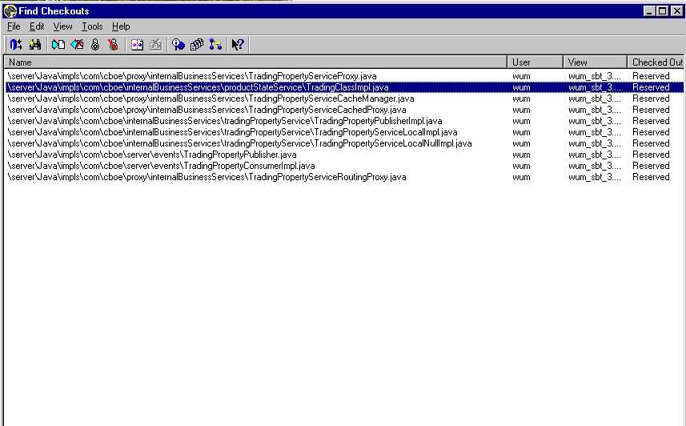

The files changed to add the new Trading Property in server branch:

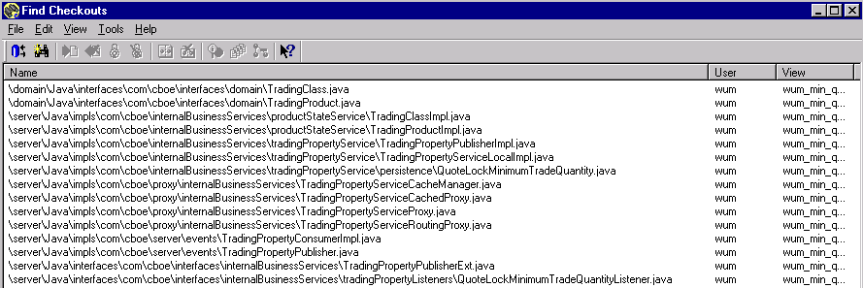

Allocation Strategy change:
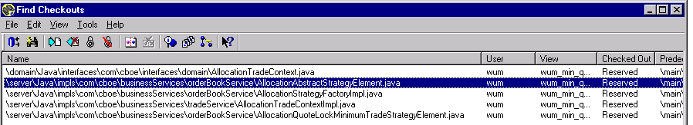

Broker & Trade Service Change:

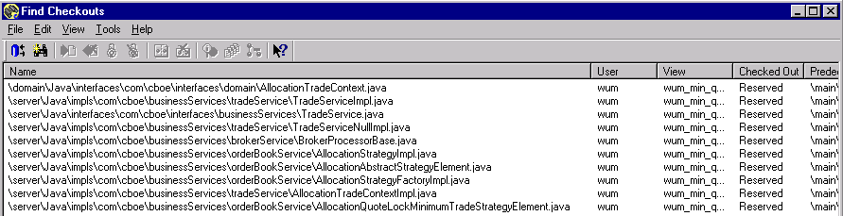

Some scripts change:

setTradingProperty
getTradingProperty
setTradingProperties
getTradingProperties
getCachedTradingProperty

