CBOEDirect GUI Test Plan
RMM4

October 5, 2005

Table of Contents
Overview of changes in this release 2
Work requests included in this release 2
Bugfixes included in this release 2
Features included in this release 2
SAGUI 3
Class Assignment by Session 3
Add Class Assignment by Session for W_MAIN 3
Add Class Assignment by Session for ONE_MAIN or CFE_MAIN 4
Add Class Assignment by Session for any Session 4
Modify Class Assignment by Session and not allow enablement changes 5
Modify Class Assignment by Session and Save Changes 5
Modify User Enablements and prompt on any Class Assignment modification 6
Add New User Acronym without class assignments 7
Add New User Acronym with class assignments 8
Remove Class Assignment 8
Remove Class Assignment 9

Overview of changes in this release
This release includes the following wor requests and and the following bug fixes:

Work requests included in this release
List all the work requests included in this release (below is an example)
- 2979 – RMM4

Bugfixes included in this release
- n/a

Regression testing should be performed besides these testing procedures

Features included in this release
Just provide the list of features from your product backlog that was completed for the scrum
example
- Modifying a User Class Assigments will generate user enablements for that class
- Class Assigments for Users will now be done by Sesssion

SAGUI

Class Assignment by Session
The Classes tab on the User Management Window has been modifed. There is a Product Selector present now for the Assigned Classes group.

Setup
none

Scenario
- Login on the SAGUI
- Open the User Management Window
- Select any User Acronym
- Select the Classes tab

Verification
- Verify that there is a product selector present for the Assigned Classes Group
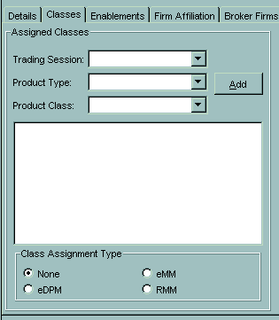

Add Class Assignment by Session for W_MAIN
The Classes tab on the User Management Window has been modifed. There is Product Selector present now for the Assigned Classes group and the User can now assign classes by Session.

Setup
Following the steps in the test case Class Assignment by Session

Scenario
- Add a class assignment to this user for the session W_MAIN
- Now save the User

Verification
- Switch to the User Enablements tab on the User Management Window, and the class you assigned should have an enablement row in the table.

Add Class Assignment by Session for ONE_MAIN or CFE_MAIN
The Classes tab on the User Management Window has been modifed. There is Product Selector present now for the Assigned Classes group and the User can now assign classes by Session.

Setup
Following the steps in the test case Class Assignment by Session

Scenario
- Add a class assignment to this user for the session ONE_MAIN or CFE_MAIN
- Now save the User

Verification
- Switch to the User Enablements tab on the User Management Window, and the class you assigned should not have an enablement row in the table.

Add Class Assignment by Session for any Session
The Classes tab on the User Management Window has been modifed. There is Product Selector present now for the Assigned Classes group and the User can now assign classes by Session.

Setup
Following the steps in the test case Class Assignment by Session

Scenario
- Add a class assignment to this user for the sessions W_MAIN, ONE_MAIN and CFE_MAIN
- Now save the User

Verification
- Switch to the User Enablements tab on the User Management Window, and the class you assigned for W_MAIN should have an enablement row in the table. The other classes you assigned for the other sessions should not have an enablement row in the table.

Modify Class Assignment by Session and not allow enablement changes
The Classes tab on the User Management Window has been modifed. There is Product Selector present now for the Assigned Classes group and the User can now assign classes by Session. Once a modification has been made to class assignments, then the user enablements tab edit action will be disabled.

Setup
Following the steps in the test case Class Assignment By Session

Scenario
- Either add a class, remove a class, or change the assignment type

Verification
- Switch to the User Enablements tab on the User Management Window, and all the edit actions will be disabled.
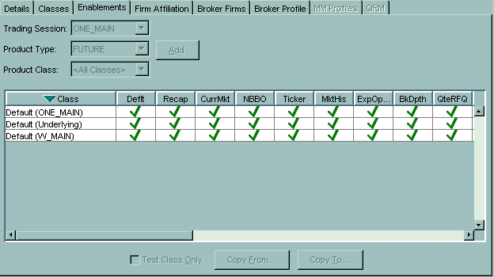

Modify Class Assignment by Session and Save Changes
The Classes tab on the User Management Window has been modifed. There is Product Selector present now for the Assigned Classes group and the User can now assign classes by Session. Once a modification has been made to class assignments, then the user enablements tab edit action will be disabled.

Setup
Following the steps in the test case Class Assignment By Session

Scenario
- Either add a class, remove a class, or change the assignment type
- Check the User Enablement tab to make sure User Enablement editing is disable (see Modify Class Assignments and not allow Enablement changes)
- Save the changes for the Users class assignments

Verification
- Switch to the User Enablements tab on the User Management Window, and make sure you can now modify user enablements

Modify User Enablements and prompt on any Class Assignment modification
If User Enablements are modified and then an attempt to modify class assignments should result in the user being prompted with a dialog stating if they change class assignments then their user enablement changes will be lost. This test has to be ran twice, so select yes the first time and select no the second time through.

Setup
none

Scenario
- Login on the SAGUI
- Open the User Management Window
- Select any User Acronym
- Select the User enablements tab
- Make a modification to the User Enablements
- Now switch to the Classes tab
- Try to modify the class assignments

Verification
- You should see the following dialog
- Yes – the class assignments changes will be allowed and the changes to user enablements will be lost
- No – the class assignments changes will not be allowed and the changes to user enablements will remain

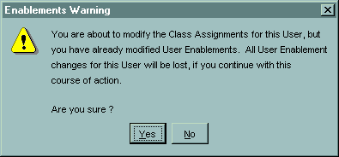

Add New User Acronym without class assignments
Adding class assignments for a user will generate user enablements for those classes from the W_MAIN session.

Setup
none

Scenario
- Login on the SAGUI
- Open the User Management Window
- Click the New User button
- 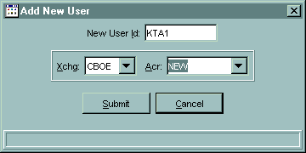
- Create a new Acronym and User Id
- Click the button Submit
- Save User the changes
- Switch to the Classes tab and add class assignment for the W_MAIN session
- Save User the changes

Verification
- Switch to the User Enablements tab on the User Management Window, and the class you assigned for W_MAIN should have an enablement row in the table.

Add New User Acronym with class assignments
Adding class assignments for a user will generate user enablements for those classes from the W_MAIN session.

Setup
none

Scenario
- Login on the SAGUI
- Open the User Management Window
- Click the New User button
- Create a new Acronym and User Id
- Click the button Submit
- Switch to the Classes tab and add class assignment for the W_MAIN session
- Save User the changes

Verification
- Switch to the User Enablements tab on the User Management Window, and the class you assigned for W_MAIN should have an enablement row in the table.

Remove Class Assignment
The Classes tab on the User Management Window has been modifed. There is Product Selector present now for the Assigned Classes group and the User can now assign classes by Session and remove assignments.

Setup
Following the steps in the test case Add Class Assignment by Session for W_MAIN, and do not modify the enablements settings.

Scenario
- Switch to the Classes tab
- Remove the class assignments you have selected for the User
- Save changes

Verification
- Switch to the User Enablements tab on the User Management Window, and the class assignment you just removed should not be visible in the enablements table.

Remove Class Assignment
The Classes tab on the User Management Window has been modifed. There is Product Selector present now for the Assigned Classes group and the User can now assign classes by Session and remove assignments.

Setup
Following the steps in the test case Add Class Assignment by Session for W_MAIN, and modify the enablements settings for each class you have added..

Scenario
- Switch to the Classes tab
- Remove the class assignments you have selected for the User
- Save changes

Verification
- Switch to the User Enablements tab on the User Management Window, and the class assignment you just removed should be visible in the enablements table and the quote entry operations should be disabled.

