RMM3 Phase I: Quote Restrictions Using User Enablements

1.Assumptions
- Quote restriction is enforced in User Enablements on CAS. No restriction on I-Orders is required now and in the near futures.

- Property channel is used for server and CAS interaction.

- Intra-day SAGUI updates are performed from the user enablement window. This becomes necessary when MPP is not available.

- Quote restriction with user enablements are constructed and persisted as part of user enablement data (called user_quote_enablement data here). They are completely separate data from user class assignment data used by trade servers for eDPM allocations (called user_class_assignment data here).

- When mm refresh occurs, both user_quote_enablement and user_class_assignment data are updated. When SAGUI updates user_class_assignment data, there is update in user_ enablement data. But only the enablements of the configured trading session(s) (configured in UserMaintenanceService.xml) will be updated in user_ enablement properties data.

- When SAGUI updates user_quote_enablement data, there is no update in user_class_assignment data.

2. CAS/SAGUI Interactions with GlobalServer
2.1 Quote restriction is enforced on CAS
- CAS will enforce quote restriction using user_quote_enablement data from GlobalServer

- CAS subscribes user_quote_enablement data updates on event channel Property as it does now. When it receives an update, CAS will replace the old assigned class list with the new one.

- CAS or firms will initiate quote cancellation request for the removed classes.

2.2 CAS/SAGUI Request user_quote_enablement data for a user or all users
- CAS requests user_quote_enablement from GlobalServer as it does for user enablements

PropertyService
{
public PropertyGroupStruct getProperties(String category, String propertyKey) throws SystemException, CommunicationException, AuthorizationException, NotFoundException
}

2.3 SAGUI subscribes user_quote_enablement data updates on Property channel.
- SAGUI subscribes user_quote_enablement data updates on event channel Property if it is not currently doing so. When it receives an update, SAGUI will refresh its gui with the new user enablements.

  - Domain conversion
- Need a domain object to construct PropertyGroupStruct for Property channel publishing. The mm class assignments and existing user enablement data are inputs for the construction. The existing user enablement data are needed since the mm class assignments contains the new enablements for the named sessions but PropertyGroupStruct needs to include all enablements of all sessions for a user. For example, if UserClassAssignment contains “W_MAIN” and “ONE_MAIN” sessions but not “CFE_MAIN”, the existing user enablements in the CFE_MAIN session should be copied to the new one.
// New data class
UserClassAssignment {
String userId;
ExchangeAcronymStruct userAcronym;
SessionClassAssignment[] SessionClassAssignments;
}
// New data class
SessionClassAssignment {
String sessionName;
Int[] classKeys;
}

// New conversion method
PropertyGroupStruct propertyGroupStruct =
Obj.toPropertyGroupStruct(UserClassAssignment userClassAssignment,
PropertyGroupStruct existingPropertyGroupStruct );

  - CAS/SAGUI will handle the class assignments using specific session names instead of ALL_SESSIONS. The server will handle mm refresh data with specific session names so CAS/SAGUI has to change accordingly.

3. GlobalServer
3.1 Interactions with CAS
- When mm refresh occurs, convert class assignments into property format data, persist them into property_group and property tables and publish them to Property channel.

- Use domain conversion method.

- Serve request for loading user enablement data as it does currently
PropertyService
{
public PropertyGroupStruct getProperties(String category, String propertyKey) throws SystemException, CommunicationException, AuthorizationException, NotFoundException
}

The category is “enablement”.
Examples of propertyKey: “CBOEWAB”, “CBOEWABTestClass”, or “propertyDefinitionKey”.

3.2 Interactions with SACAS
- When SAGUI modifies user_quote_enablement data, the server persists the changes and publishes the updates on Property channel as it does now.

3.3 Interactions with Membership Adapter
- The existing mm refresh comes from MPP: after MemAdapter polls the mm/dpm refresh from membership database, the adapter loads firm and user data and makes the following method call to UserDefinitionService implemented in UserServiceImpl in GS:

public void defineSessionProfileUser(SessionProfileUserDefinitionStruct aUser,
boolean membershipDefined)
throws TransactionFailedException, DataValidationException, SystemException

- In addition to the existing logic to update user_class_assignment data for trader servers, GlobalServer will convert class assignments into user enablement data in property format, persist them and publish them to Property channel for CAS and SACAS.

- Make sure that session name is propagated from Membership Adapter to GlobalServer

3.5 AR command to republish user enablements for a user

4 Session Name Changes
4.1 Membership Adapter

class MembershipAdapterImpl {
private void getAssignedClasses(SessionProfileUserDefinitionStruct userDefinition) throws SQLException, SystemException, AuthorizationException, CommunicationException
{
MarketMakerClassAssignmentStruct classAssignment = new MarketMakerClassAssignmentStruct();
//See the NOTE above as why we are using ALL_SESSION_NAME here.
classAssignment.sessionName = SessionNameValues.ALL_SESSION_NAME;
}
}

4.2 UserMaintenanceServiceImpl called by SAGUI and TradeServer

class UserMaintenanceServiceImpl {
//The following method query users by (classKey, assignmentType, sessionName):
public SessionProfileUserDefinitionStruct[] getUsersAssignedToClass(int classKey, short
assignmentType, String sessionName)
throws SystemException, CommunicationException, AuthorizationException,
DataValidationException
{
sessionName = SessionNameValues.ALL_SESSION_NAME;
List users = getUserHome().findByClassAssignmentType(classKey, assignmentType, sessionName);
return convertToStructs(users);
}

public void updateSessionProfileUser(SessionProfileUserDefinitionStruct existingUser) {
…
getUserHome().updateUser(theUser, existingUser, false/*not membership defined*/);
…
}
}

The method updateSessionProfileUser is called SAGUI

The method getUsersAssignedToClass is called
TradingClassImpl in HybridTradeServer
UserServiceCacheProxy
UserServiceSmartCacheProxy

To check, ar HybridTradeServer getDpmParticipantsForClass classKey
ar HybridTradeServer getEDPMsForClass classKey

4.3 Other dependency on SessionNameValues.ALL_SESSION_NAME
- /server/java/impls, /domain/java/impls, /server/eis/java/impls, /server/java/proxies. No dependency in /server/Java/interfaces, /server/eis/Java/interfaces. One occurrence in simulator/java should be ok.

- /server/java/impls
QuoteSideImpl
OrderHomeImpl
OrderImpl
UserMaintenanceServiceImpl

// May not be related to class assignments.
TradingSessionRegistrationMapHomeImpl
TradingSessionServiceLocalImpl

- /domain/java/impls
SessionProfileHelper

- /server/eis/java/impls
MembershipAdapterImpl

- /server/java/proxies
UserServiceCachedProxy
UserServiceSmartCachedProxy
UserMaintenanceServiceCacheManager

- /domain/Java/persist
AcronymUserImpl

Appendix 1: User enablements on SAGUI:
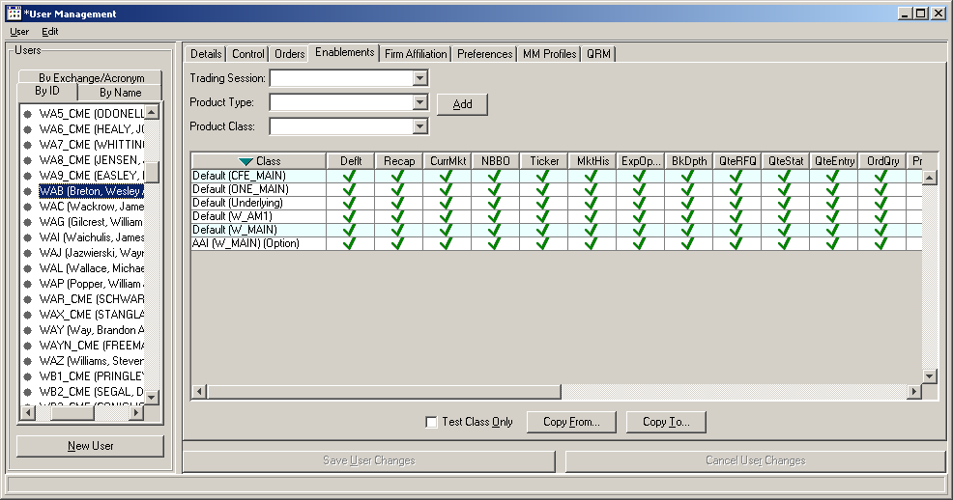
Appendix 2: User Class Assignment Data:
1) For informational purpose, below show the definitions of the views and sample data from mpp
desc sbt_mm_class_asgn
Name Null? Type
----------------------------------------- -------- ----------------------------
TRADE_DATE NOT NULL DATE
MM_ENT_UID NOT NULL NUMBER(10)
MM_ACR NOT NULL VARCHAR2(5)
CLASS_SYM NOT NULL VARCHAR2(10)
EXCH_ACR NOT NULL VARCHAR2(5)
SESS_NAME NOT NULL VARCHAR2(30)
MM_ASGN_TYPE_CODE VARCHAR2(10)
LMOD_DATE NOT NULL DATE
MM_TRADE_OFF_FLR_IND CHAR(1)

desc sbt_dpm_class_asgn
Name Null? Type
----------------------------------------- -------- ----------------------------
TRADE_DATE NOT NULL DATE
DPM_ENT_UID NOT NULL NUMBER(10)
DPM_ACR NOT NULL VARCHAR2(5)
CLASS_SYM NOT NULL VARCHAR2(10)
EXCH_ACR NOT NULL VARCHAR2(5)
SESS_NAME NOT NULL VARCHAR2(30)
LMOD_DATE NOT NULL DATE

SQL> select * from sbt_mm_class_asgn where mm_acr = 'CZA' and trunc(LMOD_DATE) = '07-FEB-05';
TRADE_DAT MM_ENT_UID MM_AC CLASS_SYM EXCH_ SESS_NAME MM_ASGN_TY LMOD_DATE M
--------- ---------- ----- ---------- ----- ------------------------------ ---------- --------- -
16-FEB-05 55835 CZA AHC CBOE W_MAIN EDPM 07-FEB-05 Y
16-FEB-05 55835 CZA APC CBOE W_MAIN EDPM 07-FEB-05 Y
16-FEB-05 55835 CZA AU CBOE W_MAIN EDPM 07-FEB-05 Y
16-FEB-05 55835 CZA CA CBOE W_MAIN EDPM 07-FEB-05 Y
16-FEB-05 55835 CZA CCU CBOE W_MAIN EDPM 07-FEB-05 Y
16-FEB-05 55835 CZA OCP CBOE W_MAIN EDPM 07-FEB-05 Y
16-FEB-05 55835 CZA VBX CBOE W_MAIN EDPM 07-FEB-05 Y
16-FEB-05 55835 CZA VCA CBOE W_MAIN EDPM 07-FEB-05 Y
16-FEB-05 55835 CZA VHS CBOE W_MAIN EDPM 07-FEB-05 Y
16-FEB-05 55835 CZA VKE CBOE W_MAIN EDPM 07-FEB-05 Y
16-FEB-05 55835 CZA VYU CBOE W_MAIN EDPM 07-FEB-05 Y

TRADE_DAT MM_ENT_UID MM_AC CLASS_SYM EXCH_ SESS_NAME MM_ASGN_TY LMOD_DATE M
--------- ---------- ----- ---------- ----- ------------------------------ ---------- --------- -
16-FEB-05 55835 CZA WHS CBOE W_MAIN EDPM 07-FEB-05 Y
16-FEB-05 55835 CZA WOA CBOE W_MAIN EDPM 07-FEB-05 Y
16-FEB-05 55835 CZA WRX CBOE W_MAIN EDPM 07-FEB-05 Y
16-FEB-05 55835 CZA WVX CBOE W_MAIN EDPM 07-FEB-05 Y
16-FEB-05 55835 CZA YPC CBOE W_MAIN EDPM 07-FEB-05 Y
16-FEB-05 55835 CZA YVA CBOE W_MAIN EDPM 07-FEB-05 Y
16-FEB-05 55835 CZA ABX CBOE W_MAIN EDPM 07-FEB-05 Y

2) Class assignments in global db
SQL> select * from asgn_class where USER_KEY = 19333151;

DATABASEIDENTIFIER USER_KEY ASGN_CLASS_KEY ASSIGNMENT SESSION_NAME
------------------- ------------------- ------------------- ---------- ------------------------------
51041391374978 19333151 39583747 1 ALL_SESSIONS
74882754831698 19333151 69206029 0 ALL_SESSIONS
74616466859186 19333151 69206035 0 ALL_SESSIONS
74977244086274 19333151 69206067 0 ALL_SESSIONS
74972949118976 19333151 69214838 0 ALL_SESSIONS
74977244086272 19333151 69215593 0 ALL_SESSIONS
51041391374980 19333151 69216535 1 ALL_SESSIONS
51041391374982 19333151 69217128 1 ALL_SESSIONS
44066364512992 19333151 69218226 1 ALL_SESSIONS
51041391374976 19333151 70582273 1 ALL_SESSIONS

10 rows selected.

Note that ASSIGNMENT_TYPE: 0 – None, 1 –eMM, 2 – eDPM, 3 -- RMM

Appendix 3: Current and Proposed MM Refresh Flow

MemAdapter

TraderServer

CasheUpdate
User
Cache
Figure 1: Current mm Refresh
dpm/mm refresh
SACAS

CAS

UserDefinition
Service
Asgn_class

MemAdapter

TraderServer

CasheUpdate
User
Cache
Figure 2: New mm Refresh (changes in red)
dpm/mm refresh
SACAS

CAS

UserDefinition
Service
Property
Service
Property
Asgn_class
Property
CAS

Appendix 4: SAGUI User Enablement and Class Assignment Update Flow

Figure 3: SAGUI Enablement Updates
(Almost no changes in Server)
SAGUI
UserEnablement
CAS

Property
Service
Property
Property

Figure 4: SAGUI Class Assignment Updates
(Changes include session names)
SAGUI
ClassAssignment
CAS

UserMaintenanceService
CacheUpdate
Asgn_class

