RMM4: Quote Restrictions Using User Enablements

1.Assumptions
- Quote restrictions are enforced in User Enablements on CAS. No restriction on I-Orders is required now and in the near futures.

- Property channel is used for server and CAS/SACAS interactions in addition to the IDL service calls.

- Intra-day SAGUI updates are performed from the user enablement window. This becomes necessary when MPP is not available. The changes from the user enablement window may be overwritten by MPP program.

- Quote restriction with user enablements are constructed and persisted as a subset of user enablement data (called user_quote_enablement data here). They are separate data from user class assignment data used by trade servers for eDPM allocations (called user_class_assignment data here).

- When mm refresh occurs, both user_enablement of quote restriction and user_class_assignment data are updated. When SAGUI updates user_class_assignment data, there is update of user_enablement in properties data. But only the quotes enablement of the configured trading session(s) (configured in UserMaintenanceService.xml) will be updated in user_ enablement properties data and published out.
- However, when SAGUI updates user_quote_enablement data, there is no update in user_class_assignment data.

2. CAS/SAGUI Interactions with GlobalServer
2.1 Quote restrictions are enforced on CAS
- CAS will enforce quote restriction using user_enablement data from GlobalServer

- CAS subscribes user_quote_enablement data updates on event channel Property as it does now. When it receives an update, CAS will replace the old assigned class list with the new one.

- CAS or firms will initiate quote cancellation request for the removed classes.

2.2 CAS/SAGUI Request user_quote_enablement data for a user or all users
- CAS/SAGUI requests user_enablement from GlobalServer as it does today for user enablements

PropertyService
{
public PropertyGroupStruct getProperties(String category, String propertyKey) throws SystemException, CommunicationException, AuthorizationException, NotFoundException
}

2.3 SAGUI subscribes user_quote_enablement data updates on Property channel.
- SAGUI subscribes user_quote_enablement data updates on event channel Property if it is not currently doing so. When it receives an update, SAGUI will refresh its GUI with the new user enablements.

  - Domain object
- Need a domain object to construct PropertyGroupStruct for property channel publishing. The method would look like

PropertyGroupStruct constructPropertyGroupStruct(PropertyGroupStruct existingPropertyGroupStruct ,
MarketMakerClassAssignmentStruct[] newMmcas);

- The inputs are the existing enablement property structure and new class assignments for the user. GlobalServer calls the method when a class assignment change for a user occurs.

- The existing user enablements are needed. The new mm class assignments contain the new enablements for the named sessions only but PropertyGroupStruct needs to include the user’s enablements for all sessions and at the session level.

- The method implementation will be done in the domain by CAS/GUI team.

  - CAS/SAGUI will handle the class assignments using specific session names instead of ALL_SESSIONS. The server now handles mm refresh data with specific session names so CAS/SAGUI has to change accordingly.

3. GlobalServer
3.1 Interactions with CAS/SAGUI
- When a class assignment change occurs, call domain objects to persist new user enablements into property_group and property tables and to publish them to Property channel.

- Serve request for loading user enablement data as it does today
PropertyService
{
public PropertyGroupStruct getProperties(String category, String propertyKey) throws SystemException, CommunicationException, AuthorizationException, NotFoundException
}

The category is “enablement”.
Examples of propertyKey: “CBOE|WAB”, “CBOE|WAB|TestClass”, or “propertyDefinitionKey”.

- When SAGUI modifies quotes user_ enablement data, the server persists the changes and publishes the updates on Property channel as it does today.

3.2 Interactions with Membership Adapter
- The existing mm refresh comes from MPP: after MemAdapter polls the mm/dpm refresh from membership database, the adapter loads firm and user data and makes the following method call to UserDefinitionService implemented in UserServiceImpl in GS:

public void defineSessionProfileUser(SessionProfileUserDefinitionStruct aUser,
boolean membershipDefined)
throws TransactionFailedException, DataValidationException, SystemException

- Provide a new interface method in UserDefinitionService for class assignment changes. The MemAdapter will call the method. The change logic is applied in UserDefinitionService on GlobalServer.

public void defineSessionProfileUserV2(SessionProfileUserDefinitionStruct aUser, boolean membershipDefined, MarketMakerClassAssignmentChangeStruct[] mmcacs)

- Make sure that session name is propagated from Membership Adapter to GlobalServer

3.3 When SAGUI updates the session profile for a user, GlobalServer will inspect the class assignment changes. GlobalServer will perform update class assignments only there is a change. This will avoid the unnecessary operations.

3.4 AR command to republish user enablements for a user

3.5 AR command to drop a user’s class assignments in case there is a need to synchronize the class assignments with MPP

4. MemAdapter
- Handle back office class assignment data changes including table definition changes and data format changes. The class assignment changes will be addition or removal instead of snapshot.

- After the change records are processed, delete them.

- Provide fail-over solution

5. Session Name Changes
This involves GlobalServer, Trade Servers, MemAdapter and SAGUI

Appendix 1: User enablements on SAGUI:
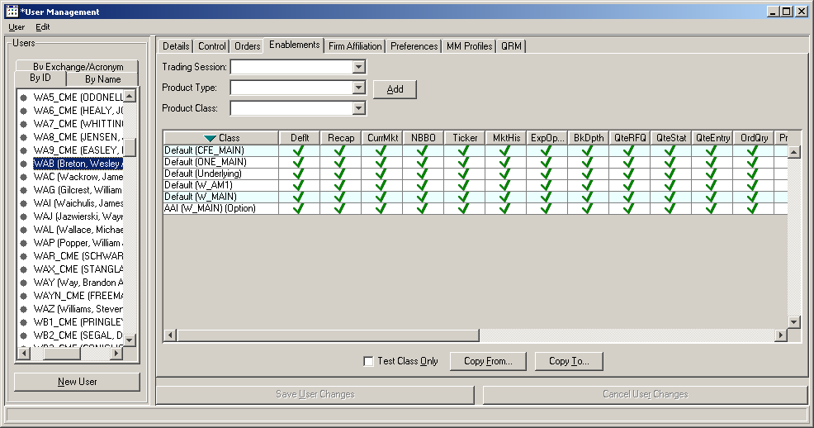
Appendix 2: Current and New MM Change Flow

MemAdapter

TraderServer

CasheUpdate
User
Cache
Figure 1: Current mm Refresh
dpm/mm refresh
CAS/SACAS

UserDefinition
Service
Asgn_class

MemAdapter

TraderServer

CasheUpdate
User
Cache
Figure 2: New mm Refresh (changes in red)
dpm/mm refresh
CAS/SACAS

UserDefinition
Service
Property
Service
Property
Asgn_class
Property
CAS/SACAS

TraderServer

CasheUpdate
User
Cache
Figure 3: Current mm update from SAGUI
CAS/SACAS

UserMaintenance
Service
Asgn_class
SAGUI/SACAS

Figure 4: New mm update from GUI (changes in red)
CAS/SACAS

Property
Service
Property
Property
TraderServer

CasheUpdate
User
Cache
CAS/SACAS

UserMaintenance
Service
Asgn_class
SAGUI/SACAS

Appendix 3: Current SAGUI User Enablement Change Flow

Figure 5: ( No Change)
SAGUI User Enablement Updates
SAGUI
UserEnablement
CAS

Property
Service
Property
Property

