SCREEN-BASED TRADING SYSTEM

FUNCTIONAL SPECIFICATIONS

Prepared by:

The SBT Committee

Date: October 29, 2002

CBOE CONFIDENTIAL
Notes on Revisions
The notation n (10) is used where the value in parenthesis is indicative and will be specified in the future.

The first version of the system will not include all the functions described in this document. The functions that are deferred to a later version are enumerated in the section, Implementation Priority of SBT Functions. Comments are also inserted in the description of functions that explain to what extent they are implemented in Version 1.

SCREEN-BASED TRADING SYSTEM
FUNCTIONAL SPECIFICATIONS

1. DIFFERENCES BETWEEN SCREEN-BASED TRADING AND CURRENT CBOE OPEN OUTCRY TRADING 1
1.1. Execution Priority 1
1.2. Marketmakers 1
1.3. Quotes and Orders 1
1.3.1. Marketmaker Quotes 1
1.3.2. Orders 1
1.3.3. Anonymity 2
1.3.4. Book Eligibility 2
1.4. Alternatives for Order and Quote Submission 2
1.4.1. By Order Providers 2
1.4.2. By Liquidity Providers 2
1.5. Market Data 2
1.6. Opening and Closing 2
1.6.1. Automated Procedures 2
1.6.2. Maximum Contract Volume Traded Opening Procedure 2
1.6.3. Series May Not Open At Same Time 3
1.7. Autoquote Facility 3
1.8. Eligible Products 3
1.9. Trader Location 3
2. GENERAL DESIGN REQUIREMENTS 4
3. OVERVIEW OF SCREEN-BASED TRADING ENVIRONMENT 5
4. TYPES OF CBOEdirect USERS 7
4.1. Marketmakers 7
4.2. Member Firm Brokers and Non-marketmaker, Professional Traders 7
4.3. Clearing Firm Users 8
4.4. SBT System Operators/Administrators 8
4.5. Trading Floor Crowd 9
4.6. Firm Booth Users 9
5. TYPES OF ORDERS SUPPORTED 10
6. ORDER HANDLING AND EXECUTION 11
6.1. Order Types Accepted at Various Product States 11
6.2. Minimum Increments for Bids and Offers 12
6.3. Order Execution 12
6.3.1. Trade Allocation and Priority 12
6.3.1.1. Customer Priority 12
6.3.1.2. DPM/LMM 's Trade Participation Right 12
6.3.1.3. Market Turner Priority 13
6.3.1.4. Configurability 13
6.3.1.5. Calculation Rules 13
6.4. Price-Time Allocation 14
6.4.1. Price-Time Example 1 14
6.4.2. Price-Time Example 2 15
6.4.3. Price-Time Example 3 16
6.5. Pro Rata Allocation 17
6.5.1. Pro Rata Example 1 18
6.5.2. Pro Rata Example 2 19
6.5.3. Pro Rata Example 3 20
6.5.4. Pro Rata Example 4 21
6.5.5. Pro Rata Example 5 22
6.5.6. Pro Rata Example 6 23
6.5.7. Pro Rata Calculation Example 24
6.6. Market Order Processing 25
6.6.1. Detail Processing Sequence for a Market Order 25
6.6.2. Market Order is On-hold and Trading is Declared Halted 32
6.7. Limit Order Processing 33
6.7.1. Limit Order Processing with No Protection Feature 33
6.7.2. Limit Order Processing with Protection Feature 33
6.8. Contingency Orders 35
6.8.1. OPG - Opening only 35
6.8.2. AON - All or none 35
6.8.3. FOK - Fill or kill 35
6.8.4. IOC - Immediate or Cancel 36
6.8.5. MIN - Minimum 36
6.8.6. STP - Stop order 37
6.8.7. STP LIMIT - Stop limit order 37
6.8.8. MOC - Market on close 37
6.9. Spread Order Processing 38
6.9.1. Dissemination of Spread Product Data 38
6.9.2. Spread Product Creation and Deletion 38
6.9.3. Spread Order Entry 39
6.9.4. Spread Quote Entry 42
6.9.5. Spread RFQ Entry 42
6.9.6. Spread Order Book 42
6.9.7. Step-by-step Processing 42
6.9.8. Spread Order Trading Rules 43
6.9.9. Spread Trade Reporting 45
6.9.10. Fill Reporting 45
6.9.11. Spread Tape 45
6.9.12. CBOEdirect GUI Requirements for Spreads 45
6.9.13. Derived Order Processing 47
6.9.14. Determination of the Derived Order’s Price 47
6.9.15. Spread Order Processing for Initial Implementation 49
6.9.16. Spread Trading Rule Deferred to Later Version 50
6.10. Cabinet Order Processing in CBOEdirect 50
6.10.1. Implementation of Cabinet Order Support 51
6.11. End of Day Process 51
6.11.1. Expiring Orders 51
6.11.2. Passing of Orders Between Sessions 51
6.11.3. Deletion of Spread Products 51
7. STATES OF OPERATION 52
7.1. Pre-opening 52
7.2. Opening Rotation 52
7.2.1. Maximum Contract Volume Traded Procedure 52
7.2.2. Modified ROS Procedure 53
7.3. Trading 53
7.4. Halted 53
7.5. Closed 53
8. OPENING AND CLOSING 54
8.1. Opening Procedure 54
8.1.1. Bad Stock Print Issue 57
8.1.2. Customer Priority in the Opening Trade 57
8.1.3. Opening Procedure for Extended Trading Hours 57
8.2. Closing Procedure 57
9. MARKETMAKER OBLIGATIONS AND BENEFITS 58
9.1.1. Marketmaker Obligations 58
9.1.1.1. DPM/LMM 58
9.1.1.2. Marketmaker 58
9.1.1.3. Calculation of the RFQ Response Rate 59
9.1.2. Marketmaker Benefits 59
10. MARKETMAKING FUNCTIONS 60
10.1. CBOEdirect Login Window 60
10.2. Display of Market’s Best Bid and Ask Orders 60
10.2.1. Market Display Window 60
10.2.1.1. The First Section 60
10.2.1.2. The Second Section 61
10.2.2. Transactions from the Shortcut Menu 63
10.2.3. Transactions from the Main Menu 64
10.2.4. Transactions from the Toolbar 64
10.2.5. Transactions from the Class Symbol Tab Menu 64
10.3. Display of Contingency Orders 64
10.3.1. Display of Contingency Orders in CBOE’s Market Display Window 65
10.4. Display of Spread Orders 65
10.4.1. Display of Spread Orders in CBOE’s Market Display Window 65
10.5. Quote Entry 68
10.5.1. Single Quote Per Product Per Marketmaker 68
10.5.2. Quote Entry Window 68
10.5.3. Quote with No Bid 70
10.5.4. Exchange Prescribed Quote Width 70
10.6. Price and Quantity Edits 70
10.7. Request for Quote (RFQ) 70
10.7.1. RFQ Window 70
10.7.2. Excessive RFQ Usage 71
10.8. Respond to an RFQ 71
10.8.1. RFQ Response Requirements 71
10.8.2. Duplicate RFQs 72
10.8.3. RFQ Alerts 72
10.8.3.1. Pending RFQ Window 72
10.8.3.2. RFQ Response Window 74
10.9. Processing of RFQ Responses (Quotes) 74
10.10. Quote Maintenance 74
10.10.1. Cancel a Quote 75
10.10.2. Cancel All Quotes 75
10.10.3. Inactivate All Quotes 76
10.10.4. Update or Cancel/Replace a Quote 76
10.10.5. Cancel/Replace Behavior 77
10.10.6. Quote Risk Monitor Function 77
10.10.6.1. Quote Risk Monitor Window 78
10.10.7. Automatic Quote Regeneration 78
10.10.7.1. Priority of Regenerated Quote 79
10.10.7.2. Opposite Side of Regenerated Bid/Offer 79
10.10.7.3. Maximum Number of Regeneration 79
10.10.7.4. Quote Regeneration Parameters 79
10.11. Concern Over Autoquote Traffic Load 80
10.11.1. How the SBT System Will Throttle Quote Input 80
10.11.1.1. Manual Quote Method 81
10.11.1.2. Mass Quote Method 81
10.12. Order Entry 81
10.13. Order Status and Maintenance 83
10.13.1. Order Status Window 83
10.13.2. Order Maintenance 84
10.13.2.1. Cancel/Replace 85
10.14. Spread Order Entry 85
10.14.1. Spread Order Entry Window 85
10.15. Trading Function 88
10.15.1. Hit the Bid 89
10.15.2. Take the Offer 90
10.15.3. Hit the Same Spread 90
10.15.4. Take the Opposite Spread 91
10.16. Marketmaker’s Trade Review and Update 91
10.17. Messaging Facility Between Trade Contra Parties 91
10.18. Intermarket Price Protection 92
10.18.1. Procedure for Handling Orders when the NBBO is Away 93
10.18.1.1. Assumptions 93
10.18.1.2. Proposed P/A Order Procedure 94
10.18.1.3. Proposed P Order Procedure 96
10.18.1.4. Proposed Satisfaction Order Procedure 97
10.18.1.5. Proposed Linkage Order Information 97
10.18.1.6. Proposed Response Information 97
10.18.2. SBT Incoming Linkage Order Procedure 97
10.18.2.1. Assumptions 98
10.18.2.2. Proposed Procedure 98
10.19. Marketmaker’s Logoff 99
10.20. Marketmaker’s Preferences 99
10.20.1. Quote Defaults 99
10.20.2. Miscellaneous Defaults 100
10.20.3. Miscellaneous Defaults Window 101
10.21. Marketmaking Without Using an SBT Workstation 101
11. MEMBER FIRM BROKER FUNCTIONS 103
11.1. Display of Market’s Best Bid and Ask Orders 103
11.2. Request for Quote 103
11.3. Order Entry 103
11.3.1. Retail Order Entry 103
11.4. Order Status and Maintenance 105
11.5. Spread Order Entry 105
11.6. Trading Function 105
11.7. Crossing Function 106
11.7.1. Cross Notification via RFQ 106
11.7.2. Cross Execution 107
11.8. Member Firm Broker’s Preferences 107
12. CLEARING FIRM USER FUNCTIONS 109
12.1. Set Order Quantity Limit 109
12.2. Force Logout of Trader 109
12.2.1. Force Logout 109
12.2.2. Force Logout and Disable 109
13. SYSTEM OPERATOR/ADMINISTRATOR FUNCTIONS 110
13.1. Market Control Functions 110
13.2. Trading Parameters 111
13.3. Unusual Trading Conditions 111
13.3.1. Fast Market Condition 111
13.3.2. Trading Halt Condition 112
13.4. SBT Trade Bust Procedure 113
13.4.1. Proposed SBT Trade Bust Procedures 114
13.4.2. Price Review Panel 116
13.4.3. Reinstatement of Orders in a Busted Trade 116
13.4.4. Bust of Spread Trades 117
13.5. Maintain Relationships Between Brokers and Executing Firm/Give-Up Firm 117
13.6. Maintain Marketmaker Profile 117
13.7. Cancel Orders for a Technically Disabled Trader 118
13.8. System Operator Audit Trail 118
14. DATA DISSEMINATION FUNCTIONS 119
14.1. Dissemination Rule 119
14.2. Dissemination to OPRA 119
14.2.1. Quoting in Fractions With Size 119
14.3. Internal Dissemination of Best Bid and Offer (BBO) 120
14.4. Internal Dissemination of Price/Last Sale 120
14.5. Fill Reporting 120
14.6. Booked Order Dissemination 121
14.6.1. Personal (Trader’s) Best Book 121
14.6.2. Book Depth Display 122
14.7. Market Status Dissemination 122
14.8. News Alert Dissemination 123
14.9. Market History Dissemination 123
14.10. Ticker Dissemination 124
14.11. NBBO Dissemination 124
14.12. Trader’s Book Activity Log 125
15. POST-TRADE REQUIREMENTS 127
15.1. New Billing Requirements 127
16. NON-FUNCTIONAL REQUIREMENTS 130
16.1. Equal and Fair Access 130
16.2. Security 130
16.2.1. User Authentication 130
16.2.2. Confidentiality and Integrity of Data 130
16.2.3. Security Audit Log 131
16.3. Responsiveness 131
16.4. High Availability 131
16.5. Scalability 131
16.6. Maintainability 131
17. INTERFACES TO EXISTING CBOE SYSTEMS 132
18. REQUIREMENTS FOR EXTENDED TRADING HOURS 133
18.1. Extended Trading Hour Sessions 133
18.2. Products 133
18.3. Member Access 133
18.4. DPM/LMM 133
18.5. Trading Parameters 133
18.6. ETH Opening Procedure 134
18.7. Orders and Order Handling 137
18.7.1. Types of Orders Handled 137
18.7.1.1. ETH Orders 137
18.7.1.2. RTH Orders 137
18.7.2. Time-in Force Indicators 137
18.7.3. Passing of Orders between Sessions 138
18.8. Quote and Last Sale Reporting to OPRA 138
18.9. Crossing Function 138
18.9.1. Alternative Crossing Procedure 138
18.9.2. Version 1 Crossing Procedure 140
18.10. CBOEdirect Floor Functions for SBT Products 140
18.10.1. Crowd Display of SBT Products 140
18.10.2. CBOE Floor Booth Functions 141
18.10.2.1. Member Firm Broker Roles 141
18.10.2.2. Market Display Window 142
18.10.2.3. Order Entry 142
18.10.2.4. Order Status Display and Update 143
18.10.2.5. Market History 143
18.10.2.6. Trader’s Activity Log 143
18.10.2.7. Other Displays 143
19. IMPLEMENTATION PRIORITY OF FUTURE SBT FUNCTIONS 144
19.1. Trade Allocation Enhancements 144
19.2. Enhancements for Institutional Customers 144
19.3. Enhancements for Retail Customers 144
19.4. Marketmaking Enhancements 145
19.5. Enhancements for DPM/LMM s 145
19.6. Order Entry 145
19.7. Additional Order Types and Order Processing 145
19.8. RFQ Processing Enhancements 146
19.9. Spread Order Processing Enhancements 146
19.10. Clearing Firm Enhancements 146
19.11. CBOEdirect GUI and Data Dissemination Enhancements 147
19.12. CBOE Help Desk Enhancements 149
19.13. NBBO or Linkage Enhancements 150
19.14. Billing Enhancements 150
19.15. Access Enhancements 150
19.16. Functions for 3rd Party Vendors 150
19.17. Recommended Features for Version 2 152
APPENDIX 156
19.18. Glossary of Acronyms 156
19.19. Cabinet Orders in Open Outcry 157
19.20. Proposed Windows Navigation 158
19.21. Opening Price Determination for the Maximum Contract Volume Traded Procedure 160
19.21.1. Determining an Expected Opening Price 160
19.21.2. Rules for Breaking Ties of Expected Opening Prices 162
19.22. Exchange Prescribed Width (EPW) Table 168
19.22.1. Standard EPW for Options 168
19.23. Modified ROS Approach to the SBT Opening 169

SCREEN-BASED TRADING SYSTEM
FUNCTIONAL SPECIFICATIONS

DIFFERENCES BETWEEN SCREEN-BASED TRADING AND CURRENT CBOE OPEN OUTCRY TRADING

This section introduces the primary differences between the current CBOE open outcry trading practice and procedures in CBOE’s SBT System, CBOEdirect. They are presented here at the beginning to alert the reader of the differences, to make him aware of the underlying assumptions, and thus make him better understand the reasons behind the SBT requirements. The reader may refer to the appropriate sections of the document to obtain more information about any of the following points.

Execution Priority
In general, execution priority of orders shall not depend on originator type, e.g., marketmaker, customer, firm, or broker-dealer. Orders shall be executed using either a strict price/time priority or a pro-rata priority. If needed, the system shall have the capability to modify these two priorities by overlaying them with customer priority, market turner priority, and trade participation right for one Designated Primary Marketmaker or Lead Marketmaker (SBT DPM/LMM).

Marketmakers
A number of marketmakers shall be assigned to each class, one of whom could be a DPM/LMM. A DPM/LMM shall be obligated to provide opening quotes for all the series in his assigned classes. In addition, the DPM/LMM and marketmakers assigned to a class shall be obligated to respond to a certain minimum percentage of requests for quotes (RFQ) in their assigned classes.

Quotes and Orders

Marketmaker Quotes
Only marketmakers may enter quotes. Quotes shall be entered as two simultaneous orders –- a buy order and a sell order --- with any width. To be credited towards marketmaker obligations, a quote should have the exchange prescribed width and at least the prescribed minimum size.

Orders
All market participants, including marketmakers, may submit regular orders, for any class.

Anonymity
The identities of the source firm of orders and the parties to trades are not. A future requirement is to enable the disclosure or non-disclosure based on a configurable parameter.

Book Eligibility
The book shall accept marketmaker, firm, and broker-dealer orders in addition to customer orders. Spread orders and certain contingency orders shall also be accepted.

Alternatives for Order and Quote Submission

By Order Providers
Customer, firm and broker-dealer orders may be submitted through the CBOEdirect workstation, the CBOE wire order facility (COMPASS), or through a computer-to-computer link using CBOE’s new API (application programming interface), known as CMi, or CBOE’s new FIX (Financial Information Exchange) interface. Order providers cannot submit quotes.

By Liquidity Providers
Marketmaker orders and quotes may be submitted through the CBOEdirect workstation or an independent software vendor’s workstation, using CBOE’s CMi, or through a computer-to-computer link using CBOE’s CMi or CBOE’s new FIX interface.

Market Data
Book depth and other market information such as the underlying security recap and sliding tick shall be available, possibly for a fee, to all participants. Marketmakers shall get this information at reduced fees.

Opening and Closing

Automated Procedures
Both opening and closing procedures shall be handled automatically.

Maximum Contract Volume Traded Opening Procedure
Two opening price determination procedures were considered: a Modified ROS (Rapid Opening System) Procedure and a Maximum Contract Volume Traded Procedure. The recommended SBT opening price determination procedure is the Maximum Contract Volume Traded Procedure. Marketmakers assigned to a class shall participate in the opening trade in an individual basis by providing their own quotes. The DPM/LMM is obligated to provide his opening quotes. The system shall determine automatically the opening price that will clear the market and trade the maximum quantity at the open. This differs from the current open outcry practice of a crowd of marketmakers who determine the opening price and who share the opening trade imbalance.

Series May Not Open At Same Time
The series of a class do not have to open all at the same time. Those that can open shall be opened and those that cannot open because of some reason, e.g., market order imbalance, will cycle through the pre-opening and opening rotation procedures until they can open.

Autoquote Facility
A CBOE autoquote facility shall not be available to marketmakers. A marketmaker may use his proprietary autoquote system to submit quotes through the CMi or FIX interface.

Eligible Products
- A product may be traded in either the SBT environment or in open outcry but not in both simultaneously.

- Subject to a membership vote, SBT shall be used for selected classes during regular trading hours (RTH). SBT trading hours may be extended if necessary to meet competition.

- SBT may be used for any class during extended trading hours (ETH).

Trader Location
Traders may be located in Chicago and other cities such as New York and San Francisco. They may trade from their offices or from any location where they have a workstation and communication link to CBOEdirect.

GENERAL DESIGN REQUIREMENTS

The following are general design requirements or principles that have to be considered in designing the various components of the SBT system.
- Operating rules, system functions, procedures, and transactions shall be designed to support marketmakers in fulfilling their responsibility of providing liquidity and to provide them the available market information needed to do so.

- The CBOEdirect GUI (graphical user interface) shall be designed to be flexible and configurable by the user. He shall be able to specify the columns of data he wants to see in displays such as the Market Display, the Order Status Display, the Market History, etc. He shall also be able to specify the background colors, the font size, etc.

- The use of popup windows shall be minimized to provide the trader a constant, unobstructed view of his trading screens.

- Speed in interactions with the system is of the utmost importance. Mouse and keyboard operations for each transaction, especially the most frequently used transactions, shall be kept to a minimum.

- Keyboard operations equivalent to the mouse operations for certain critical transactions, for example, the Cancel All Quotes transaction, shall be available for use in case of mouse failure.

- A system user’s access to system functions and data shall be enabled or disabled easily and quickly by changing his access through an automated entitlement procedure.

- The system shall be designed to use to the highest extent possible the infrastructure and building blocks of the new CBOE Trading Engine.

- The CBOEdirect Workstation shall be designed with the flexibility to communicate with multiple trading engines, the primary one being the CBOEdirect Trading Engine.

OVERVIEW OF SCREEN-BASED TRADING ENVIRONMENT

Based on the functional requirements, the screen-based trading environment requires certain CBOE components, both existing and new components. These components are presented in a logical level in the diagram below. A key, new component is the CBOEdirect Workstation that would be used by marketmakers, member firm brokers and broker-dealers, clearing firm users, system operator, Help Desk and trading system administrators. Each of these users would have their own unique set of functions and access rights to the data and functionality of the system.

Note that provision is made for a non-CBOE Workstation that could be used by any of the above users. Such a workstation shall be accommodated via one of the APIs.

The new SBT system shall collaborate with the following CBOE systems in performing its tasks. See the section, Interfaces to Existing CBOE Systems, for information on the functions contributed by these systems.
- The TPF Trading Engine
- Ticker Plant (TIPS)
- Membership System
- Trade Match System

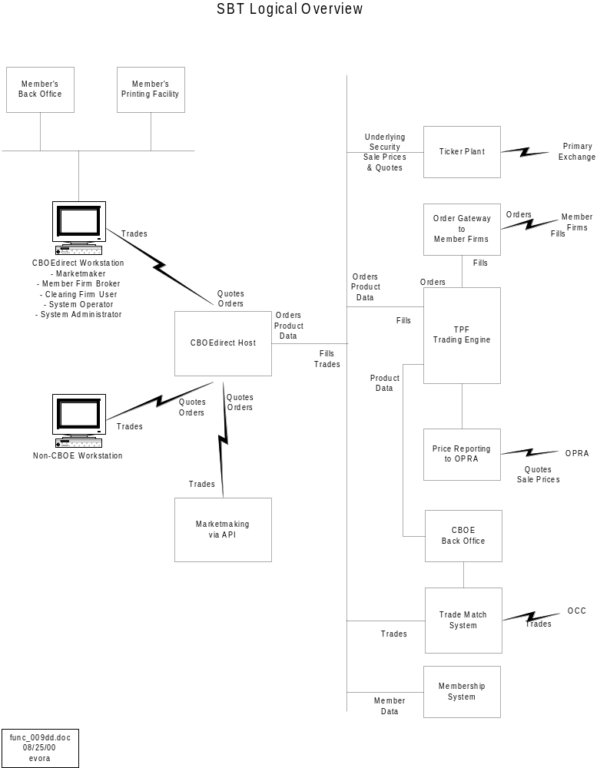

TYPES OF CBOEdirect USERS

There are six types of users.
- Marketmakers
- Member Firm Brokers (retail and firm proprietary brokers) and Non-marketmaker, Professional Traders (broker-dealers)
- Clearing Firm Users
- SBT System Operator/Administrators
- Trading Floor Crowd
- Firm Booth Users

The CBOEdirect workstation shall support different sets of functions for different user types. Third party GUI vendors are expected to provide equivalent functions to those provided by CBOEdirect for marketmakers.

Marketmakers
CBOEdirect shall support the following functions for marketmakers.
- Enter, cancel, cancel/replace, and maintain two-sided quotes
- Enter, cancel, cancel/replace, and maintain orders
- Hit bids and take offers
- Submit an RFQ
- Respond to an RFQ
- Communicate with contra parties for busting trades (limited to communication between trade parties and the Help Desk in Version 1)
- Set up defaults or preferences
- For the DPM/LMM , manually step-up to the away NBBO or ship orders to the NBBO exchange (not available in Version 1; see the section on Intermarket Price Protection).

Member Firm Brokers and Non-marketmaker, Professional Traders
CBOEdirect shall support the following functions for member firm brokers and non-marketmaker, professional traders.
- Enter , cancel, cancel/replace, and maintain orders
- Hit bids and take offers
- Submit an RFQ
- Enter cross notification (in the form of an RFQ) and cross execution orders
- Communicate with contra parties for busting trades (limited to communication between trade parties and the Help Desk in Version 1)
- Set up defaults or preferences

Note that orders from member firm brokers and broker-dealers may also be entered through CBOE’s existing member firm wire order system. It is estimated that at the initial launch of CBOEdirect up to 80% of retail orders will continue to be submitted as wire orders via CBOE’s Order Routing System (ORS). The remaining 20%, composed of contingency orders, spread orders, and large-size orders that have to be “worked”, are currently transmitted to the floor by phone. For SBT products this 20% will be submitted via the CBOEdirect or third party workstation or directly through the APIs.

Clearing Firm Users
The Clearing Firm users regulate the activities of marketmakers who clear through them. CBOEdirect supports the following functions.
- set the volume limit of marketmaker orders, by class (deferred to future version)
- force the logout of a marketmaker (available in Version 1 through the Help Desk)

SBT System Operators/Administrators
System operators/administrators operate CBOEdirect workstations located in the CBOE for the following support functions.
- start/stop the SBT system
- start/stop trading by class, by underlying security, or for whole market
- add/change/delete trader Ids to the system
- add/change/delete products (deferred to future version)
- change market status such as open, closed, fast market, halt, etc. by class, by underlying security, or for the session
- determine the operating status of any workstation or node in the network
- automated broadcast of canned administrative messages to email, fax, voice recording, trading groups, CBOE web page, and SBT blackboard (deferred to future version)
- send text message to a trader or group of traders
- maintain class groups and marketmaker assignment to classes
- maintain marketmaker profiles which will identify the accounts where trades will settle
- maintain relationships between brokers and their executing firms/give-up firms
- monitor the log-in status of traders by class (deferred to future version)
- monitor queues for all API links
- display operating status of various SBT system services
- drill-down display by class of assigned and logged-in marketmakers
- display unresponded RFQs including source of RFQ
- display a trader’s preferences (deferred to future version)
- enter, update, and display a marketmaker’s appointments
- display a trader’s device or configuration
- display a given node’s activity for troubleshooting
- display session’s activity log by trader ID
- exercise SBT workstation functions by using a test product
- display a screen from a particular trader’s point of view (deferred to future version)
- bust a trade and reinstate orders
- force the logout of a marketmaker per request from a clearing firm
- change exchange-wide trading parameters

Note that maintenance of product information, trader information, and market status shall normally be done through electronic means and interfaces with other CBOE systems such as the Integrated Class/Series System (ICS) and Ticker Processing System (TIPS). The maintenance functions cited above are being provided for use in exception cases where the information has to be updated outside of normal maintenance procedures.

Trading Floor Crowd
CBOEdirect was enhanced to provide market information on ETH products to the trading floor crowd. See section 18, Requirements for Extended Trading Hours, for the crowd display of SBT products.

Firm Booth Users
CBOEdirect was enhanced to provide ETH market information as well as order entry and maintenance functions for ETH and RTH products to booth personnel. See section 18, Requirements for Extended Trading Hours, for the CBOE floor booth functions..

TYPES OF ORDERS SUPPORTED

CBOEdirect shall support these types of orders:
- Market orders
- Limit orders
- Spread orders (deferred to future version)
- The following types of contingency orders
- AON - All or none
- FOK - Fill or kill
- IOC - Immediate or cancel
- The following types of contingency orders in a future version
- OPG - Opening only
- MIN - Minimum volume
- STP - Stop
- STP LIMIT - Stop with a limit
- MOC - Market on close

Discretionary order types handled in open outcry but not in SBT are:
- NH - Not held
- WITH - With discretion

These discretionary order types assume that a broker will have price discretion in executing the order. In SBT orders are entered with either a definite price or MKT.

In addition, the following contingency orders shall not be handled in SBT because their usage is limited.
- MIT - market if touched
- CLO - closing only

ORDER HANDLING AND EXECUTION

Order Types Accepted at Various Product States
The system shall accept certain order types at various product states and session states according to the following table. Note that the spread orders and contingency orders such as All-or-None, Fill-or-kill, Minimum, Stop, and Stop Limit do not participate in the opening trade or in the determination of the opening price.

The table below specifies which orders are accepted, and how they are processed, in the various possible product states. For example, the system accepts Fill-or-kill (FOK) orders during Open (Trading), and Fast Market states. However, they are rejected during Pre-opening, Opening Rotation, Trading Halted and Closed (Order Maintenance) states. They are rejected because they are time contingency orders, which the system has to process within a certain period of time and which then expire automatically.

Order Type | Pre-opening | Opening Rotation (book locked)  [1] | Open  (Trading) | Fast Market | TradingHalted [4] | Closed  (Order Mainte-nance) (5) | End-of-Day
Quote | Y | Y | Y | Y | N | N | N
Market Order | Y | Y | Y | Y | Y | Y | N
Limit Order | Y | Y | Y | Y | Y | Y | N
Cancel Order | Y | Y | Y | Y | Y | Y | N
Cancel/replace Order | Y | Y | Y | Y | Y | Y | N
Spread Order | Y [2] | Y | Y | Y | Y [2] | Y | N
All-or-None (AON) | Y [2] | Y | Y | Y | Y [2] | Y | N
Fill-or-kill (FOK) | N | N | Y | Y | N | N | N
Immediate-or-cancel (IOC) | N | N | Y | Y | N | N | N
Minimum (MIN) | Y [2] | Y | Y | Y | Y [2] | Y | N
Market-on-close (MOC) | Y [3] | Y [3] | Y [3] | Y [3] | Y [3] | N | N
Opening-only (OPG) | Y | N | N | N | Y | Y | N
Stop (STP) | Y [2] | Y | Y | Y | Y[2] | Y | N
Stop limit (STP LIMIT) | Y [2] | Y | Y | Y | Y[2] | Y | N
Crossing Notification or Crossing Order | N | N | Y | Y | N | N | N

Notes
N = Rejected back to sender
Y = Accepted
1 = Book locks out new orders temporarily. In-flight orders accepted, put on hold in some temporary queue, and not processed until Opening Rotation is completed
2 = Does not participate in the opening trade or in the opening price determination
3 = Not processed until n (2) minutes before closing
4 = Trading Halted is a transient condition produced by a manual or system invocation of a trading halt. The operator has to change the system state to Pre-opening state in preparation for an Opening Rotation. Orders are accepted and submitted to the book when system goes into Pre-opening.
5 = At the Closed (Order Maintenance) state, the system stops trading but it continues to accept certain orders to allow traders to maintain their orders. In Version 1 only updates to existing orders are accepted, not new orders. At some designated time t (3:15 PM), it stops accepting orders and goes into End-of-Day procedures, e.g., purge day orders.

Minimum Increments for Bids and Offers
In Version 1 the following minimum increments shall be supported:
- For orders and quotes for products that are not spread products, 1/16 or 0.05 under $3 and 1/8 or 0.10 over $3.
- For spread products, 1/16 or 0.05, with no $3 price break.

In a future version, the minimum increment for spread products shall be 1/32 or 0.01, with no $3 price break.

Order Execution
The system shall match orders according to the allocation procedure and scheme of optional priorities specified for the class. The system shall send fill reports for matched orders to the SBT workstations for display to the traders or to ORS for sending fill reports for wire orders. Matched orders shall be sent to Trade Match as a matched, locked trade.

Trade Allocation and Priority
There shall be two basic trade allocation procedures: price-time and pro rata. On top of these shall be overlaid the optional priorities for customer, market turner, and the DPM/LMM 's trade participation right. Orders with optional priorities are filled first. Then among the remaining orders at the execution price, non-contingency orders are filled next. Contingency orders are prioritized last.

Customer Priority
Customer priority is recommended to be absolute. This means that whenever customer priority is specified, it is recommended to be the highest optional priority, e.g., customer orders are filled ahead of any other order. Within the group of customer orders at the same price, the orders are prioritized by time.

DPM/LMM 's Trade Participation Right
One way of compensating DPM/LMM s for providing accountability and liquidity is by granting DPM/LMM s trade participation rights (TPR). This right is expressed as a percentage, n (30%), of the remaining quantity, after all higher priority orders are filled. The quantity is allocated up to the DPM/LMM size. A DPM/LMM cannot be allocated a total quantity greater than his total size. To participate in a trade, the DPM/LMM 's quote and/or order must be present at the best price. After the DPM/LMM TPR allocation is completed and there is remaining executable quantity to be allocated, the DPM/LMM ’s unfilled quote and/or order quantities participate in the allocation.

Under the Pro rata Allocation method the DPM/LMM ’s maximum participation quantity is limited to his original pool share of the quantity before the minimum TPR quantity is calculated.

Market Turner Priority
The market turner optional priority can only be specified under the Pro rata allocation.

The order that improves the market earns market turner priority. It gives the order the right to be filled completely before the remaining executable quantity is allocated to other orders of lower priority. The market turner priority at a given price level stays with the order once it is earned. If the market moves in the same direction established by the market turner and then moves back to the market turner’s price level, then the market turner retains priority at the price. A marketmaker who improves the market with his quote may earn market turner priority for one or both sides of his quote.

A DPM/LMM order is not entitled to market turner priority. If a market turner order is a DPM/LMM order, the market turner priority is ignored in the trade allocation.

Configurability
The ability to configure the basic and optional priority options is required. The system shall be set up to enable the switching on/off of an optional priority, e.g., turn on/off market turner priority. It shall also be able to accommodate changes to the sequence of priorities, e.g., competitive pressure may require that CBOE give priority to a market turner in front of customer orders. The algorithm shall also be configurable by option class.

Calculation Rules
Rounding Up/Down - Fractions of the contract quantity shall be rounded down if less than 0.5, rounded up if equal or greater than 0.5.

Pro Rata Calculation - The pro rata quantity for an order shall be calculated as the product of the remaining quantity to be allocated and the ratio of the order quantity and the sum of the order quantities in the pool.

Price-Time Allocation
The book stores the orders from the best price to the worst. At each price level the orders are filled in time sequence. Under this procedure two optional priorities ---customer priority and DPM/LMM trade participation right --- and their sequence may be specified.

Price-Time Example 1
The following example assumes that within the price-time allocation procedure, customer priority is specified as first and DPM/LMM as second.

The DPM/LMM 's TPR share is 30%. In this example the allocation gives the DPM/LMM his TPR share only.
Incoming market order to sell 20.
DPM/LMM TPR share of remaining quantity after filling higher priority orders = 30% X 10 = 3

Book's Resting Bids:
Time | Category | Fill | Bid | Fills | DPM Share | DPM | Remaining
 |  | Seq. | Qty |  | n (30%) | Allocation | Qty | Notes
 |  |  |  |  |  |  | 20
3 | Customer | 1 | 5 | 5 |  |  | 15
8 | Customer | 2 | 1 | 1 |  |  | 14
9 | Customer | 3 | 4 | 4 |  |  | 10
 |  |  |  |  | 3.0 | 3 | 7 | 1
1 | MM1 | 4 | 10 | 7 |  |  | 0 | 2
2 | DPM bid1 | 5 | 10 | 3 |  | -3 |  | 3
4 | B/D1 | 6 | 10
5 | DPM bid2 | 7 | 50
6 | MM2 | 8 | 10
7 | MM3 | 9 | 10
Notes
- The DPM/LMM TPR share is 30%. The DPM/LMM is allocated 3 contracts, leaving 7 for price-time allocation.
- The first order, MM1, is partially filled with 7, leaving 0.
- The DPM bid1 order is partially filled with 3 from the TPR allocation.

Price-Time Example 2
The following example assumes that within the price-time allocation procedure, customer priority is specified as first and DPM/LMM as second.

The DPM/LMM 's TPR share is 30%. In this example the allocation gives the DPM/LMM his TPR share plus a partial fill of his order in time sequence.

Incoming market order to sell 80.
DPM/LMM TPR share of remaining quantity after filling higher priority orders = 30% X 70 = 21.0

Book's Resting Bids:
Time | Category | Fill | Bid | Fills | DPM Share | DPM | Remaining
 |  | Seq. | Qty |  | n (30%) | Allocation | Qty | Notes
 |  |  |  |  |  |  | 80
3 | Customer | 1 | 5 | 5 |  |  | 75
8 | Customer | 2 | 1 | 1 |  |  | 74
9 | Customer | 3 | 4 | 4 |  |  | 70
 |  |  |  |  | 21.0 | 21 | 49 | 1
1 | MM1 | 4 | 10 | 10 |  |  | 39 | 2
2 | DPM bid1 | 5 | 10 | 10 |  | -10 | 39 | 3
4 | B/D1 | 6 | 10 | 10 |  |  | 29 | 4
5 | MM2 | 8 | 10 | 10 |  |  | 19 | 5
6 | MM3 | 9 | 10 | 10 |  |  | 9 | 6
7 | DPM bid2 | 7 | 50 | 20 |  | -11 | 0 | 7

Notes
- The DPM/LMM ’s TPR share is 30%. The DPM/LMM is allocated 21 contracts, leaving 49 for price-time allocation.
- The first non-customer order, MM1, is filled with 10, leaving 39.
- The DPMbid1 order is fully filled with 10 from the TPR allocation of 21. The quantity for price-time allocation remains unchanged at 39.
- The B/D1 order is filled with 10, leaving 29.
- The MM2 order is filled with 10, leaving 19.
- The MM3 order is filled with 10, leaving 9.
- The DPMbid2 order is partially filled with 20, which comes from the TPR remainder of 11 plus the remainder of 9.

Price-Time Example 3
The following example assumes that within the price-time allocation procedure, customer priority is specified as first and DPM/LMM as second.

The DPM/LMM 's TPR share is 30%. In this example the allocation gives the DPM/LMM his TPR share only.

Incoming market order to sell 80.
DPM/LMM TPR share of remaining quantity after filling higher priority orders = 30% X 70 = 21.0

Book's Resting Bids:
Time | Category | Fill | Bid | Fills | DPM Share | DPM | Remaining
 |  | Seq. | Qty |  | n (30%) | Allocation | Qty | Notes
 |  |  |  |  |  |  | 80
3 | Customer | 1 | 5 | 5 |  |  | 75
8 | Customer | 2 | 1 | 1 |  |  | 74
9 | Customer | 3 | 4 | 4 |  |  | 70
 |  |  |  |  | 21.0 | 21 | 49 | 1
1 | MM1 | 4 | 10 | 10 |  |  | 39 | 2
2 | DPM bid1 | 5 | 10 | 10 |  | -10 | 39 | 3
4 | B/D1 | 6 | 100 | 39 |  |  | 0 | 4
5 | DPM bid2 | 7 | 50 | 11 |  | -11 | 0 | 5
6 | MM2 | 8 | 100 |  |  |  | 0
7 | MM3 | 9 | 10 |  |  |  | 0
 | Total |  | 290

Notes
- The DPM/LMM ’s TPR share is 30%. The DPM/LMM is allocated 21 contracts, leaving 49 for price-time allocation.
- The first order, MM1, is filled with 10, leaving 39.
- The DPMbid1 order is filled with 10 from the TPR allocation of 21. The quantity for price-time allocation remains unchanged at 39.
- The B/D1 order is filled partially with 39, leaving 0.
- The DPMbid2 order is partially filled with 11, which comes from the TPR remainder.

Pro Rata Allocation
The book stores the orders from the best price to the worst. At each price level the orders are sorted in time sequence. Trades are allocated in a manner that provides incentives to create deeper and tighter markets. To get price improvement, optional priority may be given to the market turner. To encourage larger orders and deeper markets, trades are allocated pro rata to the remaining orders, including the unfilled DPM/LMM orders, after higher priority orders are filled.

Under this procedure three optional priorities, customer priority, DPM/LMM trade participation right, and market turner, and their sequence may be specified.

Pro Rata Example 1
Assume that priority is (1) customer (2) DPM/LMM (3) market turner. No customer orders are included to simplify the example.

This is an example of the case where the market turner and the DPM/LMM are both filled, with the DPM/LMM getting less than his maximum possible allocation (original pool percentage share). Note that the DPM/LMM has two orders. For this allocation method, the DPM/LMM size is aggregated and filled after the market turner is filled because the DPM/LMM gets his fill from a two-step allocation: first, from his TPR share and second, from the pro rata calculation.

Time | Category | Bid |  | Category | Fill | Bid | Bids | Pro | Fills | DPM | Remain-
 |  | Qty |  |  |  |  | for | Rata |  | 30% | ing
 |  |  |  |  | Seq. | Qty | P.R. #1 | Alloc #1 |  | Alloc. | Qty | Notes
 |  |  |  |  |  |  |  |  |  |  | 20
1 | MT | 10 |  |  |  |  |  |  |  | 6 | 14 | 1
2 | DPM bid1 | 15 |  | MT | 1 | 10 |  |  | 10 |  | 4 | 2
3 | B/D1 | 20 |  | DPM size | 2 | 65 | 59 | 3 | 9 | -6 | 1 | 3
4 | DPM bid2 | 50 |  | B/D1 | 3 | 20 | 20 | 1 | 1 |  | 0 | 4
5 | MM2 | 5 |  | MM2 |  | 5 | 5 | 0 | 0 |  | 0 | 4
6 | MM3 | 10 |  | MM3 |  | 10 | 10 | 0 | 0 |  | 0 | 4
 | Total | 110 |  | Total |  | 110 | 94 | 4 | 20

DPM Pool % = (65/110) = 59.1%
DPM Max. Share, P = (65/110) X 20 = 11.8 or 12
DPM Min. Share, M = (0.3 X 20) = 6.0 or 6
Potential additional DPM share = 6

Notes
- DPM/LMM pool share is 65/110 or 59.1%, or a maximum allocation of 12 contracts. The DPM/LMM minimum TPR share is 30% of 20 or 6 contracts. The potential additional DPM/LMM share is (P-M) or (12-6) or 6 contracts. To begin, the DPM/LMM TPR share of 6 is allocated, leaving 14.
- The market turner is fully filled with 10, leaving 4.
- The pro rata distribution of the remainder of 4 is calculated, using the remaining order sizes in the pool. The DPM/LMM 's pro rata share is 3. Since 3 + 6 (M) is not greater than P (12), then the pro rata shares are allocated. The DPM/LMM is allocated his pro rata share of 3.
- B/D1 gets his pro rata share of 1. The other two orders get zero pro rata shares.

Pro Rata Example 2

Assume that priority is (1) customer (2) DPM/LMM (3) market turner. No customer orders are included to simplify the example.

This is an example of the case where the market turner and the DPM/LMM are both filled, with the DPM/LMM getting his maximum possible allocation (original pool percentage share). Note that the DPM/LMM has two orders. For this allocation method, the DPM/LMM size is aggregated and filled after the market turner is filled.

Time | Category | Bid
 |  | Qty
1 | MT | 10
2 | DPM bid1 | 15
3 | B/D1 | 20
4 | DPM bid2 | 50
5 | MM2 | 5
6 | MM3 | 10
 | Total | 110

Category | Fill | Bid | Bids | Pro | Bids | Pro | Fills | DPM | Remain-
 |  |  | for | Rata | for | Rata |  | 30% | ing
 | Seq. | Qty | P.R. #1 | Alloc #1 | P.R. #2 | Alloc #2 |  | Alloc. | Qty | Notes
 |  |  |  |  |  |  |  |  | 85
 |  |  |  |  |  |  |  | 26 | 59 | 1
MT | 1 | 10 |  |  |  |  | 10 |  | 49 | 2
DPM size | 2 | 65 | 39 | 26 |  |  | 50 | -26 | 25 | 3
B/D1 | 3 | 20 | 20 | 13 | 20 | 14 | 14 |  | 11 | 4
MM2 | 3 | 5 | 5 | 3 | 5 | 4 | 4 |  | 7 | 4
MM3 | 3 | 10 | 10 | 7 | 10 | 7 | 7 |  | 0 | 4
Total |  | 110 | 74 | 49 | 35 | 25 | 85

DPM Pool % = (65/110) = 59.1%
DPM Max. Share, P = (65/110) X 85 = 50.2 or 50
DPM Min. Share, M = (0.3 X 85) = 25.5 or 26
Potential additional DPM share = 24

Notes
- DPM/LMM pool share is 65/110 or 59.1%, or a maximum allocation of 50 contracts. The DPM/LMM minimum TPR share is 30% of 85 or 26 contracts. The potential additional DPM/LMM share is (P-M) or (50-26) or 24 contracts. To begin, the DPM/LMM TPR share of 26 is allocated, leaving 59.
- The market turner is fully filled with 10, leaving 49.
- The pro rata distribution of the remaining 49 is done. The DPM/LMM 's pro rata share is 26. Giving the DPM/LMM 26 more would put his fill (26+26 = 52) greater than his original pool share of 50 (P). Therefore, he is only filled up to 50. This takes 24 out of 49, leaving 25.
- A second pro rata calculation is done to distribute the remainder of 25 to the non-DPM/LMM orders in the pool.

Pro Rata Example 3
Assume that priority is (1) customer (2) DPM/LMM (3) market turner. No customer orders are included to simplify the example.

This is an example of the case where the market turner and the DPM/LMM are both filled, with the DPM/LMM getting less than his minimum TPR of n (30%) because of his size. Note that the DPM/LMM has two orders. For this allocation method, the DPM/LMM size is aggregated and filled after the market turner is filled.

Time | Category | Bid |  | Category | Fill | Bid | Bids | Pro | Fills | DPM | Remain-
 |  | Qty |  |  |  |  | for | Rata |  | 30% | ing
 |  |  |  |  | Seq. | Qty | P.R. #1 | Alloc #1 |  | Alloc. | Qty | Notes
 |  |  |  |  |  |  |  |  |  |  | 85
1 | MT | 20 |  |  |  |  |  |  |  | 20 | 65 | 1
2 | DPM bid1 | 10 |  | MT | 1 | 20 |  |  | 20 |  | 45 | 2
3 | B/D1 | 35 |  | DPM size | 2 | 20 |  |  | 20 | -20 | 45 | 3
4 | DPM bid2 | 10 |  | B/D1 | 3 | 35 | 35 | 23 | 23 |  | 22 | 4
5 | MM2 | 25 |  | MM2 | 3 | 25 | 25 | 16 | 16 |  | 6 | 4
6 | MM3 | 10 |  | MM3 | 3 | 10 | 10 | 6 | 6 |  | 0 | 4
 | Total | 110 |  | Total |  | 110 | 70 | 45 | 85

DPM Pool % = (20/110) = 18%
DPM Max. Share, P = (20/110) X 85 = 15.5 or 16
DPM Min. Share, M = (0.3 X 85) = 25.5 or 26
Actual DPM share, limited by his size = 20

Notes
- DPM/LMM pool share is 20/110 or 18.2%, or a maximum allocation of 16 contracts. The DPM/LMM TPR share is 30% of 85 or 26 contracts. However, he is allocated only up to his size of 20, leaving 65.
- The market turner is fully filled with 20, leaving 45.
- The DPM/LMM is filled with his allocation of 20. The remainder stays at 45 because 45 already account for the DPM/LMM allocation.
- A second pro rata calculation is done to distribute the remainder of 45 to the non-DPM/LMM orders in the pool.

Pro Rata Example 4

Assume that priority is (1) customer (2) DPM/LMM (3) market turner. No customer orders are included to simplify the example. Note that the market turner priority is ignored if the market turner order is a DPM/LMM order.

Time | Category | Bid
 |  | Qty
1 | DPM bid1 | 15
2 | B/D1 | 20
3 | DPM bid2 | 50
4 | MM2 | 15
5 | MM3 | 10
 | Total | 110

Category | Fill | Bid | Bids | Pro | Bids | Pro | Fills | DPM | Remain-
 |  |  | for | Rata | for | Rata |  | 30% | ing
 | Seq. | Qty | P.R. #1 | Alloc #1 | P.R. #2 | Alloc #2 |  | Alloc. | Qty | Notes
 |  |  |  |  |  |  |  |  | 85
 |  |  |  |  |  |  |  | 26 | 59 | 1
DPM MT | 1 | 15 |  |  |  |  | 0 |  | 59 | 2
DPM size | 2 | 65 | 39 | 27 |  |  | 50 | -26 | 35 | 3
B/D1 | 3 | 20 | 20 | 14 | 20 | 16 | 16 |  | 19 | 4
MM2 | 4 | 15 | 15 | 11 | 15 | 11 | 11 |  | 8 | 4
MM3 | 5 | 10 | 10 | 7 | 10 | 8 | 8 |  | 0 | 4
Total |  | 110 | 84 | 59 | 45 | 35 | 85
DPM Pool % = (65/110) = 59.1%
DPM Max. Share, P = (65/110) X 85= 50.2 or 50
DPM Min. Share, M = (0.3 X 85) = 25.5 or 26
Potential additional DPM share = 24

Notes
- DPM/LMM pool share is 65/110 or 59.1%, or a maximum allocation of 50 contracts. The DPM/LMM minimum TPR share is 30% of 85 or 26 contracts. The potential additional DPM/LMM share is (P-M) or (50-26) or 24 contracts. To begin, the DPM/LMM TPR share of 26 is allocated, leaving 59.
- Since the market turner is a DPM/LMM order, the market turner order of 15 is not filled, leaving 59.
- The pro rata distribution of 59 is calculated. The DPM/LMM 's pro rata share is 27. Giving the DPM/LMM 27 more puts his fill (26+27 = 53) greater than his pool share of 50. His pro rata share is then limited to 24, leaving 35.
- A second pro rata calculation is done to distribute the remainder of 35 to the non-DPM/LMM orders in the pool.

Pro Rata Example 5
Assume that priority is (1) Customer, (2) Market turner, and (3) DPM/LMM. No customer orders are included to simplify the example.

Time | Category | Bid
 |  | Qty
1 | MT | 10
2 | DPM bid1 | 15
3 | B/D1 | 20
4 | DPM bid2 | 50
5 | MM2 | 5
6 | MM3 | 10
 | Total | 110

Category | Fill | Bid | Bids | Pro | Bids | Pro | Fills | DPM | Remain-
 |  |  | for | Rata | for | Rata |  | 30% | ing
 | Seq. | Qty | P.R. #1 | Alloc #1 | P.R. #2 | Alloc #2 |  | Alloc. | Qty | Notes
 |  |  |  |  |  |  |  |  | 20
MT | 1 | 10 |  |  |  |  | 10 | 3 | 7 | 1
DPM size | 2 | 65 | 62 | 5 |  |  | 7 | -3 | 3 | 2
B/D1 | 3 | 20 | 20 | 1 | 20 | 2 | 2 |  | 1 | 3
MM2 | 4 | 5 | 5 | 0 | 5 | 0 | 0 |  | 1 | 3
MM3 | 5 | 10 | 10 | 1 | 10 | 1 | 1 |  | 0 | 3
Total |  | 110 | 97 | 7 | 35 | 3 | 20

DPM Pool % = (65/100) = 65.0%
DPM Max. Share, P = (65/100) X 10 = 6.5 or 7
DPM Min. Share, M = (0.3 X 10) = 3.0

Notes
- The market turner is fully filled with 10, and the DPM/LMM is allocated his 30% or 3, leaving a remainder of 7.
- The pro rata distribution of the remaining 7 is done. The DPM/LMM 's pro rata share is 5. Giving the DPM/LMM 5 more would put his fill (3+5 = 8) greater than his original pool share of 7 (P). Therefore, he is only filled up to 7. This takes 4 out of 7, leaving 3.
- A second pro rata calculation is done to distribute the remainder of 3 to the non-DPM/LMM orders in the pool.

Pro Rata Example 6
Assume that priority is (1) customer, (2) market turner, and (3) DPM/LMM. No customer orders are included to simplify the example. In this case the DPM/LMM ’s original pool share is less than his minimum 30% TPR share. His participation is limited to the 30% TPR share.

Time | Category | Bid
 |  | Qty
1 | MT | 10
2 | DPM bid1 | 10
3 | B/D1 | 20
4 | DPM bid2 | 10
5 | MM2 | 50
6 | MM3 | 10
 | Total | 110

Category | Fill | Bid | Bids | Pro | Bids | Pro | Fills | DPM | Remain-
 |  |  | for | Rata | for | Rata |  | 30% | ing
 | Seq. | Qty | P.R. #1 | Alloc #1 | P.R. #2 | Alloc #2 |  | Alloc. | Qty | Notes
 |  |  |  |  |  |  |  |  | 20
MT | 1 | 10 |  |  |  |  | 10 | 3 | 7 | 1
DPM size | 2 | 20 | 17 | 1 |  |  | 3 | -3 | 7 | 2
B/D1 | 3 | 20 | 20 | 2 | 20 | 2 | 2 |  | 5 | 3
MM2 | 4 | 50 | 50 | 3 | 50 | 4 | 4 |  | 1 | 3
MM3 | 5 | 10 | 10 | 1 | 10 | 1 | 1 |  | 0 | 3
Total |  | 110 | 97 | 7 | 80 | 7 | 20

DPM Pool % = (20/100) = 20.0%
DPM Pool Share, P = (20/100) X 10 = 2.0
DPM Min. Share, M = (0.3 X 10) = 3.0

Notes
- The market turner is fully filled with 10, and the DPM/LMM is allocated his 30% or 3, leaving a remainder of 7.
- The pro rata distribution of the remaining 7 is done. The DPM/LMM 's pro rata share is 1. Giving the DPM/LMM 1 more would put his fill (3+1 = 4) greater than his original pool share of 2 (P) or his TPR share of 3. Therefore, he gets zero.
- A second pro rata calculation is done to distribute the remainder of 7 to the non-DPM/LMM orders in the pool.

Pro Rata Calculation Example
Assume the remaining quantity of 49 is to be allocated to four orders as shown below.

Alloc. % = (Order Qty X 100/Total Order Qty)
Calc. Qty = (Alloc. %) X Remaining Quantity
Alloc. Qty = Calc. Qty rounded up/down

In each step the allocated quantity is determined for one order. See Final Allocations where the 'Calc. Qty' is rounded up/down to the 'Alloc. Qty'. In the last step the 'Alloc. Qty' for the two last orders are determined.

 |  |  |  |  |  | Total Order | Remaining
 |  | Order1 | Order2 | Order 3 | Order 4 | Qty | Qty to Allocate
Step 1 | Order Qty | 20 | 39 | 5 | 10 | 74 | 49
 | Alloc. % | 27.0% | 52.7% | 6.8% | 13.5%
 | Calc. Qty | 13.2 | 25.8 | 3.3 | 6.6
Step 2 | Order Qty |  | 39 | 5 | 10 | 54 | 36
 | Alloc. % |  | 72.2% | 9.3% | 18.5%
 | Calc. Qty |  | 26.0 | 3.3 | 6.7
Step 3 | Order Qty |  |  | 5 | 10 | 15 | 10
 | Alloc. % |  |  | 33.3% | 66.7%
 | Calc. Qty |  |  | 3.3 | 6.7
Final Allocations
Step 1 | Alloc. Qty | 13 |  |  |  | 13
Step 2 | Alloc. Qty |  | 26 |  |  | 26
Step 3 | Alloc. Qty |  |  | 3 | 7 | 10
 |  |  |  | Total Allocated Qty = |  | 49

Market Order Processing
After the opening, the system “protects” market orders by automatically executing it against the best bid/ask only if there is a “legal width or standard width market”, i.e., the book width is equal or narrower than the exchange prescribed width. In other words, a pair of unrelated bid and offer orders, whose sizes may be less than the minimum quote size, separated by the exchange prescribed width, is sufficient to trigger the trade of an incoming market order. It is not necessary to have present a standard quote, i.e., a pair of bid and ask orders that are part of the same quote, meeting the minimum quote size and the prescribed exchange width requirements.

If there is no standard market, the system puts the market order “on hold” (queued). It then solicits quotes by automatically sending an RFQ message. The RFQ will include the market order quantity, but not whether the order is a buy or sell. Quote responses are exposed in the book as they are received.

The system will attempt to execute the pending market order after any one of the following conditions is true:
- The market’s width becomes n (75)% or less of the exchange prescribed width; this condition helps to minimize the queuing time of the market order
- A certain percentage, n (50)%, of assigned marketmakers has responded
- The RFQ period, n (30) seconds, has elapsed
- A limit order on the same side as the market order is received that would match the best bid/offer and at least one standard quote has been received. This condition prevents the later-arriving limit order to execute ahead of the market order, thus preserving time priority. Under this condition, if no quote has been received, the limit order would execute ahead of the market order.

The three parameters above will be specified by the exchange. They will not be made public. They will be specified system-wide for the initial version, and by class in a future version.

If a market order for a certain series is queued, subsequent market orders for the same series and side are queued behind the first one to ensure that they are processed in time sequence.

Detail Processing Sequence for a Market Order
When the system receives a market order, it shall check for the presence of a standard width market. If there is no standard width market, the system shall automatically hold the market order in queue and send an RFQ.

If a standard width market exists, the market order would execute against the best order in the book and against the other orders behind the best, at varying prices until the market order is fully filled or until the standard width market no longer exists. If the latter, the system shall hold the remainder of the market order in queue, send an RFQ, and send a notice to the originator about the order status.

Example: Standard Width Market Exists
Assume:
There are six marketmakers quoting the product.
Maximum allowable quote width for a bid range of $5.01 - $10.00 is $0.50
Legal or standard width market for a bid range of $5.01 - $10.00 is the same, $0.50.
The book looks like this.

Book Bid Size | Book Bid | Book Ask | Book Ask Size
 |  | 6.95 | 5
 |  | 6.90 | 20
 |  | 6.75 | 10
5 | 6.25
25 | 6.20
5 | 5.95

A market order to buy 35 arrives.

Since a standard width market exists (6.75 – 6.25 = 0.50), the market order gets filled with 10 at 6.75, leaving 25. Now the market width is no longer standard (6.90 – 6.25 = 0.65, wider than the 0.50 required). The system puts the market order on-hold and issues automatically an RFQ for a quantity of 25. The book now looks like this. The system reports the best quote to OPRA as 6.25-6.90, 5x20. Note that the market order is not exposed in the book.

25 Mkt
Book Bid Size | Book Bid | Book Ask | Book Ask Size
 |  | 6.95 | 5
 |  | 6.90 | 20
5 | 6.25
25 | 6.20
5 | 5.95

The system shall expose incoming quotes (RFQ responses) in the book. During the RFQ expiration time, if the market width becomes n (75)% or less of the standard width, the system shall execute the market order against the bid/offer and any other eligible booked order until the order is fully filled or until the standard market width no longer exists. If the latter, the system shall hold it in queue again, send an RFQ, and send a notice to the originator about the order status and so on.

Example: Continuing the example above, assume:

The first quote, 6.25 – 6.75, 10x10, arrives.
The market order does not trade even if the market width is standard (6.75 – 6.25 = 0.50) because none of the three conditions is true. The market width is not 75% or less of the standard width. 50% (3) or more of the marketmakers have not responded. The RFQ response period has not expired. This rule ensures that the market order does not trade against the first quote that comes in, which could have a standard width but be way off the market. The book now looks like this. The system reports the best quote to OPRA as 6.25 - 6.75, 15x10.

25 Mkt
Book Bid Size | Book Bid | Book Ask | Book Ask Size
 |  | 6.95 | 5
 |  | 6.90 | 20
 |  | 6.75 | 10
15 | 6.25
25 | 6.20
5 | 5.95

Now assume a second quote, 6.25 – 6.55, 10x10, arrives.

Since the market width is now 0.30 (6.55-6.25), 60% of the standard width, the market order trades with the best order in the opposite side and any other orders behind it, until the market width is no longer standard. The market order is filled for 10 at 6.55, then for 10 more at 6.75. The system then automatically issues a second RFQ for the remaining quantity of 5.

The book now looks like this. The system reports the best quote to OPRA as 6.25 - 6.90, 25x20.

5 Mkt
Book Bid Size | Book Bid | Book Ask | Book Ask Size
 |  | 6.95 | 5
 |  | 6.90 | 20
25 | 6.25
25 | 6.20
5 | 5.95

Now assume that a quote, 6.25 – 6.75, 10X10, arrives.

Again, the market order does not trade even if a standard width market exists. Only one marketmaker of six has responded. The quote width is not 70% or less of the standard market.

The book now looks like this. The system reports the best quote to OPRA as 6.25 - 6.75, 35x10.

5 Mkt
Book Bid Size | Book Bid | Book Ask | Book Ask Size
 |  | 6.95 | 5
 |  | 6.90 | 20
 |  | 6.75 | 10
35 | 6.25
25 | 6.20
5 | 5.95

If the system receives a limit order on the same side as the market order that could match the best bid/offer and at least one standard quote has been received, creating a standard market, then the system shall execute the market order against the best bid/offer. The market order trades ahead of the just-arrived limit order because it has time priority. The presence of a standard market coupled with a limit order on the same side as the market order, ready to trade against the best opposite side order, are deemed to be sufficient in protecting the market order from trading at an unreasonable price. If there is no standard market, then the market order is ‘protected’ from trading and the limit order is filled ahead of the market order.

Example: Continuing the example above, assume:

A limit order to buy 10 at 6.75 arrives.

The buy limit order matches the best offer and there is a standard market. Therefore, the market order trades against 5 of the best offer of 6.75. The limit order to buy then trades with the remaining 5 offered at 6.75. The book now looks like this. The system reports the best quote to OPRA as 6.75 - 6.90, 5x20.

Book Bid Size | Book Bid | Book Ask | Book Ask Size
 |  | 6.95 | 5
 |  | 6.90 | 20
5 | 6.75
35 | 6.25
25 | 6.20
5 | 5.95

If an incoming RFQ response could execute against a market order as well as older limit orders (at a particular price), then:
- If the incoming RFQ response is of large enough quantity to fill all the older limit orders and the market order, then all those orders are filled at the price of the older limit orders.

Example:
Assume that the book is as follows, with a market order to buy 5 on hold. Assume that the bids at 6.25 are older than the market order.

5 Mkt
Book Bid Size | Book Bid | Book Ask | Book Ask Size
 |  | 6.95 | 5
 |  | 6.90 | 20
 |  | 6.75 | 10
35 | 6.25
25 | 6.15
5 | 5.95

Now assume that a quote 6.0 – 6.20, 50x50, arrives. The market is crossed for an instant at 6.25 - 6.20, 35x50. The system does not report this instantaneous best quote to OPRA. It will send a best quote report after the cross is traded out. Since the 50 offered at 6.20 could fill all the limit orders to buy at 6.25 and the market order (total quantity of 35 + 5) at 6.25, then the market order is filled at 6.25. When the market is crossed the execution price is the price of the older order. The system reports the best quote to OPRA as 6.15 - 6.20, 25x10. The resulting book is as follows.

Book Bid Size | Book Bid | Book Ask | Book Ask Size
 |  | 6.95 | 5
 |  | 6.90 | 20
 |  | 6.75 | 10
 |  | 6.20 | 10
25 | 6.15
50 | 6.00
5 | 5.95

- If the incoming RFQ response is not large enough to fill all the older limit orders, the market order will be executed at the minimum price interval ahead of the older limit orders. Executing at a better price enables the market order to trade ahead of older limit orders.

Example:
Assume that the book is as follows, with a market order to buy 5 on hold. Assume that the bids at 6.25 are older than the market order.

5 Mkt
Book Bid Size | Book Bid | Book Ask | Book Ask Size
 |  | 6.95 | 5
 |  | 6.90 | 20
 |  | 6.75 | 10
35 | 6.25
25 | 6.15
5 | 5.95

Now assume that a quote 6.0 – 6.25, 10x10, arrives. The market is locked for an instant at 6.25 - 6.25, 35x10. The system does not report this instantaneous best quote to OPRA. It will send a best quote report after the locked market is traded out. Since the 10 offered at 6.25 could not fill all the limit orders to buy at 6.25 and the market order (total quantity of 35 + 5) at 6.25, then the market order is filled at 6.30, one minimum tick (assumed as 0.05) ahead of the older limit orders at 6.25. The remaining 5 offered at 6.25 trades with 5 of the older limit orders to buy at 6.25. The system reports the best quote to OPRA as 6.25 - 6.75, 30x10. The resulting book is as follows.

Book Bid Size | Book Bid | Book Ask | Book Ask Size
 |  | 6.95 | 5
 |  | 6.90 | 20
 |  | 6.75 | 10
30 | 6.25
25 | 6.15
10 | 6.00
5 | 5.95

- If the older limit order is a FOK or AON contingency order and the just-arrived order could trade with the contingency order, then the market order will be executed at the price of the contingency order. The market order need not trade at a minimum price interval to step ahead of the older contingency order because it is by order type ahead in priority.

Example:
Assume that the book is as follows, with a market order to buy 5 on hold. Assume that the 10 bid at 6.25 is older than the market order and that this bid is a FOK or AON contingency order. The system reported the best quote to OPRA as 6.20 - 6.75, 25x10. Note that the FOK or AON contingency order does not affect the best quote report sent to OPRA. Only limit orders and IOC orders show up in the best quote report to OPRA.

5 Mkt
Book Bid Size | Book Bid | Book Ask | Book Ask Size
 |  | 6.95 | 5
 |  | 6.90 | 20
 |  | 6.75 | 10
10 | 6.25
25 | 6.20
5 | 5.95

Now assume that a quote 6.0 – 6.25, 10x10, arrives. Since the 10 offered at 6.25 could not fill all the older limit orders and the market order (total quantity of 10 + 5) at 6.25, then the market order is filled at 6.25, at the price of the contingency order. Now the book looks like this.

Book Bid Size | Book Bid | Book Ask | Book Ask Size
 |  | 6.95 | 5
 |  | 6.90 | 20
 |  | 6.75 | 10
 |  | 6.25 | 5
10 | 6.25
25 | 6.20
10 | 6.00
5 | 5.95

The book is displayed as locked because the 10 AON or FOK bid at 6.25 has to be filled at its entirety. Note that only the traders in the SBT network are aware of this lock condition. The system reports to OPRA a best quote of 6.20 -6.25, 25x5.

When n (50)% of the assigned marketmakers to the class have responded to the RFQ or when the RFQ period expires and there is at least one standard quote response, the system shall execute the market order against the book. If there is volume remaining in the market order, the system shall hold it in queue and repeat the RFQ cycle again. The system shall also send a notice to the originator of the order status.

If the RFQ period expires and there is no RFQ response, the system shall continue to hold the market order, repeat the RFQ cycle, send a notice to the originator of the order status, and send an alert message to the Help Desk about the lack of RFQ response. The originator may cancel the order if he wishes. The Help Desk will contact the assigned marketmakers.

When a market order can be executed under the conditions cited above and there is one or more market orders on the opposite side, the system shall cross the market orders at a price determined as follows.
- At the middle of the best bid-offer in the book if the middle price is a legal price.
- If the middle price is not a legal price, at the next legal price from the middle that is closer to the last trade price of the product.

Market Order is On-hold and Trading is Declared Halted
When trading is declared halted while a market order is on-hold, waiting for RFQ responses, the system shall do the following.

If the market order is a GTC (good-till-cancelled) order, the system holds and executes it at the next opening, in the same day or the next day. If it is a day order, the system executes it at re-opening if trading resumes for the same day. If trading does not resume, the system purges it as part of the end-of-day procedure for purging day orders.

Limit Order Processing

Limit Order Processing with No Protection Feature
Receipt of a limit order for a series that has no existing quote shall not trigger the automatic “request for quote” message. The limit order could be far from the market and invoking the RFQ process could create an unnecessary load for the system.

The system shall attempt to match the limit order against the best bid or offer, even when there is no standard market present. If the prices do not match, then the system shall store the order in the book in the appropriate price/time sequence. If the prices match, then the orders are executed against each other. Any remainder shall stay in the book.

Limit Order Processing with Protection Feature
This protection feature for limit orders will be provided in a future version.

After the opening, the system “protects” limit orders by automatically executing it against the best bid/ask only if either of the following conditions is met.

- A legal width market is entered into the series
- The limit price on the order if executed would be in the range created by the bid of the series with the same expiration month and one strike price lower and the offer of the series with the same expiration month and one strike price higher and a standard width market exists for both of these series. An example:

SERIES SIZE BID ASK SIZE
July 50 10 10* 11 20
July 55 9.75 10
July 60 50 1.5 1.75* 25

* These two prices set the range for an acceptable execution price.

A limit order to buy 10 July 55s @ 9.75 is entered. This trade would be executed @ 9.75 because the price of execution is between the bid of the July 50s (the next lower strike) and the offer of the July 60s (the next higher strike).

“Legal or standard market” is defined as the book width being equal or narrower than the exchange prescribed width. The second condition acts as a reasonability check to ensure that the limit price is “somewhere in the ballpark” of where it should be. If neither condition is met, the system puts the limit order on hold (queued). It then solicits quotes by automatically sending an RFQ. The RFQ will include the order quantity, but not whether the order is a buy or sell. Quote responses are exposed in the book as they are received.

The system will attempt to execute the limit order after either one of the following conditions is true:

- The market’s width becomes n (75)% or less of the exchange prescribed width; this condition helps to minimize the queuing time
- A certain percentage, n (50)%, of assigned market makers has responded;
- The RFQ period, n (30) seconds, has elapsed
- A market order or limit order (independent of the RFQ responses) on the opposite side is received that would match the original limit order and a standard width market exists.

The three parameters above will be specified by the exchange. They will not be made public. They will be specified system-wide for the initial version, and by class in a later version.

If a limit order for a certain series is queued, subsequent limit orders for the same series and side are queued behind the first one to ensure that they are processed in time sequence.

Market orders for the same series and side will be queued. If a legal market remains upon completion of the limit order processing the market order will be executed against orders resting in the book. If there is not a standard width market, market order processing will begin.

If the limit order partially executes, the balance stays in the book. No subsequent RFQ will be generated.

RFQ Override
The trader submitting the Limit Order will be given an opportunity through the API to override the RFQ and enter the order into the market and, possibly, trade against standing or subsequent orders outside a legal width market. The system will log the override to execute the Limit Order.

Limit orders routed by firms through ORS will have this RFQ protection. However, the functionality to override or bypass the RFQ protection will not be available for these orders. Although this approach will potentially generate a lot of RFQs, it puts the responsibility back on the customer and minimizes the need to bust trades.

Contingency Orders
Contingency orders, except IOC, are put last in execution priority, regardless of their position in time. A contingency order, which came ahead of a limit order at the same price, shall be treated as if it came behind the limit order.

Contingency orders shall be processed as described below. At the point where the contingency order expires, or is cancelled by the system, the system shall send an appropriate message to the originator of the order.

OPG - Opening only
This order can be a market or limit order. This order is executable only in the opening trade. It expires after the opening trade or after the opening quote is disseminated.

The system shall accept an OPG order only when the system is in Pre-Opening, Trading Halt, and Closed (order Maintenance) state.

AON - All or none
This order has to be executed in its full quantity at the limit price. It cannot be partially filled. Its presence shall be indicated by the system to the trader (see Display of Contingency Orders). Its price or quantity is not disseminated to OPRA as part of the best bid/ask.

The system shall accept this type of order at anytime.

FOK - Fill or kill
A FOK order has a time contingency. It has to be filled fully within a period of time, or the system automatically cancels it.

The system shall accept this type of order only during the Open (Trading) state.

If the FOK order is at the best price, and if it cannot be filled fully, the system shall indicate its presence to traders by displaying its quantity for the Time Contingency period of, say, n (5) seconds. The system shall display quantity as explained in the section, Display of Contingency Orders. If the FOK order is at the best price by itself, the system shall display the price in color. If the FOK order is not at the best price or better, e.g., if it is a buy order lower than the best bid or a sell order higher than the best offer, the system shall reject it.

Note that the FOK order data is only disseminated internally to SBT participants using workstations or the API. Its price or quantity is not disseminated externally to OPRA as part of the best bid/ask. Only limit orders and IOC orders are included in the price and quantity disseminated to OPRA.

The system shall stop displaying the FOK price and the quantity when the FOK quantity is completely matched or when it is automatically killed (cancelled) after the Time Contingency period. The system shall also send a killed order status message to the originator of the order.

IOC - Immediate or Cancel
An IOC order has a time contingency. It has to be filled fully or partially within a period of time, or the system automatically cancels the remainder.

The system shall accept this type of order only during the Open (Trading) state.

If the IOC order is at the best price, the system shall indicate its presence to traders by displaying its quantity for the Time Contingency period. The system shall display quantity as explained in the section, Display of Contingency Orders. If the IOC order is at the best price by itself, the system shall display the price in color. If the IOC order is not at the best price or better, e.g., if it is a buy order lower than the best bid or a sell order higher than the best offer, the system shall reject it.

Note that unlike the FOK, the IOC order’s price and quantity are disseminated both internally to SBT participants and externally to OPRA as part of the best bid/ask.

The system shall stop displaying the IOC price and the quantity when the IOC quantity is completely matched or when it is automatically killed (cancelled) after the Time Contingency period. The system shall also send a killed order status message to the originator of the order.

MIN - Minimum
This order has two quantities specified: the total quantity and the minimum acceptable quantity that can be filled. The fill should at least equal the minimum quantity specified.

The CBOE user interface shall display quantity as explained in the section, Display of Contingency Orders. Its quantity is displayed as 50(10), meaning total quantity of 50 of which 10 is the MIN quantity. Its price or quantity is not disseminated to OPRA as part of the best bid/ask.

The system shall accept this type of order at anytime.

STP - Stop order
A stop order to buy becomes a market order when the product trades (after the order is accepted) or is bid at or above the stop price. A stop order to sell becomes a market order when the product trades (after the order is accepted) or is offered at or below the stop price. An example is Buy 10 ABC Dec 25 at 3½ Stop. This order becomes a market order when ABC Dec 25 trades (after the order is accepted) at or is bid at or above 3 ½.

The system shall accept this type of order at anytime. The system shall not disseminate information about this type of order except as part of the contingency count in the book depth information. The CBOE user interface shall show its presence, only to the trader who submitted it, in My Best part of the Market Display.

STP LIMIT - Stop limit order
It has two prices, the stop-limit price and the limit price. A stop-limit order to buy becomes a limit order at the second price when the product trades (after the order is accepted) or is bid at or above the stop-limit price (first price). A stop-limit order to sell becomes a limit order at the second price when the product trades (after the order is accepted) or is offered at or below the stop-limit price (first price).

An example is Buy 10 ABC Dec 25 at 3½ Stop 3 5/8 Limit. This order becomes an active limit order to buy at 3 5/8 when ABC Dec 25 trades (after the order is accepted) at or is bid at or above 3 ½.

The system shall accept this type of order at anytime. The system shall not disseminate information about this type of order except as part of the contingency count in the book depth information. The CBOE user interface shall show its presence, only to the trader who submitted it, in My Best part of the Market Display.

MOC - Market on close
This is a market order that the system shall accept at anytime up to n (4) minutes before closing time. It is executable only in the closing period, in the last two minutes of trading. If an MOC is present, the system shall send an RFQ for it four minutes before closing time. (This is done to allow traders a brief time to hedge their position.) It is possible that no RFQ response will be received. The order is cancelled after closing if it is not filled.

Spread Order Processing

CBOEdirect support for spreads shall be available in a future version.

Dissemination of Spread Product Data
At the beginning of the trading session CBOEdirect shall download option product data to all participants. Included in this download are product data on spreads that have been defined in the system. Spread product data includes the definition of the legs of the spread (the series ID, buy or sell, and the number of contracts for each leg), and the product key, assigned by CBOEdirect, that the trader may use to enter orders for the spread product.

An example of a spread product is:

Buy 1 IBM Mar 2001 100 call
Sell 1 IBM Mar 2001 105 call

This product has two legs, one buying one call and the other selling one call of the same class and expiration month. The second leg is at a higher strike price. The product key would be “verticalxxx…” where “xxx…” is a long line of digits that makes the key of this particular spread unique among all vertical spreads in CBOEdirect.

Spread Product Creation and Deletion
CBOEdirect shall allow a trader to request the creation of a new spread product. The capability shall be available through both the CMi API and the FIX API. The trader defines each leg the way he wants it, e.g., the series ID, buy or sell, and the number of contracts. Upon receipt of a product request, CBOEdirect shall determine if the particular spread or its opposite already exists. The system requires that a single spread product definition exist for the same and opposite spread orders so that it can arrange the orders in a book and match them. If it does exist, CBOEdirect responds with the product key, which the trader may then use to enter a spread order.

If CBOEdirect does not find the spread or its opposite, then it shall create a new spread product, and send a response with the new product key. For example, the system would allow Trader A to create a spread product the way he wants it, as shown below, if it or its opposite does not exist.

Buy 1 IBM Mar 2001 100 call
Sell 1 IBM Mar 2001 105 call

If the spread product, as submitted, or its opposite or mirror image (Sell the 100 call and Buy the 105 call) already exists, then CBOEdirect simply responds with the product key.

Trader A could have created the opposite spread product instead (Sell the 100 call and Buy the 105 call) and the system would have created it and supplied a product key. Thus, if a spread product exists, it would either look exactly the way a trader wants it or the opposite way.

CBOEdirect shall broadcast product data about a newly defined spread product to all participants. This product data enable them to process market updates such as last sales and top of the book updates, as well as submit spread orders, for the particular spread product.

Because of the concern over the processing load imposed by spread products that have empty books, it is recommended that CBOEdirect delete spread products that have no orders in the spread book at the end of the session. This is also the reason why it was not recommended to have the Help Desk create common or popular spread products at the beginning of the trading session. Note that spread products with day orders at the end of the session, which will be purged at the end of the session, shall not be deleted.

Spread Order Entry
Unlike regular buy or sell option orders, spread orders are submitted as ‘Same’ or ‘Opposite’. “Same’ means that the trader wants to do the spread as defined. ‘Opposite’ means the trader wants to do the opposite of the spread as defined. For example, given that the spread product is defined as:

Buy 1 IBM Mar 2001 100 call
Sell 1 IBM Mar 2001 105 call

If the trader wants to do the spread as shown above, then he specifies ‘Same’. If he wants to do the opposite (Sell the 100 call and Buy the 105 call), then he specifies ‘Opposite’.

The trader enters his spread order by specifying the information about the spread order and, if needed, the information about the legs of the spread. The following information is supplied for the spread order itself. If the trader were using CBOEdirect’s GUI or an independent software vendor’s GUI, much of this information would be pre-specified and automatically supplied by the GUI software.
- Product key
- Optional description
- Same or Opposite
- Price
- Credit or Debit; Debit is a negative price (paying out), and credit is a positive price (receiving payment). The price of zero is considered positive (credit).
- Spread quantity or Multiplier
- Order source (customer, firm, broker-dealer, marketmaker, etc.)
- Time in force (Day or GTC)
- Contingency (AON, IOC, FOK)
- CMTA
- Correspondent Firm ID
- Branch/sequence number
- Account
- Sub-account
- Optional data
- Open or Close
- Covered or Uncovered for the spread Sell legs

All the above fields apply to the whole spread and all its legs. Alternatively, the trader may want to specify the Open/Close and the Covered/Uncovered information of each leg because they are different for the legs. Then the following has to be specified for each leg.
- Series
- Buy or Sell
- Quantity
- Open or Close
- If Sell, Covered or Uncovered

The table below shows the alternatives of what has to be provided when submitting a spread order through the two APIs. For example, using CMi, Alternative 1, one way to submit an order is to specify only the product key and the spread order information. Leg information need not be specified. CBOEdirect would know what the legs are. The second way, CMi Alternative 2, is to specify both the product key and the leg information. This would be used when the trader wishes to specify the open/close and covered/uncovered items for each leg. Note that FIX has Alternative 3 that allows one to submit the legs only. The FIX engine together with CBOEdirect shall identify the spread product if it exists or create one on the fly.

API | Alternative | Product Key | Info for All Legs
CMi | 1 | Yes | No
 | 2 | Yes | Yes
FIX | 1 | Yes | No
 | 2 | Yes | Yes
 | 3 | No | Yes

In the case where the order submitted has only the legs specified (FIX Alternative 3), the system shall do the following procedure.
- The system shall compare the spread to existing spreads. If it is the same as an existing spread product, the system assigns the product key to the order. It adds the ‘Same’ category to the order (the originator of the order wants to do the same spread as defined in the product).

For example, if the spread order is submitted as:

Buy 50 IBM Mar 2001 100 call
Sell 50 IBM Mar 2001 105 call

The system reduces the quantities to the lowest ratio, from 50:50 to 1:1. If the system finds the spread product:

Buy 1 IBM Mar 2001 100 call
Sell 1 IBM Mar 2001 105 call

The system then assigns the product key to the order, sets the spread order quantity as 50 and the category as ‘Same’, e.g., the order is to do the same spread as defined.

- If the identical spread product is not found, and the incoming spread order appears to be the opposite of an existing spread product, then the system assigns the product key to the order. It adds the ‘Opposite’ category to the order (the originator of the order wants to do the opposite spread as defined in the product).

For example, if the spread order is submitted as:

Sell 50 IBM Mar 2001 100 call
Buy 50 IBM Mar 2001 105 call

The system reduces the quantities to the lowest ratio, from 50:50 to 1:1. If the system finds the opposite spread product:

Buy 1 IBM Mar 2001 100 call
Sell 1 IBM Mar 2001 105 call

The system then assigns the product key to the order, sets the spread order quantity as 50 and the category as ‘Opposite’, e.g., the order is to do the opposite of the spread as defined.

- If the system does not find the identical spread product nor its opposite, then the system creates the spread product automatically, and adds the “Same’ category to the order.

Spread Quote Entry
The system shall enable the marketmaker to enter a spread quote. A spread quote is a pair of spread orders, one to do the spread as defined for a certain quantity and price, debit or credit, and the other to do the opposite spread for a certain quantity and price, debit or credit.

Spread RFQ Entry
The system shall enable any trader to submit an RFQ for a spread product. The RFQ shall have a different ‘time to live’ from regular RFQs, e.g., n (60 seconds). Marketmakers assigned to the class are not obligated to respond to Spread RFQs. Thus, Spread RFQs and their responses or non-responses shall not be tracked for compliance or billing purposes.

Spread Order Book
CBOEdirect shall maintain a book for every unique spread product, with the ‘Same’ orders on one side and the ‘Opposite’ orders on the other. The orders in each group shall be sequenced in price from the most negative of the debits at the top (best) to the most positive of the credits at the bottom (worst). Ordinarily, the prices on one side would be negative and the prices on the other side, positive. It is possible that the top orders of the two sides are both positive.

The system shall disseminate the ‘top of the book’ prices to the participants only, not to OPRA.

Step-by-step Processing
Upon receipt of an incoming spread order, CBOEdirect shall examine the regular book of the spread’s legs for legal markets and to look for resting orders that can be associated for execution with each leg. If all legs could be filled by resting orders, then the system would trade the spread order against them.

If no trade were possible, CBOEdirect would examine the spread book for resting spread orders that could trade with the incoming spread order. If the spread order quantity is not fully filled, the system shall again examine the regular book for legal markets and for orders that can be associated or traded with each leg. If more than one leg cannot be associated with a booked order, then the system saves the spread order in the spread book. Changes to the top of the spread book, if any, are disseminated.

If only one leg cannot be associated with a booked order, then CBOEdirect shall create a ‘derived order’ that, taken together with the other associated orders, would satisfy the original spread order’s price. The derived order shall be placed in the regular book for the leg. Derived orders are discussed in more detail below.

Spread Order Trading Rules
In trading with an incoming spread order, resting regular orders have a higher priority than resting spread orders. This means that CBOEdirect shall attempt to match an incoming spread order with regular orders first, before attempting to match it with resting spread orders. CBOEdirect shall attempt to match the spread order with regular orders when the spread order arrives as well as whenever the markets of the legs change. A spread must be traded whenever the legs could be filled by regular book orders.

For a spread order to trade with regular orders or resting spread orders, not only should their prices line up as explained below, but also the spread’s individual legs must have legal markets.

A resting spread order can trade with an incoming, opposite spread order when their prices have opposite signs and the absolute value of the positive price (credit) is equal to or less than the absolute value of the negative price (debit). The trade price is equal to the price of the older, resting spread order.

For example: If a resting order's price is -1.75 (willing to pay 1.75) and the incoming, opposite spread order's price is equal to +1.75, or +0.75, or +0.00, the orders would trade at 1.75. The older, resting order pays its price of 1.75 and the incoming order receives 1.75.

If a resting order's price is +1.75 (willing to receive 1.75) and the incoming, opposite spread order's price is equal to -1.75, or a higher negative value, the orders would trade at 1.75. The older, resting order receives its price of 1.75 and the incoming order pays 1.75.

A resting spread order can also trade with an incoming, opposite spread order when their prices are both negative (both are debits, willing to pay). The trade price is equal to the price of the older, resting spread order. The older, resting order pays its price and the incoming order receives that price.

For example: If the resting spread order's price is -1.75 (willing to pay 1.75) and the incoming, opposite order's price is equal to -1.00 (willing to pay 1.00), or –2.00, the spread orders would trade at 1.75. The older, resting order pays 1.75 and the incoming order receives 1.75.

Spread orders do not trade when their prices are both positive (both are credits, want to get paid). The only exception is when both prices are zero (considered credit, positive) in which case the orders trade at zero.

A spread order priced at the minimum tick of 1/16 or 0.05 may trade with another spread order at a given price as long as no leg or only one leg trades ahead of orders in the regular book.

For example: Given a bull spread order whose net price is a multiple of the 0.05 tick, one leg to buy a call whose market is 3.10 – 3.40, and the second leg to sell a call whose market is 2.35 – 2.60.

There are three possible trade scenarios.

- The spread order can trade at a net price where both legs are priced between the markets (no leg trades ahead of book orders).

- The spread order can also trade at a net price where the first leg can be priced at 3.10 (ahead of book bids at 3.10) and the second leg is priced between 2.35 – 2.60.

- Or the spread order can also trade at a net price where the first leg can be priced between 3.10 – 3.40 and the second leg is priced at 2.60 (ahead of book offers at 2.60).

When a spread order trades with another spread order, the net trade price is known but not the prices of the individual legs. These have to be calculated automatically and must be expressed in multiples of the minimum tick appropriate to the price level.

For example, a leg executing at a price below $3 must be at 1/16 or .05 tick. If such prices cannot be calculated, the system shall use the ‘Split Trade’ Method where the quantity is split so that part of it trades at one net price and the remainder trades at another net price, where the leg prices can have the minimum tick. If the prices of the legs cannot be calculated with the appropriate tick, then the system would not match the orders and the orders would remain locked in the book. The system shall send a message to the originators of the orders to inform them of the situation.

Spread Trade Reporting
When the spread order is traded, the system shall do the following.
- Disseminate to the order source the fill report for the spread and for the individual legs.
- Disseminate last sale reports to OPRA for the individual legs, with some indication that the last sale is part of a spread trade.
- Insert the last sale report of the spread’s legs in the Market History for the individual leg’s products (series) with some indication that the last sale is part of a spread trade.
- Insert the last sale report of the spread in the Market History for the spread product.

Fill Reporting
When an order in the "Same" group is filled, the legs are filled in the way they are defined. For example, if a leg is defined as a buy, the execution results in the originator of the order buying the option.

When an order in the "Opposite" group is filled, the legs are filled opposite to the way they are defined. For example, if a leg is defined as a buy, the execution results in the originator of the order selling the option.

Spread Tape
The dissemination of a Spread Tape showing all the spread trades as they occur was suggested as a future enhancement.

CBOEdirect GUI Requirements for Spreads
- General Requirements
- The display of a spread order shall show whether the spread order is “Same” or “Opposite”.
- The prices shall indicate credit or debit, not positive or negative.

- Spread Creation
- CBOEdirect shall provide system assist in creating popular spread products such as combo, time, vertical, etc., by letting the trader specify the first leg and the system pre-fills the second leg.
- After the product is created, CBOEdirect shall provide the trader a one-click mechanism for going directly to the order entry screen.

- Find a Spread Function – CBOEdirect shall provide system assist in locating spreads quickly, e.g., the Find Spread function that, given a series, returns to the trader the existing spread products that contain that series.

- Market Display
- The "Market Bid Price" and "Market Ask Price" columns shall be replaced with "Spread Price" (same spread's price) and "Opp Spread Price" column (opposite spread's price), respectively. The "Market Bid Qty" and "Market Ask Qty" columns would be replaced with "Spread Qty" (same spread's quantity) and "Opp Spread Qty" column (opposite spread's quantity), respectively.
- The legs of the spread product shall be displayed in one of the columns.
- The spread products shall be sorted in some order, e.g., alpha order of the product key, to facilitate the search for a particular spread.
- On order entry, the system shall provide the trader the details of the spread order before he submits it so there is no confusion on what order is being submitted. For example, a screen could show the legs of the spread, the implied bid and ask of the spread product, based on the market of the legs, and text saying “Pay 1.25 each for 10 for total debit of 12.50”.
- If the trader clicks on the "Spread Price' or ‘Spread Qty’, the system would assume that he wants to trade against the spread order by entering an opposite spread order. This is akin to the ‘Hit the Bid’ function. Again, the details of the spread order shall be displayable before it is submitted.
- If he clicks on the "Opp Spread Price' or "Opp Spread Qty', the system would assume that he wants to trade against the spread order by entering a spread order that is the same to what is defined. This is akin to the ‘Take the Offer’ function. Again, the details of the spread order shall be displayable before it is submitted.

- Order Status Display
When the trader clicks on the spread product key, the system shall show the legs in the way the spread product was defined.

- Book Depth Display
- The Book Depth Display of a spread product shall have the “Same” orders on one side and the “Opposite” orders on the other.
- The orders shall be sequenced in price from the most negative (debits) at the top to the most positive (credits) at the bottom.

- Pending RFQ Display
When the trader clicks on the spread product key, the system shall show the legs in the way the spread product was defined.

Derived Order Processing
CBOEdirect creates, deletes, and trades a ‘derived order’ according to the following rules.
- The system shall try to associate the legs with booked orders at the market best price and quantity equal to the extended spread leg’s quantity (spread quantity multiplied by leg quantity).
- The system shall create a ‘derived order’ for the unmatched leg only if the derived price is within two ticks of the market. Otherwise, the ‘derived order’ is not created and no booked orders are associated with the spread order.
- The system shall ensure that the ‘derived order’ trades together with the associated orders at the same time.
- The booked orders that are associated with the legs of the spread order are not locked into the spread trade. An associated order could still be traded freely and independently of the spread order. If such an order is traded away from the spread order, or canceled, or is no longer the best priced order, then the system shall cancel the derived order, break the associations, and re-process the spread order from the top.
- If the market best for any leg of a spread order changes, the system would check whether the spread order can be traded, or a derived order can be created or deleted.

Determination of the Derived Order’s Price
CBOEdirect determines the price of the derived order by solving an equation with one unknown.

Net Price = algebraic sum of the products of the price and quantity of each leg

For example: The market of two series is as shown.

Series ID | Bid Size | Bid | Ask | Ask Size
IBM Jan 100 C | 10 | 1 1/2 | 1 3/4 | 10
IBM Jan 100 P | 5 | 5/8 | 7/8 | 5

Assume that the spread product is the combination spread:

Buy 1 IBM Jan 100 Call
Sell 1 IBM Jan 100 Put

The spread product’s implied market is 1 1/8 debit and 5/8 credit, as shown below.

Buy call/sell put, Same Spread Price = (-1 ¾ x 1) + (5/8 x 1) = -1 1/8 or 1 1/8 debit

Sell call/buy put, Opposite Spread Price = (1 ½ x 1) + ( -7/8 x 1) = +5/8 or 5/8 credit

Assume that a customer submits a combination spread order to do the same spread at a net price of 1 debit, quantity 3. He could to do the legs at the following prices.

Sell 3 puts @ 5/8 credit (associated with the order buy 5 puts @ 5/8)
Buy 3 calls @ P (unknown price of leg not associated with an order)

P, the derived order price, is calculated as follows:

Net price = -1 = (P x 1) + (5/8 x 1); P = -1 5/8

The derived order is therefore:
Buy 3 calls @ 1 5/8

In summary, to do the same spread at a net price of 1 debit, the sell leg can be associated with the booked order to buy 5 puts @ 5/8. The buy leg cannot be associated with a booked order. So a derived order to buy 3 calls @ 1 5/8 is created by the system to expose the buy leg order, with the hope that another trader may trade the derived order, thus triggering the trade of the associated order, and completing the trade of the spread.

The system adds the derived order to the regular book, improving the market as shown below, with the derived order shaded for illustration.

Series ID | Bid Size | Bid | Ask | Ask Size
IBM Jan 100 C | 3 | 1 5/8 | 1 3/4 | 10
IBM Jan 100 P | 5 | 5/8 | 7/8 | 5

Note that the system can also create another derived order, by associating the buy leg first.

Buy 3 calls @ 1 ¾ (associated order)
Sell 3 puts @ P

Net price = -1 = (-1 3/4 x 1) + (P x 1); P = +3/4.

The derived order is therefore:
Sell 3 puts @ ¾

The system adds the second, derived order to the regular book, improving the market as shown below, with the two derived orders shaded for illustration.

Series ID | Bid Size | Bid | Ask | Ask Size
IBM Jan 100 C | 3 | 1 5/8 | 1 3/4 | 10
IBM Jan 100 P | 5 | 5/8 | 3/4 | 3

In this case, the system is able to create derived orders for both legs. This may not be true in all cases.

Spread Order Processing for Initial Implementation
The requirements for spread order processing for the initial implementation have been reduced to the following for the purpose of phasing in the most important features first.

- For spread order entry:
- The trader specifies the legs: series, buy or sell, leg quantity (in lowest terms); and for the spread, the net price, the multiplier (quantity of the spread desired), the time-in-force (day or GTC), contingency.
- The spread legs to be bought or sold as a package may be entered in any order.
- The system shall treat unique spreads as separate, unique products and assign unique product names.
- The system shall support the following types of spread only. The reason is the method for pricing the legs of more complex spreads is not available in the initial implementation. This method shall be available later. Since 90% of spread activity comes from these types, the system’s capabilities are deemed adequate.
  - 2-legged spreads where the ratio is 1:1 and 1:2 only. The 1:2 is limited by the rule that the spread can only execute if the leg that touches the book is the leg with the 1 quantity.
  - 3-legged spreads where the ratio is 1:1:1 and 1:2:1 only.
  - 4-legged spreads where the ratio is 1:1:1:1 only.
- At the time of entry of the first spread of its kind the system shall create a new product and assign a unique name, on the fly, based on the spread's legs and ratio. Data about this new product shall be disseminated by the system at the point of creation to all traders.
- The system shall maintain a book for every unique spread, with bids and offers for the individual spread packages. The system shall keep track of and disseminate the best bid and offer for every unique spread.
- The API shall enable the request for and the dissemination of the current best market data (top of the book) for spreads in the book for a specified class. The data shall include the spread's legs, the aggregate spread quantity, and best bid and offer for that spread.
- The CBOE GUI shall enable a trader to ‘hit the bid’ and ‘take the offer’ for a spread order.
- Updates to a spread are limited to changes to the net price, the multiplier or the quantity of the spread desired, the time-in-force (day or GTC), and contingency.
- An increase in the multiplier changes its position in priority;
- A decrease in the multiplier does not change its position in priority.
- The legs cannot be changed. (Trader must cancel the old spread and enter a new one.)

Spread Trading Rule Deferred to Later Version
A spread whose net price is a multiple of 1/32 or 0.01 is not entitled to the same priority as a spread whose net price is a multiple of 1/16 or 0.05. The former spread may trade only if each leg’s trade price is within the legal market of the leg.

Cabinet Order Processing in CBOEdirect

See the section, Cabinet Orders in Open Outcry, in the appendix for information on cabinet orders and how they are used in open outcry.

The suggested processing rules for cabinet orders in SBT are as follows.
- Any trader, e.g., customer, firm, or Marketmaker, may submit cabinet orders. They shall be submitted and disseminated with the explicit price of $0.01 (to drop the entry of 1% or CAB as the price; if the decimal trading increment is a penny, we might have to retain CAB as the cabinet order price).
- Orders to close a position (Close) shall be accepted with no restriction. Orders to open a position (Open) shall only be accepted if they can immediately trade with an existing closing order.
- A bid or offer comprised of cabinet orders can be reported as part of the market update to CBOE's internal network traders. Thus, it shall appear as part of the Market Best in CBOE's Market Display GUI. However, the bid or offer is not reported to Quote and Trade History or to OPRA.
- Cabinet orders may be executed at anytime (no need to wait after the close). The system shall provide fill reports to the parties involved.
- Cabinet trades shall be reported by the system to Trade Match but not to OPRA and Quote and Trade History.
- Billing entries shall be generated from the trade data at end of day.

Implementation of Cabinet Order Support
Cabinet order support will require exception processing in numerous places in the SBT System. One example is the edit exception on order input, where a price of 0.01 or CAB would be made acceptable in a product trading in fractions or in decimals at nickel increment or any other increment different from a penny. Another example is the restriction in accepting opening transactions. Still another example is quote and trade reporting exceptions. It is assumed that cabinet orders can be prioritized and executed according to the trade allocation algorithm of its class. For example, if a class uses the pro rata scheme, cabinet orders would trade under that scheme. If not, then more exception handling would be required.

Support for cabinet orders and trades is deferred to a future version. With penny pricing increment, SBT might not have to treat cabinet orders and trades in an exception basis. If the SBT version without cabinet order support is used at extended trading hours (ETH) for a product that also trades in open outcry, then traders should submit cabinet orders in open outcry.

End of Day Process

Expiring Orders
The system shall automatically delete day orders and expiring GTC orders at the end of the trading day.

Passing of Orders Between Sessions
If a product is traded on both the regular trading hours (RTH) and ETH (SBT) sessions, then the system shall accept and pass eligible orders between the RTH book and the SBT book. (CBOEdirect shall not support passing of orders between sessions in Version 1. See the section on ETH Requirements.) Orders eligible for passing at this time are customer orders with no contingency and explicitly submitted for trading in both sessions. Note that marketmaker orders, non-customer professional orders, and customer orders with contingency shall not be passed from the SBT book to the RTH book because they are only eligible for booking in the SBT session.

Deletion of Spread Products
There is a concern that the ease of creating spread products could burden the system with numerous spread products with empty books. For this reason CBOEdirect shall delete spread products that have no orders at the end of the day. Spread products that have day orders, which expire at the end of the day, shall not be deleted.

STATES OF OPERATION

A product class shall have the following states of operation.
- Pre-opening
- Opening Rotation
- Trading
- Halted
- Closed

Please see the Order Handling and Execution section for a table showing the order types that the system shall accept under the various product states.

Pre-opening
The system shall accept quotes and orders, except time contingency and crossing orders, at this state, but no trading shall take place. The system shall disseminate (and display on Market Displays in CBOEdirect’s Workstation) the aggregation at the best book prices of any resting GTC orders from the previous day and orders submitted before the opening.

Opening Rotation
Two opening price determination procedures were considered: a modified ROS (Rapid Opening System) procedure and a Maximum Contract Volume Traded procedure.

Maximum Contract Volume Traded Procedure
When the primary market disseminates the underlying security’s opening trade or opening bid and offer, the class goes into Opening Rotation state. The system shall send out an RFQ to marketmakers who are assigned to that class to solicit their opening quotes. The system shall also set the starting time of the actual opening at a randomly selected time between n (20) and n (33) seconds after the dissemination of the Opening Rotation notice.

The system shall continue to accept quotes and orders, except time contingency and crossing orders, at this state. At the randomly selected time, the system goes into the actual opening where it shall establish an opening price or opening quote for each series, complete the opening trade, if any, and then change the state of the class to Trading. See the section on Opening and Closing for a more detailed description of the opening procedure.

Modified ROS Procedure
This version of the open outcry ROS procedure was rejected. Having one DPM/LMM make opening quotes and pick the moment to open a class appear unnecessary given a screen-based market’s ability to open all cleared markets at once and then focus its attention on series with imbalances. See the appendix for a description of the Modified ROS procedure.

Trading
At this state the series shall trade freely. All order types and quotes shall be accepted, except Opening-only contingency orders.

Halted
At this state trading is halted. The most common reason for a trading halt will be the primary exchange has halted trading of the underlying security or no underlying security prices or quotes are being received. The system shall send OPRA the appropriate quotes for the product that is halted. The product shall have to go through the Pre-opening and Opening Rotation procedures before it reverts to the state of Trading.

Closed
The system changes the state to Closed at a pre-determined time period. Trading is stopped but the system continues to accept certain order types to allow traders to maintain their orders. At some designated time, the system stops accepting orders and goes into end-of-day procedures such as the purging of SBT day orders, and reporting of Nothing Done order status to member firms.

OPENING AND CLOSING

Opening Procedure

The SBT opening is divided into two phases: Pre-Opening and Opening Rotation. The diagram in the next page shows the phases in a timeline and what happens at each phase.

In the Pre-Opening phase, which is a period n (5 -15) minutes before the opening of the underlying security, quotes and orders may be entered. The system shall display resting orders in the book that remain from the prior business day and any orders and quotes sent in before the actual opening process.

When the primary market disseminates the opening trade or the opening quote of the underlying security, the system shall enter the Opening Rotation phase. The system shall send an Opening Rotation Notice to market makers who have an appointment in that issue. (In extended trading hours, the sending of the Opening Rotation notice will be triggered by time (7:00 AM), since there is no underlying feed.) Marketmakers submit their opening quotes, either by manual entry or programmatically via the marketmaker’s API for quote entry.

The system shall also set the starting time of the actual opening at a randomly selected time between n (20) and n (33) seconds after the dissemination of the Opening Rotation notice. The random setting is designed to prevent traders from ‘playing games’ at the opening, submitting and canceling orders to influence the opening price.

During the Opening Rotation phase the system shall continue to accept quotes and orders and display them in the book. After the first n (15) seconds of this phase, the system shall begin to calculate and disseminate the expected opening price (EOP) given the current resting orders. The system shall re-calculate this price and disseminate the new value every n (3) seconds until the start of the actual opening process. The EOP shall appear in the Opening Price column of the Market Display.

The EOP is calculated as described in the appendix. Note that the EOP can only be calculated if an opening trade is possible. If the EOP cannot be calculated, the system shall disseminate a code that designates the reason for the missing EOP. If there is more than one EOP, the system shall use tie-breaking rules as described in the appendix.

Two conditions are required for an opening trade to happen.
- The book is crossed (highest bid higher than lowest offer), locked (highest bid equals lowest offer), or there are market orders present.
- At least one standard quote must be present. A pair of buy and sell orders, each not a part of a quote, separated by the prescribed width, is not sufficient.

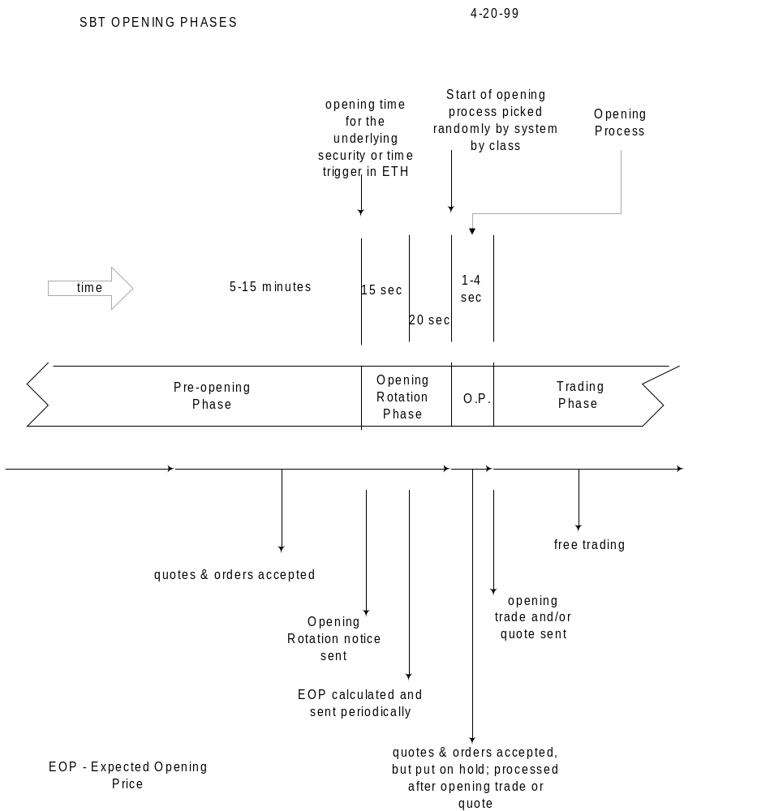

At the designated start time of the actual opening process the system shall begin to establish the opening price by series. Depending on the number of orders and opening trades the opening process for a class is expected to take 1-4 seconds, except in unusual market conditions. The system shall process the series of a class in a random order, to further minimize ‘games’. The opening price of a series is the “market-clearing” price that shall leave bids and offers which cannot trade with each other. Execution priority is given to market orders first, then to limit orders whose price is better than the opening price, and then to resting orders in time priority at the opening price.

During the opening process the system shall accept quotes and orders. However, they will be placed in a holding tank and will not participate in the opening trade. As the opening process is completed by series, the system shall change the Product State of the series to Trading, and disseminate to OPRA and to the SBT participants the opening quote and the opening trade price, if any. Fills for orders that participated in the opening trade shall be transmitted. The system shall then submit to the book in the order of their arrival the quotes and orders that were put on hold during the opening process. When all the series of a class are open, the system shall change the Product State of the class to Trading. It is possible that not all the series in a class can open.

The system shall not open the series under any one of the following conditions.
- An opening trade is possible but there is no standard quote present.
- An opening trade is possible, there is a standard quote present, but the opening price is not within the acceptable range. The upper boundary of the acceptable range is n (125)% of the highest quote offer and the lower boundary is n (75)% of the lowest quote bid.
- The opening trade would leave a market that has a market order quantity imbalance.

Under any one of these conditions, the system shall not open the series. The system shall send an opening RFQ with zero size, with one exception. The one exception is when the condition is market order imbalance; the net imbalance quantity is disseminated as the RFQ size and the direction of the imbalance (buy or sell) is included. At the end of the RFQ period, the system shall put the series into Opening Rotation. The system shall repeat this procedure until the series is open.

Note that a series may open with an opening quote that is 0-0, 0x0, when neither orders nor quotes are in the book. It may also open with a one-sided opening quote, say, 0-0.25, 0x16, when there are no bids in the book.

During the Pre-Opening and Opening Rotation phases, the system shall disseminate for each series the top of the book prices and quantities as they get updated. The book depth display shall also be available.

Bad Stock Print Issue
The SBT Committee recommended that the system not do anything to handle a bad stock print, unlike the procedure in the Rapid Opening System (ROS). The ROS opening price depends on one quote that is calculated based primarily on the opening price or quote of the underlying. The SBT opening price is determined from the mix of resting orders and multiple quotes of competing marketmakers. These quotes are independently generated and are based on a number of factors, only one of which is the underlying stock print.

Customer Priority in the Opening Trade
Customer orders have no priority in the opening trade. A future enhancement to the system shall provide such a priority, which can be turned on if needed to compete.

Opening Procedure for Extended Trading Hours
See the section, Requirement for Extended Trading Hours.

Closing Procedure
Closing shall be handled by automatically stopping the system at a specified time, e.g., n (2) minutes after the closing tick of the underlying or 3:02 PM CST. At n (4) minutes before closing, the system shall send out RFQs if Market-on-close (MOC) orders are present. (MOC orders are not supported in Version 1.) Note that the RFQs are sent two minutes before the close of the underlying to give the marketmakers a brief period to hedge their position if their quote gets filled. It is possible that no RFQ response would be received and the MOC order would be automatically canceled by the system.

MARKETMAKER OBLIGATIONS AND BENEFITS
There shall be two types of marketmakers: DPM/LMMs and regular marketmakers. Products (classes) shall be assigned to marketmakers in the same way they are assigned today, i.e., a marketmaker shall be assigned to trade a certain number of classes. He can of course trade any class but he is expected to keep a certain minimum percentage of his trading volume, e.g., 75%, in his assigned classes.

It is anticipated that active products will be quoted competitively by multiple marketmakers while inactive products will be quoted through RFQs. The Market Procedures and Planning Committee has the authority to recommend, and the Board to impose, the RFQ response rates that would ensure the highest quality markets.

Marketmaker Obligations

DPM/LMM
A DPM/LMM shall be obligated to:
- Provide opening quotes for all series in his assigned classes.
- Respond to n (60)% of RFQs for the series in his assigned classes. When he quotes a non-assigned series he assumes a regular marketmaker’s obligation for that class for the remainder of the day.
- In a world with or without electronic linkage between options exchanges:
- Step-up automatically n (1) tick to the NBBO price up to his maximum size for all his assigned classes.
- Handle the order manually --- to manually step up or to ship a P/A order to the NBBO exchange --- when the automatic step-up price is worse than the NBBO price.

See the Intermarket Price Protection section for more detail on the DPM/LMM ’s NBBO obligation.

Marketmaker
A regular Marketmaker shall be obligated to:
- Respond to n (50)% of RFQs for the series in his assigned classes. When he quotes a non-assigned series he assumes the same obligation for that class for the remainder of the day.

Calculation of the RFQ Response Rate
For each class that a marketmaker is obligated to quote via RFQ, the system shall calculate at the end of the day his RFQ response rate. This is computed as the number of times he responded with an acceptable quote (see the RFQ Response Requirements section) divided by the number of RFQs to which he is obligated to respond, expressed in percentage terms. The RFQ response rate shall be calculated on a daily basis and cumulated over the evaluation period (weekly, monthly, or quarterly). Note that these calculations are done at the end of the day, not real-time. In Version 1 the calculation shall only be based on the marketmaker’s assigned classes.

The long-term intention is to disseminate this response rate number to the marketmakers through CBOEdirect. However, It shall be made available in Version 1 through the CBOEdirect website, trader section.

The cumulative RFQ response rate is calculated for each regular marketmaker, by class. For DPM/LMM marketmakers, the rate, by class, is calculated using the aggregated responses of the DPM/LMM marketmakers. For example, DPM/LMM 1 has marketmakers MMC, who trades the call options of class ABC, and MMP, who trades the put options of the same class. The responses of MMC and MMP are aggregated for the class before the rate is calculated for that class for DPM/LMM 1. The report shall not show the individual response rates of MMC and MMP for the ABC class.

Access to the information in the CBOEdirect website shall be protected through a name and password scheme. A non-DPM/LMM marketmaker shall be able to see only his rates. A DPM/LMM person, with the appropriate DPM/LMM name and password, shall be able to see only its DPM/LMM rates.

Marketmaker Benefits

The following benefits are recommended.
- Marketmaker treatment for DPM/LMM s and Regular Marketmakers, assuming that such treatment is obtainable by providing opening quotes, responding to a certain percentage of RFQs, and participating in NBBO step-up trades.
- Reduction in fees for market data such as book depth and underlying security data.
- A DPM/LMM will get the additional benefits below in compensation for his obligations.
- Reduction in transaction fees
- Trade participation right

MARKETMAKING FUNCTIONS

The following sections use the sample CBOEdirect Workstation screens as an illustrative device for describing the various functions available for a marketmaker. The screens show the data that the CBOEdirect host shall disseminate to and accept from users of the new CBOE Market Interface (CMi).

CBOEdirect Login Window
The marketmaker logs on in this window. It has a Start button, which when clicked, drops down a menu of the following items. Selecting one of these items allows the marketmaker to see the existing windows or create new windows of the type selected.
- Market Display
- Market History
- Book Depth
- Order Status
- Activity Log
- Trades Log
- Status Window
- Preferences, for Quote and Miscellaneous preferences
- Quote Risk Monitor Maintenance
- Message Center

Display of Market’s Best Bid and Ask Orders

Market Display Window
In CBOEdirect’s GUI the marketmaker will exercise most of his marketmaking functions from the Market Display window, which is shown below. Each class of options is presented in a tabbed frame. There are two sections in a Market Display.

The First Section
The first section contains one or more tabbed frames. Each tabbed frame shows the market’s best buy and sell prices for each series of the product class and the marketmaker’s best orders for those series. He may customize this section by specifying the information he wants to display in rows and columns. He may also select and de-select series he wants to display.

The sample Market Display window below shows the following data per series:
- Series ID
- Series trading status
- Last sale price
- Last sale quantity
- Market’s total quantity at the best bid price
- Market’s best bid price
- Market’s best offer price
- Market’s total quantity at the best offer price
- Trader’s total quantity at his best bid price
- Trader’s best bid price
- Trader’s best offer price
- Trader’s total quantity at his best offer price

Other data that may be displayed are the series’ opening price, high price, low price, and total quantity traded. NBBO data may also be displayed.

The Second Section
The second section is labeled Trader Information. In this section three tabbed frames appear. The Ticker frame displays two lines that are similar to the recap and ticker lines that now appear in the bottom part of CBOE’s class displays on the trading floor. The first line is a snapshot of the day’s transactions of the underlying security of the option class as well as any indicators of news alerts. The second line is a sliding ticker showing individual sales transactions of the underlying security.

The Add Class frame provides three dropdown lists for selecting the product class to be displayed in tabbed frames in the first section. As shown in the Market Display example below, to display the product class, RUT, the trader had to specify the session, W_AM1, the product type, OPTION, and the product class, RUT, and click on the Add Tab button.

The Status frame displays the system’s acknowledgment of the trader’s actions in reverse chronological sequence --- the status of the latest action is presented first. For example, it would show the booking of an order or the execution of an order. Note that the system does not provide a status of the booking of a quote because of the large number of quotes and the negative impact on system performance. It does provide a status message when a quote is filled or cancelled.

The Status frame area is also used as a temporary workarea for doing the most frequently used transactions such as:
- Hit the bid or take the offer by selecting (clicking) the Market bid/ask quantity or price
- Update his quote or enter a new quote, if he has none, by selecting the My bid/ask quantity or price
- Order entry
- Submit an RFQ

Having this small workarea available for transactions is one solution to the requirements that popup windows do not obstruct the trader’s view of the market, and that the use of popup windows be minimized. Each trader is expected to pre-allocate his screen area to a selected set of windows he’ll use for trading. Popup windows will block his view of the screens and cause him to lose focus.

The marketmaker may specify several classes to be presented on one Market Display. He may also have multiple windows displaying the Market Display, each window showing different classes.

The trader can select between two sort sequences for the series displayed. One is all calls, then all puts. Within the calls or puts, the sort sequence is ascending expiration months, then ascending strike prices. The other sort sequence is Call/Put, e.g., a call series for a given expiration month and strike price is followed immediately by its put. The trader may switch between these two sort sequences by right-clicking on the Series column heading. The sample display illustrates the Call/Put sequence.

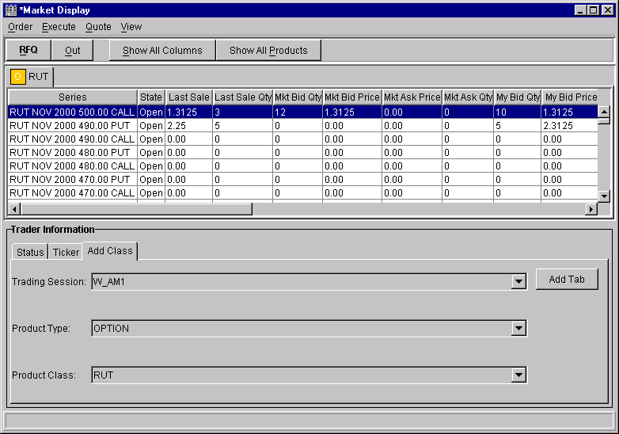

Transactions from the Shortcut Menu
From the Market Display window the marketmaker may do the following transactions by selecting (clicking the right mouse) on a particular series row, which produces a Shortcut menu, and selecting (clicking the left mouse) from the Shortcut menu items one of the following functions.
- From the Order item menu, for the selected series
- Add a new order
- View the status of the trader’s orders
- Spread order creation entry
- From the Quote item menu, for the selected series
- Enter a quote
- Cancel the existing quote
- Cancel all quotes
- Submit an RFQ
- From the View item menu, for the selected series, view
- The log of his trades (fills)
- Market History
- Activity Log
- Display Pending Price Adjustments
- Book depth
- From the Execute item menu, for the selected series
- Hit the Bid
- Take the Offer

Transactions from the Main Menu
From the main menu he may do the same transactions as the transactions available through the Shortcut menu. The item menus are also arranged as in the Shortcut menu under the following main items.
- Order dropdown menu
- Quote dropdown menu
- View dropdown menu
- Execute dropdown menu

Transactions from the Toolbar
From the toolbar he may do the following transactions.
- Get out of the market by canceling his quotes for the currently active class or for all classes that he trades (Out button)
- Respond to an RFQ (RFQ button)
- Show all columns
- Show all products

Transactions from the Class Symbol Tab Menu
By left clicking on the class symbol tab, the marketmaker invokes the tab menu from which he may do the following transaction.
- Remove the class from his display

Display of Contingency Orders
The market’s best bid and best offer quantity fields usually contain only limit orders. In the case when contingency orders are present at the best bid or offer, the system shall provide the following information for the quantity.
- Aggregate quantity of limit orders, including quantity of IOC (Immediate-or-cancel) orders
- Aggregate quantity of FOK (Fill-or-kill) orders, AON (All-or-none) and MIN (Minimum) orders
- Indicator of more than one FOK or AON or MIN order
- Smallest quantity of the minimums of the MIN orders, if any

Display of Contingency Orders in CBOE’s Market Display Window
In CBOEdirect’s GUI the quantity field shall be displayed in two sections. For example, the field may appear as 40+65*(20). The first section, 40, is the aggregate quantity of limit orders, including IOC orders. The second section, +65*, is the aggregate quantity of FOK, AON, and MIN orders. The * indicates there is more than one FOK, AON, or MIN order. The (20) is the smallest quantity of the minimums of the MIN orders.

If there are no FOK, AON, or MIN orders, then the second section is not displayed. If the FOK or IOC is at the best price by itself, then the price is displayed in flashing color. (Due to limitations in the GUI tool, the price shall be displayed in color only in Version 1).

To minimize the display field length of the quantity, not all of the characters may be displayed at once e.g., only ‘40+’ is displayed with the ‘+” to indicate that there is more information. The trader has to point to the field and the system shall display in a small tool-tip window the full field, ‘40+65*(20)’.

Display of Spread Orders
CBOEdirect shall maintain a book for each kind of spread order. It shall continually determine the best-priced spread among similar spread orders. It shall disseminate the best prices for spreads of the same kind.

Display of Spread Orders in CBOE’s Market Display Window
CBOEdirect’s GUI displays spread orders in a separate tabbed frame labeled with the class symbol and “S”, e.g., GM and S for GM spread option orders. The screen below is an example of the Spread Order Display.

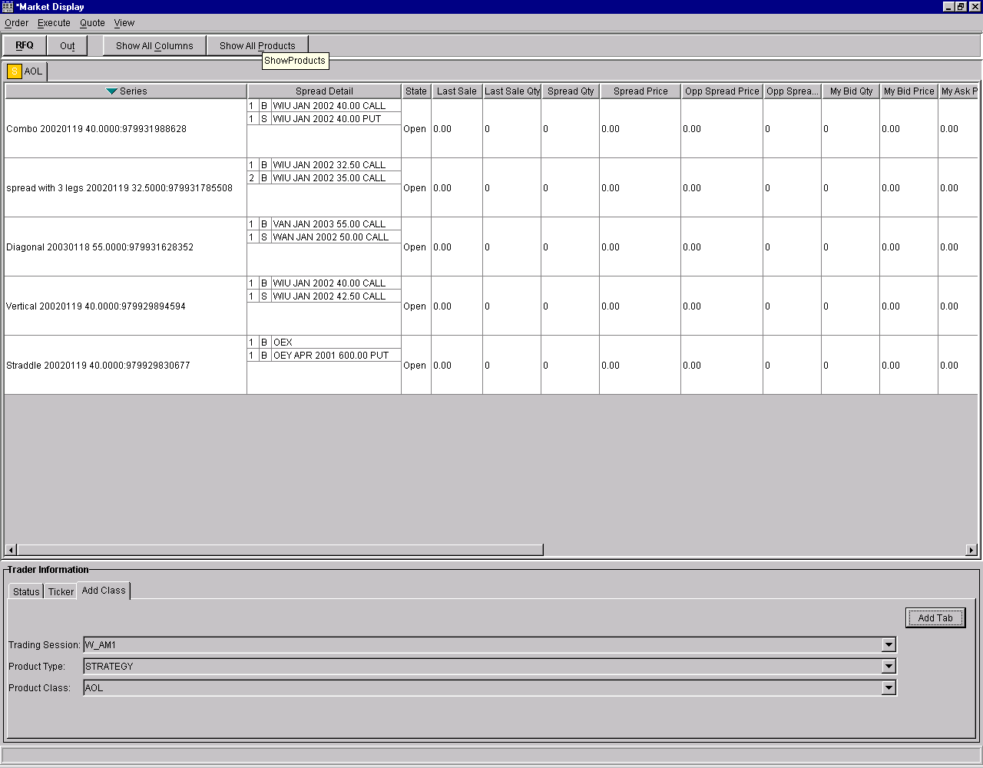

Within a spread, the legs are sorted by buy/sell, expiration month and strike price. The spreads are sorted in some order, e.g., alpha order of the product key. All the legs of a spread are displayed. The spreads are colored alternately to easily distinguish one from its neighbors.

The sample Spread Order Display shows the following data.
- For each leg of the top-of-the-book spread
- series ID
- buy or sell
- quantity
- For the top-of-the-book spread orders
- Aggregated spread quantity
- best price for the defined (same) spread, debit or credit
- best price for the opposite spread, debit or credit

See the GUI requirements for spreads in the section, CBOEdirect GUI Requirements for Spreads.

Right clicking a particular spread row selects a spread and produces a Shortcut menu similar to the one for regular options. See the section, Transactions from the Shortcut Menu.

From the Find menu item, the trader will get the dialogue below for finding the spreads that contain the specified series. The resulting query display shall present only those spreads that have the selected series as a leg.
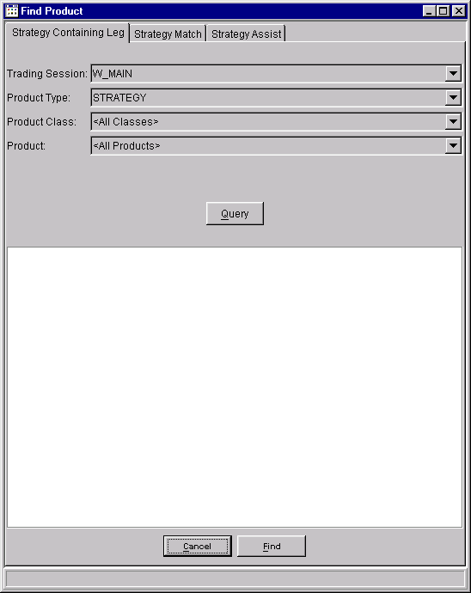

Quote Entry
A marketmaker may enter quotes in two ways: manually, by keying in at a workstation keyboard, and automatically, by generating quotes through his own autoquote system and submitting them through the CMi or FIX interface. A quote shall exist as a pair of bid and ask day orders in the book.

Single Quote Per Product Per Marketmaker
A marketmaker may have only a single quote for a product (series). A new quote shall be processed as a cancel/replace of the old quote. However, this does not preclude the marketmaker from entering other orders in the same series.

The system shall recognize and remember which orders are plain orders, unrelated to quotes, and which orders are parts of a quote. One reason for this is the requirement for the system to monitor how marketmakers are fulfilling their obligation to respond to RFQs. Another is automatic quote regeneration. (See the Automatic Quote Regeneration section below.)

Quote Entry Window
The screen below shows an example of a dialogue that the marketmaker would use to specify a quote for a series where he has no quote. This dialogue appears on the Market Display workarea when he selects on My Bid/My Ask quantity or price field.

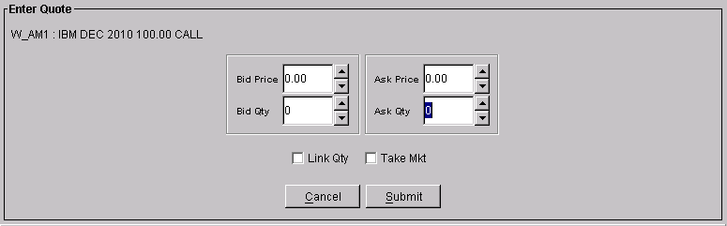

The session and the trader-selected class and series fields are displayed (W_AM1:IBM etc.). The checkbox labeled “Take Mkt” enables the marketmaker to set his bid and ask equal to the current market. The quantity fields would be pre-filled with the marketmaker’s default quote size, if available, or the exchange prescribed minimum quote size (not available in Version 1).

The checkbox labeled “Link Quantity” enables the marketmaker to enter a quantity in one of the bid and ask quantity fields and have the system replicate it on the other.

The button labeled “Take Auto” (not shown) enables the marketmaker to set his bid and ask equal to his current autoquote values. This feature, which integrates CBOEdirect’s GUI with the user’s proprietary autoquote, is not available in Version 1. To use his autoquote system, the marketmaker must log in his autoquote system and submit his autoquotes to the host directly, without going through the CBOEdirect GUI.

The bid and ask fields shall be pre-filled as follows.
- With the marketmaker’s outstanding quote, if he has one in the market. This helps the marketmaker update (cancel/replace) his quote.
- With the marketmaker’s autoquotes, if he has a current one (not submitted) and he has no quote in the market. This feature is not available in Version 1.
- With blanks, if he has no outstanding quote and no current, not submitted autoquote for that series.

He may change the bid fields, price and quantity, and the offer fields, price and quantity, by typing into the field or by using the up/down arrows.

The system shall facilitate the marketmaker’s quote entry by allowing him to enter only a bid or ask. When he clicks on he Submit button, the system shall automatically generate for him the opposite side, with his default quote width. If he does not specify size, the system shall use his default quote size, if it exists, or the exchange prescribed minimum quote size. (The features in this paragraph are all deferred to a future version).

Upon submitting his quote, the system shall give him a chance to confirm his quote if he elected to use the ‘quantity sanity check’ and the quantity in his quote is greater than the quantity threshold that he pre-specified.

A trader may have half a quote in the market. This special case arises immediately after his bid or ask is hit. If he wants to keep the remaining side, he would enter a quote with the remaining side and a new side. The system would update only the missing side. In the case where he is updating only one side of his quote, he would enter a quote with one side updated and the other side unchanged. The system would update only the changed side. In these two cases, the trader does not want to replace the bid/ask he already has in the market because that order has price/time priority.

Quote with No Bid
For quotes in the lowest premium range, quotes with no bid is acceptable if the ask price is equal to or less than the maximum quote width. For example, if the EPW requires than the maximum quote width for prices from 0 to 2 is 0.50, and minimum size is 10, then the quote, 0-0.25, 0x10, is legal. A quote with no offer is not a legal quote.

Exchange Prescribed Quote Width
Marketmakers are obligated to provide quotes that meet the exchange prescribed width. See the section, Exchange Prescribed Width (EPW) Tables, in the appendix. Different quote widths are prescribed for different product types, e.g., equities, and also for different classes, e.g., OEX, RUT, RUZ, etc. The prescribed quote width is also dependent on the price level. CBOEdirect shall be capable of supporting an EPW table for a product type, which shall serve as the default, as well as individual EPW tables per class.

Price and Quantity Edits
The following rules shall be used for accepting or rejecting quotes and single orders on the basis of their price or quantity. Both bid and offer sides of a quote have to be valid for the quote to be accepted.

- The offer price must be greater than the bid price.
- A no bid quote --- with zero bid price and zero bid quantity, and the offer price and offer quantity are both non-zero, and may be any number --- is acceptable. (If the width is wider than the EPW, then the quote won't get credit.)
- A zero quantity can only be paired with a zero price.
- Bid and offer prices of non-spread options should be positive.
- Spread prices are indicated as debit or credit prices.

Request for Quote (RFQ)
Any trader --- marketmaker, retail firm broker, or non-marketmaker professional trader --- may initiate an RFQ for a series. The trader may optionally specify the size. He does not specify whether he is interested to buy or sell. The system shall then automatically send the RFQ to marketmakers assigned to that class and to other marketmakers who subscribed to receiving RFQs for that class. The RFQ has an expiration period within which the marketmaker has to respond. This time period is a configurable system-wide parameter for the initial SBT version.

RFQ Window
The screen below is an example of the RFQ dialogue. It appears in the Market Display workarea when the trader selects a series and selects Quote Request from the Shortcut menu/Quote item menu. This example shows the trading session as W_AM1 and the IBM series selected.

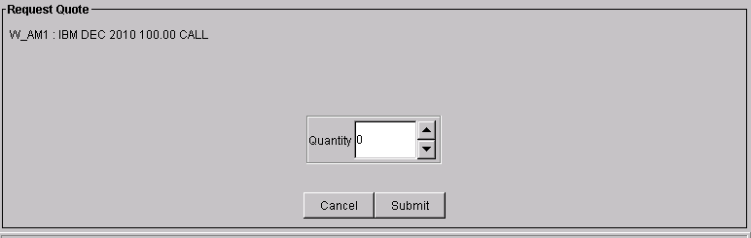

The system shall allow the dissemination of duplicate RFQs, which are RFQs for a product for which an RFQ is outstanding. This is done to give the marketmaker an indication of the increasing level of interest in the product.

Excessive RFQ Usage
It is important to limit the usage of RFQs to a reasonable level to prevent overloading the system. The system shall monitor the ratio of RFQ to trades generated by a trader. The Exchange may impose a charge per RFQ above a certain ratio.

Respond to an RFQ
RFQs come from two sources. One is the trader who manually enters an RFQ as described in the previous section.

The second source is the system itself when the system receives a market order and the current market is wider than the prescribed exchange width. The system shall then send automatically an RFQ with the size of the market order.

RFQ Response Requirements
A marketmaker shall be required to respond to a certain percentage of RFQs. To get credit for the quote response, the quote must meet all of the following requirements.
- He must respond within n (30) seconds
- The quote width must be equal or narrower than the exchange prescribed width
- The quote size must be at least equal to the specified minimum size
- He must provide a continuous market for a subsequent period of n (30) seconds unless his quote gets filled. The marketmaker may change his quote during this period but he must not cancel it.

Duplicate RFQs
Note that duplicate RFQs do not create an obligation for the marketmaker to respond to each duplicate RFQ. He is only obligated to respond once to the group of duplicate RFQs. For example, if two additional RFQs for a product are sent by the system within the life of the first RFQ, then there is the first RFQ and two duplicates. The marketmaker is only obligated to respond once to all three.

RFQ Alerts
The system shall prompt the marketmaker in two ways. First, if the class of the RFQ is the active class on the marketmaker’s Market Display, the system shall change the color of the series field to red. Second, the RFQ button on the toolbar shall turn to red. The RFQ button shall stay red as long as the trader has pending RFQs in any class. This second way is provided to alert the marketmaker in the case where the RFQ class is not the active class on the Market Display.

Pending RFQ Window
Selecting the RFQ button shall produce a window that presents the pending RFQs for all the classes to which the trader has subscribed. The screen below is an example of the Pending RFQ window.

Each RFQ item shows the class, series ID, and aggregate quantity requested, if present, and whether the RFQ item is system-generated or manually generated (not shown in the screen below).

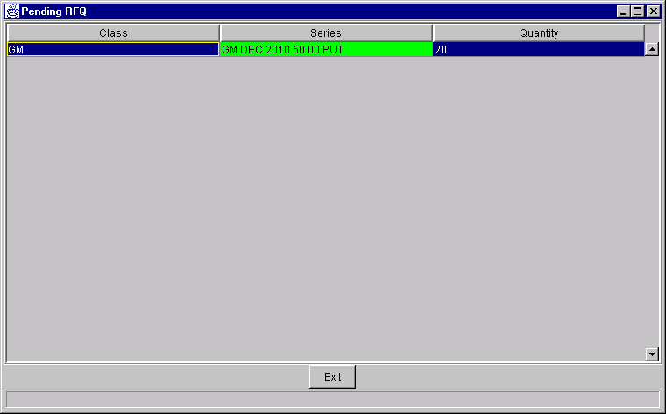

The window displays all the series that have pending RFQs, in chronological sequence of the receipt of the RFQ, from the earliest to the latest. As RFQs are received, the system adds the new series to the end of the list. The system removes the corresponding series entry from the list after the marketmaker responds to a particular RFQ or when it expires.

If the RFQ received is a duplicate RFQ, i.e., there is an outstanding RFQ item on the list, the RFQ item is changed to reflect the cumulative total quantity of RFQs for that series.

The series entries shall be color-coded: green in the first third of the response period (first 10 seconds if the response period is 30 seconds); yellow in the second third; and red in the last third. The RFQ item would be shown as system-generated if the RFQ were for a market order. This presentation scheme is intended to focus the marketmaker’s attention to the most urgent RFQs (red and system generated for a market order).

This color scheme is not affected by the arrival of duplicate RFQs. In other words, the duplicate RFQs assume the stage of life of the initial RFQ. They all age and expire together.

RFQ Response Window
The marketmaker may or may not respond to an RFQ. An existing standard quote (quote that meets exchange prescribed width and size) from the marketmaker is considered a response. If he does not want to respond, he simply lets the RFQ expire. To respond to a particular RFQ, the marketmaker selects the series entry from the Pending RFQ window. The system displays a Quote Entry dialogue, illustrated below.

The class and series fields would be pre-filled from the original RFQ. The other fields and buttons are employed as in the Quote Entry function. See the description of this dialogue under Quote Entry.

Processing of RFQ Responses (Quotes)
RFQ responses (quotes) are submitted to the book and exposed as they arrive.

Quote Maintenance
The marketmaker shall have the following functional capabilities for maintaining his quotes in the book. Note that a quote consists of two orders, a bid and an offer.
- He may cancel a specific quote (both bid and offer at the same time).
- He may cancel all of his quotes in a specified class, or all of his quotes in all classes.
- He may cancel/replace or update the bid or offer of his quote. An update of a field that is not the price or quantity does not cause the order to lose position. An order is considered to undergo a cancel/replace if its position changes due to a price change or quantity increase. Depending on how he modifies a bid or offer, the order’s position may change as follows.
- If the price is changed, the changed side loses position and the order goes behind all orders at the same price.
- If one side’s quantity is changed, the unchanged side retains position.
- If the order’s quantity is decreased, the order retains position.
- If the order’s quantity is increased, the order loses position and the order goes behind all orders at the same price.

Cancel a Quote
The screen below is an example of the dialogue that the marketmaker would use to cancel one of his quotes. This dialogue appears at the Market Display workarea. He gets to this dialogue by selecting a series and selecting Cancel Quote from the Shortcut menu/Quote item menu.

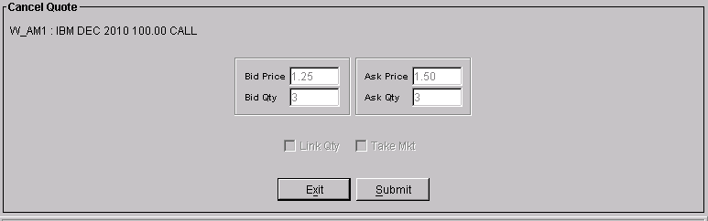

The fields are pre-filled with the particular quote’s information. The data cannot be changed. The cancel shall cause the system to delete from the book the buy and sell order pair for the quote.

If the cancel arrives at the book after one or both sides of the quote has been partially executed, then the system shall cancel the remainder, and return a ‘too late to cancel’ message for the filled quantity.

Cancel All Quotes
The screen below is an example of the dialogue that the marketmaker would use to cancel all his quotes for one, more than one, or all classes. This dialogue appears at the Market Display workarea. He gets to this dialogue by selecting a series and selecting Cancel All Quotes from the Main menu/Quote item menu.

The list would include all classes where he has quotes. The class of his active Market Display would be pre-selected. He may change the selection to be another class, or multiple classes. He may select all classes by clicking on the Select All button. Clicking on the Cancel (CXL) button would create a request to the system to delete all the specified quotes.

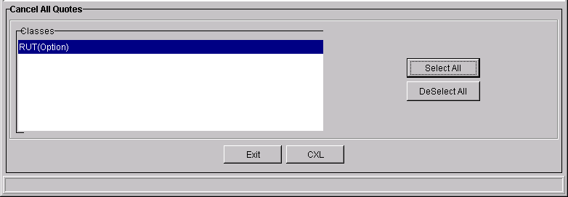

Inactivate All Quotes
Inactivate All Quotes is the dialogue that the marketmaker would use to get out of the market temporarily. He gets to the dialogue by clicking on the “panic button” labeled ‘Out’ on the toolbar. The dialogue gives the marketmaker a choice between inactivating his quotes for the active class only or for all the classes he trades.

There is a difference between canceling quotes and inactivating quotes. “Cancel” permanently deletes his quotes from the book. “Inactivate” removes his quotes temporarily from the book without deleting them. The system keeps the orders available for a specified time for “activation” or re-submission to the book without manual re-entry. For speed, the dialogue is pre-set to inactivate his quotes for the active class only.

Version 1 shall not include the inactivate/activate function. The “panic” button shall be implemented in Version 1 to cancel all quotes.

Update or Cancel/Replace a Quote
The screen below is an example of a dialogue that the marketmaker would use to update one of his quotes. It is the same dialogue used for entering a new quote. This dialogue appears on the Market Display workarea when he selects on My Bid/Ask quantity or price field. He may also get to this dialogue by selecting a series and selecting Enter Quote from the Shortcut menu. All the fields would be pre-filled with his current quote. He may change the fields by typing into the field or by using the up/down arrows. See the description of this dialogue under Quote Entry.

Cancel/Replace Behavior

Please see the section, Cancel/Replace under Order Status and Maintenance.

Quote Risk Monitor Function

This function is intended to provide benefits to both the customers and the marketmakers. For the customer, the markets would tend to be deeper and more liquid --- bigger size quotes and more marketmakers providing quotes --- because marketmakers would have better control of their risk and therefore, more willing to quote. For the marketmaker, it would allow them to control their risk after they have traded and actually taken risk.

It is expected that marketmakers who provide quotes in SBT would be exposed to greater risks than in open outcry. For example, in SBT a single marketmaker’s bids in several series, if his bids were the best, could be hit by a coordinated set of incoming orders within a few seconds, saddling him with a large position before he can react and change his quotes. In open outcry, he has less risk because he can change his market after a predetermined number of transactions have occurred.

To encourage marketmakers to provide deep and liquid markets, the system provides a way for marketmakers to control their risk after they have already taken trades and assumed risk. This system feature pulls a marketmaker’s quotes from a class when the system determines that his resting orders (quotes) have been filled in n (60) seconds or less to a total of n (200) contracts. In other words, when a number of his orders got filled within a short period of time, the system would pull his other quotes in the same class, notify him to give him a chance to react, and re-initialize its QRM counts for that class.

Note that the system would cancel his remaining quotes based on this function, not because of cancel orders sent by the marketmaker himself. It is then up to him to assess the risk he has taken so far in that class. He may provide replenishment quotes according to his quote obligations.

This function would only consider trades with the marketmaker’s resting quotes, not trades that the marketmaker initiates by hitting a bid or taking an offer. The function would also take effect even if the incoming orders were uncoordinated, coming from one or more sources. The time period within which the trade takes place and the net contract volume would be configurable by the marketmaker for each class.

Quote Risk Monitor Window
The screen below is an example of a dialogue that the marketmaker would use to specify his parameters for the Quote Risk Monitor.

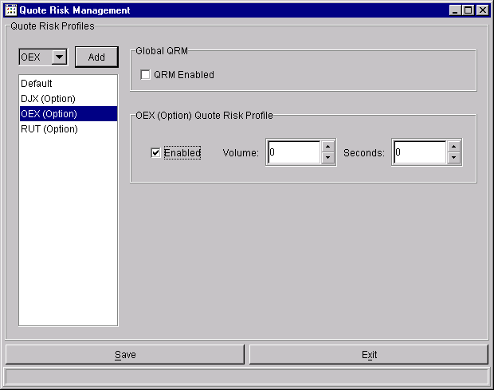

Automatic Quote Regeneration
(This function is not available in Version 1.)

The marketmaker may request the system to regenerate his quote when his bid or offer is filled fully. The system shall regenerate a new quote where the bid/offer is a pre-defined number of ticks worse than the previous bid/offer, and the size is his default size.

Priority of Regenerated Quote
The system shall position the regenerated quote based on price/time priority, except for one case. This exception case reflects current trading practice. If the regenerated quote (order) could immediately execute against the same order that hit the original quote, then that portion of the regenerated quote (order) equal to the original size executed goes ahead of all orders at the regenerated price, and is executed. The system shall position the rest of the regenerated quote based on price/time priority.

Example: A market order to sell 20 fills a quote bid for 5 at 5 ½. There’s volume remaining (15) on the market order. There are no other resting bids at the execution price. The regenerated bid for 10 (default quote size) is at the next lower price, 5 ¼, with other standing bids. Then the portion of the regenerated bid that is equal to the original execution size (5) goes ahead of all bids at the regenerated price and effectively gets first execution priority. The remaining portion of the regenerated bid (5) shall be positioned behind all other resting bids at 5 ¼.

Opposite Side of Regenerated Bid/Offer
When a bid/offer is regenerated, the system shall keep the opposite side at the same price unless the resulting width is wider than the exchange-prescribed width. If wider, the system would adjust the opposite side’s price (cancel/replace the old order) to keep the same width before the regeneration, or adjust it to bring the width to the exchange prescribed width. The marketmaker would have to make this choice as a pre-defined selection when he specifies his defaults for quote regeneration.

Maximum Number of Regeneration
The marketmaker may also specify the maximum number of times a quote may be regenerated by the system. The system maintains a regeneration count by product (series). The system resets the regeneration count to zero each time a fresh quote is received. Before the system regenerates, the system checks if the count exceeds the maximum count, and if it does, then the regeneration is not done and the remaining side of the quote is left as is. The system increments the count by one after each regeneration. If the maximum count is not specified, then the system regenerates an indefinite number of times.

Quote Regeneration Parameters
Summarizing, the marketmaker specifies the following parameters. He may specify them in two levels: default level, which applies to all the products (series) he quotes; and class level, which applies to all the products (series) under that class.

- Regenerate quotes when hit or not, yes or no
- Maximum count of regeneration
- Number of ticks pullback per regeneration
- Regenerated quote width equals former width or EPW

Concern Over Autoquote Traffic Load
The possibility of autoquote traffic overloading the network and the trading engine is of great concern. The following ideas have been suggested to help reduce autoquote traffic.

- Allow the marketmaker to specify that his autoquotes not be sent to the trading engine by the workstation if either side is n ticks worse than the market.
- Have the workstation filter autoquotes as described above as a system rule, without giving the marketmaker say in the filtering process.
- Have the system monitor the ratio of quotes to trades by marketmaker and impose a fee for a ratio higher than what would be considered a reasonable ratio. Coupled with this is the idea of giving a marketmaker credit for quotes that better the market.
- Have a throttle in the API to limit the number of outgoing messages to a certain rate. The idea is to limit the aggregate rate of messages to the SBT host to a manageable rate.
- Allow autoquote users to locate their quote engines locally in CBOE’s network and allow these users to generate quotes by passing parameters, thus removing the input quote traffic from the external network.

How the SBT System Will Throttle Quote Input

The recommendation is to not allocate bandwidth in relation to an SBT permit, e.g., an SBT permit holder shall not be programmatically limited in sending messages to the SBT system. To minimize the potential of abusing the system, the following measures were recommended.
- Specify the number of quotes over a certain time period that can be sent free by a quote provider using one permit.
- Impose a fee per message for sending a number that is clearly above the free number and for producing a ratio of quotes to trades over a certain time period that is higher than what would be considered a reasonable ratio.

For example, assume that the free number is n (4,000) quotes per class per day and the reasonable ratio of quotes to trades is n (50:1). Then the fee per message of a penny per quote becomes applicable for every quote above 4,000 if the ratio is between 56:1 and 65:1, and two pennies per message if the ratio is between 66:1 and 75:1, etc.

This cost-based governor will certainly help. However, to further protect the system, a message throttle in the API is still needed to prevent any user from overwhelming the system. This governor shall work through the two methods of entering quotes.

Manual Quote Method
The first method is for entering manual quotes through the workstation. This method allows a user to send one manual quote at a time, as fast as a human operator can do it. The system may have to throttle the input rate through this method to prevent a quote submitter from using a computer to simulate human input and overload the SBT system.

Mass Quote Method
The second method allows an autoquote engine to send a batch of quotes by class at a certain frequency. The system shall throttle the quote input rate by using a configurable timer per class. For example, the system may permit an autoquote engine to send autoquotes for IBM options every n (5) seconds. If the engine attempts to send another IBM batch before its time, the API would reject the attempt. It is up to the autoquote user to ensure that, when the API is ready, the quotes he is sending are always the most recent and the most important of his quotes.

Order Entry
Marketmakers will be able to enter orders for any class. These orders are plain orders, handled differently by the system from orders that are part of quotes.

The screen below shows an example of a dialogue for marketmaker order entry. The marketmaker gets to this screen from the Market Display window by right-clicking a series ID, and clicking on Add New Order from the Shortcut menu/Order item menu.

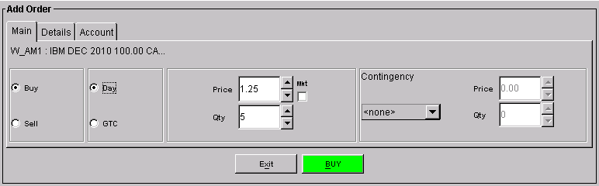

The Add Order function includes three frames: Main, Details, and Account. For speed, the dialogue in the Main frame of the Add Order function is pre-set to submit a buy, day order for the selected series. The marketmaker enters the price and quantity and specifies the contingency, if any.

The other order details appear in the Details frame and the Account frame shown below.

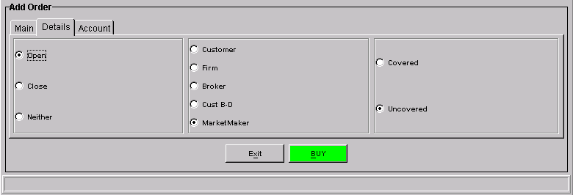

The origin type of marketmaker orders defaults to “marketmaker”. The Covered/Uncovered choices become active only for a Sell Order.

In open outcry there are times when marketmaker orders could be entered by his agent, with origin type specified as broker dealer, customer, or JBO (joint back office). The broker in CBOEdirect can also do this. The ability by the marketmaker to directly submit an order with an origin type other than marketmaker is deferred to a future version.

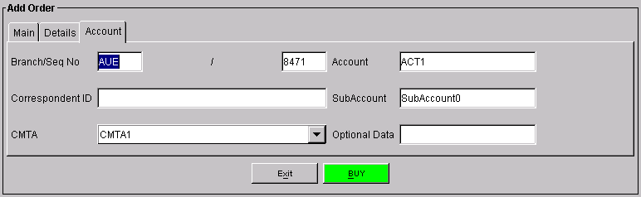

The Account details of the order are pre-set from the values provided by the trader when his profile is set up initially. All the fields except Account can be updated order by order.

Order Status and Maintenance
The marketmaker will have the capability to display the status of his active orders (submitted to the book), both regular and quote-related orders. In a future version, he will also have the capability to keep orders in the system that are inactive (not in the book). This is important because it provides the marketmaker the convenience of inactivating his designated orders when he wants to get out of the market quickly. The system takes them out of the book but keeps them so he can activate them when he wants to get back into the market.

Order Status Window
The sample screen below illustrates the Order Status dialogue. The marketmaker gets this dialogue by selecting Order Status from the Main Menu/Order item menu. He may choose from the dropdown list the session, the class, and the series of orders to display.

He may further select the orders to be displayed to include working orders, filled and canceled orders, or both; active, inactive, or both; buys, sells, or both. Working orders are orders with remaining quantity. Each line is an order, with the series ID displayed. The quantity fields provide the original quantity, filled quantity, cancelled quantity, and the remaining quantity. Also provided are the Original Price, Time-in-force, Contingency, Average Trade Price, the Session Average Price, and Session Traded Quantity.

For a marketmaker the Order Status Display includes a Quote frame. If he has an existing quote for the series, the bid and ask prices and quantities would be shown in this frame.

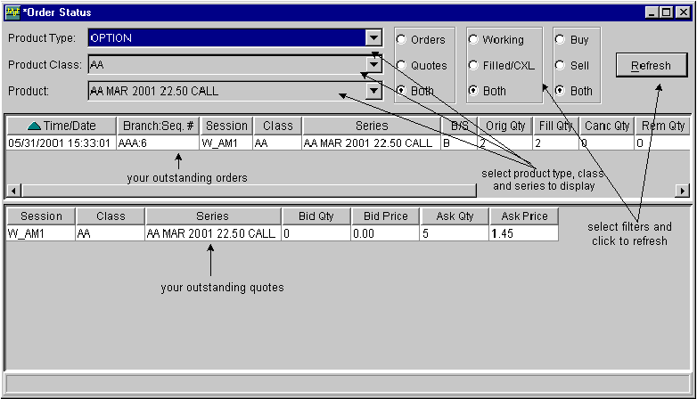

Order Maintenance
To maintain an order, he selects the order in the Order Status window by clicking on the order’s row. A Shortcut menu appears that allows him to:
- Update (cancel/replace) the order
- Cancel the order
- Activate or inactivate the order (not available in Version 1)

Selecting Update Order shall produce a workarea with fields appropriate for updating an order. Selecting cancel or activate or inactivate order shall produce a request to confirm the action.

More than one order may be selected at one time by a shift-and-click operation. He presses the shift key and clicks his chosen orders. Releasing the shift key shall produce the popup menu with the following choices.
- Cancel order(s)
- Activate or inactivate order(s)
Selecting cancel or activate or inactivate order(s) shall produce a request to confirm the action. (The features mentioned in this paragraph are deferred to a future version.)

Cancel/Replace

CBOEdirect supports the cancel/replace transaction with the following processing rules:
- Cancel/replace with different underlying security is not permitted.
- The cancel order's product (series)/price/quantity may or may not be equal to the replace order's product/price/quantity.

The system accepts the cancel/replace transaction depending, as shown below, on the relation of the cancel quantity and the remaining quantity of the order to be canceled.

Case | Condition | System Action
A | Remaining quantity Equals zero | Reject cancel/replace with too late to cancel message
B | Cancel quantity Less Than Remaining quantity | Do the cancel/replace (partial)
C | Cancel quantity Equals Remaining quantity | Do the cancel/replace (full)
D | Cancel quantity Greater Than Remaining quantity | Reject cancel/replace with mismatched quantity message

Note that in Case D, doing the cancel and then rejecting the replace order would leave the owner of the order out of the market which could create a liability. Defining better support for Case D is deferred to a later version.

Spread Order Entry

Marketmakers shall have the capability to enter spread orders. The system shall support spread orders whose legs are options of the same underlying security.

The system shall provide support for the most common, two-legged spread orders --- vertical, combo, straddle, and time. The system shall also allow a marketmaker to enter a customized spread order with more than two legs.

Spread Order Entry Window
The screen below is an example of a Spread Order Entry dialogue for a marketmaker. He gets this screen by selecting Spread Order Entry from the Shortcut menu/Order item menu.

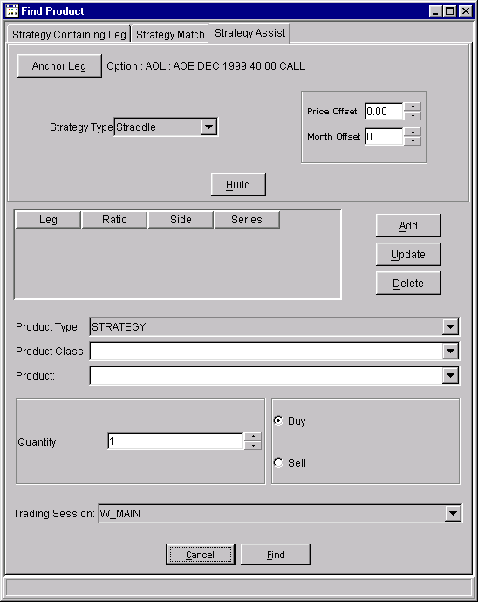

The marketmaker has three methods for entering a spread order, as shown in the three tabs of the screen.
- The Strategy Assist Method - This allows him to specify an anchor leg and a strategy type and then press on the Build button. The system then builds the spread product. He can modify the spread product by using the Add, Update, or Delete button. When he is satisfied with the spread product definition, he then presses the Find button to direct the system to check whether the product or its opposite already exists. If it does, the system brings him to the Market Display screen that highlights the product he wants and lays out the Add Strategy Order template for him, ready for his order input. If it does not exist, the system automatically creates the product, and brings him to the Market Display and Add Strategy Order template.
- The Strategy Match Method - This allows him to specify fully the legs of the spread product and press the Find button to do what is described above.
- The Strategy Containing Leg Method – This allows him to specify one leg of the spread product and to press the Query button. The system returns to him a list of all the spread products that contain the specified leg. When he selects a product, the system brings him to the Market Display screen and the Add Strategy Order template.

Under the Strategy Assist Method, based on the selections on the first leg, the system shall pre-fill the second leg as shown in the following table.

 | First Leg |  |  | Second Leg
Spread Type | B/S | C/P | Strike Price | B/S | C/P | Strike Price
Straddle | B/S | C/P | Strike Price 1 | Same | Opposite | Strike Price 1
Combo | B/S | C/P | Strike Price 1 | Opposite | Opposite | Strike Price 1
Vertical | B | C | Strike Price 1 | S | C | Higher Strike Price
Vertical | S | P | Strike Price 1 | B | P | Lower Strike Price
Vertical | S | C | Strike Price 1 | B | C | Higher Strike Price
Vertical | B | P | Strike Price 1 | S | P | Lower Strike Price
Time | B/S | C/P | Strike Price 1 | Opposite | Same | Same Strike Price, Next Month

The following screen shows the window --- Market Display and Add Strategy Order template --- that is presented to the trader when he presses the Find button.

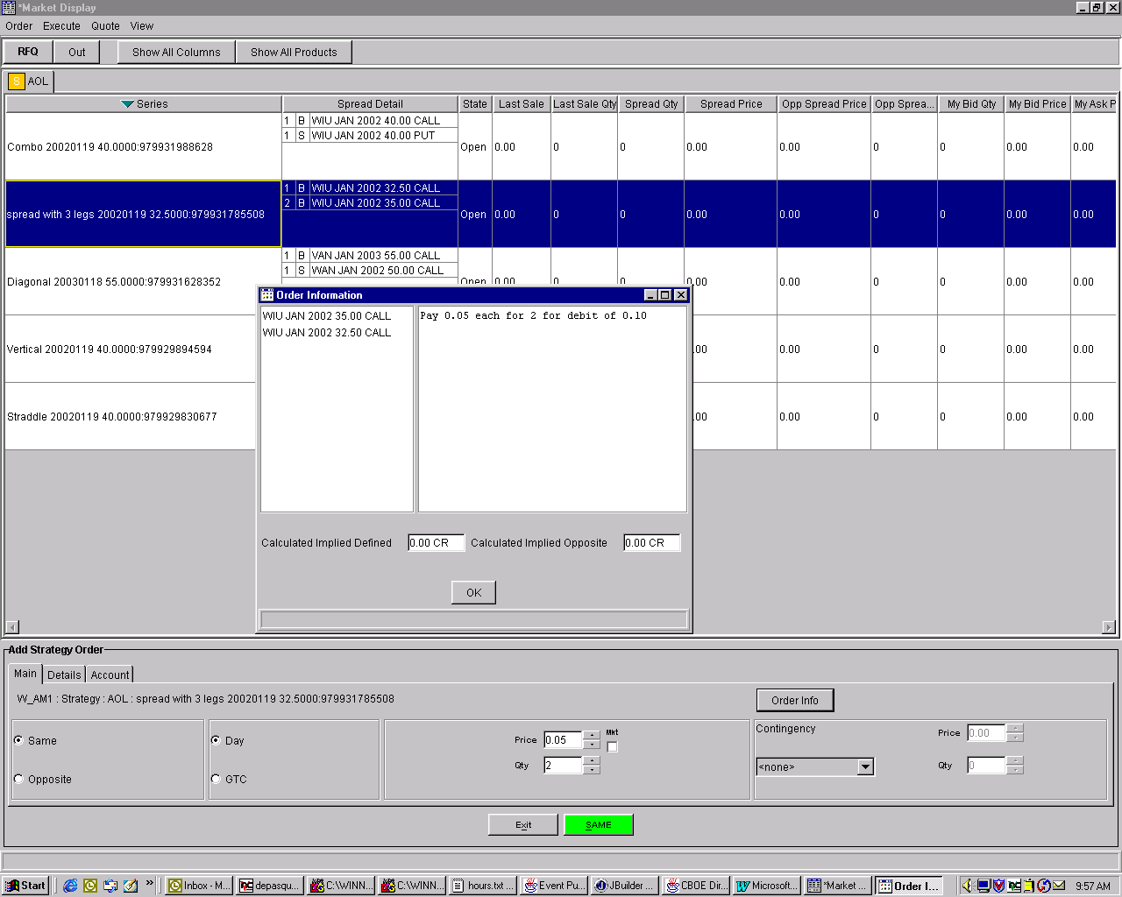

The product he wants is highlighted. The template is available for his input. After he specifies whether he wants the same or opposite spread, the time-in-force, Day or GTC, the net price and the quantity, and the contingency, he can press the Order Info button to display the Order Information window (shown).

This window serves as a sanity check for the trader. It reiterates what he is trying to do. It tells him the legs of the spread order, the Calculated Implied Price of the same spread and of the opposite spread, and most importantly, how much he is paying or receiving for each spread unit for a total debit or credit amount. He presses the OK button to close the Order Info window. He then submits the order by pressing the Same or Opposite button.

Trading Function
The CBOE GUI provides a trader the means to electronically hit a bid or take an offer.
He selects a bid or offer and clicks on the Buy or Sell button to:
- Do a full or partial execution.
- Confirm the execution. The confirmation (sanity volume check) shall occur above a size level to be set in the trader’s profile, with a bypass also available.

Hit the Bid
The ‘Hit the Bid’ or ‘Take the Offer’ dialogue appears in the workarea in the bottom section of the Market Display window when the market bid or market offer, price or quantity, is selected. The color of the ‘hit the bid’ (sell) button and ‘take the offer’ (buy) button will be different to minimize trader error. The screen below is an example of a dialogue for the “hit the bid” process. The class, series, price, and quantity are all pre-filled with the bid that was selected. The time-in-force field is pre-filled from the trader’s pre-specified choice (this feature is deferred to a future version).

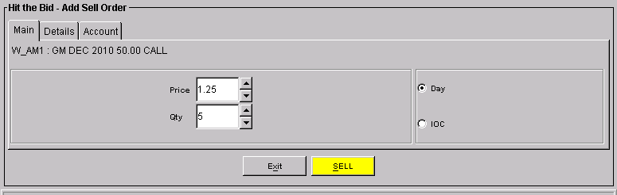

The trader may change the price field to be lower or higher than the bid price. He may also change the quantity field to be lower or higher than the bid quantity. The results of the combinations of changes appear below.

Price | Quantity | Results
Same | Same | Full execution of bid orders at bid price
Same | Lower | Partial execution of bid orders at bid price
Same | Higher | Full execution of bid orders at bid price and book new order to sell at bid price with remaining quantity
Lower | Same | Full execution of bid orders at the bid price
Lower | Lower | Partial execution of bid orders at the bid price
Lower | Higher | Full execution of bid orders at the bid price and new order to sell with remaining quantity that could either execute against lower bid orders, if any, or be booked
Higher | Any | No execution, book new order to sell

This is an alternate way for a marketmaker to enter sell orders. If the bid is no longer available for trading, e.g., if the bid was hit by another order, the system shall book the full order.

Take the Offer
The screen below is an example of a dialogue for the “take the offer” process.
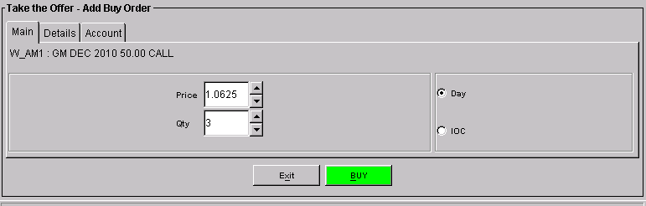

The trader may change the price field to be lower or higher than the offer price. He may also change the quantity field to be lower or higher than the offer quantity. The results of the combinations of changes appear below.

Price | Quantity | Results
Same | Same | Full execution of offer orders at offer price
Same | Lower | Partial execution of offer orders at offer price
Same | Higher | Full execution of offer orders at offer price and book new order to buy at offer price with remaining quantity
Higher | Same | Full execution of offer orders at the offer price
Higher | Lower | Partial execution of offer orders at the offer price
Higher | Higher | Full execution of offer orders at the offer price and new order to buy with remaining quantity that could either execute against higher offer orders, if any, or be booked
Lower | Any | No execution, book new order to buy

Again, this is an alternate way for a marketmaker to enter buy orders. If the offer is no longer available for trading, e.g., if the offer was taken by another order, the system shall book the full order.

Hit the Same Spread
The ‘Hit the Same Spread’ dialogue is similar to the ‘Hit the Bid’ dialogue. It appears in the workarea in the bottom section of the Spread Market Display window when the Spread Quantity or Spread Price of a product is selected (left-click).

The trader may change the price field to be lower or higher than the spread price. He may also change the quantity field to be lower or higher than the spread quantity. See the section, Spread Order Trading Rules, for the rules that the system shall employ to determine whether two spreads should trade.

This is an alternate way for a marketmaker to enter an opposite spread order. If the desired spread is no longer available for trading, e.g., if the spread was traded away, the system shall book the new spread order as a day or IOC opposite spread order, depending on the trader’s setting of the time-in-force in the order or in his preferences.

Take the Opposite Spread
The ‘Hit the Opposite Spread’ dialogue is similar to the ‘Take the Offer’ dialogue. It appears in the workarea in the bottom section of the Spread Market Display window when the Opp Spread Quantity or Opp Spread Price of a product is selected (left-click).

The trader may change the price field to be lower or higher than the opposite spread price. He may also change the quantity field to be lower or higher than the opposite spread quantity. See the section, Spread Order Trading Rules, for the rules that the system shall employ to determine whether two spreads should trade.

Again, this is an alternate way for a marketmaker to enter opposite spread orders. If the opposite spread order is no longer available for trading, the system shall book the new same spread order as a day or IOC order, depending on the trader’s setting of the time-in-force in the order or in his preferences.

Marketmaker’s Trade Review and Update
CBOEdirect submits a marketmaker’s trades to the Trade Match System in a form that causes them to settle in his designated clearing account. However, the marketmaker and his clearing firm may want to clear certain trades through another account of the marketmaker.

This function, which was intended to allow a marketmaker to review his trades at any time during the trading day and update the clearing account acronym of a particular trade, was not acceptable to the Clearing Procedures Committee (CPC). The CPC prefers to have his clearing firm do it. The functionality, available through the existing procedures of the Trade Match System, enables the update of the ‘account of’ field in the trade record.

Messaging Facility Between Trade Contra Parties
In connection with the trade bust procedures, the system shall provide a facility that would allow a trader to send messages to his contra parties to a particular trade. The system shall preserve anonymity, unless the parties themselves disclosed their identity. In this particular case, the messaging facility would be used for negotiating a trade bust with the contra party, thus reducing the burden on the Help Desk for mediating trade bust requests. A sample of the message screen is shown below. (The trader-to-trader feature is deferred to a future version. The destination of trader messages is limited to the Help Desk in the current version.)

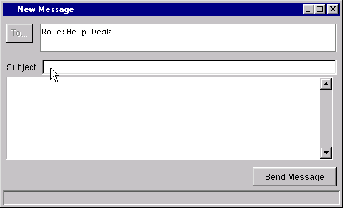

Intermarket Price Protection
This function is intended to protect customer orders from execution at prices worse than the NBBO, thus preventing the exchange from trading through other markets. Two procedures have been proposed. One is for handling customer orders when the NBBO is away. The other is for handling incoming linkage orders that are sent by other exchanges to CBOE for execution when CBOE is the NBBO.

Under the tentative market linkage plan, an exchange may send the NBBO exchange a principal/agent (P/A) order or principal order (P) for execution. The P/A order is defined as an order for the account of a specialist/DPM/LMM reflecting the terms of a customer order for which the specialist/DPM/LMM is acting as agent. The P order is an order for the principal account of a specialist/DPM/LMM and is not a P/A order. The satisfaction order is an order, for the principal account of a member who initiated a trade-through, sent through the linkage to satisfy the liability arising from that trade-through.

The requirements for the system are:
- Disseminate the NBBO updates
- Upon request from the DPM/LMM , disseminate the individual exchanges’ BBO
- Enable the DPM/LMM to specify his parameters for automatic step-up
- Perform the automatic step-up when the NBBO is away
- Enable the DPM/LMM to send P/A, P, or satisfaction order to the NBBO exchange
- Process the responses to the orders sent to the NBBO exchange
- Process and respond to the P/A and P orders sent by other exchanges
- Present the satisfaction order from another exchange to the DPM/LMM and send his response to the originating exchange
- A future requirement is to enable other marketmakers to specify their parameters for automatic step-up

The above NBBO-related requirements are subject to change from the linkage plan to be adopted for SBT by the exchanges. Draft descriptions of procedures to satisfy these requirements are given in the following sections. However, all of these requirements shall not be supported in Version 1 except for the first one, the dissemination of NBBO updates.

Procedure for Handling Orders when the NBBO is Away

Assumptions
- NBBO protection is for customer orders only.
- The DPM/LMM specifies two parameters for automatic step-up: the number of ticks and maximum order size for step-up. The Exchange prescribed size is n (20) at this time. Larger sizes by class may be negotiated with the DPM/LMM . The DPM/LMM specifies a pair of default parameters for all his assigned classes and a pair of parameters for each of his assigned classes.
- The DPM/LMM also specifies the order provider firms for which automatic step-up is done.
- The system shall attempt the automatic step-up when the DPM/LMM has a quote, whether he is at the BBO or not.
- A market linkage exists. (See Note 1.)
- Incoming customer orders, executable at the same NBBO away price, are processed as they arrive. A customer order may be filled out of sequence depending on the response of the NBBO exchange.
- A P/A order that is returned to CBOE with a ‘nothing done’ response for the whole or part of the order size causes the system to re-process the remaining size of the original customer order from the top of the procedure. As a result another P/A order may be sent to another NBBO away exchange.
- A P/A order that gets no response within the specified time, n (30) seconds, shall be executed at the CBOE stop price.
- OPRA does not disseminate quote size.
- The market linkage plan specifies an NBBO minimum protected size of n (10) contracts.

Proposed P/A Order Procedure
When the customer order specifies NBBO protection, is executable at the NBBO, and CBOE is not the NBBO, the order is processed as follows.

- In the rare occasion when the DPM/LMM is not available, e.g., DPM/LMM system failure, the system logs that condition and executes the order at the CBOE price. The sender and the DPM/LMM will then do their settlement outside the system.
- When the DPM/LMM is available, the order size is within his maximum step-up size, and he has an existing quote:
  - The system automatically performs the step-up function for the DPM/LMM for his specified number of ticks and size.
  - If the step-up price matches the NBBO and is within the DPM/LMM market, the system fills the order automatically at the NBBO price.
  - If the step-up price matches the NBBO but the step-up bid/offer is equal or better than the DPM/LMM offer/bid, then the system puts the order in the book. (The DPM/LMM refuses to automatically buy at his own offer or sell at his own bid. He might decide to do so as the order is presented to him, on an order-by-order basis.)
  - If the step-up price is worse than the NBBO, the system puts the order in the book.

- When the system puts a customer buy order in the book, the system stores it with a derived buy price equal to the NBBO offer. A customer sell order is stored at a derived sell price equal to the NBBO bid. The resulting BBO update is disseminated internally but not to OPRA, to avoid disseminating a market that would lock with the NBBO. The point of this exercise is to expose the order to CBOE traders for a very short period of time, e.g., n (2) seconds or less. The time will be calibrated to be long enough for rapid execution systems to react to it. If it is not taken out, the system pulls the order out of the book, and recalculates and re-disseminates the BBO. (Note that while these orders are in the book, any BBO calculation for transmission to OPRA should not include these orders.) The order is then presented to the DPM/LMM for manual handling.
  - Limit order example: CBOE BBO 3 ¾ - 4
NBBO 3 ¾ - 3 7/8
Customer limit order to buy at 4, executable against NBBO offer of 3 7/8. DPM/LMM offer at 4 1/8, steps up to 4. Step-up not as good as NBBO offer of 3 7/8. System puts customer order in the book at derived bid of 3 7/8, exposes it briefly for take-out. If not filled, system pulls order from book and presents it to DPM/LMM .
Resulting CBOE BBO: 3 7/8 – 4 during take-out period
3 ¾ - 4 after take-out period

- Market order example: CBOE BBO 3 ¾ - 4
NBBO 3 ¾ - 3 7/8
Customer market order to buy, executable against NBBO offer of 3 7/8. DPM/LMM offer at 4 1/8, steps up to 4. Step-up not as good as NBBO offer of 3 7/8. System puts customer order in the book at derived bid of 3 7/8, exposes it briefly for take-out. If not filled, system pulls order from book and presents it to DPM/LMM.
Resulting CBOE BBO: 3 7/8 – 4 during take-out period
3 ¾ - 4 after take-out period

- Manual handling is envisioned to be as follows.
  - The customer orders are presented to the DPM/LMM for action. The orders are listed in chronological sequence, from the oldest to the most recent. The DPM/LMM selects one and the system presents the data for the selected order. This includes the product (series), the order’s price and size, the sender firm, the NBBO markets (exchange ID, price, and guaranteed NBBO size), the automatic step-up price if available, and the reason the order requires manual handling. There are four possible reasons:
- DPM/LMM is given two choices:
- Step-up to the NBBO price and fill the order completely.
- “Stop” the order and ship the P/A order. The order is stopped at the step-up price or at the DPM/LMM -specified price, for the DPM/LMM specified-size.
- With Market Linkage
If market linkage exists, the system sends to the NBBO exchange via the market linkage a P/A order at the NBBO price for the size of the customer order.
- Without Market Linkage
If market linkage does not exist, then it is assumed that the DPM/LMM would phone his broker to trade his P/A order at the NBBO market. The DPM/LMM would then enter the result -- fill partially or completely, or nothing done – to the system.

- Handling of the Response to the Linkage Order
The NBBO exchange must respond to a linkage order within n (15) seconds of receipt of the order. The response may be a ‘nothing done’, or an execution, complete or partial, at the NBBO price or better for the size of the linkage order or less. A partial execution will have appended to it a cancellation of the remaining size.
- The system has to validate the response by assuring that the linkage order data in the execution response agrees with the data of the original linkage order. The size executed must be equal to or smaller than the linkage order size. The execution price must equal or better the reference price. The system rejects a response that fails the validation and sends an appropriate error message to the originator.
- If the NBBO market responds with a ‘nothing done’ (it is no longer the NBBO), the DPM/LMM is notified, and the original customer order is processed from the top of the procedure.
- If the NBBO market does not fill the order fully nor adjust its quote to a price inferior to the reference price within n (30) seconds from the time of sending the order, the sending market may trade through the NBBO market. The system fills the customer order at the stopped price and size, and the DPM/LMM is notified via his fill report. The remainder, if any, is processed from the top of the procedure.
- If the NBBO market fills the P/A order for a certain size, the system fills the customer order at the same execution price and for the same size, and the DPM/LMM is notified via his fill report. The remainder, if any, is processed from the top of the procedure.
- The system rejects any response reporting an execution when the response is received after the prescribed period. The rejection message must be sent within n (15) seconds of receipt of the response.
- The DPM/LMM must be able to inquire on his list of linkage orders that were sent. CBOE’s user interface shall display these orders, and upon request, the associated original customer order, if any. The system removes orders from the list as responses are received and processed.

Proposed P Order Procedure
The DPM/LMM may send a P order through the linkage to the NBBO exchange, without having an associated customer order. CBOE’s GUI shall present a P order workarea when the DPM/LMM clicks on the NBBO price or quantity field. The workarea shall include the NBBO exchange ID, NBBO price, guaranteed NBBO size, the P order size which the marketmaker has to specify, and a buy/sell button which the marketmaker has to click to send the order. The GUI shall ask for confirmation before the order is actually sent.

Sending P orders is limited by the linkage plan. At the end of each calendar quarter, CBOE shall apply the 80/20 test to the DPM/LMM for each of his assigned classes. The formula used is X divided by (X+Y), where X is the contract volume traded against customer orders in CBOE plus contract volume traded against incoming P/A orders, and Y is the contract volume traded by sending P orders through the linkage. If the calculation yields less than 80%, the DPM/LMM shall be precluded from sending P orders for that class for the next calendar quarter.

Proposed Satisfaction Order Procedure
(To be added later)

Proposed Linkage Order Information
At the minimum a linkage order shall:
- Identify whether the order is a P/A order, P order, or Satisfaction order;
- Contain a unique order ID;
- Include the CBOE name and omnibus clearing account number
- Specify the time the linkage order is sent;
- Identify the name of the receiving Participant market;
- Specify the series, including the underlying security, expiration month and strike price;
- Buy or sell;
- Number of contracts;
- Reference price.

Proposed Response Information
The response, if an execution, represents the contra side of the original linkage order. It will include all the information in the linkage order as well as the proper clearing account of the contra side, and the size executed. If the linkage order is partially executed, the execution response includes a cancellation report appended to it.

SBT Incoming Linkage Order Procedure

The following lists the assumptions and describes the proposed procedure for handling linkage orders under SBT.

The SBT Committee recommends this procedure, fully aware that it is different from the CBOE open outcry procedure. The latter requires that the exchange be firm for a minimum size equal to the automatic execution size guaranteed for customers.

Assumptions
A market linkage exists.
The CBOE market will be good for its BBO size. This is true whether OPRA is able to disseminate quote size or not.
A linkage order is an IOC limit order that the NBBO exchange must respond to within n (15) seconds under normal market conditions.
“Trade or fade” rule. The linkage order may be filled fully or partially or not at all. If the linkage order is not fully filled, the BBO has to change.

Proposed Procedure
Without Market Linkage
If market linkage does not exist, then it is assumed that the linkage order would reach the DPM/LMM by phone. The DPM/LMM would enter it to the system and it would then be processed as described below. The DPM/LMM would also communicate the result -- fill or nothing done – via phone.

With Market Linkage
Upon receipt of the linkage order the SBT system will determine whether CBOE is the NBBO and if the linkage order’s price is equal to or better than the BBO. If neither is true, the system sends a ‘Nothing Done’ response to the linkage order.

Linkage Order Price Equal to the BBO
If CBOE is the NBBO and if the linkage order’s price is equal to the BBO then:
- The linkage order is filled automatically for the linkage order size, if the linkage order size is equal to or less than the BBO size. The system then sends a fill report to the originating exchange.

- If the linkage order size is greater than the BBO size, the linkage order is traded against the BBO orders. The system shows the remainder of the linkage order as an IOC order in the Book and disseminates the new BBO. At the end of the linkage order period or earlier, the system sends a fill report if the linkage order is fully filled. If there is a remainder, the system sends a partial fill and ‘nothing done on the balance’.

Linkage Order Price is Better than the BBO
If CBOE is the NBBO and if the linkage order’s price is better than the BBO, e.g., the linkage order is buy at ¾ and CBOE’s offer is ½, the linkage order would trade against orders at the BBO and at succeeding price levels (½, 5/8, ¾). This would continue as long as CBOE is the NBBO at those price levels, there is enough size on both sides, until the price level prevents a fill, e.g., 7/8. The remainder is exposed in the Book as an IOC order as described in 2 above.

Linkage orders for the same series are processed in sequence. A linkage order that arrives while one is in process shall be queued. It shall be processed when the first one is either filled completely by the Book or the remainder is booked.

Marketmaker’s Logoff
The marketmaker logs off by selecting the Logoff item from the Main menu/File menu item. The marketmaker’s logoff shall cause the system to delete all his quotes from the book, but keep all his other orders in the book.

If the mechanism that certifies the marketmaker’s physical presence on the workstation is disabled or removed, e.g., removing the marketmaker badge from the badge reader, the system shall assume that he has logged off. (The use of a device to certify the trader’s physical presence is deferred to a future version.)

Marketmaker’s Preferences

Quote Defaults
The system shall allow the marketmaker to specify his quote-related defaults or preferences such as:
- Default quote size by class
- Default quote spread; see Appendix 20.5 for Exchange Prescribed Spread
- For Automatic Quote Regeneration (deferred to a future version)
- Whether he wants his quote to be automatically regenerated by the system when his bid is hit or his offer is taken
- The number of times his quote is regenerated for each instance of a hit/take
- The number of ticks his regenerated bid/offer is pulled back
- The spread for the regenerated quote which could be equal to or narrower than, but not wider than, the exchange prescribed spread
- The quantity of quote above which he wants the system to prompt him for confirmation before accepting the entry

Quote Preferences Window
The screen below is the dialogue that the marketmaker would use to specify his quote-related defaults.

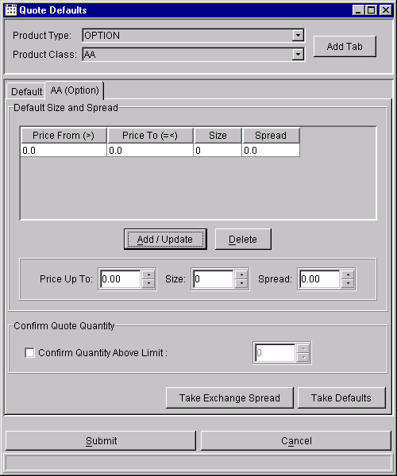

Miscellaneous Defaults
The system shall also allow the marketmaker to specify his defaults or preferences related to orders, executions, and alerts, such as:
- The quantity of an order or trade (hit the bid or take the offer) above which he wants the system to prompt him for confirmation before accepting the entry
- Preference for the time in force, day or IOC, that the system shall include in his hit- the-bid and take-the-offer orders (deferred to future version)
- Preference for printing fills
- Whether he wants audible notifications or not, e.g., for RFQs, fills, cross notifications, etc.
- The default for the Details fields in the Order Entry dialogue.

Miscellaneous Defaults Window
The screen below presents the dialogue that the marketmaker would use to specify his miscellaneous defaults.
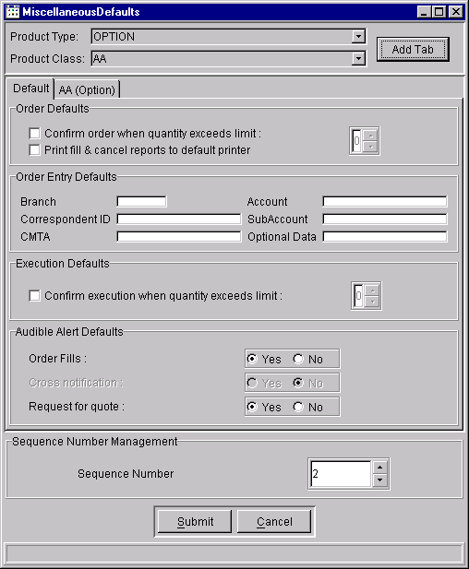

Marketmaking Without Using an SBT Workstation
Marketmakers will be able to send in automated quotes and orders through the API. A marketmaker may have his own computer connected to the system, submitting and keeping up his quotes and orders, instead of him manually entering them through a workstation. The API shall be designed to accommodate messages he sends to the system such as his quotes and orders, and messages sent by the system to him such as fills, RFQs, best book updates, and other messages necessary for a marketmaker to fulfill his obligations.

MEMBER FIRM BROKER FUNCTIONS

Display of Market’s Best Bid and Ask Orders
The member firm broker will exercise his trading functions from a display that shows the products he trades, the current best market prices, his best orders for those products, and the current market for the underlying product. This display is identical to the Market Display that the marketmaker uses. See the function description under the Display of Market’s Best Bid and Ask Orders section, Marketmaking Functions.

From this screen he may do the following:
- Hit the bid or take the offer by selecting (clicking) the market bid/ask quantity or price
- Select other trading functions from a Shortcut menu of functions by selecting a particular series.

Request for Quote
The member firm broker may submit an RFQ for a specific series and optional quantity. When he selects a series from the Market Display screen and selects RFQ from the Shortcut menu, the system shall display the Request for Quote dialogue. See the function description under the Request for Quote section, Marketmaking Functions.

Order Entry
Member firms may send orders in two ways: via wire orders through ORS or via the SBT APIs through manual entry on SBT workstations or from their own order routing system. Inbound orders shall be validated before accepting them into the SBT book.

Invalid orders shall be sent back to the source of the order with an error message. Invalid orders from ORS shall be returned to ORS to be printed for manual handling.

Retail Order Entry
The Retail Order Entry Window is the same as the Marketmaker Order Entry Window. The three frames ---Main, Details, and Account --- of the Add Order Window appear below. The following fields maybe entered.

- Class and series ID
- Call or put
- Price
- Quantity
- Time in force
- Contingency
- Whether it is an opening or closing transaction
- If a sell order, whether it is a covered or uncovered option
- Order source (customer broker-dealer, marketmaker, customer, firm, or broker-dealer)
- Branch/sequence number*
- Executing firm
- Broker acronym
- Give-up firm
- Correspondent firm ID*
- Contingency
- CMTA clearing member ID*
- Account
- Sub-account ID*
- For a customer order, an indication, e.g., yes or no, whether customer wants NBBO protection (deferred to a future version)
- Optional data

The fields marked with an asterisk, if entered, are passed without editing to the Trade Match System.

Order Status and Maintenance
The member firm broker’s order status and maintenance function is similar to that of the marketmaker. He uses the Order Status dialogue to display the status of his orders. He may select the orders to be displayed to include Working orders or Filled/Cancelled orders or both. From this dialogue he may cancel or update his Working orders. See the function description under the Order Status and Maintenance Function section, Marketmaking Functions.

Spread Order Entry

The Spread Order Entry screen for the member firm broker is similar to that of the marketmaker. Please refer to the Spread Order Entry section, Marketmaking Functions, for the function description. The additional order input fields for the member firm broker are:

- Whether it is an opening or closing transaction
- Order source (customer, firm, or broker-dealer)
- If a sell order, covered or uncovered
- Branch/sequence number
- Correspondent firm ID
- Contingency
- CMTA clearing member ID
- Optional data.

Trading Function
The member firm broker’s trading function is similar to that of the marketmaker. He may use the Hit the Bid and Take the Offer dialogues to trade against the best bid and best offer. See the function description under the Trading Function section, Marketmaking Functions. He may also simply submit a new order, using the Order Entry function, with the best bid/offer price and the system shall match electronically the new order with the best bid or offer in the book.

Order entry by the member firm broker requires more data fields than the marketmaker, e.g., firm, branch, sequence number, etc. Defaults for this information must be provided as part of the broker’s preferences.

Crossing Function
Note that the crossing function, described below, has been superseded by an alternative crossing procedure, described under the section, Requirements for Extended Trading Hours. The alternative crossing procedure guarantees the crossing firm a certain minimum percentage of the cross while the procedure below allows the crossing firm to cross 100% of the volume.

Crosses shall be permitted in the system. Crossing is defined as a member firm bringing two orders, one to buy and one to sell the same option series that may be traded against each other. The firm may or may not be willing to participate in the trade for its own account. This procedure allows the crossing firm to cross 100% of the volume.

Cross Notification via RFQ
To offer the opportunity for price improvement, the crossing firm is required to send an RFQ, whether or not a standard width market exists. The RFQ shall include the series and the quantity to be crossed. The system shall disseminate the RFQ to subscribing marketmakers.

The CBOE user interface shall display it as a separate line on the Pending RFQ window. A field on the line shall indicate that it is for a cross. The system shall alert him of the presence of this cross RFQ by flashing the RFQ button. The cross entry shall be color-coded like the regular RFQ (green, yellow, and red). It expires and is removed from the display list in n (20) seconds. (The display of the cross RFQ as a separate line on the Pending RFQ window is a feature deferred to a future version. In Version 1 the cross RFQ shall be displayed and processed as a regular RFQ.)

The marketmaker may or may not respond to the cross RFQ. If he does not want to respond, he simply lets the cross RFQ expire. To respond to a particular cross RFQ, the marketmaker selects the entry from the Pending RFQ window. The system displays a Quote Entry dialogue for the marketmaker to complete and submit.

Cross Execution
Support for cross execution is deferred to a future version. There will be a crossing procedure in Version 1 that does not require CBOEdirect to enforce it. Crossing activities shall be subjected to surveillance after the fact.

The marketmakers enter their quotes and other traders, their orders, within n (20) seconds after the RFQ. The crossing firm has to send the cross execution between n (20) seconds and n (40) seconds after the RFQ. The timing between the RFQ and the cross execution shall be surveilled offline, not in real-time.

The system shall allow cross execution only if a standard-width market exists. The system shall allow the cross to trade if the crossing price is within the market. The system shall reject the cross if the crossing price is at or outside the market.

The screen below is an example of the cross execution.

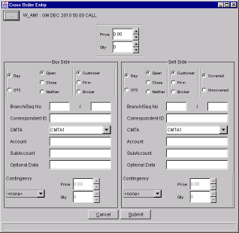

Member Firm Broker’s Preferences
The system shall allow the member firm broker to specify his defaults or preferences such as:
- Whether he wants audible notifications or not, e.g., for order fills, for cross notifications, etc.
- The volume of order above which he wants the system to prompt him for confirmation before accepting the entry
- The default entries for his Order Entry screen such as Branch ID, etc.
- The default entries for order entry fields that are required to complete his ’hit the bid’ and ‘take the offer’ orders.

The member firm broker uses the same Miscellaneous Defaults dialogue that the marketmaker uses to specify his preferences.

CLEARING FIRM USER FUNCTIONS

Set Order Quantity Limit
This function is intended to protect the clearing firm by allowing the authorized clearing firm broker to specify the maximum order quantity by class that a marketmaker may enter in his quote or order. The system shall reject any order from the marketmaker that exceeds the maximum quantity.

This function shall be implemented in the CBOEdirect GUI, not in the host. Members who wish to have a similar feature shall have to implement it in their own user interface.

This function is deferred to a future version.

Force Logout of Trader
This function is intended to protect the exchange system and clearing firms by allowing an authorized person from the clearing firm or the CBOE Help Desk to force the logout of a rogue trader or a technically disabled trader. The clearing firm, for example, may request the Help Desk to force the logout of one of its marketmakers who is trading in another geographical location. The Help Desk provides the system the trader ID and the system logs out the trader.

CBOEdirect supports two choices:
- Force Logout
- Force Logout and Disable

Force Logout
Force Logout logs out the trader, cancels all his quotes, leaves his regular orders unchanged, and does not affect his ability to log in. This is intended for situations where the trader for any reason cannot log out himself.

Force Logout and Disable
Force Logout and Disable logs out the trader, cancels all his quotes, cancels all his regular orders, and de-authorizes him as a user. He can no longer log in to the system. The Help Desk has to re-enable him before he can log in again.

In the current version this function is available to the Help Desk only.

SYSTEM OPERATOR/ADMINISTRATOR FUNCTIONS

Market Control Functions
System operators/administrators operate workstations located in the CBOE for the following support functions.
- Start/stop the SBT system
- Start/stop trading by class, by underlying security, or for whole market
- Add/change/delete trader Ids to the system
- Add/change/delete products
- Add/change/delete clearing account acronyms for marketmakers
- Change market status such as open, closed, fast market, halt, etc. by class, by underlying security, or for whole market
- Determine the operating status of any workstation or node in the network
- Automated broadcast of canned administrative messages to email, fax, voice recording, trading groups, CBOE web page, and SBT blackboard (not available in Version 1)
- Send text message to a trader or group of traders
- Maintain class groups and marketmaker assignments to classes
- Maintain marketmaker profiles which will identify the accounts where trades will settle
- Maintain relationships between brokers and their executing firms/give-up firms
- Monitor the log-in status of traders by class
- Monitor queues for all API links
- Display operating status of various SBT system services
- Drill-down display by class of assigned and logged-in marketmakers
- Display un-responded RFQs including source of RFQ and the marketmakers obligated to quote them
- Send a ‘Super RFQ’ to a group of marketmakers (not available in Version 1)
- Display a trader’s preferences
- Enter, update, and display a marketmaker’s appointments
- Display a trader’s device or configuration
- Display a given node’s activity for troubleshooting
- Display trade log by trader ID of today’s trades
- Exercise full SBT workstation functionality by using a test product
- Display a screen from a particular trader’s point of view (not available in Version 1)
- Bust a trade
- Force the logout of a trader

Trading Parameters
CBOEdirect shall allow the Help Desk and Operations staff to view exchange-wide trading parameters such as
- Exchange prescribed quote width (EPW)
- Minimum marketmaker quote default size for quote credit
- % of response to an RFQ from assigned marketmakers before execution is attempted on a market order
- Time for marketmakers to respond to an RFQ (RFQ expiration time)
- Minimum time period for marketmaker to maintain a continuous market for the quote to be counted as a legitimate response to an RFQ
- % of prescribed quote width, that a quote in response to an RFQ would need to be equal to or less, that would cause a pending market order to be immediately executed against the quote
These parameters shall be set as system configuration parameters. They can be set on an exchange level and a product (class) level. If class levels are not set, the exchange level setting serves as the default. Settings on a session level are not supported in the current version.

The ability to view the trading parameters is deferred to a future version.

Unusual Trading Conditions
Trading conditions, e.g., fast market, trading halt, may be declared by a market official or by the system automatically. Declaration of a trading condition, whether automatically by the system or manually by the market official, shall cause a notification message to be sent to the traders subscribing to the affected class. A record of the time and duration of the market condition shall be recorded in the System Trade and Quotes Log for the affected class.

Quote messages that reflect unusual trading conditions shall follow the current convention. For each affected option series, quotes under fast market shall include “F” as the type code. Quotes under a trading halt shall include “T” as the type code and the bid/ask fields shall contain 0998/0999.

Fast Market Condition
Fast market may be declared by a market official or automatically by the system.

Given the appropriate information, the system shall automatically declare a fast market for a class for the following reason:
- Loss of underlying security feed, e.g., SIAC or NASDAQ feed

The market official may declare a fast market for a class for any of the following reasons:
- Loss of underlying security feed, e.g., SIAC or NASDAQ feed
- Impending news
- Any other reason to maintain an orderly market

Under a fast market condition, the marketmaker’s quote obligation changes. He is not obligated to provide the minimum size with his quotes. The committee left the quote width required under a fast market as an open issue. It was suggested that the marketmaker be allowed to provide wider quotes, e.g., at least double the exchange prescribed width. The marketmaker’s obligation to respond to a specified percentage of RFQs remains in place. Whether or not he responds to the RFQ is up to his own discretion.

Trading Halt Condition
Trading halt may be declared by a market official or automatically by the system.

Stock Options
Given the appropriate information, the system shall automatically declare a trading halt for a stock option for the following reason:
- Trading halt is declared for the underlying security in the primary market

The market official may declare a trading halt for a stock option for any of the following reasons:
- No last sale and/or quotation dissemination either by the Exchange or by OPRA
- Primary market halts trading in one or more stocks for regulatory reasons
- Primary market non–regulatory trading halt in one or more individual equity securities
- The primary market halts trading floor–wide
- Primary market is open but is unable to disseminate last sale or quotation information
- Over–the–counter quote dissemination halt
- Expiration Friday trading in individual equity options. In the event that any of the foregoing should occur on expiration Friday, it is the preference of the Exchange to allow trading to continue on that date.
- Dissemination of news after or near the close of trading in the primary market
- Opening of the underlying security has been delayed because of unusual circumstances
- Loss of underlying security feed, e.g., SIAC or NASDAQ feed
- CBOE systems failure
- Rotation has not been completed or other factors affect the status of the rotation
- Other unusual conditions or circumstances are present

Index Option
The market official may declare a trading halt for an index option if he deems that such action is appropriate in the interest of a fair and orderly market and to protect investors. Among the facts that may be considered are the following:
- Initiation of a market-wide trading halt commonly known as a circuit breaker on the New York Stock Exchange
- Activation of price limits on futures exchanges
- The extent to which trading is not occurring in stocks underlying the index;
- The current calculation of the index derived from the current market prices of the stocks is not available
- The extent to which the rotation has been completed or other factors regarding the status of the rotation
- Other unusual conditions or circumstances detrimental to the maintenance of a fair and orderly market are present

Any Security Other than an Option
The market official may declare a trading halt for any of the following reasons:
- The opening of such security has been delayed due to order imbalances
- The Exchange has been advised that the issuer of the security is about to make an important announcement affecting such issue
- Trading in such security has been halted or suspended in the primary market for such security

It is recommended that the person who decides and declares the trading condition be an exchange official who has no economic interest in the trading condition of a particular option. It is also recommended that the market official be provided a list of market participants who might provide information about market conditions, should the market official deem such information necessary. These participants must be easily accessible by phone, email, or via an electronic chat room.

SBT Trade Bust Procedure

The basic features of this procedure were synthesized from regulations of various electronic trading facilities. Common threads among the practices of the various systems are:
- Timeliness of injured party's complaint
- Significant size of error in terms of loss
- Obvious deviation from realistic price
- No protection for size of order (confirmation of order terms is left to the front-end)

Most systems do not provide for proactive correction by the operating Exchange entity. Where such activity does take place, significant system resource is deployed to automatically monitor the market.

Procedurally, varying levels of authority are granted to the Exchange to determine realistic prices in error situations. One or more of the following tools are used in this process:
- Price Review Panel of non-involved marketmakers
- Recent last sale and quote stream
- Contract price limits
- Theoretical price modeling software

It is well recognized that the process of busting a trade can quickly become an unwieldy task in an active SBT environment. Coupled with the logistical problem of locating the parties, is the risk of the innocent party having to reverse hedging activity he may have taken subsequent to the errant trade execution. For these reasons CBOE seeks a procedure where only gross errors are candidates for dissolution. In an SBT environment, the submitter must be responsible for filtering out clerical errors prior to exposing his order to the market.

Proposed SBT Trade Bust Procedures

The Exchange allows two types of trade bust. First, the trade bust negotiated and agreed upon by all the parties to a trade. Second, the trade bust mandated by the Exchange because of an obvious price error.

Negotiated Trade Bust
Negotiation may be conducted through an SBT messaging facility that would allow a trade party to exchange messages with his contra-parties in a particular trade. The system shall preserve the anonymity of the parties, and it is up to the parties themselves to disclose their identities. When all parties have mutually agreed to the trade bust, one party contacts the Help Desk, which then confirms the agreement and performs the following procedure.

- Bust the trade in the matched trade system
- Notify all parties involved
- Disseminate cancellation information in prescribed OPRA format
- Coordinate a resolution to the problem trade by attempting to reestablish order(s) and their respective priorities in the book on a best-efforts basis.

Mandated Trade Bust: Trade With an Obvious Price Error
For a bust request to be automatically processed by the Help Desk, it must be made within n (2) minutes of execution and all of the following conditions must be met. Practically speaking, the only time this would occur is if a bad execution price takes place in a series that the original party did not want to trade. For example, the customer wanted to pay 6 for the June 50 calls. He mistakenly entered an order for the June 60 calls and at the time there was not a good market in the June 60s.

- At the time of the execution, a market at or within the exchange prescribed width was not present.

- The price of the executed trade is greater than the reasonable price level of the series plus (in case of a buy) or minus (in case of a sell) the variation amount.

The reasonable price level will be considered by the Help Desk to be the lowest bid (on sells) or the highest ask (on buys) of the executed series within a given time period. This period spans the n (10) minutes immediately preceding the placement of the order and the n (5) minute interval beginning n (30) seconds subsequent to the alleged erroneous execution.

The variation amount will be set in normal market activity at:
50% of the reasonable price for premiums less than $5
40% of the reasonable price for premiums between $5 and $10
30% of the reasonable price for premiums over $10

The percentage will be increased proportionally to the widening of the exchange prescribed quote width for the class during unusual market activity.
In the event that data is lacking to establish a reasonable price in this manner, a Price Review Panel will determine the theoretical market of the option. An alternative to the Review Panel approach is to equip the Help Desk with the tools necessary to perform this function autonomously. The applicable variation percentage, adjusted by a factor of n (1.5), is applied to this market to determine the reasonable price for determining justification of a trade bust. The purpose of the factor is to approximate the price range resulting from the reasonable price level calculation made when a quote stream is available.

The system will provide the data needed by the Help Desk to determine whether a trade is eligible for the mandatory trade bust.

In the event that both conditions are met, the Help Desk will:
- Bust the trade in the matched trade system
- Notify all parties involved
- Disseminate cancellation information in prescribed OPRA format
- Coordinate a resolution to the problem trade by attempting to reestablish order(s) and their respective priorities in the book on a best efforts basis.
- The contra-party may take to arbitration the party that initiated the bust request to recover any loss incurred due to a change in price in the underlying when the contra-party unwounded the hedging transaction.

Price Review Panel
The Price Review Panel is made up of three appointed marketmakers who have no interest in the product. They are expected to run their autoquote engines for the products assigned to them, so they can be ready to respond with a theoretical price when called upon by the Help Desk. This responsibility is part of their marketmaking obligations.

Reinstatement of Orders in a Busted Trade
Given a Trade ID, the system shall provide the Help Desk a display of all the orders that are involved in a trade. The Help Desk can enter whether the contra-party agreed to bust or not, the trade quantity to bust, and whether that quantity is to be reinstated or not. The bust/reinstate transaction shall be attempted as a single operation, although if problems were encountered in the reinstate step, only the bust step would be completed.

The following orders shall not be reinstated:
- Order of party requesting the bust
- Market order
- Order that was originally one side of a quote
- Contingency order

A reinstated order is handled like any incoming order, but it retains its original entry time. If it locks or crosses the CBOE market and CBOE is the NBBO, it would execute; against opposite orders in the book; otherwise, it goes into the book in price/time priority. If it is first in time priority at the insertion price level, it gets market turner priority. If there is a market turner order at the same price level, of lower time priority, that order loses its market turner status.

Bust of Spread Trades
Support for busting spread trades shall not be available in Version 1. The function for busting spread trades is not considered high priority because its use is projected to be infrequent. It shall be provided in a later version if needed. Traders who want to get out of positions due to a spread trade have to trade out of those positions.

Maintain Relationships Between Brokers and Executing Firm/Give-Up Firm
The system expects the SBT broker to enter executing firm and give-up firm data with an order. When the order is executed, the trade is considered a locked trade, in the sense that both sides are entered and automatically submitted to the Trade Match System as a matched trade. This is different from the current practice where the executing firm or give up firm is able to intervene and correct a trade entry before it is submitted to the Trade Match System. For example, the firm is able to do this correction today when a broker delivers a trade ticket to a firm booth on the trading floor. For orders entered at BERS terminals, the entry of an authorizing firm is ensured by allowing the firm to be selected from a list of authorized firms for that terminal.

The SBT system shall include a procedure similar to the BERS procedure above, except that the stored relationship is between a broker and his authorizing firms, and not between a terminal and authorized firms. Because the Membership System or any other CBOE system does not store this relationship, the Help Desk shall enter and maintain these relationships under SBT. These data shall be used to ensure that at order entry the originating broker can only identify the executing firm and/or give-up firm from firms that have been pre-authorized for him by the Help Desk.

Maintain Marketmaker Profile
The Help Desk shall maintain profiles for each marketmaker, which will identify the accounts where his trades will settle. For each marketmaker, there will be a default profile and, if desired, a profile per class. The data entered has to be valid and recognized in the Membership System. Each profile shall contain the following data.
- Acronym of marketmaker
- Joint account ID
- Sub-account ID
- Firm ID

These data shall be used to edit marketmaker orders upon receipt. The system shall reject orders that fail the edits. These data shall also be applied by the system to a quote bid or offer that gets filled before the trade is submitted to the Trade Match System. Any subsequent changes to the data on the trade record must be submitted using the current procedures of the Trade Match System.

Cancel Orders for a Technically Disabled Trader
In case an SBT marketmaker or broker completely loses connection to the system (including all backup options), the Help Desk shall have the ability to cancel all his orders upon his request. This function is intended to help a marketmaker who has regular orders in the book in addition to his quotes. CBOEdirect is designed to automatically cancel his quotes when he loses his connection. However, his regular orders persist. He can call the Help Desk to cancel those orders. The Help Desk calls him back to confirm the request and then enters the request to the system.

The Help Desk shall be limited to the cancel capability. It shall not be able to enter new orders or update existing orders for the marketmaker.

This function is deferred to a later version. To cancel all orders of a trader under the current version, the Help Desk can use the ‘Force Logout of Trader and Disable function’. The difference between the ‘cancel all orders’ and the ‘Force Logout and Disable’ functions is that the latter de-authorizes the trader, requiring re-authorization by the Help Desk before he can log in again.

System Operator Audit Trail
Significant system operator actions that change how the system behaves shall be logged. Information recorded shall include the operator ID, date, time, action, etc.

DATA DISSEMINATION FUNCTIONS

Dissemination Rule
Traders will have access to the same trading information. However, marketmakers may pay lower fees for the information. An example is book depth summary, which will be accessible to all traders, but available to marketmakers at a lower fee.

Dissemination to OPRA
The system shall disseminate quote and trade (last sale) information externally to OPRA. Only series, price, and quantity shall be disseminated for trades. Only series and price, not size, are intended at this time to be disseminated for quotes.

However, the SBT system shall include the capability to disseminate quote with size. CBOE has not decided at this point to use it. CBOE intends to disseminate quote size to OPRA when OPRA and the vendors have the capacity to receive the increased traffic. This means that the system has to be capable of disseminating quotes with or without size by class or for all classes, with an easy and quick way of switching from one to the other.

Every best book bid or ask change --- price or size, if size is disseminated --- shall generate a quote report to OPRA. Unlike the quotes disseminated for open outcry, the SBT quote may have a bid-ask spread that is wider than the prescribed spread. Two unrelated orders, a bid and an offer, separated by more than the standard quote width, may be the best orders, causing the system to send their prices as the best quote.

Quoting in Fractions With Size
OPRA and a limited number of vendors currently have the capability to accept and process quotes in fraction format with size. It is anticipated that OPRA and the options industry will not be able to accept and/or process quotes in decimal format with size until sometime between summer 2000 and spring 2001. SBT is being developed to only have decimal format capability on Day One. This poses a problem if the SBT system is used when the industry can only handle fractions.

The proposed approach to address this problem is as follows. The system shall support fraction prices for the current order routing from member firms. It shall also support reporting to OPRA of prices in fractions and quotes in fractions with size. However, inside SBT including the API, dissemination, processing, and storage of data shall all be done in decimal format. The CBOE SBT GUI, as originally planned, shall accept orders and quotes in decimal, and display prices in decimal.

In other words, CBOE shall communicate to order providers in fractions and quote in fractions with size for OPRA. But its GUI shall display in decimal and users of its GUI will have to enter orders and quotes in decimal. For example, 1/8 would display and be entered as .125, 1/16 as .0625, 1/32 as .03125, 1/64 as .015625, etc. Its API users will send and receive order prices in decimal.

Internal Dissemination of Best Bid and Offer (BBO)
The system shall disseminate the best bid and best offer (BBO) --- series, price, and size --- internally to SBT workstations and API users that subscribed to a given class. The system shall disseminate the BBO whenever the price or the quantities of the best bid or best offer changes. The following table shows the effect of an incoming bid, whether it is a quote bid, a simple buy limit order, or an IOC buy limit order on the best bid and quantity. The effect of AON and FOK contingency orders on the BBO is explained in the section, Display of Contingency Orders.

Incoming Bid Compared to Best Bid | Resulting Best Bid Price | Resulting Best Bid Quantity
Incoming Bid Price > Best Bid Price | Equal to Incoming Bid Price | Equal to Incoming Bid Quantity
Incoming Bid Price = Best Bid Price | No Change | Equal to Previous Best Bid Quantity +  Incoming Bid Quantity
Incoming Bid Price < Best Bid Price | No Change | No Change

The following table shows the effect of an incoming offer, whether it is a quote offer, a simple sell order, or an IOC sell limit order on the best offer and quantity.

Incoming Offer Compared to Best Offer | Resulting Best Offer Price | Resulting Best Offer Quantity
Incoming Offer Price > Best Offer Price | No Change | No Change
Incoming Offer Price = Best Offer Price | No Change | Equal to Previous Best Offer Quantity +  Incoming Offer Quantity
Incoming Offer Price < Best Offer Price | Equal to Incoming Offer Price | Equal to Incoming Offer Quantity

Internal Dissemination of Price/Last Sale
The system shall disseminate last sales information internally to SBT workstations and API users that subscribe to a given class. This information shall include series, price and size.

Fill Reporting
Fills shall be returned to the source of the order. Fills for orders that came through the wire and ORS shall be sent through the wire. Fills for orders that came from the API shall be sent through the API to the order source, which could be a workstation.

In the CBOE user interface a fill notification shall be accompanied by an audible signal which the trader may set on or off. Upon request, a copy of the fill may be sent to the back office system designated by the trader.

The screen below illustrates the Trades Log screen where the trader can view only his trades. This contrasts with the Market History screen which displays trades and quotes for a given product (series) by all traders. The screen shall display the fills for the day in reverse chronological order, starting with the latest fill. The display can be set up to display fills for one series, for one class, or for all classes.

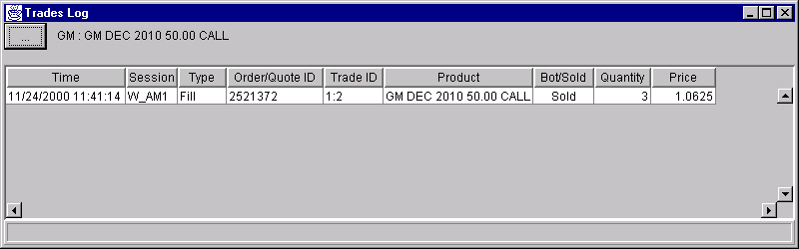

The screen, if active, updates automatically when a fill is sent to the workstation.
If a user is not logged in, the system shall store the fills for call up or display and optional printing at a later time. These fill reports shall be printed at a designated printer. As an optional default, users may request printing of all fills at a designated printer.

Booked Order Dissemination
When a trader requests a display of an option class, the CBOE user interface shall provide the Market Display which presents the Market and Trader book’s best bids, asks, and their total quantities for each series of the class requested. The display may also include the last sale, day’s trade volume, and the trader’s best order and size on both sides. What is displayed shall be configurable by the trader.

Personal (Trader’s) Best Book
The MKT orders will not be placed in the Personal Best Book or used or the Personal Best calculation.

Book Depth Display
Upon request, the system shall disseminate a summary of the market depth, i.e., the aggregate quantity by order source (marketmaker, customer, or non-customer professional trader), the sum of contingency orders, and the total number of contracts at each price. The screen below presents the dialogue for the display of the book depth for a selected series. This book depth information is intended to be a snapshot, and not updated continually. Clicking the Refresh button causes a new book depth display request to be sent.

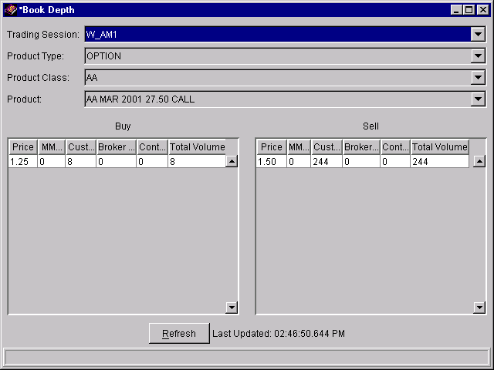

The breakdown by order source of the aggregate quantity is only available to the Help Desk. To preserve anonymity, the trader would get the aggregate quantity total, under both the Total column and the Customer column, and the quantity of contingency orders.

Market Status Dissemination
The system shall disseminate changes of a product’s market status, e.g., open, closed, fast market, halt, etc., to participants who subscribed to the particular product. The Market Display shall show under the State column the market status indicators for the products that are currently displayed.

News Alert Dissemination
The system shall disseminate news indicators only, not news reports. The CBOE user interface shall display news indicators such as DJ and RN in the Ticker frame of the Market Display, together with the recap line of the underlying security.

The system shall not provide news alerts and scrolling news because these are readily available from vendors, in a variety of formats, content, and terminal device. If the user wishes to display news alerts and scrolling news on the SBT workstation, he would have to subscribe to a vendor data feed and news application. The SBT application and the vendor news application would then be displayed in separate, independent windows.

Market History Dissemination
The system shall disseminate upon request the quote and trades history of a product in reverse chronological sequence, starting with the latest entry. It includes the best quotes only and the trades disseminated by the system. In the current version this history reflects only the trades and best quotes sent to the internal network of CBOEdirect traders, e.g., what is called the internal view. These internal quotes reflect contingency order data in the best quote, which is not disseminated to OPRA. The external view of quotes will be available from CBOE’s MDR System. In a future enhancement the history will also include the best quotes disseminated externally to OPRA.

This dissemination is intended as a snapshot and is not updated by the system continually. The user may specify a particular date and time as a beginning point of the history to be requested. Clicking the Submit button causes a new display request to be sent. In the CBOE user interface the user may specify whether he wants the display to include quotes only, trades only, or both quotes and trades. The screen below is an example of the Market History requested by a trader who wants to see quotes and trades.

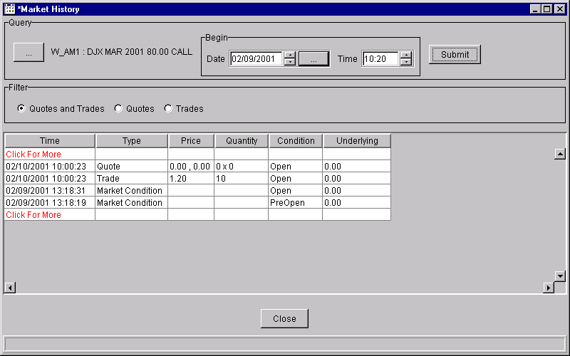

Ticker Dissemination
The system shall disseminate a sliding ticker of the trades and a recap of the day’s trading of the underlying security. These are shown in the Ticker frame of the Market Display.

The system shall disseminate a ticker of option trades as they occur. The CBOE user interface shall display this option ticker in a separate window. This function is deferred to a future version.

NBBO Dissemination
The system shall disseminate the National Best Bid and Offer for multiple-listed classes. The data shall include the following.
- Series
- NBBO bid price
- NBBO bid quantity
- NBBO bid exchange(s)
- NBBO offer price
- NBBO offer quantity
- NBBO offer exchange(s)

In CBOE’s workstation, the NBBO data shall be displayable as part of the Market Display.

The Market Linkage Plan endorsed by the CBOE requires that the system make available to CBOE traders the NBBO information as described above, as well as the individual exchange’s bids and offers.

Trader’s Book Activity Log
CBOEdirect shall maintain a trader’s book activity log, available for request via the API or for display on the CBOE SBT workstation. Traders will have access only to their own order information. The log is intended to show the sequence and timing of activities of a trader. It is not meant to show all the data about an order and what happened to it. That is available through the Order Status request.

The user may filter the data by product (class and series) and by type of activity, e.g., order fills, or order cancels, etc. The time period covered by the log request is between the current date and time and the specified Begin Date and Begin Time. The activities logged are:
- Order Booked
- Order Cancelled
- Order Cancel/replaced
- Order Filled
- Order Maintenance
- Quote Booked
- Quote Cancelled
- Quote Filled
- RFQ Submitted
- Trade Bust
- Order Reinstated

An example of the Activity Log is shown below.

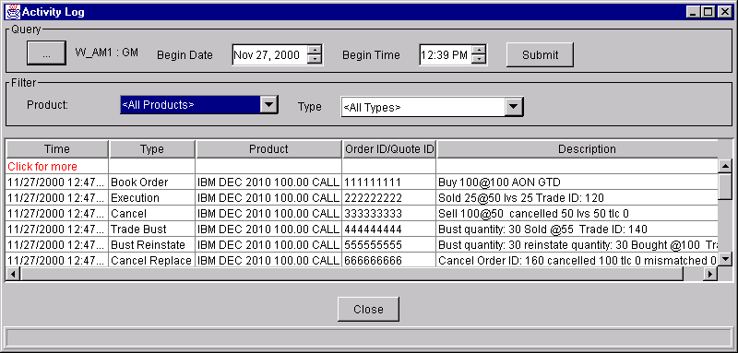

POST-TRADE REQUIREMENTS

New Billing Requirements
The following items are recommended as potential billing items. $$$

- Access Fee

Access fee will be imposed for each seat used in SBT. The fee is recommended to be a small amount per seat per quarter. $500 is suggested as a starting figure. To encourage participation in ETH, the access fee will be zero in the first six months of SBT operation.

Another alternative is an access fee of $0.10 per contract side charged to the marketmaker. Monies accumulated from this fee would be distributed to the seat owners.

- Transaction Fees

ETH transactions will be charged at the same rates as RTH transactions.

- Fee for Market Information
- Book depth will be available for a fee.
- Underlying security sale price and volume, bid and ask prices and sizes, cumulative volume for the day, etc., will be available for a fee.
- Each user (brokers, DPM/LMM s, marketmakers) would be charged a monthly fee for market information. DPM/LMM s and marketmakers would be charged a discounted fee for each of the services.
- In the current version the system does not keep track of the traders’ subscription to individual services such as book depth, underlying security information, etc. For this reason no fee will be charged for market information during the initial phases of operation. There shall be no fee until the system can record for billing purposes the subscription of individual services.

- Fine for Marketmakers Not Meeting their Quote Obligation

This has two parts: opening quote obligation for DPM/LMM s and RFQ response rate obligation.

a. Opening Quote Obligation for DPM/LMM s
DPM/LMM s are obligated to provide opening quotes for all series in their assigned classes. A fine shall be imposed to the DPM/LMM for not meeting this obligation. This monthly fine shall be calculated as the sum of fines for the classes assigned to the DPM/LMM . The class fine shall be calculated as the number of missed opening quotes less an allowance n (2) multiplied by the fine per missing quote.

b. RFQ Response Rate Obligation
Marketmakers are obligated to respond to a percentage of RFQs in their assigned classes. The suggested starting point for RTH is 50% for Regular Marketmakers, and 60% for DPM/LMM ’s. The rates shall be different for ETH: 85% for DPM/LMM and 10% for marketmakers. The percentage amount will be configurable.

The obligation only exists for the regular marketmaker while he is logged in. Since the billing system in Version 1 does not have the log-in/log-off data of marketmakers, this fine shall not be imposed initially on regular marketmakers.

This log-in condition shall not apply to the DPM/LMM . The DPM/LMM fine shall be calculated in Version 1 without accounting for his log-in status.

The billing system shall use a sliding scale of fines calibrated against the percentage of how far away a DPM/LMM is from the norm. The suggested sliding scale is as follows.

Response Rate | Monthly Fine per Class
Between 90% and 100% of Expected Rate | $500
Between 75% and 90% of Expected Rate | $2,500
Less than 75% of Expected Rate | $2500 plus Market Performance Committee Review

- Fine for Submitting Excessive RFQs

A monthly fine per class shall be imposed if the ratio of RFQ to Trades generated by a trader in a class exceeds a specified ratio. The SBT Committee set the RFQ to trade base ratio as 5:1.

Ratio of RFQ to Trade | Fine
Equal to or less than 5:1 | No fine
Between 5:1 and 10:1 | $1 per RFQ for all RFQs
Above 10:1 | $5 per RFQ for all RFQs

- Fine for Excessive Quotes
- A marketmaker shall be entitled to submit a certain number of free quotes per class per day, e.g., n (4,000) quotes per class per day.
- A fine per quote shall be imposed for sending a number that is clearly above the free number and for producing a ratio of quotes to trades over a certain time period that is higher than what would be considered a reasonable ratio.
- For example, assume that the free number is n (4,000) quotes per class per day and the reasonable ratio of quotes to trades is n (50:1). Then the fine of a penny per quote becomes applicable for every quote above 4,000 if the ratio is between 56:1 and 65:1, and two pennies per message if the ratio is between 66:1 and 75:1, etc.
- The fine shall be calibrated to the class level since classes have different quoting behavior and different quote to trade ratios. For example, a reasonable quote to trade ratio for an index class would be higher than that for an equity class. Also, an inactive class would have a higher ratio than an active class.
- The base ratio of Quotes to Trades shall be configurable.
- This fine will not be charged initially until a few months' operation can be evaluated. Data will have to be collected and analyzed to determine what should be the free number of quotes and the reasonable quote to trade ratio per class or per product type.

- Fees for CBOE provided hardware, software, and network

This information is available elsewhere.

- Training Fees

Training class fee per person – There is no recommendation at this time.

- Help Desk Fees

- Trade Bust Services – There is no recommendation at this time.

The SBT system shall provide quote, trade, RFQ, and other data to the Integrated Billing System to be used for billing purposes.

NON-FUNCTIONAL REQUIREMENTS

Equal and Fair Access
Traders must have equal and fair access to trading. A trader must not have an advantage over another because of his geographical proximity to the system host. The transmission times, for traders in different locations, to send and receive data to and from the SBT system host must be close enough that the small difference in timing does not confer an advantage to any trader.

One wide area network provider assured CBOE that there will be little difference in transmission times, up to 60 milliseconds, between points in the North American continent. In other words, the difference in transmission time between a message that traverses the distance from the West Coast to the East Coast and one that traverses the distance from across the street is up to 60 milliseconds. Based on this assumption, no special mechanisms, such as delays or additional hops, in the network are deemed necessary to equalize the transmission times.

Security

User Authentication
Traders will be able to enter orders manually on SBT workstations located off-floor, in the offices of marketmakers and member firm brokers, and on the perimeter of the trading floor. Because physical access to the workstation is not under the control of the exchange, the system must be able to authenticate the user of the workstation as an authorized trader.

Assuming that the system will operate under the current organizational structure, one suggestion is for the system to require an active CBOE badge for login and an SBT appointment (allocation) to operate the workstation. The badge should be plugged in continuously to the workstation badge reader when the workstation is in use.

In Version 1 access to CBOEdirect shall be controlled by a user name and password scheme. Other authentication schemes shall be considered in the future if necessary.

Confidentiality and Integrity of Data
The system must be able to protect the confidentiality and integrity of the data sent between the user and the system. The messages must be protected against being read or tampered in transit.

Security Audit Log
The system must be able to keep a log of all security-related events such as user authentication, access to the trading application, time of day and location of access.

Responsiveness
A response time of 1 to 2 seconds for workstation transactions is required.

High Availability
The system must be able to recover from failures of any processing or communication component of the SBT system. If a communication component fails, alternative paths of communication must be available to allow traders to continue to trade. If a processing component fails, either redundant or backup components must be available to handle the load.

Scalability
The system must be capable of incremental increase in capacity to handle a growing number of products and traders. Currently, the upper limits envisioned if all CBOE products are traded under SBT are:
- 2,000 classes
- 100,000 series
- 1,000 workstations

Maintainability
Because the CBOE rules of trading under SBT are in the process of development and have not been tested under real trading conditions, the probability of the rules being modified in the future is high. For this reason, the system must be built in a way that facilitates changes in the business rules.

INTERFACES TO EXISTING CBOE SYSTEMS
The SBT system shall have interfaces to existing CBOE systems that currently provide functions to the open outcry environment, functions that will also be used in the SBT environment.

CBOEdirect shall have interfaces to the following.
- The TPF Trading Engine for the following functions:
- Reporting SBT product prices and quotes to OPRA;
- Receiving product data
- Routing wire orders and fill reports between the CBOE member firms and SBT or TPF
- The Trade Match System for submitting locked trade data to OCC and for passing Trade History data, Billing data, and data for Surveillance to the appropriate CBOE Back Office systems.
- Ticker Plant, for receiving market data on underlying securities
- Membership System, for member data, and member’s class assignment data
- Distributed Printing System

REQUIREMENTS FOR EXTENDED TRADING HOURS
CBOE originally intended to use CBOEdirect during regular trading hours when and if the need arises for a screen-based trading system to respond to competitive pressures. The SBT Committee recommended that the system be deployed before it is actually needed so that the network could be built and its functionality and performance checked under actual trading conditions. Using it to trade proprietary products in extended trading hours is deemed to be the most appropriate way to do so.

Extended Trading Hour Sessions
CBOEdirect shall initially support trading in the early morning, 6:00-8:15 AM, known as the AM session. ETH support may be expanded to the early evening hours, the PM session, when sufficient demand materializes.

Products
The products recommended for ETH are the DJX, OEX, and RUT index options. Other index options may be added in the future. All series shall be available for trading. However, the SBT LMM shall continuously quote the series in the front two months only and the other months shall be quoted in response to RFQs.

Member Access
To give the ETH products the greatest chance for success, access will initially be ‘open’ to all members. The plan is to give blanket appointments to ETH products to all marketmakers for a certain number of months.

An SBT right will be associated with each seat. The member has to assign a valid acronym for trading in ETH. This acronym shall be the log-in ID to be used by the ETH trader to access CBOEdirect. It could be the same as or different from the acronym used in RTH for that seat.

DPM/LMM
CBOE plans to appoint DPMs or LMMs for each of the proposed index products for ETH. Potential DPM/LMM obligations in ETH are:
- Provide opening quotes
- Respond to a certain percentage of RFQs
- Respond to every quote request generated by the Help Desk when no marketmaker responds to an RFQ.

Trading Parameters
The following trading parameter values have been suggested for ETH. The appropriate market performance committee has to prescribe the values to be set for these parameters and other trading parameters, for the whole system or for each class or product.
- Maximum quote width - three times the standard RTH width
- Fast market maximum quote width – three times the non-fast market width or nine times the standard RTH width
- Minimum quote size - 10
- RFQ Response Rate – 85% for DPM/LMM and 10% for marketmakers

ETH Opening Procedure

The ETH Opening Procedure is slightly different from the RTH Opening Procedure because of the lack of underlying security data. A timer instead of an opening quote or trade of the underlying security triggers the opening rotation phase.

- When the ETH session starts, e.g., at 6:00 AM, the classes are set to the state of “Closed”. No orders are accepted at the “Closed” state.

- The system has two major, configurable timers: one for going into the “Pre-opening” state and another for going into the “Opening Rotation” state. Both times are configurable. For example, Pre-opening could be set at 6:30 AM and Opening Rotation at 7:00 AM.

- At the specified time for pre-opening, e.g., 6:30 AM, the system:
- Changes the state of all ETH products (series) and classes to “Pre-open”
- Disseminates the new state to the internal network and to Market History.
- Begins to accept orders and quotes.

- At the specified time for opening rotation, e.g., 7:00 AM, the system:
- Changes the state of all ETH products (series) and classes to “Opening Rotation”
- Disseminates the new state to the internal network and to Market History.
- Disseminates the new state to OPRA
- Sets the actual opening process of each product at a random time between n (20) and n (33) seconds from the beginning of the Opening Rotation Phase.
- After an initial delay of n (5) seconds, begins to calculate the Expected Opening Price (EOP) of each product every n (3) seconds.
- Disseminates the EOP to the internal network and to Market History.

- At the opening process of a product the system:
- Determines whether an opening trade is possible. If a trade is possible, the system matches the orders for the opening trade, and disseminates the fills to the sources of the orders, the last sale report and the opening quote to OPRA and the internal network. The opening trade and the opening quote are recorded in Market History. The system then changes the state of the product to “Open” and disseminates the new state to the internal network and to OPRA.
- If a series cannot open for some reason (see 7 below), the system would send an RFQ. At the end of the RFQ period, the system resets the timers and enters the Opening Rotation phase again without doing the state change. (The product stays in the state of “Opening Rotation”.)

- When all the series are open the system changes the state of the class to “Open” and disseminates the new state to the internal network.

- The system shall not open the series under any one of the following conditions.
- An opening trade is possible but there is no standard quote present.
- An opening trade is possible, there is a standard quote present, but the opening price is not within the acceptable range. The upper boundary of the acceptable range is n (125)% of the highest quote offer and the lower boundary is n (75)% of the lowest quote bid.
- The opening trade would leave a market that has a market order quantity imbalance.
- There are two or more possible opening prices that have the identical highest matched quantity.

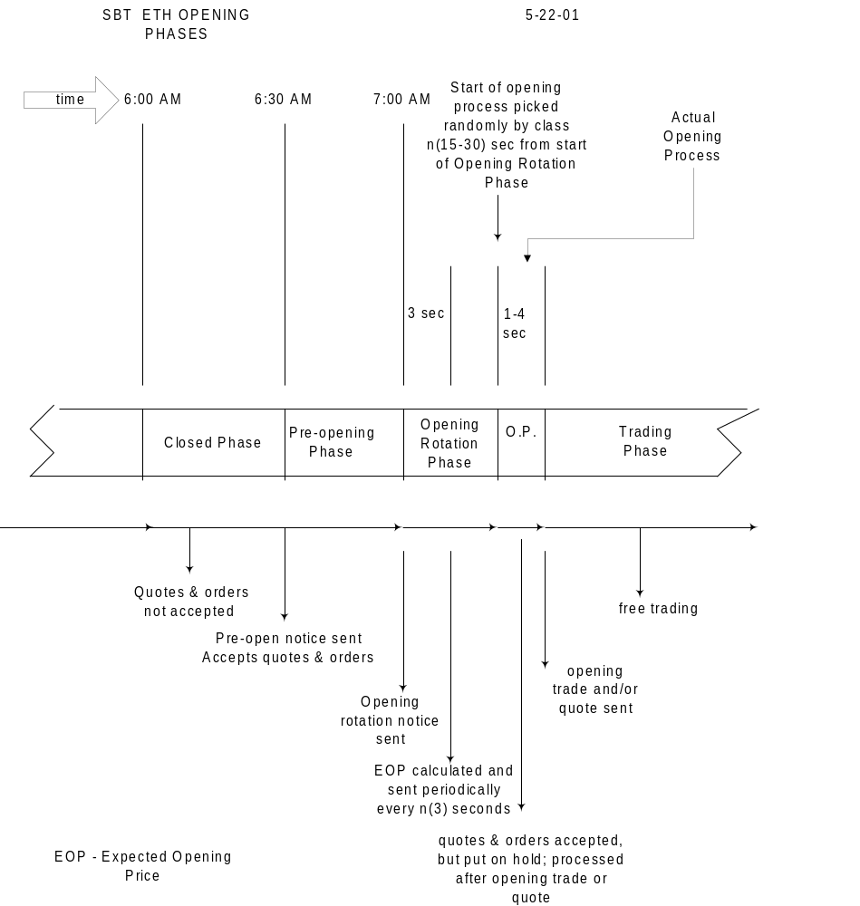

Orders and Order Handling

Types of Orders Handled

ETH Orders
CBOEdirect shall support limit orders, contingency orders, and spread orders in ETH. Although CBOEdirect can handle market orders, these orders, by request of the member firm community, shall not be accepted in ETH Version 1. The intent is to protect customers who may not be fully aware of the risk of using market orders in SBT or in ETH.

RTH Orders
CBOEdirect shall be capable of being used as an order submission mechanism for the RTH session. For a retail firm, using CBOEdirect for submitting RTH orders shall be equivalent to using COMPASS, the wire interface to ORS. CBOEdirect shall accept and pass on to ORS any RTH order entered by a retail firm.

RTH orders routed by a marketmaker or a marketmaking firm shall be rejected in Version 1. These entities should send such orders to the trading floor in the same way --- by phone or other means --- they are sent today. It may be possible in the future for CBOEdirect to accept such orders.

Time-in Force Indicators
CBOEdirect shall recognize the time-in-force indicators that order submitters will use to designate the session where the order should go. Orders destined for RTH shall use the DAY and GTC indicators.

In Version 1 orders destined for ETH shall use DAA for the AM session, and DAP for the PM session. These ETH orders expire at the end of the session. The capability to handle ETH orders that live beyond one session, e.g., good till cancelled, shall be included in Version 2 or later.

To further protect customers from inadvertently submitting orders to the wrong session, CBOEdirect shall only accept orders submitted for the current or next session of the current day. Orders submitted for the next day or for a session that is not the next shall be rejected.

Passing of Orders between Sessions
Passing of orders between sessions shall not be available in Version 1. For this reason ETH orders in Version 1 are restricted to orders that only live during the session they are submitted to. Passing orders from one session to another shall be available in Version 2 or later.

Quote and Last Sale Reporting to OPRA
The market environment is expected to be markedly different between the RTH and ETH sessions. Quotes in ETH are expected to be wider than in RTH. It is important for users to know from which session a given quote or last sale report originated. To minimize customer confusion between RTH and ETH reports, the ETH quote and last sale reports shall be identified with a session indicator in a new message field of the OPRA message format.

When implemented, the new session indicator should help distinguish the ETH reports from the RTH reports in the OPRA messages, data vendor displays, as well as in CBOE’s own MDR floor displays.

Crossing Function
The SEC and the Index marketmakers have expressed concerns about the lack of opportunity for the marketmakers to participate in the SBT Crossing Function described in an earlier section. To alleviate these concerns, the SBT Committee proposed the following alternative crossing procedure, which guarantees the crossing firm a certain percentage of the cross.

Alternative Crossing Procedure
- The crossing firm is entitled or guaranteed to cross at least n (40) % and up to 100% of the quantity to be crossed, if no other traders participate in the trade, as long as the order exposed is at the best price and has the highest priority at that price.

- The crossing firm is required to submit an RFQ with size equal to the quantity to be crossed.

- The crossing firm is required to submit the crossing transaction within a time window between n (20) seconds and n (40) seconds after the RFQ was submitted.

- A standard market must exist when the crossing transaction is accepted by the system. Otherwise, the system rejects the crossing transaction.

- The crossing transaction includes the pair of orders to be crossed, with the crossing quantity and the crossing price, and the indication of which side, buy or sell, is the side to be exposed to the market. One side could be the customer order and the other side the firm order, or both sides could be customer orders.

- The crossing price must be within the market. The system rejects the crossing transaction if the crossing price is at or outside the market at the time it is received. Once accepted by the system, the system will keep the crossing transaction for the duration of the crossing period even when the market gets better than the crossing price.

- The system immediately crosses the two orders for the quantity equal to the guaranteed crossing percentage, n (40) %.

For example, if the crossing quantity is 1,000 and the guaranteed crossing percentage is 40%, the system immediately trades 400.

- The system exposes the remaining volume of the designated order in the book for a crossing period of n (20) seconds. The order’s price and the remaining quantity are disclosed. There is no indication that the order is part of an impending cross.

- The system puts the remainder of the opposite order on hold as a stealth or shadow order. It is not visible except to the submitter.

- As long as the exposed order is the highest priority order at the best price, other traders can trade against it during the crossing period. If the exposed order is fully filled by other traders, the system cancels the remaining quantity of the shadow order and sends the crossing firm a message that the crossing transaction is completed.

- At the end of the crossing period:
  - If the exposed order is at the best price and has the highest priority, then the system fills the remainder of the order with the shadow order. The system cancels the remaining quantity of the shadow order and sends the crossing firm a message that the crossing transaction is completed.

  - If the exposed order has quantity remaining and it is NOT the highest priority order at the market, the system cancels the remaining quantities of the exposed order and the shadow order. Then the system sends the crossing firm a message that the crossing transaction is completed.

For example, the original crossing order quantity was 1000 and 400 were immediately crossed. The exposed (customer) order quantity was 600 and 300 were filled before the end of the crossing period. If the order is at the best price and has the highest priority, then the remaining 300 would be filled by the shadow order.

However, if the exposed order is not at the best price or does not have the highest priority at its price, then the remaining 300 of the exposed order and of the shadow order would be canceled.

Version 1 Crossing Procedure
Since the Alternative Crossing Procedure cannot be implemented in time for Version 1, an interim crossing procedure, one that does not require CBOEdirect to enforce it, was recommended. Crossing activities shall be subjected to surveillance after the fact. Crosses of all sizes shall be monitored. The timings indicated shall be configurable in the surveillance programs.

The Version 1 Crossing Procedure is as follows.

- A trader wishing to cross two orders must send an RFQ with the size of the orders to be crossed. The RFQ response period will be n (30) seconds.

- At the end of this RFQ response period and within the next n (20) seconds, the trader must enter one of the orders. CBOEdirect shall expose that order to the market.

- N (10) seconds after the first order was entered, if another market participant has not completely taken out the order, the trader may then enter the opposite order to cross the balance.

This procedure shall remain in place until the Alternative Crossing Procedure replaces it.

CBOEdirect Floor Functions for SBT Products

Crowd Display of SBT Products
The RTH crowd requires a display of ETH data for reference in the RTH opening. Data for the previous ETH session and the current ETH session shall be accessible for display. No RTH data shall be shown in this display. For a previous session, the display shall be a still picture of the data at the end of the session. For the current session, the display shall be dynamic, showing the data as they change.

During the AM session, the previous day’s PM session data and the current AM session data shall be accessible. During the RTH session, the current day’s AM session data shall be accessible. During the PM session, the current day’s AM session data and the current PM session data shall be accessible.

Data required per product are:
- Session’s date
- Session label (AM,PM)
- Per product (series) the high price, low price, total quantity traded, last sale price, last sale quantity, best quote (bid, ask, and sizes)

A sample crowd display is shown below.

Date: mm-dd-yy AM Session |  |  |  | DJX |  |  | Time: | hh:mm:ss
Series ID | High | Low | Last | Lqty | Tqty | BB Size | BB Price | BO Price | BO Size
DJX mmm yyyy PPP C | dd.d | dd.d | dd.d | qqq | qqq | sss | dd.d | dd.d | sss
DJX mmm yyyy PPP C | dd.d | dd.d | dd.d | qqq | qqq | sss | dd.d | dd.d | sss
DJX mmm yyyy PPP C | dd.d | dd.d | dd.d | qqq | qqq | sss | dd.d | dd.d | sss
DJX mmm yyyy PPP C | dd.d | dd.d | dd.d | qqq | qqq | sss | dd.d | dd.d | sss
DJX mmm yyyy PPP C | dd.d | dd.d | dd.d | qqq | qqq | sss | dd.d | dd.d | sss
DJX mmm yyyy PPP P | dd.d | dd.d | dd.d | qqq | qqq | sss | dd.d | dd.d | sss
DJX mmm yyyy PPP P | dd.d | dd.d | dd.d | qqq | qqq | sss | dd.d | dd.d | sss
DJX mmm yyyy PPP P | dd.d | dd.d | dd.d | qqq | qqq | sss | dd.d | dd.d | sss
DJX mmm yyyy PPP P | dd.d | dd.d | dd.d | qqq | qqq | sss | dd.d | dd.d | sss
DJX mmm yyyy PPP P | dd.d | dd.d | dd.d | qqq | qqq | sss | dd.d | dd.d | sss
DJX mmm yyyy PPP P | dd.d | dd.d | dd.d | qqq | qqq | sss | dd.d | dd.d | sss

This display shall also be available in the booth.

CBOE Floor Booth Functions
The advent of SBT in ETH while trading in RTH continues in open outcry requires market participants to operate in a mixed environment. The member firm brokers on the floor may be affected if they have to deal with orders from both RTH and ETH sessions. To assist brokers on the floor, the following functions shall be available in Version 1 for use in CBOE booth locations only.

Member Firm Broker Roles
A member firm broker in the booth can log in to a CBOEdirect workstation to assume one of three roles.
- A firm trader (broker-dealer) who can enter, read, and update his own orders only
- A firm-level trader with read-only access right: He can see all the firm’s ETH orders. These orders include ETH orders entered through COMPASS and ETH orders entered by the firm through the SBT API (FIX and CMi). He can see only a subset of the firm’s RTH orders: He has read-only access to RTH orders submitted through the SBT APIs but not to RTH orders submitted through COMPASS. He has no order entry or update capability.
- A firm-level trader with the same access right as the trader above plus order entry and update capability.

Market Display Window
All the series for any class traded in CBOE shall be accessible in CBOEdirect. RTH classes have to be accessible to enable entry, inquiry, and update of orders for the RTH session. Although not all series of the ETH classes may be traded in ETH, all the series shall be accessible. An ETH broker may use the select series function to hide the series that are not traded.

During the ETH session, AM or PM, the Market Display Window shall be populated with the particular session’s data. There shall be no underlying security market data to display since there is no official source of the underlying security market in the ETH session.

During the RTH session, the Market Display Window shall not be populated with RTH data. RTH data shall be available from the existing floor display systems. However, the Market Display Window shall display the series of any class, a necessity for the proper navigation of the workstation functions, e.g., order entry.

As described in the section, Display of Market’s Best Bid and Ask Orders, the Market Display Window shall show the personal best book of the individual trader. For a firm-level trader, who is concerned with the status of his firm’s orders, and not really trading those orders, the idea of a personal best book is not meaningful. It shall not be provided.

Order Entry
A firm-level trader in the booth may enter an order for any session by selecting the series from the Market Display Window, selecting Order Entry from the drop down function list, filling up the order entry fields, and submitting the order. He directs orders to the RTH session by specifying DAY or GTC as the time-in-force indicator.

He directs ETH orders by selecting classes that trade in ETH and by specifying the ETH session. An order with a non-ETH class and time-in-force of DAA or DAP shall be rejected. In addition, CBOEdirect shall only accept ETH orders for the current or next session of the trading day.

Order Status Display and Update
A firm-level trader in the booth may display an order by selecting the series from the Market Display Window, selecting Order Status from the drop down function list, and selecting the particular order. Any existing order for his firm may be displayed except RTH orders submitted through COMPASS. He may update the order or cancel it by selecting the order, selecting the desired function from the dropdown function list, and completing the transaction.

Market History
When a firm-level trader requests a display of Market History, an equivalent of the MDR floor display, CBOEdirect shall present a consolidated log of ETH --- AM and PM --- quote and trade data for a certain number of trading days, starting from the current one.

Trader’s Activity Log
When a firm-level trader requests a display of the Trader’s Activity Log, CBOEdirect shall present the consolidated log of ETH --- AM and PM --- activities of all his firm’s traders. Activities for orders include booking, cancel, cancel-replaced, and update. Fill reports and trade busts are also listed. Since this log can be lengthy, the broker shall have the ability to filter the data by category, e.g., fills, by branch, and by correspondent firm.

Other Displays
The Book Depth Display shall display data for the current session only. My Trades Log Display shall display fills for only those orders entered at the workstation.

IMPLEMENTATION PRIORITY OF FUTURE SBT FUNCTIONS

Version 1 of the SBT system does not include the following functions. Providing these functions in Version 2 or later does not reduce the viability of the first version of the system.

The enhancements listed below are categorized by functional area. The items marked with the symbol ♦ are the items that the SBT Committee endorses as high priority items.

Trade Allocation Enhancements
- Modify the trade allocation procedure to recognize orders that are booked within n (5) milliseconds as tied in priority of being ‘first at a price’

Enhancements for Institutional Customers
- ♦ Block trading facility
- ♦ Crossing procedure that guarantees the crossing firm a certain minimum percentage of the cross.
- Allowing a cross execution with more than one order on a side.
- Support for cabinet orders

Enhancements for Retail Customers
- ♦ Passing of eligible orders from one session to another, e.g., ETH to RTH to ETH, etc.
- ♦ Accept GTC orders and remove Version 1 restriction of only accepting ETH orders for the current or next session of the current trading day
- ♦ Limit order processing with protection features
- Customer priority in the opening trade
- Process cancel/replace when cancel quantity is greater than remaining quantity (currently rejected)
- ♦ Trade Match Systems shall include an indicator on the trade record identifying the session a trade occurs in.
- ♦ CBOEdirect shall add the matched sequence number to the fill report so firms using TP25 transactions can identify the trade.
- ♦ Exception processes in Market Surveillance Systems shall be evaluated for changes required if the system is used during the RTH session or is used for equity products.
- ♦ Develop an electronic interface between CBOEdirect and CTM for handling error conditions such as fatal errors on either side or when for whatever reason, the "processed ack" from CTM is not received.

Marketmaking Enhancements
- ♦ One trader nominates a replacement trader; when the first trader logs off, his orders and quotes are moved to the replacement trader without loss of book priority
- The system retains a marketmaker’s quote sides (orders) that have priority as market turner when the marketmaker updates his quotes
- ♦ Enhance marketmaker control of his Quote Risk Monitor by specifying other parameters that measure his risk better. The change replaces the 'total quantity traded' with two sums: the sum of (long calls + short puts) and the sum of (short calls + long puts). The system shall keep track of the two sums and when either sum exceeds the quantity specified, the QRM function is triggered, pulling all the marketmaker’s quotes for that class.
- ♦ Quote regeneration process
- Processes to activate and inactivate quotes or single-sided orders
- ♦ The marketmaker function for canceling all orders for a class or all classes (different from the function, ‘cancel all quotes for a class or all classes’)
- Dissemination through the API of the cumulative RFQ response rate by marketmaker or DPM/LMM

Enhancements for DPM/LMM s
- For the Pro rata algorithm, limit the DPM's maximum participation to his original pool share after the higher-priority orders are filled. The DPM is not entitled to market turner priority. If the market turner order is a DPM, the market turner priority is ignored.
- DPM/LMM ’s trade participation right in the opening trade

Order Entry
- Add a new field, Marketmaker_Initiator, to the Broker Order Entry screen to enable entry of the acronym of the marketmaker who initiates the order, for credit to a Q-account

Additional Order Types and Order Processing
- Contingency order support functions to book, display, process, and trade the following contingency types:
- OPG (Opening only)
- MIN (Minimum volume)
- MOC (Market on close)
- STP (Stop)
- STP LIMIT (Stop limit)
- Market order with contingency such as AON, FOK, and IOC
- ♦ Process order source types other than marketmaker, firm, customer, and broker dealer; examples are non-member marketmaker orders (type 'N' orders); underlying specialist orders (type 'Y' orders); marketmaker orders with origin type of broker/dealer, JBO (joint back office), or customer.
- Processing of complex orders such as buy-writes
- Accept new orders, not just updates of existing orders, at the Closed (Order Maintenance) state
- ♦ For RTH the requirement is to reject marketmaker orders at this time.

RFQ Processing Enhancements
- ♦ Enable specification by class of the following parameters that are used to trigger the processing of a market order after an RFQ is generated by the system.
- Percentage of assigned marketmakers who responded
- RFQ response period

Spread Order Processing Enhancements
- ♦ Initial support for spreads (see section 6.10.1)
- ♦ Spreads whose net price is a multiple of 1/32 or .01 and their processing priority
- ♦ Pricing of the legs of a spread to satisfy a net price, using the ‘split trade’ method
- ♦ 2-legged spreads with ratios other than 1:1 and 1:2; for example, ratio spreads of 3:5 or 1:3
- 3-legged spreads with ratios other than 1:1:1 and 1:2:1.
- 4-legged spreads with ratios other than 1:1:1:1.
- Any spread with more than four legs.
- ♦ Derived orders
- Spread book depth
- Support for “must use” prices
- ♦ RFQ for a spread
- ♦ The system automatically sending an RFQ for the one leg of a spread that does not have a legal market when all the other legs of the spread order can trade
- Spread orders comprised of legs of different classes, e.g., OEX-SPX spread
- Disseminate spread quotes via PULSE

Clearing Firm Enhancements
- Clearing firm function to force the logout of a trader (can be done now through the Help Desk)
- CBOE GUI function that allows the authorized clearing firm broker to specify the maximum order quantity by class that a marketmaker may enter in his quote or order

CBOEdirect GUI and Data Dissemination Enhancements
- ♦ Provide a text search capability for long dropdown lists by typing one or more characters of the text.
- ♦ Enable the user to specify preferences for the session (ETH, RTH) and product type (option, spreads (strategy))
- ♦ Provide a Market Display that has calls and puts side by side, e.g., the strike prices in the middle, calls on the left, and puts on the right
- Provide a Market Display that can be populated with series from different classes in a single frame
- CBOE GUI feature that displays the cross RFQ as a separate line on the Pending RFQ window and gives it an expiration period different from that of a regular RFQ.
- Display in CBOE’s GUI of the FOK and IOC price in flashing color if the FOK or IOC order is the only order at the best price (currently displayed in color only)
- System configuration choice of disseminating or not the contingency count in the Book Depth Display
- Number of RFQs in the RFQ Item of the Pending RFQ Window
- Order maintenance where more than order maybe selected at one time for operations such as cancel and activate.
- Option trades ticker
- Disseminate an RFQ designated as a cross RFQ
- Messaging facility between traders; the messaging facility is limited in Version 1 between the Help Desk and the traders.
- The capability to disclose more information about a trader’s contra-parties and orders in the book. This should be able to be switched on or off on the system level. This includes the following functions.
- Include contra-party ID in fill reports.
- Display the top of the book; order by order, including the owner and quantity of each order, for orders that exceed the quantity of n (50).
- Integrate trader’s autoquote with CBOE GUI, e.g., enable a trader using CBOE’s GUI with a proprietary autoquote to see his autoquote before submitting it to CBOEdirect
- Facilitate the marketmaker’s quote entry by allowing him to enter only a bid or ask. The system shall automatically generate for him the opposite side, with his default quote width. If he does not specify size, the system shall use his default quote size, if it exists, or the exchange prescribed minimum quote size.
- In Market History Retrieval, disseminate both internal and external views of the market. These views differ because the internal view includes quotes showing the presence of contingency orders while the external view shows only quotes and trades reported to OPRA, which do not include contingency orders. Currently, only the external view is disseminated. The internal view quantity fields should include the + indicator when a contingency order exists at the best price.
- In Quote Entry, allow the marketmaker to tick both bid and ask prices up or down Provide a text search capability for long dropdown lists by typing one or more characters of the text.
- ♦ Enable the user to specify preferences for the session (ETH, RTH) and product type (option, spreads (strategy))
- ♦ Provide a Market Display that has calls and puts side by side, e.g., the strike prices in the middle, calls on the left, and puts on the right
- Provide a Market Display that can be populated with series from different classes in a single frame
- CBOE GUI feature that displays the cross RFQ as a separate line on the Pending RFQ window and gives it an expiration period different from that of a regular RFQ.
- Display in CBOE’s GUI of the FOK and IOC price in flashing color if the FOK or IOC order is the only order at the best price (currently displayed in color only)
- System configuration choice of disseminating or not the contingency count in the Book Depth Display
- Number of RFQs in the RFQ Item of the Pending RFQ Window
- Order maintenance where more than order maybe selected at one time for operations such as cancel and activate.
- Option trades ticker
- Disseminate an RFQ designated as a cross RFQ
- Messaging facility between traders; the messaging facility is limited in Version 1 between the Help Desk and the traders.
- The capability to disclose more information about a trader’s contra-parties and orders in the book. This should be able to be switched on or off on the system level. This includes the following functions.
- Include contra-party ID in fill reports.
- Display the top of the book; order by order, including the owner and quantity of each order, for orders that exceed the quantity of n (50).
- Integrate trader’s autoquote with CBOE GUI, e.g., enable a trader using CBOE’s GUI with a proprietary autoquote to see his autoquote before submitting it to CBOEdirect
- Facilitate the marketmaker’s quote entry by allowing him to enter only a bid or ask. The system shall automatically generate for him the opposite side, with his default quote width. If he does not specify size, the system shall use his default quote size, if it exists, or the exchange prescribed minimum quote size.
- In Market History Retrieval, disseminate both internal and external views of the market. These views differ because the internal view includes quotes showing the presence of contingency orders while the external view shows only quotes and trades reported to OPRA, which do not include contingency orders. Currently, only the external view is disseminated. The internal view quantity fields should include the + indicator when a contingency order exists at the best price.
- In Quote Entry, allow the marketmaker to tick both bid and ask prices up or down together.
- In Hit the Bid /Take the Offer, enable the right-click of the price or quantity of the bid/offer to set up an order to join the bid/offer.
- Allow the dual-role traders to choose, when they log in, whether they will be acting as a Market Maker or Broker and default to that role until changed.
- Allow a broker-dealer to set his default Give-up Firm and specify a particular order to his list of Give-up Firms.
- Allow a trader to delete previously created Market Displays. (Provide a ‘Remove Tab’)
- Display Nothing Dones as Nothing Dones (not as cancels) in the status window in the Market Display screen.

CBOE Help Desk Enhancements
- ♦ Provide the Help Desk with the capability to view the complete trade history of a trade specified by trade ID. The history includes all the orders that participated and the parts of the trade that were busted.
- ♦ The Help Desk function to send a ‘Special RFQ’ to a group of marketmakers
- ♦ Help Desk function to specify a multiplier, by session by class, that would be applied to a base set of exchange prescribed quote width (EPW) table, instead of entering the values for each EPW table
- ♦ Automated broadcast of canned administrative messages to email, fax, voice recording, trading groups, CBOE web page, and SBT blackboard
- ♦ Bust of trades involving one or more spreads
- Communicate with contra parties for busting trades
- Display a screen from a particular trader’s point of view
- ♦ Enable setting of trading parameters on a session level
- Remove the step of sending ‘Nothing Dones’ from the End of Session procedure. Trigger the sending of ‘Nothing Dones’ when the product is closed. These enhancements would enable the Help Desk to do trade busts and other tasks between the Product Close and End of Session with as much time is necessary.
- Help Desk function to undo a trade bust
- Help Desk function to cancel an order or a quote to facilitate the open and to cancel all the one-sided orders of a technically disabled trader
- Provide the Help Desk with a quick way of determining the Trade ID of a particular order submitted by a firm or trader
- Help Desk function to display the identity of marketmakers quoting a given class

NBBO or Linkage Enhancements
- ♦ NBBO support beyond disseminating the NBBO updates, such as:
- Disseminate the individual exchanges’ BBO upon request
- For a customer order, an indication, e.g., yes or no, whether customer wants NBBO protection
- Proposed P/A Order procedure for handling orders when NBBO is away
- Proposed P Order procedure for handling orders when NBBO is away
- Proposed Satisfaction Order procedure
- Proposed Incoming Linkage Order procedure for handling orders when CBOE is the NBBO
- Enable marketmakers other than DPM/LMM s to specify to the system their parameters for automatic step-up to the away NBBO

Billing Enhancements
- ♦ Data collection and billing changes to include the evaluation of a DPM/LMM or regular marketmaker’ s RFQ response rate for a non-assigned class. The basis for this billing is the rule that when a marketmaker quotes a non-assigned series, he assumes a regular marketmaker’s obligation for that class for the remainder of the trading session.
- ♦ Credit transaction fees against hardware, software, and network fees
- ♦ Billing of fines for failure to respond to ‘Special RFQs’
- ♦ Billing of fines for assigned marketmakers for failing to provide opening quotes where the class has no DPM or LMM
- ♦ Keep track of the traders’ subscription to individual services such as book depth, underlying security information, etc.
- ♦ Keep track of the DPM/LMM and the marketmaker’s log-in and log-off status for the assessment of compliance with quote obligations

Access Enhancements
- Control access to CBOEdirect through other authentication methods in addition to the current username and password method.

Functions for 3rd Party Vendors
The SBT Committee recommended that the following applications not be provided by CBOE and that users should look at third-party vendors to provide these applications.

- Autoquote function at the SBT workstation
- Stock entry function at the SBT workstation
- Position keeping function at the SBT workstation

Recommended Features for Version 2
The SBT Committee selected 42 of the highest priority items from the list above and assigned their relative priorities below on a scale of A, B, or C. The features to be delivered in the next release shall be selected from the A group.

Recommended Features for Future Releases | No. | Priority
Block trading function | 1 | TBD
High Priority Items
Initial support for spreads (see section 6.10.1) | 2 | A
For both price-time and price-time pro rata allocation, the DPM/LMM trade participation right (TPR) share should be calculated based on his TPR percentage, n (30%). | 3
Book Depth Data --- The new requirement is to provide the data --- the total quantity of orders at each price, and a breakdown of the quantity according to their origin (marketmaker, customer, broker/dealer and firm), and the total of contingency orders --- only to the Help Desk. For traders, book depth data should only include the total quantity of orders and the total of contingency orders at each price. | 4 | A
Quote Risk Monitor (QRM) --- The change replaces the 'total quantity traded' with two sums: the sum of (long calls + short puts) and the sum of (short calls + long puts). The system shall keep track of the two sums and when either sum exceeds the quantity specified, the QRM function is triggered, pulling all the marketmaker’s quotes for that class. | 5 | A
For RTH the requirement is to reject marketmaker orders at this time. | 6 | A
Provide the Help Desk with the capability to view the complete trade history of a trade specified by trade ID. The history includes all the orders that participated and the parts of the trade that were busted. | 7 | A
Crossing procedure that guarantees the crossing firm a certain minimum percentage of the cross. | 8 | A
Quote regeneration process | 9 | A
RFQ for a spread | 10 | A
Help Desk function to specify a multiplier, by session by class, that would be applied to a base set of exchange prescribed quote width (EPW) table, instead of entering the values for each EPW table | 11 | A
Automated broadcast of canned administrative messages through CBOEdirect | 12 | A
Keep track of the traders’ subscription to individual services such as book depth, underlying security information, etc. | 13 | A
Keep track of the DPM/LMM and the marketmaker’s log-in and log-off status for the assessment of compliance with quote obligations | 14 | A
Limit order processing with protection features | 15 | A
NBBO Enhancements (procedures without linkage) | 16 | A
Process order source types other than marketmaker, firm, customer, and broker dealer; examples are non-member marketmaker orders (type 'N' orders); underlying specialist orders (type 'Y' orders); marketmaker orders with origin type of broker/dealer, JBO (joint back office), or customer. | 17 | A
CBOEdirect shall add the matched sequence number to the fill report so firms using TP25 transactions can identify the trade. | 18 | A
Exception processes in Market Surveillance Systems shall be evaluated for changes required if the system is used during the RTH session or is used for equity products. | 19 | A
Medium Priority Items
Passing of eligible orders from one session to another, e.g., ETH to RTH to ETH, etc | 20 | B
Accept GTC orders for ETH; remove Version 1 restriction of only accepting orders for the current or next session of the current trading day | 21 | B
The system automatically sending an RFQ for the one leg of a spread that does not have a legal market when all the other legs of the spread order can trade | 22 | B
Help Desk function to send a ‘Special RFQ’ to a group of marketmakers | 23 | B
Enable specification by class (currently system-level) of the following parameters that are used to trigger the processing of a market order after an RFQ is generated by the system.  - Exchange prescribed width  - Percentage of assigned marketmakers who responded  - RFQ response period | 24 | B
Enable setting of trading parameters on a session level | 25 | B
Create a derived order for a spread order where all the legs except one can execute with booked orders | 26 | B
2-legged spreads with ratios other than 1:1 and 1:2; for example, ratio spreads of 3:5 or 1:3 | 27 | B
Billing of fines for failure to respond to ‘Special RFQs’ | 28 | B
Billing of fines for assigned marketmakers for failing to provide opening quotes where the class has no DPM or LMM | 29 | B
Low Priority Items
Spreads whose net price is a multiple of 1/32 or .01 and their processing priority | 30 | C
Pricing of the legs of a spread to satisfy a net price, using the ‘split trade’ method | 31 | C
Data collection and billing changes to include the evaluation of a DPM/LMM or regular marketmaker’ s RFQ response rate for a non-assigned class. The basis for this billing is the rule that when a marketmaker quotes a non-assigned series, he assumes a regular marketmaker’s obligation for that class for the remainder of the trading session. | 32 | C
Credit transaction fees against hardware, software, and network fees | 33 | C
Enhance marketmaker control of his Quote Risk Monitor by specifying other parameters that measure his risk better | 34 | C
The marketmaker and broker function for canceling all orders for a class or all classes (different from the function, ‘cancel all quotes for a class or all classes’ which is supported in Version1) | 35 | C
Provide a Market Display that has calls and puts side by side, e.g., the strike prices in the middle, calls on the left, and puts on the right | 36 | C
Automated broadcast of canned administrative messages to email, fax, voice recording, trading groups, CBOE web page, and SBT blackboard | 37 | C
Bust of trades involving one or more spreads | 38 | C
One trader nominates a replacement trader; when the first trader logs off, his orders and quotes are moved to the replacement trader without loss of book priority | 39 | C
Develop an electronic interface between CBOEdirect and CBOE Trade Match (CTM) System for handling error conditions such as fatal errors on either side or when for whatever reason, the "processed ack" from CTM is not received. This shall replace a manual procedure. CTM shall include an indicator on the trade record identifying the session a trade occurs in. | 40 | ?
Provide a text search capability for long dropdown lists by typing one or more characters of the text. | 41 | C
Enable the user to specify preferences for the session (ETH, RTH) and product type (option, spreads (strategy)) | 42 | C

TBD To be determined

The SBT Committee selected the following as the top five priority items from the “A” list:
- Initial support for spreads
- For both price-time and price-time pro rata allocation, the DPM/LMM trade participation right (TPR) share should be calculated based on his TPR percentage, n (30%).
- NBBO Enhancements (procedures without linkage)
- Quote regeneration process
- Quote Risk Monitor (QRM) --- The change replaces the 'total quantity traded’ with two sums: the sum of (long calls + short puts) and the sum of (short calls + long puts). The system shall keep track of the two sums and when either sum exceeds the quantity specified, the QRM function is triggered, pulling all the marketmaker’s quotes for that class.

APPENDIX

Glossary of Acronyms

API Application Programming Interface
BBO Best Bid and Offer
COMPASS CBOE’s Communications Passthrough System (wire order facility)
CMi CBOE Market Interface
CMTA Clearing Member Trading Agreement
DJ Dow Jones
DPM Designated Primary Marketmaker
EOP Expected Opening Price
EPW Exchange Prescribed Width
ETH Extended Trading Hours
FIX Financial Information Exchange protocol
GUI Graphical User Interface
ICS CBOE’s Integrated Class/Series System
LMM Lead Marketmaker
MDR CBOE’s Market Data Retrieval System
NBBO National Best Bid and Offer
OBO Order Book Official
OCC Options Clearing Corporation
OPRA Options Price Reporting Authority
ORS CBOE’s Order Routing System
P Principal, as in P order
P/A Principal as agent, as in P/A order
QRM Quote Risk Monitor
RFQ Request for Quote
RN Reuters News
ROS CBOE’s Rapid Opening System
RTH Regular Trading Hours
SBT Screen Based Trading
TF Time in Force
TIPS CBOE’s Ticker Processing System
TPF Transaction Processing Facility
TPR Trade Participation Right

Cabinet Orders in Open Outcry
Cabinet orders are used for giving away a position for tax reasons. These are limit orders priced at one cent or $1 per option contract. The price is always $1 regardless of how many shares in the contract.

In open outcry cabinet orders are handled manually by the OBO or the DPM under the following rules.
- They have to be submitted in writing. EBook does not support processing of cabinet orders.
- Cabinet orders may be placed for customer, firm, and Market-Maker accounts. They are processed in time sequence.
- Closing transactions may be submitted with no restriction. Opening transactions may only be accepted when the OBO/DPM has unexecuted contra, closing orders with which the opening orders may immediately match.
- When the OBO/DPM receives a closing buy/sell order, he attempts to match it against the closing sell/buy orders in his possession. If any part of the order cannot be immediately matched, the OBO/DPM displays the order in the Class Display book columns. The price is displayed as 1% with the book size equal to the aggregate size of unmatched cabinet orders in the paper book.
- Any trader in the crowd may trade against the cabinet orders.
- Matched cabinet orders are actually executed after the close. Cabinet trades are then entered into a data entry screen (EBook), which generates billing entries for OBO execution fees to the Billing System.
- Cabinet trades are not reported to OPRA and MDR.
- The firms involved in the trade get fills in the form of paper tickets, from which they submit trade entries to Trade Match.

Proposed Windows Navigation

Marketmaking Functions
To Get to | Starting from | Selection Steps
Quote Entry | Market Display | Click on My Bid or My Ask cell (blank)
Request for Quote | Market Display | Click on series, Click on RFQ from Shortcut menu
Pending RFQ | Market Display | Click on RFQ button
Cancel Quote | Market Display | Click on series, Click on Cancel Quote from Shortcut menu
Cancel All Quotes | Market Display | Click on series, Click on Cancel All Quotes from Shortcut menu
Cancel All Quotes | Market Display | Click on OUT button
Update Quote | Market Display | Click on My Bid or My Ask cell
Add New Order | Market Display | Click on series, Click on Add New Order from Shortcut menu
Add Spread Order | Market Display | Click on series, Click on Add Spread Order from Shortcut menu
Hit the Bid | Market Display | Click on Market Bid quantity or price cell
Take the Offer | Market Display | Click on Market Offer quantity or price cell
Respond to RFQ | Pending RFQ | Click on series
Respond to RFQ | Market Display | Click on RFQ cell
Order Status | Market Display | Click on series, Click on Order Status from Shortcut menu
Update any Order | Order Status | Click on order, click on Update Order from Shortcut menu
Activate an Order | Order Status | Click on order, click on Activate Order from Shortcut menu
Inactivate an Order | Order Status | Click on order, click on Inactivate Order from Shortcut menu
Activate multiple Orders | Order Status | Shift-and-Click on multiple orders, click on Activate Order(s) from Shortcut menu
Inactivate multiple Orders | Order Status | Shift-and-Click on multiple orders, click on Inactivate Order(s) from Shortcut menu
Cancel an Order | Order Status | Click on order, click on Cancel Order from Shortcut menu
Cancel multiple Orders | Order Status | Shift-and-Click on multiple orders, click on Cancel Order(s) from Shortcut menu

Member Firm Functions
To Get to | Starting from | Selection Steps
Hit the Bid | Market Display | Click on Market Bid quantity or price cell
Take the Offer | Market Display | Click on Market Offer quantity or price cell
Request for Quote | Market Display | Click on series, Click on RFQ from Shortcut menu
Add New Order | Market Display | Click on series, Click on Add New Order from Shortcut menu
Add Spread Order | Market Display | Click on series, Click on Add Spread Order from Shortcut menu
Order Status | Market Display | Click on series, Click on Order Status from Shortcut menu
Update Best Order | Market Display | Click on My Bid or My Ask cell
Update any Order | Order Status | Click on order, click on Update Order from Shortcut menu
Activate an Order | Order Status | Click on order, click on Activate Order from Shortcut menu
Inactivate an Order | Order Status | Click on order, click on Inactivate Order from Shortcut menu
Activate multiple Orders | Order Status | Shift-and-Click on multiple orders, click on Activate Order(s) from Shortcut menu
Inactivate multiple Orders | Order Status | Shift-and-Click on multiple orders, click on Inactivate Order(s) from Shortcut menu
Cancel an Order | Order Status | Click on order, click on Cancel Order from Shortcut menu
Cancel multiple Orders | Order Status | Shift-and-Click on multiple orders, click on Cancel Order(s) from Shortcut menu

Opening Price Determination for the Maximum Contract Volume Traded Procedure

Determining an Expected Opening Price
The objective is to determine the expected opening price (EOP) that would leave no orders in the book that can be matched.

Here’s a sample beginning book, Table 1.

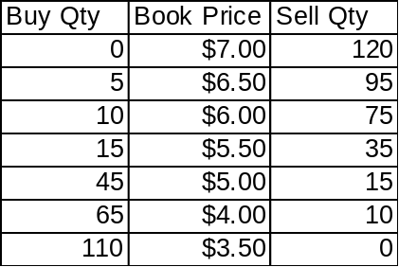

This means there are 0 to buy and 120 to sell at $7.00; there are 5 to buy and 95 to sell at $6.50, etc.
Assume that there is a market order to buy 3 and a market order to sell 7.

To determine the EOP:
- If the book is crossed (best bid price higher than the lowest offer) or locked (best bid price equals best offer price) or there are market orders, then there must be at least one standard quote in this book before the EOP determination can proceed to the next step. Otherwise, the EOP is not calculated and no EOP is disseminated. This stems from the requirement that a standard quote must be present for an opening trade to occur.
- Calculate the cumulative buy quantity and cumulative sell quantity at each price level. Cumulative Buy Qty is cumulated from the highest buy price to the lowest buy price. Cumulative Sell Qty is cumulated from the lowest sell price to the highest sell price. Market buy orders (of which there are 3 in this example) are added as if they are buy orders at the highest price, e.g., $7.00. Market sell orders (of which there are 7 in this example) are added as if they are sell orders at the lowest price, e.g., $3.50. The resulting table is shown below as Table 2. The cumulative columns are read as follows: There are 78 to buy at $5.00 or higher price, and there are 32 to sell at $5.00 or lower price.
Table 2
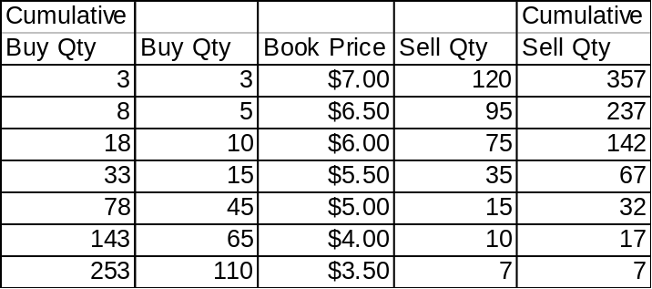

- At each price level, for the pair of cumulative quantities, select the smaller quantity. The smaller quantity is the matched quantity at that price. The resulting table is shown in Table 3.

Table 3
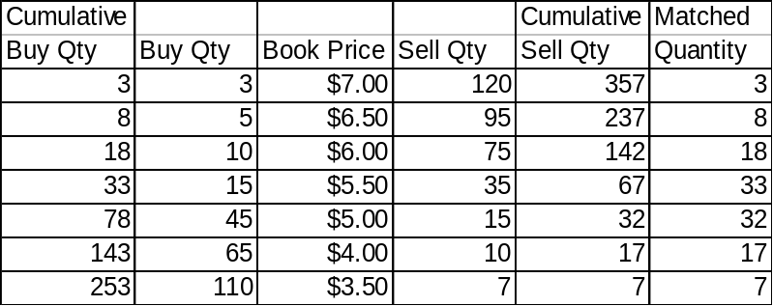

- The EOP is the price with the highest matched quantity. In the example, it is $5.50 with 33 as the matched quantity. On the buy side, these orders will be matched: 3 at market, 5 at $6.50, 10 at $6.00, and 15 at $5.50. On the sell side, these orders will be matched: 7 at market, 10 at $4.00, 15 at $5.00, and 1 at $5.50. All of these orders will be executed at $5.50. Both buy and sell orders get a break. The buy orders willing to buy at higher than $5.50 execute at that lower price. The sell orders willing to sell at lower than $5.50 execute at that higher price. The resulting book is shown as Table 4.

Table 4
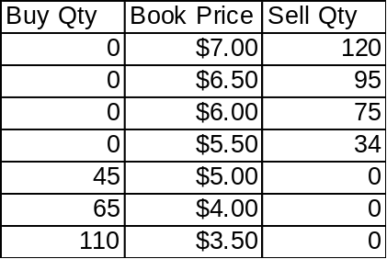

Note that the resulting, opening quote is 45 at $5.00 and 34 at $5.50.

This example covers the case where there are crossed or matching orders in the book. If there were no crossed or matching orders in the book, then there would be no opening trade or price, and EOP would be disseminated as zero. After the opening rotation the best bid and the best offer in the book are disseminated to OPRA as the opening quote whether or not they are within the exchange-prescribed-width. A half-quote (no bid or no ask) may also be disseminated to OPRA.

If the calculation results in two or more prices in Table 3 that have identical highest matched quantity, then the system shall determine the opening price by using the tie-breaking rules below.

Rules for Breaking Ties of Expected Opening Prices

- For each EOP, determine if the opening price falls within or on the resulting opening quote. If not, discard it.
- After step 1, if only one EOP is left, open at that price.
- If more than one EOP remain, select the one closest to the midpoint of the resulting opening quote.
4. If there are two EOPs that are equally close to the midpoint, break the tie as follows.
- If the underlying price is available, as in RTH, if the direction of the last underlying change is positive and the option is a Call/Put, open at the higher/lower price. For negative change and the option is a Call/Put, open at lower/higher price.
- If the underlying price is not available, as in ETH, select the opening price randomly, e.g., the system would ‘flip a coin’.
- If resulting quote is missing the bid price and the EOPs are not on the resulting quote, use the lowest EOP.

- If resulting quote is missing the ask price and the EOPs are not on the resulting quote, use the highest EOP.

The spreadsheet below is used to determine the EOP, which are the prices where the maximum contract volume can be traded. It presents the book price in the middle column and, on either side, the total buy and sell quantities at each price. To determine the EOP: First, the cumulative buy quantity is cumulated from the top, the cumulative sell quantity from the bottom. Second, the matched quantity is obtained by picking the smaller number between the cumulative buy and sell quantities at each price level. Third, the price with the highest number among the matched quantities is the EOP.

Examples
- Even number of EOPs after Step 1. The quotes are shaded.

Situation: | Customer orders crossing @ $1.10.
 | MM quotes are 0.85-.95, 10x10, 0.80-1.00, 10x10, 0.90-1.15, 10x10.
 | Cannot open because of more than one possible opening price.
Cumulative |  |  |  | Cumulative | Matched
Buy Qty | Buy Qty | Book Price | Sell Qty | Sell Qty | Qty
0 |  |  |  | 31 | 0
0 |  |  |  | 31 | 0
0 | 0 | $1.20 | 0 | 31 | 0
0 | 0 | $1.15 | 10 | 31 | 0
10 | 10 | $1.10 | 1 | 21 | 10 |  | EOP
10 | 0 | $1.05 | 0 | 20 | 10 |  | EOP
10 | 0 | $1.00 | 10 | 20 | 10 |  | EOP
10 | 0 | $0.95 | 10 | 10 | 10 |  | EOP
20 | 10 | $0.90 | 0 | 0 | 0
30 | 10 | $0.85 | 0 | 0 | 0
40 | 10 | $0.80 | 0 | 0 | 0
Step 1: Determine if EOP falls within or at resulting opening quote.
Resulting opening quote is 0.90-1.00, 10x10
EOPs of 1.05 and 1.10 are outside the opening quote, so discard them.
EOPs of 0.95 and 1.00 are at or within the opening quote, so keep them.
Step 2: The midpoint of the opening quote is 0.95, therefore, select 0.95
as the opening price.

2. Odd number of EOPs after Step 1.

Situation: | Customer orders crossing @ $1.10
 | MM quotes are 0.85-.95, 10x10; 0.75-1.25, 10x10; 0.95-1.05, 10x10 (shaded)
 | Cannot open because of more than one possible opening price.
Cumulative |  |  |  | Cumulative | Matched
Buy Qty | Buy Qty | Book Price | Sell Qty | Sell Qty | Qty
0 |  |  |  | 40 | 0
0 |  |  |  | 40 | 0
0 | 0 | $1.50 | 0 | 40 | 0
0 | 0 | $1.25 | 10 | 40 | 0
0 | 0 | $1.15 | 0 | 30 | 0
10 | 10 | $1.10 | 10 | 30 | 10 |  | EOP
10 | 0 | $1.05 | 10 | 20 | 10 |  | EOP
10 | 0 | $1.00 | 0 | 10 | 10 |  | EOP
20 | 10 | $0.95 | 10 | 10 | 10 |  | EOP
30 | 10 | $0.85 | 0 | 0 | 0
40 | 10 | $0.75 | 0 | 0 | 0
Step 1: Determine if EOP falls within or at resulting opening quote.
Resulting Opening Quote = 0.95 -1.05, 10x10.
EOP of 1.10 is outside the opening quote, discard.
EOPs of 0.95, 1.00, and 1.05 are either at or within the opening quote. Keep.
Step 2: The midpoint of the opening quote is 1.00. Therefore, select 1.00 as the
opening price.

3. Even number of EOPs after Step 1.

Situation: | Orders crossing @ $0.75 for 10 contracts
 | MM quotes are 0.80-.95, 10x10, 1.05-1.15, 10x10
 | Cannot open because of more than one possible opening price.
Cumulative |  |  |  | Cumulative | Matched
Buy Qty | Buy Qty | Book Price | Sell Qty | Sell Qty | Qty
0 |  |  |  | 30 | 0
0 | 0 | $1.25 | 0 | 30 | 0
0 | 0 | $1.20 | 0 | 30 | 0
0 | 0 | $1.15 | 10 | 30 | 0
0 | 0 | $1.10 | 0 | 20 | 0
10 | 10 | $1.05 | 0 | 20 | 10 |  | EOP
10 | 0 | $1.00 | 0 | 20 | 10 |  | EOP
10 | 0 | $0.95 | 10 | 20 | 10 |  | EOP
10 | 0 | $0.90 | 0 | 10 | 10 |  | EOP
10 | 0 | $0.85 | 0 | 10 | 10 |  | EOP
20 | 10 | $0.80 | 0 | 10 | 10 |  | EOP
30 | 10 | $0.75 | 10 | 10 | 10 |  | EOP
30 | 0 | $0.70 | 0 | 0 | 0
Step 1: Determine if EOP falls within or on resulting opening quote.
Resulting opening quote is 0.80 - 0.95, 10x10.
EOP of 0.75, 1.00, and 1.05 are outside the resulting opening quote. Discard.
EOP of 0.80, 0.85, 0.90, and 0.95 are either at or within the resulting opening quote. Keep.
Step 2: The midpoint of the opening quote is 0.875. There are two EOPs that are
equally close to the midpoint, 0.85 and 0.90. The system randomly selects one, e.g.,
0.90 as the opening price.

- Resulting opening quote is a no-offer quote.

Situation: Inverted book.
MM quotes is 0.55-0.70, 10x10
Cannot open because of more than one possible opening price.

Cumulative |  |  |  | Cumulative | Matched
Buy Qty | Buy Qty | Book Price | Sell Qty | Sell Qty | Qty
0 | 0 | $1.00 | 0 | 10 | 0
200 | 200 | $0.95 | 0 | 10 | 10 |  | EOP
200 | 0 | $0.75 | 0 | 10 | 10 |  | EOP
200 | 0 | $0.70 | 10 | 10 | 10 |  | EOP
210 | 10 | $0.55 | 0 | 0 | 0
210 | 0 | $0.50 | 0 | 0 | 0
210 | 0 | $0.25 | 0 | 0 | 0
210 | 0 | $0.20 | 0 | 0 | 0

Step 1: Determine if EOP falls within or at the resulting opening quote.
Resulting opening quote is 0.95-0, 190x0.
Of all the EOPs, only 0.95 is at the resulting opening quote. Keep. The others are lower than the opening bid. Discard.
Therefore, select 0.95 as the opening trade price. However, this trade price does not meet the test of being within the acceptable price range (.75 x $0.55 to 1.25 x $0.70). The system does not open, sends an RFQ, and issues the message ‘PRICE NOT IN QUOTE RANGE’ in the Opening Price column.
- Resulting opening quote is a no-bid quote.

Situation: Inverted book.
MM quotes is 0.55-0.70, 10x10
Cannot open because of more than one possible opening price.

Cumulative |  |  |  | Cumulative | Matched
Buy Qty | Buy Qty | Book Price | Sell Qty | Sell Qty | Qty
0 | 0 | $1.00 | 0 | 210 | 0
0 | 0 | $0.95 | 0 | 210 | 0
0 | 0 | $0.75 | 0 | 210 | 0
0 | 0 | $0.70 | 10 | 210 | 0
10 | 10 | $0.55 | 0 | 200 | 10 |  | EOP
10 | 0 | $0.50 | 200 | 200 | 10 |  | EOP
10 | 0 | $0.25 | 0 | 0 | 0
10 | 0 | $0.20 | 0 | 0 | 0

Step 1: Determine if EOP falls within or at the resulting opening quote.
Resulting opening quote is 0-0.50, 0x190.
Of all the EOPs, only 0.50 is at the resulting opening quote. Keep. The others are higher than the opening offer. Discard.
Therefore, select 0.50 as the opening trade price.

Exchange Prescribed Width (EPW) Table

Standard EPW for Options
For ETH the Index Market Performance Committee recommended that the EPW be three times that of the standard EPW. The quote width shown in the table below is three times the standard.

Bid Range | Maximum Allowable Quote Width
Less than $2.00 | $0.75
$2.00 - $5.00 | $1.20
$5.01 - $10.00 | $1.50
$10.01- $20.00 | $2.40
$20.01 - higher | $3.00

Exception: For in-the-money series where the underlying security market is wider than the widths specified above, the maximum allowable quote width maybe as wide as the underlying security market. (This exception does not apply to ETH.)

Modified ROS Approach to the SBT Opening

This approach opens all series in a class at one time, with the assurance that all the series open at the same underlying price. The marketmakers (MM) and the DPM/LMM assigned to a class share in taking the opposite side of the imbalance of customer orders in the opening trade. The DPM/LMM represents the MM group in providing the opening quotes.

Classes start with the status of ‘pre-open’. When the first underlying price (last sale or quote) is received, the DPM/LMM sends in his quote and series delta for all series in the class. The host calculates the class net delta. The DPM/LMM may change the class net delta to his satisfaction by altering and sending his quotes. As orders enter the book or as the DPM/LMM sends in his changed quotes, the class net delta is recalculated and displayed.

When the DPM/LMM is satisfied with the class net delta, he locks the class, causing the host to change the status of the class from ‘pre-open’ to ‘opening’, and to hold new, incoming orders for the class in a queue. These orders are de-queued and processed after the class is unlocked or opened.

When the class is locked, the DPM/LMM has the option of unlocking the class or opening it. Unlocking the class puts the class back to ‘pre-open’ and submits the queued orders to the book. If the DPM/LMM is satisfied with the class net delta, he may then issue an open request.

When the DPM/LMM issues the open request, the host:
- Calculates an opening price for each series based on the opening quotes
- Creates opening trades based on the opening quotes and the book orders
- Assigns trades to MMs assigned and logged in to the class
- Uses the quotes for locking the series as the opening quotes
- Sends fill reports
- Sends the opening quotes and last sale reports to OPRA
- Changes the class status ‘opening’ to ‘trading

