CBOqa06679 Linkage order does not trade when there is AON order on the same side

Overview

Current problem
Currently the Par orders (External linkage order) does not trade with quotes while there is an existing AON order on the same side.

The following sequence of events will produce the problem.
1. User1 sends in an AON ordder to buy 100 @1.0
2. User2 sends in a quote 0.8 - 1.0 60x60
3. From Par sends in an order with quantity = 60, but instruction of
trading only 10.
Because when an order's original quantity > the instructed trade
volume, the order will have to return to TPF.
The bug in TradeService prevents the order from Par trades with the
quote when there is an AON order on the same side

On January 5, 2005 this bug caused another linkage order to timeout,
when it should have traded.

Class: BORL, BC22a
Product: BLQ Feb0512.50 CALL

Contact CBOEDirectSupport for more information

Analysis
In absence of a Par system it is not possible to reproduce the bug exactly as stated above. However there is a workaround to simulate the the condition of a Par order.
In the Order Entry screen in the Optional Data field we enter string “REMAIN=2;MAXEX=10;
“ for Remainder Handling and Max Executing Volume. This will simulate the condition send by the Par Order as described above.

The above scenario was recreated with the simulation as described above. The order did not trade against the AON order on the same side as in the problem report.

The problem was traced to TradeServiceImpl’s internalCreateRegularTrade() method implementation.
internalCreateRegularTrade() method is called by allocateTradable() of BrokerProcessorBase via createRegularTrade() of TradeServiceImpl to to obtain the allocated quantity for trade. internalCreateRegularTrade() method returns 0 quantity for allocatedQuantity thus preventing any trade of incoming orders with handling instructions on Maximum Execution Volume when Contingency orders like AON are existing. In the internalCreateRegularTrade() method the the calculation of available quantity includes the waiting AON quantity as well which results in different quantities in the opposite and same sides by the call to createParticipationLists(). This in turn results in no allocation quantity for trade to proceed.

Proposed Solution:
The solution strategy needs to consider the following
- In the scenario described above with Contingency Order (AON or FOK) existing in the book, the available quantity needs to be readjusted by removing the all qualified tradables ( meaning with matching or better price) contingency orders.
- We must allow the normal trade to happen for existing Contingency Orders like the scenario depicted below.
  - SELL AON 1.20 x 100
  - BUY AON 1.20 x 80
  - BUY 1.00 x 60 with MAXEX=20;
Both AONs and Incoming Orders with MAX Execution Volume of 20 must all trade.
- To preserve scenarios like (b) we will have to proceed with allowing the trade to happen without any adjustment first. Then if trade cannot happen then adjust the quantity to allocate by following step (a) and redo the sequence for trade to happen by calling the same method again with adjustedQuantity passed to it and completing the trade

Major Sequence Flows

Given below is the class diagram sequence diagrams of the current implementation

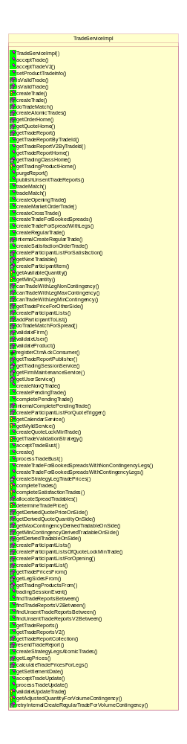TradeServiceImpl class
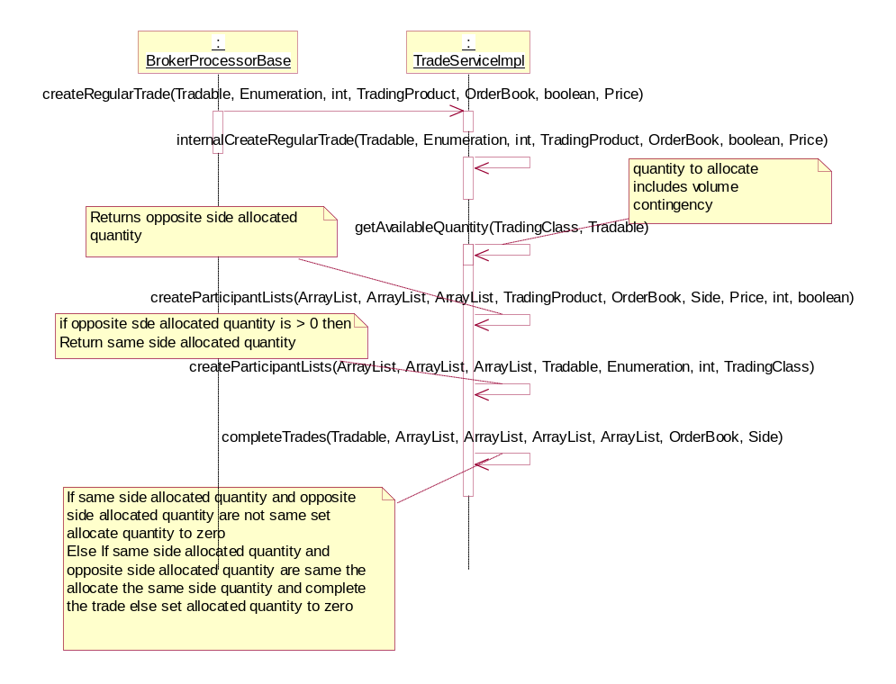
Sequence of Current Implementation of TradeServiceImpl internalCreateRegulerTrade()

Given below are the sequence diagrams of the proposed change.

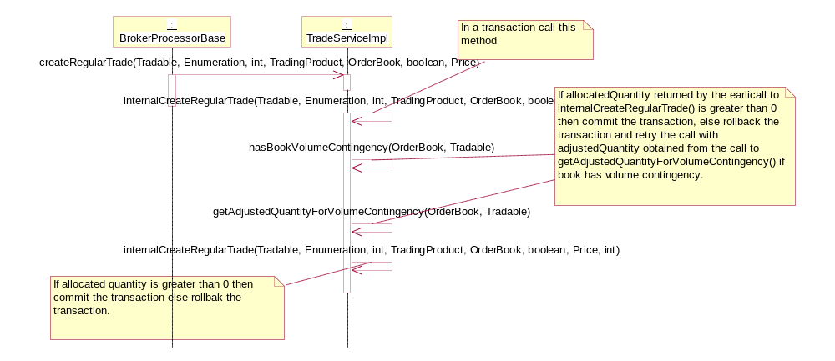

Sequence of Proposed Implementation of TradeServiceImpl internalCreateRegulerTrade()

Assumptions
- None

Interface Changes
None

Implementation
Changes:
- Two methods getAdjustedQuantityForVolumeContingency() and hasBookVolumeContingency() are added to TradeServiceImpl class. The first method returns the the adjusted quantity for volume contingency for all qualified contingency tradables that needs to subtracted from the quantity to allocate for trade allocation. The second checks for existence of Volume Contingency in the Order Book.
- TradeServiceImpl’s createRegularTrade() method implementation is modified to try trade after volume contingency adjustment in the event the trade could not happen first time (As depicted in the sequence above) and transaction rolled back. In a new transaction the process is retried again by calling a internalCreateRegularTrade() again with an adjustedQuantity. internalCreateRegularTrade() method signature has been changed to take this extra parameter. During normal call this parameter value is 0.

Scripts
- None

Database
- None

SetContext
- None

XML/DTD
- None

Homes/Services
- None

ImplPlan/Rollout Dependencies
- None.

PerformanceTestingProcedure
- None

TestingProcedure
See CBO06679 Test_Plan.doc

OperatorProcedure
- None.

Fallback/Failover
- Fallback to previous release

