CBOqa06754 Acornym > 5 characters should not be allowed

Overview

Current processing
Currently in User Management service through SA GUI when creating/updating new user, User Acronym field accepts any number of characters and does not validate user acronym.

New requirement
In the new requirement when creating/updating new user through User Management Service, User Acronym field is limited to 5 characters only to solve the problems with replication and clearning.

Assumptions
- None

Interface Changes
None

Implementation
Changes
In UserServiceImpl class add a method validateUserAcronym(String acronym) to throw DataValidationException if length of acronym data field is greater than 5 characters.

Major Sequence Flows
Call the new method validateUserAcronym(String acronym) method from addUser(SessionProfileUserDefinitionStruct newUser, boolean membershipDefined) method implementation and updateSessionProfileUser(SessionProfileUserDefinitionStruct existingUser) implementation of UserServiceImpl just before calling validateExchange() method

The implementation is shown in the following sequence diagrams
New User Creation Seuence – with the changes

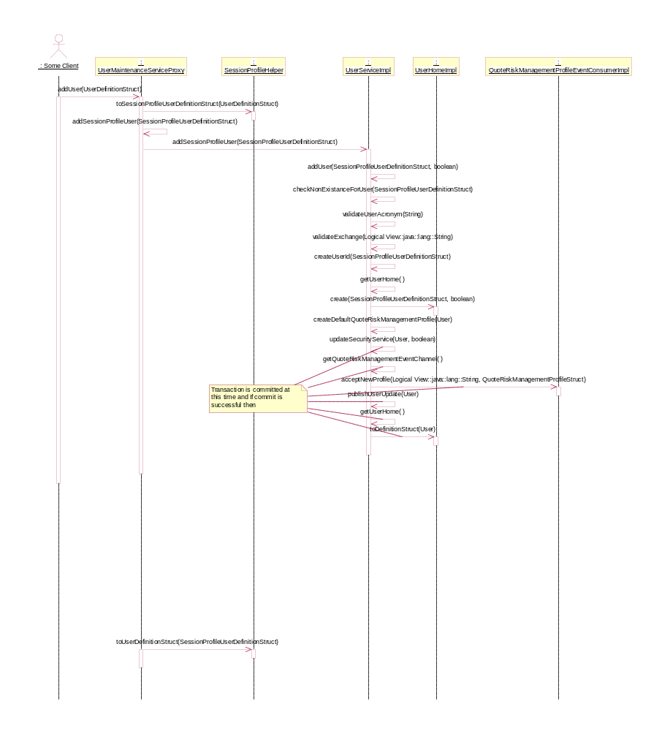

Update User sequence – with changes

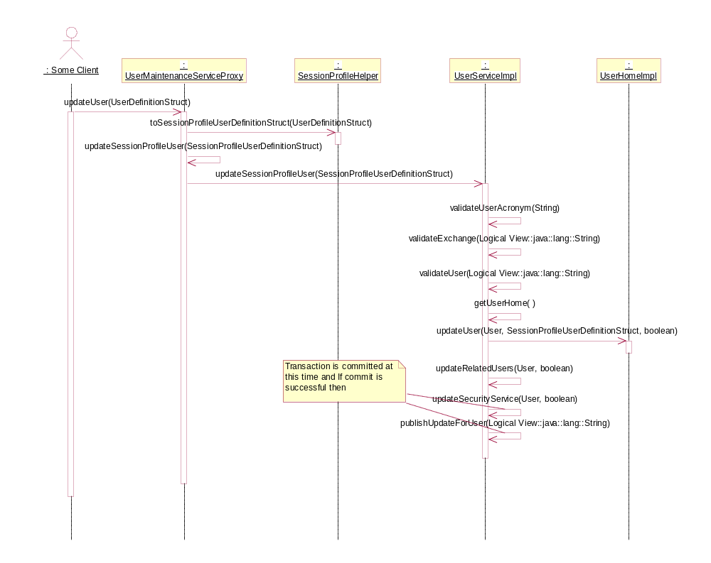

Scripts
- None

Database
- None

SetContext
- None

XML/DTD
- None

Homes/Services
- None

ImplPlan/Rollout Dependencies
- None.

PerformanceTestingProcedure
- None

TestingProcedure
See CBOqa06754Test_Plan.doc

OperatorProcedure
- None.

Fallback/Failover
- Fallback to previous release

