CBOqa06849 Ignore buy-writes during opening.

Overview

Current problem
Currently we ignore buy-write products on the BC side during opening
but we need to have the same behavior on the GC side.

Analysis
Recreate the Problem:
- Open SAGUI and select a Class. Put them in ‘Pre-Open’ states – both option and strategy
- Start the script by issuing the following command at prompt
- $ pubAAIunderlying
- That script file contains the ecTest command as above,.
- You should see AAI strategy products not going through ‘Opening Rotation’ while BUY_WRITE products remain in ‘Closed’ state. They remained in ‘Pre-Open’ state

Identify Classes / Services
com.cboe.businessServices.tradingSessionService.TradingSessionServiceLocalImpl

Determine the Scope of Change
Only the above class needs to be modified.

Proposed Solution:
In the com.cboe.businessServices.tradingSessionService.TradingSessionServiceLocalImpl class the method areAllProductsForClassInStateAndInTimeRange() method needs to check for existence of BUY_WRITES and bypass the the state verifying logic to alow opening rotation to proceed.
Here is the code change in bold

public boolean areAllProductsForClassInStateAndInTimeRange(String sessionName, int classKey, short state) {

TradingSessionElement[] elements = elementHome.findCurrentForSession(sessionName);
SessionElementClass elementClass = null;
TradingSessionElement sessionElement = null;

for (int i = 0; (elements != null) && (i < elements.length); i++) {
try {
sessionElement = elements[i];
elementClass = sessionElement.findClass(classKey);
break; // class can be in only one element of a session.
}
catch (NotFoundException e) { // may not be in this element
}
}

// if the class is not found in the session then just return now.
if (elementClass == null) {
return false;
}

// If the current time is not withing the product pre-open and close time then
// abort now.
long currTime = System.currentTimeMillis();
if (currTime <= sessionElement.getProductPreOpenTime() || currTime >= sessionElement.getProductCloseTime()) {
return false;
}

if (elementClass.getClassState() == ClassStates.SUSPENDED && blockAutoTransitionFromSuspended)
{
// We only bother checking for 'suspended' at the class level.
//
Log.information("Prevented state change on underlying tick for " + classKey + " since this class is currently in a SUSPENDED state.");
return false;
}

// Check if all products are in the same specified state.
// Ignore this check if the 'state' is -1.
SessionElementProduct[] elementProducts = null;
Product theProduct=null;
ProductQueryServiceImpl prodQueryService = null;
int productKey=0;
if (state != -1) {
elementProducts = elementClass.getProducts();
for (int j = 0; j < elementProducts.length; j++) {
try {
productKey = elementProducts[j].getProductKey();
theProduct = getProductHome().findByKey(productKey);
if (((ProductImpl)theProduct).getProductSubType() == StrategyTypes.BUY_WRITE )
{
if (Log.isDebugOn())
{
Log.debug(this,"Ignoring product state of BUY-WRITES for opening classes.");
}
}
else
{
if (state != elementProducts[j].getProductState())
{
return false;
}
}
} catch (NotFoundException e) {
Log.exception(this, "Unable to find TradingProduct for given productKey = " + productKey, e);
}
}
}

return true;
}

Major Sequence Flows

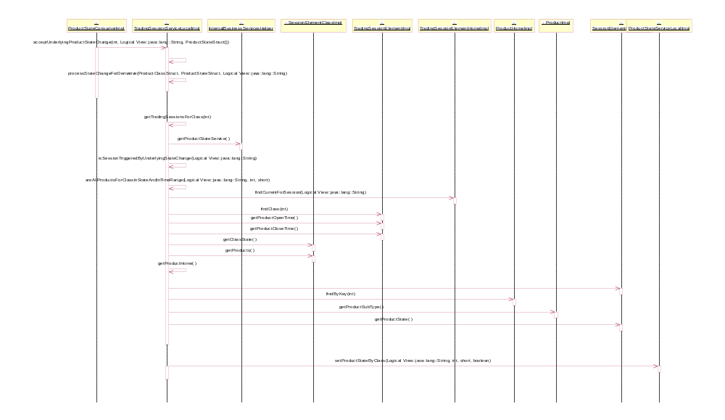

Assumptions
- None

Interface Changes
None

Implementation
Changes:

Scripts
- None

Database
- None

SetContext
- None

XML/DTD
- None

Homes/Services
- None

ImplPlan/Rollout Dependencies
- None.

PerformanceTestingProcedure
- None

TestingProcedure
See CBO06849 Test_Plan.doc

OperatorProcedure
- None.

Fallback/Failover
- Fallback to previous release

