Table of Contents
CBOqa07070 – TradingPropertyServiceCacheManager unsafe initialization: Test Plan 3
Pretest Condition: 3
Test Plan 3
Test Case 1: 3
Test Case 2: 3
Test Case 3: 3
CBOqa06995 Opening Delays: Test Plan 4
Pretest Condition: 4
Unit Test: 4
Full Test: 4
CBOqa07126 – Find the missing orders when TpfAdapter is down: Test Plan 5
Pretest Condition: 5
Test 1: Enter orders when TpfAdapter is down 5
CBOqa07115 – TipsAdapter product cache does not have intraday product updates: Test Plan 6
CBOqa06880 – QRM's Quotes not cancelled due to Update Exception: Test Plan 7
Pretest Condition: 7
Test 1: Cancel Quotes for Class due to QRM Condition 7
CBOqa06909- Get Lost size is called when products not in session: Test Plan 8
Unit Test: 8
CBOqa07095 – Creating new Spread during PRE_OPEN prevents state change: Test Plan 9
Pretest Condition: 9
Test 1: Create a strategy using the Trader Gui prior to the opening 9
CBOqa06881-NullPointer in getOpeningRequirementCode before session star: Test Plan 10
Unit Test: 10
CBOqa07007 – Spread market order is not routing back to TPF: Test Plan 11
Pretest Condition: 11
Test 1: Market Spread order routed back to TPF with “rejected” reason when the Strategy product is ON_HOLD 11
Test 2: Market Spread order routed back to TPF (PAR) with “No Market” reason when leg market volume depleted 11
CBOqa06940- "Trader Activity" Events are dropped when times are identical: Test Plan 13
Unit Test: 13
CBOqa06568-Strategy order leg quantity validation: Test Plan 14
Pretest Condition: 14
Test 1: Reject a strategy order with invalid leg quantity 14
CBOqa07073 – Interday Strategy Add Remains in ON_HOLD State. 15
Pretest Condition: 15
Test 1: 15
Test 2: 15
CBOqa06494 – Quote Error Message To GUI 16
Pretest Condition: 16
Test 1: Enter various quotes with incorrect or missing data 16
CBOqa07098 17
CBOqa07154 – ITS adapter connection configuration changes 18
Pretest Condition: 18
Test Plan 18
Table of TradingProperties: 18
CBOqa07067- Opening Delays: Test Plan 20
Testing Tips Driver 20
CBOqa07134 – Product fails to open with "handleInopenability>>Should not get to here" 21
Pretest Condition: 21
Test 1: Product Opening Test using Bulk Quote Driver from Jimmy 21
CBOqa07151- COB - Cancel/Re not being taken out of the book: Test Plan 22

CBOqa07070 – TradingPropertyServiceCacheManager unsafe initialization: Test Plan

Pretest Condition:
- Server Installation and configuration completed and ready to start.
- Tail Global and Hybrid logs on separate xterms.

Test Plan

Test Case 1:
- Start the GC/BC server processes as per documentation
- Start W_MAIN session with - startSession W_MAIN
- Check global and hybrid logs for any ‘lock’ being held or being waited for.
- Stop W_MAIN session with – endSession W_MAIN
- Repeat the above 3 steps several times.

Test Case 2:
- Start the GC/BC server processes as per documentation
- Start ONE_MAIN session with - startSession ONE_MAIN
- Check global and TradeServer logs for any ‘lock’ being held or being waited for.
- Stop ONE_MAIN session with – endSession ONE_MAIN
- Repeat the above 3 steps several times.

Test Case 3:
- Start the GC/BC server processes as per documentation
- Start CFE_MAIN session with - startSession CFE_MAIN
- Check global and TradeServer logs for any ‘lock’ being held or being waited for.
- Stop CFE_MAIN session with – endSession CFE_MAIN
- Repeat the above 3 steps several times.

CBOqa06995 Opening Delays: Test Plan

Pretest Condition:

Note: these steps must be taken immediately after the new install before any other tests are run
- Copy setContext.template from /sbt/…/tradeeng/run_dir/bin to /sbt/tradeeng and rename it from setContext.template to setContext
- Hand-edit the setContext in the tradeeng base directory in the same way setContext is currently edited in the run_dir/bin directory. For help, see /sbt/…/tradeeng/run_dir/bin/setContext.readme

Unit Test:
Do the following tests on each BC/GC/FE upgraded:
- Login with the tradeeng id (tradengp, etc.), and verify that no error messages are printed to the screen on login.
- Start all services for this machine. Verify that all processes came up and started correctly
- Type echo $RUN_SET_CONTEXT;echo $SBT_PREFIX;echo $INSTANCE_ID;echo $BASE_PORT;echo $INFRA_BASE_PORT;echo $CLUSTER_ID;echo $SUB_CLUSTER_ID;echo $CLUSTER_TYPE;echo $ALT_HOST;echo $RUN_DIR;echo $INFRA_HOME_DIR;echo $ORACLE_VERSION and verify that the values echoed are the same as those set in the setContext file in the tradeeng base directory
- Type echo $ALL_SESSION_NAMES and verify that the response is ONE_MAIN W_MAIN CFE_MAIN W_STOCK
- Type echo $ALL_DATABASE_SCHEMA_NAMES and verify that the response is NOT a blank line
- Type echo $JAVA_HOME and verify that the response is NOT a blank line

Full Test:

In order to fully test these changes after the unit test is run, do another “new” install. This install can use either the same code base or a different one. After this install do not modify any of the setContext files, but perform the Unit Test (above) once again, and verify that all of the conditions are met.

CBOqa07126 – Find the missing orders when TpfAdapter is down: Test Plan

Please use the corresponding Pretest Condition below that is specific for ATG or development environment testing.

Pretest Condition:
    - Tests are for Hybrid.
    - W_MAIN Session is started
    - Products are in OPEN state

Test 1: Enter orders when TpfAdapter is down
- Enter several orders while TpfAdapter is up.
- Run findMissingOrders script. It should not print out any orders entered in step 1.
- Shut down TpfAdapter. Enter several orders.
- Run findMissingOrders script. It should print out the orders entered in step 3.

CBOqa07115 – TipsAdapter product cache does not have intraday product updates: Test Plan
1) The test requires Tips running with BOTR traffic or BOTR driver
running

2) run ar command to find a product in the BadProductList:
ar TipsAdapter showBOTRContext
From ar command output, find a product in the BadProductList. The
product has key like "C:G:W". We use "C:G:W" as example.

3) Open SAGui start/Products/ProductDefinition,choose option reporting
class C, and create a new product with Month code G and Strike Price
code W.

4) run command again
ar TipsAdapter showBOTRContext
and make sure that C:G:W is not in the BadProductList anymore.

CBOqa06880 – QRM's Quotes not cancelled due to Update Exception: Test Plan
Please use the corresponding Pretest Condition below that is specific for ATG or development environment testing.

Pretest Condition:
- Set up QRM for Class via SAGUI
- Go to User management QRM tab
- Add option class to the QRM controlled list.
- Select the class in the list box and click on Global QRM Enabled, and Class QRM Profile Enabled check boxes
- In the CLASS QRM Profile change the Volume = 5, and Seconds = 1
- Save settings.

Test 1: Cancel Quotes for Class due to QRM Condition
- Login to Trader GUI and open Market Display, add the target Class tab from W_MAIN/options.
- Enter quotes for several products
- Produce a trade for one of the products. The trade volume must be > 5.
- Make sure all quotes in the class are canceled.

Note: This bug fix must go through the PERF testing before it can be released into PROD

CBOqa06909- Get Lost size is called when products not in session: Test Plan

Unit Test:
- If session W_MAIN has already been started from the command line on the GC enter ‘endSession W_MAIN’

- If the Hybrid TradeServer is currently running kill it and bring it back up

- Using a trader GUI log on and open a market display window.

- Pick a class and add it to the market display window. Verify that the products are currently in ‘NO SESSION’ state

- Using the GUI attempt to enter a quote for one of the products in no session state. The following error should appear: (verify that the “No Session assigned to product…” message appears at the bottom of the box.)

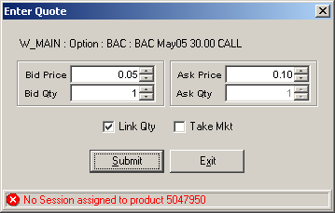

CBOqa07095 – Creating new Spread during PRE_OPEN prevents state change: Test Plan

Please use the corresponding Pretest Condition below that is specific for ATG or development environment testing.

Pretest Condition:
- Tests are for Hybrid.
- W_MAIN Session is started
- Products are in PRE_OPEN state

Test 1: Create a strategy using the Trader Gui prior to the opening
      - Any strategy created should move into ON_HOLD state
      - After the opening timers are triggered, underlying ticker data feeds from Tips should move the products to OPENING_ROTATION
      - Check to make sure all existing strategies and outright products move to OPENING_ROTATION – except BUY_WRITES, which should remain CLOSED
      - Open all products.
      - The newly created strategy should remain ON_HOLD.
      - Enter valid quotes on legs of strategies.
      - The newly created strategies should move to OPEN state.

CBOqa06881-NullPointer in getOpeningRequirementCode before session star: Test Plan

Unit Test:
1. If session W_MAIN has already been started from the command line on the GC machine enter ‘endSession W_MAIN’
2. If the Hybrid TradeServer is currently running kill it and bring it back up
3. Using a SAGUI log on and open a Product State Maintenance window.
4. Click a class under W_MAIN Hybrid. Verify that the NotFoundException error should appear with message “Trading Session W_MAIN is not Available.”
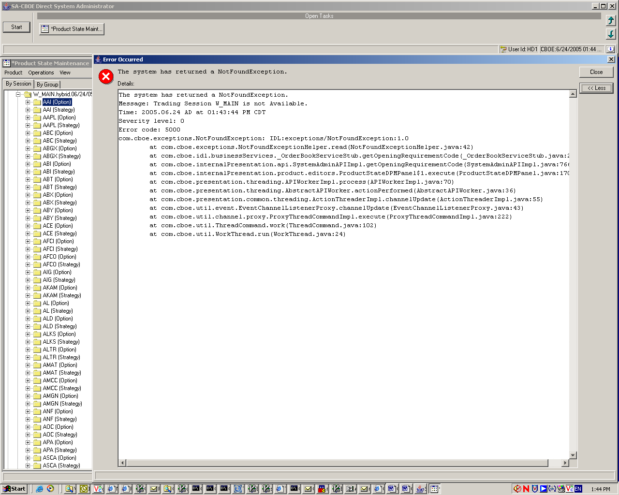

CBOqa07007 – Spread market order is not routing back to TPF: Test Plan
Please use the corresponding Pretest Condition below that is specific for ATG or development environment testing.

Pretest Condition:
- Tests are for Hybrid.
- W_MAIN Session is started
- Create a 2 leg B/S strategy
- Strategy product ON HOLD
- TPF flags to be set to allow routing back
- CBOE Direct flag to be set to allow Spread Market Orders

Test 1: Market Spread order routed back to TPF with “rejected” reason when the Strategy product is ON_HOLD

Buy 1/ Sell 1 Strategy Product

0.00-0.0 0x0 Leg # 1
0.00-0.0 0x0 Leg # 2
Product Status ON_HOLD

1. Submit “C” market spread order 10 @ MKT SAME SIDE from PAR

Order routed back to PAR. Make sure PAR got the order back with reason “Rejected”.

Test 2: Market Spread order routed back to TPF (PAR) with “No Market” reason when leg market volume depleted

Buy 1/ Sell 1 Strategy Product

0.00-0.00 0x0 Leg # 1
0.00-0.00 0x0 Leg # 2
Product Status ON_HOLD

- Submit quote for Leg 1: 1.00 – 1.25 10x10
- Submit quote for Leg 2: 1.00 – 1.25 10x10
- Strategy product state changed to OPEN
- Submit “C” Market Spread Order 20 @ MKT SAME SIDE from PAR

Result:

Spread order trades quantity of 10 against legs and leave 10.
Leg market changes to:
1.00 – 0.0 10x0
- – 1.25 0x10
The Spread Market order with remaining quantity of 10 is routed back to par with reason “NO MARKET”.

Make sure PAR got the order back with reason “NO MARKET”.

CBOqa06940- "Trader Activity" Events are dropped when times are identical: Test Plan

Unit Test:
1. Enter quote for a hybrid option from TraderGui
2. Enter order trade against the quote from step 1.
3. On the TraderGui, select Start->History->Activity Log->Create New Window to display the activities for the option. Should see Execution with the same time stamp.

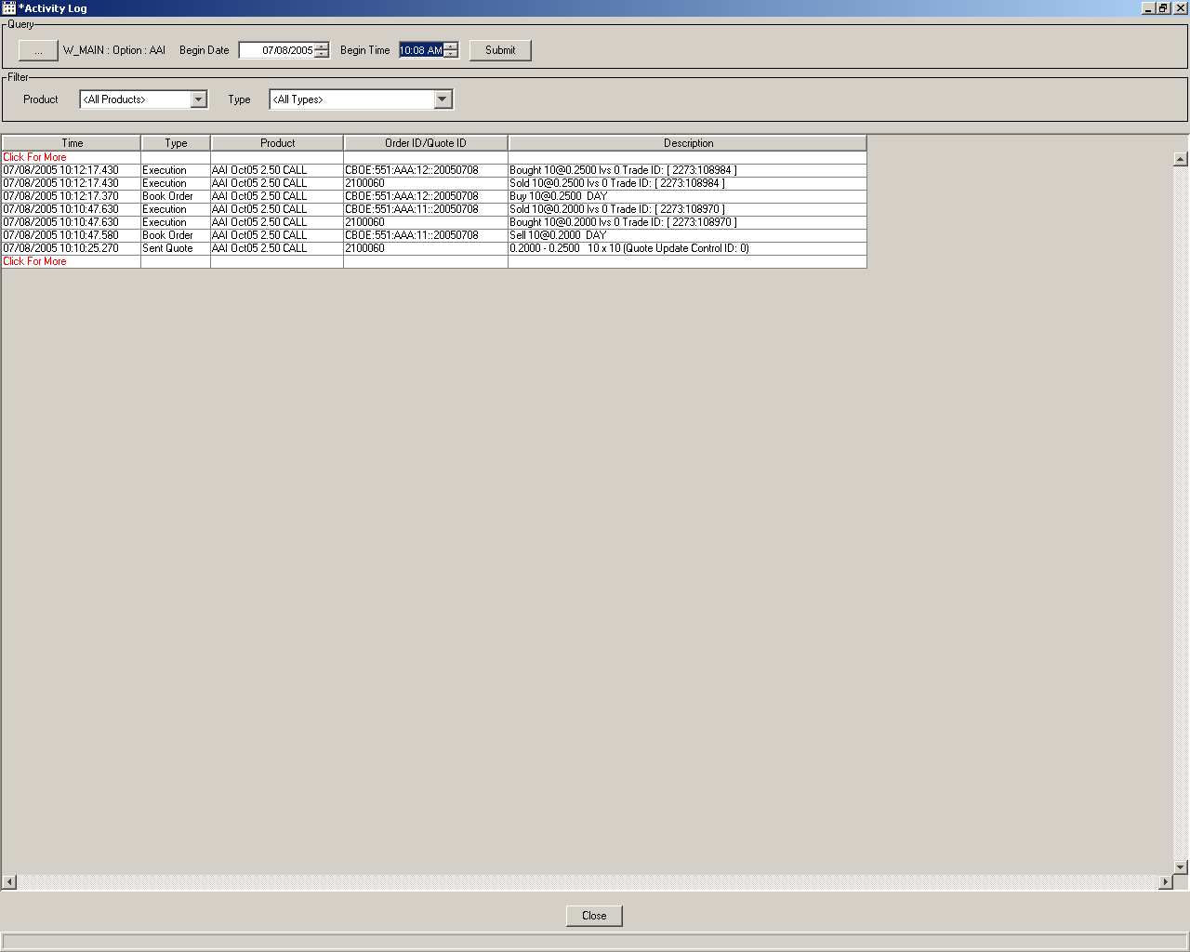

CBOqa06568-Strategy order leg quantity validation: Test Plan
Please use the corresponding Pretest Condition below that is specific for ATG or development environment testing.

Pretest Condition:
- Tests are for Hybrid.
- W_MAIN Session is started
- Create strategy with 100 leg ration
- Strategy leg products must be OPEN
- Strategy product ON HOLD, OR OPEN

Test 1: Reject a strategy order with invalid leg quantity
Enter order for the strategy with 100-leg ratio.
Enter the order quantity @ 100000. On order submission invalid quantity message is shown on Trader GUI.

CBOqa07073 – Interday Strategy Add Remains in ON_HOLD State.
Please use the corresponding Pretest Condition below that is specific for ATG or development environment testing.

Pretest Condition:
- Tests are for Hybrid.
- W_MAIN Session is started
- Products are in Closed state

Test 1:

- Set all option + Strategies in OPENING_ROTATION.
- Create a new Strategy (Should be in "OPENING_ROTATION" state).
- Enter valid quotes for legs.
- Change state of legs to OPEN.
- Strategy state should change to OPEN..

Test 2:

- Set one option product to PRE_OPEN, then OPENING_ROTATION.
- Set another option product to PRE_OPEN.
- Create a new Strategy using these two legs(Should be in "ON_HOLD" state).
- Enter valid quotes for legs.
- Change state of option product in PRE_OPEN to OPENING_ROTATION
- Strategy state should move to OPENING_ROTATION
- Change state of legs to OPEN.
- Strategy state should change to OPEN.

CBOqa06494 – Quote Error Message To GUI
Please use the corresponding Pretest Condition below that is specific for ATG or development environment testing.

Pretest Condition:
- Tests are for Hybrid.
- W_MAIN Session is started
- Products to use must be at least in PRE_OPEN

Test 1: Enter various quotes with incorrect or missing data
- Check Status line of trader gui for valid error message which corresponds to incorrect data entered.

CBOqa07098

Perform the following tests for each of the trading properties listed in the table below:

- setTradingProperty sessionName classSym prodType tradingProperty value
- getTradingProperty sessionName classSym prodType tradingProperty (to verify it was set correctly)
- setTradingProperty sessionName classSym prodType tradingProperty value seqNum
- getTradingProperty sessionName classSym prodType tradingProperty (to verify it was set correctly)

where sessionName = W_AM1, W_MAIN, ONE_MAIN, CFE_MAIN, W_STOCK, Underlying
and
classSym = the acronym for the class, or "default".
and
prodType = option, strategy, index, equity or future.

CBOqa07154 – ITS adapter connection configuration changes

Pretest Condition:
ITSAdapter process is up and running on linkage box

Test Plan

Case 1: Start ITS connection test

Login to linkage box that is set up for the env. Open the session.
Star tailing ITSAdapter.log. Run the following ‘ar’ command:

ar ITSAdapter startAllServices

Monitor ITSAdapter to make sure connection is occurred with no exceptions.

Table of TradingProperties:

- PrescribedWidthRatio
- FastMarketSpreadMultiplier
- AllocationStrategies
- ContingencyTimeToLive
- DPMParticipationPercentage
- ExchangePrescribedWidth
- OpeningPeriodTimeRange
- OpeningPriceDelay
- OpeningPriceRate
- PreClosingTimePeriod
- RFQTimeout
- MinQuoteCreditDefaultSize
- RFQResponseRatio
- ContinuousQuotePeriodForCredit
- MinSizeForBlockTrade
- BookDepthSize
- IPPMinSize
- IPPTradeThroughFlag
- QuoteLockTimer
- QuoteLockNotificationTimer
- QuoteTriggerTimer
- DPMRightsSplitRate
- LinkageEnabledFlag
- SatisfactionAlertFlag
- FPQS
- FCQS
- SOrderTimeToLive
- POrderTimeToLive
- PAOrderTimeToLive
- SOrderTimeToRejectFill
- SOrderTimeToCreate
- SOrderTimeToCreateBeforeClose
- ProductOpenProcedureType
- DPMRightsScales
- UMASplitRate
- UMAEqualDistributionWeightForDPM
- LotSize
- ETFFlag
- IPPToleranceAmount
- NeedsDpmQuoteToOpen
- TradeType
- PreferredDPMRightsRate
- QuoteLockMinimumTradeQuantity
- AuctionTimeToLive
- AuctionMinPriceIncrement
- AuctionMinQuoters
- AuctionReceiverTypes
- InternalizationGuaranteedPercentage
- AuctionOrderTicksAwayFromNBBO
- AutoExEligibleStrategyTypes
- AuctionEnabled
- AuctionMinOrderSizeForTicksAboveNBBO
- AuctionMinMaxOrderSize
- OpeningPriceValidation
- AllowMarketOrder
- OpeningExchangePrescribedWidth
- PriceProtectPercentage
- SizeIncreasePercentageForNewRfp
- PDPMRightsScales

CBOqa07067- Opening Delays: Test Plan

Testing Tips Driver
- On an xterm login to GC box (devenvx) with tradexx/tradexx
- On another GC login xterm open global log with tail –f Glo*log
- On another xterm login to GC box (devenvx) with tradexx/tradexx
- loginDb GLOBAL
- Set Product State to 7 in SESSION_ELEMENT_PRODUCT table with Update SESSION_ELEMENT_PRODUCT A Set PROD_STATE=7 where exists (Select 1 from PRODUCT B where A.PROD_KEY=B.DATABASEIDENTIFIER and B.PROD_TYPE_CODE=3); May include Index as well product_type_code=5
- Verify Products Pre-Open, Open and Close Time. They should be within Session Start and End Time and also should be on current day, ar GlobalServer printTemplatesAndSessions
- Stop Global and TipsAdapter server
- Restart Global and TipsAdapter one after another
- Open SA GUI and on a session W_MAIN pre-open all W_MAIN hybrid.
- Verify Product States by showProductStatesBySession, should be in Pre-Open for the specific session W_MAIN
- products, ar HybridTradeServer1 setAllProductStates W_MAIN 2
- Verify Underlying and Derivative Queues with ar GlobalServer showQueue %ProductStateConsumer% They are empty.
- Start Tips Driver program with
- java -DORB.OrbName="openingsim"$$ -DSBT_PREFIX=${SBT_PREFIX} -DORB.InitRefURL=${IOR_FILE} -Dport=20001 -Daddr=170.137.237.255,170.137.238.255 com.cboe.server.util.OpeningRotationSimulator -groups test9HybridTradeServer1 -pcts=100 -waits=0
- start tips connection with ar TipsAdapter startAllServices UnderlyingUdp
- Look at Global log and see the product state change and time taken in ms.
- Verify Underlying and Derivative Queues with ar GlobalServer showQueue %ProductStateConsumer% There should be meesages showing ttlEnq(xxx) and ttlDeq(xxx)
- Verify Product States by showProductStatesBySession, should be in Opening Rotation for the specific session W_MAIN

Timings were measured with different number of underlying and derivative threads in TradingSessionService.xml.

CBOqa07134 – Product fails to open with "handleInopenability>>Should not get to here"

Please use the corresponding Pretest Condition below that is specific for ATG or development environment testing.

Pretest Condition:
- Tests are for Hybrid.
- W_MAIN Session is started
- Products are in PRE-OPEN state
- USER ABC setup as DPM user
- Setup Bulk Quote Driver to send quotes in block. (Jimmy helped)

Test 1: Product Opening Test using Bulk Quote Driver from Jimmy

      - Issue ar command to put product in ‘Opening Rotation’ state.
ar HybridTradeServer1 setAllProductStates W_MAIN 3
      - Check HybridTradeServer1.log
      - Login to fujicas2 with infrap/infrap
      - cd /sbt/prod/infra/v2run_dir/tmp/test9env/agent_1.
      - Execute runTest -B test.ini to enter 100 quote/second in 20/block from user ABC
      - Check HybridTradeServer1.log, look for information “If it got here, try requeueing timerTask again. This time it should open.”
      - You should not see any product state remaining in ‘Opening Rotation’ after step 4.

CBOqa07151- COB - Cancel/Re not being taken out of the book: Test Plan

Test Setup:
- Configure for Real Tpf – Ask lab to connect to VPARS1
- Ask lab to setup for Customer Order to Route back to SBT and all others to route to VPARS1.
- buildLocalRep in infra and Restart Global, HTS, Tpf
- Connect to Tpf services – ar TpfAdapter startAllServices
- Open test products and put test strategy product on Opening Rotation.
- Enter quotes for strategy legs.

Test Plan:
Test case 1: Strategy – Customer Order – Order Routing back from Tpf.
- Enter a complex customer order from Trader Gui
- See it getting booked in SBT
- Open Order Status Screen.
- Ask lab to set MM order not to route Back
- Do a Cancel / Replace with Customer Origin
- See original order getting cancelled, and new order being booked.
- See Current Market getting updated appropriately.

Test case 2: Strategy – Market Maker Order – Orders Not Routing Back from Tpf
- Enter a complex MM order from Trader Gui
- Ask Lab to Book it
- Open Order Status Screen.
- See it getting booked in SBT
- Ask lab to set MM order not to route Back
- Do a Cancel / Replace with Market Maker Origin
- See original order getting cancelled, and new order being booked.
- See Current Market getting updated appropriately.

Test case 3: Simple – Customer Order – Order Routing back from Tpf.
- Enter a simple customer order from Trader Gui
- See it getting booked in SBT
- Open Order Status Screen.
- Ask lab to set MM order not to route Back
- Do a Cancel / Replace with C Origin
- See original order getting cancelled, and new order being booked.
- See Current Market getting updated appropriately.

Test case 4: Simple – Market Maker Order – Orders Not Routing Back from Tpf
- Enter a simple MM order from Trader Gui
- Ask Lab to Book it
- Open Order Status Screen.
- See it getting booked in SBT
- Ask lab to set MM order not to route Back
- Do a Cancel / Replace withy MM Origin
- See original order getting cancelled, and new order being booked.
- See Current Market getting updated appropriately.

