TIPS Stock Adapter Modification Plan for StoC_Hybrid
This document provides high-level details on proposed modifications in the TIPS stock adapter for the StoC_Hybrid. The primary objectives for these modifications are:
- Performance improvement / code re-factoring
- Add implementation to ensure that the most recent NBBO quotes are provided to trade engine in cases where multiple NBBO quotes for the same product are queued up at the TIPS stock adapter.

Current Implementation of TIPS Stock Adapter
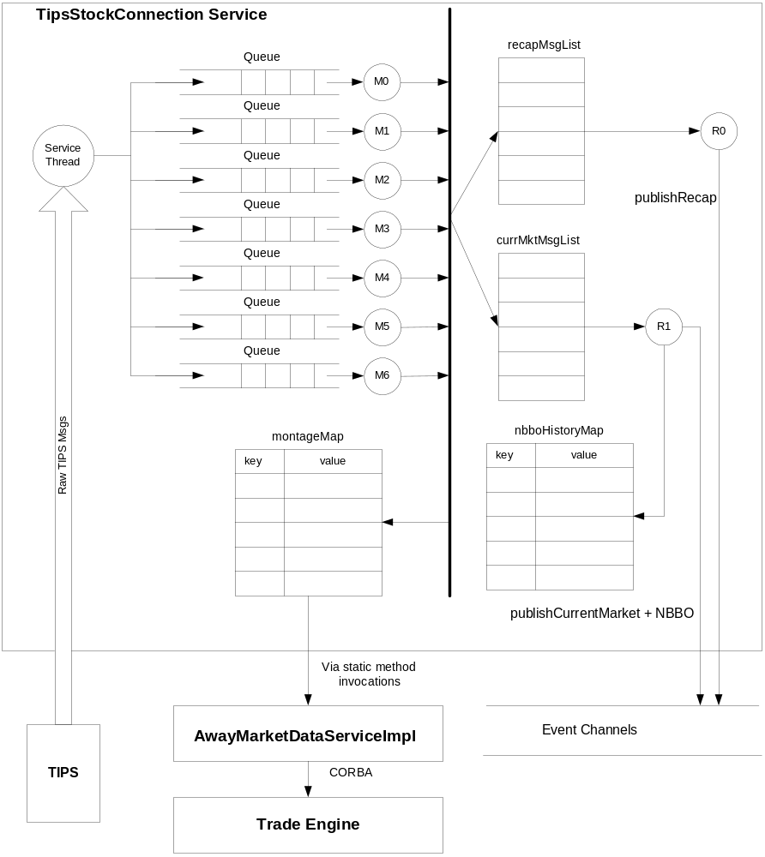
Figure 1: Information flow in current implementation of TIPS stock adapter
Figure 1 shows the information flow in the current implementation of TIPS stock adapter in StoC_Hybrid. The connection service thread reads raw TIPS messages from TCP stream. There is a quick parse of the product symbol performed, and the raw byte data of the message is placed in one of the seven queues based on hashing of product symbol. This guarantees that TIPS messages of same product will be in the same queue.

The queues are serviced by seven dispatcher threads M0 through M6, one for each queue. The messages are fully parsed into TIPSLWMessage in message dispatcher threads. Each TIPS message is then placed in two lists: currMktMsgList and recapMsgList. Each list is read by its associated thread. Thread R0 simply depopulates the message from the recapMsgList and publishes market recap event.

Thread R1 publishes current market and NBBO. A TIPS quote message may not contain price and size information for both bid and ask sides. When a quote side’s price and size is unchanged, that side is not included in TIPS quote message. To provide a complete NBBO quote with both sides, TIPS stock adapter manages a map to store quotes from each exchange. This map uses the combination of product symbol and SIAC exchange code as the key and the TIPSLWMessage as value. When a TIPS quote message is missing either side, its historic value is retrieved from the map based on the product key and exchange which is listed as NBBO exchange in the TIPS message.

Proposed Modifications
- Remove the intermediate currMktMsgList and recapMsgList and their associated threads. It appears that the original intention of this intermediate stop for information flow from message dispatcher to the event channel was to provide a throttling mechanism for information flow from TIPS stream to event channel. The throttling mechanism has been removed, and with its removal threads R0 and R1 add no value. There is heavy contention on these two lists between the message dispatcher threads M0 through M6 and the event publishing threads R0 and R1. The events will be published directly from the message dispatcher threads. Each message dispatcher thread will use its associated montage map rather than to share one global montage. Since each message dispatcher thread process only one queue and no one product can be distributed across multiple queues, any one message dispatcher will only write to a single montage map. Note that the montage map are thread-local. They are shared with the AwayMarketDataServiceImpl who is the reader of montage maps.
- Remove the nbboHistoryMap as this is redundant with introduction of the montage map. The montage map maintains most recent quotes for each product symbol from all exchanges.
- Replace the queues which are QueueBaseImpl instances with a queue implementation in JDK 1.5. The full capabilities of the QueueBaseImpl are not utilized by TIPS stock adapter, and so we can replace them with more light-weight efficient queues available in JDK 1.5.
- Add overlay mechanism to ensure that the most recent NBBO quotes are supplied to trade engine when multiple NBBO quotes for the same product arrive in quick succession. According to Jerry Hamm, the overlay mechanism may introduce greater complexity and potential for sending wrong quote data to the trade engines due to the nature of NBBO message flows from TIPS to TIPS stock adapter. A single NBBO quote message from TIPS requires coordination with other TIPS quote messages. It is this coordination algorithms that may add risks that may outweigh the benefits. We will make the performance improvements and watch the queue depths for very large backup of TIPS messages. If the queues are exhibiting large depth high-water marks, we will investigate the addition of an overlay mechanism. As to the acceptable number for depth high-water mark without overlay is something that is TBD.

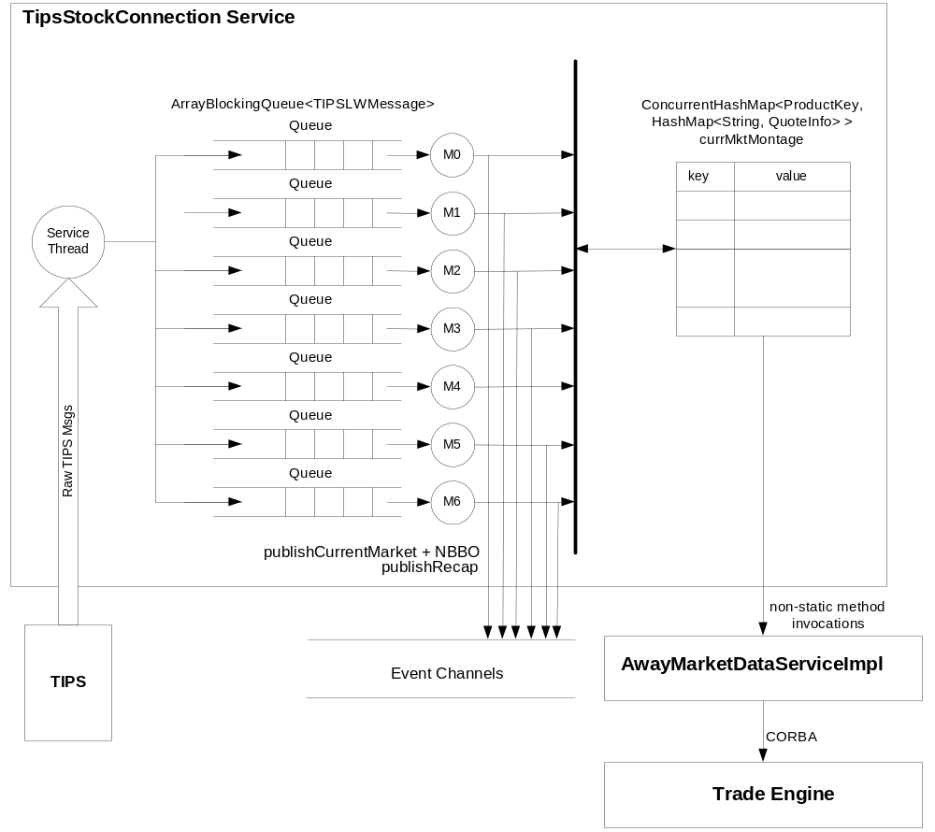

Figure 2: Information flow in current implementation of TIPS stock adapter
- Currently the AwayMarketDataServiceImpl uses static methods of TIPSEquityUpdateImpl to access the montage data inside TIPSEquityUpdateImpl declared as static data. This access approach will be replaced with more foundation-framework compliant approach where the AwayMarketDataServiceImpl gains access to the actual instance of TIPSEquityUpdateImpl via the ConnectionServiceHome. The AwayMarketDataServiceImpl will use non-static methods on reference to TIPSEquityUpdateImpl instance.

With the introduction of the above listed modifications, the information flow in modified implementation of TIPS stock adapter will resemble the diagram in figure 2.

