New changes:
Since there are 7 environments on same server asrlc01a, I have to assign different port for each it.
Remember to set environment accordingly in your window’s property if you want to use server GUI.
For Unix server, the port will be set for you automatically.

8888 for all other server-port
8889 for atgtest1-port
8890 for atgtest2-port
8891 for atgtest3-port
8892 for atgtest4-port
8893 for apitest1-port
8894 for apitest2-port

How to check linkage server status?
/sbt/prod/tradeeng/run_dir/bin $ checkLinkageConnection
setup Talarian environment
Autolink is connected to ITS.
ITS is connected to ITS Simulator
QtyNotFill<=2000

------------------------------------------------
Connection status for server ItsAdapter/its
------------------------------------------------

ServiceName ConnectionInfo
-------------------------- ----------------

ItsConnectionService Connected to localhost:8888

How to start ItsSimulator server?
Login to asrlc01a using id=tradengp

asrlc01a /sbt/prod/tradeeng/run_dir/bin/startItsSimulatorServer
if server is running, it will not start a new one.

asrlc01a /sbt/prod/tradeeng/run_dir/bin/stopItsSimulatorServer
stop server

asrlc01a /sbt/prod/tradeeng/run_dir/bin/checkItsSimulatorServer
check the running status

How to start ItsSimulator server GUI on your desktop?

Extract zip file from directory:
G:\private\GUIInstalls\ItsSimulatorGui\itssimgui.zip
to your own directory, double click to run
release\bin\runServerGui.bat

currently it is connection to test15lc, if you want to connect to different server, you have to change ip address in relase\properties\ItsSimulator.properties
IPAddress=yourIP

How to use:
In GUI, click on about->help, it will give you a brief manual on how to use it.
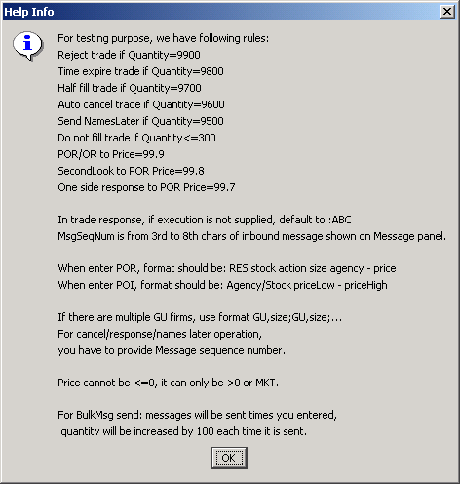

- Normal situation, you will get a fill immediately after you send a commit.
Here are the exceptions:
Qty=9900, get rejected automatically.
Qty=9800, get rejected because of time expiration.
Qty=9700, get 50% filled back.
Qty=9600, get cancelled automatically.
Qty=9500, get filled with names later.
Qty=9400, get did not get filled, this will allow you have chance to manual fill.

- When you response to a commit, you have to enter the message sequence number show on GUI.
- POI message format: Agency/Stock priceLow – priceHigh
If priceLow is 99.9, a POR message will be sent out.
- POR message format: RES stock action size agency – price
If price is 99.8, a SecondLook message will be sent out.
If price is 99.7, an one-side response message will be sent out.
- GU format: GU,size;GU,size;...
All firms size total should equal to the trade quantity.
- BulkMsg send, will automatically create N messages you entered, quantity will be increased by 100 each time it is sent.

How to change ITS simulator properties?
The properties on GUI side, is just for Help menu display, not for functional purpose. You have to change the property on server side in LC box.

(1). Stop server
(2). Modify property
(3). Start server.

test15lc /sbt/prod/tradeeng/run_dir/bin $ ls -l *Its*
-rwxr-xr-x 1 tradengp prodsbt 189 Dec 12 09:34 checkItsSimulatorServer
-rwxr-xr-x 1 tradengp prodsbt 637 Dec 12 09:34 startItsSimulatorServer
-rwxr-xr-x 1 tradengp prodsbt 212 Dec 12 09:34 stopItsSimulatorServer
test15lc /sbt/prod/tradeeng/run_dir/bin $ stopItsSimulatorServer
Stop Its Simulator ...
Done.
test15lc /sbt/prod/tradeeng/run_dir/bin $ cd ../prop*
test15lc /sbt/prod/tradeeng/run_dir/properties $ ls -l It*
-rw-r--r-- 1 tradengp prodsbt 389 Dec 13 09:40 ItsSimulator.properties
test15lc /sbt/prod/tradeeng/run_dir/properties $ vim ItsSimulator.properties
test15lc /sbt/prod/tradeeng/run_dir/properties $ startItsSimulatorServer
setup Talarian environment
Starting Its Simulator Server ...
/sbt/prod/tradeeng/run_dir/log/ItsSimulatorServer_test15lc_010507132559.log
ItsSimulatorServer has been started.

How to switch from real ITS to Its simulator?
(1). stop ItsAdapter
(2). Modify /sbt/test2/tradeeng/setContext, change following line
export ItsAdapter_CONFIG_NAME=DEV_ITS
(3). export ItsAdapter_CONFIG_NAME=DEV_ITS
(4). startServer -m ItsAdapter
(5). ar ItsAdapter startAllServices
(6).connectionStatus its

How to switch from Its simulator to real ITS?
(1). stop ItsAdapter
(2). Modify /sbt/test2/tradeeng/setContext, change following line
export ItsAdapter_CONFIG_NAME=SIM_ITS
(3). export ItsAdapter_CONFIG_NAME=SIM_ITS
(4). startServer -m ItsAdapter
(5). ar ItsAdapter startAllServices
(6).connectionStatus its

