- AR command for add test symbol
ar StockFixLinkageAdapter changeStockTestSymbol –display
Found target service, getting command
Invoke atgtest3LC01LinkageServer1B.changeStockTestSymbol( "-display" "" )
Result:
There is no Test Symbol.

ar StockFixLinkageAdapter changeStockTestSymbol -add ZVZZT
Found target service, getting command
Invoke atgtest3LC01LinkageServer1B.changeStockTestSymbol( "-add" "ZVZZT" )
Result:
ZVZZT has been ADDED to the Test Symbol list.

ar StockFixLinkageAdapter changeStockTestSymbol -display
Found target service, getting command
Invoke atgtest3LC01LinkageServer1B.changeStockTestSymbol( "-display" "" )
Result:
[ZVZZT] will be used for Test Only.

ar StockFixLinkageAdapter changeStockTestSymbol -remove ZVZZT
Found target service, getting command
Invoke atgtest3LC01StockFixLinkageAdapterB.changeStockTestSymbol( "-remove" "ZVZZT" )
Result:
ZVZZT has been REMOVED to the Test Symbol list.

setup Montage and NBBO
ar TipsStockAdapter updateStockQuote 334364916 BSE B 0.50 200
ar TipsStockAdapter updateStockQuote 334364916 BSE A 1.00 200
ar TipsStockAdapter updateCurrentMarket 334364916 0.50 BSE:200 1.00 BSE:200
ar TipsStockAdapter printEquityMontage 334364916

enter buy 100 at price of 1.00 or sell 100 at price of 0.5
you will see ZVZZT is filled.

If you remove ZVZZT from test symbol list, then it will be sent to REDI.

- AR command for routing change
Add AR command to dynamically switch routing destination.
In LinkageServer.xml
Default value:
<sendToRedi booleanValue="false"/>
<sendToRediSymbol></sendToRediSymbol>
which means, everything is routed to ITS, no override symbol goes to REDI.

If we have:
<sendToRedi booleanValue="false"/>
<sendToRediSymbol>IBM,SPY</sendToRediSymbol>
which means, everything is routed to ITS with the exception of IBM, SPY goes to REDI.

asrlc01a /sbt/prod/tradeeng/run_dir $ ar LinkageServer1 changeStockLinkageRoutingToRedi -display

Found target service, getting command
Invoke test10LC01LinkageServer1A.changeStockLinkageRoutingToRedi( "-display" "" )
Result:
Stock Linkage is connected to ITS.

asrlc01a /sbt/prod/tradeeng/run_dir $ ar LinkageServer1 changeStockLinkageRoutingToRediSymbol -display

Found target service, getting command
Invoke test10LC01LinkageServer1A.changeStockLinkageRoutingToRediSymbol( "-display" "" )
Result:
There is no override symbol configured to send to REDI.

asrlc01a /sbt/prod/tradeeng/run_dir $ ar LinkageServer1 changeStockLinkageRoutingToRediSymbol -add OEF

Found target service, getting command
Invoke test10LC01LinkageServer1A.changeStockLinkageRoutingToRediSymbol( "-add" "OEF" )
Result:
OEF has been ADDED to the REDI routing list.

asrlc01a /sbt/prod/tradeeng/run_dir $ ar LinkageServer1 changeStockLinkageRoutingToRediSymbol -display

Found target service, getting command
Invoke test10LC01LinkageServer1A.changeStockLinkageRoutingToRediSymbol( "-display" "" )
Result:
[OEF] will be sent to REDI

asrlc01a /sbt/prod/tradeeng/run_dir $ ar LinkageServer1 changeStockLinkageRoutingToRediSymbol -remove OEF

Found target service, getting command
Invoke test10LC01LinkageServer1A.changeStockLinkageRoutingToRediSymbol( "-remove" "OEF" )
Result:
OEF has been REMOVED to the REDI routing list.

WARNING: null
asrlc01a /sbt/prod/tradeeng/run_dir $ ar LinkageServer1 changeStockLinkageRoutingToRediSymbol -display

Found target service, getting command
Invoke test10LC01LinkageServer1A.changeStockLinkageRoutingToRediSymbol( "-display" "" )
Result:
There is no override symbol configured to send to REDI.

asrlc01a /sbt/prod/tradeeng/run_dir $ ar LinkageServer1 changeStockLinkageRoutingToRedi -change false

Found target service, getting command
Invoke test10LC01LinkageServer1A.changeStockLinkageRoutingToRedi( "-change" "false" )
Result:
Received admin request to CHANGE changeStockLinkageRoutingToRedi flag to false, flag changed to false

WARNING: null
asrlc01a /sbt/prod/tradeeng/run_dir $ ar LinkageServer1 changeStockLinkageRoutingToRedi -display

Found target service, getting command
Invoke test10LC01LinkageServer1A.changeStockLinkageRoutingToRedi( "-display" "" )
Result:
Stock Linkage is connected to ITS.

WARNING: null

- How to start?
(1). Make sure sendToRedi is set to “true” in LinkageServer.xml
<sendToRedi booleanValue="true"/>
(false is for ITS routing)
(2). startServer -m -n1 linkage //start linkage server
(3). startServer –m stockFixLinkageAdapter //start stock fix linkage server
(4). Fixometer, need to be connect manually, see fixometer section.

- How to start simulator?
(1). startServer -m -n1 linkage //start linkage server
(2). startServer –m stockFixLinkageSim //start stock fix linkage server simulator
(3). startServer –m stockHubLinkageSim //start redi hub simulator
(4). Fixometer, connection will be setup automatically, you don’t need to connect manualy.
(4). ar StockHubLinkageSim startSimulationService scripts/stk_p.order //will send an order from Hub to stock adapter. If you have quote in system, the stock will trade with quote.
(5). Send trade from trader GUI. Order will be filled automatically by simulator.

- How to check Fix message?
Following command will show you the messages sent/received.
test10lc /sbt/prod/tradeeng/run_dir/log/fixLogs/stockFixLinkageAdapter $ showFixLog stockFixLinkageAdapter -fileName C20061222.log

======>>RECEIVED : 2006/12/22 08:51:19:264:
BeginString[8]=FIX.4.2 BodyLength[9]=0059 MsgType[35]=A(Logon) MsgSeqNum[34]=1
SenderCompID[49]=CBSX TargetCompID[56]=REDI SendingTime[52]=20061222-14:51:19 EncryptMethod[98]=0
HeartBtInt[108]=90 CheckSum[10]=242

<<======SENT : 2006/12/22 08:53:41:034:
BeginString[8]=FIX.4.2 BodyLength[9]=0059 MsgType[35]=A(Logon) MsgSeqNum[34]=2
SenderCompID[49]=CBSX TargetCompID[56]=REDI SendingTime[52]=20061222-14:53:41 EncryptMethod[98]=0
HeartBtInt[108]=90 CheckSum[10]=240

======>>RECEIVED : 2006/12/22 08:53:45:300:
BeginString[8]=FIX.4.2 BodyLength[9]=59 MsgType[35]=A(Logon) SenderCompID[49]=REDI
TargetCompID[56]=CBSX MsgSeqNum[34]=1 SendingTime[52]=20061222-14:53:45 EncryptMethod[98]=0
HeartBtInt[108]=90 CheckSum[10]=147

showFixLog stockFixLinkageAdapter –wait //works like tail a file.

- fixometer
Fixometer is used to connect Appia engine with Redi.
Make sure you have correct configuration file, suppose you run linkage in test10lc, then you fixometerASSR_stock_test10lc.ini should have correct ip address.

Run fixometer_stock_test10lc.cmd from windows to start fixometer gui.
Right click you mouse, you should be able to connect to redi, reset sequence, run end of day services.
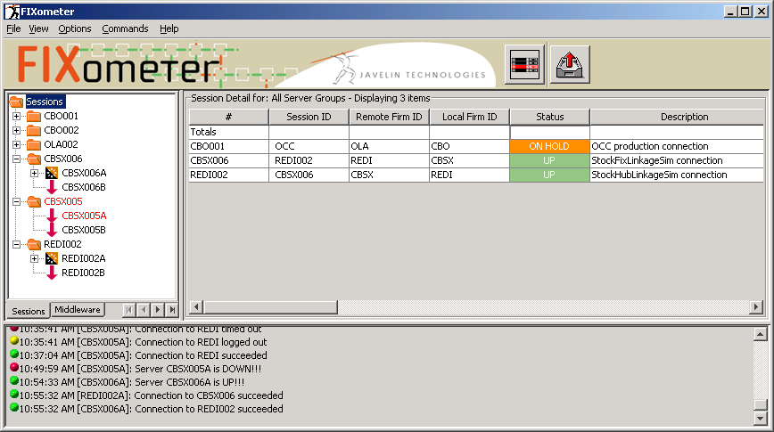

- How to check linkage server status?
/sbt/prod/tradeeng/run_dir/bin $ checkLinkageConnection
setup Talarian environment
Autolink is connected to ITS.
ITS is connected to ITS Simulator
QtyNotFill<=2000

------------------------------------------------
Connection status for server ItsAdapter/its
------------------------------------------------

ServiceName ConnectionInfo
-------------------------- ----------------

ItsConnectionService Connected to localhost:8888

- How to test Fill, cancel, etc?
(1). Fill: by default all the order will be filled completely.
There is no need to run following command:
ar StockHubLinkageSim addPropertyValue N ProductsToBeFilled IBM

(2). Partial Fill:
Use command:
ar StockHubLinkageSim addPropertyValue N ProductsToBePartiallyFilled IBM

use this to check:
ar StockHubLinkageSim getPropertyValue N ProductsToBePartiallyFilled

Found target service, getting command
Invoke test3LC01StockHubLinkageSimA.getPropertyValue( "N" "ProductsToBePartiallyFilled" )
Result:
Property values for MessageHandler N Property ProductsToBePartiallyFilled: IBM;
(3). ProductsToBeDelayFilled
ar StockHubLinkageSim addPropertyValue N ProductsToBeDelayFilled IBM
(4). ProductsToBeCanceled
ar StockHubLinkageSim addPropertyValue N ProductsToBeCanceled IBM
(5). ProductsToBeRejected
ar StockHubLinkageSim addPropertyValue N ProductsToBeRejected IBM

How to remove the property:
ar StockHubLinkageSim removePropertyValue N ProductsToBeRejected

- Exchanges that is configured in StockHubLinkage Simulator.
A,BX,N,ISX,C,S

A for AMEX
BX for Boston stock exchange
N for NYSE
ISX for international stock exchange
C for pacific stock exchange
S for NASDQ

