- Message flow:
TraderGui <--> EquityServer <--> LinkageServer <--> StockFixLinkageAdapter <--> Redi
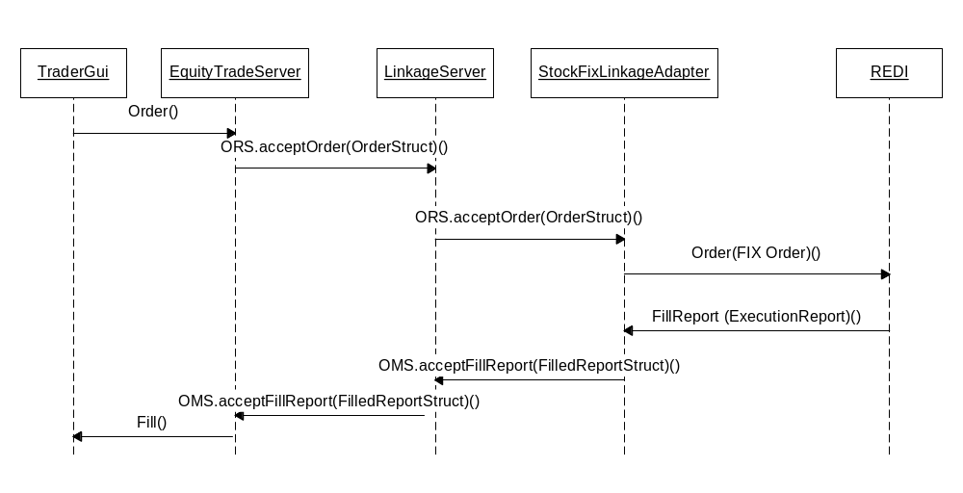

Inbound message come from external system, Redi.
Outbound message come from autolink.

Outbound message need to go to Redi, it is routed based on property defined in LinkageServer.xml. If sendToRedi is true, the trade will be routed to redi, otherwise, it will be routed to ITS.
LinkageServer.xml: <sendToRedi booleanValue="true"/>

- StockFixLinkageAdapter
For inbound message from Redi,
(1). Get message from Redi.
(2). Map message from Appia Fix format message to CBOE orderStruct.
(3). Send CBOE orderStruct to LinkageServer.

For outbound message to Redi,
(1). Get message from LinkageServer.
(2). Map message from CBOE order struct to Appia Fix format message.
(3). Send message out via Appia adapter to Redi.

