

System Requirements

Admin Request GUI
WR #5103

Draft
Version 0.9

Requirements Sign off Sheet: 3
Executive Summary 4
Project Goal 4
Requirement Details: 4
Server Requirements 4
Implementation of the AsyncAdminRequest 4
AR Command Type and Severity Indicators 4
Help and Parameter switches for AR Commands 5
GUI Requirements 5
Display System Processes & Process States 5
Execute Commands 5
Legacy AR Commands 5
Security and NonRepudiation 6
Dependencies 6
Process Watcher 6
Asynchronous Admin Request 6
Event Channels and DN 6
NonRepudiation of AR Commands 6
Publishing Logging Agent 6
Foundation Framework 7
Systems Impacted 7
Appendix I. Sample GUI Screenshots 8

Requirements Sign off Sheet:

Requirements as discussed in this document are correct and final for the development team to start design and development tasks.

Date: July 5st, 2005

Steve Blaho _________________

Mike Todd _________________

Terry Land _________________

Paul Ciciora _________________

Chuck Maslowski _________________

Nicholas DePasquale _________________

Bobbie Piwnicki _________________

Eva Kolasinski _________________

Brad Shively _________________

Tom Lynch _________________

Alex Brazhnichenko _________________

Executive Summary
CBOEDirect SAGUI implements a number of functions that are critical for system operation and control. All of the SAGUI functional modules are using services that run on the GlobalServer. These services are ProductStateService, UserMaintenanceEventService, TradingSessionService, TradingSessionEventStateService, ProductMaintenanceEventService, ProductQueryService, TradingPropertyService, TradeMaintenenceService, and others. By using these services SAGUI provides users with screens that display important system information in real time and allow system operators to change various settings, parameters, and states. In the event when GlobalServer becomes unavailable or unresponsive these system critical SAGUI functions cannot be executed because of the SAGUI Global dependency.
Admin Request GUI will provide some of the most critical functions when GlobalServer cannot be used. This new application will provide functionality to retrieve system data and execute commands directly against CBOEDirect business clusters and other processes. This Application will use Infrastructure layer for process discovery and process state information, and Asynchronous Admin Request mechanism to invoke commands against BCs and other processes and services.

Project Goal
Implement the AR GUI as a new module of SystemHealthMonitor to provide a backup tool for Operations and Support groups in cases when services usually running on Global Server are unavailable. The AR GUI will provide a list of processes and allow user to execute Admin Request commands to display system critical information, and change system parameters, states, and properties.

Requirement Details:

Server Requirements

Implementation of the AsyncAdminRequest
The AR GUI will use Asynchronous Admin Request mechanism to execute Admin Request commands against server processes. This will require all the processes to implement AsyncAdminRequest interface instead of regular AdminRequest they implement now. This can be accomplished by updating XML configuration for each process.

AR Command Type and Severity Indicators
All AR commands will be assigned one of the following two types: Display Information and Execution. Display Information indicator will be used with commands that only query server side processes to display current state information. For example: showQueue, dispalyOrderBook, etc. Execution indicator will be used with commands that cause server process to perform some operation. For example: changeProductStates, goMaster, forceRepublish, etc.

For each AR command the new severity indicator will be provided. The indicator will have one of the following severity levels: Low, Medium, High, and Restricted. This will allow GUI to display commands with corresponding visual indicator for severity and filter out restricted commands.

Help and Parameter switches for AR Commands
I order to provide consistent AR Command help and usage information each AR Command should be reviewed to make sure that it gives sufficient information to the end user.

GUI Requirements

Display System Processes & Process States
The AR GUI will display all processes with their current state (Up, Down, Master, Slave). Information about the processes will be obtained from the ProcessWatcher. AR GUI will also listen for Process Events published by ProcessWatcher to display current state of the processes.
The user should be able to navigate the process list, select individual processes or groups of processes, and execute commands for these processes.

Execute Commands
The AR GUI will allow users to execute Admin Request commands. Each CBOEDirect process implements a set of Admin Request commands that allows to get information from the process and/or service, and set parameters and properties for the service. AR GUI will allow user to execute AR commands by providing interactive menus and dialogs for command execution, and displaying execution results back to the user. The set of commands can be configured per process. This commands can be directed or broadcast commands. Directed commands will be sent to a specific process. Broadcast commands will be broadcasted and it will be up to the each process to implement how it will handle each command.
The example of the commands available from AR GUI can be commands used to set product state by product and by product class. They can be executed against a specific BC or broadcasted to all BCs.
Additionally AR GUI will display a Severity level for each of the Admin Request Commands. The levels can be defined as follows: Low, Medium, High, and Restricted. They can be shown to the user in different graphical and/or color representation. Depending on the setup and configuration the AR GUI will also allow hiding of some commands based on the Severity Level. For example, it can hide all Restricted and High Severity commands from end user.
Confirmation dialogs will be used to make sure the command is not being executed by mistake and user understands possible ramifications.

Legacy AR Commands
The changes to implement AsyncAdminRequest and new AR Command format will be done incrementally, most likely they will be done process by process. AR GUI should be able to support both old and new format of Admin Request commands.

Security and NonRepudiation
The AR GUI will be implemented as a new special screen off the System Health Monitor GUI. The SHM GUI is installed on the number of workstations in the Operations and Support areas. This provides first level of security since only authorized personnel allowed access to these workstations. Additionally AR GUI screen will be only available when user enters “Support Mode” which requires user to supply a password.
NonRepudiation of the AR commands will provide a way to monitor usage of AR GUI and generate reports from NonRepudiation database. Additional level of NonRepudiation will be achieved by enabling AR GUI to log location specific information (workstation’s IP address) information to the Central Log.

Dependencies

Process Watcher
The AR GUI uses Process Watcher to obtain list of all processes and it requires Process Watcher to be running before AR GUI itself is started. In the current production environment the instance of the Process Watcher with the full list of processes runs on GC2.
The AR GUI should be configurable, so it can point to a different Process Watcher instance if necessary.

Asynchronous Admin Request
The AR GUI uses Asynchronous Admin Request mechanism to execute Admin Request commands. This requires all processes to implement AsynchAdminRequest interface instead of regular AdminRequest they implement now. This can be accomplished by updating XML configuration for each process.

Event Channels and DN
The AR GUI uses Admin Channel.
The Admin Channel is required for AsynchAdminRequest implementation. DN filtering will not be used for AR Commands.

NonRepudiation of AR Commands
NonRepudiation of AR commands needs to be implemented for both AdminRequest and AsyncAdminRequest interfaces. This will allow audit and monitoring for all usages of the AR.

Publishing Logging Agent
In order to enable AR GUI to log messages to the Central Log it will use a new Logging Agent This new Logging Agent will be publishing log messages on the “Logging” event channel. This way AR GUI can log additional information to the Central Log without adding direct dependency on the LoggingService and the GC.

Foundation Framework
The AR GUI requires the following Foundation Framework services.
- Trader Service is required only at startup to initialize and connect to AdminEvent channel
- Process Watcher is required to be able to get full list of processes and get state changes for those processes.
- Event Channels

Systems Impacted

System / Sub-System | Enhancement/Change Summary | Rollout Implications
CBOEDirect-Server
All Server Processes | - Implement AsyncAdminRequest for all Processes.  - Implement Severity Indicator for all AR Commands.  - Implement Help and Usage features for all AR commands.
CBOEDirect-Client
IDL changes | No change
CAS | No change
Trader-GUI | No change
SA-GUI | No change.
SHM-GUI | Develop AR GUI screen and dialogs for execution of AR commands.
CBOEDirect-Infra
 | No change.
TPF
 | No change.
PAR
 | No change.
CDB | No change
Membership System | No change
TIPS
TIPS | No change.

Appendix I. Sample GUI Screenshots
The screenshots provided in this section are examples of how AR GUI interface may look like. They are taken from the XTP module of the System Health GUI.
This screenshot is taken from the XTP Details window of the System Health GUI. The tree in the left most column displays XTP processes. The state of the process displayed in the second column from the left. The pop-up menu displays the Admin Request Commands available for the item currently selected in the table. These commands are “startLine Opra1”, “stopLine Opra1”, and “switchLine Opra1”.

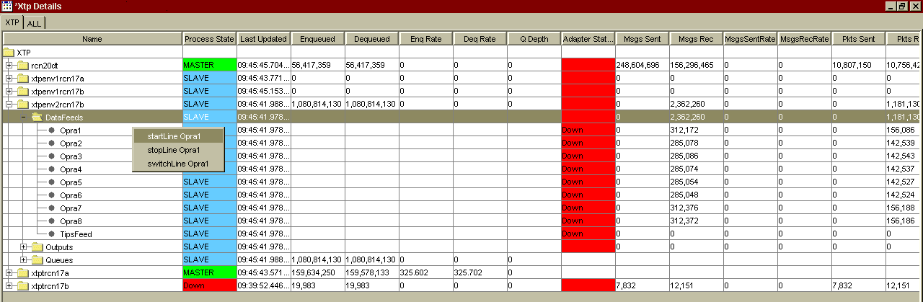
The screenshot shown below is a dialog that allows to send Admin Request commands to XTP processes. The first combo box contains a list of all XTP processes, the second combo box is populated with the list of the AR Commands available for the process selected in the first combo box. The third combo box contains a list of arguments that can be passed with the command selected in the second combo box.

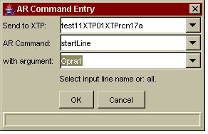

The following dialog also allows user to sent AR Command to the XTP processes. It allows to send a command to several processes at the same time.

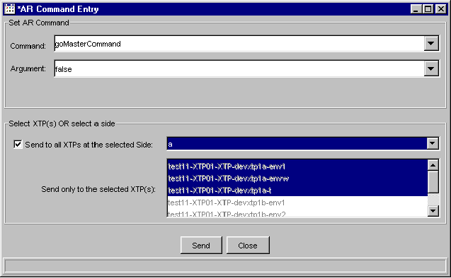

The screenshot below is an example of the AR Command help:

