Combined on new processor
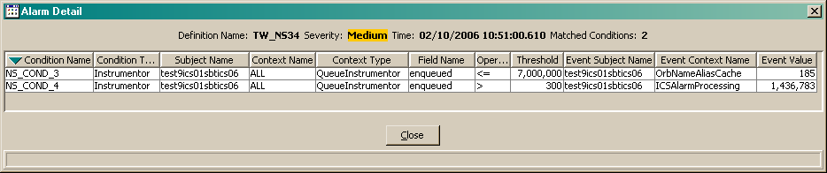

Single on new processor
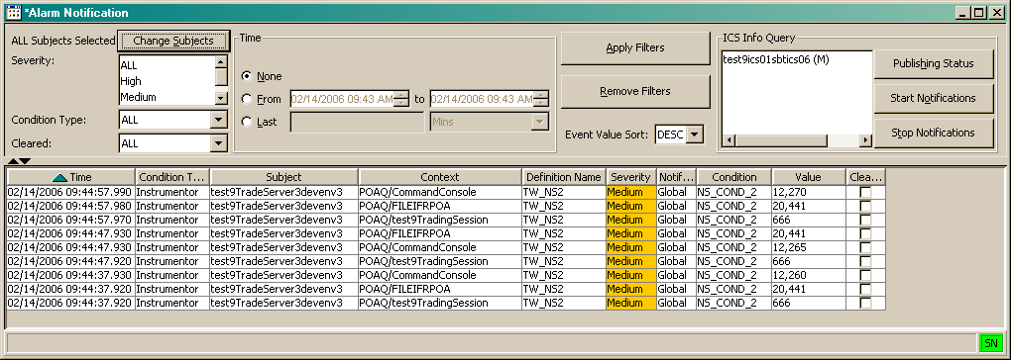

Combined on old processor
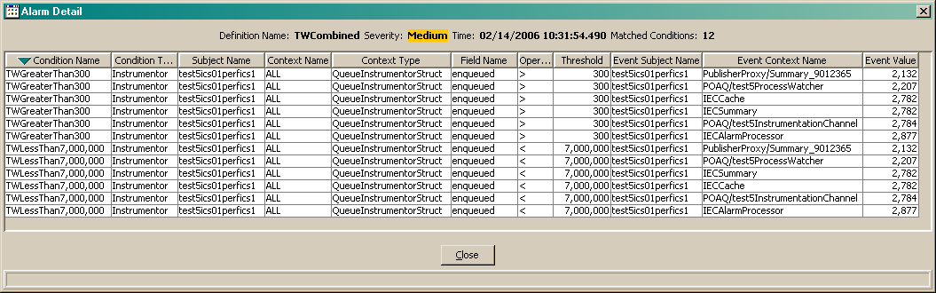

Single on old processor
