

System Health Monitor User Guide
Version 4.1

Disclaimer

Copyright © 2004 Chicago Board Options Exchange. All rights reserved.
The information contained in this document constitutes confidential and/or trade secret information belonging to CBOE. This document is made available to CBOE members and member firms for use with CBOEdirect™. This document is provided "As Is" with all faults and without warranty of any kind, either expressed or implied.

Change Notices

The following change notices are provided to assist users of the System Health Monitoring application in determining the impact of changes to their processing.
If you have any questions or review comments about this document, please contact Odalys Castro at (312) 786-8817.

Date | Version | Description of Change
2/03/05 | 4.1 | New user interfaces to monitor Extreme Ticker Plant (XTP)
11/01/04 | 4.0 | Updated System Health user interfaces  CAS Monitor interface updates  New user interface for Preferences  New section for Alarms
6/22/04 | 3.0 | New Orb Name Alias Admin user interface  CAS Monitor interface updates  Display of process status in Open Tasks toolbar
4/12/04 | 2.0 | CAS Monitoring interface updates  New user interface for Search and Filter options  New System Summary User Interface
02/17/04 | 1.0 | First draft.

Table of Contents
Table of Contents iii
Introduction v
Purpose v
Intended Audience v
Conventions Used in this Guide vi
Section 1: Screen-Based Trading System Health Monitor 7
Getting Started 8
Alarms 9
Set Alarm Conditions 9
Create an Alarm Condition 10
Update an Alarm Condition 11
Delete an Alarm Condition 11
Apply Filters 11
Alarm Activation 12
Create Alarm Definitions 13
Update Alarm Definition 14
Delete an Alarm Definition 14
Activate an Alarm Definition 15
Update Alarm Activation 15
Delete Activation 16
Apply Filters 16
Display Alarm Notifications 17
Apply Filters 18
Edit Column Preferences 21
Sort and Rearrange Columns 21
CAS Monitoring 22
CAS Monitor Display 23
View CAS Properties 24
Edit Column Preferences 25
Edit the Orb Name 25
View Alarm Notification 26
Sort and Rearrange Columns 27
Save Window Preferences 27
Orb Name Alias Admin 28
Preferences 31
Business Preferences 31
Saved Configuration Maintenance 32
System Health 34
System Health Functionality 35
Access Components and Processes 36
Verify Process State 36
Subscribe for Instrumentors 37
Subscribe for Multiple Orbs 38
View the Context Details of a CAS 39
Copy/Print Cell Information 43
Condense Instrumentor Branches 45
Editing the Orb Name 45
View Notifications 45
Notification Processing 46
Edit Preferences 47
Queue 48
Thread Pool 49
Method 51
Network 52
Heap 53
Count 55
Event 56
Filter and Search Options 57
Sort and Rearrange Columns 60
Edit Column Preferences 60
Save Window Preferences 60
System Summary 61
Cluster Summary 61
Process Summary 62
XTP Monitoring 63
XTP Alarm Notification Display 64
Filter Alarms by Severity 65
Cleared and Acknowledge Checkboxes 65
XTP Process Status 65
Change Process Status 66
Change Process Status Using AR Commands 67
XTP Process Details 68
Start, Stop and Switch Network Instrumentators 69
Sort and Rearrange Columns 72
Console Window 73
Open Console Window 73
Exit the System 75
Exit the System 75
Section 2: Reference Guide 76
Task Toolbar 77
About System Health Monitor 77
Open Tasks 77
Resize 77
Save Configurations 78
Apply Default Preferences 78
Window Control 79
Customizing System Health Monitor Windows 80
Edit Column Preferences 80
Display 82
Sizing Windows 82

Introduction

Purpose | This user guide was written to assist CBOE Operators and Developers in managing, identifying and error troubleshooting the CBOEdirect screen-based trading system.
Intended Audience | This user guide is intended for System Operators or any person interested in the state of the CBOEdirect screen-based trading system.
Conventions  Used in this Guide | The System Health Monitor application was designed so that you can perform all of your activities from several display windows. Some fields are sensitive to both right and left mouse clicks. Window control functions can also be activated by using keyboard commands.  Section 1 of the document illustrates how to perform the necessary functions of the monitoring tool. Additional information about window configuration and sizing can be found in Section 2: Reference Guide.  There are several conventions used throughout this guide to help trigger important information:
 | Bolding | Used to highlight menu selections (e.g., Login) and button names (e.g., Update)
 |  Note: | This notation is used to indicate important information you should note when performing the associated function.
 | Brackets [ ] | Used to highlight keyboard commands (e.g., [Alt]-[O]). Note that when [Alt] or [Ctrl] are used in conjunction with another key, hold down the first key while pressing the second.  Some button functions can be executed through keyboard commands. Hold down the [Alt] key and press the keyboard character of the underlined letter in the command. For example:  [Alt]-[R] Restores an active window
 | 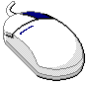 | This mouse graphic with the right mouse button highlighted will appear in the margin when accompanying instructions relate to functions activated by clicking the right mouse button.  All other mouse commands (such as double clicking to display a window) refer to a normal left mouse click.
 | Process Status Values | This graphic will appear in the margin when there is information relating to process status values.

 | Section 1:  Screen-Based Trading System Health Monitor

This section of the user guide will direct you through all functions of the System Health Monitor tool for CBOEdirect and its interfaces with related CBOE systems.

Getting Started

When you launch the System Health Monitor application, the following menu window will display.
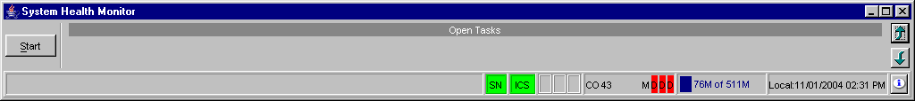
From this window, you have the ability to display various components of the CBOEdirect screen-based trading system. In addition, you can quickly view the status of the System Health Monitor and Collector from the right-hand corner of the Open Tasks toolbar.

In the example above, “SN” indicates that the subscription for alarm notification is active. “CO 40” represents the Instrumentation Collector Server (ICS) where the instrumentor data is being received. If the instrumentor data were being received by the Event Channel (EC), the Open Tasks toolbar would display “EC”. In the example above, ICS is up.
The status of all ICS processes display as Master (M), Slave (S) or Down (D). In the example above, one process is in Master mode. The other processes are Down. A tool tip for the process status displays the Orb name of the ICS display.
If status information displays in red, two consecutive periods have passed where the number of instrumentors received is zero. If status information displays in yellow, one consecutive period has passed where the number of instrumentors received is zero.
Once you have verified the status of the System Health Monitor and Collector, you can proceed to use all the functions of the System Health Monitor application.

Alarms

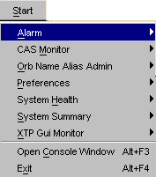  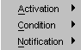 | Situations that are considered critical to CBOEdirect are highlighted through alarms in the System Health Monitor. From the Alarms section of the Start Menu, you can create alarm conditions for CBOEdirect processes, activate alarms and view alarm notifications.
Set Alarm Conditions | If you want the System Health Monitor to notify you when a CBOEdirect process is in a critical state, you must create a condition for that process. From the Alarm sub-menu, select Condition, Create New Window. The Alarm Condition window will display.
 | 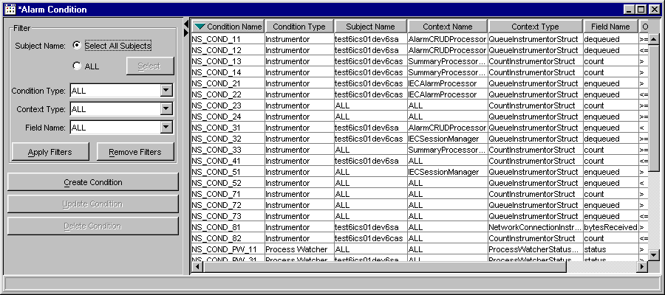
 | Scroll to the right to view additional data fields.
 | 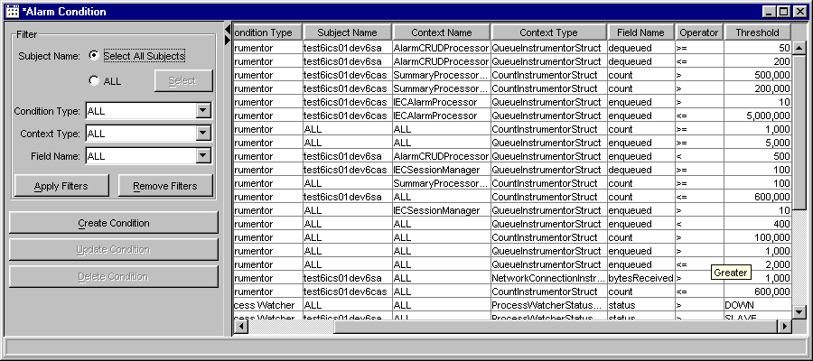
 | From this window, you have the capability to create, update or delete alarm conditions. For ease of readability, you can also select filters to sort the conditions.

Create an Alarm Condition
To create an Alarm condition, click Create Condition or right-mouse click on any data row and select Create Condition. The Create Condition window displays.
 | 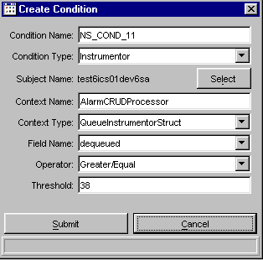
- Enter a logical name for the alarm condition in the Condition Name text box.
- Select the Condition Type (ie. Instrumentor or Process Watcher).
- Choose the Subject Name you are setting the condition for from the Select button.
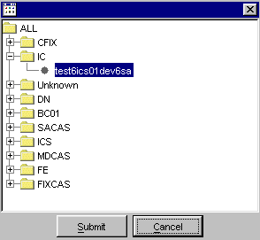
- Enter the Context Name in the text field.
- Select the Context Type from the drop down list.
- Choose the Field Name where the condition will be monitored.
- Select the type of operation that will be monitored in the Field Name from the Operator drop down list.
- Enter the limit in the Threshold text field.
- Click Submit. Click Confirm. The alarm condition displays in the window field box.
- If you decide not to create a new alarm condtion, click Cancel. The system will return to the Alarm Condition window.

Update an Alarm Condition
To update an alarm condition, select the condition you wish to update and click Update Condition or right-mouse click on the data row and select Update Condition. The Update Condition window displays.
 | 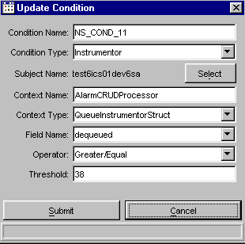
- Update the necessary fields.
- Click Submit. Click Confirm. The updated alarm condition displays in the window field box.
- If you decide not to update the condtion, click Cancel. The system will return to the Alarm Condition window.

Delete an Alarm Condition
To delete an alarm condition, select the condition and click Delete Condition. The System Health Monitor will prompt you to verify you are sure you want to delete the condition. Click Yes to perform the deletion. Click No to cancel the request.
You can also delete a condition by right-mouse clicking on the condition data row you wish to delete and select Delete Condition.

Apply Filters
You can sort the alarm conditions by Condition Type, Context Type and Field Name.
From the Filters section of the window, select the Subject Name radio button. If you choose Select all Subjects the filtering mechanism will apply to all Subject Names. If you select All you can specify which component to sort.
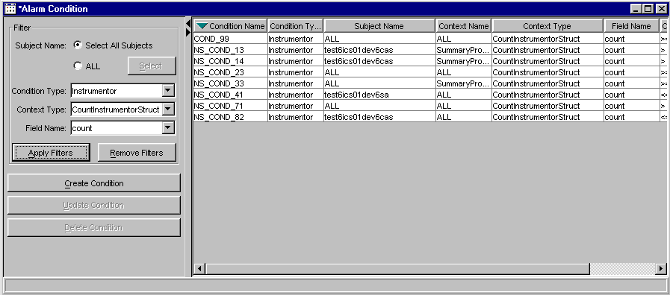

- To filter by condition type, select the Condition Type from the drop down list and click Apply Filters. The alarm conditions for the condition type you chose will display.
- To filter by Context Type, choose the context from the drop down list. Click Apply Filters. The alarm conditions for the context type you chose will display.
- To filter by Field Name, select the field name from the drop down list. Click Apply Filters. The alarm conditions for the field name will display.
- To remove the applied filters, click Remove Filters. All the alarm conditions display.
Alarm Activation | Once you have created alarm conditions, the Alarm Definition Activation window allows you to create definitions for the conditions and set activation.  To display the window, select Activation from the Alarm sub-menu.
 | 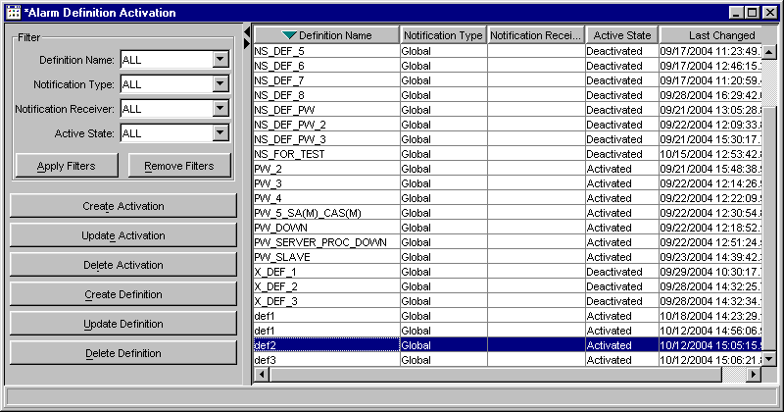

Create Alarm Definitions
To create an alarm definition:
- Click Create Definition. The Create Definition window will display with the Alarm Condition window at the bottom. For alarm condition details, refer to the section: Set Alarm Conditions, page 10.
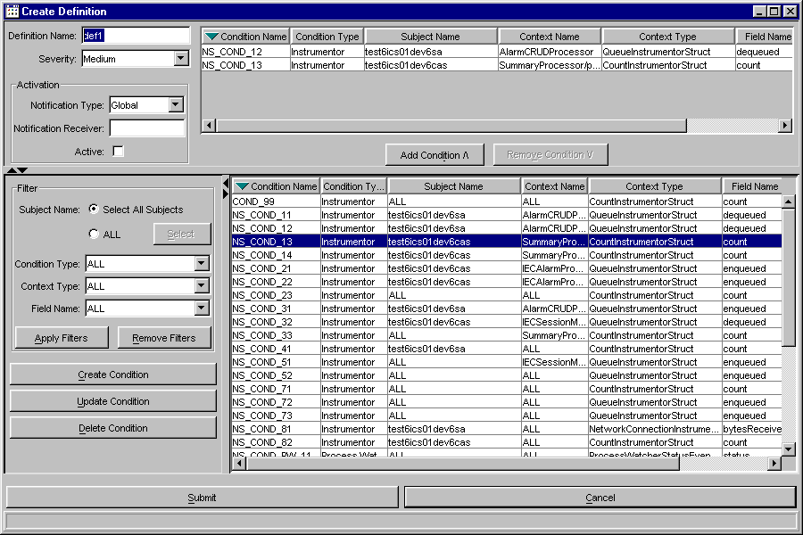
- Enter the Definition Name in the text box.
- Select the Severity level from the drop down list. For alarm severity level details, refer to the Business Preferences section, page 32.
- From the condition list box, select the alarm condition(s) you would like to apply to the definition. Click Add Condition^. The alarm condition appears in the as a data row in the window.
- From the Activation section of the window, choose the Notification Type.
 Note: Version 4.1 supports only global notification. Global alarms activation will appear in all System Health GUIs and live past the life of the GUI.
Local activation will be only sent to the System Health GUI that requests the alarm. Local alarm activations will be removed when the GUI is shutdown. – Version 4.1 does not support local notification
- Enter the Notification Receiver (i.e. e-mail address) in the required text box.
 Note: The Notification Receiver is not supported in Version 4.0
- If you would like to start the alarm, select the Active checkbox. Deselect the checkbox, to deactivate the alarm.
- If you wish to cancel your changes before submitting them into the system, click Cancel. The system will return you to the Alarm Definition Activation window.
- Click Submit. Click Confirm. The Create Definition window closes and the new definition appears in the Alarm Definition Activation window.

Update Alarm Definition
To update an existing alarm definition:
- Select the definition from the Alarm Definition Activation window.
- Click Update Definition.
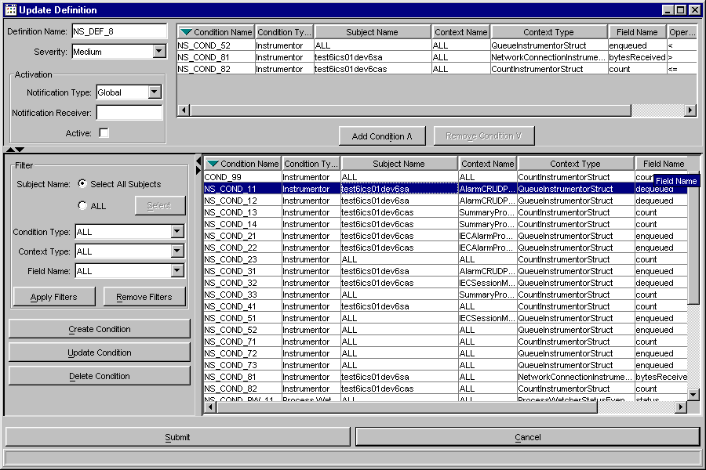
The Update Definition window will display. The Definition Name defaults to the definition name you selected in the Alarm Definition Activation window. Activation information and conditions for the definition name appear in the top portion of the window.
At this point, you can add new conditions or change the Activation status of the alarm definition.
- If you wish to cancel your changes before submitting them into the system, click Cancel. The system will return you to the Alarm Definition Activation window.
- Click Submit, Click Confirm. The Update Definition window closes and the updated definition appears in the Alarm Definition Activation window.

Delete an Alarm Definition
You can delete an alarm definition by highlighting the data row and clicking Delete Definition or by right-mouse clicking on the data row and selecting Delete Definition. The system will prompt you to confirm that you wish to delete the alarm definition and all its activations. Click Yes to confirm. The alarm definition is removed from the system. Click No to return to the Alarm Definition window without deleting the defintion.

Activate an Alarm Definition
To activate an existing alarm definition, return to the Alarm Definition Activation window and then:
- Select the alarm definition from the box list and click Create Activation or right-mouse click on the data row and select Create Activation.
 | 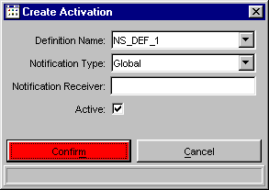
- The Create Activation window will display with the set Definition Name, Notification Type, Notification Receiver and activation state. If you wish, you can change the Definition Name, Notification Type and Notification Receiver.
 Note: Global alarms activation will appear in all System Health GUIs and live past the life of the GUI. – Version 4.1 supports only global alarms
Local activation will be only sent to the System Health GUI that requests the alarm. Local alarm activitions will be removed when the GUI is shutdown. – Not implemented in Version 4.1
- Select the Active checkbox to activate the alarm definition.
- If you wish to exit the Create Activation window without saving your changes, click Cancel. The system will return you to the Alarm Definition Activation window.
- To save your changes, click Submit. Click Confirm. The alarm definition and its conditions will be monitored by System Health.

Update Alarm Activation
To update the activation status of an existing alarm:
- Select the alarm definition from the box list and click Update Activation or right-mouse click on the data row and select Update Activation.
 | 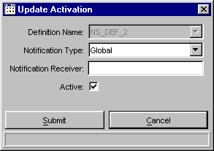
The Update Activation window will display with the selected Definition Name, Notification Type and Notification Receiver. The Definition Name will be grayed out and cannot be changed.
- If desired, change the Notification Type and Notification Receiver.
 Note: Global alarms activation will appear in all System Health GUIs and live past the life of the GUI.- Version 4.1 supports only global alarms
Local activation will be only sent to the System Health GUI that requests the alarm. Local alarm activitions will be removed when the GUI is shutdown. - Not supported in Version 4.1
- Select the Active checkbox to activate the alarm definition or deselect the checkbox to deactivate the definition.
- If you wish to exit the Update Activation window without saving your changes, click Cancel. The system will return you to the Alarm Definition Activation window.
- To save your changes, click Submit. Click Confirm.

Delete Activation
You can delete an alarm definition activation by highlighting the data row and clicking Delete Activation or by right-mouse clicking on the data row and selecting Delete Activation. The system will prompt you to confirm that you wish to delete the alarm definition and all its activations. Click Yes to confirm. The alarm definition activation is removed from the system. Click No to return to the Alarm Definition window without deleting the defintion.

Apply Filters
You can sort the alarm definitions by Definition Name, Notification Type, Notification Receiver and Active State.
From the Filters section of the window, select the Definition Name, Notification Type, Notification Receiver and Active State. Click Apply Filters.
 | 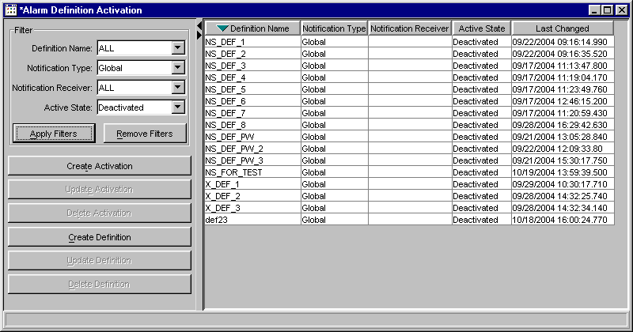
In the example above, the Alarm Definition window displays all defintion names with global notification types in deactive state with all types of notification receivers.
To remove the applied filters, click Remove Filters. All the alarm definitions will display.
Display Alarm Notifications | When the System Health Monitor alarm notifies you that a CBOEdirect process is in a critical state, you can view the details of the notification through the Alarm Notification window.  From the Start menu, select Alarms, Notification, Create New Window. The Alarm Notification window will display.
 | 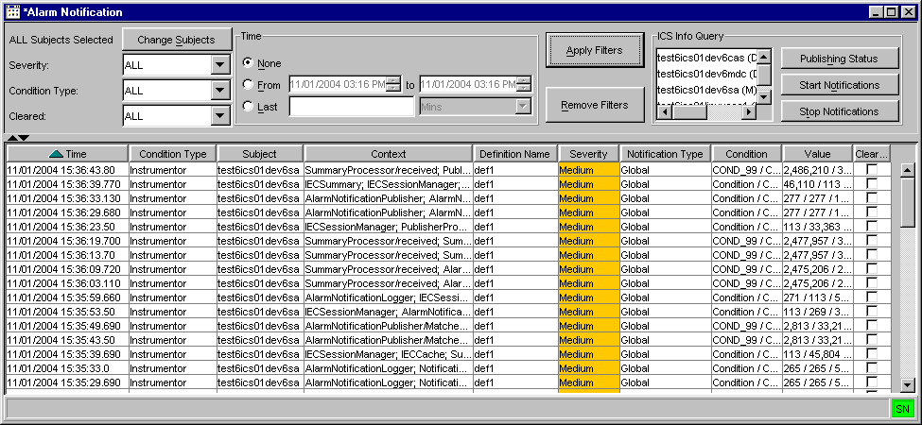
 | The notification window displays the time the alarm triggered, its condition and condition type, subject, context, defintion name, severity level, notification type and value.
 | A multi-line tooltip displays the full condition name, context name and values.
 | 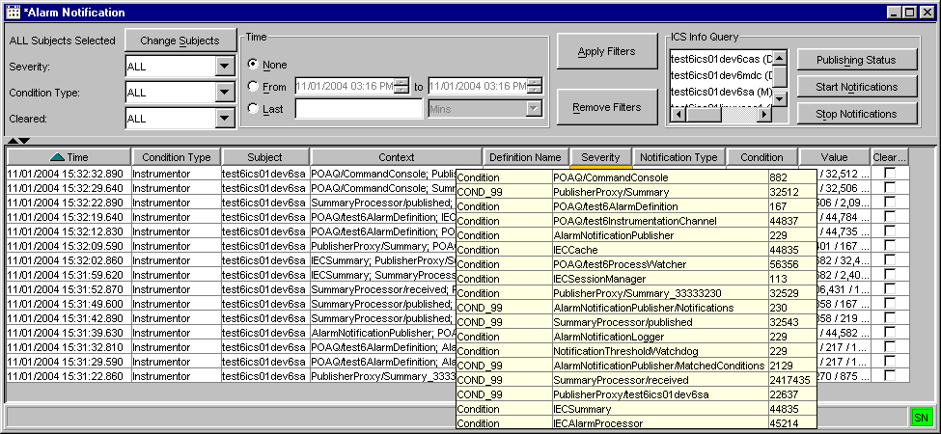
 | You can view additional information for a specific alarm by right-mouse clicking on the alarm’s data row and selecting Show Detail.
 | 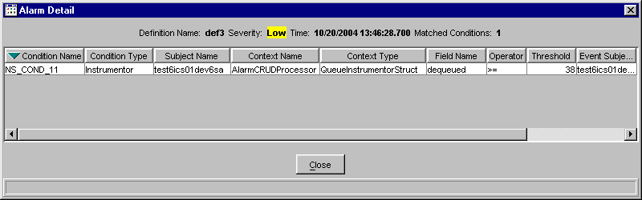
Scroll to the right to view additional data fields.
To return to the Alarm Notification window, click Close.

Apply Filters
You can sort alarm notifications by process/subject, severity, condition type, cleared status and time.
To select which process to filter, click Change Subjects and make your selection.
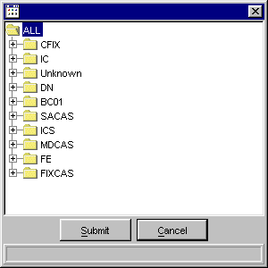

 | Select additional filters and click Apply Filters. The Alarm Notification window displays with the requested information.
 | 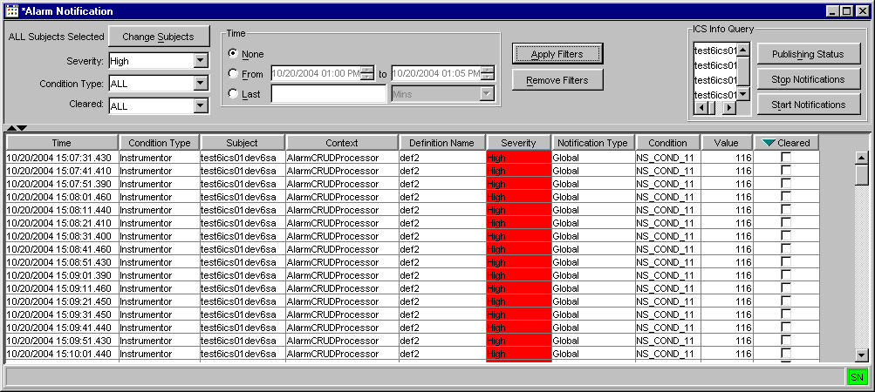
To sort by time, select the From radio button in the Time section of the window and choose the time range to filter. Click Apply Filters.
Or, select the Last radio button to sort by minutes or hours. For example, enter the number 2 and select minutes from the drop down list. Click Apply Filters. The system will sort alarm notifications for the last two minutes.

 | To clear alarm notifications for multiple conditions:
 | 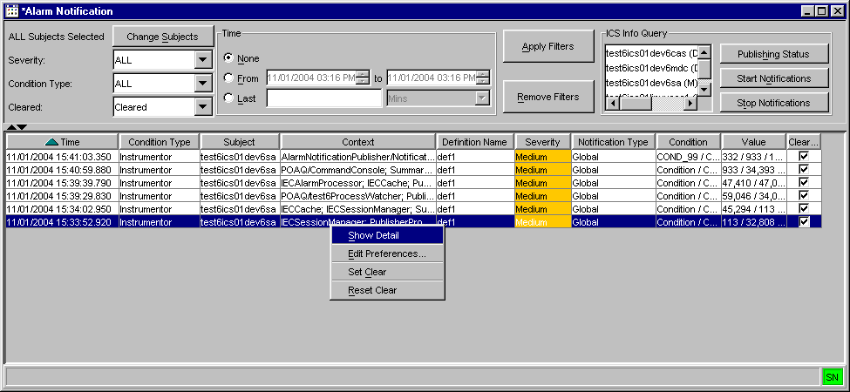
- Highlight multiple data rows and perform a right-mouse click. A sub-menu will display.
- Click Set Clear. The Clear column will display check boxes for the highlighted data rows.
- If you would like to query for only the cleared alarm notifications, select Cleared from the Cleared drop down list. Click Apply Filters. The system will display only the cleared alarms.
- If you would like to reset the alarms: highlight the data rows and choose the option, Reset Clear. The system will deselect the check boxes from the Clear column.
- To filter alarms notifications that are not cleared, select Not Cleared from the Cleared drop down list. Click Apply Filters. The system will display all the alarm notifications that have not been cleared.
- Click Remove Filters to edit out the applied filters and retain the original notification list.
 | To query ICS status, select the process from the ICS Info Query section of the window and click Publishing Status. The Alarm Notification Publishing State window displays with the state of the notification.
 | 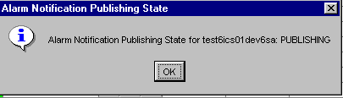
In the example above, alarm notification is publishing for test6ics01dev6sa.
Click OK to close the window.
 | If you would like to begin monitoring conditions for the process, select the option: Start Alarm Notifications.
 | 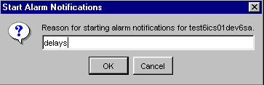
The Start Alarm Notifications window displays. Enter the reason for starting alarm notifications for the process and click OK. Alarm notifications will activate.
Click Cancel to close the window without starting notifications.
 | If you would like to stop alarm notifications for the process, select the option: Stop Alarm Notifications.
 | 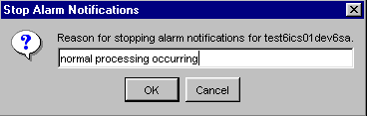
The Stop Alarm Notifications window displays. Enter the reason for starting alarm notifications for the process and click OK. Alarm notifications will deactive.
Click Cancel to close the window without starting notifications.
Edit Column Preferences | You can customize your Alarm windows by selecting or deselecting specific columns to display. To filter columns, right mouse click on a data row. Select Edit Preferences. The Edit Column Preferences window will display.  - Select or deselect columns for viewing and modify column arrangement as desired.  - To save your changes, click Ok.  - If you wish to retain the default settings, click Cancel.  For detailed information, refer to the Edit Column Preferences section, page 82.
Sort and Rearrange Columns | You can sort any column on the Alarm windows at any time by clicking on the column heading. The column changes to reflect the sorted data.  To rearrange the display of the columns, place your cursor on the column heading, then using your mouse, click on the column and drag it to the desired position.

CAS Monitoring

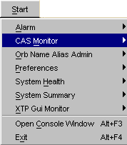 | The System Health Monitor application allows you to view the status of CASs in relation to CBOEdirect.  To open the CAS Monitor window, click the Start button from the Menu window. Select CAS Monitor, Create New Window. The CAS Monitor window will display. CAS data is automatically updated every n (30) seconds.  If at anytime you wish to exit the CAS Monitor window, click Close.
 | 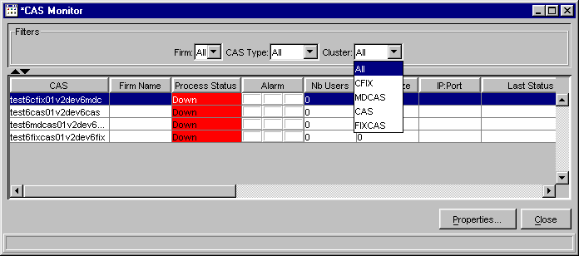
 | Move the scroll bar to the right to view additional data fields.
 | 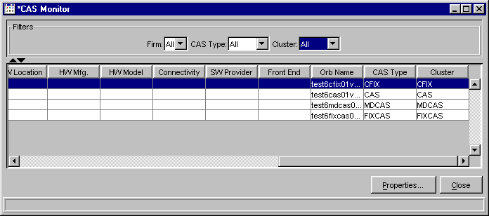
CAS Monitor Display | The CAS Monitor window displays a summary of the state of the CAS components in column format.  - The CAS column displays all the CASs used in a CBOEdirect environment. The list will show all CAS, MDCAS, CFIX and FIXCAS processes for an environment. In the example above, the CAS column shows all the processes in the test6 environment.  - The Firm Name column shows which Firm is assigned to the CAS.  - The Process Status column displays the state of the process. The background color of the cell reflects the state of the process. If the process is Up, the background color displays in green. If the process is Down, the background color displays in red.
- The Alarm column indicates alarm state of High, Medium or Low for a process.
- The number of users on a particular CAS is shown in the Nb Users column.
- The queue size for the CAS processes will display in the Queue Size column.
 Note: If you are monitoring a development or test environment, zero will usually display in the column.
 Note: You must be subscribed to instrumentors for the CAS to see data in this field. For instructions on how to subscribe to instrumentors and Orbs, refer to the Subscribe for Instrumentors section of the document, page 38.
- The IP address and port location display in the IP:Port column.
- The Last Status column reflects the time and date of the last change made to the data for the CAS. This column updates every 30 seconds.
- The Memory Usage column displays the system memory usage of the CAS in megabytes (Mb), if the CAS process status is Up. If the CAS process status is Down, the memory usage displays as 0.00 Mb.
- The Heap Size column shows the heap size for the CAS in megabytes (Mb), if the CAS process status is Up. If the CAS process status is Down, the heap size displays as 0.00 Mb.
- The version of code installed in the CAS displays in the Version column.
- The location of the CAS hardware appears in the HW Location column.
- The HW Mfg. column displays the name of the hardware manufacturer for the CAS.
- The HW Model column shows the CAS model number.
- The Connectivity column indicates the network connectivity provider for the CAS.
- The name of the CAS software provider displays in the SW Provider column.
- The Front End column references which FE connects to the CAS.
- The name of the Orb pertaining to the CAS appears in the OrbName column.
- The CAS Type column describes the kind of CAS that is being displayed.
- The Cluster column shows where the CAS is collected.

You can filter the CAS Monitor by Firm name, CAS Type or Cluster.
- To filter by Firm name, select the Firm from the drop down list in the Filters section of the window. The CASs for the select Firm immediately display on the CAS Monitor window.
- To filter by CAS type, make your selection from the CAS Type drop down list. Data for the selected type of CASs display on the CAS Monitor window.
- To filter by cluster, choose your cluster from the Cluster drop down list. The CASs that are collected in that cluster display on the CAS Monitor window.
View CAS Properties | The properties that have been defined for a CAS can be viewed at anytime as long as the CAS is up. Right mouse click on the CAS data row and select CAS properties,  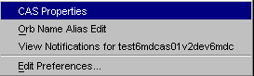  or click on the Properties button. The CAS Properties window displays.
 | 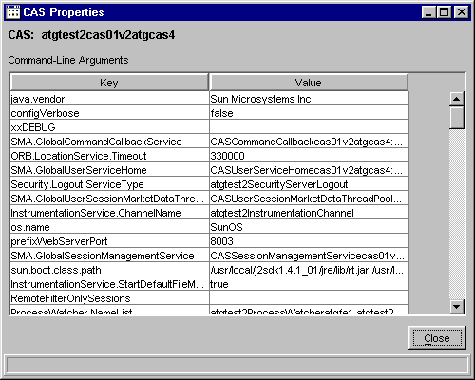
From this window, you can view the command line arguments that have been defined for the CAS.
- You can sort either the Key or Value columns by clicking on the corresponding column header. The columns change to reflect the sort.
- Click Close to exit the window and return to the CAS Monitor display.
Edit Column Preferences | You can customize your CAS Monitor window by selecting or deselecting specific columns to display. To filter columns, right mouse click on a data row. Select Edit Preferences. The Edit Column Preferences window will display.  - Select or deselect columns for viewing and modify column arrangement as desired.  - To save your changes, click Ok.  - If you wish to retain the default settings, click Cancel.  For detailed information, refer to the Edit Column Preferences section, page 82.
Edit the Orb Name | The system has been designed to display the Orb Name as the CAS name in the CAS column. If you wish to change the Orb Name in the CAS column to be more descriptive of the CAS, right mouse click on the CAS data field and select Orb Name Alias Edit.  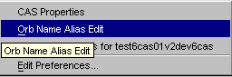  The Orb Name Alias Edit window displays.
 | 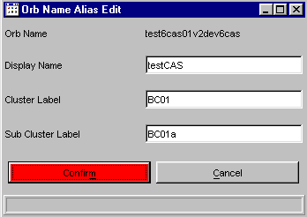
The Orb Name displays with its values along with editable text fields for Display Name, Cluster Label and Sub Cluster Label.
- In the Display Name text field, enter the name you want displayed in the CAS column in place of the Orb Name.
- In the Cluster Label text field, enter the name of the server cluster (i.e. BC01)
- If you wish, you can enter the name of the sub cluster (i.e. BC01a) in the Sub Cluster Label text field.
- Click Submit. Click Confirm.
 | 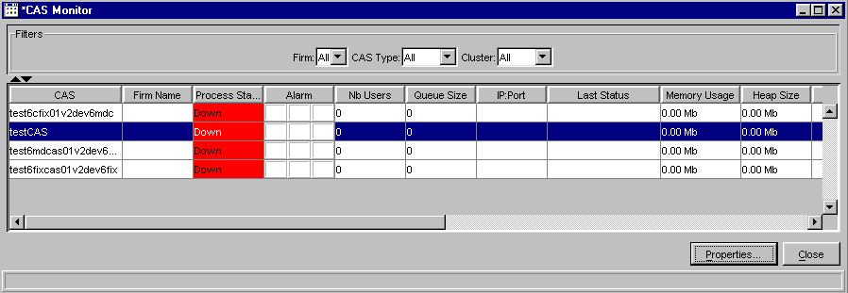
All the System Health Monitor windows automatically update with the edited fields. The CAS column changes to show the name typed in the Display Name text field, which in this example is testCAS. The Orb Name column will still show the full Orb Name.
In the System Summary window, BC01 displays in the Cluster list. BC01a displays in the Cluster list as the Sub Cluster of BC01. When you select the BC01 cluster checkbox, testCAS appears as a process under the BC01 Cluster.
In the System Health window, BC01 displays as the Cluster, BC01a displays as the Sub Cluster and testCAS displays below the Sub Cluster.
 |  Note: Only one production box has permissions to change and store Orb Names. All other production boxes read the information from that box.
View Alarm Notification | As long as the CAS is up, alarm notifications can be viewed at anytime.  Right mouse click on the CAS data row you are interested in viewing and select View Notifications.  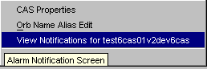  The Alarm Notification window will display. For notification details, refer to the Display Alarm Notifications section, page 18.
Sort and Rearrange Columns | You can sort any column on the CAS Monitor window at any time by clicking on the column heading. The column changes to reflect the sorted data.  To rearrange the display of the columns, place your cursor on the column heading, then using your mouse, click on the column and drag it to the desired position.
Save Window Preferences | If you want to save your changes and automatically open the window with your preferences, be sure to save the configuration on the Open Tasks toolbar.  To save window preferences:  - Right mouse click on the corresponding window task button.  - Select Save Configuration. The Save Configuration window will display.  - Enter the Configuration Name for the window.  - Click Submit. Click Confirm. The saved window will appear when you open a new CAS Monitor window.  - If you decide you do not wish to save the new configuration, click Cancel.  For detailed information, refer to the Save Configurations section, page 80.
 | Orb Name Alias Admin

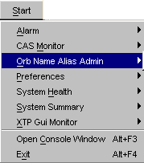 | The Orb Name Alias Admin allows you to view and modify all processes in CBOEdirect from one window.  From the Start menu, select Orb Name Alias Admin, Create New Window. The Orb Name Alias Admin window will display.  Click Cancel at any time to exit the window.
 | 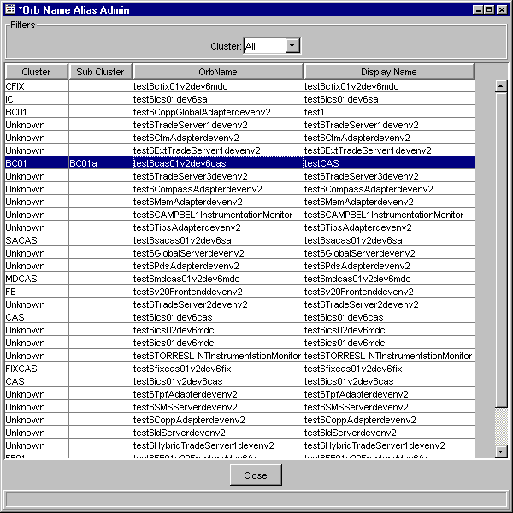
To edit the name of an Orb, right-mouse click on the OrbName row and select Orb Name Alias Edit.
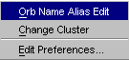
 | 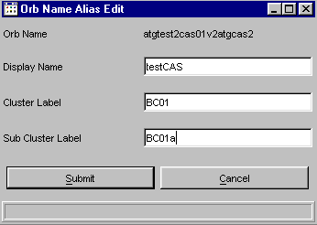
The Orb Name Alias Edit window displays. The Orb Name displays with its values along with editable text fields for Display Name, Cluster Label and Sub Cluster Label. Edits in this window can only be performed on one row at a time.
- In the Display Name text field, enter the name you want displayed in the Display Name column in place of the Orb Name.
- In the Cluster Label text field, enter the name of the server cluster (i.e. BC01)
- If you wish, you can enter the name of the sub cluster (i.e. BC01a) in the Sub Cluster Label text field.
- Click Submit. Click Confirm. The Display Name column labels the Orb Name as testCAS. The Cluster and Sub Cluster columns display BC01 and BC01a, respectively. The Orb Name column will still show the full Orb Name.
You can change the cluster or sub cluster of an Orb Name by right-mouse clicking on the Orb Name row and selecting the Change Cluster option. The Change Cluster window displays.
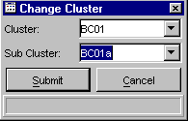
You can select multiple rows to edit as long as the Orb Name will use the same cluster and sub cluster.
Enter the new cluster in the Cluster field or you can select a cluster from the drop down list.

Enter the sub cluster in the Sub Cluster field. Click Submit. Click Confirm. The Orb Name Alias Admin window displays with the new cluster and sub cluster labels for all highlighted rows.
 | The Orb Name Alias Admin window can be filtered by cluster. Select the cluster from the Cluster drop down list in the Filters section of the window. The window displays only the Orb Name information based on your cluster selection.
You can customize your Orb Name Alias Admin window by selecting or deselecting specific columns to display. To filter columns, right mouse click on a data row. Select Edit Preferences. The Edit Column Preferences window will display.
- Select or deselect columns for viewing and modify column arrangement as desired.
- To save your changes, click Ok.
- If you wish to retain the default settings, click Cancel.
For detailed information, refer to the Edit Column Preferences section, page 82.
 | Preferences

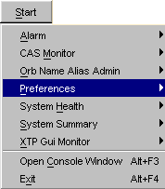  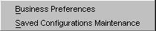 | System Health Monitor configuration and alarm preferences are saved through the Preferences window.  From the Start menu, select Preferences. A sub-menu displays allowing you to choose business preferences or configuration preferences.
Business Preferences | To save alarm perferences, select Business Perferences from the Preferences sub-menu. The preferences window will display.
 | 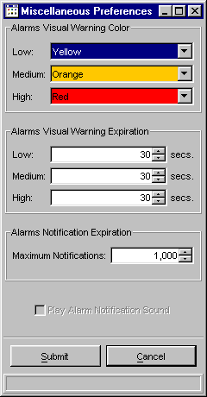
From this window, you can designate the colors and/or patterns and threshold values for alarms.
- Select the visual warning color for the severity of the alarm from the Low, Medium and High drop down lists.
- Enter the alarms visual warning expiration time in seconds for low, medium and high severity levels.
- Enter the maximum number of alarm notifications.
- If you would like the alarm notification to be heard, select the Play Alarm Notification checkbox.
- To save your changes, click Submit. Click Confirm.
- If you decide to exit the preferences window without saving your changes, click Cancel.
Saved Configuration Maintenance | Previous versions of System Health Monitor are saved in the Preferences window.  From the Start menu, select Preferences, Save Configurations Maintenance. The Saved Configuration Maintenance window will display.
 | 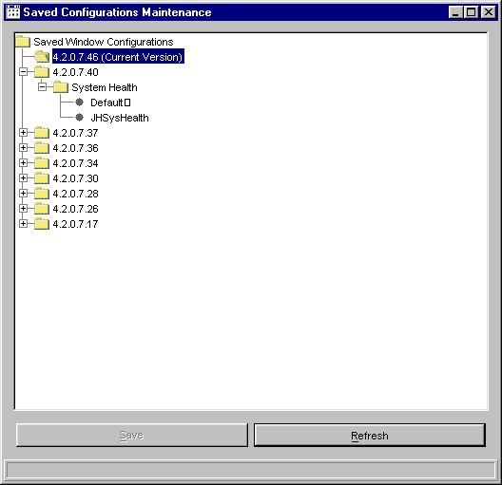
 | From this window, you can apply your previously defined window configurations to the current version of the System Health Monitor. For example, to apply the default configurations for the System Health Monitor from version 4.2.0.7.40 to version 4.2.0.7.46, double-click on the folder labeled 4.2.0.7.40. Click on the System Health folder. After the folder is highlighted, drag and drop it with your mouse onto the folder labeled System Health under version 4.2.0.7.46. The system will prompt you to confirm the conversion.
- Click the Current Version folder to expand the directory tree.
- Click Refresh to condense the Saved Window Configurations directory tree.

System Health

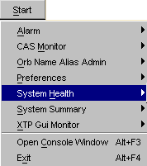 | The System Health window of the System Health Monitor application allows you to monitor and manager the various components (SACAS, FE, BC, etc.) of CBOEdirect. System Health data is automatically updated every n (30) seconds.  To display the System Health window, click Start from the main window. Select System Health, Create New Window. The System Health window will display.
 | 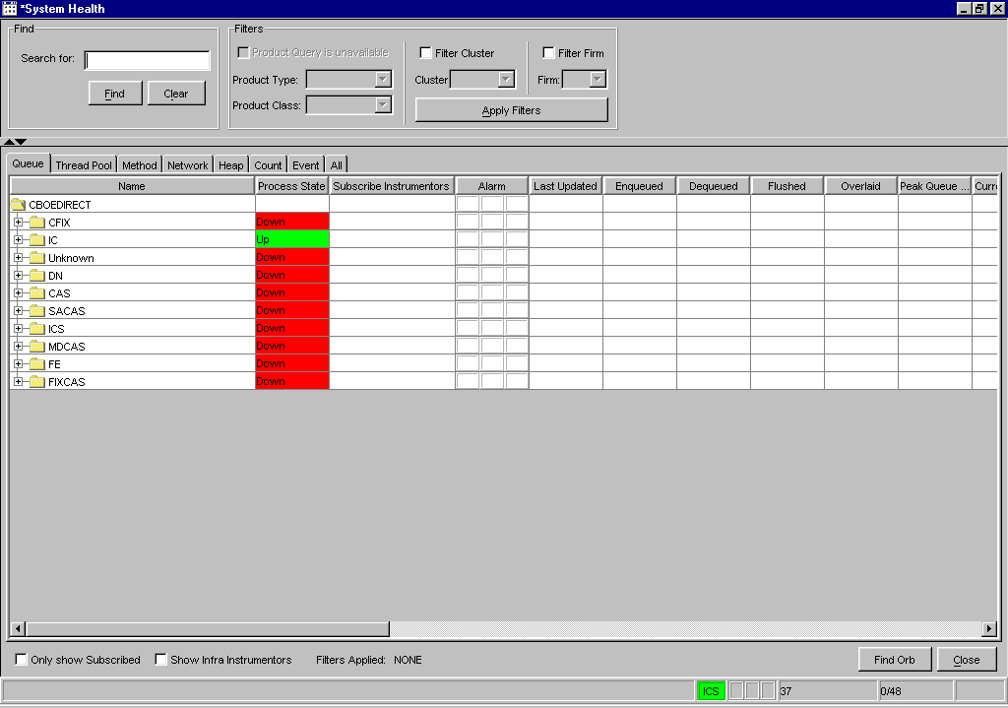
The window displays with search options, filters and eight System Health tabs: Queue, Thread Pool, Method, Network, Heap, Count, Event and All. Each tab provides specific data for the components and sub-processes in column format. The All tab contains all of the individual tabs data fields. The columns that are common to each tab are:
- Name - the component and process names
- Process State - the status of the component and its processes
- Subscribe Instrumentors - denotes a component or process is set to subscribe for all instrumentors
- Alarm - indicates alarm state of High, Medium or Low for a process
- Last Updated - the date and time the information for the component or process was updated
- User Data - free form text field
- Firm Name - the name of the Firm associated to the component
- Orb Name - the name of the Orb related to the component
This section of the user guide will walk you through all the functions of System Health using the IC component and the All tab as an example. Although only the IC will be used as an example, each of the functions described can be performed for any component in any System Health tab.
System Health Functionality | To begin using System Health functionality, click on the All tab to display all the data fields. From the All tab, you can view queue data, thread pool information, method call rates and peaks, network bytes sent through the system as well as disconnects and memory data.  If at anytime you wish to exit the System Health window, click Close.
 | 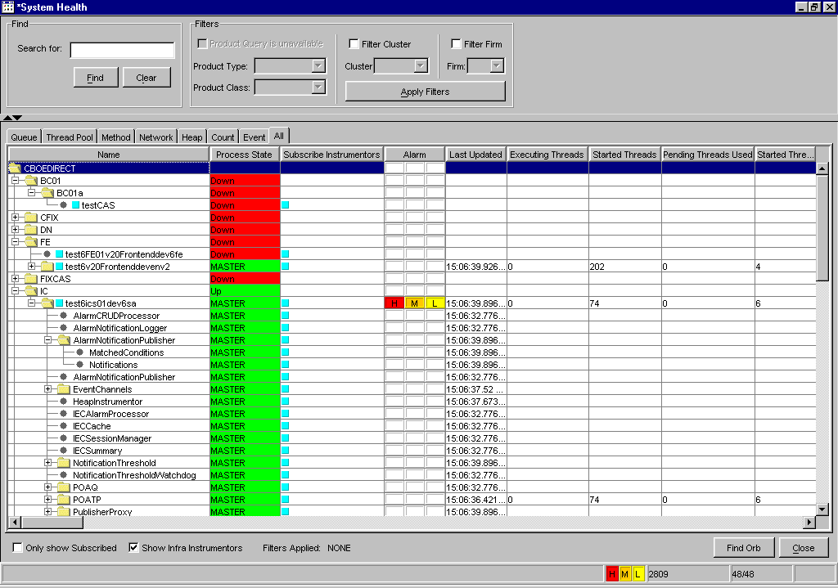
 | Use your scroll bar to view additional data fields to the right of the window.
 | 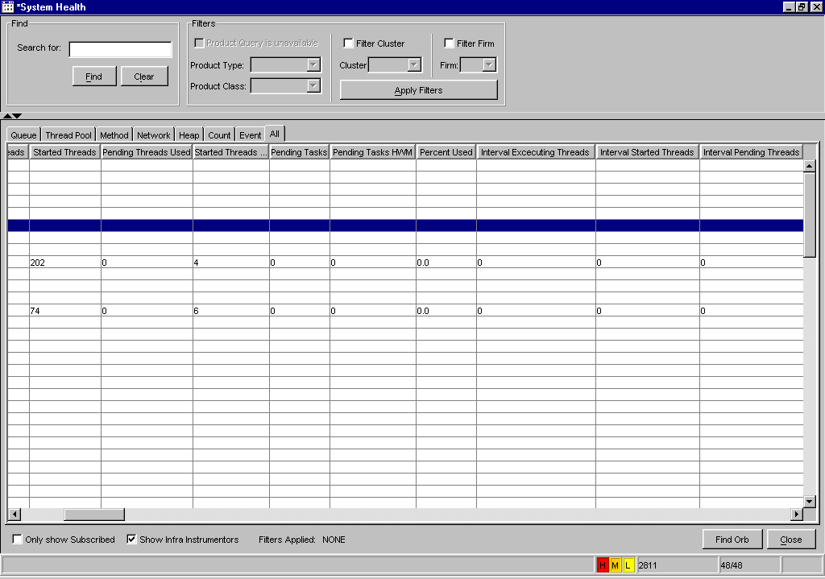
➢ | Access Components and Processes  Initially, the ALL tab appears with the Name column displaying the components at the base container level. You have the ability to determine what level of data you want to view by selecting which level of the component tree to display.  If you wish to view the components at the process level, click the component’s folder to expand the process list. In the example above, the IC tab has been expanded to display its processes.
➢ | Verify Process State  The Process State column displays the status of each process. The background color of the cell reflects the state of the process. For CAS processes (FIXCAS, SACAS, MDCAS and CFIX), if the process is Up, the background color displays in green. If the process is Down, the background color displays in red.  The Server processes will show a process state of Master, Slave, Unkown or Down. Server processes include: IC, BC, GC or any component that is not a CAS.  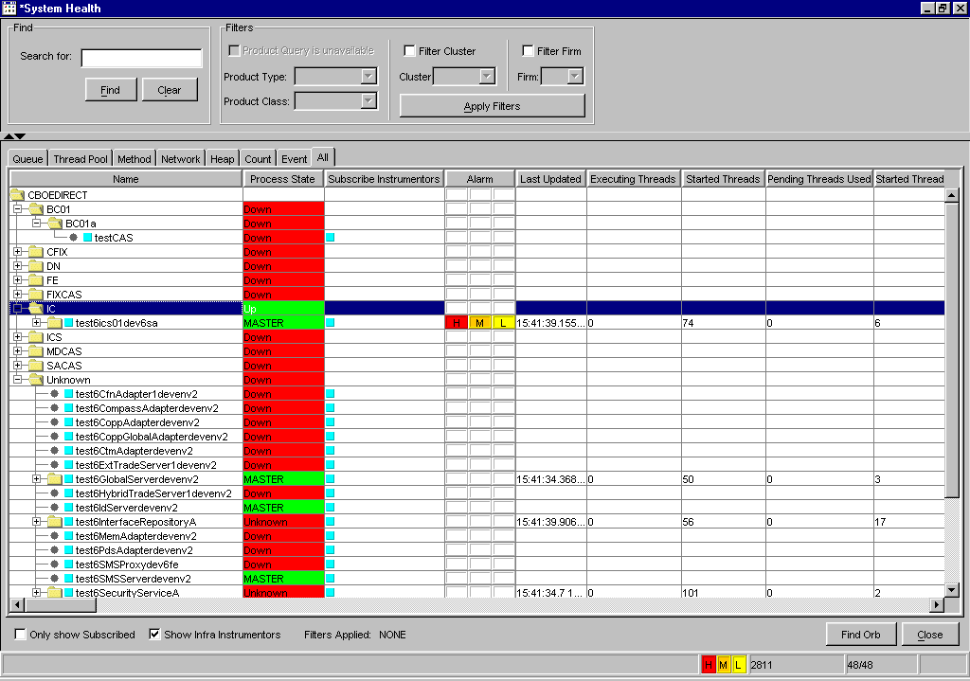  See below for a list of Server process status identifiers.
Process State Values
  Server Status | Background Color
  Up | Green
  Master | Green
  Slave | Blue
  Unknown | Red
  Down | Red
 |  Note: If any of the processes are unknown or down for a cluster, the status of the entire cluster will display as Down or Unknown.

Subscribe for Instrumentors
To subscribe for Instrumentors for a process, right-mouse click on the process name. A new menu displays.
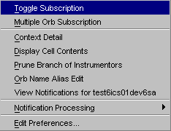

- Select the Toggle Subscription option. A blue box displays in front of the process name and in the Subscribe Instrumentors column, indicating the request for instrumentor information.
- You can subscribe for instrumentors for multiple processes by holding down the Shift or Ctrl key on your keyboard and highlighting the process names. Once the names are highlighted, right-mouse click on a row and select the Toggle Subscription option.
- To display Infra instrumentors, select the Show Infra Instrumentors checkbox on the System Health window. POATP, POAQ and TIOP processes will display beneath the processes.
 Note: The total number of Instrumentors is noted in the lower right-center of the window. In the example above, the total number of instrumentors is 2,811.
- To only display the processes with subscribed instrumentors, click the Only Show Subscribed checkbox on the System Health window. The processes that do not request instrumentor subscriptions will be removed from the display.

Subscribe for Multiple Orbs
To subscribe for Multiple Orbs, right-mouse click on the CAS name. A new menu displays.
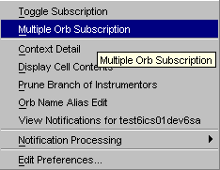

- Select the Multiple Orb Subscription option. The Orb Filter window displays.
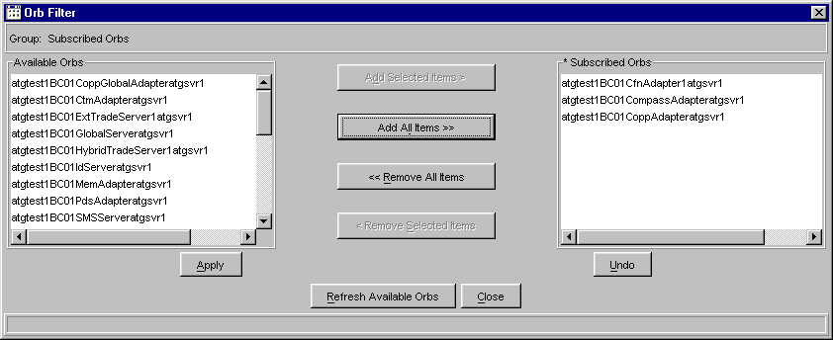

- From the Available Orbs list box, select the Orbs you want to subscribe to. To subscribe to multiple Orbs, hold down the Shift Key on your keyboard and highlight the desired Orbs. Click Add Selected Items. The Orbs will appear in the Subscribed Orbs list box.
- To subscribe to all Orbs, click Add all Items. All the Orbs in the Available Orbs list box will display in the Subscribed Orbs list box.
 Note: If the selected Orbs exceed the maximum number of Orbs set in the property file (currently set at 50), an error message will display. If you receive the error message, reduce the number of Orb subscriptions and continue.
- To unsubscribe from Orbs, select the Orbs from the Subscribed Orbs list. Click Remove Selected Items. The Orbs will display in the Available Orbs list box.
- To unsubscribe from all the Orbs, click Remove All Items or click Undo. The subscribed Orbs will appear in the Available Orbs list box.
- When you are satisfied with your selections, click Apply. Click Close. The subscribed Orbs will appear in the All tab as sub-processes of the CAS.
 Note: The subscribed and total number of Orbs appears in the lower right-center of the System Health window. In the example above, the number of Subscribed/Total Orbs is 48/48.
- To update the available Orbs selection, click Refresh Available Orbs. The available Orbs will update in the Available Orbs list box.

View the Context Details of a CAS
The System Health Monitor allows you to view background details of a CAS. Context detail is only available for CASs.
To veiw the context deails of a CAS, right-mouse click on the CAS name and select Context Detail.

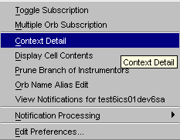

The Context Detail window displays.
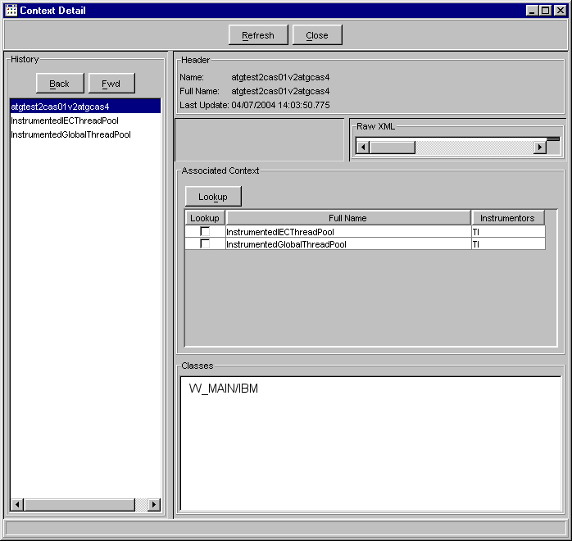
- Initially, the window displays with the Header information, which contains the full name of the CAS and the date and time it was last updated.
- The Raw XML section shows XML related to the CAS.
- The Associated Context section displays the full name of the instrumentors you are interested in.

- Product class information for the CAS appears in the Classes section of the window.
- The History section of the window displays the name of the selected CAS. The Back and Fwd buttons allow you to move backwards and forwards in the list, reflecting previous and refreshed data.
- Click the Refresh button to retrieve current instrumentor updates.
- Click the Close button to exit the window at anytime.

- To display related Thread Pool and XML data for an instrumentor, right-mouse click on the desired instrumentor in the Associated Context section. The following menu displays.
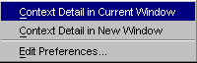

- You have the option to displays the detailed data in the current window, or in a new window. Select Context Detail in Current Window to show the data in the current window. If you wish to open a new window, select Context Detail in New Window. The XML, ThreadPool Instrumentor and History sections update to display the requested data.
 | 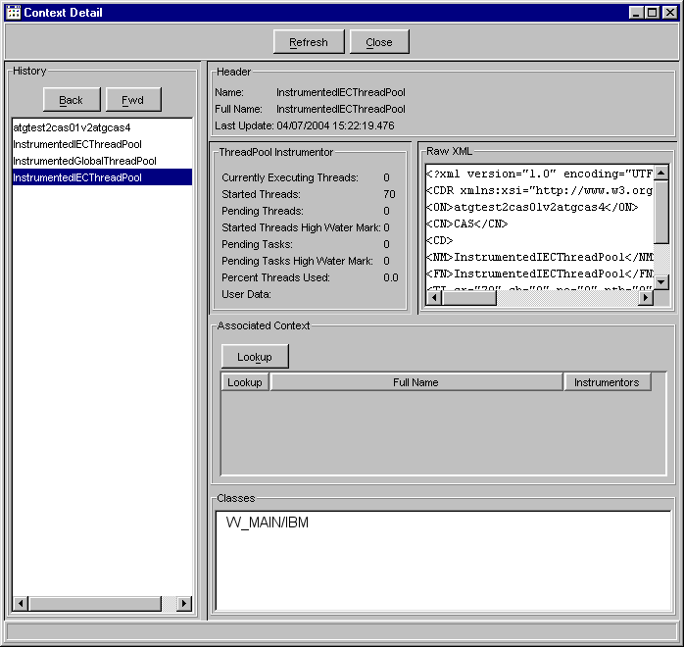
- To retrieve additional Thread Pool, Method or Queue instrumentor information, select the Lookup checkbox next to the instrumentors of your choice from the Associated Context section of the window. Click the Lookup button. The Multiple Context Detail window displays.
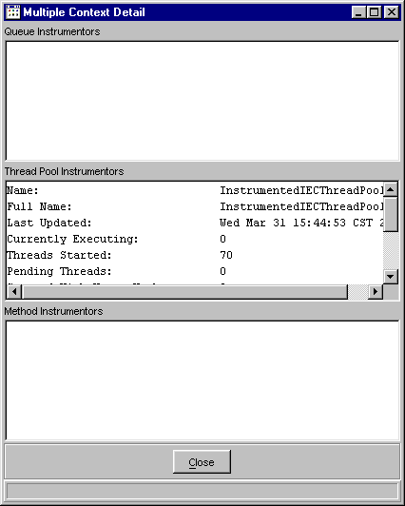
The Thread Pool Instrumentors section of the window displays with the following fields: Currently Executing Threads, Started Threads, Pending Threads, Start Threads High Water Mark, Pending Tasks, Pending Tasks High Water Mark, Percnet Threads Used and User data.
Information for Queue and Method Instrumentors display in their corresponding text boxes.
To copy the information in the window to Outlook or Microsoft Word, highlight the text. Press Ctrl-C to copy the contents to the clipboard. Open a Microsoft Word window and paste the clipboard into a document or paste the information into Outlook to send it as an email.
To exit the window at anytime, click Close.

Copy/Print Cell Information
Any cell data for any component can be copied or printed. For this example, right-mouse click in the Last Updated column cell for the CAS name, select Display Cell Contents.
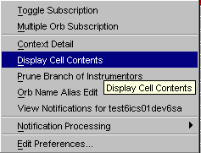

The Cell Contents window displays with the information that appears in the cell.
 | 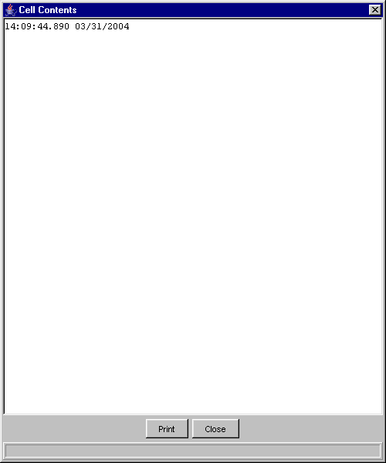
- To print the window, click Print. The window contents prints to a printer.
- To copy the information in the window, highlight the text. Press Ctrl-C to copy the contents to the clipboard. Open a Microsoft Word window and paste the clipboard into a document or you can paste the information into Outlook to send it as an email.
- To exit the window, click Close.

Condense Instrumentor Branches
For ease of visibility, you can quickly condense the Instrumentor branches on any component. Right-mouse click on a component process and select Prune Branch of Instrumentors.
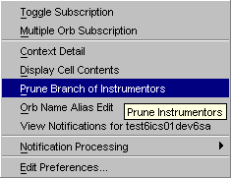

 | The instrumentors are immediately removed from the component tree. Within 30 seconds, the instrumentors reappear for monitoring.

Editing the Orb Name
Changing the name of a process to be more descriptive can be accomplished by displaying a new label. Select a process and right-mouse click to display the menu below.
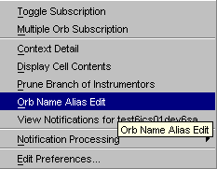

Select the Orb Name Alias Edit option. For details on editing Orb Names, refer to the Edit the Orb Name section, page 26.

View Notifications
Detailed alarm notifications for a particular process can be viewed at anytime. Right-mouse click on the data row you are interested in viewing and select View Notifications.
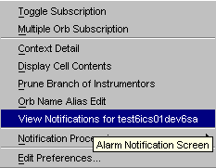
 | The Alarm Notification window displays. For detailed information, refer to the Edit Column Preferences section, page 82.

Notification Processing
You can start/stop alarm notifications for a process from the Notification Processing option. Right-mouse click on the process and select Notification Processing.

 | 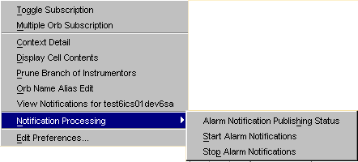
A sub-menu appears that allows you to: (1) view the publishing status of the alarms, (2) start alarm notifications and (3) stop alarm notifications.
If you select Alarm Notification Publishing Status, a window displays with the state of the notification.
In the example above, alarm notification is publishing for test6ics01dev6sa.
Click OK to close the window.
 | If you would like to begin monitoring conditions for the process, select the option: Start Alarm Notifications.
The Start Alarm Notifications window displays. Enter the reason for starting alarm notifications for the process and click OK. Alarm notifications will activate.
Click Cancel to close the window without starting notifications.
 | If you would like to stop alarm notifications for the process, select the option: Stop Alarm Notifications.
The Stop Alarm Notifications window displays. Enter the reason for starting alarm notifications for the process and click OK. Alarm notifications will deactive.
Click Cancel to close the window without starting notifications.

Edit Preferences
You can edit column preferences at any time. Right-mouse click on a data row. The Edit Column Preferences window displays.
For detailed information, refer to the Edit Column Preferences section, page 82.
Queue | The Queue tab allows you to monitor specific queue information for CBOEdirect components.
 | 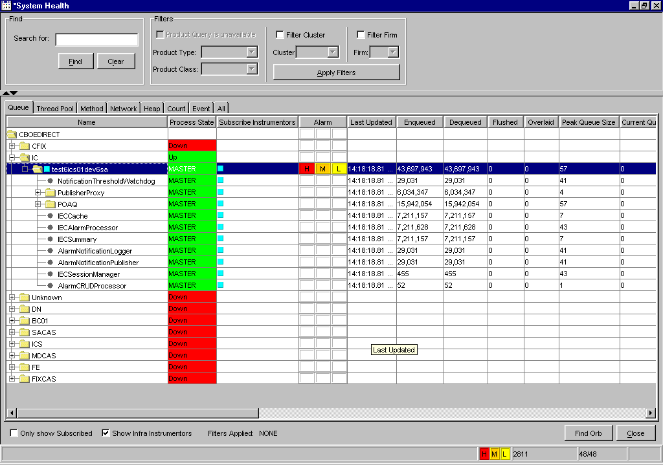
 | Use your scroll bar to view additional queue information.
 | 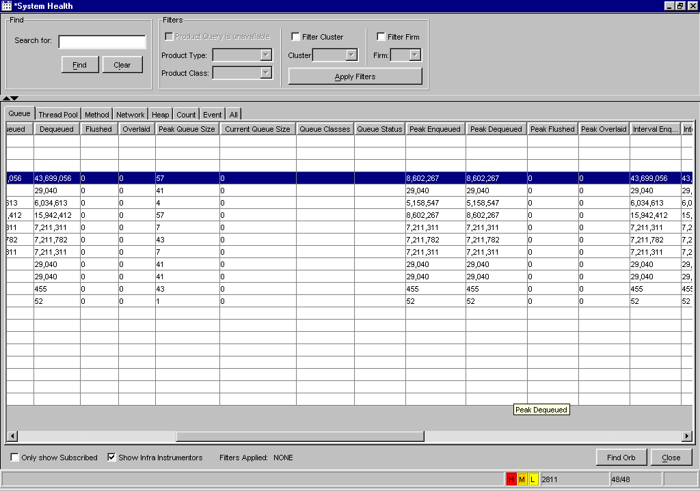
The Queue tab displays enqueued and dequeued data, peak queue information and average queue times.

Expand the IC folder to display its sub-processes. The Queue tab Process State column varies based on the state of the threads.
- If the thread is initializing, waiting or running, the background color of the cell displays in green.
- If the thread has not started, the background color of the cell displays in yellow.
- The background color of the cell displays in red if the thread has exited.
- A background color of white, states the queue status is not reported and should be ignored.
The Queue tab only displays queue instrumentors, not thread pool, method, heap or network instrumentors. For instructions on how to subscribe to instrumentors and Orbs, refer to the Subscribe for Instrumentors section of the document, page 38.
Thread Pool | Click on the Thread Pool tab to view threading information for CBOEdirect components.
 | 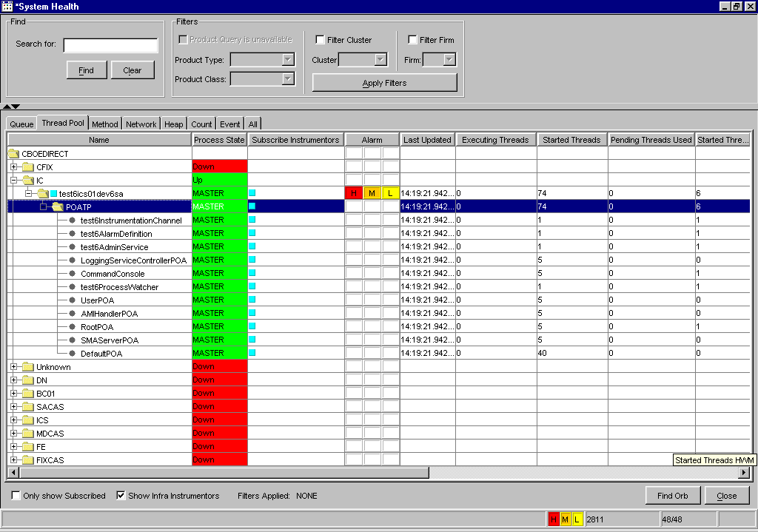
 | Use your scroll bar to view additional thread pool fields.
 | 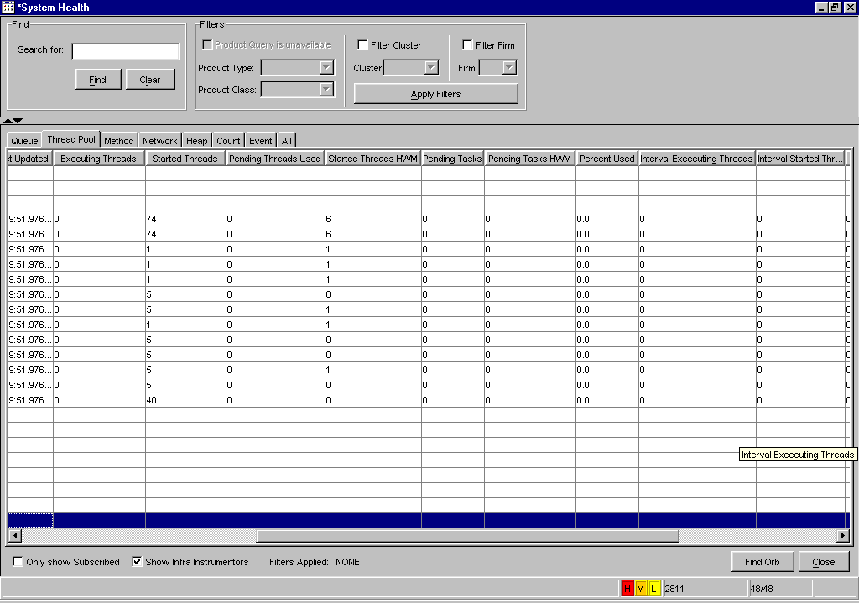
The Thread Pool tab provides current thread pool information as well as data that occur at peak intervals.
Expand the IC folder to display its sub-processes. To determine the state of any process in the Thread Pool tab, refer the Verify Process State section of the document, page 37.
The Thread Pool tab displays only thread pool instrumentors. For instructions on how to subscribe to instrumentors and Orbs, refer to the Subscribe for Instrumentors section of the document, page 38.
Method | Click on the Method tab to display the number of method calls accessed through CBOEdirect, as well as peak and average method rates.
 | 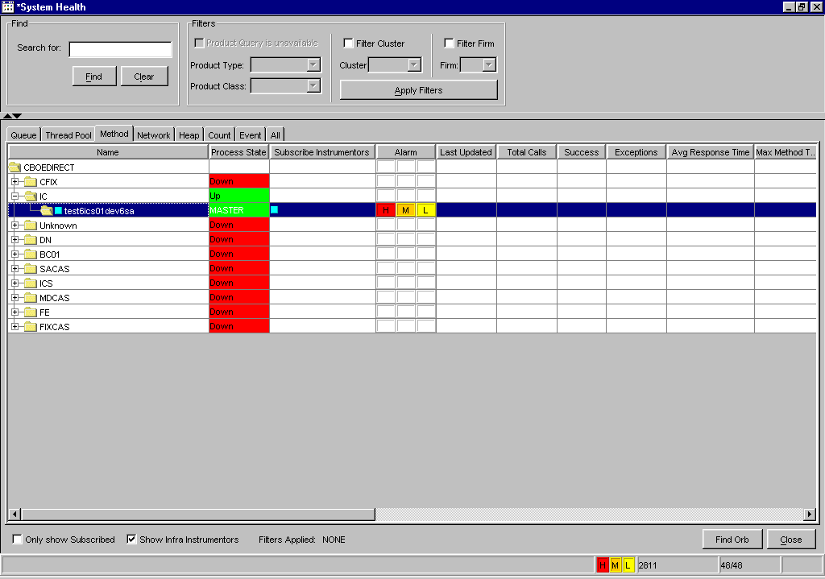
 | Scroll to the right to view additional method data.
 | 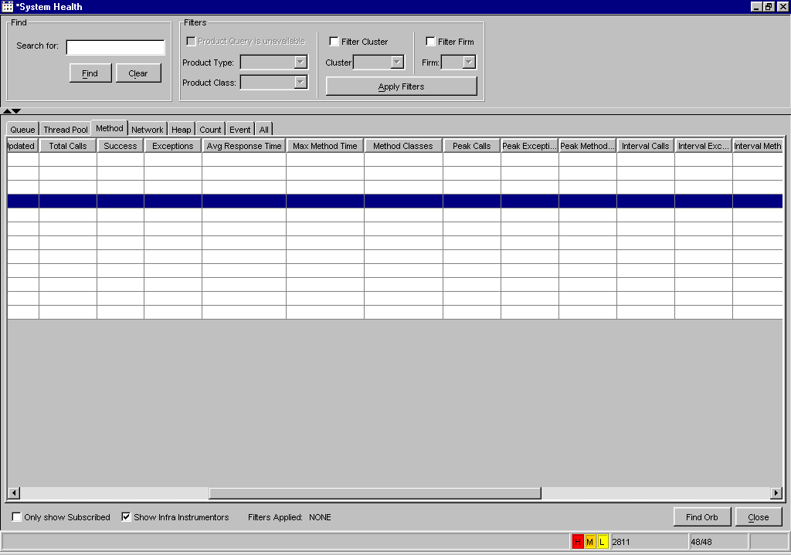
Expand the IC folder to display its processes. The Method tab does not display instrumentors.
 Note: All times are represented in milliseconds.
To determine the state of any process in the Method tab, refer the Verify Process State section of the document, page 37.
Network | Click on the Network tab to view the number of bytes sent through CBOEdirect, network disconnects and external adapter information.
 | 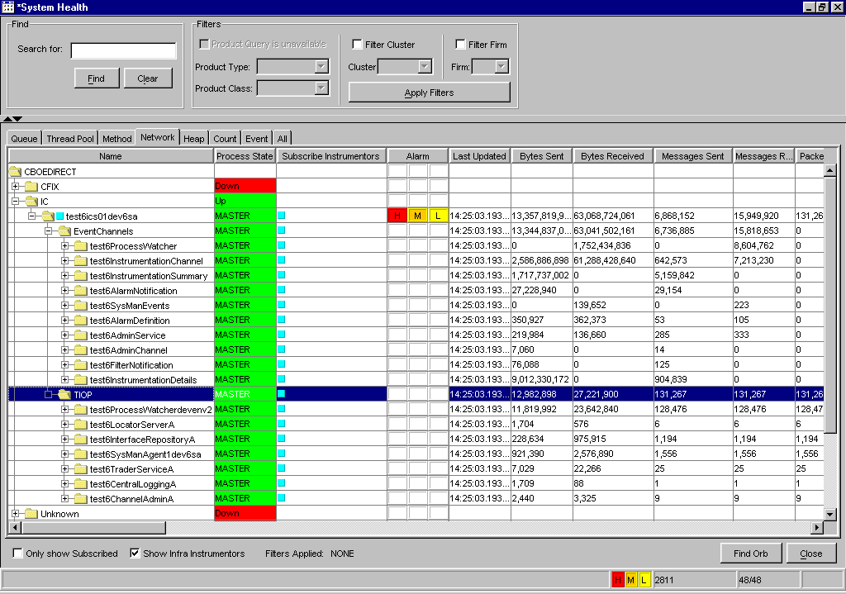
 | Use your scroll bar to view additional network information.
 | 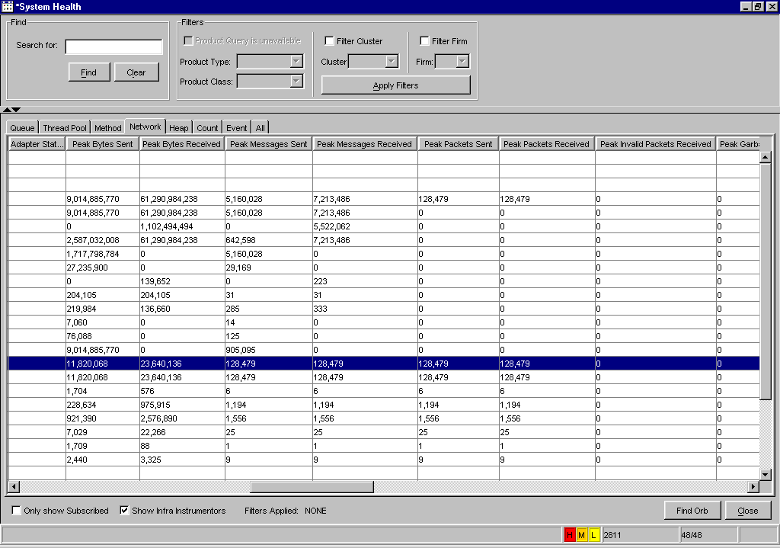
The Network tab Process State column varies based on the state of the adapters.
- If an adapter is Up or initializing the background color of the cell displays in green.
- The background color of the cell displays in red if the adapter is down.
The Network tab displays only network instrumentors. For instructions on how to subscribe to instrumentors and Orbs, refer to the Subscribe for Instrumentors section of the document, page 38.
Heap | To view system memory usage for any component and its processes, click on the Heap tab.
 | 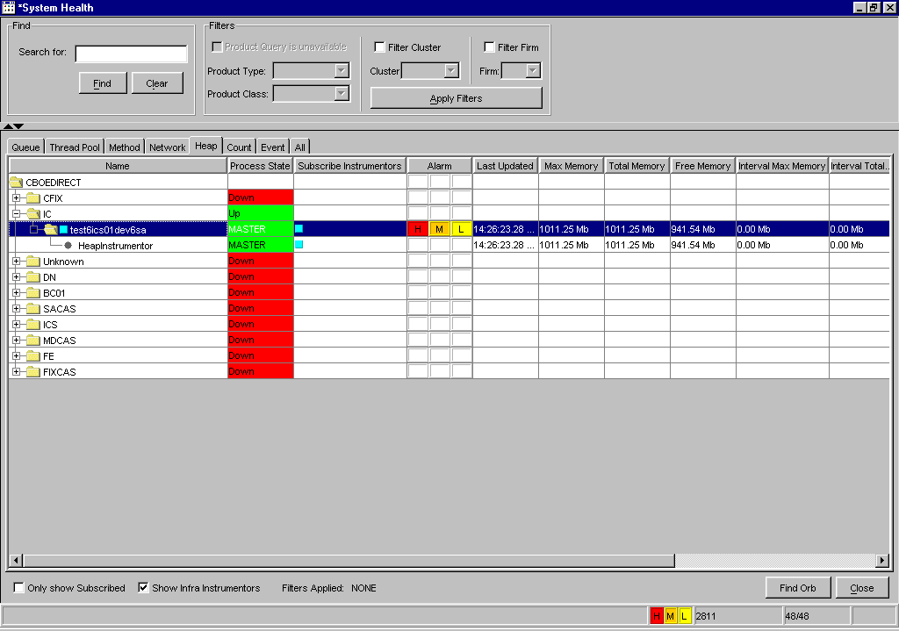
 | Scroll to the right to view additional heap data.
 | 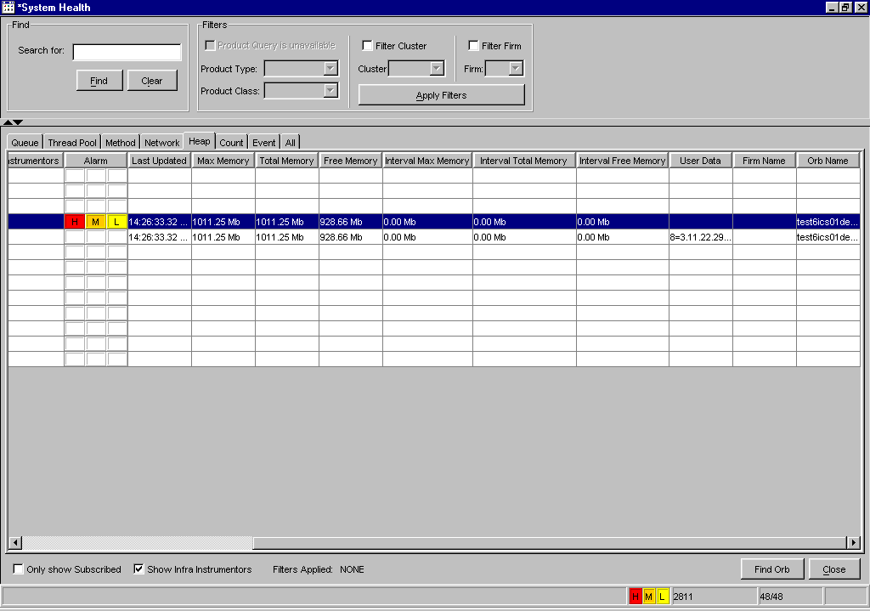
Expand the IC folder to display its sub-processes. To determine the state of any process in the Heap tab, refer the Verify Process State section of the document, page 37.
The Heap tab displays only heap instrumentors. For instructions on how to subscribe to instrumentors and Orbs, refer to the Subscribe for Instrumentors section of the document, page 38.
Count | To view the message count for any component and its processes, click on the Count tab
 | 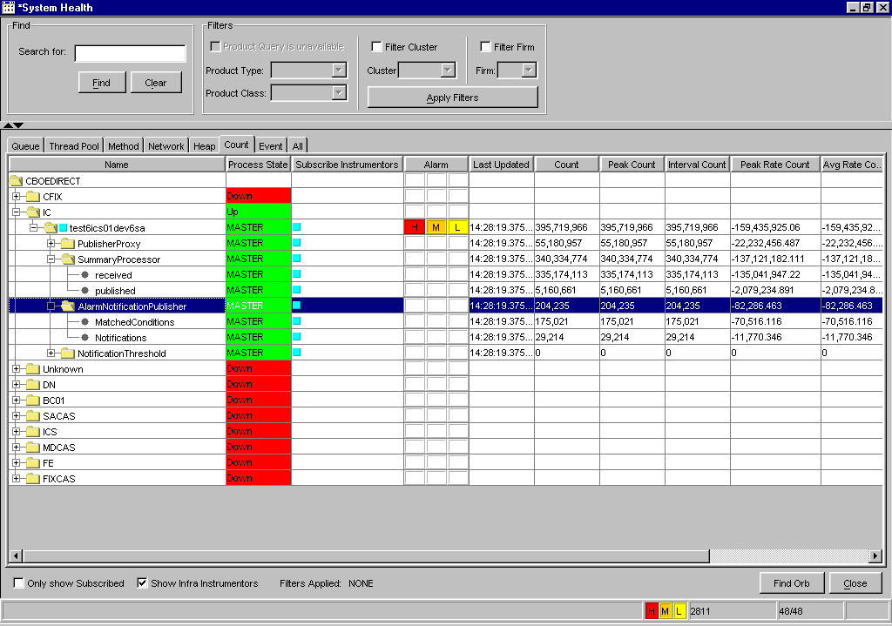
 | Scroll to the right to view peak and total data counts.
 | 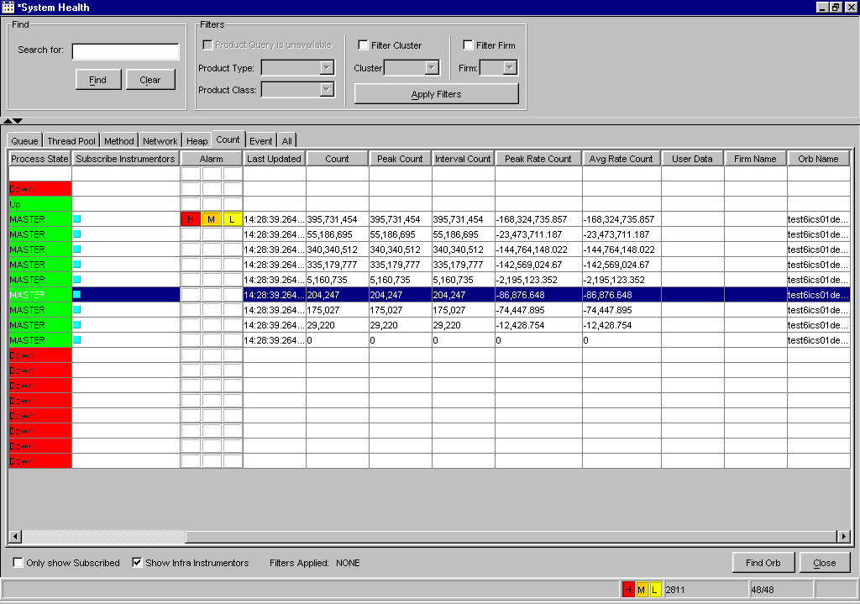
Expand the IC folder to display its sub-processes. To determine the state of any process in the Count tab, refer the Verify Process State section of the document, page 37.
For instructions on how to subscribe to instrumentors and Orbs, refer to the Subscribe for Instrumentors section of the document, page 38.
Event | Click on the Event tab to monitor the impact of event channels through CBOEdirect.
 | 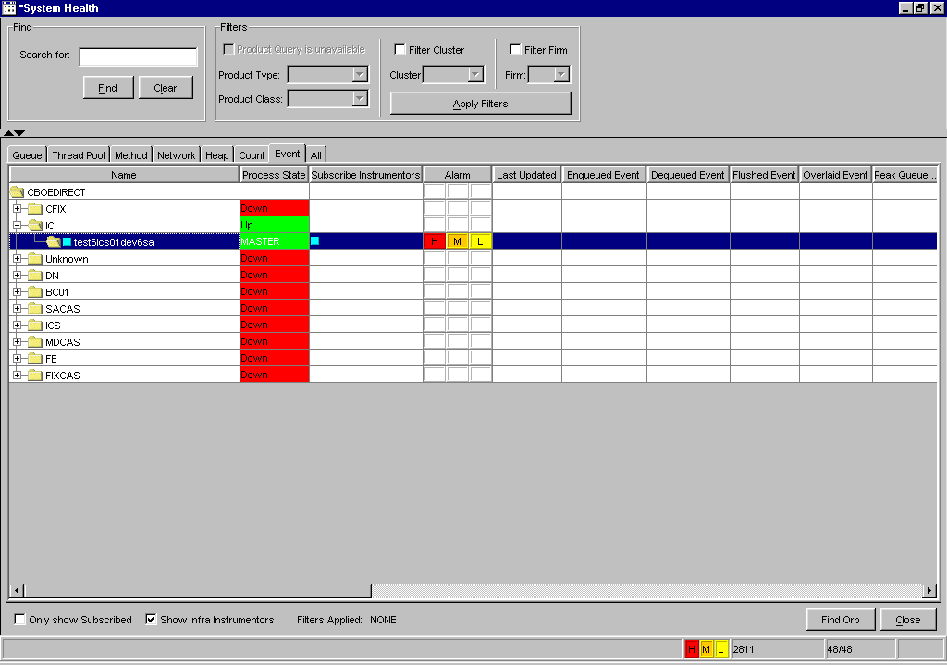
 | Scroll to the right to view additional data fields.
 | 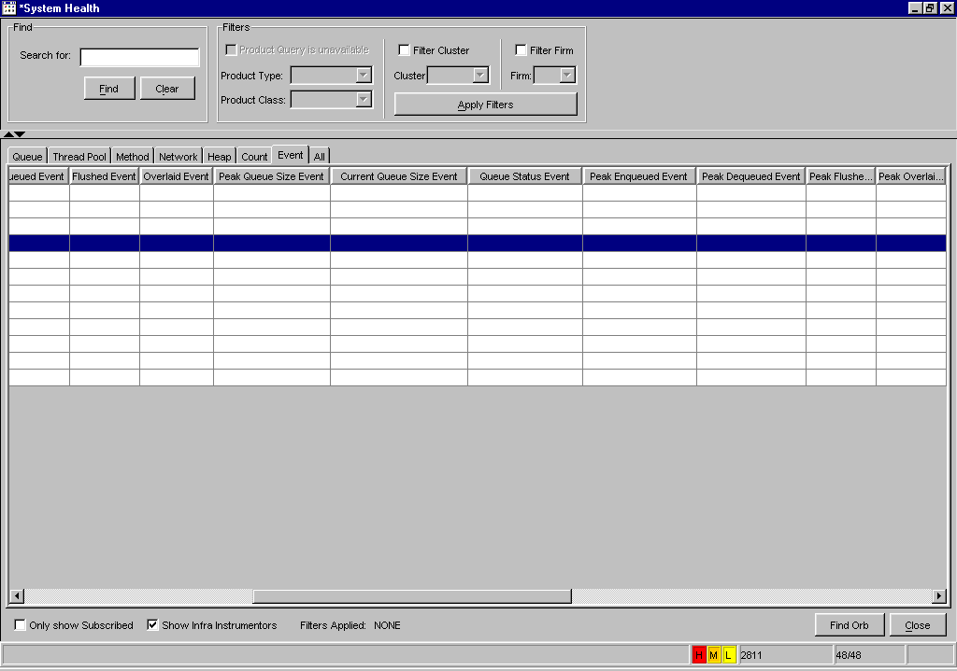
Expand the IC folder to display its processes and related event channels. To determine the state of any process in the Event tab, refer the Verify Process State section of the document, page 37.
For instructions on how to subscribe to instrumentors and Orbs, refer to the Subscribe for Instrumentors section of the document, page 38.
Filter and Search Options | The filter and search options in the System Health Monitor tool allows you to quickly locate specific information. The Find and Filter sections are located at the top section of the System Health window.
 | 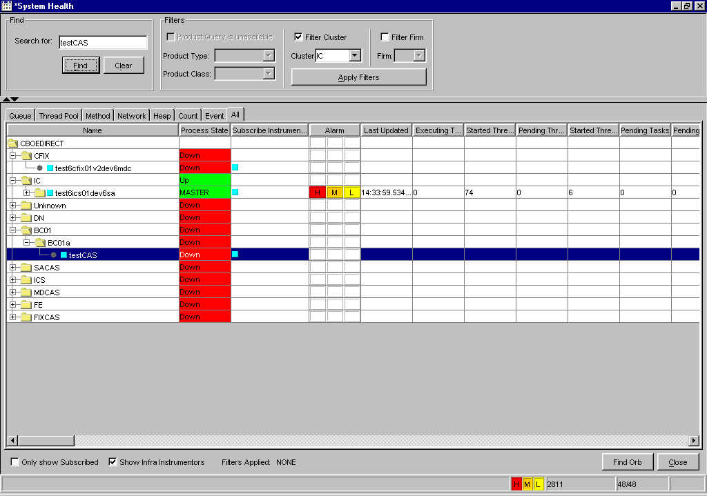
To find a specific component or process:
- Partially enter the component name or process name in the Search for text field. In the example above, the search is for testCAS.
- Click Find. The row in the component tree where the testCAS is located is highlighted.
- Click Clear to remove the previous search request.
To filter information by class:
- Select the Filter Class checkbox.
- Select the Product Type and Product Class from the drop down lists.
- Click Apply Filters. All instrumentors that do not contain class ABT disappear. At the bottom of the window, the filter label shows Filters Applied: Class ABT (Options).
To filter by Firm:
- Deselect the Filter Cluster checkbox.
- Select the Filter Firm checkbox and select a Firm from the drop down list.
- Click Apply Filters. All processes that are not in the Firm are removed. The filter label at the bottom of the window displays: Filters Applied: Class ABT (Option) Firm: Test Firm 1001.
 | 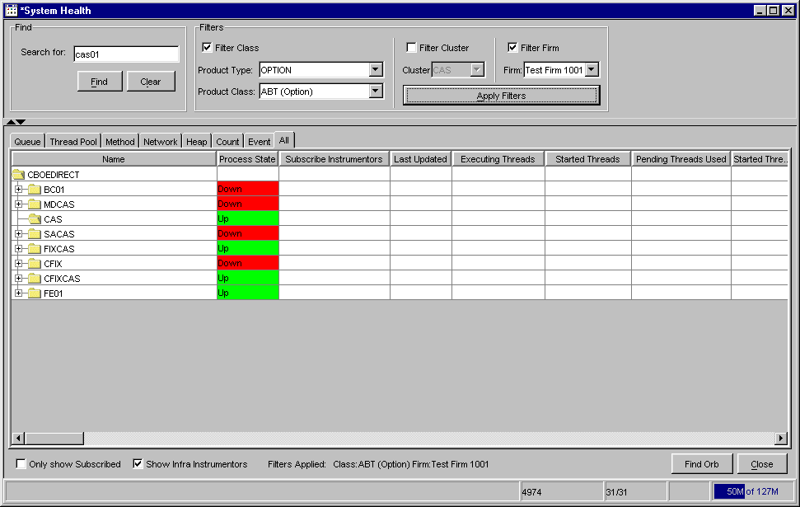
To further filter your request by cluster, select the Filter Cluster checkbox. Then select the cluster from the Cluster drop down list. In the example below the IC has been selected.
Click Apply Filters. All the clusters, except for the IC, are removed. Only the data rows that contain the ABT class display in the components tree. The filter label at the bottom of the window shows Filters Applied: Cluster: IC.
 | 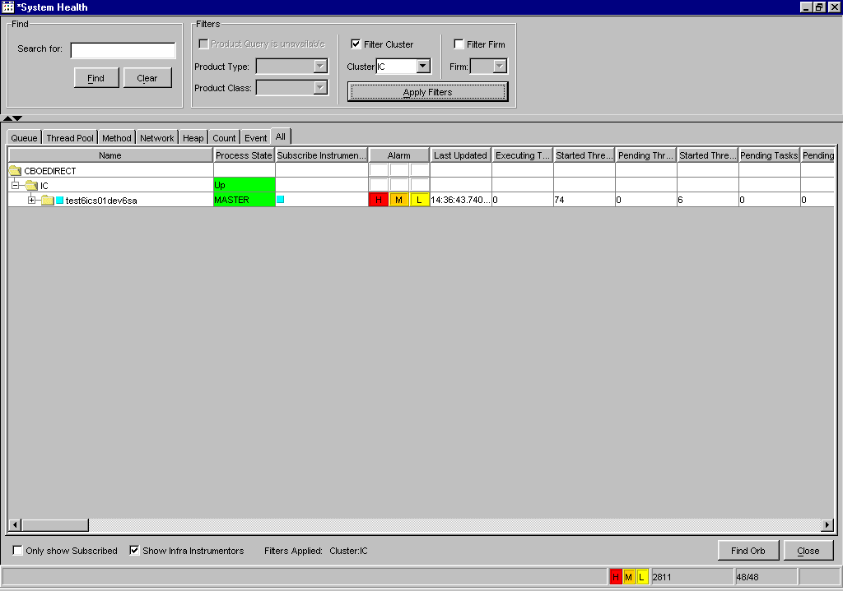
 | To turn off all filters, deselect the Filter checkboxes and click Apply Filters. All the clusters and processes display. The filter label at the bottom of the window reads: Filters Applied: NONE.
To quickly find a specific Orb, click the Find Orb button. The Find Orb window displays.
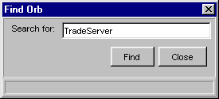

- Enter the specific Orb you are searching for in the Search for text box. In the example above, TradeServer has been entered in the search field.
- Click Find. The system scrolls to the TradeServer process, expanding the tree to properly show the process.
- To exit the Find Orb window, click Close.
Sort and Rearrange Columns | You can sort any column on the System Health window at any time by clicking on the column heading. The column changes to reflect the sorted data.   Note: The sort is not refreshed.  To rearrange the display of the columns, place your cursor on the column heading, then using your mouse, click on the column and drag it to the desired position.
Edit Column Preferences | You can customize your System Health window by selecting or deselecting specific columns to display. To filter columns, right mouse click on a data row. Select Edit Preferences. The Edit Column Preferences window will display.  - Select or deselect columns for viewing and modify column arrangement as desired.  - To save your changes, click Ok.  - If you wish to retain the default settings, click Cancel.  For detailed information, refer to the Edit Column Preferences section, page 82.
Save Window Preferences | If you want to save your changes and automatically open the window with your saved window preferences, be sure to save the configuration on the Open Tasks toolbar.  To save window preferences:  - Right mouse click on the corresponding window task button.  - Select Save Configuration. The Save Configuration window will display.  - Enter the Configuration Name for the window.  - Click Submit. Click Confirm. The saved window will appear when you open a new System Health window.  - If you decide you do not wish to save the new configuration, click Cancel.  For detailed information, refer to the Save Configurations section, page 80.
 | System Summary

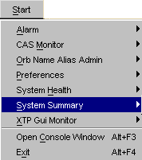 | The System Summary window contains a list of the CBOEdirect components and processes along with their state of availability. This window allows you to quickly monitor the state of a component or process.  To open the System Summary window, click the Start menu button and select System Summary, Create New Window. The System Summary window displays.  This window can remain open throughout the duration of your monitoring.
 | 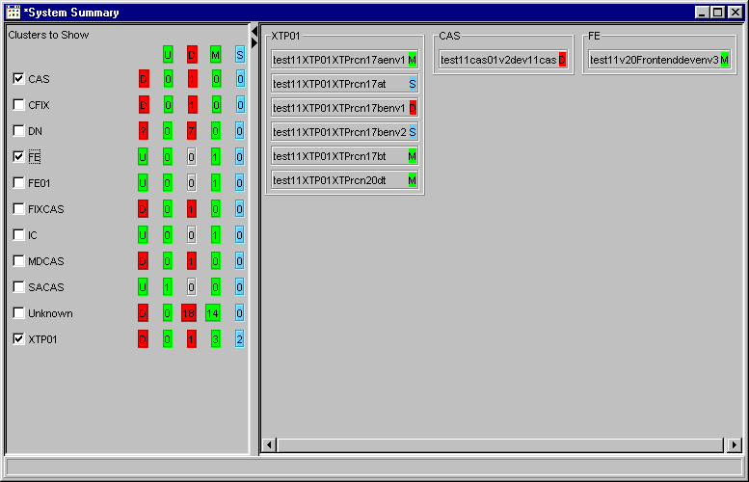
Cluster Summary | When you initially open the System Summary window, the CBOEdirect clusters display with checkboxes to the left. To the right of the clusters are five columns that list the state of the clusters. The column to the far left, with no label, is the Process State Summary column. This column represents the worst status of all in the cluster.  The remaining columns are labeled as follows:  - U column - represents the number of Up processes. In the example above, one process is up in the SACAS cluster.  - D column - represents the number of Down processes. In the example above, there are seven processes that are down in the DN cluster.  - M column - represents the number of Master processes. FE01 has one process in master mode.  - S column - represents the number of Slave processes. CAS has zero processes in slave status.
 | Process status identifiers are as follows.
Process State Values
  Server Status | Background Color
  Up (U) | Green
  Master (M) | Green
  Slave (S) | Blue
  Unknown (?) | Red
  Down (D) | Red
Process Summary | To display the processes of any cluster, click on the checkbox next to the cluster. The processes for that cluster appear to the right of the window.
To quickly scroll to the processes of a listed cluster, right-mouse click on the specific cluster. A menu displays with the following option:

Click on the option. The window will scroll to the cluster’s process list.
If the System Health window is active, you have the option to quickly view any of the processes in that window.
- Right-mouse click on the process. The following menu displays.
 | 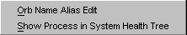
 | - Select Show Process in System Health Tree. The System Health window opens and expands to the appropriate process.
To edit the Orb Name of one of the process, right-mouse click on the process and select Orb Name Alias Edit. The Orb Name Edit window displays.
For details on editing the Orb Name, refer to the Edit the Orb Name section on page 26.
 | XTP Monitoring

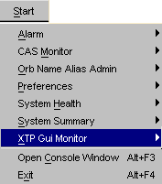 | The System Health Monitor application allows you to view the state of the Extreme Ticker Plant (XTP) processes in relation to CBOEdirect.  To open the XTP GUI window, click the Start menu button and select XTP Gui Monitor, Create New Window. The XTP Gui Monitor window displays.  You can exit the window at anytime from the File menu by selecting File, Close.
 | 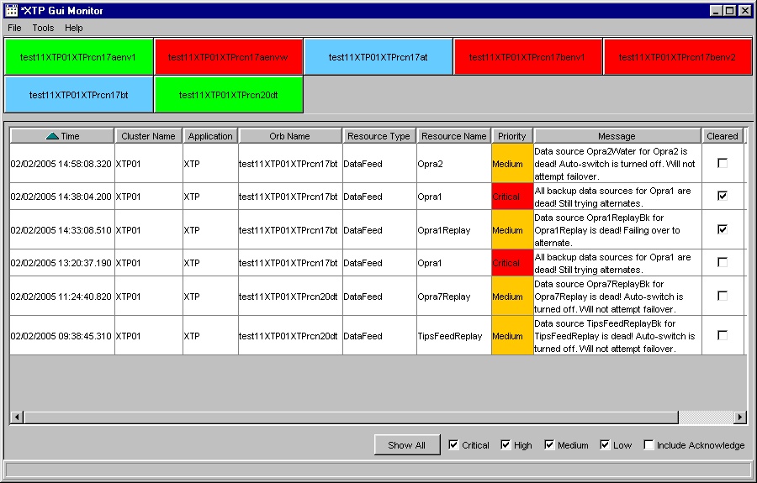
 | The XTP Gui monitor contains two panels of information. The top panel displays an icon for each XTP process in the environment. The lower panel contains a scrollable table displaying alarm notifications. Move the scroll bar to the right to view additional data fields.
 | 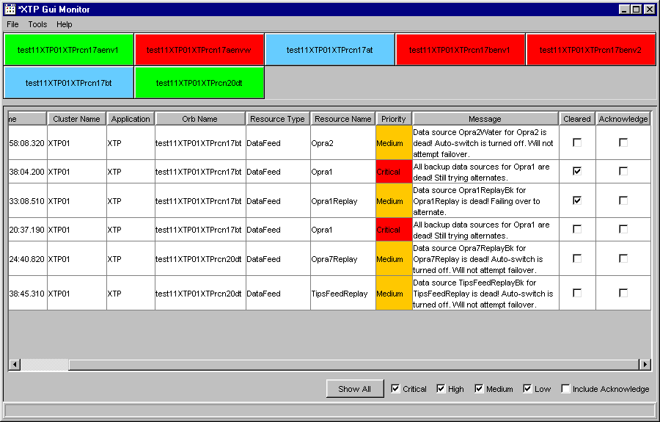
XTP Alarm Notification Display | Alarm notifications for XTP components in relation to CBOEdirect are displayed in the lower panel of the XTP GUI Monitor window in column format. The columns are labeled as follows:  - Time - denotes the date and time when the alarm activated  - Cluster Name - identifies the name of the XTP cluster  - Application - represents where the alarm occurred  - Orb Name - indicates the XTP server that generated the alarm  - Resource Type - displays the kind of resource (i.e. data feed, queue, etc.) that triggered the alarm  - Resource Name - identifies the name of the resource that triggered the alarm  - Severity - indicates the seriousness of the alarm   Note: For Version 4.1, all alarms will have a severity level of either “Critical” or “Medium”  - Message - displays the alarm message  - Cleared - checkbox indicating that the alarm has been cleared/uncleared by the XTP server  - Acknowledge - checkbox indicating that the alarm has been acknowledged/unacknowledged

Filter Alarms by Severity
You have the option to filter alarms according to severity level by selecting/deselecting the alarm severity checkboxes shown on the lower portion of the XTP GUI Monitor window.
- To view notifications for all alarm severity levels, click Show All. The Critical, High, Medium, Low and Include Acknowledge checkboxes will display selected. The XTP Alarm Display will update to include processes that have generated alarms with high, medium and low severity levels. The Acknowledge checkbox in the display will be selected for alarms that have been cleared by the XTP server
 Note: For Version 4.1, all alarms will have a severity level of either “Critical” or “Medium”.
- To display only critical level alarms, select the Critical checkbox. Components that have generated critical level alarms will display.
- To show only high level alarms, select the High checkbox. Components that have generated high level alarms will display.
- To view only medium level alarms, select the Medium checkbox. Processes that have produced medium level alarms will display.
- To display only low level alarms, select the Low checkbox. Processes that have generated low level alarms will display.
- If you would like to display alarms that have been acknowledged by the XTP server, select the Include Acknowledge checkbox. The XTP Alarm Display will update to include these alarms.

Cleared and Acknowledge Checkboxes
Alarm data rows display with Cleared and Acknowledge checkboxes. If the Cleared checkbox is selected for a data row, that means the alarm has been cleared by the XTP server.
- If you select the Acknowledge checkbox for a data row that has been cleared, the checkbox will remain selected.
- If you select the Acknowledge checkbox for an alarm data row that has not yet been cleared by the server, the Acknowledge checkbox will return to deselected after a few seconds.
XTP Process Status | The top panel of the window displays an icon for each XTP process in the environment. XTP process status identifiers are as follows.
Process State Values
  Process Status | Background Color
  Master | Green
  Slave | Blue
  Down - defined but not currently running | Red
  Unknown - defined but not properly configured | Orange

Change Process Status
The System Health Monitor application gives you the ability to change the state of an XTP process through the XTP process icon. Right-mouse click on any process icon in the environment. The following menu will display.
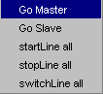

➢ | Go Master  To change the process status from master to slave:  - Right-mouse click on a process icon that is in master state.  - Click Go Slave. The icon color changes to blue and an alarm appears on the alarm panel. In addition, the color and text change accordingly in the Process State column of the System Health window for that XTP process.
➢ | Go Slave  To change a process from slave state to master state:  - Right-mouse click on the slave process icon.  - Select Go Master. The icon color changes to green and an alarm appears on the alarm panel. The System Health window Process State column will change accordingly.
➢ | startLine all  To start the datafeed lines for a process that is in master mode:  - Right-mouse click on the master process icon.  - Select startLine all. The system will prompt you to verify you wish to send the command. Click OK to send the command. The datafeed lines for the process will start and display as “Up” in the Adapter Status column of the System Health Monitor window.  - Click Cancel to return to the XTP GUI Monitor without sending the startLine all command. The system will return to the XTP GUI Monitor window.
➢ | stopLine all  To stop the datafeed lines for a process that is in master mode:  - Right-mouse click on the master process icon.  - Select stopLine all. The system will prompt you to verify you wish to send the command. Click OK to send the command. The datafeed lines for the process will stop and display as “Down” in the Adapter Status column of the System Health Monitor window.  - Click Cancel to return to the XTP GUI Monitor without sending the stopLine all command. The system will return to the XTP GUI Monitor window.
➢ | switchLine all  To switch the datafeed lines from primary to backup or from backup to primary:  - Right-mouse click on the master process icon.  - Select switchLine all. The system will prompt you to verify you wish to send the command. Click OK to send the command. The datafeed lines for the process will display as “Bk” (backup) or “Pri” (primary) in the User Data column of the System Health Monitor window.  - Click Cancel to return to the XTP GUI Monitor without sending the switchLine all command. The system will return to the XTP GUI Monitor window.

Change Process Status Using AR Commands
Process status changes can be performed from the Tools menu in the XTP GUI Monitor window.
- From the Tools menu, select AR Command. The following window displays.
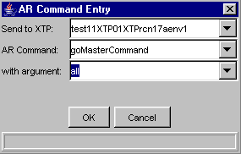
- Choose the process from the Send to XTP drop down list.
- Select the command you wish to perform for the process from the AR Command drop down list.
- Select the argument from the with argument drop down list.
- Click OK. Process status changes will be visible in the System Health Monitor window.
- Click Cancel to exit the AR Command Entry window without making any changes.
 Note: The AR Command and with argument text boxes are editable and can be used for defining new command and arguments.

XTP Process Details | If you wish to display the details of a process, click on the icon for the process. For example, click the icon for process test11XTP01XTPrcn20dt. The XTP Details window displays with tabs labeled XTP and ALL and defaults to the XTP01XTPrcn20dt process in the XTP tab.  Expand the XTP01XTPrcn20dt process node to reveal Queue and Network instrumentors. The Queue and Network tabs in the System Health Monitor window display the same data.
 | 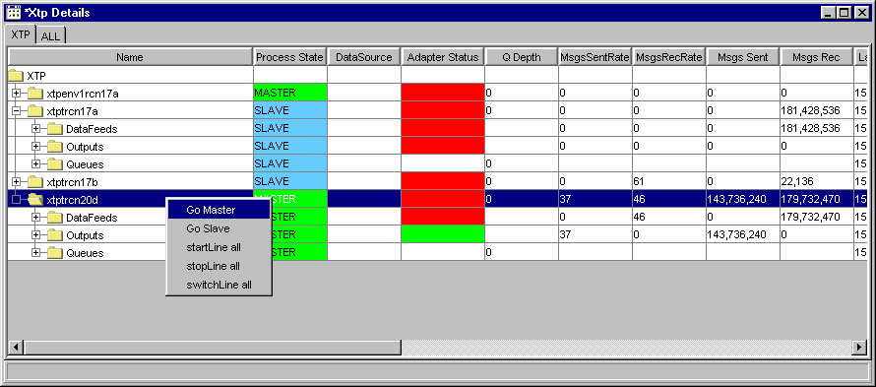
 | Use the scroll bar to view additional data fields.
 | 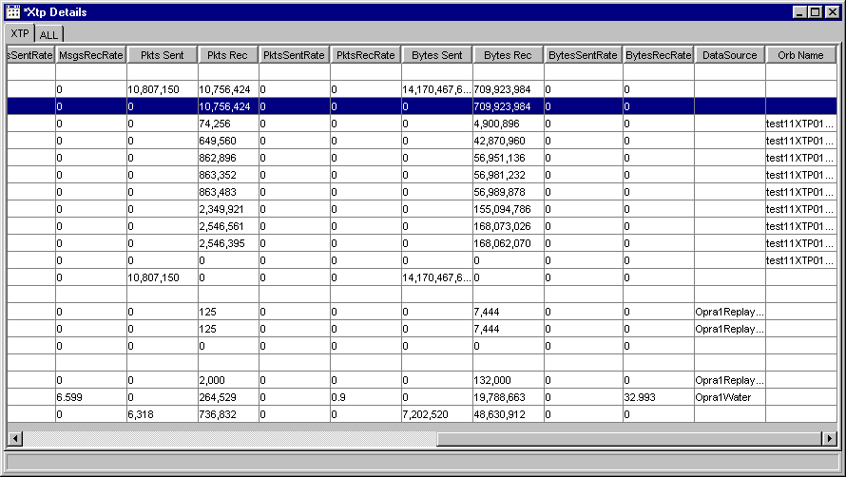
From this window, you can view queue data, adapter status, message rates and bytes sent through the system.
 Note: Adapter Status, Bytes Received, Messages Received and Packets Received columns update every n (10) seconds.
 | From the XTP Details window, you have the ability to change the state of an XTP process. Right-mouse click on any process node. The following menu will display.
 | Refer to the Change Process Status section above for instructions on how to change the status of XTP processes.

Start, Stop and Switch Network Instrumentators
From the XTP tab, you have the ability to start, stop and switch network instrumentators, such as data feed and output lines.
 | 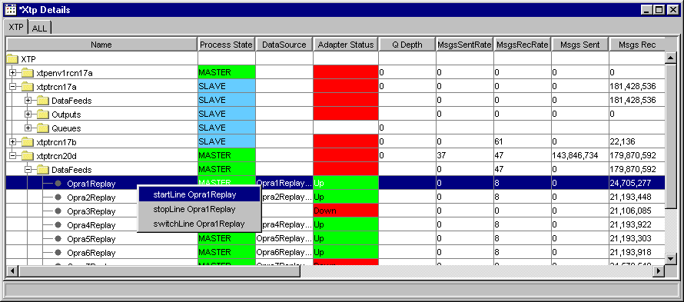
To start a data feed line:
- Right-mouse click on the data feed row.
- Select the startLine command. The system will prompt you to verify you wish to send the command. Click OK to send the command. The Adapter Status cell for the line will display as “Up” with a green background and the Pkts Rec (Packets Received) column will start updating.

To stop a data feed line:
- Right-mouse click on the data feed row.
- Select the stopLine command. The system will prompt you to verify you wish to send the command. Click OK to send the command. The Adapter Status cell for the line will display as “Down” with a red background and the Pkts Rec (Packets Received) column will stop updating.

To switch a data feed line from backup to primary or from primary to backup:
- Right-mouse click on the data feed row.
- Select the switchLine command. The system will prompt you to verify you wish to send the command. Click OK to send the command. The datafeed lines for the process will display as “Bk” (backup) or “Pri” (primary) in the Network User Data column of the System Health Monitor window
 | The XTP output lines can be started or stopped through the XTP details window.
 | 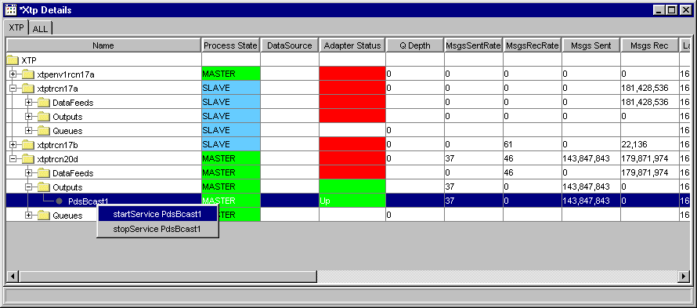
To start an output instrumentator:
- Right-mouse click on the instrumentator row.
- Select the startService command. The system will prompt you to verify you wish to send the command. Click OK to send the command. The Adapter Status cell for the line will display as “Up” with a green background and the Pkts Sent (Packets Sent) column will start updating.
To stop an output instrumentator:
- Right-mouse click on the instrumentator row.
- Select the stopService command. The system will prompt you to verify you wish to send the command. Click OK to send the command. The Adapter Status cell for the line will display as “Down” with a red background and the Pkts Sent (Packets Sent) column will stop updating.
 | The ALL tab in the XTP Details window arranges the XTP processes by their DataFeeds, Outputs and Queues.
 | 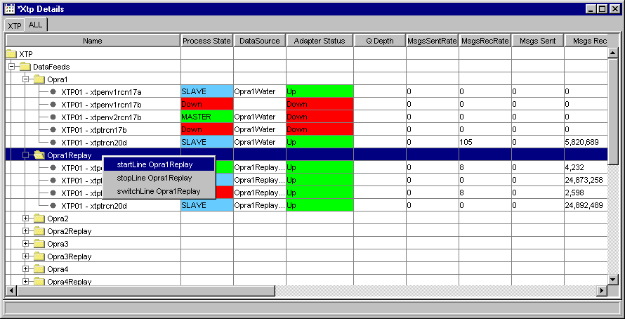
Expand the DataFeeds node to display the input lines. You can reveal the processes that belong to the data feed line by further expanding the node.
From the ALL tab, like the XTP tab, you can start, stop and switch data feed lines. Refer to the Start, Stop and Switch Network Instrumentators section above for instructions.
 | 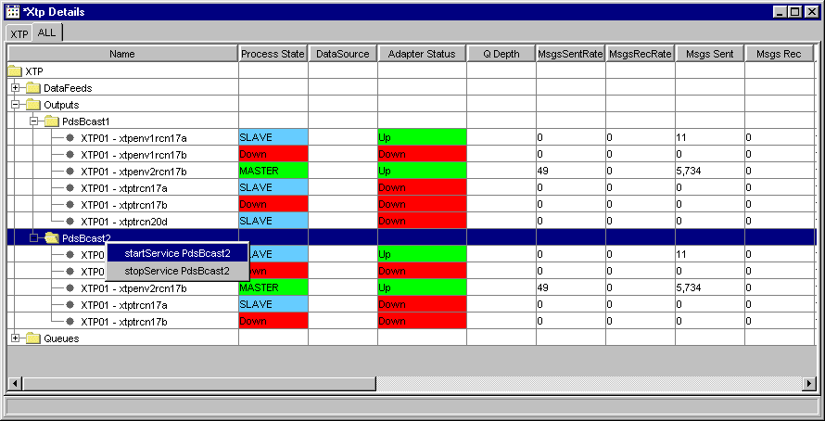
Expand the Outputs node to reveal the output lines as well as its processes.
From the ALL tab, like the XTP tab, you can start, stop and switch output lines. Refer to the Start, Stop and Switch Network Instrumentators section above for instructions.
 | 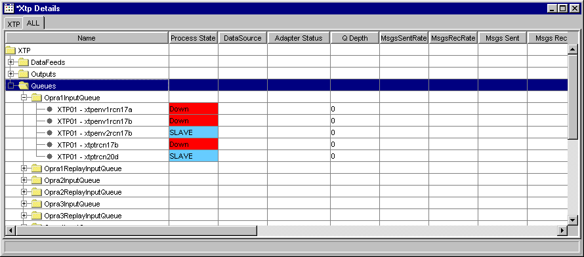
 | Expand the Queues node to view the data feed and output queue data for each XTP process.
Sort and Rearrange Columns | You can sort any column on the XTP GUI Monitor windows at any time by clicking on the column heading. The column changes to reflect the sorted data.  To rearrange the display of the columns, place your cursor on the column heading, then using your mouse, click on the column and drag it to the desired position.

Console Window

Open Console Window | The System Health Monitoring application allows you to view system messages that are generated by the functions you perform. To view the messages, select Open Console Window from the Start Menu or press Alt F3 on your keyboard from anywhere on your screen. The Console Window will display.
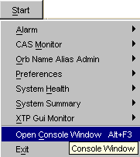 | 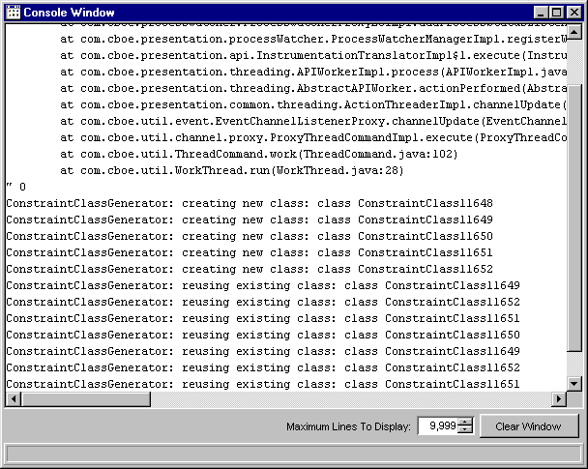
The information in this window can be copied to any text editor on your PC. To copy text from this window,
- place your cursor on the line you which to copy and using your mouse highlight the text.
- press Ctrl C on your keyboard to copy the text.
- open your text editor (Word, Notepad, etc.) and place your cursor in the text entry area.
- press Ctrl V on your keyboard. The text is copied to your editor.
The window defaults to display 9,999 lines. You can change the maximum lines to display by entering a new quantity in place of the default value, or you can select a higher/lower quantity by clicking the up/down arrows until the desired quantity is reached.
If you wish to clear the window of all its contents, click the Clear Window button.

Exit the System

Exit the System | To exit the System Health Monitor, select Exit from the Start Menu. You will be prompted to verify that you wish to close all windows and exit. Click Yes. The application will be closed and you will be returned to your system desktop.

◻ | Section 2:  Reference Guide

Task Toolbar

When you launch the System Health Monitor, the Open Tasks toolbar will display. From this window you can open tasks, save window settings and perform window controls.
Note: The toolbar remains active during the trading session.
 | 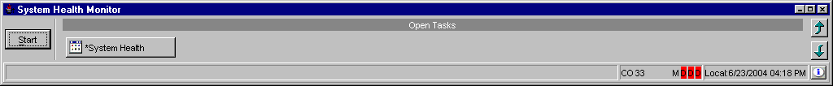
About System Health Monitor | To display system information about The System Health Monitor application, click . The About window will display.
 | 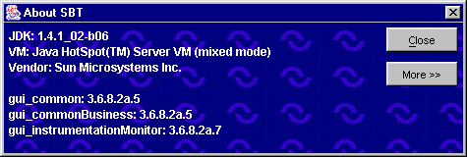
To view specific configuration information, click More. Detailed system information will display.
To exit the window, click Close.
Open Tasks | Initially, the Open Tasks toolbar will be empty. For each window you create, a task button will appear on the toolbar. From the task button, you can resize or change the configuration name of each window.  To resize the window or to change the default configuration name, click on the window task button. The active window will display. Right mouse click on the task button for the corresponding window. The resize and configuration menu will display.  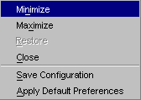
➢ | Resize  To resize a window:  - Highlight the resize choice or  - Hold down the [Alt] key and press the character of the underlined letter in the command.
➢ | Save Configurations  The system allows you to retain window configurations.  To save the configuration of a window:  - Right mouse click on the window’s task button and select Save Configuration. The Save Configuration window will display.  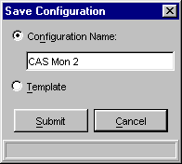  - Select the Configuration Name radio button. The text box displays in editable format.  - Enter the configuration name for the window. In the example above, the CAS Monitor window name will be changed to “CAS Mon 2”.  - To submit your configuration without setting a template, click Submit. Click Confirm. The system will save the configuration for the window and the task button will display with the new name.  - To set this configuration to be the default configuration for all windows, select the Template radio button. Click Submit. Click Confirm.  - If you decide not to change the default configuration, click Cancel instead of Submit.
➢ | Apply Default Preferences  The System Health Monitor application allows you to apply a default preference template to a window that has been already created.  For example, if you previously saved the configuration of a CAS Monitor window, right mouse click on the new CAS Monitor window task button and select Apply Default Preferences. The CAS Monitor window settings will be changed to the default preferences for all CAS Monitor windows.
Window Control | The system allows you to organize your windows. From the Open Tasks toolbar, click the button. The Window Control toolbar will display.
 | 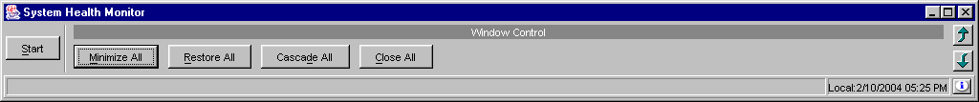
You have the ability to minimize, restore, cascade or close all of your active windows.
- To minimize all your windows, click Minimize All or hold down the [Alt] key and press "M" on your keyboard.
- To restore all your windows, click Restore All or hold down the [Alt] key and press "R" on your keyboard.
- To cascade all your windows, click Cascade All or hold down the [Alt] key and press "D" on your keyboard.
- To close all your windows, click Close All or hold down the [Alt] key and press "C" on your keyboard.

Customizing System Health Monitor Windows

Edit Column Preferences | Several System Health Monitor windows that exhibit data in column format can be customized to display specific information. For example, to modify the CAS Monitoring window, right mouse click on any data row. Select Edit Preferences.  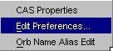  The Edit Column Preferences window will display. From this window, you can rearrange column positions and select or deselect columns for viewing.
 | 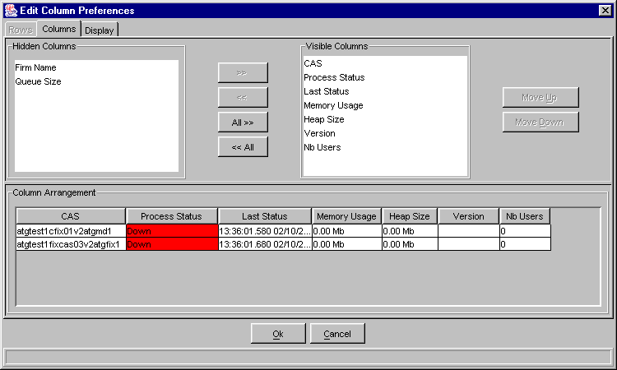
If there is a data column you do not wish to view:
- Select the column name in the Visible Columns list box. To select a continuous range of columns, hold down the shift key and highlight the column names. Hold down the ctrl key to select individual, non-continuous, column names.
- Click << to move the column name to the Hidden Columns list box.
- Click Ok to update the column arrangement.
- If you decide to retain the default layout, click Cancel.
To hide all columns:
- Click <<All to move all the column names in the Visible Columns to the Hidden Columns list box.
- Click Ok to update the column arrangement.
- If you decide to retain the default layout, click Cancel instead of Ok.

 |  Note: If you hide all columns, you will subsequently have to make some columns visible before the update will take effect.
To display a hidden column:
- Select the column name(s) from the Hidden Columns list box.
- Click >> to move the selected column name(s) to the Visible Columns list box.
- Click Ok to update the column arrangement.
- If you decide to retain the default layout, click Cancel instead of Ok.
To display all hidden columns:
- Click All>> to move the column names to the Visible Columns list box.
- Click Ok to update the column arrangement.
- If you decide to retain the default layout, click Cancel instead of Ok.
You may prefer to view data columns in a different order than the default display.
To move a column:
- Highlight the column name from the Visible Columns list box.
- Click Move Up or Move Down until you reach the new column location.
- Click Ok to update the column arrangement.
- If you decide to retain the default layout, click Cancel.
From the Column Arrangement section of the window, the columns can be resized to make viewing information easier for you.
To resize a column:
- Place the mouse on the right edge of the column header (where the column titles are displayed) until it becomes a two-sided arrow.
- Hold the left mouse button down and move it to the desired size.
- Click Ok to save the new column size.
- If you decide to retain the default column size, click Cancel instead of Ok.

Display
In addition to customizing column settings, the System Health Monitor allows you to adjust the text on your windows. From the Edit Column Preferences window, select the Display tab.
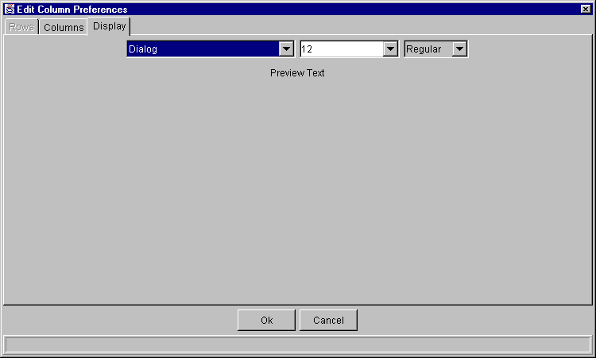
Select the font type, font size and font style from the drop down lists. Your selection will display in the Preview Text section of the window.
- Click Ok to set the new text style.
- If you wish to retain the default text settings, click Cancel.
Sizing Windows | The System Health Monitor windows are sizable. That is, they can be resized on the screen to make viewing information easier for you.
 | 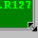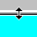 | Place the mouse on any edge of the window until it becomes a two-sided arrow. Hold the left mouse button down and move it to the desired size.
Resizing a window on the corner will expand or contract it in both directions (i.e. up and down and side-to-side). Resizing it on the side or top/bottom will expand or contract the window only in that one direction.
Windows can also be resized using the center glyph in the upper right corner of the window.
 |  | Click the left button () to minimize the window. Click the right button () to close the window. The center button is used for sizing.
If  is displayed, clicking it will increase the window size to a full-screen display.
If  is displayed, clicking it will return the window to its default size.

