Design: TB Button for COB

Overview

CBOEDirect will trade the Spread order that is sent by using the TB button at PAR workstation with the customer COB resting order without fist trading with the legs when they are at the same price as the COB resting order.

Implementation

The implementation will be done on both OHS and TE sides as follows:

OHS side:
There is not IDL changes for TB. Since the current code supports the TA for Spread orders, we only need to add a case statement for TB spread order to get validated by calling the existing method validateComplexTrade() on the OrderValidationOpenOutcrySpread class.

- The Order Handling Instruction remains the same as the simple order for TB as follows:

NP:1.0500:10:1:2:2:true:0:-1:F:F:0.3

- The ActivityType is the same as the simple order for TB as follows:

public static final short MANUAL_ORDER_TB = (short) 702;

- The TradingRestriction is the same as the simple order for TB, NON_Q_ONLY, as follows:

public interface TradingRestrictionsOperations
{
/* Constant Declaration */
public static final short NONE = (short) 1;
/* Constant Declaration */
public static final short NON_Q_ONLY = (short) 2;
/* Constant Declaration */
public static final short SWEEP_AND_RETURN = (short) 3;
/* Constant Declaration */
public static final short AUCTION = (short) 1001;
/* Constant Declaration */
public static final short BOOK = (short) 1002;
/* Constant Declaration */
public static final short AUTO_EX = (short) 1003;
/* Constant Declaration */
public static final short PAR_AUCTION = (short) 1004;
/* Constant Declaration */
public static final short TOP_SPREAD_BOOK = (short) 1005;
/* Constant Declaration */
public static final short PAR_TRADE_ALL = (short) 1006;
}

The following is the sequence diagram for displaying how the orders flow from PAR to TE:

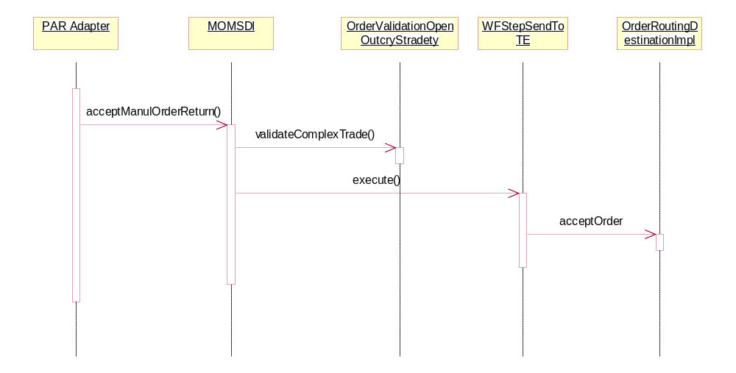
TE Side:

The existing code for trade Spread to Spread trades the leg first since the leg trade has a higher priority over spread-to-spread for Non-CrossProduct. we need to add new business logic to check if the customer COB price is equal to or better than the net leg price and there is no customer orders on all of the leg BBOs, then the TB Spread order will trade immediately with the customer COB.

The existing logic for spread trade is the following:

- If the customer COB price is better than the net leg price, then the incoming Spread Order gets traded again the COB.
- If the customer COB price is equal to the derived quote, the leg trade happens immediately. If there is a remaining quantity, then the customer COB gets traded at the same price.
- Any remaining quantity of the Spread order is booked.

The new logic code will be added to the methods, tradeWithRestingSpreadOrders() and canFirstTradeWithSpreadOrders() on the BrokerProcessorSpreadImpl class to support the new business requirement above. Also The implementation will modify the postProcess() on the BrokerProcessorSpreadHybridImpl class to return the remaining quantity of the Spread order to the PAR.

The new logic will be implemented as the follows:

- If the customer COB price is equal to the Derived quote and there is no customer order on all of the leg BBOs, the incoming Spread Order trades immediately with the customer COB at the same.

- Any remaining quantity of the Spread Order is routed back to the originating PAR workstation without trying to trade with the legs.

The following is the sequence diagram that shows how the current code flows for a Spread order sent to CBOEDirect on the scenario when the customer resting Spread order price is equal to the net leg price, the leg trades happen before Spread-to-Spread trade.

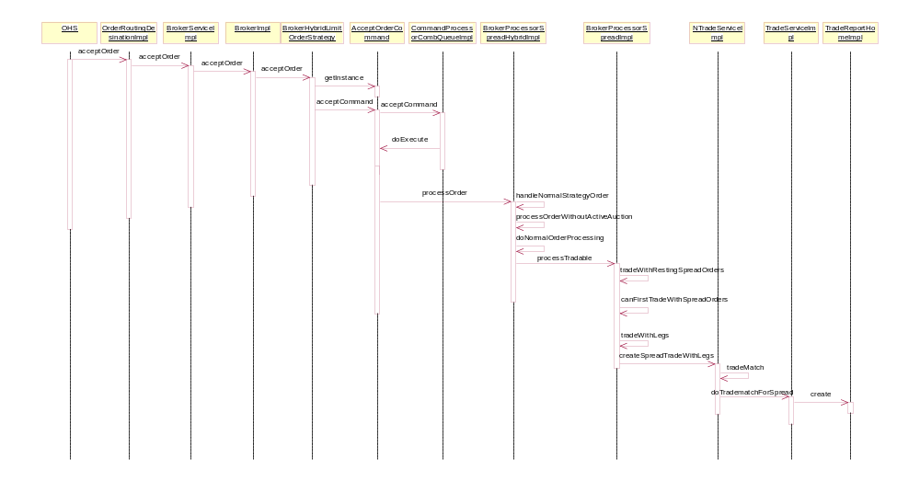

Code Changes:
- Add a new method, isTBForCOB, on the OrderImpl.

