WR# 6393 – Trade Through Alert Enhancements

Goal
The goal of the system changes for this project is allow new types of Trade Through evaluations for simple orders and complex orders. For simple orders, Trade through Processing was done for opposite side market only. Now trade through of same side market will be identified for simple order which could be potentially auto-closed. For complex orders, Trade through processing was done with respect to the leg prices of opposite side only. Now complex order trade through will also be evaluated against the resting complex order and quote in the COB and Leg BBO of the same side. Trade through alerts for the cross product spreads will be evaluated against the resting COB only.

Functionality changes
- Simple Orders TT Alerts, Complex Order TT Alerts and Cross Product Order TT Alerts are listed in below matrix, of when they get generated.
Trade through Alerts Matrix

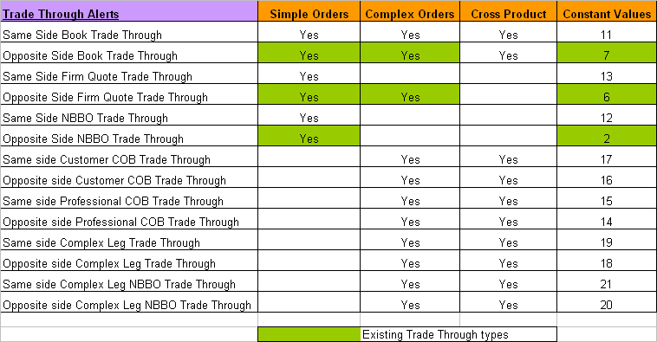

Summary of Changes
- A new struct ManualFillStructV2 was introduced with the new fields required for new Alerts.
- New method acceptManualFillV2(…) was added on ‘ManualOrderMaintenanceService’ to accept manual fills with the new Manual Fill Struct.
- New TT Alerts types have been added to ‘cmiConstants.idl’.
  - SAME_SIDE_BOOK_TRADE_THROUGH = 11; // Opp-Side today = 7
  - SAME_SIDE_NBBO_TRADE_THROUGH = 12; // Opp-Side today = 2
  - SAME_SIDE_FIRM_QUOTE_TRADE_THROUGH = 13; // Opp-Side today = 6
  - OPPOSITE_SIDE_PROFESSIONAL_COB_TRADE_THROUGH = 14;
  - SAME_SIDE_PROFESSIONAL_COB_TRADE_THROUGH = 15;
  - OPPOSITE_SIDE_CUSTOMER_COB_TRADE_THROUGH = 16;
  - SAME_SIDE_CUSTOMER_COB_TRADE_THROUGH = 17;
  - OPPOSITE_SIDE_COMPLEX_LEG_TRADE_THROUGH = 18;
  - SAME_SIDE_COMPLEX_LEG_TRADE_THROUGH = 19;
  - OPPOSITE_SIDE_COMPLEX_LEG_NBBO_TRADE_THROUGH = 20;
  - SAME_SIDE_COMPLEX_LEG_NBBO_TRADE_THROUGH = 21;
- In SBTAlert Table, currently the field ‘comments’ is empty, this will be populated with a corresponding valid text with prices, sides and product key, describing why the TT alert was generated.

Turning on – New TT Alerts
- There are no new properties added to turn on/off this feature.
- REG-Dev PAR data load needs to be installed before PAR server rolls.
- CDB, DWH, Market Replay – No dependency on rollout order, each of these apps can be rolled out at any point in time.
- CBOEDirect, Par client – no dependencies on rollout order, can be rollout out any time.
- PAR Adapter, PAR Server will be loaded together at the end after all other applications mentioned above have been rolled out.
- The functionality gets turned on as and when the PAR Adapter and PAR Server start getting installed.
- No CD Client rollout is required for this release.

