Tips Adapter Elimination

Revision | Date | Change Description | Originator
 | 02/24/10 | Initial draft from design discussions including Steve’s System and John’s Event diagrams. | Hari

Table of Contents
1 Table of Contents 2
2 General 3
2.1 Purpose 3
2.2 Overview 3
2.3 Scope 6
2.3.1 In Scope 6
2.3.2 Out Scope 6
2.4 References 6
2.5 Definitions and Acronyms 6
2.6 Dependencies and Assumptions 6
3 Design 6
3.1 Current System Design for Opening 6
3.2 New System Design for Opening 7
3.3 Underlying Product State Mapping 9
3.4 Underlying Product State Processing for Derivative Opening 9
3.5 Codecs 12
3.5.1 Product State 12
3.5.2 Quote Recap 12
3.5.3 New Last Sale Recap 12
3.6 Object Sequences 13
3.6.1 Underlying Product State Determination 13
3.6.2 Derivative Option Product Opening 13
3.6.3 Underlying Last Sale Recap Processing 13
3.6.4 Underlying Quote Recap Processing 13
4 Release 13
4.1 Rollout Plan 13

General

Purpose

The purpose of the project feature is,

i) To make the opening rotation of option derivative products faster by moving the underlying product state determination and propagation from Tips Adapter (TA) and Global processes to the host server processes on the BC.

ii) To eliminate the TA altogether by replacing of following its other hosted or supported functionality,
- Publishing of recap event for CD server and client processes.
- Publishing of ticker event for CAS.
- Servicing of MDS interface requests/queries.

The main purpose of this document is to describe the technical and design details to achieve the above goals form the CD system perspective.

Overview

TA basically gets the underlying equity data (current market and last sale) from the Global XTP and transforms it into product state, recap and ticker events for CD server and client systems. The TA also caches the received equity data to support the client queries through MDS interface.

TA determines the equity product state transition based on the new incoming recap prefix and cached product state. Currently Global consumes the new equity product state from TA and requests the corresponding BC to open its hosted derivative product(s).

But, similar to Global XTP, the BC's XTP can also access the same underlying equity data so, instead of propagating the state change through TA and GC, in this new implementation, the BC directly consumes the product state from local XTP to opens its derivative products.

Coming to MDS, it is not sure yet if any client is dependent on TA's MDS so if needed all the needed data should be alternatively routed to BC so that it can alternatively host the MDS service.

The below diagrams show TA events publishing and routing to target CD systems. As we notice some of these events have no active current consumer(s) and it seems the CAS is also no longer in need of them as it is consuming the equivalent event data from MDX. The BC needs recap for generating MDH so it is going to consume the recap data from the local BC's XTP in the new implementation.
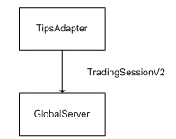
Fig. Product State on TSS EC

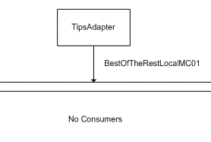
Fig. BOTR EC

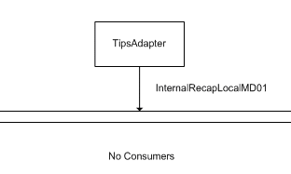
Fig. Internal Recap EC

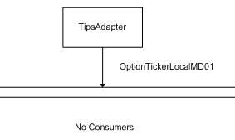
Fig. Option Ticker EC

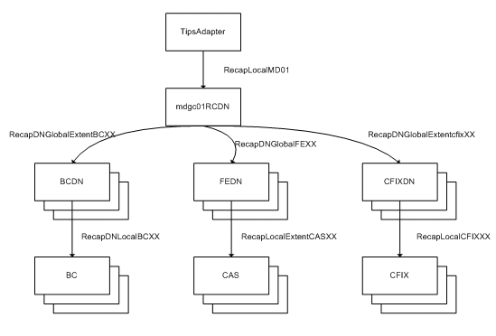
Fig. Recap EC

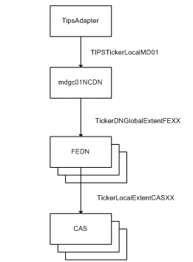
Fig. Ticker EC

Scope

In Scope
- The design and implementation is limited to W_MAIN and C2_MAIN sessions.

Out Scope
- The design details for -
  - Replacement or re-routing of recap event publishing and routing to CFIX (and CAS if needed).
  - Alternative hosting of MDS in the BC?
- The documentation of BC’s XTP design details.

References

Definitions and Acronyms
CAS – Client Application Server
CD – CBOE Direct, broadly includes trade server and client systems?
EC – Event Channel
HTS – Hybrid Trade Server
MDS – Market Data Service
MDX – Market Data Express
PSS – Product State Service
TA – Tips Adapter
TSS – Trading Session Service

Dependencies and Assumptions
- Unless specified the term hybrid can also refer or applicable to C2 e.g. C2 server for HTS.
- It is assumed that equity product state does not have to be persisted in the new implementation.

Design

Current System Design for Opening

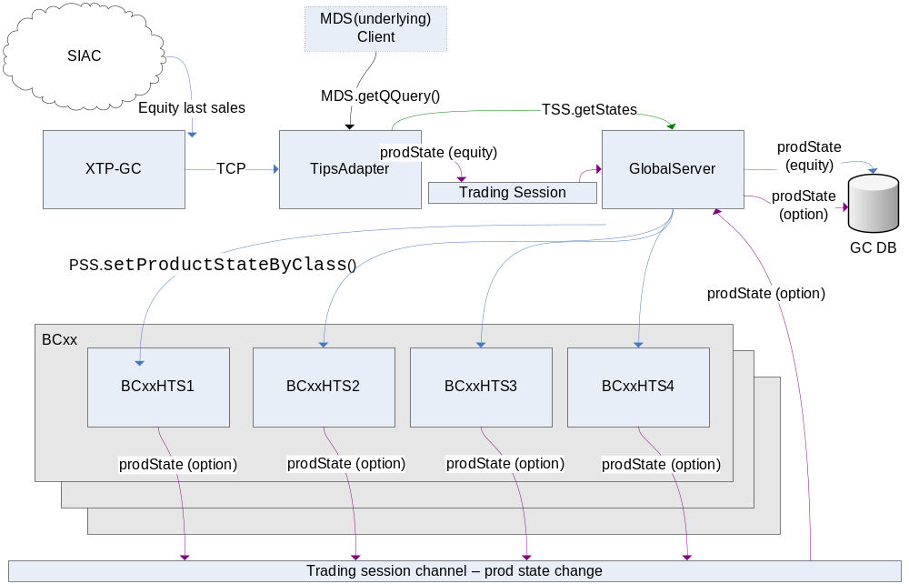

Fig. Current System Opening

New System Design for Opening

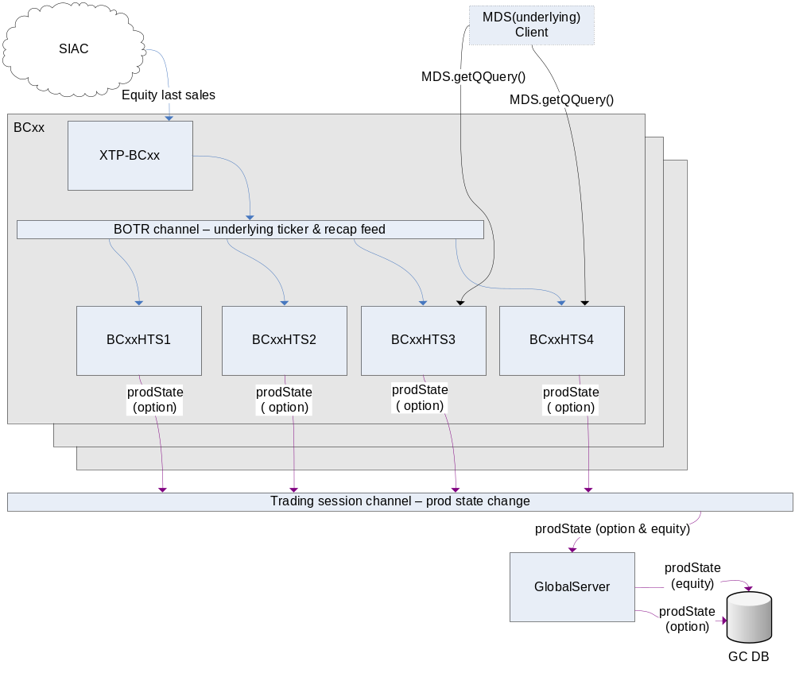

Fig. New System for Opening

In the new system implementation,
- BC’s XTP publishes underlying equity product state, recap (Quote and Last Sale).
- Server processes in the BC consume local XTP’s product state for option product opening and recap for MDH generation. Note that the BC will continue to process the product state change request from GC or any other client through PSS but I will stop listening to recap from TA.
- BC server (Master and Salve) caches the equity product state but will not publish on the TSS EC.
- The Global continues to consume the equity product state from TA and persist it until all the BCs are upgraded.

Underlying Product State Mapping

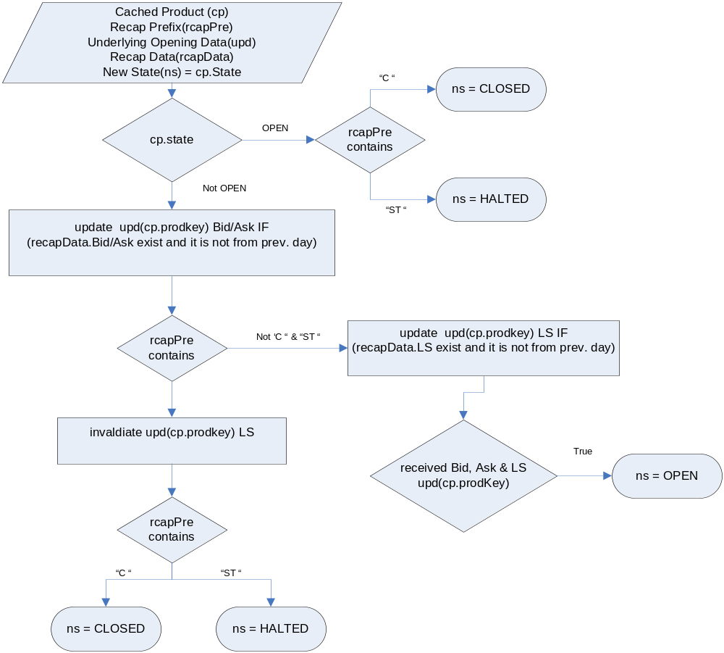

Fig. Equity Product State transition from Recap Prefix and Underlying Cache

Underlying Product State Processing for Derivative Opening

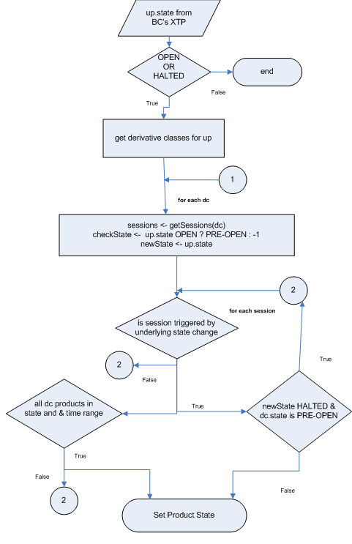
Fig. Derivative Product State(s) Transition based on the Underlying Equity State

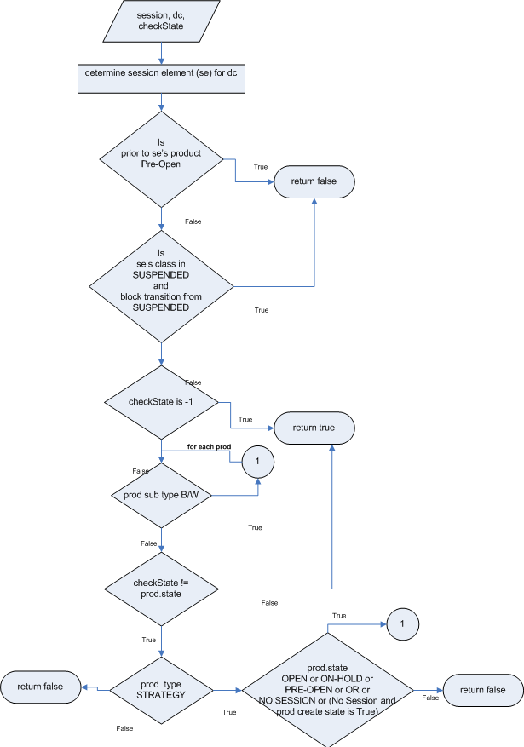
Fig. Derivative Product State(s) and Time Range verification

Codecs

Product State
The existing away market buffer header will have the new product state filed.

AwayMarketDataMessageHeaderCodec
{
…
ByteFieldCodec productState;
}

The first three bit positions are going to encode the Open, Closed and Halted states using the respective bit masks 0x01, 0x02 and 0x04. The Open state is mutually excusive with Closed and Halted states. And, to avoid the confusion in case of XTP default or failover state, the state 0x00 is considered as special NO state change.

Quote Recap
The existing UnderlyingCompositeCodec will support following new fields for quote recap information.

UnderlyingCompositeCodec
{
…
LongFieldCodec bidTime
LongFieldCodec askTime
ByteFieldCodec bidDirection
ByteFieldCodec isOTC // looks like related Price Scale?
IntFieldCodec openInterest // need to be supported?
}

New Last Sale Recap
The new UnderlyingLastSaleCodec will have following fields for LS recap information.

UnderlyingLastSaleCodec
{
LongFieldCodec tradeTime
CompressedIntFieldCodec lastSalePrice
IntFieldCodec lastSaleVolume
IntFieldCodec totalVolume
ByteFieldCodec tickDirection
ByteFieldCodec netChangeDirection
CompressedIntFieldCodec netChange
CompressedIntFieldCodec previousClosePrice
CompressedIntFieldCodec tick
CompressedIntFieldCodec lowPrice
CompressedIntFieldCodec highPrice
CompressedIntFieldCodec openPrice
CompressedIntFieldCodec closePrice
}

Object Sequences

Underlying Product State Determination

Derivative Option Product Opening

Underlying Last Sale Recap Processing

Underlying Quote Recap Processing

Release

Rollout Plan

Day 1:
Rollout Global Server with a flag indicating to continue subscribe underlying product state change events from TA.

Day 2:
Rollout BC’s XTP, let’s say BC06’s XTP06, to publish new recap and last sale codecs including the underlying product state change.

Day 3:
Rollout BC, i.e. BC06. The BC06 synchronizes the derivative product state change process by simultaneously consuming product state change event from XTP06 and continuing to accept the GC’s state change request. It efficiently handles the redundant state change events/requests by using a product state cache. The BC06 starts processing recap (Quote and Last Sale) codecs from XTP06 and stops listening to recap event from TA.

Day 4:
Repeat above two rollout steps for other BCs.

Day 5:
Turn off the flag on Global Server to stop subscribing to underlying events from TA.

