Existing Allocation Approaches

There are two totally different ways regarding the allocation: one is through order book, and the other does not. We will discuss them separately

1. Allocation TOB (Through OrderBook)

Main Interfaces

OrderBook

- Iterator OrderBook.getPrioritySets(Side, Price, int, AllocationTradeContext)
- Iterator OrderBook.getPrioritySets(ArrayList, Price, int, AllocationTradeContext);

The first method is the generic allocation method used by TradeService. The second method is exclusively used for quote trigger trade allocation. Both methods will return an iterator of PriorityTradableSet, which contains a set of tradables on one side of market which trade at the same price and same priority.

AllocationStrategy (com.cboe.businessServices.orderBookService)

OrderBook depends on this interface to accomplish the allocation. There are a lot of overloaded methods in this interface.

- getPrioritySets(OrderBook, OrderBookSideItem, Price, int, AllocationTradeContext). This method is the main method for general allocation.
- getPrioritySets(OrderBook, OrderBookSideItem, TradingClass, Price, int, AllocationTradeContext, int). This method is used for Spread to Leg COA trade
- getPrioritySets(AuctionBook, OrderBook, TradingClass, PriceRange, int, Context, int, List). This method is used for spread to spread COA trade
- getPrioritySets(ArrayList, Price, int, TradingClass). This method is mainly used for quote trigger allocation
- getPrioritySets(AuctionBook, OrderBook, Price, int, Context, int, Tradable, Boolean, Tradable). This method is used for AIM allocation
- getAONAuctionPrioritySets(AuctionBook, OrderBook, Price, int, Context, int, Tradable, Boolean, Tradable). This method is used for AON auction.
- getPrioritySets(ArrayList, TradingClass, Price, int, Context, int). It seems this method is not used.

Allocation TOB Call Flow

BrokerProcessorBase

- processTradable. Process the incoming tradable by trying to trade it against existing orders in the book.
- processTradableWrap. Check the quote locking logic first, and process the incoming tradable accordingly.
- doRegularTradableProcessing. While loop checks canDoTrade.
- allocateTradable. Note: parameter list
- requestedTradeEndingPrice
- incomingTradable
- sameSideTradables
- sameSideQuantity
- book
- tradableIsBooked (Boolean)
- needsSingleFillOnly (Boolean)

TradeServiceImpl

- createRegularTrade.
- internalCreateRegularTrade. This method has one additional parameter adjustedQuantity for taking out the volume contingencies. adjustedQuantity is actually the AON quantity on the same side of the incoming order.
Create opposite side participant lists
Create the same side participant lists
Create trade reports
- createParticipantLists. For opposite side participant list.
- book.getPrioritySets
- while loop through priority set to create participant list at each price

OrderBookImpl

- getPrioritySets. Allocate the total quantity to tradables in the book on a side and up to a price
- side
- tradeEndingPrice
- quantityToAllocate
- allocationContext
This method finds the appropriate allocation strategy based on the allocation context, and ask the allocation strategy to getPrioritySets

AllocationStrategyImpl

- getPrioritySets.
- getPrioritySetsAsList. The parameters are
- book
- sideItem
- priceContraint
- volumeConstraint
- allocationContext
This method loops through each price item in the book from the top price until either price constraint or volume constraint is violated. For each price item, call the following method.
- greaterNEMAAllocation. Determine the allocation types: regular_allocation, mena_allocation, or greater_nema_allocation
For regular_allocation, apply the priority strategies.
- applyPriorityStrategies. Loop through configured priority allocation elements one at a time, until volume is exhausted.
For nema_allocation, get the prority set configured for the NEMA, and apply.
For greater_nema_allocation, compare the regular and nema allocation, return the greater.

OrderBook and AllocationStrategy Relations

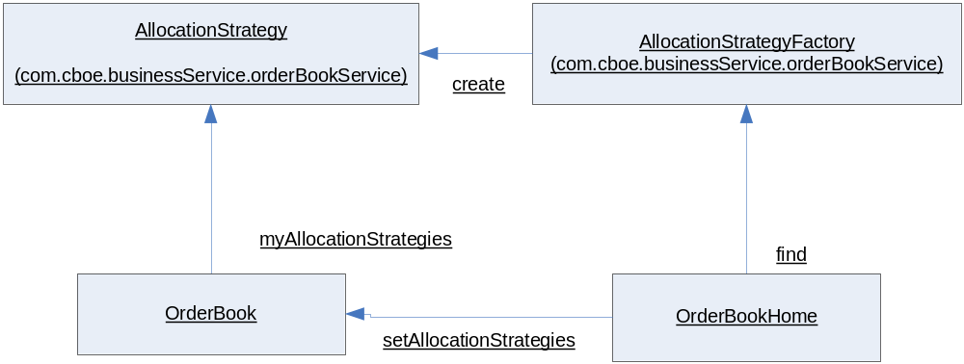

Allocation Strategy Hierarchy

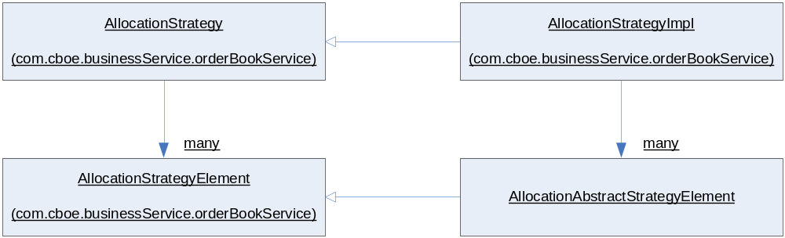

AllocationAbstractStrategyElement has following concrete implementations

- AllocationAbstractUMACUMAStrategyElement
- AllocationBestDpmComplexUmaStrategyElement
- AllocationBestDpmUmaStrategyElement
- AllocationCappedUMAIgnoreDPMGroupStrategyElement
- AllocationCappedUMAStrategyElement
- AllocationComplexPreferredDPMStrategyElement
- AllocationContingencyStrategyElement
- AllocationCustomerBeforeAuctionStrategyElement
- AllocationCustomerContingencyStrategyElement
- AllocationCustomerReservedQuantityStrategyElement
- AllocationCustomerStrategyElement
- AllocationDPMComplexRevisedStrategyElement
- AllocationDPMComplexStrategyElement
- AllocationDPMParticipationStrategyElement
- AllocationElectronicPreferredDPMStrategyElement
- AllocationFixedDPMParticipationStrategyElement
- AllocationInternalizationRightStrategyElement
- AllocationManualQuoteBeforeAuctionStrategyElement
- AllocationManualQuoteStrategyElement
- AllocationMarketOrderStrategyElement
- AllocationMarketTurnerStrategyElement
- AllocationNonCustomerReservedQuantityStrategyElement
- AllocationOpeningStrategyElement
- AllocationPreferredDPMStrategy2Element
- AllocationPreferredDPMStrategyElement
- AllocationPriceTimeProrataCustomerReservedQuantityStrategyElement
- AllocationPriceTimeProrataNonCustomerReservedQuantityStrategyElement
- AllocationPriceTimeProrataReservedQuantityStrategyElement
- AllocationPriceTimeProrataStrategyElement
- AllocationPriceTimeReservedQuantityStrategyElement
- AllocationPriceTimeStrategyElement
- AllocationQuoteLockMinimumTradeStrategyElement
- AllocationScaledDPMParticipationStrategyElement
- AllocationStrategyElement
- AllocationTakeAllStrategyElement
- AllocationUMAIgnoreDPMGroupStrategyElement
- AllocationUMAStrategyElement

Allocation Strategy Configurations

An allocation strategy consists of an ordered collection of allocation strategy elements. Allocation strategy can be configured by allocation trade types. Available trade types are defined:

REGULAR = 0;
OPENING = 1;
QUOTE_TRIGGER = 2;
QUOTE_LOCK_MIN_TRADE = 3;
INTERNALIZATION_AUCTION_TRADE = 5;
INTERNALIZATION_NO_AUCTION_TRADE = 6;
STRATEGY_AUCTION_TRADE = 8;
SAL_AUCTION_TRADE = 9;
BOB_SAL_AUCTION_TRADE = 10;
ALLOC_ALL_TO_RIGHTS_TRADE = 11;
NON_ENTITLEMENT_WITH_CUSTOMER_JOINTERS = 12;

We will use an example to illustrate how allocation strategy is configured for a class. Following is the default allocation strategy configuration for all classes of W_MAIN on atgtest6:

0=1;4;20,2=1;4;16,5=1;4;30;31;32,6=1;4;30;31;32

These could break up into four strategies:

- 0=1;4;20, which defines allocation strategy for regular trade type (0). Default allocation strategy element is price time (1). The prioritized the allocation strategy elements are customer (4) and preferred DPM UMA2 (20). The allocation priority specify by this configuration is customer first, and then DPM UMA2, and finally there is any remaining quantity, then use the default element which is price time.
- 2=1;4;16, which defines the allocation strategy for quote trigger trade (2). Customer is allocated first (4), and then use cappeduma_with_dpm.
- 5=1;4;30;31;32, which defines the allocation strategy for internalization auction trade
- 6=1;4;30;31;32, which defines the allocation strategy for internalization non-auction trade.

2. Allocation NTOB (Not Through OrderBook)

Main Interfaces

This is through a completely different interface with the same name but with different package path.

AllocationStrategy (com.cboe.interfaces.businessServices)

- ParticipantList allocation(TradingClass, TradableList, int, AllocationContext)

This interface is mainly used by NTradeServiceImpl for spread auction trade.

Allocation NTOB Call Flow

AuctionProcessorSpreadHybridImpl

- processAuctionExpire(AuctionInternal, short, Tradable). Check if there should be any trade upon auction ends
- endAuctionWithTrade(AuctionInternal, incomingTradables, DerivedQuote). Depending on the derived quote, the whole auction trade may have to be done in multiple steps (in different price ranges), for each step, there is beginning price, and ending price.

NTradeServiceImpl

- createSpreadAuctionTrade(AuctionInternal, incomingTradables, DerivedQuote, PriceRange, Boolean).
- createSATWithResponse(auction, auctionSideTradables, responseSideTradables, priceRange, derivedQuote, bypassPennyBetterCheck). SAT represents “Spread Auction Trade”. CreateSATResponseSidePLList(…)
CreateAuctionSidePLList(..)
- createSATResponseSidePLList().
- createResponseSidePLList(). This method will loop through different price points of responses and for each price point, it will call allocate on AllocationStrategy.

SpreadAuctionAllocationStrategy

- allocate(TradingClass, TradableList, int, AllocationContext). This method first groups the tradables into different priority groups: customer, beforeAuctionStart, afterAuctionStart, volumeContingency, reservedOrder, then applys different algorithm.

AllocationStrategy Hierarchy

This hierarchy of allocation strategies implements AllocationStrategy defined in the package com.cboe.interfaces.businessService which is totally different from the AllocationStrategy defined in package com.cboe.businessServices.orderBookService.

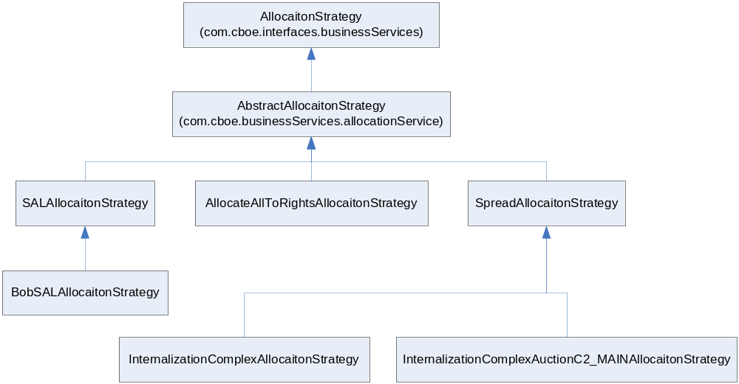

AllocationStrategy implementation consists of a collection of AllocationAlgorithm, which is an interface defined in com.cboe.interfaces.businessServices. Note: concept of the implementation of allocation strategy here is different from the concept of implementation of allocation strategy defined in the order book service. Here specific collection of allocation algorithms are combined to form named AllocationStrategy, such SALAllocaionStrategy, while in the order book, AllocationStrategy is a generic implementation which is used to instantiate different kinds of AllocationStrategy by configuring different kind of combinations of AllocationStrategyElements.

AllocationAlgorithm

- allocation(participantList, quantity, tradingClass, allocationContext)

The following is a list of all implementation of AllocationAlgorithm

- AbstractAllocationAlgorithm
- AllocateAllToDPMAllocationAlgorithm
- AllocateAllToPMMAllocationAlgorithm
- AllocationAlgorithmGroup
- DpmComplexRightsAllocationAlgorithm
- InternalizationComplexRightAllocationAlgorithm
- MarketTurnerAllocationAlgorithm
- OrderedAllocationAlgorithm
- PreferredMMRightsAllocationAlgorithm
- PriceTimeAllocationAlgorithm
- PriceTimeProrataReservedAllocationAlgorithm
- ProRataAllocationAlgorithm
- QMAAllocationAlgorithm
- UMAAllocationAlgorithm
- VolumeContingencyAllocationAlgorithm

3. Common Concepts of Allocation Methods

AllocationGroup

Some allocation algorithm requires dividing a collection of tradables into a different groups, such ICM group and non-ICM groups in UMA allocation algorithm, and then the algorithm is applied o the groups. AllocationGroup is a class designed for this grouping purpose.

Allocation Strategy Persistent Mapping

Allocation strategy is persisted as trading property. The mapping is as follows:

SESSION_NAME | Session
CLASS_KEY | Class key (0 for default)
PROP_TYPE | 4 (allocation strategy)
INT_VAL1 | Allocation strategy element code
INT_VAL2 | Index of this element
INT_VAL3 | Trade Type

Note: Index of an allocation strategy element defines the order of the allocation strategy elements in the whole strategy. Index = -1 indicates that the element is the default element for that allocation strategy.

A survey on production configurations show that the following allocation strategy elements are used:

1 PRICE_TIME
2 PRO_RAT
3 DPM_FIXED_PCT
4 CUSTOMER
5 MARKET_TURNER
10 BEST_OF_DPM_UMA
13 BEST_DPMCOMPLEX_UMA
14 LOCK_MINIMUM_TRADE
15 CAPPEDUMA
16 CAPPEDUMA_WITH_DPM
20 PREF_DPM_UMA2
21 COMPLEX_PREF_DPM
30 INTERNALIZATION_FIXED_PCT
31 UMA_NO_DPM_CHECK
32 CUMA_NO_DPM_CHECK

The default allocation strategy configuration different sessions are list below:

W_MAIN | 0=1;4;20,2=2;4;15,5=1;4;30;31;32,6=1;4;30;31;32,8=2;4;21
W_STOCK | 0=1
CFE_MAIN | 0=1;3,3=14
COF_MAIN | 0=1;3
ONE_MAIN | 0=1;3,3=14

4. TradeServiceImpl

TradeServiceImpl implements three interface

- TradeService
- TradeMaintenanceServiceLocal, which extends TradeMaintenanceService with two new methods
- TradingSessionListener

TradeService interface is a local interface, and is not exported as CORBA service. TradeService is used by various services inside the TradeServer, mainly broker service, to create trades.

TradeServiceImpl also implements the TradeMaintenanceService interface, which is exported to the outside world as a CORBA service.

TradeServiceImpl also implements the TradingSessionListener interface, and mainly interested in the trading session events of PURGE_SESSION type.

Proposal of the Enhancement

Overview

The first existing approach requires the allocation strategy is closely coupled with order book. It means that allocation strategy needs to know the internal structure of order book. In addition, the allocation strategy directly works on OrderBookPriceDetail while carries out the allocation, which makes tasks difficult if the allocation requires to choose a better allocation from two or more algorithms.

Second approach is simpler and clearer conceptually. It tried to avoid the close coupling of allocation and order book. But the composition of allocation strategy is too rigid, and not configurable.

So the enhancement will focus on the following aspects

- Totally decouple the allocation strategy and order book. Allocation strategy will only concern with the quantity to be allocated, a collection of tradables to which the quantity to be allocated, and an allocation context which determines which allocation strategy to use.
- The composition of an allocation strategy needs to be configurable. An allocation strategy normally consists of a few allocation elements/algorithms which are put together in certain order. It should be flexible enough to change the composition of an allocation strategy without changing the code.
- There should be restriction on the allowable compositions, not all different kind of combinations of the allocation elements/algorithms should be allowed. There should be some restrictions. Approach for this is through xml.
- TradeService ultimately controls the whole allocation process: Which price a trade should start at? Which price a trade should end at? What price levels trades should be done at? Which tradables should participated in each price levels?
- There seems a tendency that large quantity of objects are passed around during the allocation processes, which makes the methods different to read, and implementation difficult to follow. A container object, which contains all necessary parameters to accomplish the allocation, may be needed to simplify the methods, and make the parameters are easier to manage.

2. Design

