Multiple Routers Design

Overview

Current processing
- Currently CBOE direct handles linkage connection to 3 router vendors: OLA, REDI and ITS ( no longer active ).
- When an order is received by the linkage server and the destination is confirmed to be a linkage outbound request, based on the product the order is routed to the options linkage adapter or to the stock linkage adapter.
- Once the path for the stock router is decided, the linkage server verifies the value of the flag “sendToRedi” for sending the order the stock fixFixLinkageRouter or the old ITSLinkageRouter.
- The Stock Fix Linkage Adapter defines only one APPIA adapter to handle the mapping and connection to the External linkage provider. The original message is always mapped as destination “REDI” and sent to the APPIA Adapter as any incoming event for the APPIA adapter is mapped as origin REDI.

New approach
- The OrderStruct now will contain a field with the id of the router vendor to be used by the linkage server ( stock or options).
- When the order is received by the linkage server, it will be follow the same steps to determine if its an options or stock outbound linkage order.
- Once the order is determined to be stock, skip the checking of the flag for ITS and send directly to the stockFixLinkageAdapter.
- Once the StockFixLinkageRoutingAdapter receives the order, it will mapped to a basic message with destination based on the router vendor specified in the order.
- If no router is specified by the order the default destination will continue be “REDI”.
- Multiple APPIAAdapter instances will be initialized with connection ids based on the external destinations( REDI, OES, BRASS). Each instance will reference its own server connection to their respective vendor and listener for events from the connection.
- Each adapter references its own mapper which will correspond to the FIX requirements of each vendor.

Assumptions
- – ITS is no longer in use

Diagrams

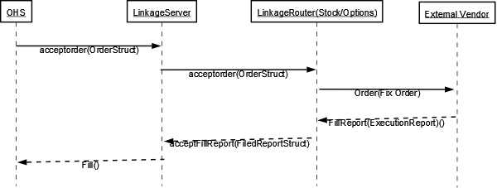

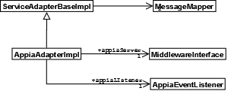

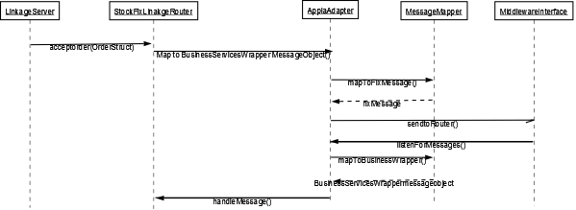

Items need to be changed:

- IDL Changes
  - cmiContants.idl
Location: cmi/idl/cmiConstants.idl
Add constant to ExtensionFields
interface ExtensionFields
{
const ExtensionField LINKAGE_ROUTER_VENDOR = "linkageRouterVendor";
}

- Scripts(1)
- None
- Database
- None

- Modify the appia configuration files to include the connection to each one of the routers.

- setContext
- Modify setContext.main to include the references to the configuration files for the different appia adapters.

- XML/DTD(.5)
  - ServiceAdapterHome.xml
    - Include references to the APIABrassAdapter and APIAOESAdapter to use their respective configuration files.
  - MessageObjectMapperHome.xml
    - Categorize the mapper actions by router vendor
  - StockFixMessageObjectMapperHome.xml
    - Categorize the mapper actions by router vendor

- Homes/Services(.5)
- None

- ImplPlan(.5)
- None

- TestingProcedure(1)
- Update for all possible senarios.

- OperatorProcedure(.5)
- None

- Fallback/Failover
- None

Changes

  - LinkageDeliveryKeys
  - Modify public static String STK_FIX_EXTERNAL = "REDI"; to have the value “STK_FIX_EXTERNAL”.
  - Rename OLA to be CBO_FIX_EXTERNAL with value “CBO_FIX_EXTERNAL” and update all the references.
  - Add the constant ROUTER_VENDOR with value “ROUTER_VENDOR”. This constant will be used to include information about the vendor in the message body.
  - Add constant DEFAULT_STK_ROUTER with value “REDI” and DEFAULT_CBO_ROUTER with value “OLA”.

  - LinkageDeliveryKeysMapperImpl and StockFixLinkageDeliveryKeysMapperImpl
  - mapDeliveryKeys(BusinessServicesWrapper businessServicesWrapper, Message message)
Include in the message the ROUTER_VENDOR field with the value from the order struct, if its not present, insert the value of DEFAULT_STK_ROUTER/ DEFAULT_CBO_ROUTER.

  - LinkageOrderRoutingHelper
  - getOrderRoutingService(OrderStruct order).
Remove references to ITS and the sendToRedi flag, and call for the stockfixLinkagRouter.

  - LinkageMessageHandlerImpl
  - sendMessage(Message message)
Use ROUTER_VENDOR of the message.
  - sendLinkageAdminMessage(Exception exception, Message message)
Include the information about the router vendor

  - MessageObjectMapperHomeImpl and StockFixMessageObjectMapperHomeImpl
  - Load multiple configurations of mappers for the different router vendors. Add a find message with the action and the router vendor id to locate the right mapper.

  - AppiaAdapterImpl
  - Change the implementation sessionId and messageid to handle multiple appia connections with their own sessionid and messageid.
  - When sending a message to appia, obtain the router id from the message to route it to the correct connection, if none is specified, use the default conecction specified.
  - Modify the listener to include the information of the remote_firm_id of the event to include it in the message from appia.

