Allocations during Trading

Overview

Current processing
The BOB class uses Allocation strategy similar to non-BOB classes.

New requirement
The requirement below applies to handling of Allocation during trading for New BOB/SPX Linkage.
- For No Auction: When there is no Auction going on and trade happens on the same price point the allocation should be in the order given below --
  - Customer Order in time priority.
  - Manual Quote orders.
  - Auto Quotes, non-Customer using UMA.
- For HAL Auction: When trade happens following the HAL auction on the same price point the allocation should be in the order given below --
  - Customer Orders in book (before auction).
  - Manual Quote orders in book (before auction).
  - Customer Order arrived during auction.
  - Auto quotes, Manual Quote orders arrived during auction, non customer orders, and auction responses using CUMA.

Assumption
- Trading Class will be enabled for New BOB (SPX Linkage) functionality.
- New HAL will be “ON”.
- Current logic for Allocation during SAL will work as is except that will include Manual Quote orders in allocation.
For detail please refer to Requirement document.

Implementation
No Auction logic
- These trading will use mostly Regular Allocation configured for BOB class through Trading Property.
- Manual Quote order allocation strategy will be added after the Customer order allocation strategy in the list of strategies (in Trading Property) to be used during trading allocation process.

During HAL auction logic
- These trading will use HAL Allocation configured for BOB class through Trading Property.
- All the tradables that arrived before auction will be marked as such to get preference during trading allocation.
- Trading allocation strategies list (in Trading Property) will be Customer orders before auction, Manual Quote orders before auction, Customer orders arrived during auction, and everything else using CUMA allocation strategy.

The new classes are listed below that will be implemented for this functionality; AllocationStrategyFactoryImpl will be modified to find these newly implemented Allocation Strategy classes:
- AllocationCustomerBeforeAuctionStrategyElement – Used to allocate quantity during trading to Customer order that arrived before auction started.
- AllocationManualQuoteBeforeAuctionStrategyElement – Used to allocate quantity during trading to Manual Quote order that arrived before auction started.
- AllocationManualQuoteStrategyElement - Used to allocate quantity during trading to Manual Quote orders.

Main Flow
- When there is no Auction going on an time comes to trade the incoming Order createRegularTrade() of TradeService gets called to allocate and complete the trade.
  - This will pick Regular Trading Allocation as allocation type and hence the list of associated/configured allocation strategies elements from TradingClass.
  - The AllocationStrategyImpl method applyPriorityStrategies will be called that will loop through each AllocationStrategyElement to allocate accordingly.
- SweepService will call BrokerProcessorHybrid2Impl method processSweepTradable() which in turns will call doSweepByPricePoint() to trade for each price point.
  - This method will first check if there is no auction then it will follow the logic same as # 1.
  - If there was an auction then it will call doNewBOBSweepByPricePoint().
  - Method addToSweepListNewBOB() will mark all the Tradables that came during auction and will put in the OrderBook silently.
  - Then the createSweepTrade() method will be called on TradeService for each price point.
  - That will call getPrioritySets() on OrderBook.
  - This call will be delegated to AllocationStrategyImpl through getPrioritySets().
  - Where AllocationStrategyImpl will call getPrioritySetsAsList() and then applyPriorityStrategies() methods to allocate.
  - The applyPriorityStrategies() method will retrieve all configured Allocation strategy elements for this allocation type through TradingClass.
  - It will keep looping through these allocation strategy elements in the sequence AllocationCustomerBeforeAuctionStrategyElement, AllocationManualQuoteBeforeAuctionStrategyElement, AllocationCustomerStrategyElement, and AllocationCappedUMAStrategyElement respectively to assign allocation for trading at that price point.

Scripts
- None

Database
- None

SetContext

XML/DTD/IDL
- constants.idl – Add constants for different allocation strategies:
- const tradingProperty::AllocationStrategyCode MANUAL_QUOTE = 33;
- const tradingProperty::AllocationStrategyCode CUSTOMER_PRE_AUCTION = 34;
- const tradingProperty::AllocationStrategyCode MANUAL_QUOTE_PRE_AUCTION = 35;

Homes/Services
- AllocationCustomerBeforeAuctionStrategyElement
- AllocationManualQuoteBeforeAuctionStrategyElement
- AllocationManualQuoteStrategyElement

ImplPlan
- Sequence Diagram
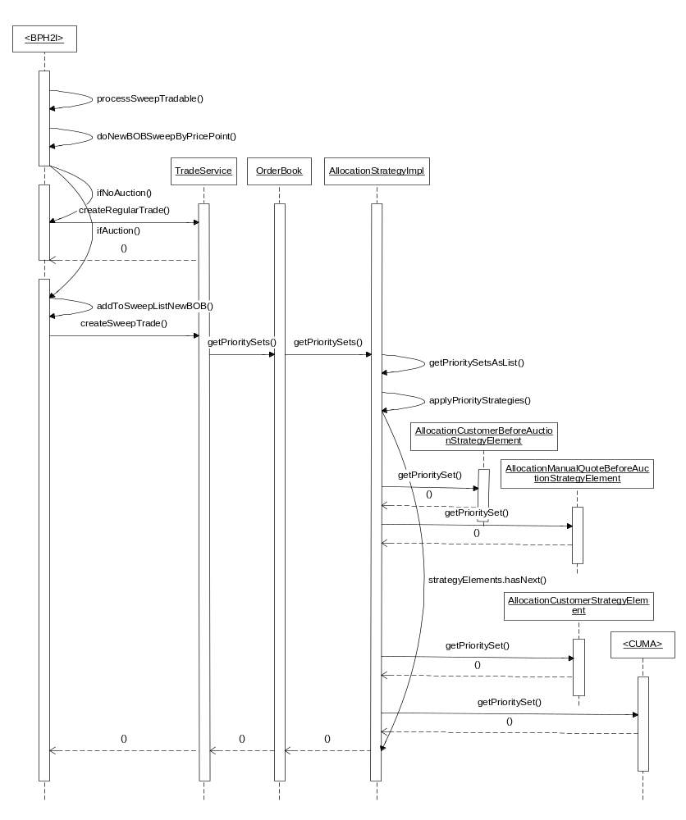

PerformanceTestingProcedure
- .

TestingProcedure

OperatorProcedure
- .

Fallback/Failover

