Foundation Framework Requirements

Khiem Luc
18 December 1998
The Technical Resource Connection, Inc.

Change History:
Version | Date | Author | Reason for Change
0.2 | 10/19/98 | Khiem Luc | Updated after the CBOE Functional review meeting – reduce in functionality: no activation and deactivation …
0.3 | 10/23/98 | Khiem Luc | Update per expanding in requirement scope – to support service object for both CORBA and Non-CORBA object
0.4 | 11/03/98 | Khiem Luc | Updated per the QRC 10/30/98
0.5 | 11/16/98 | Khiem Luc | Updated after the CBOE 11/04/98 review – remove all the Threading management, Transaction management, automatic tracing, automatic logging functionality. Add the ability to use the Infrastructure services directly without going through the Framework.
1.1 | 12/16/98 | Judd Herman | Added Service Interface Pattern
Document Cross Reference:
No. | Title | Reference

Copyright © 2026 The Technical Resource Connection, Inc.
All rights reserved. No part of this document may be reproduced or copied in any form or by any means, electronic or mechanical, including photocopying, recording, or by information storage and retrieval system without permission in writing. This document contains information that is considered company sensitive. While The Technical Resource Connection, Inc. and CBOE may freely copy and distribute this material, all copies must remain in the possession The Technical Resource Connection, Inc. and CBOE
Product names are trademarked by their respective companies.

Document Tracking Information
File Name: | 0000.doc
Document  Reference: | Foundation Framework Requirements/document/0000.doc/Khiem Luc/CBOE1/Requirements
Version: | Version 0.51
Status: | draft
Sign-off
Authorized by
Signature

Contents

1. Introduction 1
1.1 Scope 1
1.2 Components and Concepts 3
1.2.1 Foundation Framework Execution Process 3
1.2.2 Business Object Container (BOContainer) 4
1.2.3 Business Service Object Home (BOHome) 5
1.2.4 Business Service Object Interceptor (BOInterceptor) 6
1.2.5 Business Service Object Instance (BObject) 6
1.2.6 Service Invocation Dispatching 6
1.2.7 Application Process Management 7
1.2.8 Service Interface Pattern 7
2. Functional Requirements 9
2.1 Actors 10
2.1.1 Application/Service Process 10
2.1.2 Client 10
2.1.3 System Management Process 10
2.1.4 Log Service 10
2.1.5 Application Configuration Service 10
2.1.6 Business Service Object Instance 10
2.1.7 Persistent Framework/Service 10
2.1.8 Transaction Service 10
2.1.9 Security Service 11
2.1.10 Event Infrastructure 11
2.1.11 The ORB 11
2.2 Use Case 11
2.2.1 Configuration 11
2.2.2 Service Dispatching 14
2.2.3 Transaction Management 15
2.2.4 Rollback Changes 16
2.2.5 Event Logging 18
2.2.6 Generic Exception Handling 20
2.2.7 Service Management 21
3. Non-Functional Requirements 25
3.1 Operations 25
3.2 Performance 25
3.3 Component Management 25

Figures
Figure 1. Foundation Framework Components Overview 3
Figure 2. Service Invocation 7
Figure 3. Overview of Actors and Use Cases 9
Figure 4. Initialize Scenario 11
Figure 5. Set Instrumentation Option 12
Figure 6. Configure Task Manager Scenario 13
Figure 7. Dispatch Request Scenario 14
Figure 8. Commit Changes Scenario 15
Figure 9. Rollback Changes Scenario 16
Figure 10. Object Managed Transaction Scenario 17
Figure 11. Log Event Scenario 18
Figure 12. Control Log Propagation Level Scenario 19
Figure 13. Raise Exception Scenario 20
Figure 14. Control Service Properties 21
Figure 15. Control Service Operation 21
Figure 16. Retrieve Service Instrumentation Data Scenario 22
Figure 17. Collect Instrumentation Data scenario 23

Foreword
The document presents the scope and requirements for the Foundation Framework of the CBOE Screen Based Trading (SBT) effort.

Scope
The document details the Foundation Framework’s scope and requirements. It uses the UML notation to specify the framework’s actors and use cases.

Audience
This document is written for SBT project team members who need to understand the Foundation Framework’s scope and requirements.

Prerequisites
Readers should be versed in CORBA technology, and must be able to read use case diagrams. A familiarity with the SBT Application Architecture, and CBOE Integration Architecture is helpful.

Organization
This document is organized into the following sections:
- The Introduction provides the scope of the Framework what functionality is included and what is excluded. It presents the components and overview concept of the framework.
- Functional Requirements provides an overview of the actor and the use cases. It details the use cases with the scenarios and the related actors.
- Non-Functional Requirements provides the operations and performance requirement involved with Foundation Framework.

Conventions
Commands you need to key in and programming code appear in Courier New.
Menu items appear in Title Case. Menu paths follow in order Main Menu>Menu or Submenus>Command. For example, saving a file is File>Save.
Keys or keystroke combinations appear in bold.
Files and directory names appear in italics.
Notes look like:

Note
Description of the hint, problem, or precaution.

Related Documents
- SBT Application Architecture
- CBOE Integration Architecture.
- SBT Foundation Framework Interface Definition
- JavaGrinder Rose Model and HTML

Introduction
This document details the current Screen Based Trading (SBT) Foundation Framework’s scope and requirements.

Scope
The Foundation Framework is a set of Java classes that enables using certain SBT infrastructure services in a consistent and effective manner for both the Application Service developers and Business Service developers.
Overall the Foundation Framework functionality will provide a default standard usage of the SBT infrastructure service. The developers will not be affected by the changing infrastructure technology, and they are not required to work with the infrastructure service directly. However, it will not force the developers to use the framework to get to the infrastructure services.
In more detail, the framework provides an application or business server process with the ability to have multiple execution contexts where many service objects can be deployed using specified execution policies and a mechanism to provide authorization validation at the method invocation level. A mechanism is provided that collects and instruments the service statistical profile data by intercepting the invocation of the business service object, capturing the necessary information, then delegating the work back to the business service object. The service process is consistently managed by exposing an administration interface to allow an external application management process to have reactive or proactive control over the process operation. It facilitates a logging integration, allowing a developer to statically define all log information at the development phase, and dynamically control the amount of log information to propagate to a central log repository. It also provides a standard interface to use the Persistent Framework/Service. The framework specifies creating, deleting, and finding operation interfaces the developer will code to. The implementation of the operation for each business object and the actual operation of maintaining the mapping between the object and the persistent layer is outside the scope of the Foundation Framework. The framework simply provides a façade interface to enable an underlying Transaction Framework/Service. There is no additional functionality of transaction management to be implemented at the framework.
This list details the Foundation Framework’s specific functionality:
- Thread management—provides the following threading policy:
- Reuse threading—uses the same thread as the caller. In this model, the framework relies on the developer to provide a threading model (the developer can implement the threading at the business object implementation, at the ORB, or at the Event Infrastructure).
Other threading policies that can be implemented in the future include:
- Shared thread policy—all incoming invocations are handled by a single shared thread. Service invocation is serviced one at a time by the shared thread.
- Thread per request policy—for each incoming service invocation a thread is created and services the request. Service invocations are serviced in parallel.
- Security Integration—provides the security mechanism to validate authorization with the Security Service at the service invocation level. It collaborates with the Security Service to provide the authorization.
- Application management interface:
- provides a mechanism to collect and calculate the service statistical data.
- provides an interface to process administration and operation commands from an external management process
- provides a standard interface to allow access and control application/service properties
- Log Integration—provides an easy access entry point to the Log Service. From this log access, the developer can control the logging and the amount of log information to be propagated to the Log Service.
- Event Integration—provides an easy access entry to enable the using the Event Infrastructure.
- Generic Exception Facility—provide a default implementation of generic exception to interface with the Log Service.
- Persistent Service Integration—specifies the factory, finder, load and store interfaces a developer needs to implement to. The underlying persistence framework is JavaGrinder. The developers will implement the business object using the JavaGrinder to the specified interfaces.
- Transaction Management— provides the common access to the session object in the JavaGrinder transaction framework. From this session object the developer can start a transaction, commit, rollback transactional business object. They can allow a thread to join or leave a session using the same exposed session object. The specific behaviors of these operations are details in the JavaGrinder documentation.

Components and Concepts
The following diagram details the overview components and concepts of how the Foundation Framework operates.
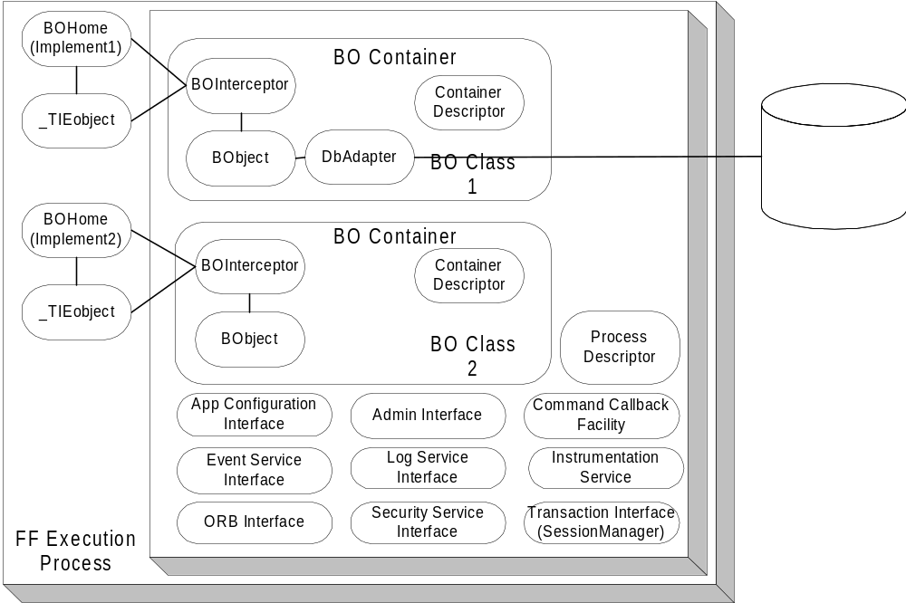

Figure 1. Foundation Framework Components Overview

Foundation Framework Execution Process
The Foundation Framework Execution Process is a singleton object that encapsulates all the infrastructure functionality and exposes an easy-to-use interface for the underlying infrastructure services. It contains a list of execution BO Containers, a Process Descriptor, the interface to the Application Configuration Service, Log Service, Event Service, Transaction Service, an Admin interface, and a Command Callback Facility. The developer simply instantiates the Foundation Framework Execution process in the main Java VM program to deploy business service objects to operate in the specified execution containers.
Each of the BO Containers provides a different execution container for a group of business service object instances (BObject). A service method invocation is always invoked on a BOInterceptor, a peer object to the BObject. The Foundation Framework code to implement the functionality is interjected at the interceptor level and the actual work to service the request is delegated back to the BObject.
At this level, all the process level information that is shared between BO Containers is specified and exposed in the Process Descriptor. It contains:
- The process security identity—the identity of the whole process.
- A list of execution containers.
- A list of home implementations.
- An environment property provides the customizable name pair values, which can be defined and retrieved using the standard Properties object.
Within the process boundary, the framework exposes at this level the following interfaces:
- The Application Configuration Service interface – through this interface the start up default properties of the process can be accessed.
- The Security Service interface – provides the access to the Security Service
- The Transaction Service interface – provides the interface to the JavaGrinder SessionManager object. From this SessionManager, Session can be created to groups a number of threads together working on a set of transactional objects. The transactional objects will be commit and rollback together using session commit and rollback operations.
- The ORB Service interface – through this interface the basic Object Request Broker functionality like network parameters (request queue, time-out. The Trader service can be accessed through this interface.
- The Event Service interface – provides a simple access to the Event Service.
- The Log Service interface – provide the access to the Log Service. From this interface, the control of propagation level and the logging functionality is delegated to. The Logging Service defines the following log types: DEBUG, INFORMATION, ABORTION, THROTTLE, SYSTEM, RESOURCE and EXCEPTION. Each log type has ten levels of priority ranging from the one (lowest) to ten (highest). Along with the priority log level, a quality of service can be specified. The quality of service used to control the amount of messages to package and send at the sender type depends on the repetition of the message sent. Please refer to the Log Service for the detailed quality of service.
- Instrumentation Service interface –provides the mechanism to actively collect the service statistical profile.
The framework also exposed an Admin interface beyond the process boundary so that it can participate in the system control and management.

Business Object Container (BOContainer)
A business object container provides an execution container for a group of business service objects. Each service invocation is intercepted and controlled by the policies in the BOContainer Descriptor. The following policies are shared at the container level:
- A Transaction Policy: OBJECT_MANAGED and CONTAINER _MANAGED. With OBJECT_MANAGED, the business service object will make calls to the Foundation Framework Transaction Management directly. With CONTAINER_MANAGED, the transactional begin demarcation and commit demarcation will be provided at the peer interceptor object.
Only the OBJECT_MANAGED is available for the first release of SBT. The framework will expose a JavaGrinder session object per container. The transactional object will manage its transaction begin and end explicitly.
- Thread Policy: REUSE_THREAD, SHARED_THREAD and THREAD_PER_REQUEST. The REUSE _THREAD policy executes the task in the same thread of the caller. The SHARED_THREAD policy uses the single shared thread in the execution container to process tasks one at a time. Incoming tasks are blocked in this model until the current task is finished. The THREAD_PER_REQUEST will execute the task in a separate thread. For each task, a new thread is created and the dispatching of the task happen within the new thread. Tasks are dispatched in parallel.
Only the REUSE_THREAD is available for the first release of SBT.
- Instrumentation Policy: ON and OFF. ON policy starts the process of collection and instrumentation of the statistical profile data of service invocations. The running average timing and the number of invocation at the request level will be collected and stored in memory. OFF policy turns the processing off. The instrumentation data will be available when request and also available in the public broadcast event channel.
- Security Policy: PROCESS_IDENTITY and SPECIFIED_IDENTITY. The PROCESS_IDENTITY policy uses the process level security identity as the identity to validate the authorization. The SPECIFIED_IDENTITY policy allows the container to control the identity at the invocation level (in this case a client identity can be used instead of the process identity).
- Exception Policy: THROW_BACK, ABORT_CURRENT_TASK, and ABORT_PROCESS. TRHOW_BACK policy propagates the exception thrown to the caller. ABORT_CURRENT_TASK policy dictates the execution container to abort the current task, log the exception, and continue to the next task. ABORT_PROCESS policy allows the exception to be logged and other execution containers to be notified that shutdown is in process, and finally terminates the process.
Since the Foundation Framework will not have any threading implementation for the first release of SBT, the only exception policy support is THROW_BACK. The developers have to code the EXCEPTION event log directly at the time of exception raise and it will be raised back to the caller the normal way.

Business Service Object Home (BOHome)
For each business service object class in the system, a Business Object Home is available to provide the finding and creation of a service object instance and its peer interceptor. In the case of implementing a CORBA object the TIE object can be managed by the BOHome as well. Business Service Object Home is shared between the execution container. There is only one Business Service Object Home per class of business service object in the VM process.
There can be multiple BOHome objects. Each one can handle the creation and finding of a selected implementation of a business service object. One BOHome object can be responsible for the CORBA proxy object (which in turn communicates with a server business service object). Another BOHome object can be responsible a local stubbed out version of a business service object; and one can take care of the actual business server service object at the server side. These multiple homes facilitate a consistent usage pattern and promotes the iterative development effort.

Business Service Object Interceptor (BOInterceptor)
For each business service object instance (BObject), a peer service interceptor object is created. It is a one-to-one relationship between the peer interceptor object and the instance object. This peer object exposed all the service that a BObject provides. At this interceptor level all Foundation Framework features are provided. The interceptor delegates the actual work to the business service object instance.

Business Service Object Instance (BObject)
BObject is an instance of a business service object. A Business Service Object is defined as a large-grained object that provides some business or application service. There is a small number of service object instances in the process. The main process usually creates the service object instance at the initialization stage. The service object is running until the process is terminated. There is no activation and passivation of BObject at the framework.
The service object instance can be a transient object with no persistent data or can be stored and loaded from a persistent service. When implemented with the JavaGrinder persistence framework, a JavaGrinder DBAdapter will be associated with the object to provide the persistence capability. There are different DBAdapters to persist data to different persistent medium: one for a relational database, one for a text file, and one for a binary file. When implemented with the JavaGrinder Transactional interface, BObject will implement the interface to support commit and rollback of the data (the in process memory data attributes)
The service object instance can be a CORBA IDL implementation object or any object.

Service Invocation Dispatching
When the service invocation (a business method) arrives to the peer interceptor object, the interceptor accepts the invocation. Before submitting the service invocation and processing the reply invocation, the interceptor object enables the Foundation Framework functionality.
To enable the Foundation Framework functionality, the service invocation only needs to go through the interceptor object. To the caller, the syntax and calling signature is the same between the service instance and its interceptor. If the service object is a CORBA object, use the interceptor object as the implementation object instead of the service object to inherit the Foundation Framework functionality.
When using the TIE approach to provide the CORBA object, the tie object (server side IDL generated object) can be associated with the interceptor object to enable the Foundation Service functionality the same way. Dispatching the CORBA request to the interceptor using the TIE mechanism and the dispatching between the interceptor and the instance object should proceed normally.
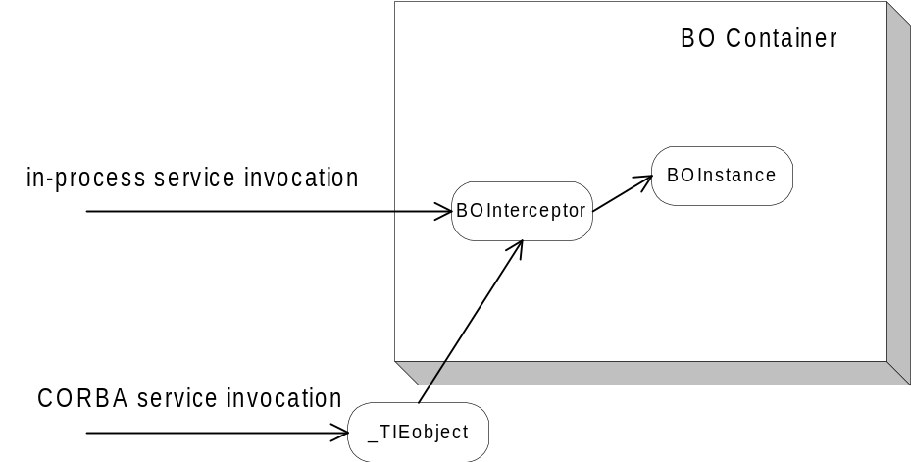

Figure 2. Service Invocation

Application Process Management
At the process level a Command Callback facility is exposed. It contains a map of registered callbacks, allowing the Foundation Framework to enable the process to be controlled and managed from an external process. A developer register “command” as a string key name to an action at initialization stage and the call back will be invoked from an IDL admin interface.
An external management process binds to the admin interface to retrieve process configuration information, to change process behaviors, and to retrieve the statistical instrumentation profile data.

Service Interface Pattern
The Service Interface Pattern is composed of a triad of java to uniformly expose the functionality of services like the security and event services. The purpose of the Service Interface Pattern is to standardize the interfaces to all of the services, since the underlying service interface may be different from one service to the next. Each service interface will allow the developer to get an instance of the service, initialize the service and to expose the public functions of that service. A Service consists of three classes, an abstract which acts as a base implementation class, an interface class and an implementation class.

Functional Requirements
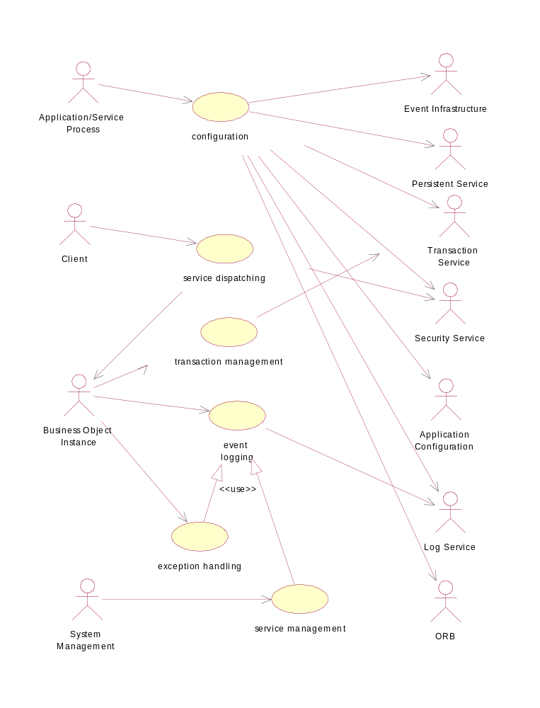

Figure 3. Overview of Actors and Use Cases

Actors

Application/Service Process
Any application service or business service process that is deployed in the SBT environment with the Foundation Framework.

Client
Any object in the VM process including CORBA object, non-CORBA object, and CORBA IDL object implementation.

System Management Process
Any external process that uses the administration interface to provide control of service properties and operations.

Log Service
The Log Service from the SBT Infrastructure Service.

Application Configuration Service
The Application Configuration Service from the SBT Business Services.

Business Service Object Instance
An instance of a service object.

Persistent Framework/Service
A persistent framework or service that provides the persistent capability, as well as a mechanism to map the object data and the persistent store format.
The JavaGrinder framework is selected and will be extended to provide the Persistent Service. To participate, the business object has to implement the JavaGrinder persistent interface. Within the JavaGrinder framework, a persistent object is also a transactional object. It will participate in the transaction with the commit and rollback capability.
Each of the JavaGrinder persistent objects delegates the persistent work to a DBAdapter. There can be multiple implementation of the DBAdapters. Each implement to use a different persistent medium to store the data.

Transaction Service
A transaction service or framework that provides the actual transaction management of maintaining data consistency between objects operations.
The JavaGrinder is selected as the Transaction Service. It provides the commit and rollback functionality of transient object as well as persistent object. To participate, the object has to implement the JavaGrinder Transactional interfaces. The JavaGrinder session interface is provided to allow the object from different java VM threads to participate in a session. Objects in a session are commit and rollback together within a session.

Security Service
The Security Service from SBT Infrastructure Services.

Event Infrastructure
The Event Infrastructure from SBT Infrastructure Services

The ORB
The Object Request Broker’s run-time and its Trader Service.

Use Case

Configuration

2.2.1.1 Initialize
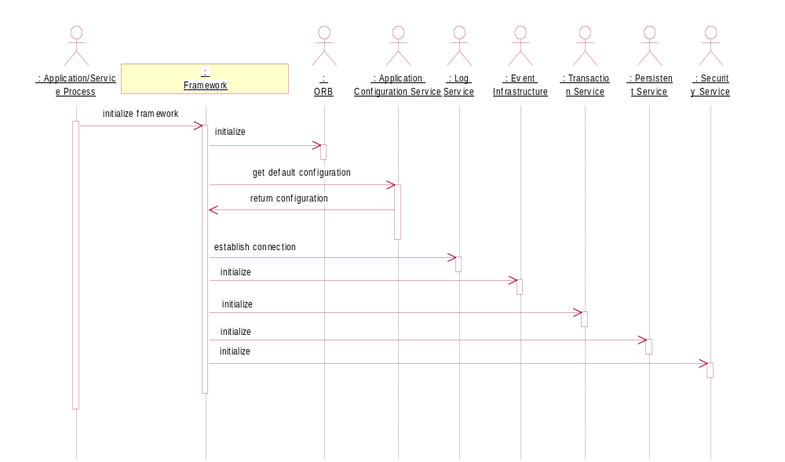

Figure 4. Initialize Scenario
The Appliation/Service process uses this senario at the beginning of the process to initialize the foundation framework. It initialize the ORB for the communication, then retrieves the default configuration from the Application Configuration Service and iterates over the other infrastructure services to initialize them. When this senario finishes, the Application/Service process should have established a default Log Service, intialized the Event Infrastructure, Transaction Service, and Persistence Service. It should have also authenticated its service and retrieved the security context from the Security Service.

2.2.1.3 Set Instrumentation Option
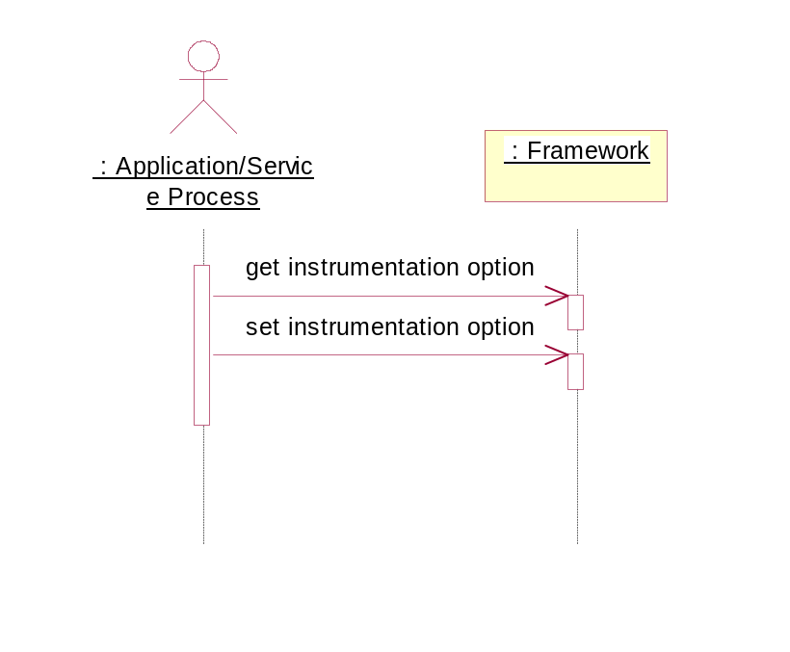

Figure 5. Set Instrumentation Option
This scenario can be used at any time when the Application/Service process is in operation. When the instrumentation option is turned on, the service’s statistical service profile data is instrumented on the fly. This information is kept to support the proactive management effort. The information can be reset, and turned on and off as often as necessary.

2.2.1.4 Configure BO Container
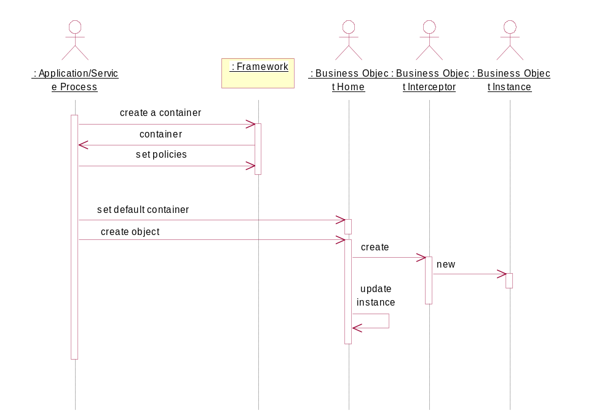

Figure 6. Configure BO Container Scenario
This scenario is used when the business service object is created. A BO container is created with the appropriate policies. The container is then associated as a default container with a BOHome. When the BOHome object receives the create object operation, it creates the BOInterceptor object and update the instance internal map. The BOHome can then be queried later to return the object interceptor given a BObject.
In the case of a business service object, an instance needs to be created and deployed in a different container. A special create object scenario can be used with a container as a parameter.

Service Dispatching

2.2.2.1 Dispatch
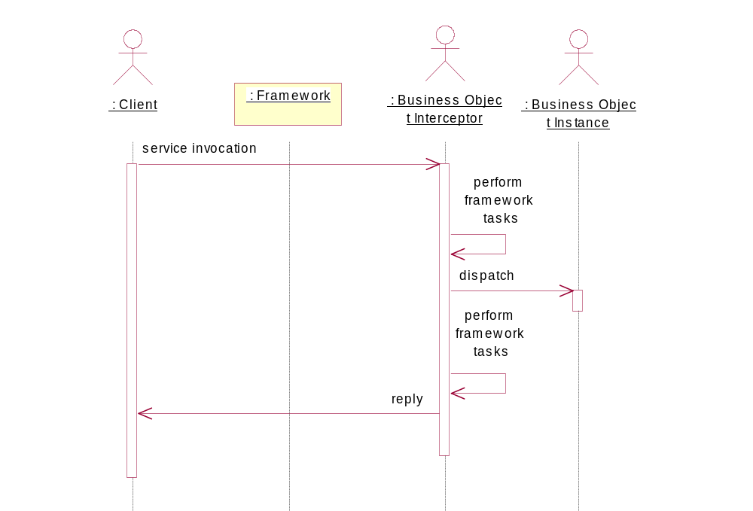

Figure 7. Dispatch Request Scenario
This scenario is exercised whenever an incoming request is arrived at the BOInterceptor. The interceptor intercepts the request and dipatches the request to the BObject. From within this interceptor, the authorization validation takes place (optional) before finally dispatching to the instance object. The reply returns back to the client process the normal way.
To remove overhead at run time, the interceptor can contain a bypass flag to ignore all the pre and post framework task. In this case, the interceptor is just a thin wrapper of the instance object. All the Foundation Framework functionality is turn off when this flag is set.

Transaction Management

2.2.3.1 Commit Changes
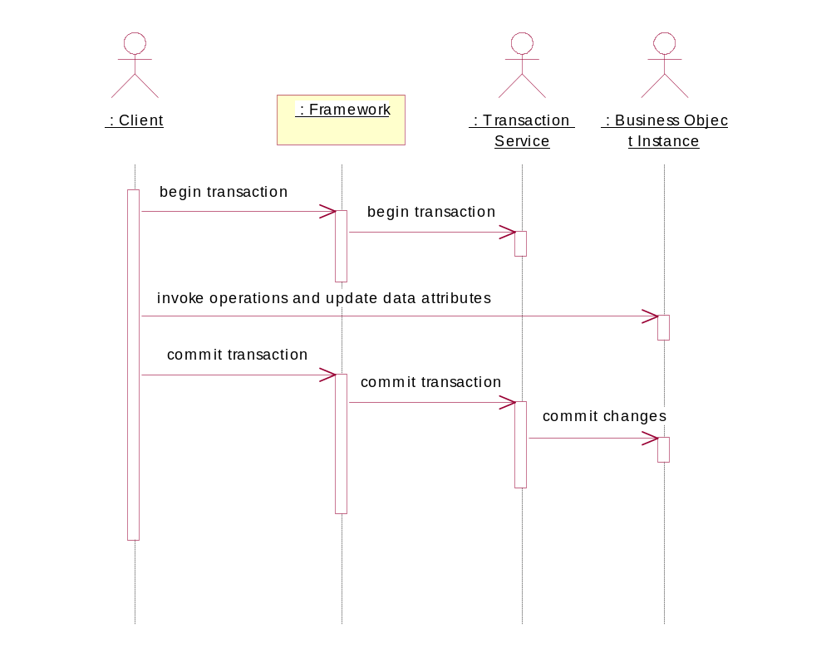

Figure 8. Commit Changes Scenario
A client interacts with the Framework transaction scenario by invoking the Framework begin transaction and ends the scenario with a commit to commit the changes.

Rollback Changes
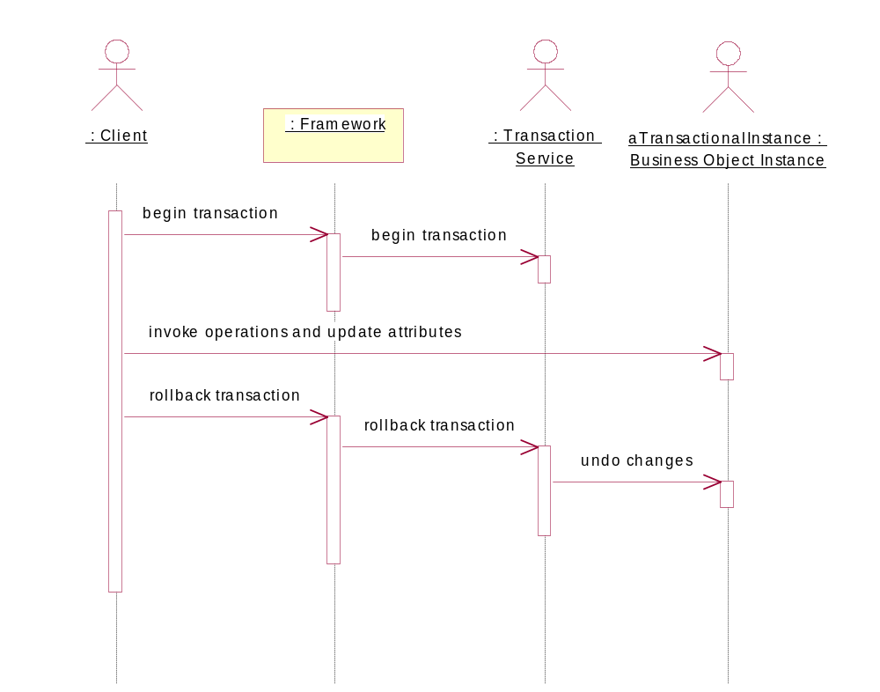

Figure 9. Rollback Changes Scenario
A client interacts with the Framework transaction rollback scenario by invoking the Framework to begin the transaction, and to end the scenario with a rollback to ignore the changes to its data attribute.

2.2.3.3 Object Managed Transaction
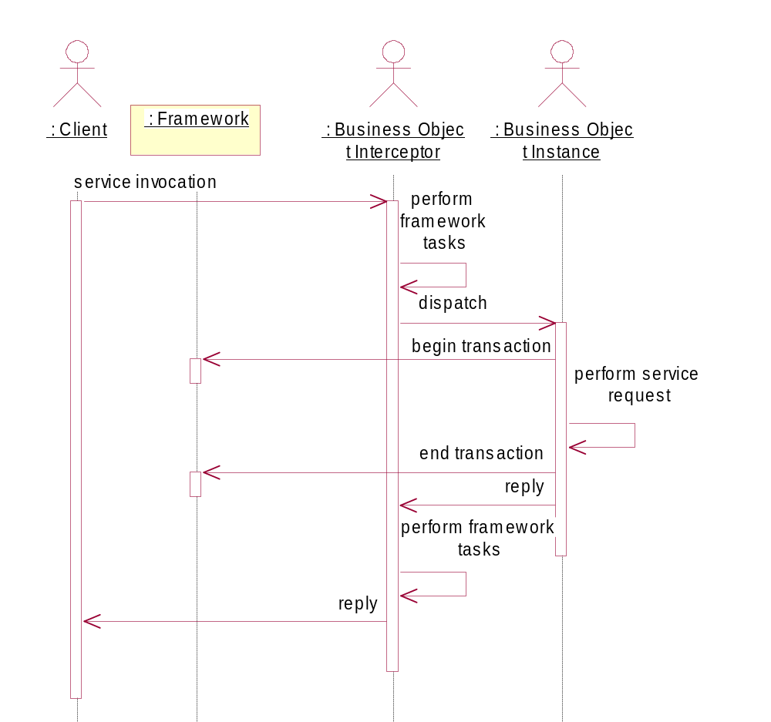

Figure 10. Object Managed Transaction Scenario
In this scenario, the service object instance makes the explicit call to start a transaction and to end a transaction.

Event Logging

2.2.4.1 Log Event
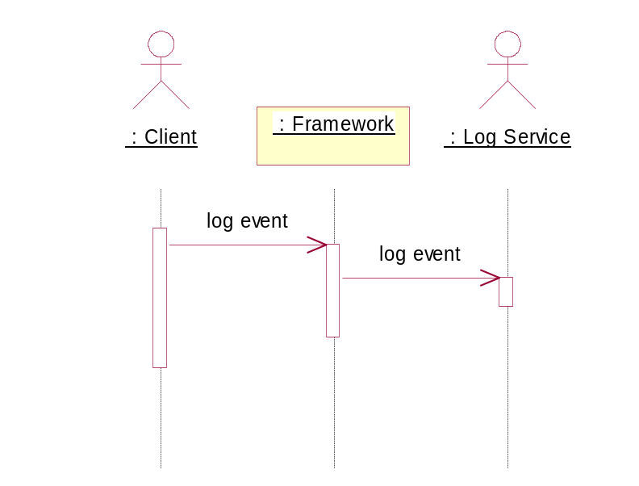

Figure 11. Log Event Scenario
The object instance implementation code uses the log event scenario whenever it needs to log an event. Each event is categoried with different Logging levels and priority code so that it can be filtered and processed efficiently at the centralized Log Service.

2.2.4.2 Control Log Propagation Level
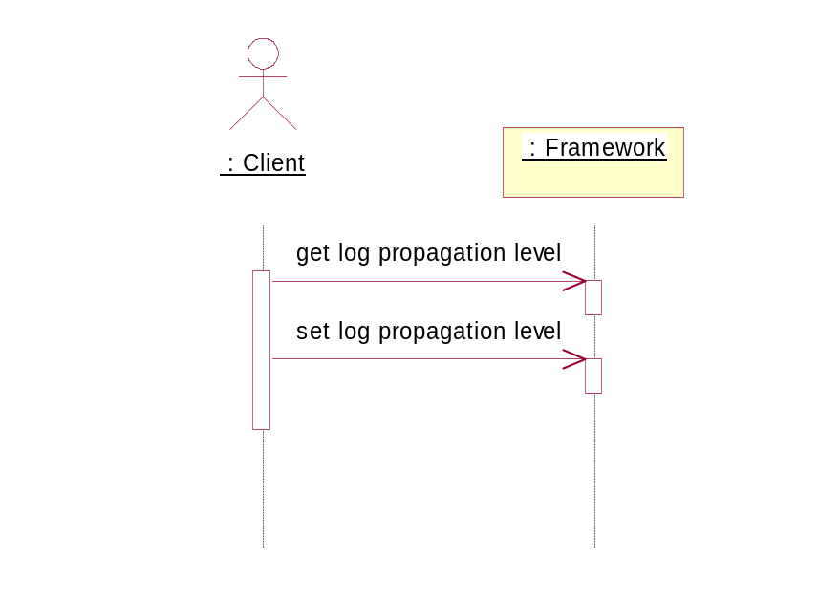

Figure 12. Control Log Propagation Level Scenario
This scenario is used to control the level of log events to be sent to the Log Service. All log events with priority level above the pre-set propagation level will be propagated ( will be sent ) to the log server. For each of the Logging types, there will a different log propagation priority level.

Generic Exception Handling

2.2.5.1 Raise Exception
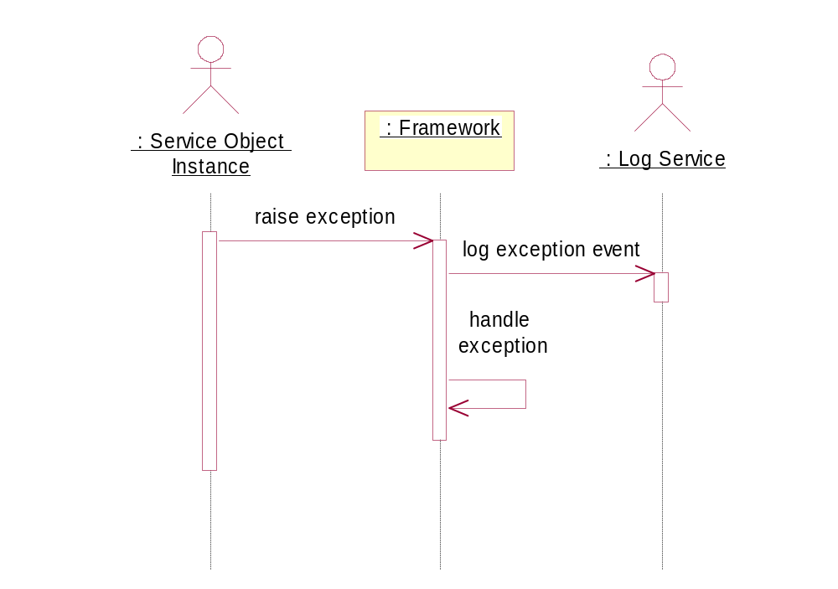

Figure 13. Raise Exception Scenario
The raise exception scenario is used whenever an exception is raised from the object instance. The exception message is captured and logged with the exception level. Based on the specified exception policy, the framework handles it appropriately.

Service Management

2.2.6.1 Control Service Properties
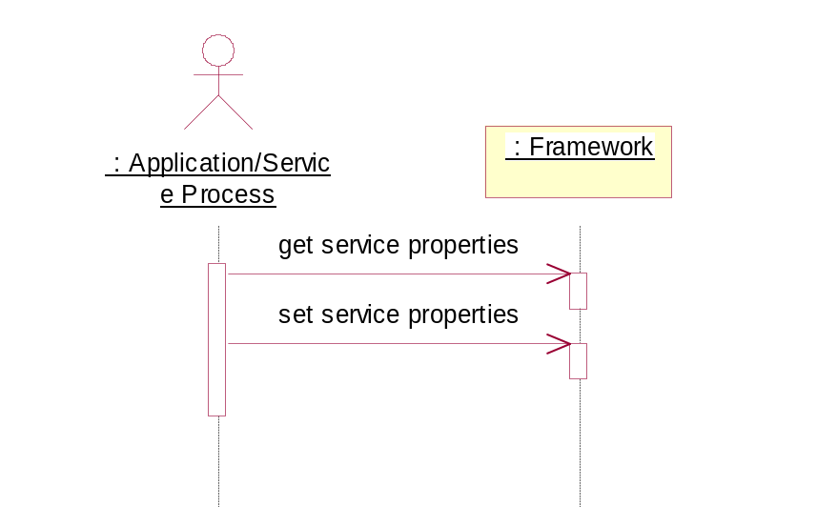

Figure 14. Control Service Properties
The Application/Service process uses this scenario to get service properties and set service properties. The Framework accesses the default configuration properties from the Application in the initialize scenario and uses this scenario to expose this information.

2.2.6.2 Control Service Operation
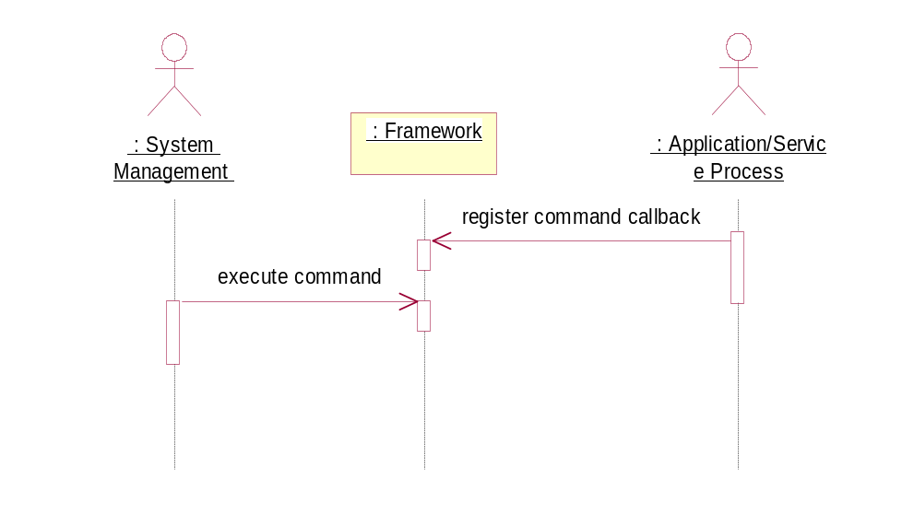

Figure 15. Control Service Operation
A system management process uses this scenario to send commands to the service process. Before a command is supported, the Applicatoin/Service process requires that the command call back function is registered for processing. The Framework facilitates the call back invocation and the Applicatoin/Service process defines the command it supports and provides the call back.

2.2.6.3 Retrieve Service Instrumentation Data
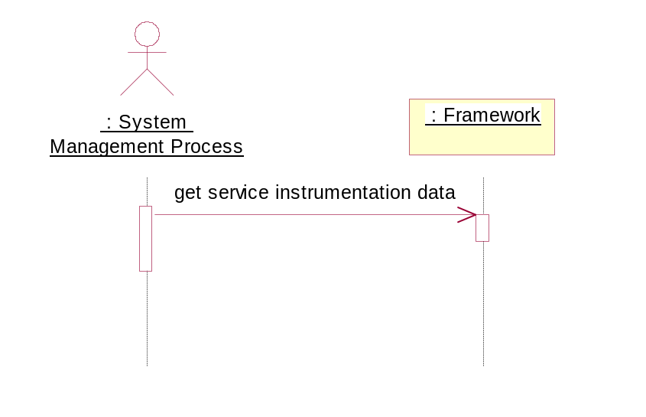

Figure 16. Retrieve Service Instrumentation Data Scenario
A system management process uses this scenario to retrieve the service’s statistical data. The statiscal data is instrumented as it comes in and is kept at the Framework level. The set instrumentation scenario controls the option to collect the data, but this scenario is the one that provides the access to them.

2.2.6.4 Collect Instrumentation Data
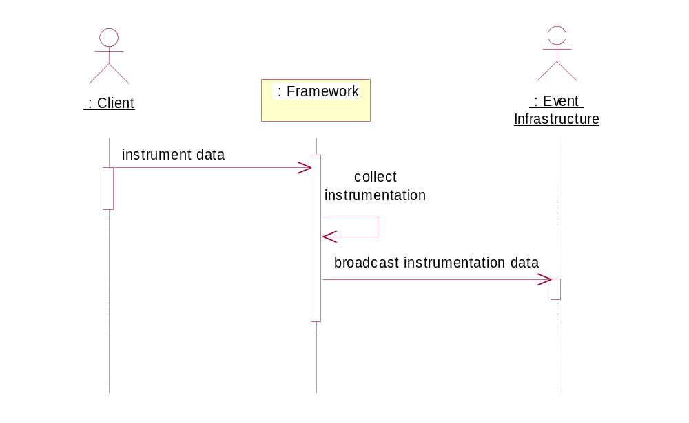

Figure 17. Collect Instrumentation Data scenario
The scenario begin when a client code, usually the interceptor code, but can be any code in the VM process, instructs the framework to collect the instrumentation data. The running data is kept in memory when the process is running. At any point the framework can be instructed to reset the data to record the new set of instrumentation.

Non-Functional Requirements

Operations
The Application Service and Business Service developers import the Foundation Framework classes in their code and use the provided operations to set up and access the functionality.
All the classes should be contained in the proper Foundation Framework package to avoid name clashes with other packages.

Performance
All of the expensive operations of the Foundation Framework should happen at the initialized stage where the application process is not in full operation mode. There is some overhead in the normal operations, which is detailed by functionality in the following list:
- Security integration—overhead in the invocation with the Security Service to authorize the operation using the client security identity token and the service process identity token.
- Log integration—overhead in the remote invocation with the Log Service when the log events are propagated to the centralized logging repository.
- Generic Exception Handling—overhead in the remote invocation with the Log Service.
- Transaction/Persistence Management—overhead in hand off and the actual work at the JavaGrinder Transaction and Persistence framework level.

Component Management
Importing the classes and instantiating the framework objects in the Application Service process or Business Service server process is required to deploy the Foundation Framework functionality. There is no external daemon process needed to provide the functionality.

Note
The Foundation Framework itself provides the functionality to enable the process to be managed. Please refer to the Components and Concepts section on application process management.

