腾讯漫画的接口分析

1. <https://ac.qq.com/Comic/all/search/hot/vip/1/page/1>

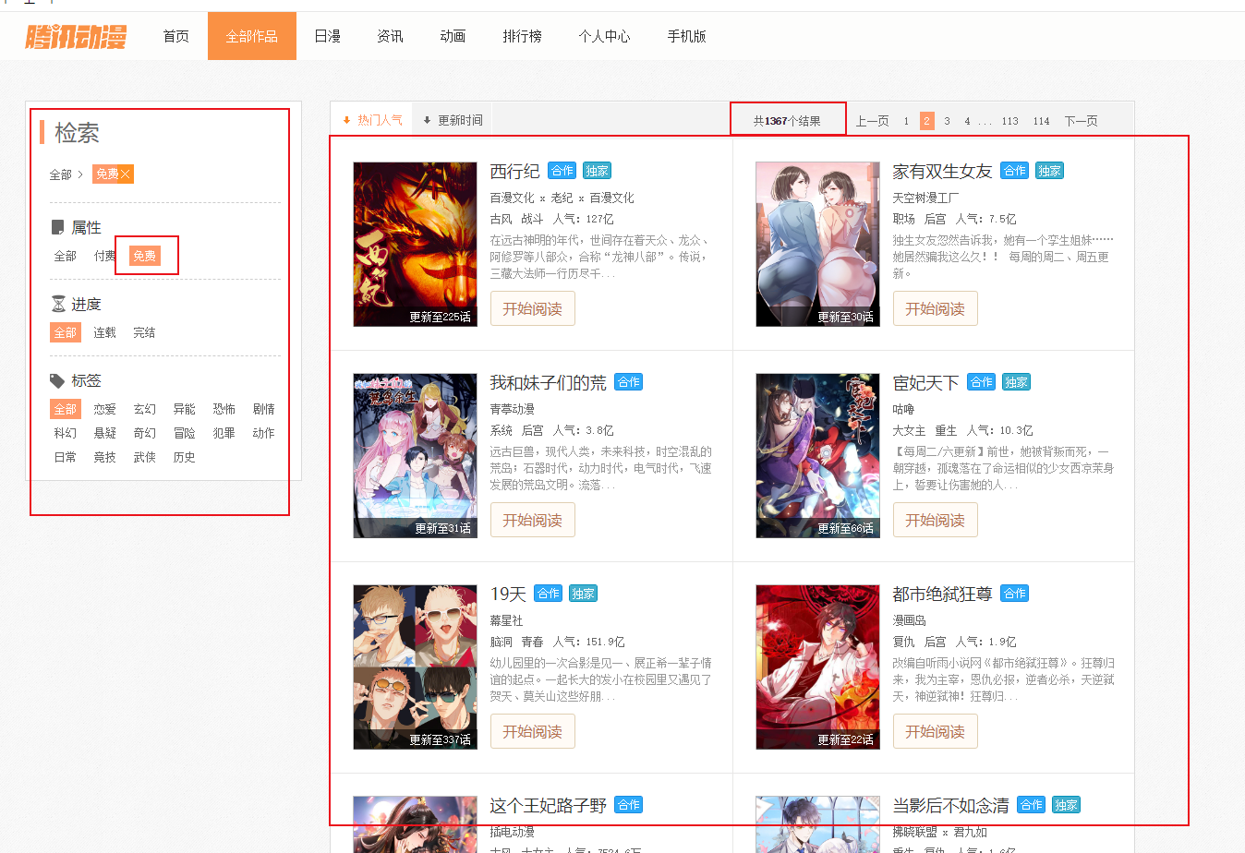

获取小说的列表：

红色部分是页码；

获取html页面源代码，里面有列表小说的详细信息：

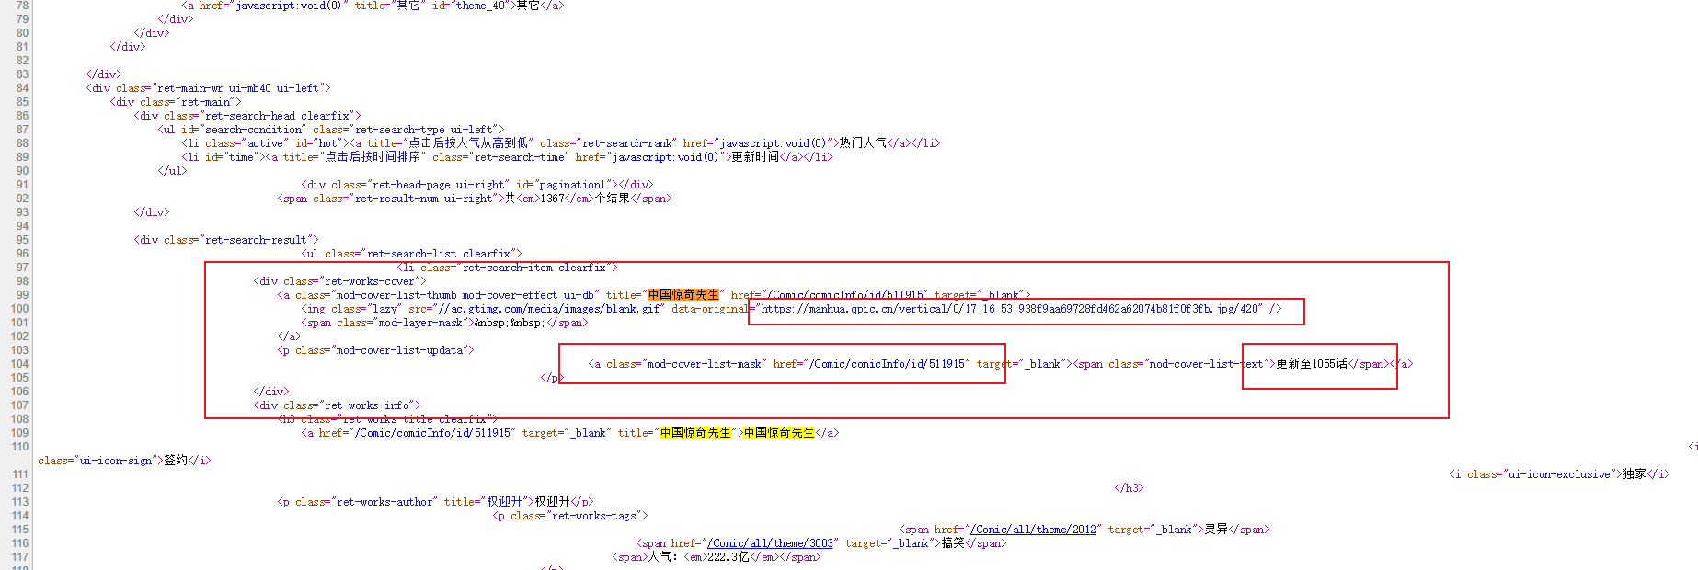

1. <https://ac.qq.com/Comic/comicInfo/id/511915>

查出该漫画的详细信息，包括所有的章节，简介，评论，新作榜

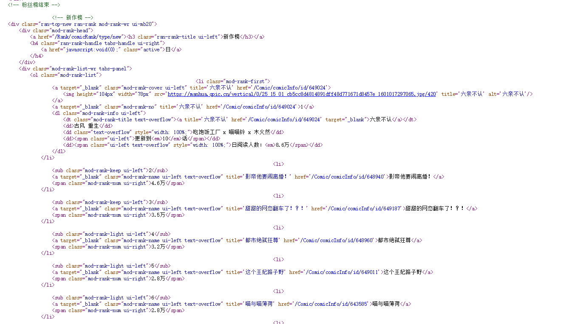

1. <https://ac.qq.com/ComicView/index/id/541812/cid/7>

需要的参数：

window.nonce、window.DATA

在该网页的html里有两处存着window.nonce，取第二个

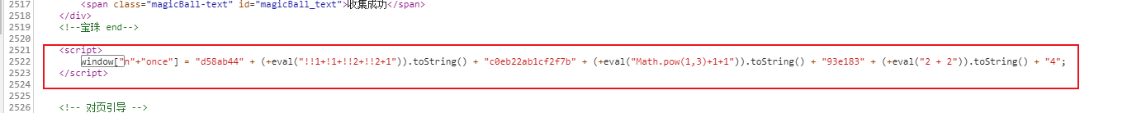

|  |
| --- |
| window.DATA = 'XXXXXX';  W = window;  window["n"+"once"] = "d58ab44" + (+eval("!!1+!1+!!2+!!2+1")).toString() + "c0eb22ab1cf2f7b" + (+eval("Math.pow(1,3)+1+1")).toString() + "93e183" + (+eval("2 + 2")).toString() + "4";  function Base(){  _keyStr = "ABCDEFGHIJKLMNOPQRSTUVWXYZabcdefghijklmnopqrstuvwxyz0123456789+/=";  this.decode = function (c) {  var a = "", b, d, h, f, g, e = 0;  for (c = c.replace(/[ ^ A - Za - z0 - 9\+\/\=]/g, ""); e < c.length;)  b = _keyStr.indexOf(c.charAt(e++)), d = _keyStr.indexOf(c.charAt(e++)), f = _keyStr.indexOf(c.charAt(e++)), g = _keyStr.indexOf(c.charAt(e++)), b = b << 2 | d >> 4, d = (d & 15) << 4 | f >> 2, h = (f & 3) << 6 | g, a += String.fromCharCode(b), 64 != f && (a += String.fromCharCode(d)), 64 != g && (a += String.fromCharCode(h));  return a = _utf8_decode(a)  };  _utf8_decode = function (c) {  for (var a = "", b = 0, d = c1 = c2 = 0; b < c.length;) d = c.charCodeAt(b), 128 > d ? (a += String.fromCharCode(d), b++) : 191 < d && 224 > d ? (c2 = c.charCodeAt(b + 1), a += String.fromCharCode((d & 31) << 6 | c2 & 63), b += 2) : (c2 = c.charCodeAt(b + 1), c3 = c.charCodeAt(b + 2), a += String.fromCharCode((d & 15) << 12 | (c2 & 63) << 6 | c3 & 63), b += 3);  return a  }  }  var B = new Base(), T = W['DA' + 'TA'].split(''), N = W['n' + 'onc' + 'e'], len, locate, str;  N = N.match(/\d+[a-zA-Z]+/g);  len = N.length;  while (len--) {  locate = parseInt(N[len]) & 255;  str = N[len].replace(/\d+/g, '');  T.splice(locate, str.length)  }  T = T.join('');  console.dir(T) |

表格里的T，进行base64解码就能够解析出当前漫画的该章节的详细信息！！！