# **Jolt VS freemarker**

|  |  |  |
| --- | --- | --- |
| Library name | JOLT | FREE MARKER |
| Usage/Implementation | A bit Hard for newbie | EASY |
| Performance | Very Good | Good |
| Learning | Have to spend more time,  Easy to maintain | Easy to learn |
|  |  |  |

Benchmark Testing (Library used : jmh)

Throughput :

JOLT : 3282.409

FREEMARKER : 850.957

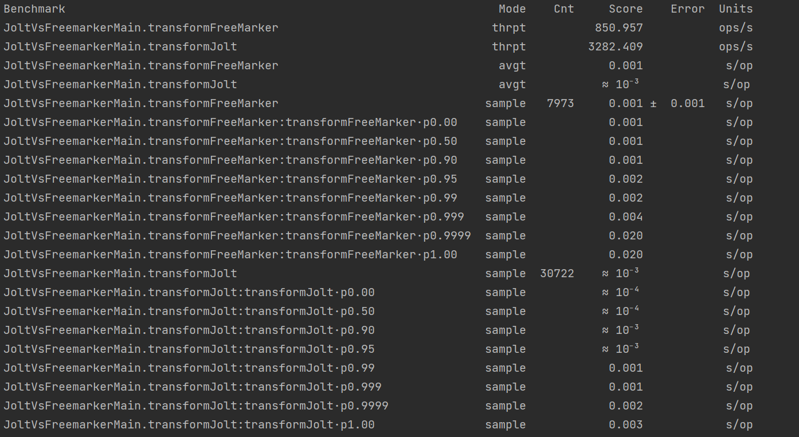

**Complex Structure (ti to shipment)**

|  |  |  |
| --- | --- | --- |
| Library | Throughput | Average |
| JOLT | 1.642 | **0.622** |
| FREEMARKER | 0.539 | 1.912 |

Free marker

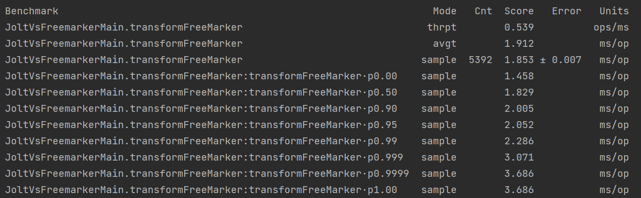

Jolt

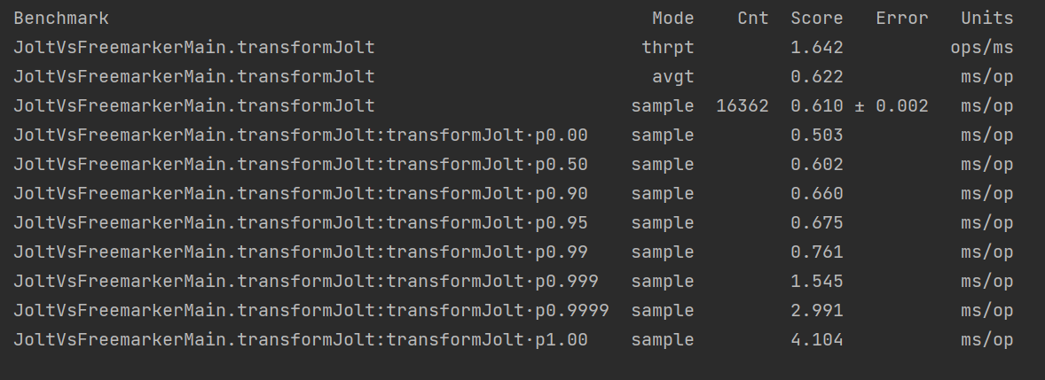

2nd Time Run

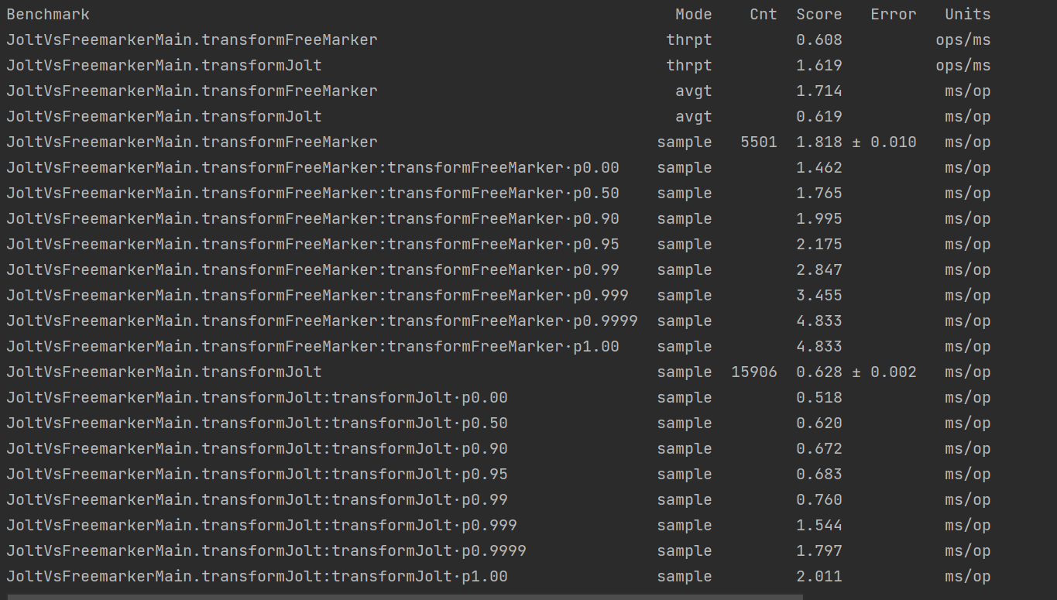

Fork -20 Thread

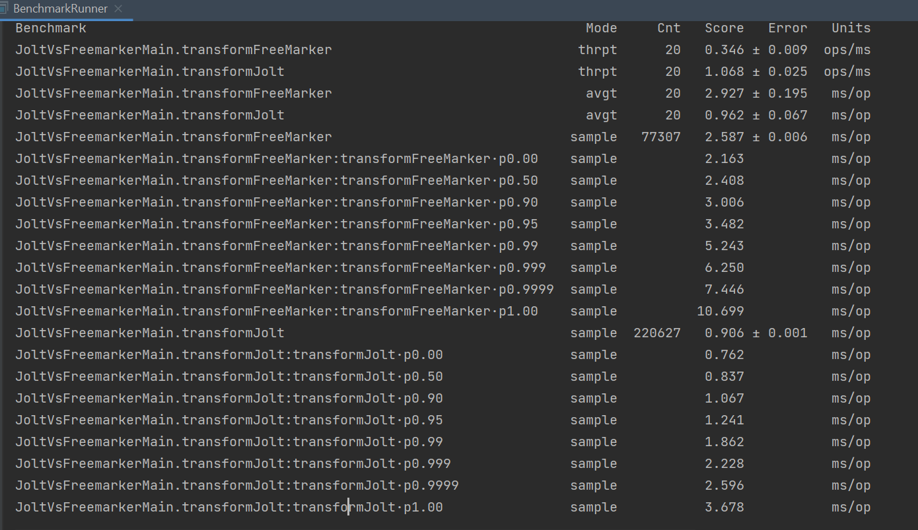

Without warmup iteration

