Jolt VS FreeMarker

|  |  |  |
| --- | --- | --- |
| Operation | JOLT | FREE MARKER |
| Performance | Excellent | Good |
| Ease of Use | A bit hard | Easy |
| Learning Curve | Initially takes time to learn | Easy to learn |
| Maintainability | Spec can be externalized. So easy to maintain | Spec can be externalized. So easy to maintain |

# **Time complexity:** Micro-Benchmark Testing (JMH)

**Throughput:** Measures the number of operations per second

**Average:** Average time taken for an iteration to complete.

## Test performed with basic JSON structure (nested)

|  |  |  |  |
| --- | --- | --- | --- |
| Library | Throughput (mill sec) | Average | Iteration |
| JOLT | 3282.409 | **0.001** | **1** |
| FreeMarker | 850.957 | **10-3** | **1** |

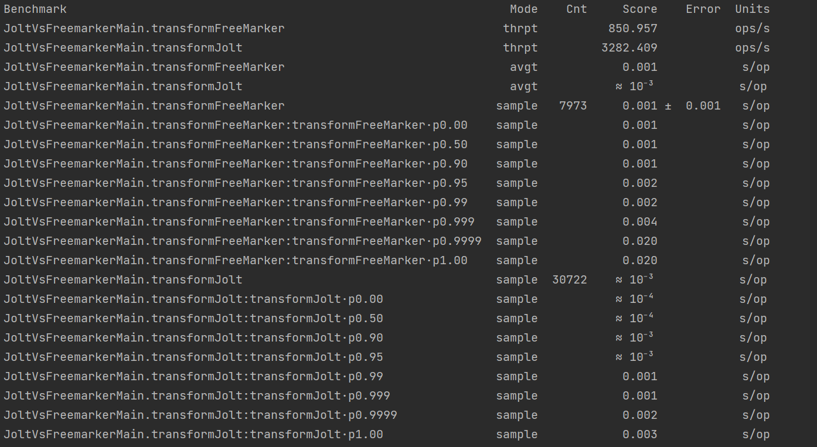

## Test with Complex JSON structure Complex Structure **(ti to shipment) –** With Warmup

|  |  |  |  |
| --- | --- | --- | --- |
| Library | Throughput (mill sec) | Average | Iteration (20 Thread) |
| JOLT | **1.642** | **0.622** | **5** |
| FREEMARKER | **0.539** | **1.912** | **5** |

Free marker

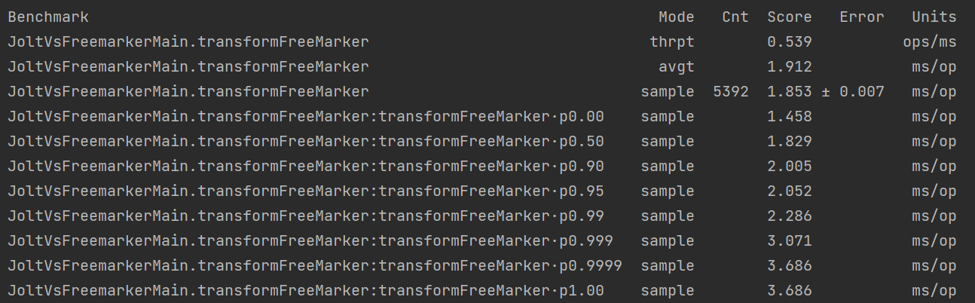

Jolt

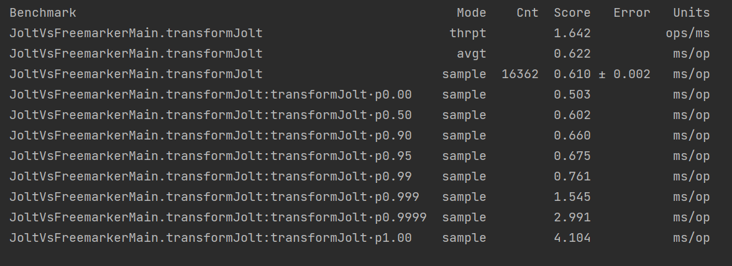

Running the Same Configuration again

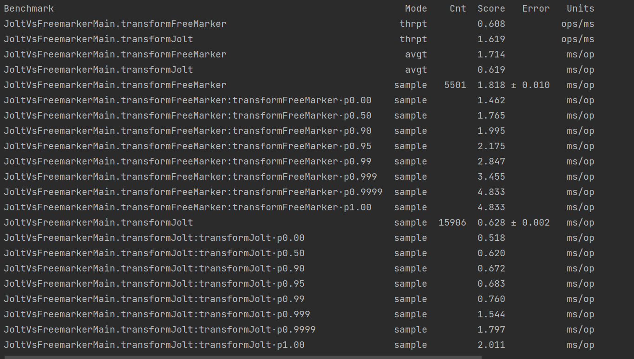

## Test with Complex JSON structure with 20 Thread without warm up iteration

|  |  |  |  |
| --- | --- | --- | --- |
| Library | Throughput (mill sec) | Average | Iteration (20 Thread) |
| JOLT | **1.068** | **0.963** | 5 |
| FREEMARKER | **0.346** | **2.927** | 5 |

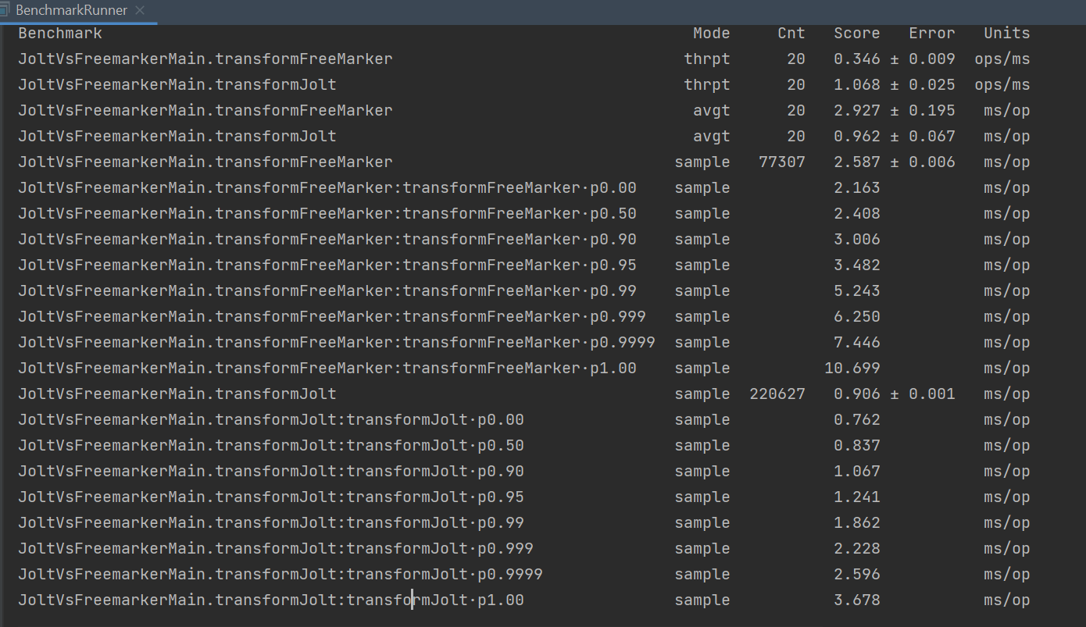

# **Space complexity**: VisualVM

**Heap Dumb Analysis**

## **Jolt:**

Bytes Allocated: 5,159,085 B

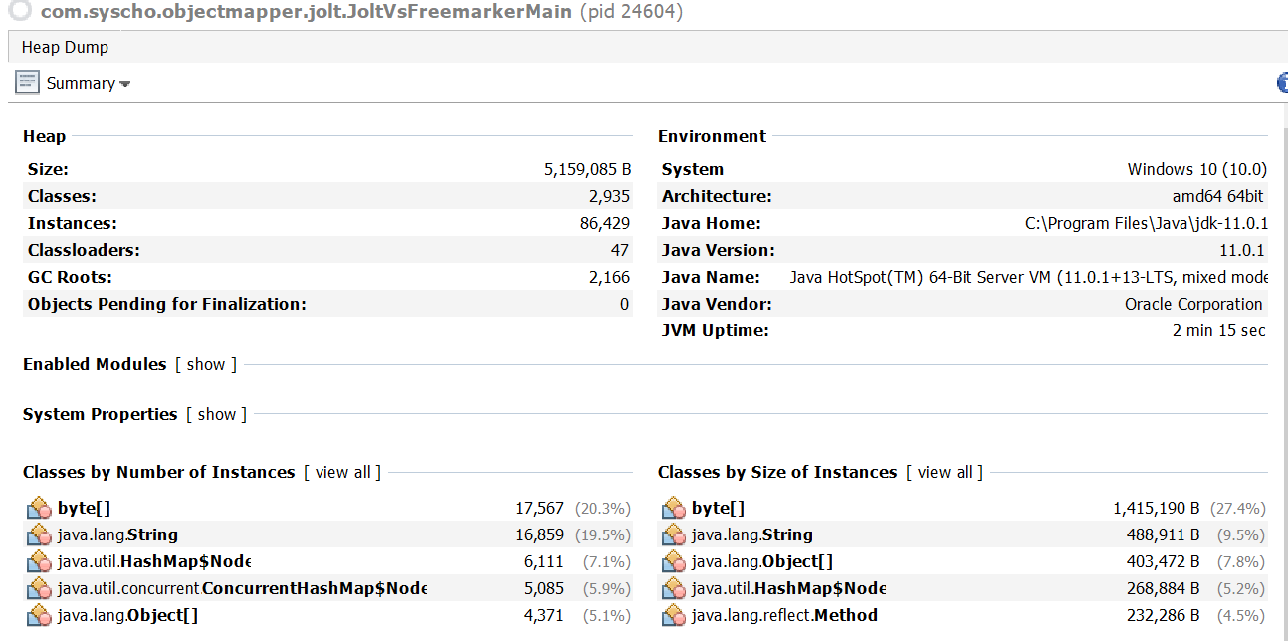

## **Free marker:**

Bytes Allocated: 12,102,119 B

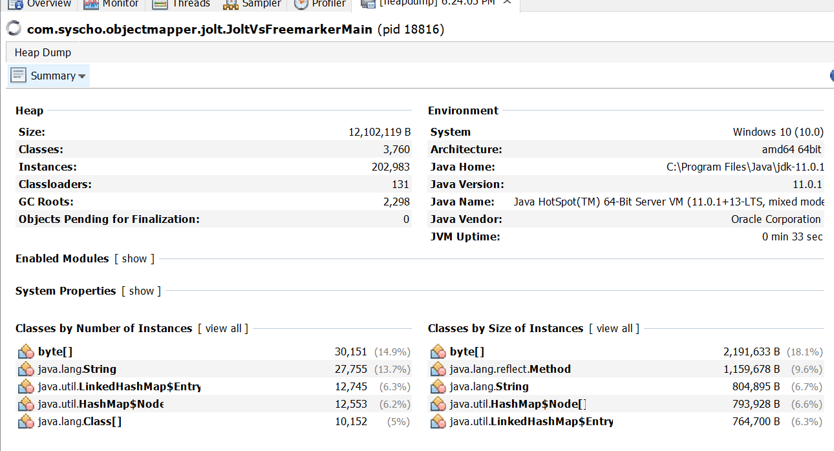

# **End to End Performance Testing**: JMETER

Integrated with Shipment Entity BFF for GET operation (Req/Res)

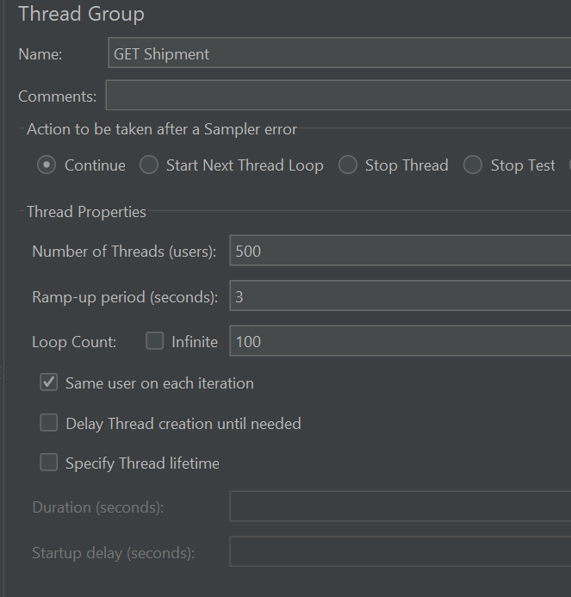

## **FreeMarker:**

|  |  |  |
| --- | --- | --- |
| No Of Request | Average | Throughput in Seconds |
| 50,000 | 4603 | 213.3 |
| 1,00,000 | 3095 | 311.1 |

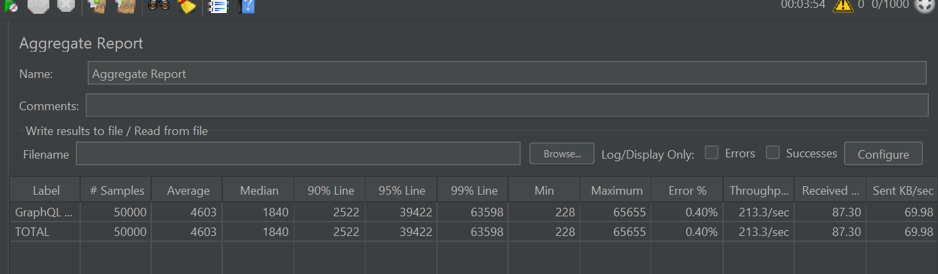

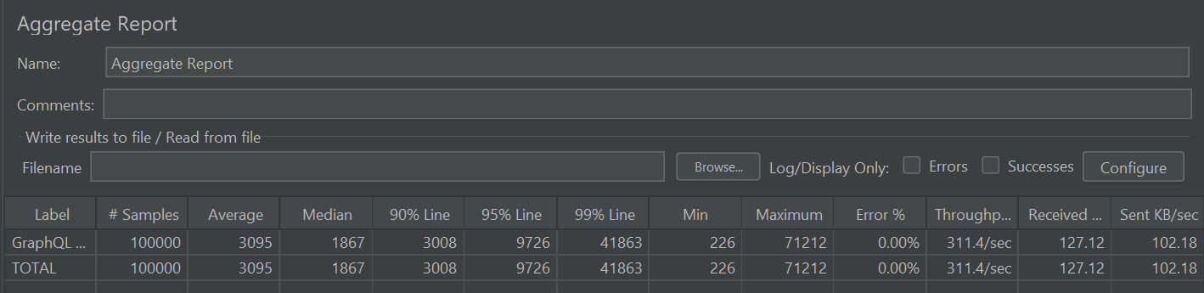

## **JOLT**

|  |  |  |
| --- | --- | --- |
| No Of Request | Average | Throughput in Seconds |
| 50,000 | 3292 | 242.2 |
| 1,00,000 | 3325 | 271.1 |

