# How to generate file delta in linux environments

1. Extract folder delta generator to any place , then go to working folder “**script**”

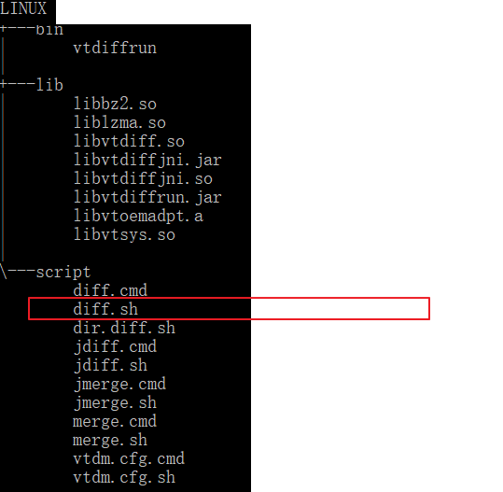

1. Go to working folder script

Example: *cd linux/script/*

1. Ready to generate delta file from firmware F1=71, and F2=72

Syntax: ./diff.sh <f1 filepath> <f2 filepath> <delta filepath>

Example*: ./diff.sh ./../../updates/71.bin ../../updates/72.bin ./../../updates/tempdelta_7172.bin*

