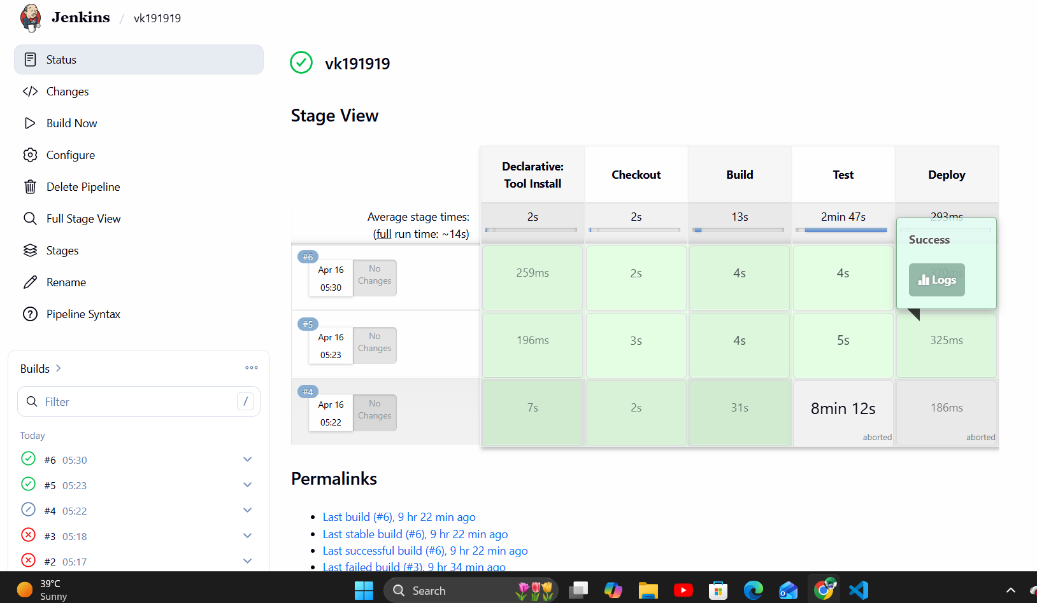

pipeline {
agent any

tools {
maven 'Maven3'
}

stages {

stage('Checkout') {
steps {
git branch: 'main',
url: 'https://github.com/bellore123/maven21.git'
}
}

stage('Build') {
steps {
bat 'mvn clean compile'
}
}

stage('Test') {
steps {
bat 'mvn test'
}
}

stage('Deploy') {
steps {
echo 'Deploy successful'
}
}
}
}

