/\*

KAHLIL BELLO

DATA STRUTURES

SEPTEMBER 19, 2018

project 3 prob 2

\*/

#include <iostream>

#include <ctime>

#include "STACKPAC.h"

using namespace std;

int main()

{

srand(time(0));

//i.) CREATE STACK ALL

STACK <int, 10> ALL;

STACK <int, 10>EVEN;

STACK <int, 10>tempEVEN;

STACK <int, 10>ODD;

STACK <int, 10>tempODD;

ALL.clearStack();

EVEN.clearStack();

ODD.clearStack();

tempEVEN.clearStack();

tempODD.clearStack();

int n;

for (int i = 1; i <= 10; ++i)

{

//ii.) STORE 10 RANDOM NUMBERS <=50 IN STACK ALL

n = rand() % 50+1;

ALL.pushStack(n);

}

cout << "Stack ALL: ";

while (!ALL.emptyStack())

{

//iii.) DISPLAY STACK ALL AND COLLECT EVEN AND ODD IN STACKS

int x = ALL.popStack();

cout << x << " ";

if ((x % 2) == 0)

{

EVEN.pushStack(x);

}

else

{

ODD.pushStack(x);

}

}//endwhile

//iv.) DISPLAY BOTH STACK EVEN and ODD AS DISPLAYED ON PAPER

cout << "\n\nDisplaying EVEN and ODD in REVERSED" << endl;

cout << "EVEN numbers: ";

while (!EVEN.emptyStack())

{

int xEven = EVEN.popStack();

tempEVEN.pushStack(xEven);

cout << xEven << " ";

}

cout << endl;

cout << "ODD numbers: ";

while (!ODD.emptyStack())

{

int xOdd = ODD.popStack();

tempODD.pushStack(xOdd);

cout << xOdd << " ";

}

//iv.) DISPLAY BOTH STACK EVEN and ODD AS DISPLAYED ON PAPER

cout << "\n\nDisplaying EVEN and ODD in ORDER they CAME OUT" << endl;

cout << "EVEN numbers in ORDER: ";

while (!tempEVEN.emptyStack())

{

int xEven = tempEVEN.popStack();

cout << xEven << " ";

}

cout << endl;

cout << "ODD numbers in ORDER: ";

while (!tempODD.emptyStack())

{

int xOdd = tempODD.popStack();

cout << xOdd << " ";

}

cout << "\n\n";

system("pause");

return 0;

}

/\*

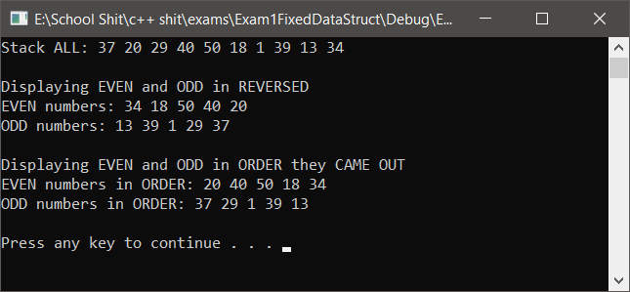OUTPUT:

Stack ALL: 37 20 29 40 50 18 1 39 13 34

Displaying EVEN and ODD in REVERSED

EVEN numbers: 34 18 50 40 20

ODD numbers: 13 39 1 29 37

Displaying EVEN and ODD in ORDER they CAME OUT

EVEN numbers in ORDER: 20 40 50 18 34

ODD numbers in ORDER: 37 29 1 39 13

Press any key to continue . . .

OUTPUT2:

Stack ALL: 22 11 14 23 7 49 50 16 9 10

Displaying EVEN and ODD in REVERSED

EVEN numbers: 10 16 50 14 22

ODD numbers: 9 49 7 23 11

Displaying EVEN and ODD in ORDER they CAME OUT

EVEN numbers in ORDER: 22 14 50 16 10

ODD numbers in ORDER: 11 23 7 49 9

Press any key to continue . . .

\*/

