/*

KAHLIL BELLO

DATA STRUCTURES

SEPT 26, 2018

PROJ 4 PROB 1

*/

HEADER FILE

#pragma once

#ifndef STACKPAC

#define STACKPAC

template<class T, int n>

class STACK

{

private:

T a[n];

int counter;

public:

void clearStack()

{

counter = 0;

}//end clearStack

bool emptyStack()

{

return (counter == 0) ? true : false;

}//end emptyStack

bool fullStack()

{

return (counter == n) ? true : false;

}//end fullStack

void pushStack(T x)

{

a[counter] = x;

counter++;

}//end pushStack

T popStack()

{

counter--;

return a[counter];

}//end popStack

};//end class STACK

#endif

//----------------------------------------------------------

Source.cpp

#include <iostream>

#include <string>

#include "STACKPAC.h"

using namespace std;

int main()

{

int a[7] = {5,9,7,6,2,3};

char c[5] = {'e','o','a','i','u'};

string months[12] = {"Jan", "Feb", "Mar","Apr","May","Jun","Jul","Aug","Sep","Oct","Nov","Dec"};

STACK<int, 7> NUM;

STACK<char, 5> CHAR;

STACK<string, 12> MONTH;

NUM.clearStack();

CHAR.clearStack();

MONTH.clearStack();

cout << "Outputting integers in order they came out:\n";

for (int i = 0; i < 6; ++i)

{

cout << a[i] << " ";

NUM.pushStack(a[i]);

}

cout << "\nOutputting integers in REVERSED ORDER:\n";

while (!NUM.emptyStack())

{

int num = NUM.popStack();

cout << num << " ";

}

cout << "\n__________________________\n";

//-------------CHARACTERS----------------------

cout << "Outputting characters in order they came out:\n";

for (int i = 0; i < 5; ++i)

{

cout << c[i] << " ";

CHAR.pushStack(c[i]);

}

cout << "\nOutputting characters in REVERSED ORDER:\n";

while (!CHAR.emptyStack())

{

char chr = CHAR.popStack();

cout << chr << " ";

}

cout << "\n__________________________\n";

//--------------STRINGS-------------------

cout << "Outputting string in order they came out:\n";

for (int i = 0; i < 12; ++i)

{

cout << months[i] << " ";

MONTH.pushStack(months[i]);

}

cout << "\nOutputting string in REVERSED ORDER:\n";

while (!MONTH.emptyStack())

{

string str = MONTH.popStack();

cout << str << " ";

}

cout << "\n__________________________\n";

system("pause");

return 0;

}//end main

/*

OUTPUT:

Outputting integers in order they came out:

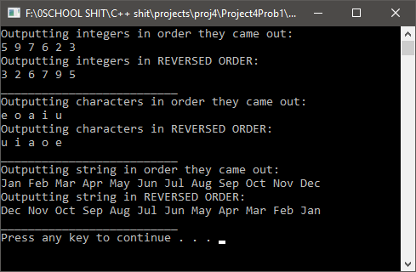5 9 7 6 2 3

Outputting integers in REVERSED ORDER:

3 2 6 7 9 5

__________________________

Outputting characters in order they came out:

e o a i u

Outputting characters in REVERSED ORDER:

u i a o e

__________________________

Outputting string in order they came out:

Jan Feb Mar Apr May Jun Jul Aug Sep Oct Nov Dec

Outputting string in REVERSED ORDER:

Dec Nov Oct Sep Aug Jul Jun May Apr Mar Feb Jan

__________________________

Press any key to continue . . .

*/

/*

KAHLIL BELLO

DATA STRUCTURES

SEPT 26, 2018

PROJ 4 PROB 2

*/

#include <iostream>

#include "STACKPAC.h"

int main()

{

STACK <int, 10> S;

S.clearStack();

int a = 5, b = 7, c = 8, d = 2;

int x, y, r;

char p;

char again = 'y';

do

{

std::cout << "Enter a postfix expression : ";

std::cin >> p;

while (p != '$')//

{

switch (p)

{

case('a'):

S.pushStack(a);

break;

case('b'):

S.pushStack(b);

break;

case('c'):

S.pushStack(c);

break;

case('d'):

S.pushStack(d);

break;

case('+'):

x = S.popStack();

y = S.popStack();

r = y + x;

S.pushStack(r);

break;

case('-'):

x = S.popStack();

y = S.popStack();

r = y - x;

S.pushStack(r);

break;

case('*'):

x = S.popStack();

y = S.popStack();

r = y * x;

S.pushStack(r);

break;

case('/'):

x = S.popStack();

y = S.popStack();

r = y / x;

S.pushStack(r);

break;

}//end switch

std::cin >> p;

}//endwhile

using std::endl;

std::cout << "The value of the expressions is: " << S.popStack() << endl;

std::cout << "CONTINUE(y/n)? ";

std::cin >> again;

} while ((again == 'y') || (again == 'Y'));

std::system("pause");

return 0;

}

/*

OUTPUT:

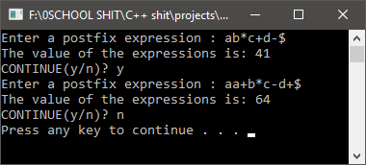

Enter a postfix expression : ab*c+d-$

The value of the expressions is: 41

CONTINUE(y/n)? y

Enter a postfix expression : aa+b*c-d+$

The value of the expressions is: 64

CONTINUE(y/n)? n

Press any key to continue . . .

*/

/*

KAHLIL BELLO

DATA STRUCTURES

SEPT 26, 2018

PROJECT 4 PROB 3

*/

#include <iostream>

#include "STACKPAC.h"

using namespace std;

int main()

{

STACK<char, 100> LR;

STACK<char, 100> RL;

STACK<char, 100> TEMP;

char again = 'y';

do {

LR.clearStack();

RL.clearStack();

TEMP.clearStack();

char c;

cout << "Enter a sentence: ";

while (cin.get(c), c != '\n')

{

if (isalpha(c))

{

c = toupper(c);

RL.pushStack(c);

TEMP.pushStack(c);

}//endif

}//endwhile

//copy temp to LR

while (!TEMP.emptyStack())

{

char chr = TEMP.popStack();

LR.pushStack(chr);

}//endwhile

//test for palindrome

while (!RL.emptyStack())

{

char c1 = RL.popStack();

char c2 = LR.popStack();

if (c1 != c2)

break;

}//endwhile

if (RL.emptyStack() == true)

{

cout << "You have a PALINDROME" << endl;

}

else

{

cout << "You DO NOT have a PALINDROME" << endl;

}

cout << "CONTINUE(y/n)? ";

cin >> again;

cin.ignore(1, ('\n'));

} while ((again == 'y') || (again == 'Y'));

system("pause");

return 0;

}//end main

/*

OUTPUT:

Enter a sentence: Taco Cat

You have a PALINDROME

CONTINUE(y/n)? y

Enter a sentence: Do Geese see God?

You have a PALINDROME

CONTINUE(y/n)? y

Enter a sentence: Too bad, I hid a boot

You have a PALINDROME

CONTINUE(y/n)? n

Press any key to continue . . .

*/

