KAHLIL BELLO

DATA STRUCTURES

SEPT 24, 2018

QUIZ 2

**HEADER FILE**  
#pragma once

#ifndef STACKPAC

#define STACKPAC

template <class T, int n>

class STACK

{

private:

T a[n];

int counter;

public:

void clearStack()

{

counter = 0;

}//end clearStack

bool emptyStack()

{

return (counter == 0) ? true : false;

}//end emptyStack

bool fullStack()

{

return (counter == n) ? true : false;

}//end fullStack

void pushStack(T x)

{

a[counter] = x;

counter++;

}//end pushStack

T popStack()

{

counter--;

return a[counter];

}//end popStack

};//end STACK class

#endif

**Source.cpp**

#include <iostream>

#include "STACKPAC.h"

#include <ctime>

using namespace std;

int main()

{

srand(time(0));//seed time

STACK <int, 6> ALL;

STACK <int, 6> EVEN;

STACK <int, 6> tempEVEN;

STACK <int, 6> ODD;

STACK <int, 6> tempODD;

ALL.clearStack();

EVEN.clearStack();

ODD.clearStack();

tempEVEN.clearStack();

tempODD.clearStack();

int random;

for (int i = 0; i < 6; ++i)

{

random = rand() % 20;

ALL.pushStack(random);

}//end forloop

cout << "ALL randomized numbers:\n";

while (!ALL.emptyStack())

{

int x = ALL.popStack();

cout << x << " ";

if ((x % 2) == 0)

{

EVEN.pushStack(x);

}//endif

else

{

ODD.pushStack(x);

}//endelse

}//end while

//---------OUTPUTTING EVEN------------

while (!EVEN.emptyStack())

{

int xEven = EVEN.popStack();

tempEVEN.pushStack(xEven);

}//endwhile

cout << "\n_______________________\nEVEN in order:\n";

while (!tempEVEN.emptyStack())

{

int xEven = tempEVEN.popStack();

cout << xEven << " ";

}//end while

//---------OUTPUTTING ODD------------

while (!ODD.emptyStack())

{

int xOdd = ODD.popStack();

tempODD.pushStack(xOdd);

}//endwhile

cout << "\n_______________________\nODD in order:\n";

while (!tempODD.emptyStack())

{

int xOdd = tempODD.popStack();

cout << xOdd << " ";

}//endwhile

cout << endl;

system("pause");

return 0;

}

/*

KAHLIL BELLO

DATA STRUCTURES

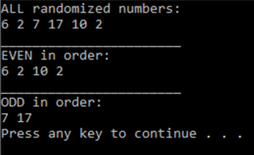SEPT 24, 2018

QUIZ 2

OUTPUT 1:

ALL randomized numbers:

6 2 7 17 10 2

_______________________

EVEN in order:

6 2 10 2

_______________________

ODD in order:

7 17

Press any key to continue . . .

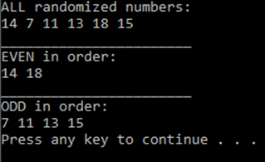OUTPUT 2:

ALL randomized numbers:

14 7 11 13 18 15

_______________________

EVEN in order:

14 18

_______________________

ODD in order:

7 11 13 15

Press any key to continue . . .

*/