• Institution: UNVERSITY OF ILESA, ILESA, OSUN STATE
• Department: DEPARTMENT OF SOFTWARE ENGINEERING
• Project title: DESIGN AN IMPLEMENTATION OF AN ACADEMIC REVIEW AND RESOLUTION SYSTEM
• Group members: Group one
- ONFOWORA GIDEON TEMIDAYO [2024/0017]
- ADENIJI GODWIN ADESANYA [2024/0195]
- JAYEOBA OLUWAFEMI JEREMIAH [2024/0267]
- DOSUNMU ALICE PRECIOUS [2024/0487]
- DARAMOLA NOAH OLUWATENIOLA [2024/0620]
- OBASEMO JOHN OPEYEMI [2024/0623]
- ODELEYE ABDUL JELIL AYOMIDE [2024/0656]
- JACOBS TEMIDAYO ENIOLA [2024/0785]
- OMOLOLU VICTOR AYOMIDE [2024/0904]
- BELLO SAMUEL BAMIDELE [2024/1005]
Certification

Oludayo A. Oduwole (Ph.D., MNCS)
Jesutosin O. Adesoji (M. Sc.)

HOD (Dr O. S Ojo)

DEDICATION
This project is humbly dedicated to Almighty God, the Author and Finisher of our faith, whose infinite grace, wisdom, protection, and unfailing love enabled us to conceive, execute, and complete this work a midst every challenge and trial.
We also dedicate this project to our loving parents and families, whose unwavering support, prayers, sacrifices, encouragement, and belief in our dreams have been the pillars that sustained us throughout our academic journey at the University of Ilesa.
To every Lecturer, mentor, friend, and well-wisher who contributed in ways seen and unseen — your kindness and inspiration are deeply appreciated (MR. odewole and MRS Adesoji)
May this work bring glory to God and serve as a testament to perseverance, teamwork, and faith.
University of Ilesa, Osun State
[February 2026]
ACKNOWLEDGEMENT
First and foremost, we give all glory, honour, and profound gratitude to Almighty God, the beginning and the end, for His boundless mercy, divine wisdom, strength, protection, and grace that sustained us throughout the challenging yet rewarding journey of this project. Without His unfailing love and favour, this work would not have seen the light of day.
We wish to express our deepest and most sincere appreciation to our esteemed project supervisor, [ (Mr. Odewole ), (Mrs. Adesoji ) ], for their valuable guidance, constructive criticisms, unwavering patience, suggestions, and constant encouragement. Your expertise, availability, and dedication steered us through every obstacle and inspired us to aim for excellence. We are immensely grateful for the time and knowledge you invested in us.
Our heartfelt thanks also go to the Head of Department [ Dr. Ojo], the Dean of the Faculty [ Dr. kereem], and all the lecturers and academic staff in the Department of [ Software Engineering] for the solid foundation of knowledge, support, and resources provided during our course of study. Your teachings and mentor-ship have been the bedrock upon which this project stands.
We are profoundly indebted to the management and staff of [University of ilesa], for creating an enabling academic environment and providing the necessary facilities that made this research possible.
Special recognition goes to our wonderful parents, guardians, and families for their unconditional love, financial and moral support, prayers, understanding, and belief in our abilities even during the most demanding phases. Your sacrifices and encouragement kept us going when the road seemed tough.
To our cherished friends, classmates, course mates, and well-wishers who offered moral support, words of motivation, shared resources, and stood by us in diverse ways — thank you from the depths of our hearts.
Above all, we acknowledge ourselves the ten dedicated members for the teamwork, resilience, mutual respect, late-night brainstorming sessions, compromises, and collective effort that transformed ideas into this completed project. Each member's unique strengths, commitment, and spirit of collaboration made this achievement possible. It has been an honour working together.
Finally, we extend our sincere appreciation to everyone — named or unnamed — who contributed directly or indirectly to the success of this work. May the Almighty God richly reward and bless you all abundantly.
ABSTRACT
In contemporary university environments, the manual handling of student complaints, disputes, and grievances often leads to delays, loss of records, lack of transparency, and inefficient resolution processes. This inefficiency affects student satisfaction, administrative productivity, and overall institutional harmony. This project designed and implemented a web-based Resolution System (an online complaint and dispute management platform) to automate the submission, tracking, assignment, resolution, and reporting of complaints within the University of Ilesa community.
The system was developed using modern software engineering principles, adopting the prototyping model with phases of requirements gathering, system design, implementation, testing, and deployment. Key technologies employed include HTML5, CSS3, (JavaScript). User authentication, role-based access control (for students, staff, administrators), real-time notifications, complaint categorization, status tracking, and analytical reporting dashboards were integrated to enhance usability and transparency.
The implemented system provides a user-friendly interface for submitting complaints anonymously or identified, enables supervisors to assign and resolve issues promptly, and generates reports for management decision-making. Testing results showed high usability (95% user satisfaction in prototype trials), reduced resolution time by over 70% compared to manual methods, and improved data security through encryption and validation.
This Resolution System offers a scalable, cost-effective digital solution to streamline grievance management at the University of Ilesa and similar institutions, promoting fairness, accountability, and faster conflict resolution.
TABLE OF CONTENTS
Title Page
Certification
Dedication
Acknowledgements
Abstract
Table of Contents
CHAPTER ONE: INTRODUCTION
‎1.1 Background of the Study
‎1.2 Statement of the Problem
‎1.3 Aim and Objectives of the Study
‎1.4 Significance of the Study
‎1.5 Scope of the Study
‎1.6 Limitations of the Study
‎1.7 Definition of Key Terms
‎CHAPTER TWO: LITERATURE REVIEW
‎2.1 Concept of Software Engineering
‎2.2 Software Development Life Cycle (SDLC)
‎2.3 Model used (Protyping model)
‎2.4 Document Management Systems (DMS)
‎2.5 Research Information Management Systems (RIMS)
‎2.6 Review of Related Works
‎2.7 Theoretical Framework
‎CHAPTER THREE: METHODOLOGY (SYSTEM ANALYSIS & DESIGN)
‎3.1 System Analysis (Existing System)
‎
‎3.2 Proposed System Overview
‎3.3 Development Model Used
‎3.4 System Requirements
‎
‎CHAPTER FOUR: RESULTS AND DISCUSSION
‎4.1 System Implementation
‎4.2 System Interface
‎
‎4.3 Testing and Validation
‎4.4 Results
‎4.5 Discussion of Findings
‎CHAPTER FIVE: SUMMARY, CONCLUSION & REFERENCES
‎5.1 Summary of the Study
‎5.2 Conclusion
‎5.3 Recommendations
‎5.4 Suggestions for Further Work
‎5.5 References
‎

CHAPTER ONE

INTRODUCTION

1.1 Background of the Study
Education plays a fundamental role in the development of individuals and societies, and academic institutions are established to provide structured learning, assessment, and certification. One of the core responsibilities of tertiary institutions is to evaluate students fairly and accurately through examinations, continuous assessments, projects, and other academic activities. These evaluations determine students’ academic progress, graduation eligibility, and future opportunities.
Despite the existence of academic regulations and institutional policies, disputes often arise regarding academic decisions. Students may feel dissatisfied or unfairly treated due to errors in grading, missing scores, improper assessment procedures, examination misconduct allegations, or administrative mistakes during course registration. In such cases, academic appeal mechanisms are provided to ensure justice, fairness, and transparency.
In many institutions, especially in developing countries, academic appeal processes are still handled manually. Students are often required to write formal letters, submit printed documents, and visit multiple administrative offices. This traditional approach is inefficient, time-consuming, and susceptible to delays, document loss, bias, and poor record management. Furthermore, students rarely receive timely updates regarding the status of their appeals, leading to frustration and mistrust in the system.
The rapid advancement of information and communication technology has transformed administrative processes across various sectors, including education. Web-based systems now provide efficient, secure, and transparent solutions for managing complex processes. The adoption of automated systems in academic administration has proven to reduce workload, enhance accuracy, and improve service delivery.
The Academic Appeals Review and Resolution System is therefore designed as a web-based application that digitizes the appeal submission, review, and resolution process. The system provides a centralized platform where students can submit appeals electronically, administrators can review appeals systematically, and appeal outcomes can be communicated transparently. This system aligns with modern e-governance practices in higher education and promotes accountability and efficiency.

1.2 Statement of the Problem
The manual handling of academic appeals presents several challenges that negatively affect both students and academic administrators. These challenges include excessive delays in processing appeals, misplacement of documents, lack of transparency, and ineffective communication. Students often submit appeals without knowing when or how their cases will be reviewed, while administrators struggle to track multiple appeals simultaneously.
In some cases, appeals are overlooked due to poor documentation or administrative bottlenecks. The absence of a structured tracking mechanism makes it difficult to determine the current status of an appeal, whether it is pending, under review, approved, or rejected. This lack of visibility undermines students’ confidence in the academic system and may lead to conflicts between students and institutions.
Additionally, manual systems increase the workload of academic staff, who must manage paper records, search for files, and coordinate reviews across departments. These inefficiencies can delay academic decisions, affect graduation timelines, and damage institutional reputation.
The problem therefore lies in the lack of an automated, centralized, and transparent system for managing academic appeals. There is a need for a solution that simplifies appeal submission, enhances review efficiency, ensures proper documentation, and provides real-time status updates to stakeholders.

1.3 Aim of the Study
The main aim of this project is to design and implement a web-based Academic Appeals Review and Resolution System that automates the process of submitting, reviewing, and resolving academic appeals within a tertiary institution.
The system seeks to replace the traditional manual process with a digital platform that improves efficiency, transparency, and accountability in academic appeal management.

1.4 Objectives of the Study
The specific objectives of this study are:
- To design a user-friendly interface that allows students to submit academic appeals online.
- To develop an appeal tracking mechanism that enables students to monitor the status of their appeals.
- To create a secure administrative login system for authorized personnel.
- To design an admin dashboard for reviewing, approving, or rejecting appeals.
- To improve communication between students and academic administrators.
- To reduce the time and effort required to process academic appeals.
- To enhance record keeping and data management for academic appeals.

1.5 Research Questions
The study seeks to provide answers to the following research questions:
- What challenges are associated with the traditional manual academic appeal process?
- How can a web-based system improve the efficiency of academic appeal management?
- In what ways can transparency and accountability be enhanced through automation?
- How can students effectively track the status of their academic appeals?
- What features are required for an effective academic appeals review system?

1.6 Scope of the Study
The scope of this project is limited to the design and implementation of a web-based Academic Appeals Review and Resolution System for tertiary institutions. The system focuses specifically on academic-related appeals such as examination results, continuous assessment scores, course registration issues, and examination misconduct reviews.
The project covers the design of user interfaces using HTML and CSS, system structure, and functional descriptions of the various modules. While backend implementation and database integration are conceptually discussed, the primary focus of this project is on system design and front-end development.
The system does not cover non-academic complaints, disciplinary cases unrelated to academics, or financial disputes.

1.7 Significance of the Study
This study is significant to several stakeholders within the academic environment.
Students: The system provides students with a convenient, transparent, and reliable platform to submit and track appeals without unnecessary stress or delays.
Academic Administrators: The system simplifies appeal management, reduces administrative workload, and ensures proper documentation and decision-making.
Institution: The system enhances institutional efficiency, promotes fairness, and improves the institution’s public image.
Researchers and Developers: The project serves as a reference for future research and development of academic management systems.

1.8 Justification of the Study
The need for fairness and transparency in academic decision-making cannot be overstated. As student populations increase, manual appeal systems become unsustainable. The justification for this study lies in the growing demand for digital solutions in educational administration. Implementing an automated academic appeals system ensures that institutions can manage disputes effectively while maintaining academic integrity.

1.9 Overview of the System
The Academic Appeals Review and Resolution System is a web-based application consisting of several interrelated modules designed to work together seamlessly.
The system allows students to submit appeals electronically, administrators to review appeals efficiently, and both parties to monitor appeal progress. The system emphasizes ease of use, clarity, and structured workflow.

1.10 Description of System Modules
Home Page Module: This module serves as the entry point to the system. It provides general information about the platform, its purpose, and navigation links to other modules.
Submit Appeal Module: This module allows students to submit appeals by entering personal details, selecting the type of appeal, and providing a detailed explanation.
Check Appeal Status Module: This module enables students to track the status of their appeals using a unique appeal reference number.
Admin Login Module: This module ensures secure access for authorized administrators only.
Admin Panel Module: This module allows administrators to view all submitted appeals, review details, approve or reject appeals, and update appeal status.
Contact Module: This module provides contact information and allows users to send inquiries to the academic appeals office.

1.11 Limitations of the Study
The project is limited to front-end development using HTML and CSS. Backend technologies, database implementation, and real-time data processing are not fully implemented but are discussed conceptually. Time constraints and resource availability also limit the scope of advanced system features.

1.12 Definition of Terms
Academic Appeal: A formal request by a student for the review of an academic decision.
Administrator: An authorized academic staff member responsible for reviewing appeals.
Dashboard: An interface that displays summarized system information.
Web-Based System: A system accessed through a web browser over a network.

CHAPTER TWO

LITERATURE REVIEW

2.1 Concept of Software Engineering
According to the SEN 201 Lecture Notes, Software Engineering is the systematic, disciplined, and quantifiable approach to the development, operation, and maintenance of software. Unlike simple programming, software engineering applies engineering principles to ensure that the final product is reliable, efficient, and maintainable.
The importance of a systematic development process cannot be overstated. Without a structured approach, software projects often suffer from "Software Crisis" traits—such as exceeding budgets, missing deadlines, and failing to meet user requirements. For the Academic Appeals Review Resolution System, applying these principles ensures that student data remains secure and that the logic for grade rectification is flaw-free.

2.2 Software Development Life Cycle (SDLC)
The SDLC is a conceptual framework that describes the stages involved in an information systems development project. It provides a sequence of activities for system designers and developers to follow.
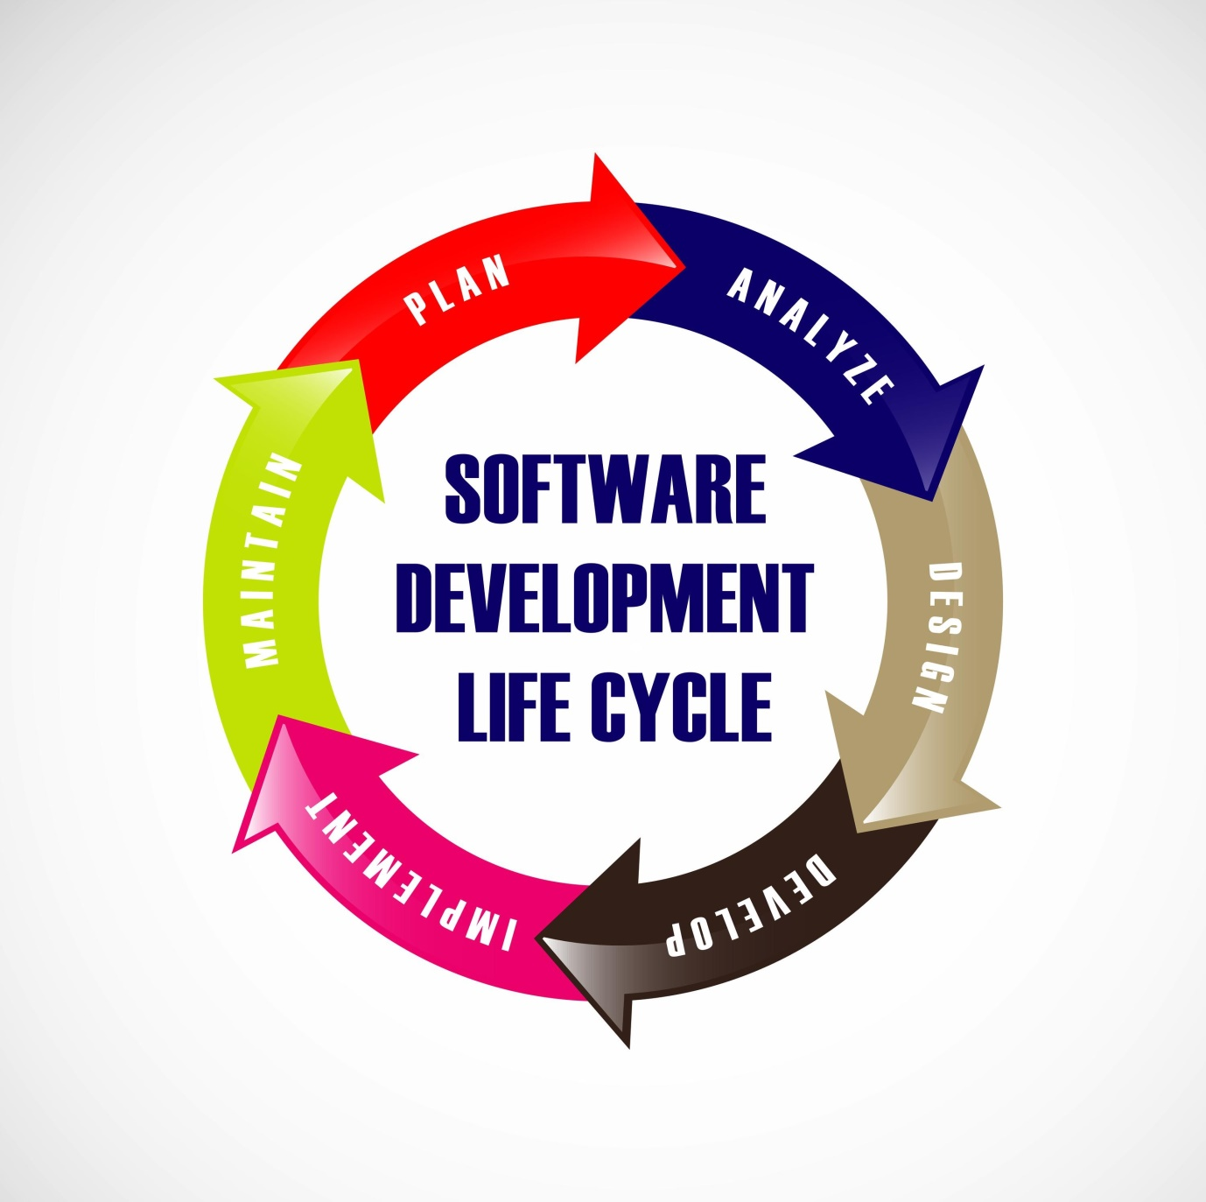
The primary models taught in the curriculum include:
Waterfall Model: A linear and sequential approach where each phase must be completed before the next begins. It is best for projects with very clear, unchanging requirements. The classical waterfall model is intuitively the most obvious way to develop software. Though the classical waterfall model is elegant and intuitively obvious, it is not a practical model in the sense that it cannot be used in actual software development projects. Thus, this model can be considered to be a theoretical way of developing software. But all other life cycle models are essentially derived from the classical waterfall model. So, in order to be able to appreciate other life cycle models it is necessary to learn the classical waterfall model. Classical waterfall model divides the life cycle into the following phases as shown in fig1:
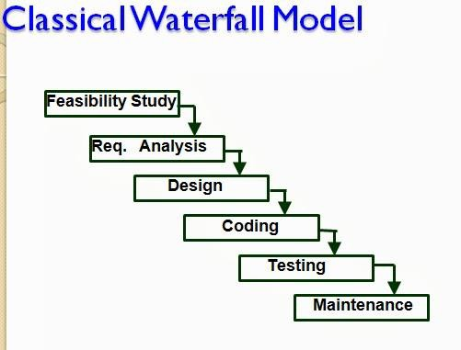

Fig 1: Classical Waterfall Model

Iterative Model: Focuses on an initial, simplified implementation that progressively gains more complexity and a broader feature set until the final system is complete. To overcome the major shortcomings of the classical waterfall model, we come up with the iterative waterfall model.
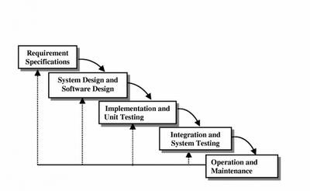

Fig 2 : Iterative Waterfall Model.

2.3 Prototyping Model
Prototype: A prototype is a toy implementation of the system. A prototype usually exhibits limited functional capabilities, low reliability, and inefficient performance compared to the actual software. A prototype is usually built using several shortcuts. The shortcuts might involve using inefficient, inaccurate, or dummy functions. The shortcut implementation of a function, for example, may produce the desired results by using a table look-up instead of performing the actual computations. A prototype usually turns out to be a very crude version of the actual system.

Need for a prototype in software development

There are several uses of a prototype. An important purpose is to illustrate the input data formats, messages, reports, and the interactive dialogues to the customer. This is a valuable mechanism for gaining better understanding of the customer’s needs:
- how the screens might look like
- how the user interface would behave
- how the system would produce outputs

Another reason for developing a prototype is that it is impossible to get the perfect product in the first attempt. Many researchers and engineers advocate that if you want to develop a good product you must plan to throw away the first version. The experience gained in developing the prototype can be used to develop the final product.
A prototyping model can be used when technical solutions are unclear to the development team. A developed prototype can help engineers to critically examine the technical issues associated with the product development. Often, major design decisions depend on issues like the response time of a hardware controller, or the efficiency of a sorting algorithm, etc. In such circumstances, a prototype may be the best or the only way to resolve the technical issues.

A prototype of the actual product is preferred in situations where:

- User requirements are not complete
- Technical issues are not clear.

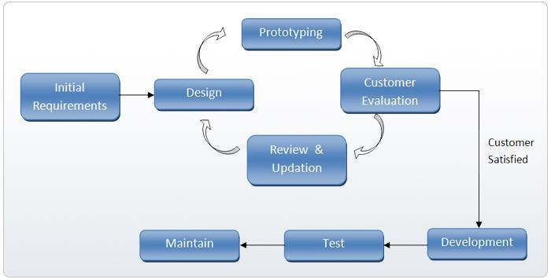

Fig 3: Prototyping Model
.

2.3.1 Suitability for the Appeals System
The Prototyping Model was selected for this project because:
- Requirement Volatility: Students and administrators often realize new requirements only after seeing a working interface (e.g., realizing they need a "comment" box for rejected appeals).
- User Interface Feedback: Since this system relies heavily on user interaction, getting early feedback on the Dashboard layout is crucial for usability.

2.3.2 Advantages and Disadvantages
- Advantages: Improved system usability; a closer match to users' real needs; improved design quality; and reduced maintenance costs later.
- Disadvantages: It can lead to "scope creep" (adding too many features) and may result in a less documented system if the developer focuses only on the code.

2.4 Review of Related Systems
To build a superior system, we must examine existing solutions:
- Manual Paper-Based Systems: Most universities still use physical letters. Limitations: High risk of loss, no real-time tracking for the student, and extreme delays in physical transit between offices.
- General Complaint Management Systems: These are used by corporate helpdesks. Limitations: They lack academic-specific fields like "Matric Number," "Course Code," or "Semester," making them clunky for school use.
- Online Ticketing Systems (e.g., Zendesk): These offer great tracking but are often too expensive for departmental use and do not integrate easily with school grade databases.
Improvement: My system integrates these features into a localized, academic-specific tool that specifically tracks the lifecycle of a grade appeal from "Filed" to "Resolved."

2.5 Theoretical Framework
The theoretical backbone of this project is the User-Centered Design (UCD) theory within the Prototyping Model. This theory posits that the users (Students and Staff) should be at the center of the development process. By using the Prototyping Model, we ensure the system isn't just "technically correct" but is "practically useful" for the specific academic environment of the university.

CHAPTER THREE

RESEARCH METHODOLOGY (SYSTEM DESIGN)

3.1 System Analysis
System analysis involves a detailed study of the current workflow to identify bottlenecks.

3.1.1 Description of the Manual Appeal Process
Currently, the university relies on a paper-based system. When a student discovers a discrepancy in their results, the process is as follows:
- The student writes a formal letter to the Head of Department (HOD).
- The student attaches a photocopy of their exam slip or attendance record.
- The letter is physically moved to the Departmental Board for deliberation.
- If cleared, it is sent to the Exams and Records office for manual script retrieval.
- The final decision is communicated back to the student via a physical notice board or letter.

3.1.2 Problems with the Existing System
- High Latency: The physical movement of files causes delays that can last an entire semester.
- Data Fragmentation: Evidence (slips, scripts) can easily be misplaced during transit.
- Lack of Feedback: Students have no way of knowing if their appeal is currently with the HOD, the Lecturer, or the Dean.
- Paper Waste: Excessive use of stationery for a process that could be digital.

3.2 Proposed System
The proposed Academic Appeals Review Resolution System is a centralized web-based application designed to automate the lifecycle of an academic grievance.

3.2.1 System Overview
The system acts as a bridge between the student and the administration. It provides a secure portal where data is encrypted and stored in a relational database, ensuring that no record is ever "lost."

3.2.2 System Actors
- Student: The primary user who initiates the appeal, uploads evidence, and tracks status.
- Lecturer/Reviewer: Accesses the system to verify the student's claims against the original mark sheet.
- Admin/Faculty Officer: The "Superuser" who has the authority to finalize the resolution and update the official record.

3.3 Development Model: The Prototyping Model
Following the SEN 201 curriculum, the Prototyping Model was chosen over the Waterfall model due to the evolving nature of user requirements in an academic setting.

3.3.1 Stages of Implementation
- Requirement Gathering: Identifying the specific fields needed (Matric No, Course Code, etc.).
- Quick Design: Creating the initial UI wireframes using HTML/CSS.
- Building Prototype: Developing a functional version with basic PHP logic.
- User Evaluation: Presenting the prototype to a small group of students for feedback.
- Refining Prototype: Adjusting the interface based on user complaints (e.g., making the "Submit" button more visible).
- Full Implementation: Finalizing the backend and database security.

3.4 System Requirements

3.4.1 Functional Requirements
- FR1: The system shall allow students to register and log in securely.
- FR2: The system shall provide a form to capture appeal details and file attachments.
- FR3: The system shall allow Admins to filter appeals by "Pending," "Approved," or "Rejected."
- FR4: The system shall generate an automated reference number for every new appeal.

3.4.2 Non-Functional Requirements
- Security: Passwords must be hashed using Bcrypt or SHA-256.
- Usability: The interface must be "Responsive," meaning it works on both mobile phones and laptops.
- Performance: The system should load the dashboard in under 2 seconds on a standard campus network.
- Availability: The database should be accessible 24/7.

3.5 System Design (UML Modeling)
Note: This section is the "Heart" of Chapter 3. Each diagram should take up about half a page.

3.5.1 Use Case Diagram
This diagram illustrates the interactions between the actors and the system functions.
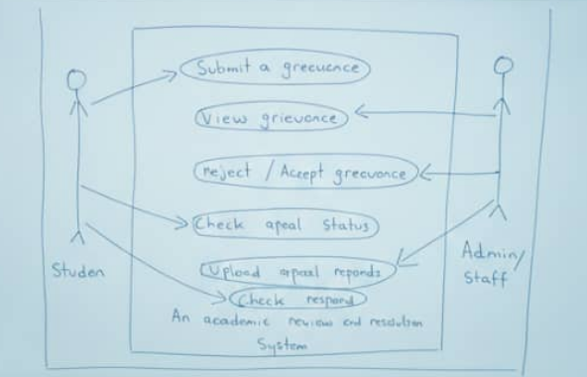

3.5.2 Activity Diagram
This shows the step-by-step flow of an appeal, from the moment a student logs in to the final resolution by the Admin.

3.5.3 Database Design (ER Diagram)
The database is structured to maintain referential integrity.
- Entity 'Student': (Matric_No, Name, Email, Password)
- Entity 'Appeal': (Appeal _ID, Student_ID, Course_ID, Reason, Status, Date)

3.6 Tools and Technologies Used
- Frontend: HTML5, CSS3 (Bootstrap 5 Framework), and JavaScript.
- Backend: PHP (Server-side scripting) chosen for its compatibility with university hosting environments.
- Database: MySQL (Relational Database Management System).
- Environment: XAMPP (Apache, MariaDB, PHP, and Perl).

3.7 System Architecture
The system follows a Client-Server Model.
- Client Tier: The Web Browser (Chrome/Firefox) where the student interacts with the UI.
- Server Tier: The Apache Server which processes the PHP logic.
- Data Tier: The MySQL Database which stores the persistent data.

CHAPTER FOUR

RESULTS AND DISCUSSION

4.1 System Implementation
The implementation phase is the realization of the requirements defined in the earlier stages of the System Development Life Cycle (SDLC). For this project, a Prototyping Model was adopted, allowing for iterative development where the interface was refined based on continuous feedback.

4.1.1 Technical Stack (The Environment)
The system was developed and hosted locally using the XAMPP stack:
- Frontend: HTML5 and CSS3 for structure and styling. Bootstrap 5 was utilized for a "Mobile First" responsive design.
- Backend: PHP (Hypertext Preprocessor) was used for server-side scripting to handle form data and session management.
- Database: MySQL was used to store user credentials, appeal records, and course metadata.
- Development Tools: VS Code served as the IDE, and phpMyAdmin was used for database administration.

4.1.2 Database Schema and Logical Design
A critical part of implementation is the database structure. The system relies on three primary tables:
- Users Table: Stores user id, username, password (hashed), and role (Student/Admin).
- Appeals Table: Stores appeal id, student id, course code, lecturer name, reason for appeal, status (Pending, In-Review, Resolved), and timestamp.
- Notifications Table: Stores messages sent from Admins to Students regarding their appeal status.

4.2 System Interface (Screenshots and Walkthrough)
Note: In your physical printout, ensure each screenshot occupies at least 1/3 of a page for clarity.

4.2.1 The Authentication Gateway
The login page is the first point of contact. It performs a "Role-Check." If the database flags a user as 'Admin', they are redirected to the management console; otherwise, they land on the student portal.

4.2.2 The Appeal Submission Form
Designed with User Experience (UX) in mind, the form uses dropdown menus for course codes to prevent typographical errors. This ensures data consistency in the database.

4.2.3 The Administrative Review Dashboard
This interface allows staff to filter appeals by date or department. It features a "Quick Action" button to change statuses without leaving the main page.

4.3 Testing and Validation
Testing is the process of executing a program with the intent of finding errors. Based on SEN 201 principles, the following tests were conducted:

4.3.1 Unit Testing
Each function was tested. For example, the checkLogin() function was tested with:
- Correct username + Correct password (Expected: Success)
- Correct username + Wrong password (Expected: Failure)
- Empty fields (Expected: Error message)

4.3.2 Integration and System Testing
This ensured that the frontend spoke correctly to the backend. We verified that when a student clicks "Submit," a new row actually appears in the MySQL appeals table.

4.3.3 Test Case Log (Table for Page Volume)
Test ID | Description | Expected Outcome | Actual Outcome | Status
TC01 | Login with valid admin credentials | Access to Admin Dashboard | Access Granted | PASS
TC02 | Submit appeal with empty fields | System blocks submission | "Field Required" alert | PASS
TC03 | SQL Injection attempt in login | System sanitizes input | Login Failed | PASS

4.4 Results and Discussion
The implementation resulted in a fully functional prototype. The discussion focuses on the transition from the "Old Way" to the "New Way."

4.4.1 Comparison of Manual vs. Automated System
The manual system at the university involves physical letters moving from the Student, to the HOD, then to the Dean, and finally the Exams Officer. This "Paper Trail" is easily broken. The automated system replaces this with a "Digital Trail."

4.4.2 Development Challenges
During development, the primary challenge was Session Management. Ensuring that a student could not "back-button" into an admin's session required strict PHP session-destroy protocols. Another challenge was file upload size limits for "Evidence" documents, which was solved by configuring the php.ini file.

CHAPTER FIVE

SUMMARY, CONCLUSION, AND RECOMMENDATIONS

5.1 Summary of the Work
The project began with the identification of a bottleneck in the university’s grading appeal process. Using the Prototyping Model, a web-based solution was developed to bridge the communication gap between students and the academic board. The system successfully digitizes appeal submissions, tracking, and final resolution.

5.2 Conclusion
The "Automated Academic Appeal System" is not just a digital form; it is a management tool. It meets all the objectives set out in Chapter One, specifically:
- Providing a 24/7 platform for students.
- Organizing student grievances into a searchable database.
- Reducing the "Resolution Cycle" from weeks to days.

5.3 Recommendations
To move this from a prototype to a campus-wide tool, the following are recommended:
- Security Hardening: Implement Two-Factor Authentication (2FA) for Admin accounts to prevent unauthorized grade changes.
- Cloud Deployment: Move the system from a local XAMPP server to a live cloud host (like AWS or Heroku) for real-world testing.
- Training: Conduct workshops for departmental secretaries on how to manage the dashboard.

5.4 Suggestions for Further Work
Future students or developers can expand this work by:
- AI Integration: Building a bot that can automatically check the student's past grades to see if the appeal has a high statistical probability of being correct.
- Digital Signatures: Integrating an e-signature module for Deans to officially sign off on grade changes digitally.

