3---------------------------------------------------

#include <stdio.h>

int main()

{

int a,b;

scanf("%d%d",&a,&b);

printf("a=%d\n",a,"\n");

printf("b=%d\n",b);

printf("和:a+b=%d\n",a+b);

printf("差:a-b=%d\n",a-b);

printf("积:a\*b=%d\n",a\*b);

printf("商:a/b=%d\n",a/b);

printf("余数:a%b=%d\n",a%b);

}

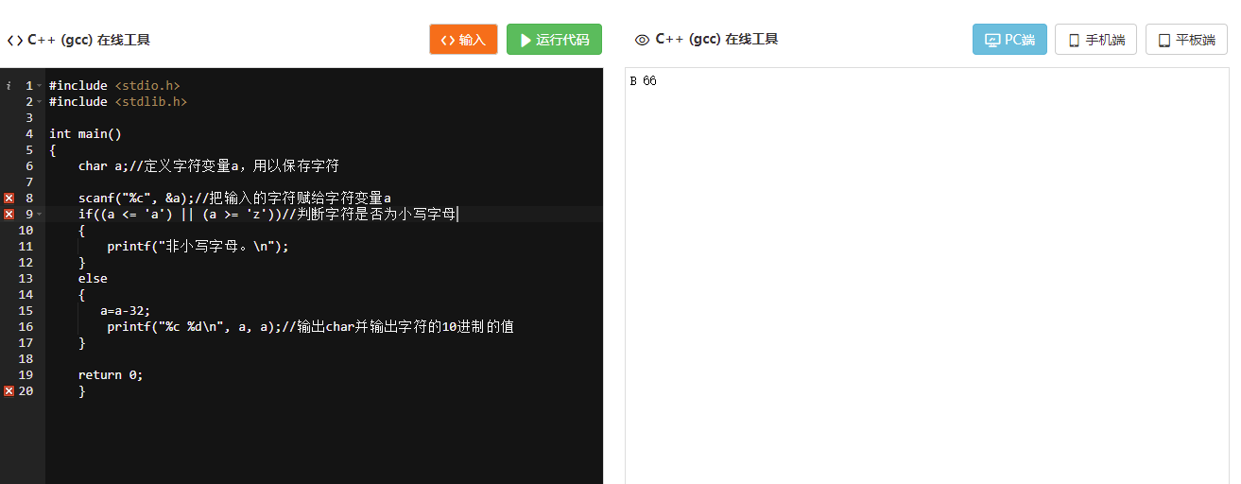

4--------------------------------------------------------------------------------------------

#include <stdio.h>

#include <stdlib.h>

int main()

{

char a;//定义字符变量a，用以保存字符

scanf("%c", &a);//把输入的字符赋给字符变量a

if((a <= 'A') || (a >= 'Z'))//判断字符是否为大写字母

{

printf("非大写字母。\n");

}

else

{

printf("%c %d\n", a, a);//输出char并输出字符的10进制的值

}

return 0;

}

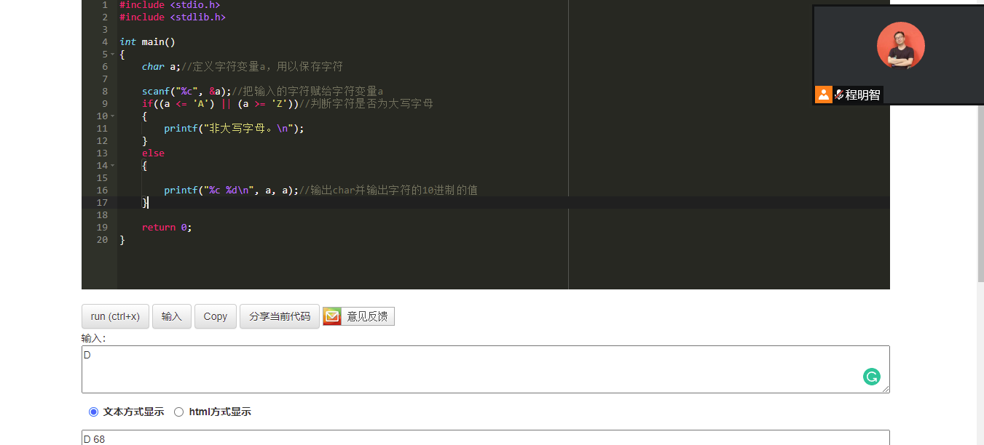

5---------------------------------------------------------------------------------------

#include <stdio.h>

#include <stdlib.h>

int main()

{

char a;//定义字符变量a，用以保存字符

scanf("%c", &a);//把输入的字符赋给字符变量a

if((a <= 'a') || (a >= 'z'))//判断字符是否为小写字母

{

printf("非小写字母。\n");

}

else

{

a=a-32;

printf("%c %d\n", a, a);//输出char并输出字符的10进制的值

}

return 0;

}

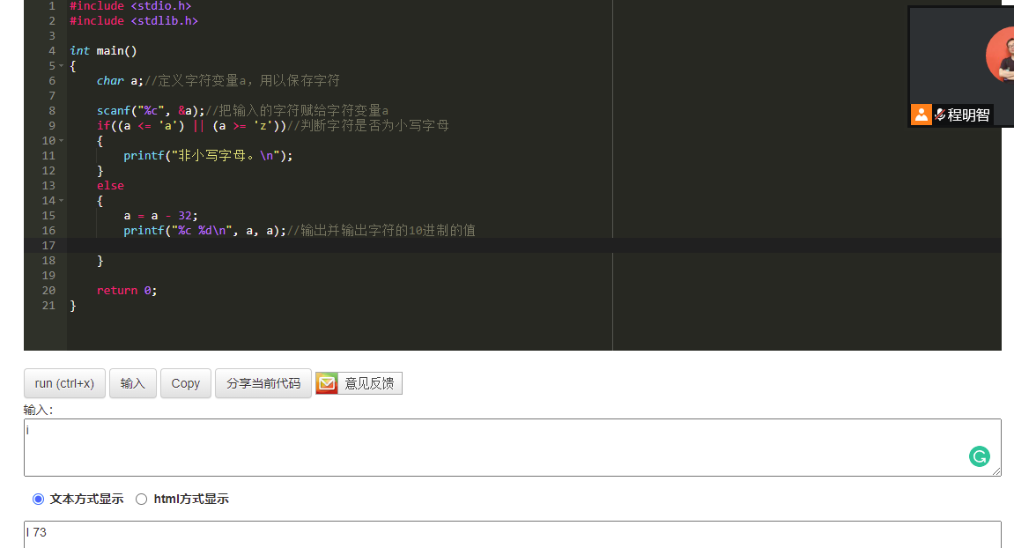

6----------------------------------------------------------------------------

#include <stdio.h>

#include <stdlib.h>

int main(void)

{

int num;

printf("请输入一个三位整数：\n");

scanf("%d",&num);

if((num<99)&&(num>1000)){

printf("非三位数字。\n");//&&是并且的意思,这个if用来判断输入的是不是三位数\*/)

}

else{

printf("%d的百位是%d，十位是%d"

"个位是%d\n",num,abs(num)/100,abs(num)/10%10,abs(num)%10);//分解这个数字，首先确定是否为3位正整数，然后从第三位，逐位的将数字降到各位，然后用int型数据把小数部分扔掉

return 0;

}

}

