Zero File Conversion Corpus
Editable layout, CJK text, tables, images, columns, headers and footers
English paragraph. 中文段落用于验证字体、换行与阅读顺序。

Document structure
- Preserve headings and paragraph order.
- Keep editable text instead of rasterizing the page.
- Retain explicit page breaks and repeated document furniture.

Comparison table
Format | Expected target | Important structure
PDF | DOCX | Reading order and editable text
DOCX | PDF | Pagination and embedded image
中文 | 双向 | 字体与表格布局

Embedded image
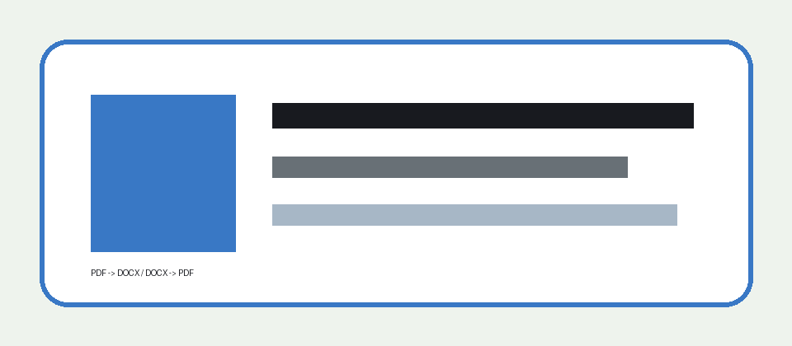

Column sample 1. Local conversion should keep this reading order and paragraph boundary.
Column sample 2. Local conversion should keep this reading order and paragraph boundary.
Column sample 3. Local conversion should keep this reading order and paragraph boundary.
Column sample 4. Local conversion should keep this reading order and paragraph boundary.
Column sample 5. Local conversion should keep this reading order and paragraph boundary.
Column sample 6. Local conversion should keep this reading order and paragraph boundary.
Column sample 7. Local conversion should keep this reading order and paragraph boundary.
Column sample 8. Local conversion should keep this reading order and paragraph boundary.

Explicit page break
This section begins on a new page. 第二页内容应保持可编辑。

