1. Get started with cloning the repo and starting a new ionic project. > git clone //lvdpssdev/C$/Code/ProjectMongo

> Ionic start MongoDBProject1 sidemenu

> ionic g page AddReviewPage

> ionic g provider Reviews

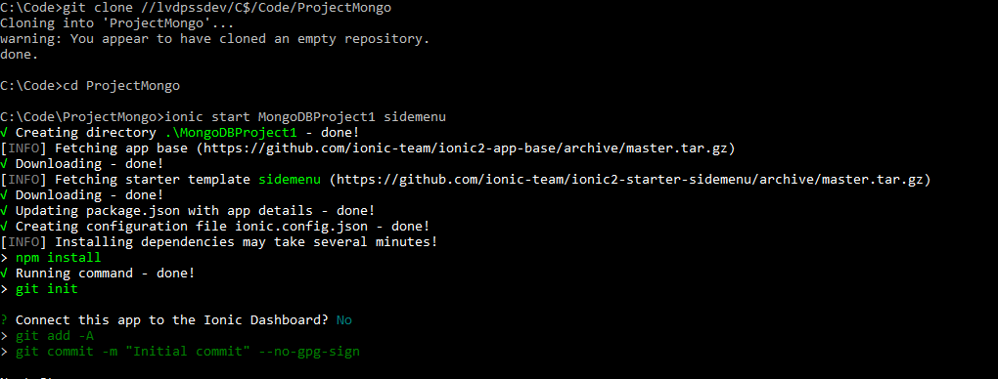

2. Add following to app.module.ts in /app folder.

|  |  |
| --- | --- |
|  | |
| import { BrowserModule } from '@angular/platform-browser';  import { ErrorHandler, NgModule } from '@angular/core';  import { NgModule } from '@angular/core';  import { IonicApp, IonicErrorHandler, IonicModule } from 'ionic-angular';  import { MyApp } from './app.component';  import { HomePage } from '../pages/home/home';  import { ListPage } from '../pages/list/list';  import { AddReviewPage } from '../pages/add-review-page/add-review-page';  import { Reviews } from '../providers/reviews';  import { StatusBar } from '@ionic-native/status-bar';  import { SplashScreen } from '@ionic-native/splash-screen'; | import { ReviewsProvider } from '../providers/reviews/reviews';  @NgModule({  declarations: [  MyApp,  HomePage,  ListPage,  AddReviewPage  ],  imports: [  BrowserModule,  IonicModule.forRoot(MyApp),  ],  bootstrap: [IonicApp],  entryComponents: [  MyApp,  HomePage,  ListPage,  AddReviewPage  ],  providers: [  StatusBar,  SplashScreen,  {provide: ErrorHandler, useClass: IonicErrorHandler},  ReviewsProvider  ]  })  export class AppModule {} |

3. Connect Mongodb: paste these contents in package.json

|  |  |  |
| --- | --- | --- |
|  | |  |
| {  "name": "MongoDBProject1",  "version": "0.0.1",  "author": "Ionic Framework",  "homepage": "http://ionicframework.com/",  "engines": {  "node": "6.11.4"  },  "main": "server.js",  "scripts": {  "start": "node server.js"  },  "private": true,  "scripts": {  "clean": "ionic-app-scripts clean",  "build": "ionic-app-scripts build",  "lint": "ionic-app-scripts lint",  "ionic:build": "ionic-app-scripts build",  "ionic:serve": "ionic-app-scripts serve"  }, | "dependencies": {  "@angular/common": "4.4.3",  "@angular/compiler": "4.4.3",  "@angular/compiler-cli": "4.4.3",  "@angular/core": "4.4.3",  "@angular/forms": "4.4.3",  "@angular/http": "4.4.3",  "@angular/platform-browser": "4.4.3",  "@angular/platform-browser-dynamic": "4.4.3",  "@ionic-native/core": "4.3.0",  "@ionic-native/splash-screen": "4.3.0",  "@ionic-native/status-bar": "4.3.0",  "@ionic/storage": "2.0.1",  "ionic-angular": "3.7.1",  "ionicons": "3.0.0",  "rxjs": "5.4.3",  "sw-toolbox": "3.6.0",  "zone.js": "0.8.18"  }, | "devDependencies": {  "@ionic/app-scripts": "3.0.0",  "typescript": "2.3.4",  "mongoose": "^4.6.2",  "body-parser": "^1.15.2",  "cors": "^2.8.0",  "del": "2.2.0",  "express": "^4.14.0",  "http": "0.0.0",  "method-override": "^2.3.6",  "morgan": "^1.7.0",  "superlogin": "^0.6.1"  },  "description": "An Ionic project"  } |

And the following to server.js : http://gso-m915e45e:27017/api/reviews

|  |  |  |
| --- | --- | --- |
|  | |  |
| mongoose.connect('mongodb://GSO-M915E45E/', {useMongoClient: true}); | var port = 27017; | console.log("App listening on port 27017"); |

> npm install mongodb

> npm install

3.

|US-DOCS\95001986.1||