**Product Requirements**

**Team: The Procrastinators**

***Note: this is a “living document”, meaning its content will change with the implementation of the project. Use it to capture key project requirements and make sure that your product features match the requirements exactly – if you wish to add any features, they must be added first to the requirements. The requirements document, and all changes to it, must be approved by the customer (instructor).***

***Remove/replace the blue text and the descriptive paragraphs in each section prior to your submission as directed by your instructor.***

|  |  |  |  |
| --- | --- | --- | --- |
| ***Revision Number*** | ***Revision Date*** | ***Summary of Changes*** | ***Author(s)*** |
| *0.1* | *02/08/2016* | *Initial Changes* | *Chris Lim* |
| ***0.2*** | ***03/06/2016*** | ***R1 Modifications*** | ***Chris Lim*** |
| ***0.3*** | ***03/28/2016*** | ***Adjustments to plan for R2*** | ***Maximillian McMullen*** |
| ***0.4*** | ***04/26/2016*** | ***Started Use Cases for R2*** | ***Maximillian McMullen*** |
| ***0.5*** | ***05/05/2016*** | ***Additional revisions to Use Cases*** | ***Maximillian McMullen*** |
| ***0.6*** | ***05/06/2016*** | ***Formal use cases finalized*** | ***Maximillian McMullen*** |
| ***0.7*** | ***05/06/2016*** | ***UML Diagrams Revised To Reflect New Cases*** | ***Maximillian McMullen*** |

***The Revision Table above must be augmented after any version of this document is updated. Insert any necessary rows at the bottom of the table.***

# Brief problem statement

We must create a hospital management program that keeps track of patient information, manages patient information, and gathers statistical data, all in an easy to use method.

There must be a permissions system, an overview of information (appointments, patient profiles, tests), and means for patients, doctors, and nurses to modify, access, and export the information.

# Stakeholders

**HAccelerator Board of Directors** – oversee the projects funding and expenses. Have vested interest in the proven success of the product but are not involved in the planning and execution.

**HAccelerator Product Owner** – will act as principle representative for HealthNet product needs. He/she champions the product with the Board of Directors, helps facilitate product decisions and has the ultimate say on when and what features should be released.

**Software Engineering Team** – is responsible for the day-to-day operations and coordination of all aspects related to the software product's life-cycle. This include, among others: planning and delegation of team roles and responsibilities; elicitation and clarification of requirements; analysis and design; implementation, testing and release of all software components.

**Beta Testing Team** – represent the target user base for HealthNet. Will be available in later phases of the project to conduct acceptance testing and provide feedback on product release.

# Users profile

Patient must have:

* Have basic experience using computers and browsing the internet. Has filled out online forms or surveys and may have purchased or sold a product.
* Have a computer with access to the internet
* Have an interest in improving their health by using an online way of interacting with their hospital
* Be willing to share information such as home address and contact information as well as more personal information such as medical history

Doctor must have:

* Have basic experience using computers and browsing the internet. Has received all proper certification, and consulted with the Hospital’s administrator.
* Have a computer with access to the internet
* Have an interest in staying organized and keeping track of their patients by using an online way of interacting with their hospital
* Be willing to release all medical information online in a protected environment to the patient, as well as leave comments or advice for the patient.

Nurse must have:

* Have basic experience using computers and browsing the internet. Has received all proper certification, and consulted with the Hospital’s administrator.
* Have a computer with access to the internet
* Have an interest in staying organized and keeping track of patient and doctor schedules at their hospital

Administrator must have:

* Have moderate to high experience using computers and browsing the internet. Has received all proper certification, and consulted with the Hospital’s administrator.
* Have a computer with access to the internet
* Have an interest in monitoring hospital activity as well as assisting hospital staff in setting up and using the system.

# System requirements

At a high-level this project will be source controlled in SVN, run on Django using python, sqlite and needs to be compatible with the latest browsers.

Although the application needs to be accessible through the internet, deployments and demonstrations for this phase of the project will take place within the RIT Software Engineering environment. To this end, you must understand and document the target platforms from the perspective of the client browser as well as that of the server. Make sure to capture versions or software dependencies, programming languages and hardware specifications that are available for your use and proceed only after you document and confirm these with the customer.

# Feature requirements (user stories)

The following list of user stories is neither final nor comprehensive. You must consider it your responsibility to maintain its relevance, clarify any misunderstandings and keep it up-to-date. Any changes must be discussed with the Product Owner for approval.

|  |  |  |  |
| --- | --- | --- | --- |
| **No.** | **User Story Name** | **Description** | **Release** |
| **1** | Patient Registration | Users sign up to become a Patient by providing their personal contact information, proof of insurance and unique login credentials.  Additionally, a patient should provide the system with some basic medical profile information, a choice of preferred hospital and emergency contact information (linked to another patient if they are already in the system). | **R1** |
| **2** | Administrator Registration | Doctors, Nurses, and Administrators will be added to the system by other administrators. All information for creating these new accounts will be done through an administrator account. | R2 |
| **3** | Update Patient Profile Information | Patients can update their profile information. | **R1** |
| **4** | Update Patient Medical Information | Doctors and Nurses can update patient medical information. | R2 |
| **5** | Export Information | Patients will be able to export their information and their test results from the system with relevant privacy warnings. | R2 |
| **6** | Create or Update Patient Appointment | Patients, doctors and nurses can create or update an appointment with a doctor and at one of the doctor’s available locations.  If the patient or doctor already has an appointment at the time selected, then the system will not allow for the appointment. | **R1** |
| **7** | Cancel Patient Appointment | Patients can cancel their existing appointments.  Doctors can cancel their existing appointments.  Nurses cannot cancel (only modify) existing appointments. | **R1** |
| **8** | Appointment Calendar | Doctors and patients will easily be able to view all of their appointments in a calendar view.  Nurses will be able to see all appointments for the day and week between Patients and Doctors. | **R1** |
| **9** | Add/Remove Prescriptions | Doctors can add or remove a prescription to a patient record.  Nurses can view the prescriptions of patients belonging to the same hospital.  Patients can view their prescriptions from their account. | R2 |
| **10** | Viewing Patient Medical Information, Prescriptions and Tests and Results | Doctors can view all medical information for any patient in the system (regardless of Hospital).  Nurses can only view patient medical information in the hospital they work for.  Patients can view their tests (pending or completed) and view the corresponding results for those tests that have been released by the doctor.  Prescriptions and other non-sensitive information is viewable by the patient without a need for doctor’s release. | R2 |
| **11** | Release Test Results | Doctors (within the patient’s hospital) can, upon evaluating a patient’s test results, release them for view by that patient.  Comments may be added to the specific test result for view by the patient. | R2 |
| **12** | Logging System Activity | For security, many actions in the system will be logged for review at a later date.  Some examples of actions to be logged include but are not limited to updating of a Patient’s information, viewing of a Patients information/records, and transfers of a Patient from one hospital to another. | **R1** |
| **13** | Admission and Discharge to/from Hospital | Doctors and Nurses can admit a patient to the hospital for an extended stay (reasons could be: emergency, observation, surgery, etc.). These are typically unexpected visits but can result from a decision made after a scheduled appointment. This event is recorded by the system.  Doctors are the only ones to approve a patient’s discharge from the Hospital. This event is recorded by the system. | R2 |
| **14** | Viewing Activity Log | Administrators will be able to view the logs of all system activity for a given time-frame at their hospital. Some examples of this might be:   * breakdown of the viewing activity of patient records or by system user * most common system activities (or by user)   Other important and informative statistics yet to be determined. | **R1** |
| **15** | Viewing System Statistics | Administrators will be able to view compiled statistics for a given time-frame at their hospital. Some examples of this might be:   * number of patients visiting the hospital * average number of visits per patient * average length of stay (from admission to discharge) * most common reasons for being admitted to the hospital * prescription statistics   Other important and informative statistics yet to be determined. | R2 |
| **16** | Patient Transfer | Patient can be transferred between hospitals.  Transfers can be carried out by either administrators or by doctors (ones who are at the receiving hospital). | R2 |
| **17** | Upload Patient Information | Doctors will be able to upload the results of a patient’s tests if needed.  Doctors will be able to upload images such as those used in X-Rays to update a patient’s record.  Uploads are considered as updates to a patient’s medical information. | R2 |
| 18 | Send Private Message | Doctors, nurses, patients and administrators can send private messages of limited length via the system. | R2 |

**Use case context diagram**

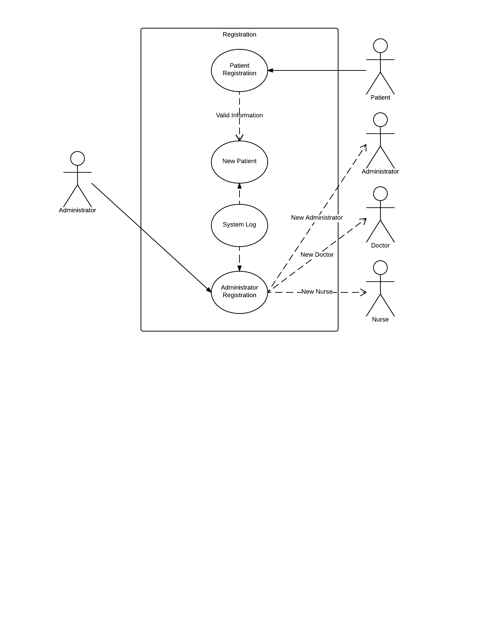

|  |  |
| --- | --- |
| **Use Case Number:** | ***UC-01*** |
| **Use Case Name:** | ***Patient Registration*** |
| **Overview:** | ***Registrant provides personal, medical and emergency contact information to the System upon registering and becoming a Patient.*** |
| **Actor(s):** | ***Registrant*** |
| **Pre-condition(s):** | ***- System has been setup and configured.***  ***- System is running and open for registrations.***  ***- Registrant has accessed website via URL*** |
| **Scenario Flow:** | ***Main (success) Flow:***   1. ***Registrant selects option to register*** 2. ***System requests personal information*** 3. ***Registrant provided personal information.*** 4. ***System verifies required information is provided.***  * ***If information is invalid System displays message. Return to Step 2***  1. ***System requests basic medical information*** 2. ***Registrant provides medical information*** 3. ***System verifies required information is provided.***  * ***If information is invalid System displays message. Return to Step 5***  1. ***System requests emergency contact information*** 2. ***Registrant provides emergency contact information*** 3. ***System verifies required information is provided***  * ***If information is invalid System displays message. Return to Step 8***  1. ***System requests login information*** 2. ***Registrant provides login information*** 3. ***System verifies required information is provided***  * ***If information is invalid System displays message. Return to Step 11***   ***System displays confirmation of registration*** |
| ***Alternate Flows:*** | ***Alternate Flow #1: After Step 2 in success scenario System will display the option to Cancel the registration process. The following steps would occur:***   1. ***Registrant selects option to cancel during registration*** 2. ***System requests confirmation to cancel*** 3. ***Registrant confirms intent*** 4. ***System returns to main screen***   ***Alternate Flow #2: The emergency contact information is an existing user in the system. After step 10 the following steps would occur:***   1. ***Registrant selects option to select an emergency contact from the system*** 2. ***System displays a search bar for the Registrant to input the user’s name*** 3. ***Registrant inputs the user’s name and presses enter*** 4. ***System returns a list of users with matching names*** 5. ***Registrant chooses intended user***   ***System sets that user as an emergency contact*** |
| **Post Condition:** | ***If Registrant completed registration, information is stored and Registrant is added to the System as a Patient. If Registrant does not complete registration, information is not stored.*** |

|  |  |
| --- | --- |
| **Use Case Number:** | ***UC-02*** |
| **Use Case Name:** | ***Administrator Registration*** |
| **Overview:** | ***Doctors, Nurses, and other Administrators are registered by an Administrator account.*** |
| **Actor(s):** | ***Admin*** |
| **Pre-condition(s):** | ***- Administrator account has been set up***  ***- Hospital model has been set up*** |
| **Scenario Flow:** | ***Main (success) Flow:***  ***1. Admin accesses the Administrator Panel***  ***2. Admin navigates to Doctor or Nurse Profile model pages***  ***3. Admin selects the create new profile button***  ***4. Admin creates the nurse or doctor’s user account***  ***5. Admin fills in the rest of the nurse or doctor’s profile information***  ***6. Admin saves changes*** |
| ***Alternate Flows:*** | ***Alternate Flow #1: After Step 3, if the nurse or doctor already has a user account but not a profile yet:***  ***1. Admin selects the nurse or doctor’s user account from existing accounts.***  ***2. Admin proceeds with registration as per usual.*** |
| **Post Condition:** | ***The doctor or nurse has a user account and a profile.*** |

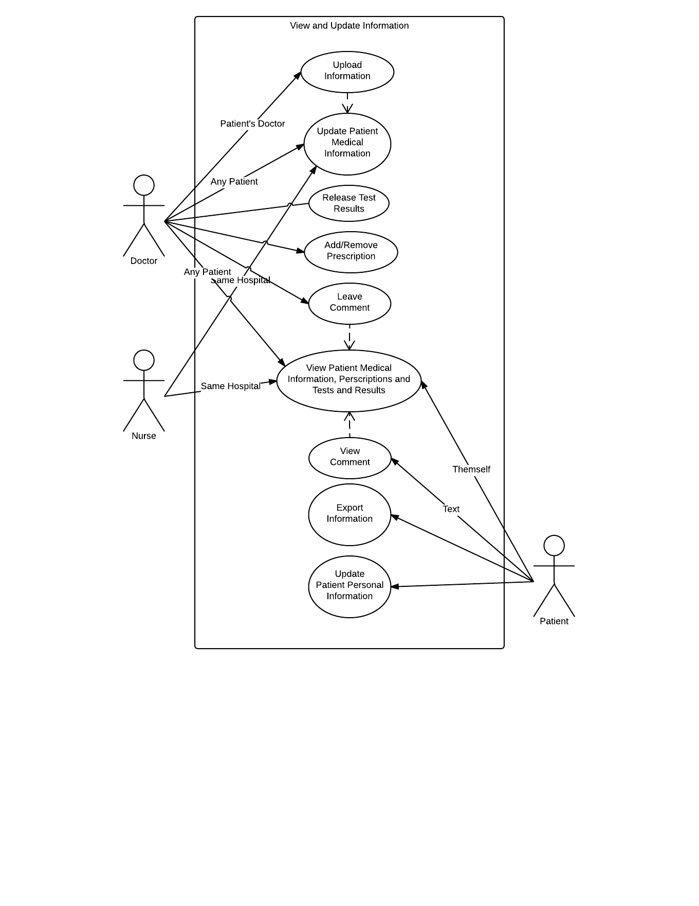

|  |  |
| --- | --- |
| **Use Case Number:** | ***UC-03*** |
| **Use Case Name:** | ***Update Patient Personal Information*** |
| **Overview:** | ***Patients can update their profile information.*** |
| **Actor(s):** | ***Patient*** |
| **Pre-condition(s):** | ***- System has been setup and configured.***  ***- System is running and open for changes.***  ***- Patient has accessed website via URL***  ***- Patient has logged in to existing account*** |
| **Scenario Flow:** | ***Main (success) Flow:***   1. ***Patient selects option to change profile information*** 2. ***System brings up list of patients’ information in an editable format*** 3. ***Patient changes personal information*** 4. ***System verifies provided information***  * ***If information is invalid, System displays a message. Return to Step 2, fields not reset***  1. ***System displays confirmation of changes*** |
| ***Alternate Flows:*** | ***Alternate Flow #1: After step 2 in success scenario, System will display the option to Cancel the process. The following steps would occur:***   1. ***Patient selects option to cancel during changes*** 2. ***System requests confirmation to cancel*** 3. ***Patient confirms intent*** 4. ***System returns to main screen*** |
| **Post Condition:** | ***If Patient completed changes, information is stored. If Patient does not complete changes, information is not stored.*** |

|  |  |
| --- | --- |
| **Use Case Number:** | ***UC-04*** |
| **Use Case Name:** | ***Update Patient Medical Information*** |
| **Overview:** | ***Doctors and Nurses update Patient medical information.*** |
| **Actor(s):** | ***Employee*** |
| **Pre-condition(s):** | ***- The patient has an account***  ***- The employee has sufficient privileges to view this patient*** |
| **Scenario Flow:** | ***Main (success) Flow:***  ***1. Employee accesses the patient’s medical information.***  ***2. Employee makes appropriate changes to the patient’s medical information***  ***3. Employee saves changes***  ***4. Employee gets sent back to main screen*** |
| ***Alternate Flows:*** | ***Alternate Flow #1: After Step 2, if Employee decides that they don’t want to save the changes, they would do the following:***  ***1. Employee clicks the cancel button***  ***2. Employee gets sent back to main screen*** |
| **Post Condition:** | ***Employee has made the desired changes to the patient*** |

|  |  |
| --- | --- |
| **Use Case Number:** | ***UC-05*** |
| **Use Case Name:** | ***Export Information*** |
| **Overview:** | ***Patients export their information and test results*** |
| **Actor(s):** | ***Patient*** |
| **Pre-condition(s):** | ***- Patient’s profile has been set up and filled in with all their personal data*** |
| **Scenario Flow:** | ***Main (success) Flow:***  ***1. Patient navigates to their medical information page***  ***2. Patient clicks on the export button***  ***3. The system displays a privacy warning to Patient***  ***4. Patient accepts the notification***  ***5. The system converts Patient’s information into a file***  ***6. Patient receives the file via a download***  ***7. Patient is returned to their medical information page*** |
| ***Alternate Flows:*** | ***Alternate Flow #1: After Step 3, if Patient chooses not to accept the privacy warning:***  ***1. Patient clicks a button indicating that they do not accept the privacy warning.***  ***2. Patient is returned to their medical information page*** |
| **Post Condition:** | ***Patient has successfully downloaded their medical information*** |

|  |  |
| --- | --- |
| **Use Case Number:** | ***UC-06*** |
| **Use Case Name:** | ***Create or Update Patient Appointment*** |
| **Overview:** | ***A patient, nurse, or doctor, can create or update an appointment with a doctor, but only if the doctor has the specified period of time free.*** |
| **Actor(s):** | ***User*** |
| **Pre-condition(s):** | ***-Appointment system setup***  ***-Doctor availability configured***  ***-User has logged in***  ***-User has navigated to appointment screen*** |
| **Scenario Flow:** | ***Main Flow:***  ***1. User chooses to create a new appointment, or modify existing appointments displayed in a list.***  ***2. User provides or changes details about appointment, including the patient and doctor information.***  ***3. System verifies information (valid user, valid doctor, etc.).***  ***-If information is invalid, go back to step 2 and display error message.***  ***4. Display available doctor times and current patient appointments, and ask user for a time.***  ***5. System checks times for conflicts.***  ***-If time conflicts with either Doctor or patient appointments, repeat step 4 and display an error message.***  ***6. Submit all information to databases to update.***  ***7. User is sent back to the original appointment screen.*** |
| **Alternate Flows:** | ***Alternative Flow #1: For steps 1-4, the user can choose to cancel appointment creation.***  ***1. User opts to cancel creation.***  ***2. User confirms intent to cancel.***  ***3. User is sent back to home screen.***  ***Alternative Flow #2: For step 2, if the user is a patient, then patient and doctor information is already filled in. They still need to provide the rest of the relevant appointment information however.*** |
| **Post Condition:** | ***-Appointment has been successfully created*** |

|  |  |
| --- | --- |
| **Use Case Number:** | ***UC-07*** |
| **Use Case Name:** | ***Cancel Patient Appointment*** |
| **Overview:** | ***A patient or doctor can cancel one of their existing appointments.*** |
| **Actor(s):** | ***Appointee*** |
| **Pre-condition(s):** | ***-An appointment has been created***  ***- Appointee is a patient or doctor (nurses can’t delete appointments)***  ***- Appointee has navigated to appointment screen*** |
| **Scenario Flow:** | ***Main Flow:***  ***1. Appointee chooses to delete an appointment, displayed in a list.***  ***2. Appointee confirms that they want to delete the appointment.***  ***3. The appointment is deleted from databases, and doctor availability is modified.***  ***4. Appointee is sent back to the original appointment screen.*** |
| ***Alternate Flows:*** | ***Alternative Flow #1: For step 2, Appointee may choose not to confirm that they want to delete the appointment.***  ***1. Appointee doesn’t confirm***  ***2. Appointee is sent back to the original appointment screen*** |
| **Post Condition:** | ***-The appointment is deleted***  ***-Database and doctor availability are updated*** |

|  |  |
| --- | --- |
| **Use Case Number:** | ***UC-08*** |
| **Use Case Name:** | ***Appointment Calendar*** |
| **Overview:** | ***Patients and Doctors will be able to view their appointments in a detailed calendar view. Nurses can view everyone’s appointments.*** |
| **Actor(s):** | ***Viewer*** |
| **Pre-condition(s):** | ***-Appointments have been set up***  ***-Viewer has navigated to the calendar screen*** |
| **Scenario Flow:** | ***Main Flow:***  ***1. Calendar scale adjusts based on how spread out the Viewer’s appointments are.***  ***2. Viewer can see all of their appointments on the calendar.***  ***3. Viewer can change the calendar scale.***  ***4. Viewer can click on an appointment to view specific appointment information.*** |
| ***Alternate Flows:*** | ***Alternative Flow #1: For step 2, if Viewer is a nurse, they can see all appointments for the next week (adjustable via the scale). Appointments at the same time are displayed side by side on that day.***  ***Alternative Flow #2: For step 4, the Viewer has the option to modify that appointment.***  ***1. Viewer chooses to modify the appointment.***  ***2. Viewer is redirected to the specific appointment at the appointment screen.*** |
| **Post Condition:** | ***-Viewer has viewed all of their appointments*** |

|  |  |
| --- | --- |
| **Use Case Number:** | ***UC-09*** |
| **Use Case Name:** | ***Add or Remove Prescriptions*** |
| **Overview:** | ***Doctors add or remove patient prescriptions. Nurses view the prescriptions of patients in the same hospital. Patients view their prescriptions.*** |
| **Actor(s):** | ***User*** |
| **Pre-condition(s):** | ***- User has the permission to view the patient’s profile; doctor’s can view any patient, nurses can view patients in their hospital, patients can view themselves*** |
| **Scenario Flow:** | ***Main (success) Flow:***  ***1. User navigates to the patient’s medical profile***  ***2. User scrolls to the prescription section***  ***3. User clicks on a button to edit prescriptions***  ***4. User clicks on a button to add a prescription***  ***5. User fills out appropriate prescription information***  ***6. User submits the prescription***  ***7. User is returned to the patient’s medical profile*** |
| ***Alternate Flows:*** | ***Alternate Flow #1: After Step 3, if the User chooses to remove a prescription instead:***  ***1. User finds the prescription they wish to delete***  ***2. User clicks a button to delete that prescription***  ***3. User is returned to the patient’s medical profile***  ***Alternate Flow #2: If User is a nurse or patient, they stop at step 2 in the main flow.*** |
| **Post Condition:** | ***User has successfully added or removed a prescription.*** |

|  |  |
| --- | --- |
| **Use Case Number:** | ***UC-10*** |
| **Use Case Name:** | ***Viewing Patient Medical Information, Prescriptions, Tests and Results*** |
| **Overview:** | ***Doctors, Nurses, and Patients view Patient Medical Information, Prescriptions, Tests, and Results*** |
| **Actor(s):** | ***User*** |
| **Pre-condition(s):** | ***- User has the permission to view that patient’s medical information; doctors can view any patient, nurses can view patients in their hospital, patients can view only released information on themselves (including non sensitive information)*** |
| **Scenario Flow:** | ***Main (success) Flow:***  ***1. User navigates to the patient’s medical profile***  ***2. User scrolls to the medical, prescriptions, or tests sections*** |
| ***Alternate Flows:*** | ***Alternate Flow #1: After Step 1, if the user is a patient, nonreleased tests won’t be viewable under the tests section*** |
| **Post Condition:** | ***User has viewed the medical information they were seeking*** |

|  |  |
| --- | --- |
| **Use Case Number:** | ***UC-11*** |
| **Use Case Name:** | ***Release Test Results*** |
| **Overview:** | ***Doctors release test results after they are evaluated*** |
| **Actor(s):** | ***Doctor*** |
| **Pre-condition(s):** | ***- Test has been carried out in the hospital*** |
| **Scenario Flow:** | ***Main (success) Flow:***  ***1. Doctor navigates to a user’s medical profile***  ***2. Doctor scrolls to the tests section***  ***3. Doctor clicks a button to edit tests***  ***4. Doctor clicks the test that they are releasing***  ***5. Doctor fills in any relevant notes or information for the test***  ***6. Doctor changes the ‘released’ field in the test to be true***  ***7. Doctor saves changes***  ***8. Doctor is returned to the user’s medical profile*** |
| ***Alternate Flows:*** | ***Alternate Flow #1: After Step 3, if the test isn’t already in the database:***  ***1. Doctor clicks a button to add a new test***  ***2. Doctor proceeds with steps 5-8 in the main flow*** |
| **Post Condition:** | ***Doctor has released the test that they have evaluated*** |

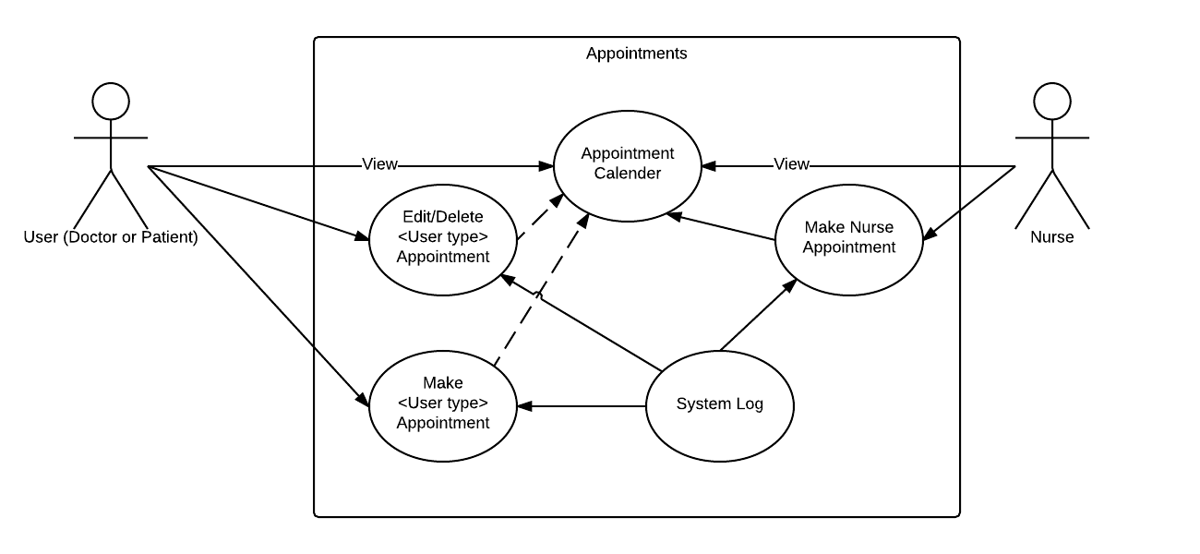

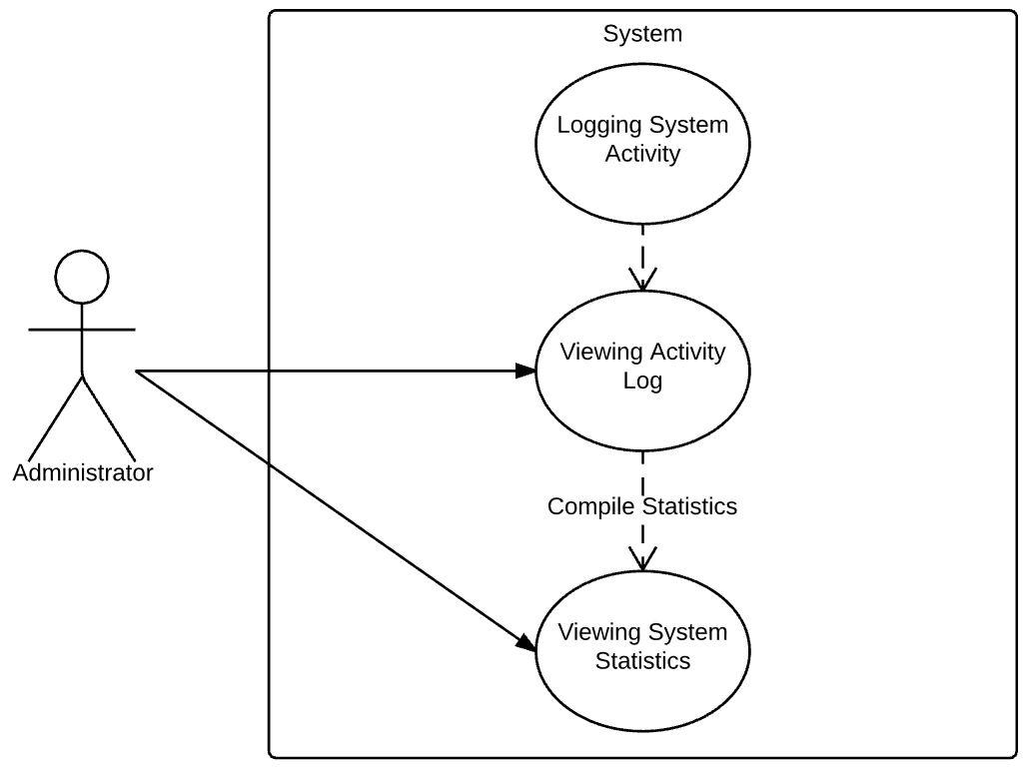

|  |  |  |
| --- | --- | --- |
| **Use Case Number:** | | ***UC-12*** |
| **Use Case Name:** | | ***Logging System Activity*** |
| **Overview:** | | ***For security, many actions in the system will be logged for review at a later date.***  ***Some examples of actions to be logged include but are not limited to updating of a Patient’s information, viewing of a Patients information/records, and transfers of a Patient from one hospital to another.*** |
| **Actor(s):** | | ***Administrator*** |
| **Pre-condition(s):** | | ***- System has been setup and configured***  ***- System recognizes an action.***  ***-System stores the log*** |
| **Scenario Flow:** | | ***Main (success) Flow:***  ***System recognizes an action that has occurred***  ***System takes the action and puts it in the log***  ***Log is accessed by admin for viewing*** |
| ***Alternate Flows:*** | ***Alternate Flow #1: If the user is admin the admin can edit the log.***  ***Admin finds an error in the log***  ***Admin presses edit and edits***  ***The edited log stores what was edited*** | |
| **Post Condition:** | | ***Log has been stored in the system.*** |

|  |  |
| --- | --- |
| **Use Case Number:** | ***UC-13*** |
| **Use Case Name:** | ***Admission and Discharge to or from Hospital*** |
| **Overview:** | ***Doctors and Nurses admit a patient to a hospital.*** |
| **Actor(s):** | ***Employee*** |
| **Pre-condition(s):** | ***- The patient visiting has an account with the hospital***  ***- Employee has the appropriate privileges to view and edit the patient*** |
| **Scenario Flow:** | ***Main (success) Flow:***  ***1. Employee navigates to a patient’s medical profile***  ***2. Employee scrolls to the visits section***  ***3. Employee clicks a button to edit visits***  ***4. Employee clicks a button to add a new visit***  ***5. Employee fills in the appropriate details regarding the visit, leaving the ‘discharged’ field unmarked***  ***6. Employee clicks a button to save changes***  ***7. Employee gets sent back to the patient’s medical profile*** |
| ***Alternate Flows:*** | ***Alternate Flow #1: After Step 3, if Employee is a doctor and wishes to discharge a patient:***  ***1. Employee clicks on the specific visit that the patient is involved in***  ***2. Employee modifies the ‘discharged’ field to be true***  ***3. Employee follows steps 6-7 in the main flow*** |
| **Post Condition:** | ***The patient has been admitted or discharged from the hospital*** |

|  |  |
| --- | --- |
| **Use Case Number:** | ***UC-14*** |
| **Use Case Name:** | ***Viewing Activity Log*** |
| **Overview:** | ***Administrators will be able to view the logs of all system activity for a given time-frame at their hospital. Some examples of this might be:***  ***breakdown of the viewing activity of patient records or by system user***  ***most common system activities (or by user)*** |
| **Actor(s):** | ***Administrator*** |
| **Pre-condition(s):** | ***- System has been setup and configured.***  ***- User is logged in*** |
| **Scenario Flow:** | ***Main (success) Flow:***  ***Admin has logged on***  ***User has a view activity log tab***  ***User is prompted a time slot***  ***time slot will be weekly, monthly, or daily.***  ***User views the logs*** |
| ***Alternate Flows:*** | ***Alternate Flow #1: After step 4 if user wishes to change the time frame***  ***User clicks on change time frame***  ***and from there will choose a new time frame and will refresh.*** |
| **Post Condition:** | ***Activity log has been seen*** |

|  |  |
| --- | --- |
| **Use Case Number:** | ***UC-15*** |
| **Use Case Name:** | ***Viewing System Statistics*** |
| **Overview:** | ***Administrators view compiled statistics from the hospital*** |
| **Actor(s):** | ***Admin*** |
| **Pre-condition(s):** | ***- System and user activity has been logged*** |
| **Scenario Flow:** | ***Main (success) Flow:***  ***1. Admin navigates to activity log page***  ***2. Admin views desired activity logs*** |
| ***Alternate Flows:*** | ***N/A*** |
| **Post Condition:** | ***Admin has seen an overview of the hospital activity*** |

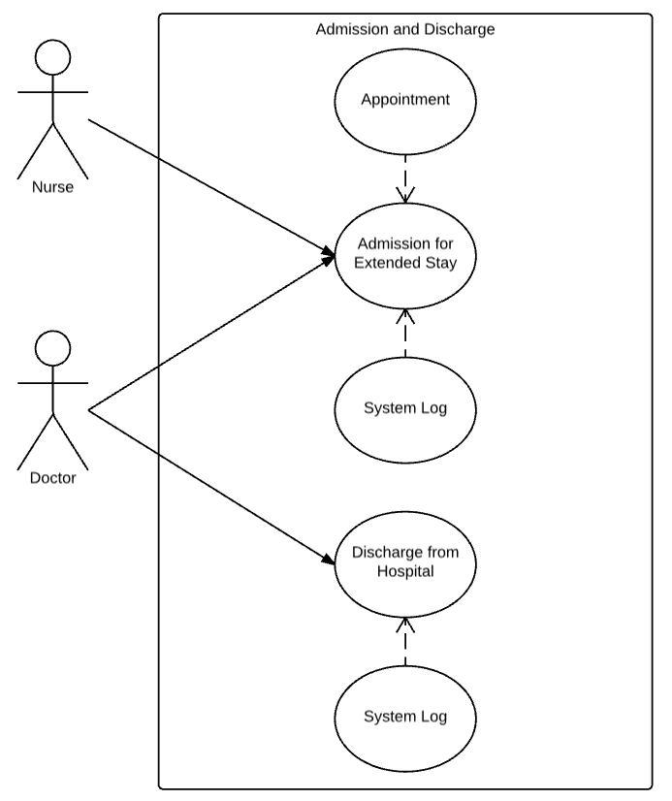

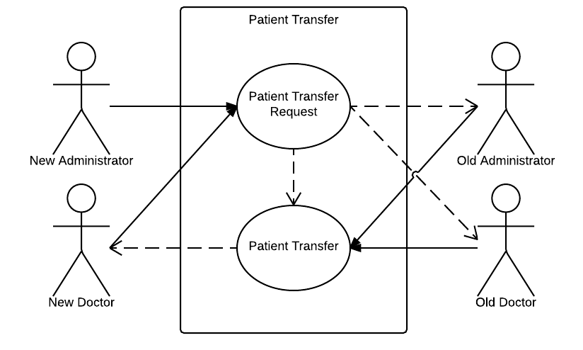

|  |  |
| --- | --- |
| **Use Case Number:** | ***UC-16*** |
| **Use Case Name:** | ***Patient Transfer*** |
| **Overview:** | ***Patient is transferred between hospitals by administrators or doctors*** |
| **Actor(s):** | ***Employee*** |
| **Pre-condition(s):** | ***- The patient has an account at the old hospital***  ***- Employee knows what patient is being transferred (ie they were told by phone or were messaged)*** |
| **Scenario Flow:** | ***Main (success) Flow:***  ***1. Employee navigates to the transfer page***  ***2. Employee selects the hospital that the patient is at***  ***3. Employee clicks accept next to the patient***  ***4. Employee is sent to the patient’s medical profile*** |
| ***Alternate Flows:*** | ***Alternate Flow #1: If Employee is an administrator, they do the following:***  ***1. Employee navigates to the patient models***  ***2. Employee selects the patient that is being transferred***  ***3. Employee changes the hospital field to the hospital the patient is being transferred to***  ***4. Employee changes the patient’s doctor to be a doctor at the new hospital*** |
| **Post Condition:** | ***The patient has been transferred to another hospital, and has a doctor at the new hospital*** |

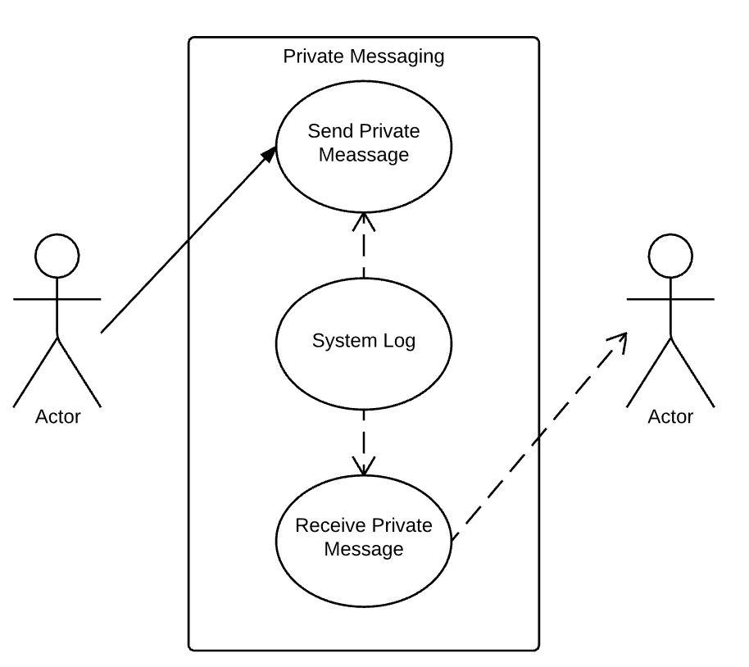

|  |  |
| --- | --- |
| **Use Case Number:** | ***UC-17*** |
| **Use Case Name:** | ***Upload Patient Information*** |
| **Overview:** | ***Doctors upload the results of a patient’s tests*** |
| **Actor(s):** | ***Doctor*** |
| **Pre-condition(s):** | ***- The test has been evaluated and is in a file***  ***- The test is already in the database*** |
| **Scenario Flow:** | ***Main (success) Flow:***  ***1. Doctor navigates to the patient’s medical profile***  ***2. Doctor navigates to the tests section***  ***3. Doctor clicks a button to edit tests***  ***4. Doctor clicks on the test they want to upload results to***  ***5. Doctor clicks a button to upload files***  ***6. Doctor chooses the file they wish to upload***  ***7. Doctor saves the changes to the test***  ***8. Doctor is sent back to the patient’s medical profile*** |
| ***Alternate Flows:*** | ***N/A*** |
| **Post Condition:** | ***The patient’s results have been uploaded to their profile*** |

|  |  |
| --- | --- |
| **Use Case Number:** | ***UC-18*** |
| **Use Case Name:** | ***Send Private Message*** |
| **Overview:** | ***Doctors, Nurses, Patients, and Administrators send private messages*** |
| **Actor(s):** | ***Sender, Recipient*** |
| **Pre-condition(s):** | ***- User knows the username of Recipient*** |
| **Scenario Flow:** | ***Main (success) Flow:***  ***1. Sender navigates to the messaging page***  ***2. Sender clicks a button to compose a new message***  ***3. Sender writes out their message***  ***4. Sender fills in the username of Recipient***  ***5. Sender clicks a button to send the message***  ***6. Recipient receives the message in their inbox***  ***7. Sender gets sent back to the messaging page*** |
| ***Alternate Flows:*** | ***Alternate Flow #1: After Step 5, if the body of the message is larger than the character limit:***  ***1. Sender receives a message indicating that their message is too long***  ***2. Sender does steps 3-7 in the main flow***  ***Alternate Flow #2: After Step 5, if the username does not exist:***  ***1. Sender receives a message indicating that the user does not exist***  ***2. Sender does steps 4-7 in the main flow*** |
| **Post Condition:** | ***Sender has sent a private message to Recipient*** |