Git Guide

GETTING STARTED WITH GIT
Objective: Learn how to use Git to create a local project and upload files to a remote server with the command line.
Git is a difficult subject to tackle for self-taught web developers who didn’t learn to code with a team. If you’ve always worked alone you may feel a bit put off by git at first but stick with it and I promise it will drastically improve the way you think about projects.

GOALS
- Learn what Git is and how it can be useful.
- Create a local project and launch it to a live server with Git using the command line.

WHAT IS GIT?
Git is a version control system (VCS) for code. It is used to keep track of revisions and allow a developer or dev team to work together on a project through branches.
_Git is not GitHub._ Git is the system, and GitHub is a hosting service (the most popular of many).

STEP 1: INSTALLATION

MAC
Open the Terminal program. Type git and press enter. If a series of options is returned, Git is already installed; otherwise you should receive a prompt to install developer tools, Say yes to this. If you get an error about user permissions you will need repeat the command with the extra word sudo like this sudo git

WINDOWS
Download Git for Windows. You will be using the Git Bash program. It will utilize all the same commands as Terminal.

STEP 2: CREATE AN ONLINE GIT REPOSITORY
GitHub is the most popular location to host repositories, so go ahead and make an account there if you dont already have one.
I’ll assume your username is you. This would make your new GitHub account github.com/you. This github username will likely be seen by employers so try to keep it professional.
Once you’ve made your account, create a repository by clicking Add New Repo. Do not initialize with a README.md or .gitignore at this point. We can call the repository project. Your repository has been created at github.com/you/project. It should be completely empty.

STEP 3: CREATE A LOCAL PROJECT
If you’re not at all familiar with the command prompt, please read the Command Line Lessons.
Here are the most important commands, and all you need to know to get started.

BASIC COMMAND LINE REFERENCE
- pwd Print Working Directory – shows the exact directory you’re working in.
- ls List Directories – lists all the files and folders in your current directory.
- cd Change Directory – change to another directory.
- mkdir Make Directory – create a new directory.
Remember, Terminal (Mac) and Git Bash (Windows) are both command line shells. Any Git related Shell commands can be done the same through both.
When you open Terminal, you will start off in your main directory. I will assume your computer has the same username as your GitHub account.

1. CONFIRM YOUR LOCATION.
pwd
/Users/you

2. CREATE A NEW FOLDER CALLED PROJECT-LOCAL.
mkdir project-local

3. LIST YOUR DIRECTORIES.
ls
You should see project-local in the list of directories. Of course, you could have created the directory through Finder or Explorer, but it’s a useful command to know.

4. MOVE INTO THE NEWLY CREATED DIRECTORY.
cd project-local
Now you’re in the folder where your local project and Git repository will live. From here, we will begin using git commands. There is a massive amount of commands for Git, but we only need to know a few to get started.

BASIC GIT COMMAND REFERENCE
- git config – Configure Git
- git init – Initialize Git repository
- git status – Check the status of a Git repository
- git add – Track files
- git commit – Commit tracked files
- git push – Upload files
- git pull – Download files
All of the future commands we do today will only apply to your local Git environment. However, there is one important global step to take before doing anything else – configure your Git account. Change the content inside the quotations to match your own name. Notice the email doesnt use quotes.

5. CONFIGURE YOUR GLOBAL GIT ACCOUNT.
git config --global user.name "Name"git config --global user.email username@email.com

6. INITIALIZE GIT REPOSITORY.
IMPORTANT: Make sure you’re still in the `project-local` folder before running the next command.
git init
Great! Now you have an empty Git repo on your local computer. Our goal here is to tie our local project to the project that we created at github.com. This will give you a backup of your project online as well as make it easy for other developers to collaborate with you on projects... but more on that later.

7. HOOK UP LOCAL DIRECTORY WITH THE REPO WE MADE AT GITHUB.COM.
git remote add origin https://github.com/you/project
The Terminal won't respond, but it was successful. Go ahead and add a file to the project-local directory. Now let's add two files – index.html and style.css.

8. CHECK THE STATUS OF YOUR LOCAL REPOSITORY.
$ git status
you should get the following readout.
On branch master Initial commit Untracked files:(use "git add ..." to include in what will be committed) index.html style.css nothing added to commit but untracked files present (use "git add" to track)
Okay, so now git knows that there are two files in the directory, but they are not part of the Git repository yet. At this point we have to tell git to track the files with the add command.

9. ADD ALL THE FILES TO THE REPO.
(case sensitive command!)
git add .
Let’s check the status again with git status.
On branch masterInitial commit Changes to be committed:(use "git rm --cached ..." to unstage) new file: index.html new file: style.css
So, what did that do? The files are green now instead of red. This means git has tracked the files as changed.

10. COMMIT TRACKED FILES TO THE MASTER BRANCH
git commit -m "Initial Commit"
\[master (root-commit)\] Initial 2 files changed, 34 insertions(+) create mode index.html create mode style.css
With this command, you are committing all the tracked files and including a message (-m) (“Initial Commit”). Everything in this line is mandatory.
Do not forget to add a comment when you commit your files. Strategic commenting in Git is as important as commenting code. If you accidentally forget to add a comment and end up in a strange screen where you can no longer enter any commands, press ESC and type :q! followed by ENTER. Congrats you just escaped VIM more on that later.

11. PUSH THE FILES TO THE GIT REPO AT GITHUB.COM.
git push origin master
The Terminal will prompt you to enter your GitHub username and password. When you type in your password, it might not show that you’ve typed anything, but it’s being entered.
Now refresh your GitHub page. Success! All your files are now hosted at Github.com! Thats it were done.
Now open up a code editor and edit your index.html file to something like this
<!DOCTYPE html><html lang="en"><head> <meta charset="UTF-8"> <meta name="viewport" content="width=device-width, initial-scale=1.0"> <meta http-equiv="X-UA-Compatible" content="ie=edge"> <title>Working with Git</title></head><body> <h1>Git is Fun!</h1></body></html>
HTML
Copy
Save the file and repeat steps 8 - 11. This time when you run the push command you can omit origin master
git push

Integrating with VSCode

INTEGRATING GIT WITH VSCODE
Now that we have added our project to github lets see how we can use VSCode to track some of the changes that have occurred.
On the left of your VSCode window you will see an icon that looks like a stethoscope (see image below). As we make changes in different files we will be presented with an indicator of the number of untracked changes to our git as well as indications of what type of changes have occurred.
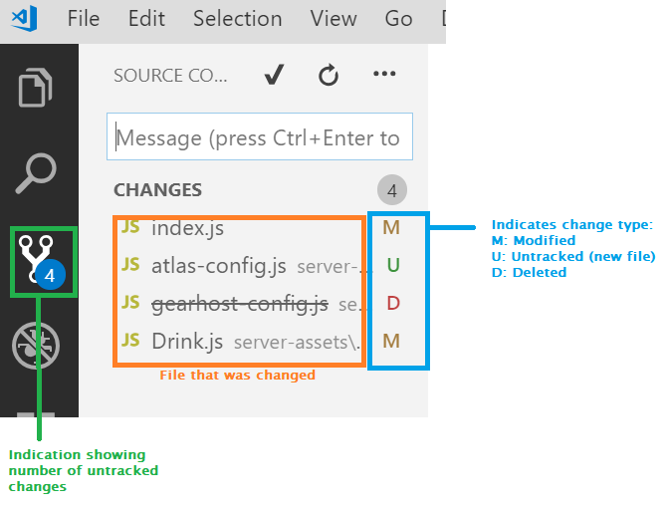
In this project we can see that the user has 4 untracked changes, 2 modified files, 1 created or untracked file, and 1 deleted file.

COMMITTING
When you are ready for your code to be committed, you will need to complete the following steps:
- Enter a message into the "Message" field above the changes
- Click the Check button above the message or Ctrl+Enter (CMD+Enter on Mac)
This will now commit our code to our local git repository. When we're ready for it to actually get pushed to github the final step will be to click the three dots above the "commit message" box and choose Push.
Note: You can commit multiple times before pushing to github, however be sure to push to github frequently to adhere to industry standards.

SYNCING WITH GITHUB
Alternatively, instead of just pushing to github you will eventually have multiple people (or computers) pushing to the same repository, you will want to pull things down first. You can achieve both of these actions through a sync. The button next to your current branch will both notify you of unpushed commits, and also changes that need to be pulled down.
