UI/UX Design System Reference - Nivara
This document serves as the master design system and visual style guide for the Nivara Mobile Wellness platform. By centralizing our design tokens, reusable components, and behavioral states, we ensure visual coherence and functional consistency across all customer, vendor, and administrator dashboards.
---
🎨 1. Core Brand Colors
Our color palette reflects a premium, serene, and grounding wellness experience.
Role | Color Name | HEX Code | CSS Variable | Visual Swatch
:--- | :--- | :--- | :--- | :---
**Primary** | Premium Navy | `#0A2540` | `--primary`
**Secondary** | Forest Green | `#2C5234` | `--secondary`
**Accent** | Warm Amber | `#D4A373` | `--accent`
**Background** | Premium Cream | `#FAF8F5` | `--background`
**Border** | Sand Gray | `#E5E1D8` | `--border`
---
✍️ 2. Typography
We combine high-contrast classic serifs with clean sans-serif bodies.
- Headings (`font-serif`): *Playfair Display*, serif. Used for page titles, hero headers, and card titles to emphasize a luxurious and tranquil tone.
- Body Text (`font-sans`): *Inter*, sans-serif. Used for secondary text, forms, logs, meta info, and navigation to guarantee clean readability.
---
🎛️ 3. Reusable UI Components
🖱️ Buttons
All buttons feature standard `rounded-md` (6px) or `rounded-lg` (8px) corners, explicit hover transitions, and a shadow-sm.
Button Type | normal state CSS | hover state CSS | Spacing & Padding | Usage
:--- | :--- | :--- | :--- | :---
**Primary Action** | `bg-[#0A2540] text-white` | `hover:bg-[#0A2540]/95` | `px-4 py-2` or `py-3 px-4` | Prominent calls to action (e.g. *Book New Session*)
**Secondary Action** | `bg-[#2C5234] text-white` | `hover:bg-[#2C5234]/95` | `px-4 py-2` | Success actions (e.g. *Confirm Refuel*)
**Outline/Ghost** | `bg-white border-[#E5E1D8] text-primary` | `hover:bg-gray-50` | `px-4 py-2` | Secondary actions (e.g. *Cancel selection*, *Trigger Demo*)
**Destructive/Danger** | `border-red-200 text-red-600` | `hover:bg-red-50` | `py-2 px-4` | Critical cancellations (e.g. *Cancel Session*)
Visual Example: Landing Page Buttons and Header Actions
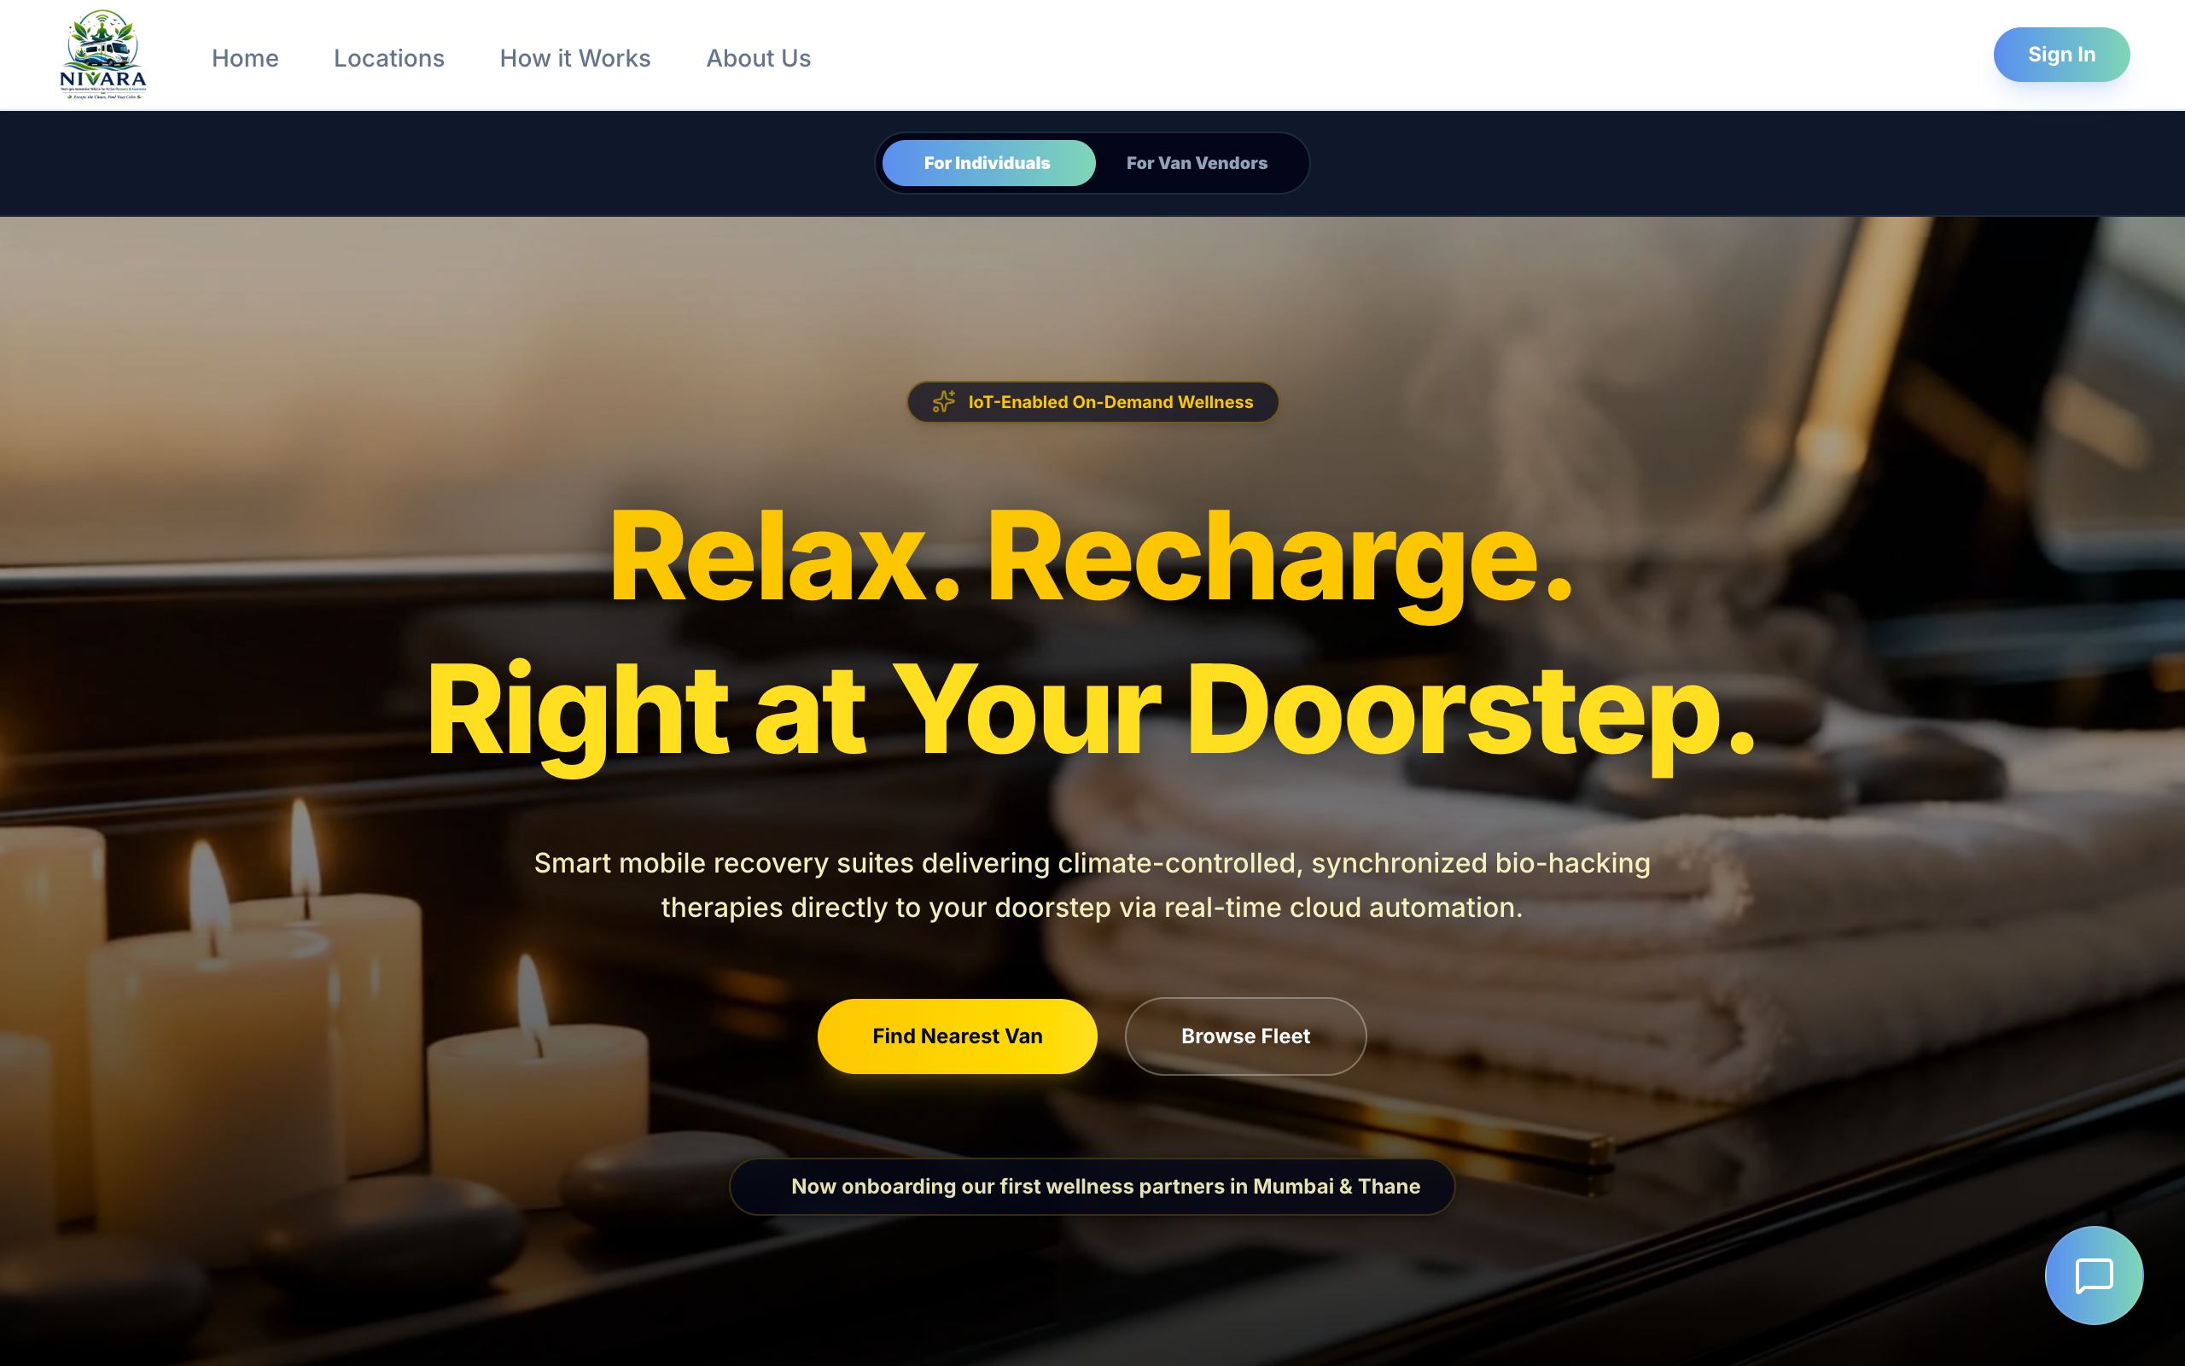
Figure: Homepage View
---
💳 Cards & Panels
Cards are the building block of our layout content containment.
- Glass Cards:
- Styles: `bg-white/80 backdrop-blur-md border border-[#E5E1D8] rounded-xl (12px) p-5 shadow-sm transition-all duration-300 hover:scale-[1.01]`.
- Usage: Key metric displays (e.g. *Nivara Balance*, *Upcoming Bookings* cards).
- Flex List Cards:
- Styles: `bg-white border border-[#E5E1D8] rounded-xl p-5 hover:shadow-md transition-shadow`.
- Usage: Lists of user bookings and vendor van items.
Visual Example: Corporate Policy Page Layout & Informational Panels
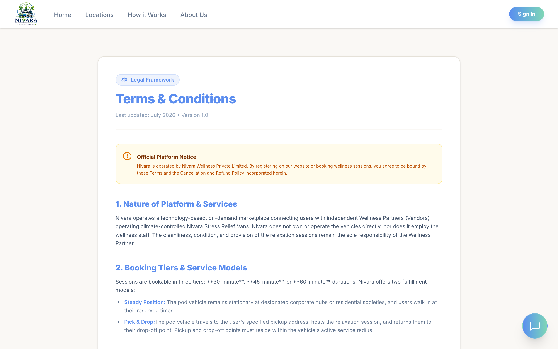
Figure: Terms and Conditions layout
---
📝 Form Fields & Input Elements
Inputs are designed to have soft, readable fields:
- Text & Number Inputs:
- Styles: `bg-[#FAF8F5] border border-[#E5E1D8] rounded-lg (8px) px-4 py-2 text-primary focus:outline-none focus:ring-1 focus:ring-[#2C5234]`.
- Usage: Wallet refuel field, login/register forms, search query inputs.
- Option Selector Toggles:
- Styles: Flex cards with `border border-[#E5E1D8] hover:bg-gray-50 rounded-xl p-4 cursor-pointer`. Select state: `border-[#2C5234] bg-[#2C5234]/5 ring-1 ring-[#2C5234]`.
- Usage: Checkout page payment method selectors (Card vs. Wallet Balance).
Visual Example: Login Credentials Inputs & Forms
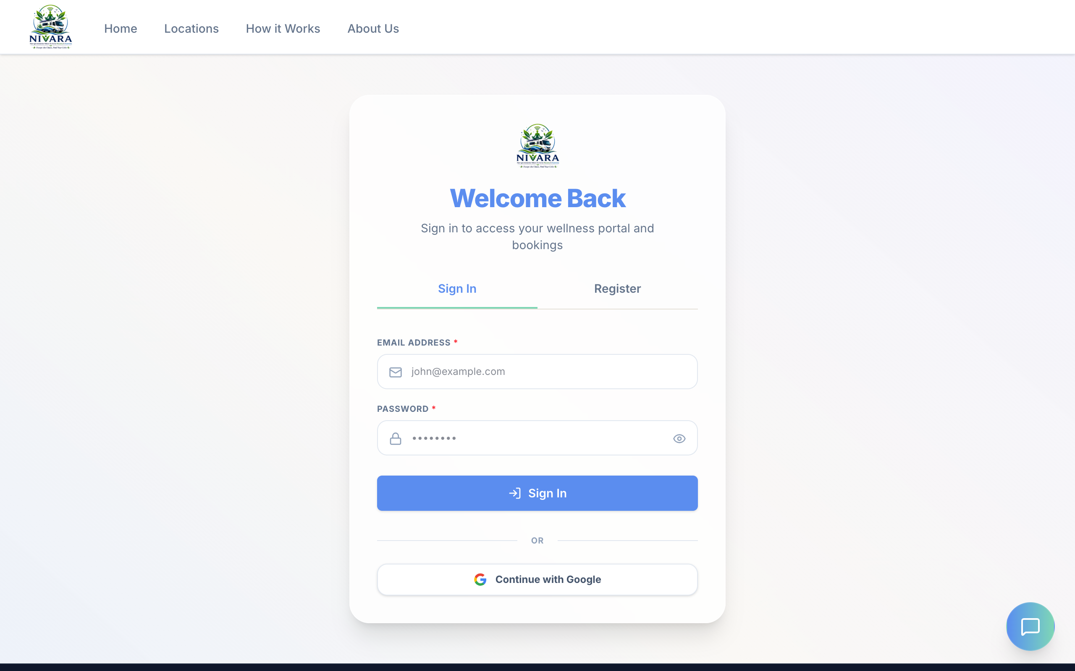
Figure: Login Panel and Forms
---
🔔 4. Interactive Live Warning Popups
🚀 Zomato/Swiggy-Style Alert
Designed to capture immediate attention without completely obstructing the screen.
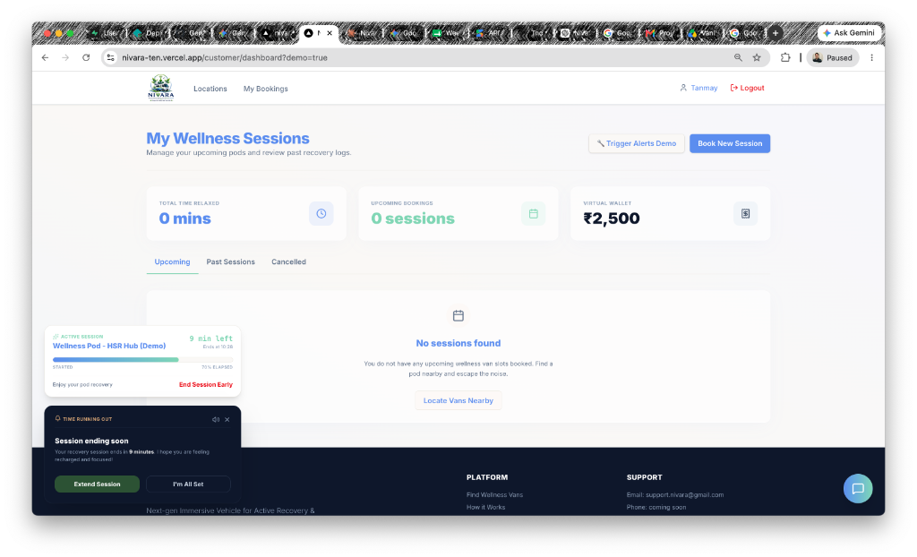
Figure: Active Session warning popup and countdown
- Design Specifications:
- Position: Floating bottom-left on desktop (`fixed bottom-6 left-6 z-50`), full-width sliding up from screen bottom on mobile.
- Theme: Premium dark theme context card (`bg-slate-950 text-slate-100 p-5 rounded-2xl border border-slate-800 shadow-2xl`).
- Audio: programmatically synthesized soft dual-tone meditation chime (A4 + A5 sine waves, 1.8s decay, volume toggle).
- Call to Actions: Secondary Green button (`Extend Session`), outline dark button (`I'm All Set`).

