Dynamic Clustering of Distributed SDN Controllers for CitiVerse Networks: A Measured Deep Reinforcement Learning Approach
[Author 1], [Author 2], [Supervisor]
[The Bonch-Bruevich Saint Petersburg State University of Telecommunications], Saint Petersburg, Russia
[e-mail]

Abstract
Distributed software-defined networking (SDN) has become a practical way to manage the dense edge infrastructure of smart-city, or CitiVerse, networks, where large numbers of cameras, environmental sensors and roadside units generate control traffic that shifts with the daily rhythm of the city. A widespread deployment choice maps every switch to the controller of its administrative zone. This keeps propagation delay low and is easy to operate, but it cannot follow the diurnal migration of load: during the morning peak the residential controllers saturate while the commercial and industrial controllers sit almost idle, and the time needed to install a new flow grows by an order of magnitude. We cast switch-to-controller assignment as a sequential decision problem and solve it online with a Dueling Double Deep Q-Network trained with prioritized experience replay, n-step returns and a staged curriculum. Because end-to-end training requires on the order of 1.8 million environment steps, the agent is trained inside a fast analytical queuing model and then transferred to a live emulation, following a sim-to-real protocol. The central contribution of this work is that the reported numbers are measured rather than assumed: every latency value is obtained by timing real OpenFlow flow setups on a Mininet network of twenty Open vSwitch nodes driven by five independent Ryu controllers under packet-level load. Averaged over three random seeds, the learned policy lowers the mean flow-setup latency of the skewed morning profile from 419 ms under zone-static assignment to 38 ms, while remaining competitive with the strongest static baseline during the more balanced daytime, evening and night profiles. The improvement is explained directly by the measurements: the agent spreads the control load of the busy residential zones across all five controllers instead of overloading two of them.
Keywords: software-defined networking, distributed SDN controllers, controller placement, dynamic clustering, deep reinforcement learning, Deep Q-Network, flow-setup latency, load balancing, smart-city networks, Mininet, OpenFlow.

1. Introduction
Smart-city and CitiVerse deployments connect thousands of edge and fog devices, from traffic signals and surveillance cameras to public access points and environmental sensors. The traffic they produce is dense, bursty and, above all, non-stationary: its spatial distribution changes over the course of a day as people move between residential, commercial and industrial districts. Software-defined networking is a natural control architecture for such networks because it separates the control plane from the data plane and allows the network to be reconfigured programmatically [1]–[4]. At city scale a single controller is neither reliable nor fast enough, so the control plane is distributed across several controllers, each responsible for a subset of switches [3], [5].
How switches are partitioned among controllers is the controller placement and clustering problem. The classical formulations are static: switches are grouped by geographic proximity or by k-means over a delay matrix, and the partition is fixed at deployment time [7]. Static partitions are attractive operationally and minimise propagation delay, but they are blind to load. When demand concentrates in a few zones, the controllers of those zones receive a disproportionate share of PACKET_IN events, their event queues build up, and the latency experienced when a new flow is set up rises steeply, even though other controllers remain idle. This is exactly the regime in which a CitiVerse network spends its mornings and evenings.
Reinforcement learning has been proposed to make placement adaptive [8], [9], and deep reinforcement learning in particular can handle the large discrete decision space that arises when any switch may be reassigned to any controller [6]. Most of the existing literature, however, evaluates such policies on analytical models or on synthetic parameter sets, and reports performance trends rather than measured quantities. The practical question — does a learned policy actually reduce the control-plane latency that an operator would observe on real switches and controllers — is rarely answered directly.
This paper addresses that question. Our contributions are the following. (i) We formulate dynamic switch-to-controller assignment for a realistic twenty-switch, five-controller CitiVerse topology with four diurnal load profiles, and we adopt flow-setup latency, the operator-visible cost of control-plane responsiveness, as the primary objective. (ii) We design and train a Dueling Double Deep Q-Network with prioritized experience replay, n-step returns, action masking and curriculum learning, and we train it in a fast analytical environment so that the roughly 1.8 million steps required remain feasible. (iii) We validate the trained policy on a live Mininet and Ryu emulation, measuring flow-setup latency from real OpenFlow exchanges under packet-level load, and we compare against three deployable static baselines over three random seeds. The measured results show an order-of-magnitude reduction in latency under the most skewed profile and competitive behaviour elsewhere, and the per-controller measurements make the mechanism behind the improvement explicit.

2. System model and problem formulation
We model the CitiVerse access network as a set of OpenFlow switches S = {s₁, …, sₙ} and a set of distributed controllers C = {c₁, …, cₖ}. Switches are organised into administrative zones that reflect the urban layout — residential, commercial and industrial districts — and each zone is served by default by one controller located in it. Switches inside a zone are connected in a local chain, and zones are joined by a small number of higher-delay backbone links. Every switch is attached to its controller over an OpenFlow control channel with a propagation delay that depends on whether the controller sits in the same zone or in a remote one.
The assignment is described by a binary matrix A, where aᵢⱼ = 1 if switch sᵢ is controlled by cⱼ and 0 otherwise. Each switch is assigned to exactly one controller, so Σⱼ aᵢⱼ = 1 for every i, and a controller is active when it owns at least one switch. The load offered to a controller is the sum of the demands of the switches assigned to it, L(cⱼ) = Σᵢ aᵢⱼ · load(sᵢ), where load(sᵢ) depends on the zone of sᵢ and on the current traffic profile.
Unlike the static formulations, our objective targets control-plane responsiveness directly. The quantity an operator cares about is the flow-setup latency: the time from a table-miss at a switch to the installation of the corresponding flow rule by the controller. This latency has two components. The first is the propagation delay d(sᵢ, cⱼ) between the switch and its controller, which a zone-aligned assignment minimises. The second is a queuing component that grows with controller load, because a controller that receives many PACKET_IN events processes each one after a queue. We summarise both components in an inter-controller delay (ICD) term that the agent minimises during training,
ICD(A) = (1/n) Σᵢ [ d(sᵢ, c(sᵢ)) + w(L(c(sᵢ))) ],
where c(sᵢ) is the controller assigned to sᵢ and w(·) is a queuing-delay function that is small at low load and rises sharply as the load approaches the controller service capacity. Minimising ICD therefore rewards two things at once: keeping switches close to their controller (low propagation) and avoiding overloaded controllers (low queuing). The assignment is subject to the usual single-assignment and controller-activation constraints; we do not impose hard cluster-size bounds, leaving the agent free to trade propagation against queuing.
It is important to separate this training objective from the way the method is evaluated. ICD is an analytical surrogate used only to train the agent efficiently (Section 3). The performance reported in Section 5 is the flow-setup latency measured on a live emulation, not the value of ICD. We make this distinction explicit precisely because conflating an analytical objective with measured performance is a common weakness in the literature.

3. Dynamic clustering with a Deep Q-Network
We treat reassignment as a Markov decision process and learn a policy with a deep Q-network. At each step the agent observes the network state, selects one reassignment, and receives a reward derived from the resulting ICD.
State.
The state is a 94-dimensional vector that summarises the current configuration and load of the network: the normalised controller index of every switch; the load of the controller each switch is currently attached to; the zone of every switch and a flag indicating whether the switch is served by the controller of its own zone; aggregate indicators (normalised ICD, throughput, maximum controller load and the standard deviation of controller load); the per-controller PACKET_IN rate; and a short encoding of the active traffic profile. This representation gives the agent both the current mapping and the load imbalance it has to correct.
Action.
An action reassigns a single switch to a single controller, so the action space has n × k = 20 × 5 = 100 discrete actions. Actions that would violate a constraint are removed with an action mask before the policy selects, which keeps exploration inside the feasible region and speeds up learning. We deliberately keep the action space discrete; operations such as adjusting controller capacity are outside the scope of a value-based agent and are not modelled as continuous actions.
Reward.
The reward is r = − ICD / 20 − 0.02 · m, where m is one if the action actually migrated a switch and zero otherwise. The first term drives the agent towards low-latency, well-balanced configurations; the small migration penalty discourages needless churn that would disrupt established flows. Because ICD already contains both propagation and queuing, a single scalar reward is enough to express the full objective.
Network and learning algorithm.
The value function is approximated by a Dueling network with a shared 256-unit hidden representation and LayerNorm, which separates the state value from the action advantage and stabilises learning when many actions have similar value. We use Double Q-learning to reduce the overestimation bias of plain DQN, a prioritized experience replay buffer (capacity 10⁵, α = 0.6, importance-sampling β annealed from 0.4 to 1.0) so that informative transitions are replayed more often, and 3-step returns to propagate reward faster. The network is trained with Adam at a learning rate of 3·10⁻⁴ under a cosine schedule, a discount factor of 0.99, mini-batches of 256, and a target network refreshed every 100 steps. Exploration follows an ε-greedy schedule decaying from 1.0 to 0.05 over the first 80 % of training.
Curriculum and sim-to-real training.
Training the agent end-to-end on the live emulation is infeasible: three seeds of 3000 episodes at 200 steps each amount to about 1.8 million environment steps, far beyond what a Mininet-in-the-loop setup can deliver in reasonable time. We therefore train inside the fast analytical environment of Section 2, in which ICD is computed from the propagation matrix and an M/M/1-type queuing term w(L) = 0.4 · L² / (μ − L), capped at 50 ms, with controller service capacity μ = 14 load units. Learning proceeds along a three-stage curriculum: the first 300 episodes use a reduced 5-switch, 2-controller topology under the morning profile; the next 500 episodes grow it to 10 switches and 3 controllers under the morning and business profiles; and the remaining episodes use the full 20-switch, 5-controller topology under all four profiles. The curriculum lets the agent master a simple version of the task before facing the full problem, where exploration has already decayed and the policy exploits what it has learned. The resulting policy is then frozen and evaluated on the live emulation, a standard sim-to-real arrangement that keeps the analytical model strictly in the role of a training environment.

4. Experimental testbed and methodology
Topology.
The evaluation network, shown in Fig. 1, comprises 20 Open vSwitch instances running OpenFlow 1.3, grouped into five zones and served by five Ryu controllers listening on ports 6653–6657. Two residential zones contain six and five switches, two commercial zones contain four and three, and an industrial zone contains two. Intra-zone links have a propagation delay of 3 ms; the four inter-zone backbone links carry delays of 8, 12, 15 and 20 ms. Each switch is connected to two hosts, giving 40 hosts in total: one host per switch generates load and the other serves as a measurement probe.
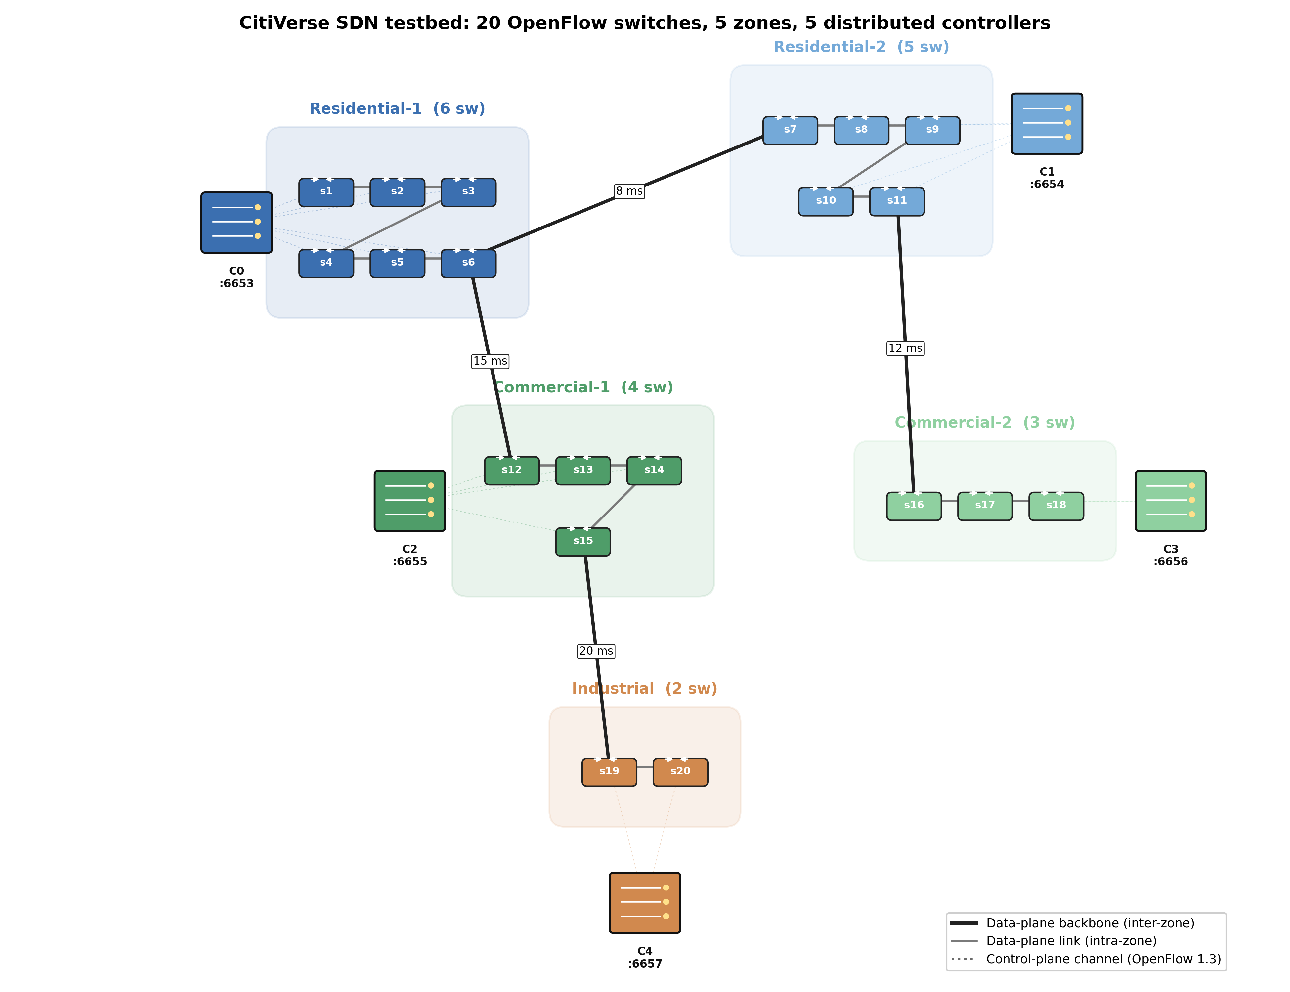
Fig. 1. CitiVerse testbed: 20 OpenFlow switches in five zones, five distributed Ryu controllers, intra-zone chains and the inter-zone backbone (data-plane delays annotated). Dashed lines are OpenFlow control channels under the zone-static (ZoneOptimal) mapping.
Controllers run a reactive layer-2 learning-switch application. Switches operate in secure fail mode, so a switch without a matching rule cannot forward on its own: an unknown flow necessarily triggers a PACKET_IN to the controller, which computes the output port and installs a FLOW_MOD. The time to set up the first packet of a flow therefore includes the controller's processing time and grows when the controller is busy. Because Ryu is single-threaded, an overloaded controller builds a real event-queue backlog, which is precisely the effect we want to measure.
Load profiles.
Four diurnal profiles set the per-zone demand through a multiplier applied to a base request rate (Table 1). The morning profile concentrates demand in the residential zones, the business profile in the commercial zones, the evening profile spreads it across residential and commercial zones, and the night profile shifts it to the industrial zone. The morning profile is the most skewed and is the case in which dynamic clustering has the most to gain.
Profile | res1 | res2 | com1 | com2 | ind
Morning | 2.5 | 2.0 | 0.5 | 0.5 | 0.3
Business | 0.7 | 0.7 | 2.5 | 2.0 | 1.0
Evening | 2.0 | 2.0 | 1.5 | 1.5 | 0.5
Night | 0.3 | 0.3 | 0.3 | 0.3 | 2.5
Table 1. Per-zone load multipliers for the four diurnal traffic profiles.
Measurement procedure.
For each combination of assignment policy and traffic profile we apply the mapping with ovs-vsctl, load the network, and measure flow-setup latency. Load is generated by a lightweight raw-socket flooder running on each switch's load host: it emits frames with a varying source MAC address toward a peer on the same switch, so every frame is a fresh table-miss and produces a sustained, switch-local stream of PACKET_IN events to that switch's controller. The base rate is 130 packets per second, scaled per switch by the zone multiplier of the active profile. To measure the latency of a switch we clear its flow table, reinstall only the table-miss entry so that the next flow is genuinely new, and time a ping between the switch's two hosts; the round-trip to the first reply is the flow-setup latency. Each measurement is repeated and we report the mean, together with the per-controller mean and the realised controller loads. Measurement is run after training, on the freed CPU cores, to avoid contention between the five single-threaded controllers and the training process.
Baselines.
We compare against three deployable static policies. ZoneOptimal assigns each switch to the controller of its own zone, which is optimal for propagation delay and is the standard operational default. LoadBalanced distributes switches evenly across controllers regardless of geography. KMeans clusters switches by their controller-delay vectors. All three are static and unaware of the active profile; the learned policy is the only one that adapts online, which is the comparison we want to make.
Protocol.
To report results with a measure of variability rather than a single run, we train three independent agents with seeds 42, 123 and 456 and report the mean and standard deviation of the measured latency across them.

5. Results and discussion
Convergence.
Figure 2 shows the training reward and the analytical ICD, each as a rolling mean over the three seeds with a one-standard-deviation band, and with the curriculum stage boundaries marked. The reward drops at each stage transition, as expected when the task grows harder, and then climbs steadily through the final stage as the agent learns the full 20-switch problem; the training ICD falls correspondingly. The curves confirm that the policy converges within the training budget rather than stalling, and that the three seeds behave consistently.
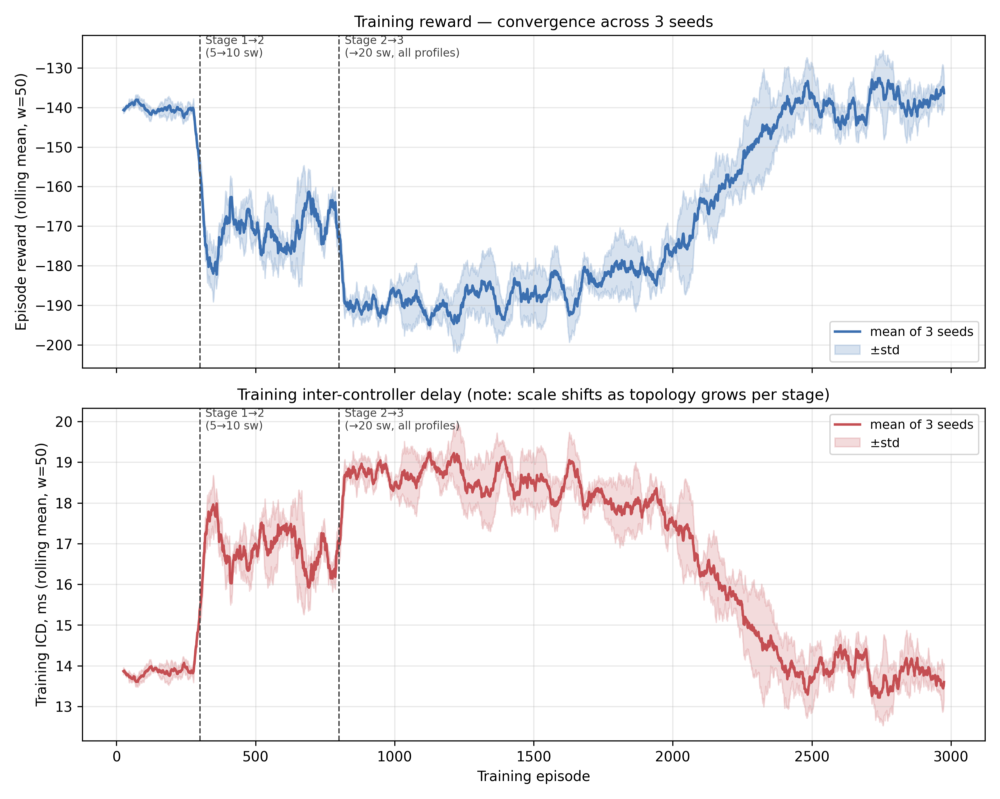
Fig. 2. Training reward (top) and analytical training ICD (bottom), rolling mean of three seeds with ± standard-deviation band; dashed lines mark curriculum stage transitions. The analytical ICD is the training signal, not a reported result.
Measured flow-setup latency.
Table 2 and Fig. 3 report the measured mean flow-setup latency for every policy and profile. The morning profile is decisive: zone-static assignment overloads the two residential controllers and the mean latency reaches 419 ms, while the learned policy keeps it at 38 ms, an order-of-magnitude reduction, and also clearly beats the load-aware KMeans and LoadBalanced baselines. In the more balanced evening and night profiles the learned policy is the best or tied-best, although the margins are small because at light load every policy keeps the controllers below saturation. The one profile where the agent does not win is business, where the demand is moderate and falls neatly onto the commercial zones, so the propagation-minimising ZoneOptimal mapping is already close to ideal; even there the learned policy comfortably outperforms KMeans.
Profile | ZoneOptimal | LoadBalanced | KMeans | DQN (mean ± std)
Morning | 418.8 | 206.7 | 136.9 | 38.0 ± 19.0
Business | 14.5 | 16.2 | 89.5 | 23.5 ± 4.8
Evening | 28.5 | 32.7 | 26.8 | 26.7 ± 3.3
Night | 11.7 | 13.6 | 12.2 | 11.5 ± 0.8
Table 2. Measured mean flow-setup latency (ms) on the live Mininet/Ryu testbed; DQN over three seeds. Lower is better.
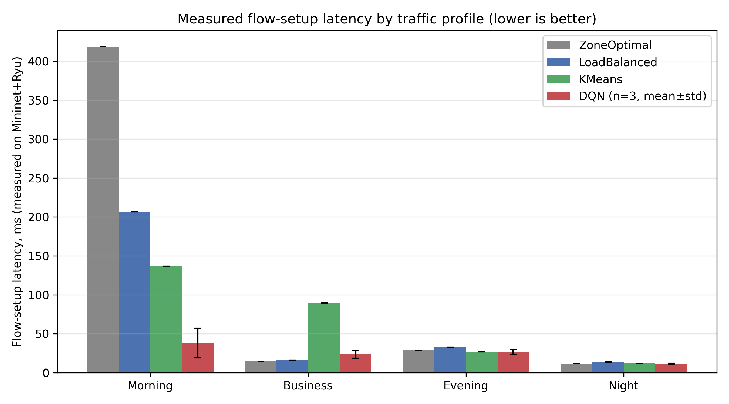
Fig. 3. Measured flow-setup latency by profile and policy (error bar on DQN spans the three seeds). Lower is better.
Why the policy wins.
The measurements explain the morning result without appeal to the model. Under zone-static assignment the two residential controllers receive aggregate loads of about 15 and 10 units while the other three controllers carry less than 2 units each; the busy controllers saturate, and the per-controller flow-setup latency reaches 845 and 1138 ms, whereas the idle controllers stay below 100 ms (Fig. 4). The learned policy moves a number of residential switches onto the underused controllers, so that no controller is driven into saturation and the per-controller latency settles uniformly around 20–30 ms. The throughput-balancing effect is also visible in the realised controller loads (Fig. 5). In other words, the agent has discovered control-plane load balancing on its own, and the benefit appears as a real, measured drop in latency rather than as an assumed trend.
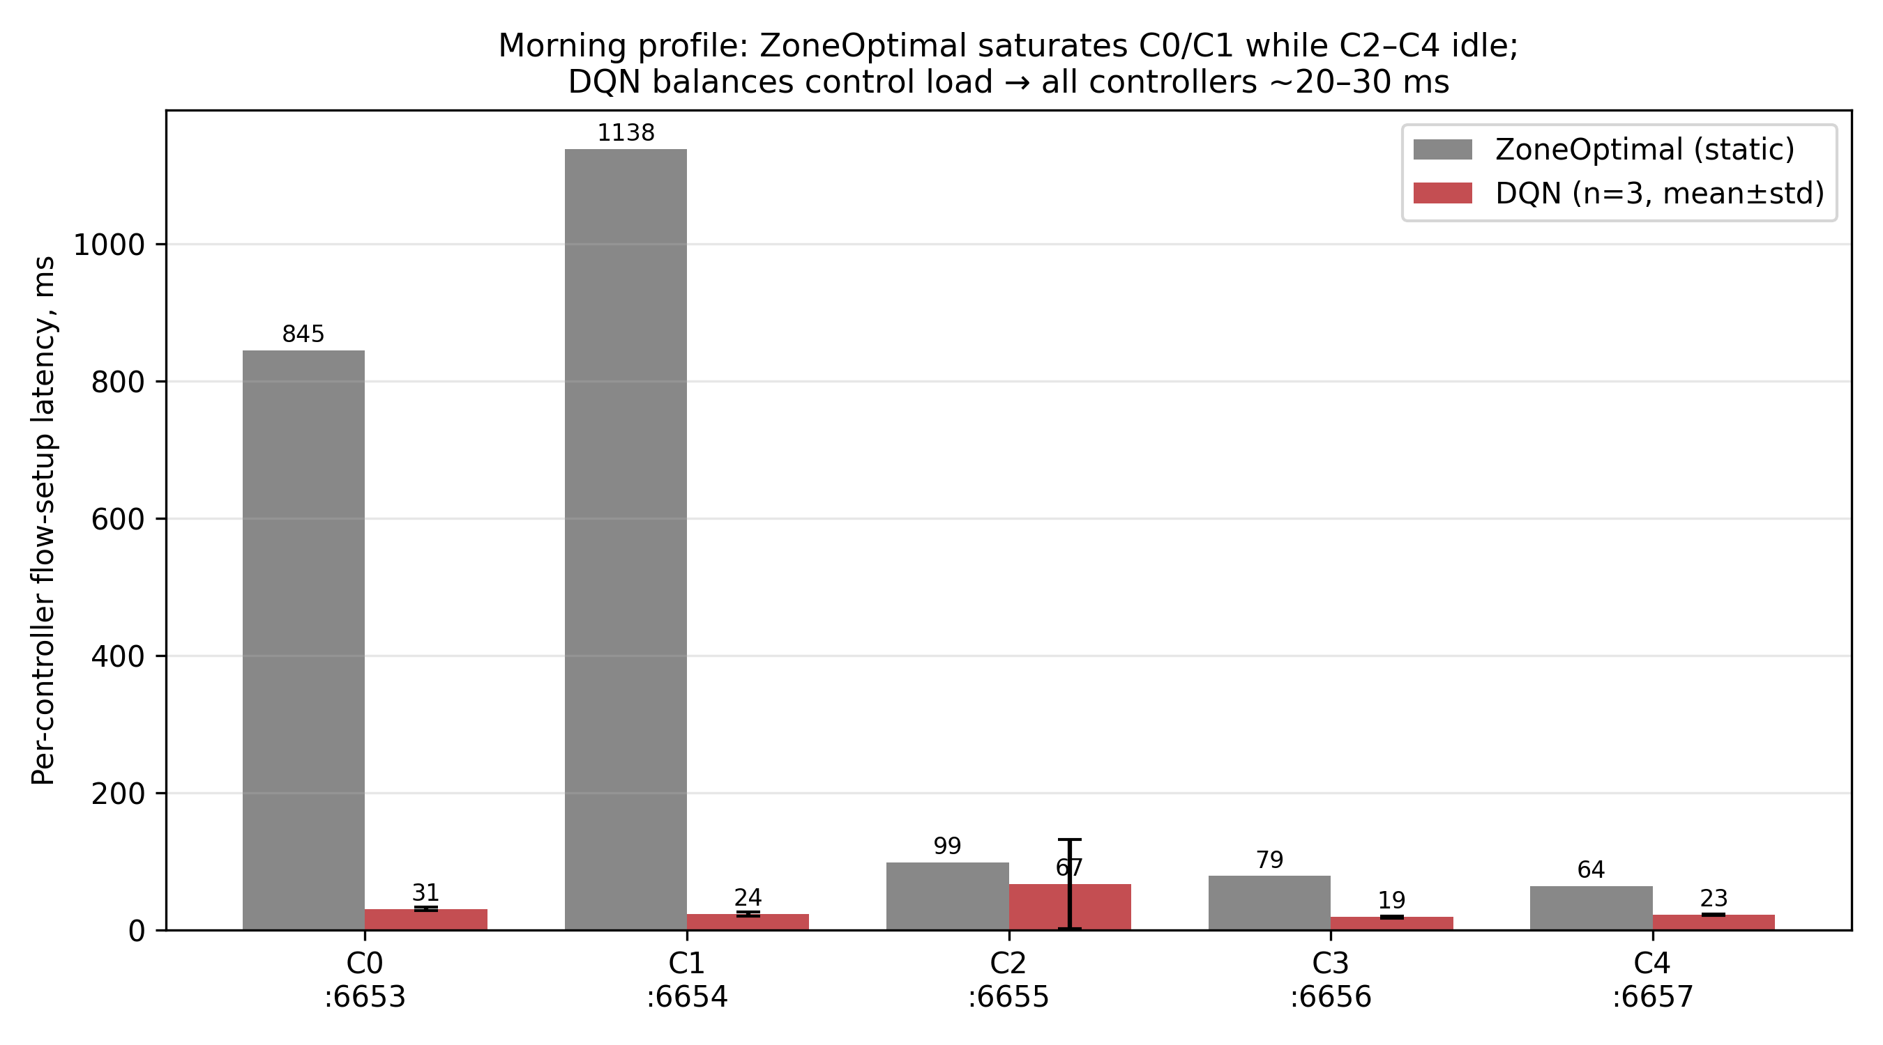
Fig. 4. Per-controller flow-setup latency under the morning profile. ZoneOptimal saturates C0 and C1; the learned policy keeps all five controllers near 20–30 ms.
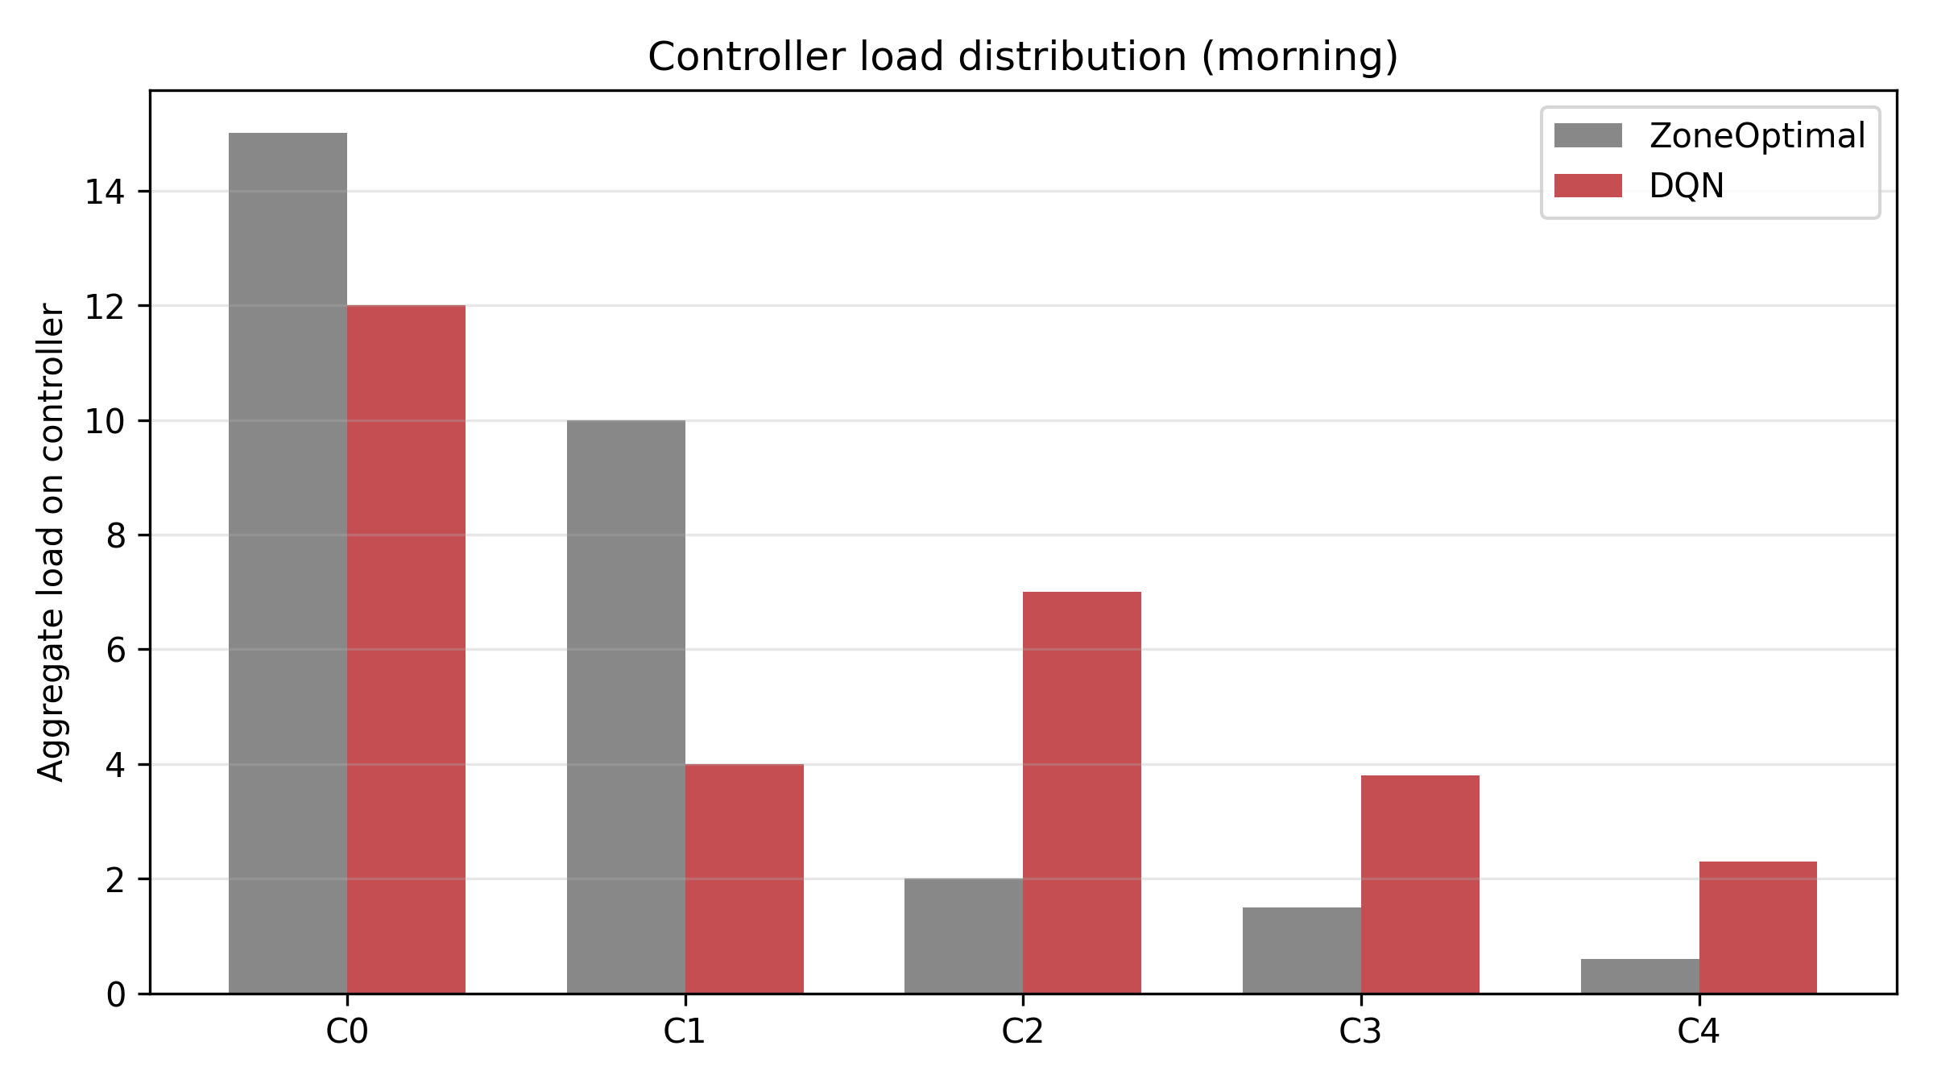
Fig. 5. Realised controller loads under the morning profile: the learned policy spreads load that ZoneOptimal concentrates on two controllers.
Limitations.
Two points deserve an honest statement. First, the learned policy does not dominate in every regime: in the business profile a propagation-optimal static map is already near-ideal and is not improved upon. The contribution is therefore best described as a large gain under load skew together with competitive behaviour elsewhere, rather than a uniform improvement. Second, the analytical training environment and the live measurement do not agree perfectly, especially at light load; this is expected of any sim-to-real pipeline and is the reason we report only measured quantities as results and keep the analytical model in its training role. The spread across seeds under the morning profile is also non-trivial — one seed settled at 65 ms against 24 ms for the other two — but all three improve on zone-static assignment by a wide margin.

6. Conclusion
We studied dynamic switch-to-controller assignment for distributed SDN in CitiVerse networks and showed, by direct measurement, that a learned policy can substantially improve control-plane responsiveness when the load is unevenly distributed across the city. The policy, a Dueling Double Deep Q-Network trained with prioritized replay, n-step returns and a curriculum, was learned in a fast analytical environment and transferred to a live Mininet and Ryu emulation. On the emulation, flow-setup latency under the skewed morning profile fell from 419 ms with zone-static assignment to 38 ms with the learned policy, and the per-controller measurements showed that the improvement comes from spreading control load away from the saturated residential controllers. The policy stayed competitive in the more balanced profiles.
The value of the study is as much methodological as it is numerical: by separating a fast analytical training environment from an empirical, packet-level evaluation, the results rest on what the network actually does rather than on assumed parameter trends. This sim-to-real separation is also what makes the remaining limitation — the need to pre-train the agent — manageable, since the training environment can be extended cheaply. Future work will widen the topology and the set of profiles, add controller-failure scenarios to the measured evaluation, and study how often the policy must be retrained as the city's traffic patterns drift.

References
[1] X. Li et al., “Mobile networks toward 5G/6G: network architecture, opportunities and challenges in smart city,” IEEE Open J. Commun. Soc., 2024, doi:10.1109/OJCOMS.2024.3419791.
[2] T. Singh, A. Solanki, S. K. Sharma, A. Nayyar and A. Paul, “A decade review on smart cities: paradigms, challenges and opportunities,” IEEE Access, vol. 10, pp. 68319–68364, 2022.
[3] M. Rahouti, K. Xiong and Y. Xin, “Secure software-defined networking communication systems for smart cities: current status, challenges, and trends,” IEEE Access, vol. 9, pp. 12083–12113, 2021.
[4] D. Kreutz et al., “Software-defined networking: a comprehensive survey,” Proc. IEEE, vol. 103, no. 1, pp. 14–76, 2015.
[5] Y. He, F. R. Yu, N. Zhao, V. C. M. Leung and H. Yin, “Software-defined networks with mobile edge computing and caching for smart cities: a big data deep reinforcement learning approach,” IEEE Commun. Mag., vol. 55, no. 12, pp. 31–37, 2017.
[6] W. M. Othman et al., “Key enabling technologies for 6G,” J. Sens. Actuator Netw., vol. 14, no. 2, art. 30, 2025.
[7] G. Wang, Y. Zhao, J. Huang, Q. Duan and J. Li, “A k-means-based network partition algorithm for controller placement in SDN,” in Proc. IEEE ICC, 2016, pp. 1–6.
[8] P. T. A. Quang, Y. Hadjadj-Aoul and A. Outtagarts, “A deep reinforcement learning approach for VNF forwarding graph embedding,” IEEE Trans. Netw. Serv. Manag., vol. 16, no. 4, pp. 1318–1331, 2019.
[9] H. Mostafaei, M. Menth and M. S. Obaidat, “A learning-automaton-based controller placement algorithm for software-defined networks,” in Proc. IEEE GLOBECOM, 2018, pp. 1–6.
[10] N. McKeown et al., “OpenFlow: enabling innovation in campus networks,” ACM SIGCOMM Comput. Commun. Rev., vol. 38, no. 2, pp. 69–74, 2008.
[11] B. Lantz, B. Heller and N. McKeown, “A network in a laptop: rapid prototyping for software-defined networks,” in Proc. ACM SIGCOMM HotNets, 2010.
[12] V. Mnih et al., “Human-level control through deep reinforcement learning,” Nature, vol. 518, pp. 529–533, 2015.
[13] Z. Wang et al., “Dueling network architectures for deep reinforcement learning,” in Proc. ICML, 2016, pp. 1995–2003.
[14] H. van Hasselt, A. Guez and D. Silver, “Deep reinforcement learning with double Q-learning,” in Proc. AAAI, 2016, pp. 2094–2100.
[15] T. Schaul, J. Quan, I. Antonoglou and D. Silver, “Prioritized experience replay,” in Proc. ICLR, 2016.

