Assignment 2

Our implementation of the Menu, MenuItem, and MenuIterator classes work together to display a menu in Main which has multiple functions including variations of iterating over the menu, adding an item to the menu, and deleting an item to the menu. There exists four MenuIterator classes the AllItemsIterator, ItemIterator, HeartHealthyIterator, and PriceIterator. For work division Andrew Rosscoe implemented the “backend” of the application which includes the Menu, MenuItem, and MenuIterator classes while Brendan Benlolo implemented the “fronted” Main class.

* On execution:

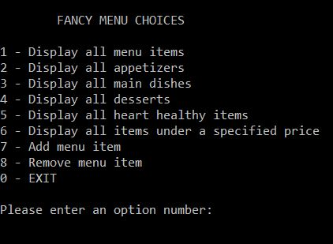

* Option 1 (display all menu items using AllItemsIterator):

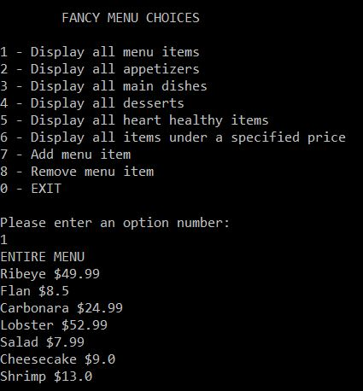

* Option 2 (display all appetizers using MenuItemIterator):

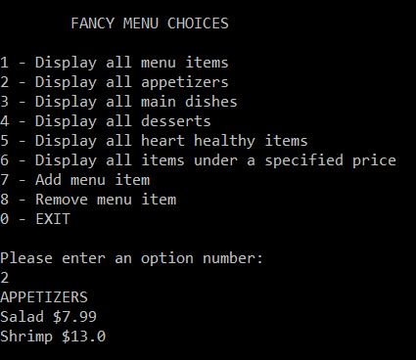

* Option 3 (display all main dishes using MenuItemIterator):

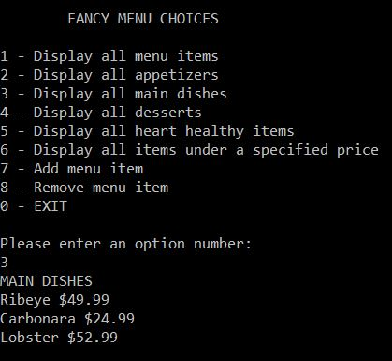

* Option 4 (display all desserts using MenuItemIterator):

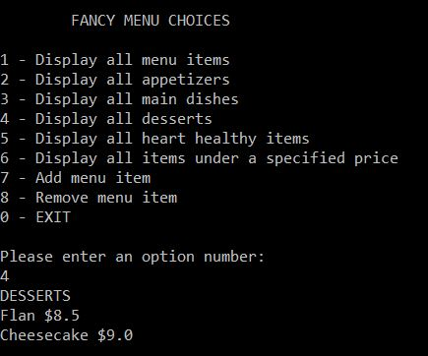

* Option 5 (display all items heart healthy items using HeartHealthyIterator):

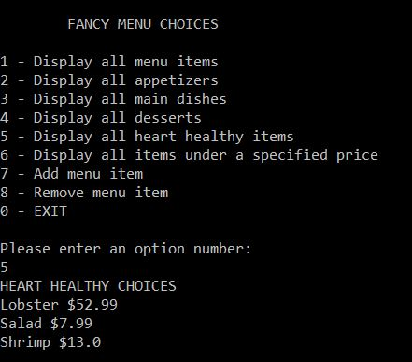

* Option 6 (display all items under a specified price using PriceIterator):

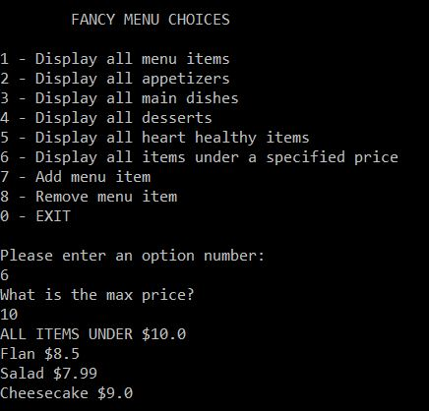

* Option 7 (add menu item):

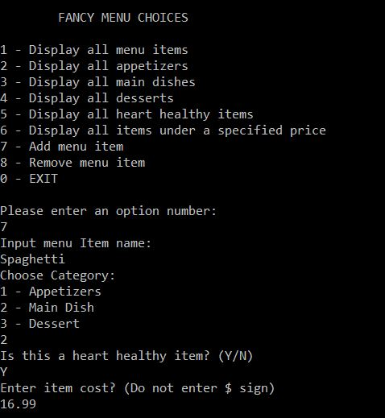

* Option 8 (remove menu item):

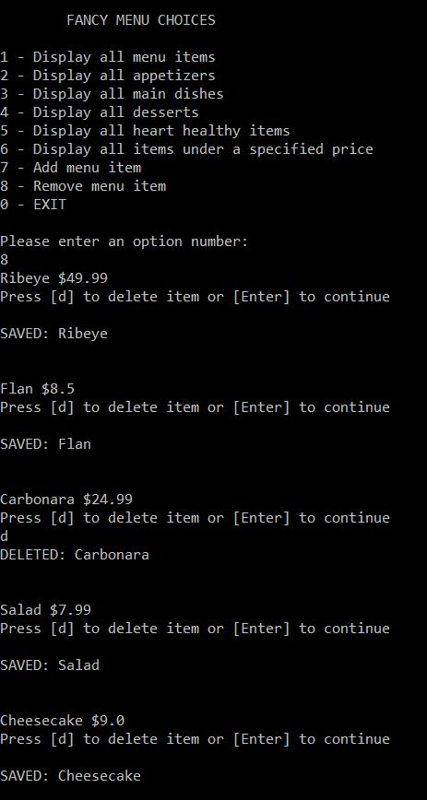

* Option 0 (exit):

