Display menu choices on start:

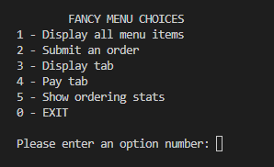

Display all menu items (1):

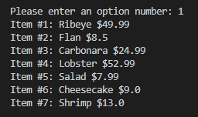

Submit an order (2):

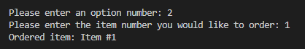

Display tab (3):

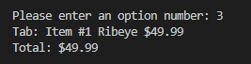

Example with more orders:

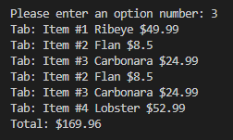

Pay tab (4):

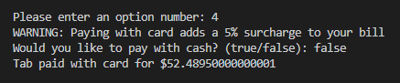

Example with cash option selected:

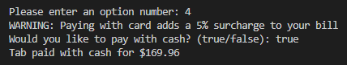

Show ordering stats (5):



Example with multiple tabs:

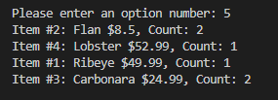

Exit (0):

