

Astana IT University
Department of Software Engineering

REPORT
for Final Project
Course: Cross Platform Development

GROUP:SE 2416
CREATED BY: Zhumirov B., Kalzhigit S., Zhaksybay A., Kairzhan B.
Astana 2026

1. Introduction

L'Artisan Dulce is a mobile app we built for a premium pastry shop. The whole idea was to make something that actually looks and feels premium - not just another generic food delivery clone. It runs on both Android and iOS from a single Flutter codebase, which saved us a lot of time.
The app lets users browse desserts, filter them by category or mood, view detailed product pages, add stuff to cart, manage favourites, and track orders. Simple enough on paper, but we put a lot of effort into making every screen feel polished.

1.1 Goals
The main goal was to build something that looks like it belongs in the App Store alongside actual commercial apps - good animations, clean architecture, and real shopping features all working together. More specifically, we wanted to nail the visual identity of a high-end brand, keep the navigation fast and simple, add something unique with the Mood Filter, and make sure the code is structured well enough that swapping in a real backend later won't be a nightmare.

1.2 Team
Member | Main Area
Akhmet | Architecture & project lead
Bekzat | UI/UX and animations
Sultan | State management and data layer
Batyrkhan | Features and testing

2. Market Analysis & Technology Choice

Apps like Glovo and Wolt are fine for mass-market food delivery but they can't really represent a premium brand well - everything looks the same. A purpose-built app gives full control over the look and feel, which matters a lot for a high-end pastry shop.

2.1 Flutter vs. the Alternatives
Criterion | Flutter | Native iOS/Android | React Native
Codebase | Single codebase | Two separate codebases | Single but JS-bridged
Animation quality | Excellent - frame-perfect control | Native (great) | OK but bridge overhead
Dev speed | Fast - hot reload | Slower iteration | Medium
UI consistency | Pixel-perfect cross-platform | Platform differences | Some inconsistencies
Team cost | One language, one team | Two teams needed | One team

We went with Flutter because a single codebase cuts the workload roughly in half, the animation engine is genuinely great for the kind of fluid transitions we wanted, and the Material Design 3 theming system made it easy to build a consistent dark theme. Hot reload also made iteration much faster during the UI-heavy parts of development.

3. Architecture

We used what we'd call a Clean Lightweight Architecture - four layers that each have a clear job, but without the heavy boilerplate that comes with BLoC or Redux. The layers are Presentation (screens and widgets), State (AppStateProvider), Repository (data logic and cache), and Persistence (shared_preferences).

3.1 Data Flow
Here's basically how data moves through the app:

Flutter UI Screens
|
v reads state / calls methods
AppStateProvider (InheritedNotifier)
AppState (ChangeNotifier)
| |
v v
ProductRepository shared_preferences
(5-min cache) (favorites, profile, auth)
|
v
ApiService (Mock - TheMealDB format)

3.2 Repository Pattern
The ProductRepository is the only thing that talks to the API. UI code never calls the API directly - it goes through AppState, which calls the repository. This means if we swap the mock API for Firebase later, nothing in the UI needs to change. The repository also handles the 5-minute cache so screens never have to think about it.

3.3 AppStateProvider
State is managed through a custom AppStateProvider built on Flutter's ChangeNotifier + InheritedNotifier - no external packages needed. It manages user info, cart contents, favourites, orders, and product filters all in one place, and calls notifyListeners() whenever something changes so the UI updates automatically.

class AppStateProvider extends InheritedNotifier<AppState> {
static AppState of(BuildContext context) {
return context
.dependOnInheritedWidgetOfExactType<AppStateProvider>()!
.notifier!;
}
}

3.4 Why Not BLoC or Redux?
Pattern | Problem for this project
BLoC / Cubit | Too much boilerplate for a 4-person portfolio project
Redux | Even more boilerplate, actions/reducers everywhere
ChangeNotifier | Simple, native, zero dependencies - fits the project size perfectly

4. UI/UX Design

The whole visual direction is built around a premium dark theme with a warm peach accent colour (#D4936C). The dark background makes product photos pop and gives the app that high-end feel. The peach accent was chosen because it subtly evokes caramel and pastry without being too literal about it.

4.1 Colour Palette
Role | Value | Where it's used
Background | Dark charcoal (#1A1A2E) | Every screen background
Accent | #D4936C (warm peach) | Buttons, highlights, active states
Cards / tags | Cream and cocoa tones | Product cards, category chips
Primary text | Soft white | Product names, headings
Secondary text | Muted beige | Descriptions, metadata

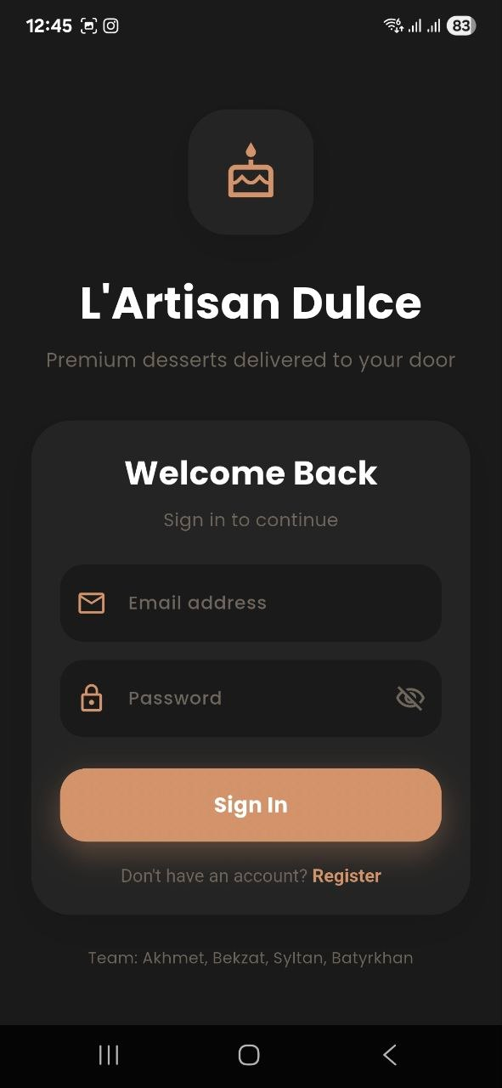 | 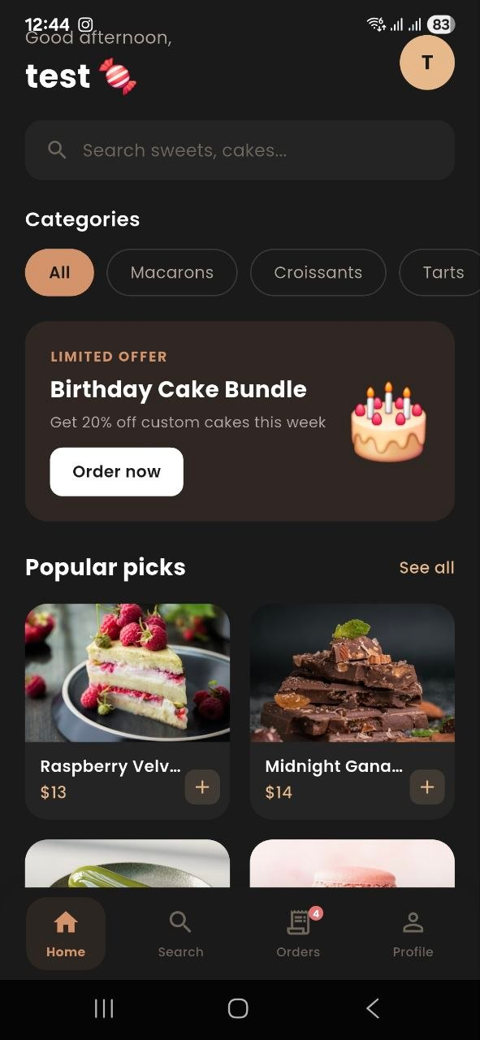
Login screen | Home screen

4.2 Animations

Hero Transitions
When you tap a product card it smoothly expands into the detail screen - that's Flutter's Hero widget with a unique tag per product. It makes navigation feel connected rather than just cutting between screens.

Hero(
tag: 'product-image-${product.id}',
child: ClipRRect(
borderRadius: BorderRadius.circular(28),
child: Image.asset(product.imagePath, fit: BoxFit.cover),
),
)

TactileWrapper
All interactive elements are wrapped in a custom TactileWrapper that fires HapticFeedback.lightImpact() on tap and gives a slight scale-down visual effect. Small detail but it makes buttons feel noticeably more responsive.

4.3 Mood Filter
The Mood Filter is probably the most interesting UX feature we added. Instead of forcing users to browse categories, it asks how they're feeling and recommends desserts accordingly - Comfort maps to creamy cakes, Celebration to macarons and gift sets, Energy to fruit desserts, and Indulgence to premium chocolate. It reduces decision fatigue and makes the experience feel more personal.

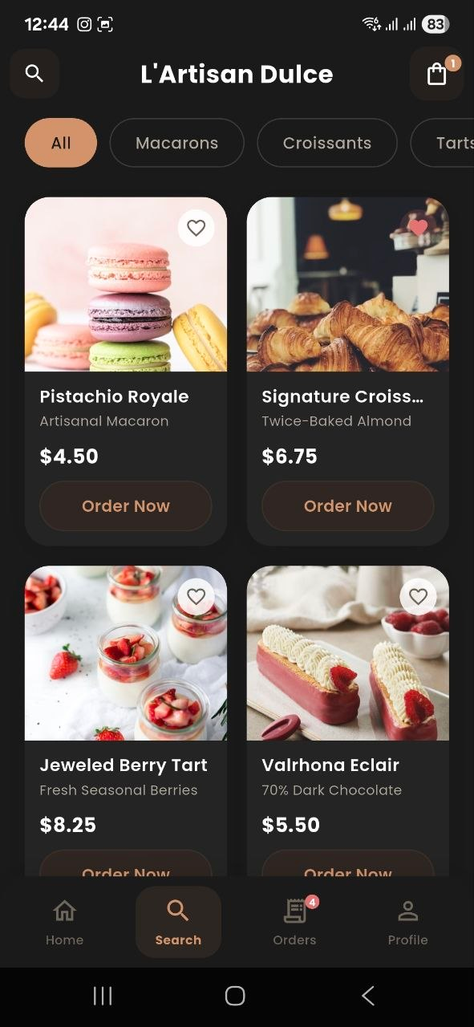 | 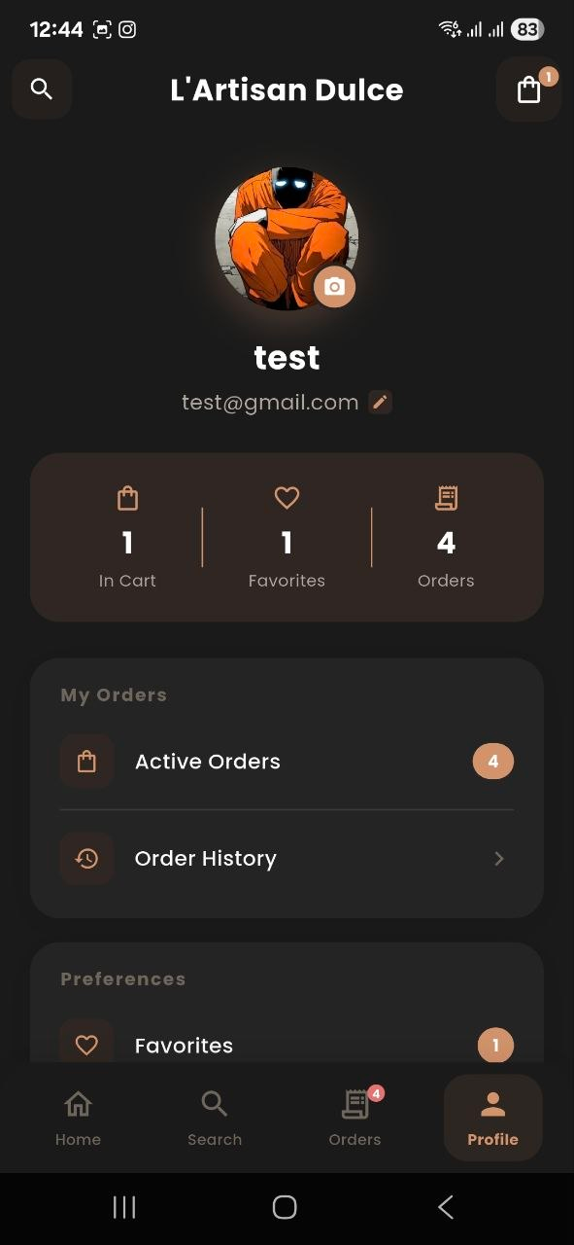
Product catalogue / search | Profile screen

5. Features

5.1 Auth & Profile
The welcome screen gives three options - login with email, register, or just browse as a guest. Profile editing covers name, email, delivery address, and payment card, plus a camera/gallery integration for profile photos. There's also a full order history showing active and past orders with statuses.

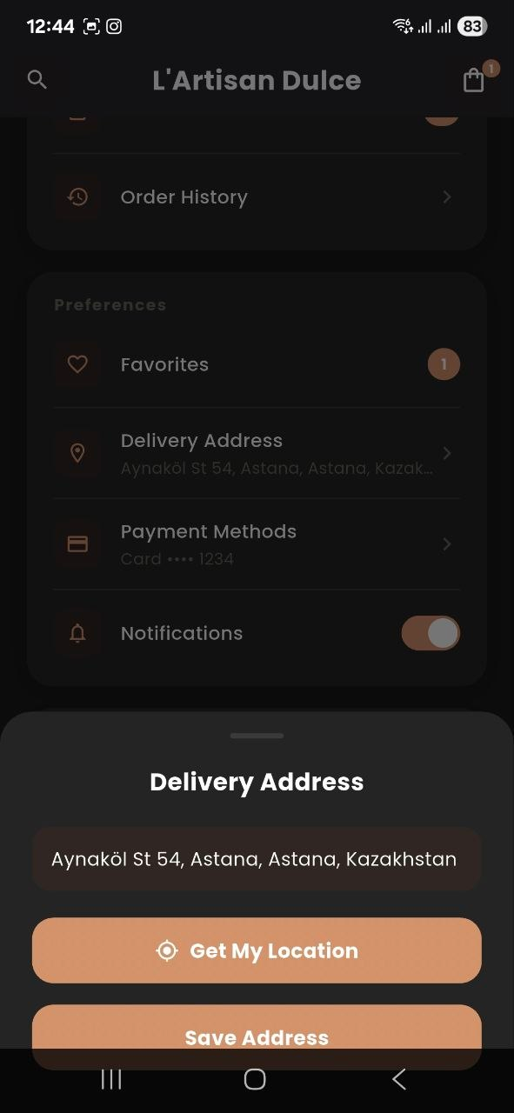 | 
Profile settings & delivery address | Profile overview

5.2 Catalogue & Navigation
The home screen greets you by name with a time-based message (Good morning, Good evening, etc.), shows promo banners, and displays a popular picks grid. Category filters run horizontally across the top - Macarons, Croissants, Cakes, and so on. There's also a global search that works across product names, categories, and ingredients.

5.3 Cart & Shopping
Products can be added to cart with a quantity selector, and the total updates in real time. The heart button on each card adds to favourites with a small animation. Both the cart and favourites persist across app restarts via shared_preferences so nothing gets lost if you close the app.

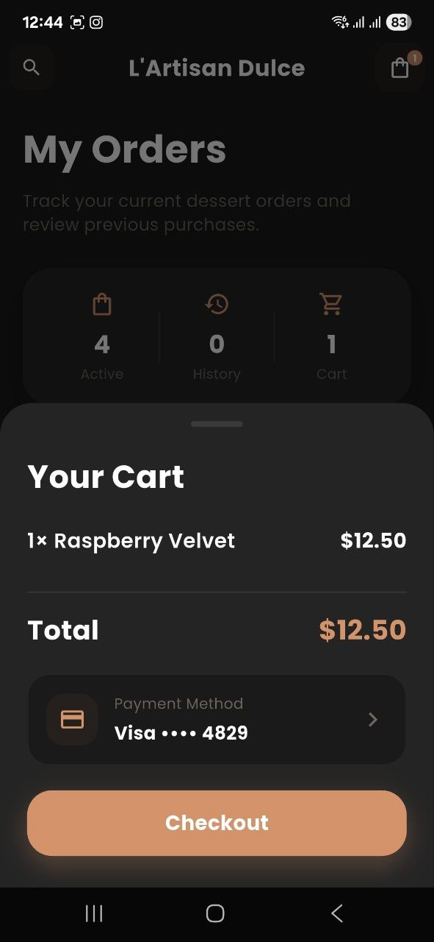 | 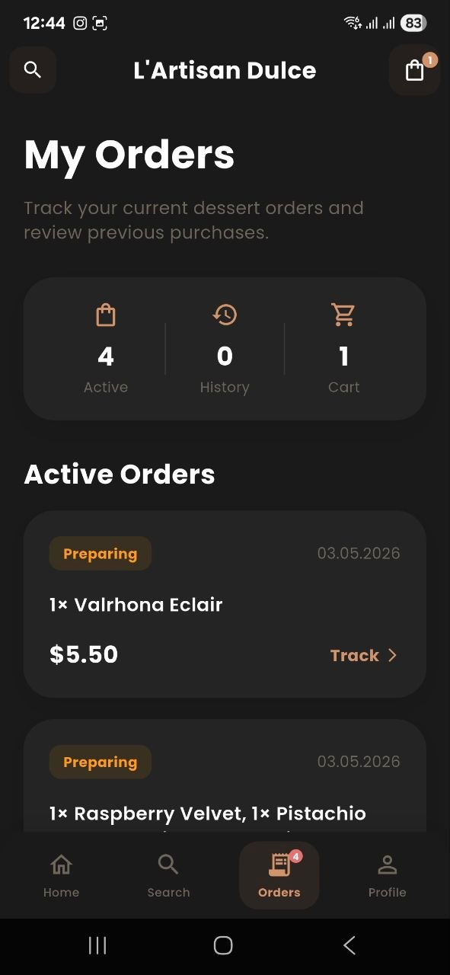
Cart and checkout | Order tracking

5.4 Order Status Flow
Orders move through four stages - Order Created, then Preparing, then On the Way, and finally Delivered. Each stage is shown clearly in the order history screen with a status badge.

5.5 Product Detail View
The detail screen is basically the most important screen in the app. It shows a fullscreen hero image, the name and price up front, an ingredients list, nutritional info (calories, protein, fat, carbs), a share button, and a rating dialog with 1-5 stars. The star rating also shows an emoji reaction that changes as you slide - nothing at 1 star, up to a 🤩 at 5 stars.

6. Technical Details

6.1 Cache Strategy
ProductRepository keeps an in-memory cache with a 5-minute TTL. Every call to getProducts() checks if a cache exists and if it's less than 5 minutes old - if yes, it returns immediately. If not, it hits the API and resets the cache timer. This keeps the app fast without hammering the network.

Future<ApiResponse<List<Product>>> getProducts() async {
final now = DateTime.now();
if (_cache != null &&
now.difference(_cacheTime!) < const Duration(minutes: 5)) {
return ApiResponse.success(_cache!);
}
final response = await _apiService.fetchProducts();
if (response.isSuccess) { _cache = response.data; _cacheTime = now; }
return response;
}

6.2 Local Persistence
We use shared_preferences to save favourites, auth state, profile info (name, address, card details), and the local path to the user's avatar image. It's basically a key-value store backed by NSUserDefaults on iOS and SharedPreferences on Android - simple and reliable for this kind of data.

7. Testing & Quality

We did unit tests for the things that actually matter - the cache invalidation logic in ProductRepository, cart total price calculations (including edge cases like empty cart and max quantity), and the mood-to-product mapping. Widget tests covered the TactileWrapper callbacks, the rating dialog emoji updates, and cart quantity controls.

7.1 Edge Cases We Handled
Situation | What happens
Empty cart at checkout | Checkout button is disabled, empty state shown
API timeout | Returns last cached data if available, shows retry option
Rating the same product twice | Dialog shows existing rating pre-selected, updates rather than duplicates
Avatar fails to load | Falls back to initials-based placeholder
Search returns nothing | Empty state with suggested category links

8. Practical Value & Innovation

A premium pastry shop has a genuine problem - their physical brand doesn't translate to generic delivery platforms. This app solves that by giving the business full control over presentation. The dark theme, the product photography focus, the smooth animations - these aren't just nice-to-haves, they're what separates a brand that feels premium from one that just lists items in a grid.

8.1 Mood Filter as a Differentiator
Most food apps make you browse or search - you need to know what you want before you start. The Mood Filter flips that. It starts from how you're feeling and works backwards to appropriate products, which is actually how people think about treating themselves with desserts. It also exposes products that users would never search for directly, which is good for the business.

8.2 Technical Points Worth Mentioning
The whole state management system uses zero external state packages - just Flutter's built-in ChangeNotifier and InheritedNotifier. The Hero animations create spatial continuity between screens that most apps don't bother with. TactileWrapper gives consistent haptic feedback on both platforms. And the Repository abstraction means the current mock API can be swapped for Firebase without touching a single screen.

9. Future Plans

The mock API is the obvious next thing to replace. The architecture is already set up for it - just swap ApiService for a real implementation. Firebase Firestore is the most likely first choice since it handles real-time updates well, but the code would work just as cleanly with a REST API, Supabase, or GraphQL.

9.1 Phase 2 - Backend
Integration | Technology | What it enables
Database | Firebase Firestore | Live product updates, real inventory
Auth | Firebase Auth / Supabase | Secure login, social sign-in
Payments | Stripe Flutter SDK | In-app checkout
Push notifications | Firebase Cloud Messaging | Order status alerts
Analytics | Firebase Analytics | Track which moods convert best

Further down the line we'd want to add a loyalty programme, user-generated photo reviews, and a basic admin dashboard for the bakery staff to manage products and orders. AR dessert preview would be a fun stretch goal - let users see how a cake looks on their table before ordering.

10. Conclusion

L'Artisan Dulce is a solid cross-platform Flutter app that covers all the core features a premium pastry shop needs - auth, catalogue with Mood Filter, cart, favourites, order tracking, and detailed product pages. The architecture is clean enough that adding a real backend is straightforward, and the UI actually looks good enough to show to someone as a real product rather than just a school project.

The Mood Filter is the standout feature from a UX perspective, and the animation work (Hero transitions, TactileWrapper haptics) gives it that premium feel we were going for from the start. Built by Akhmet, Bekzat, Syltan, and Batyrkhan using Flutter and Dart.

