3/23/2016

Mohamed Beltagy (UNIV LUGANO)

IMEC

BeagleBoneBlack server Documentation

# Part one: setting up the VNC server

1 - Connect the BBB with the computer through the USB cable

2- Using Putty choose SSH connection and write the IP 192.168.7.2

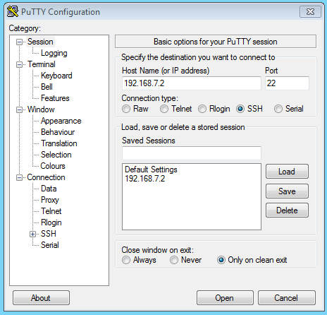

3- In the terminal it will ask you the log in username type “root” and press enter

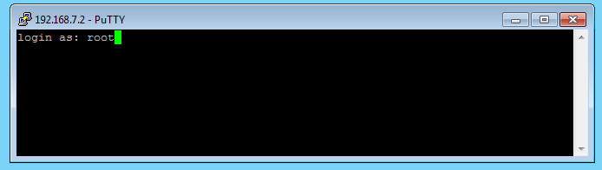

Now you are IN :) 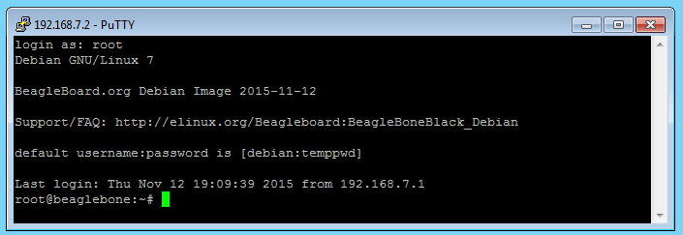

We can edit the files and run the python files through the terminal, But that is quite boring and takes a lot of time and effort :S so let us go through these steps so we can run it in a GUI environment so we can develop faster without the over head of the terminal.

4- Download TightVNC for Windows and install in it in BBB using the command “sudo apt-get install tightvncserver”,if it didn’t work try first “sudo apt-get update”

5- For the first time you must run “tightvncserver” to set the password and remember this password it will be used later

6- run “vncserver :1 -geometry 1280x800 -depth 24 -dpi 96 ”

7-Tip: next time you run the BBB just type “vncserver” and it is ready.

9- run”ifconfig” to get the IP address of the BBB , Ofcourse the ethernet cable should be connected to the board

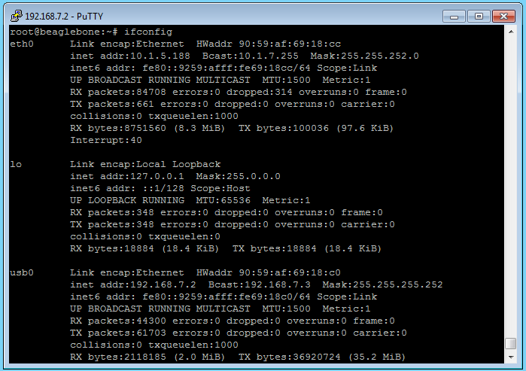

Now write down the IP number here it is 10.1.5.188

10-next open tight viewr from the computer and write the ip number you get from step 9 followed by :1 like that “10.1.5.188:1” if you will connect through a computer in the same network or if you will use the computer connected by USB to the BBB then just type “192.168.7.2:1” press connect and type the password you set in the settings in the BBB in step 5

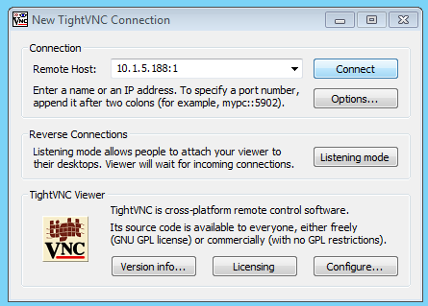

11- Now you are in :) Congratulation

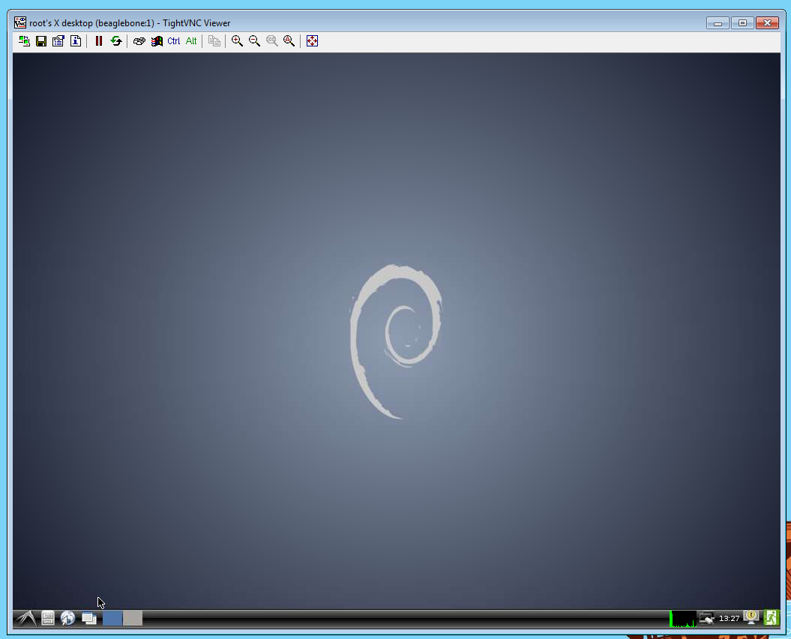

# Part 2

## Setting Chromium

1. Now we are in let us open a website using the browser chromium but this error will appear

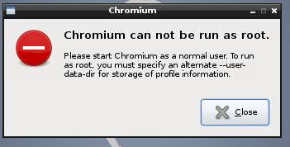

To fix that follow these steps

1. Go to this directory /etc.chromium

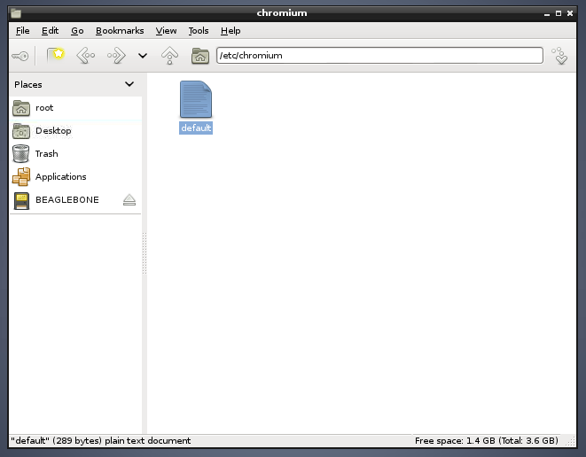

1. Open default with a text editor and add that line

CHROMIUM_FLAGS="--password-store=detect --user-data-dir=/root/chrome-profile/"

The file should look like that and then save and open chromium

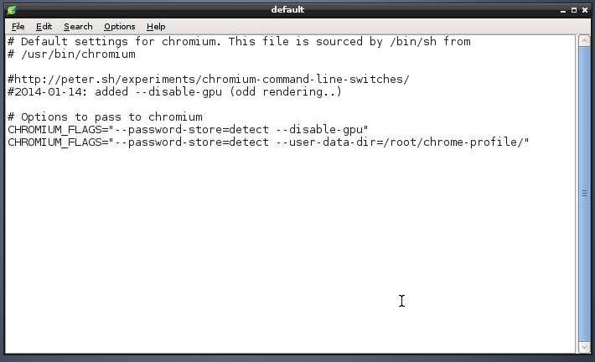

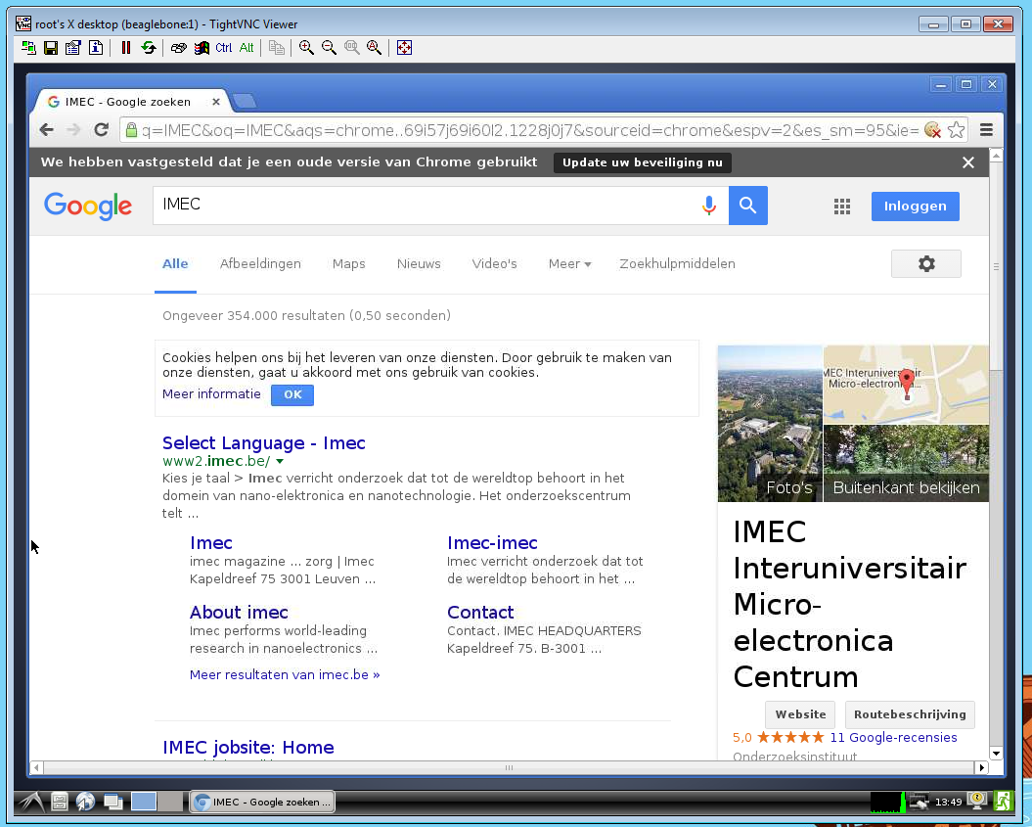And now we are done with setting Chromium

## 2-Installing K-write

The default editor is Leafpad I don’t recommend using it as it is very limited, I recommend using K-write and to install it just do the following

1. Run a terminal window using the start-> accessories -> LXterminal

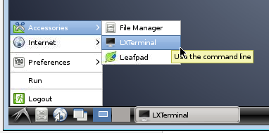

1. Run this command “apt-get install kwrite” it will take some time to download and install

## 3-Downloadin the repository from github

Here we will get the files from my repository in github through this steps

1. Run this command in the terminal in the directory you want to clone (download) “git clone <https://github.com/beltagymohamed/Beagle_Bone_Black>”

## 4- Installing Cherrypy

We will need to install cherrypy using this command ”pip install cherrypy”

## 5-Running the server

1. Run the server using this command in the folder you just cloned “python server.py”
2. Tip: if you change the python file or the html it will automatically compile and run the new version but if there is an error it will stop the server in this case running the server again will get you this error

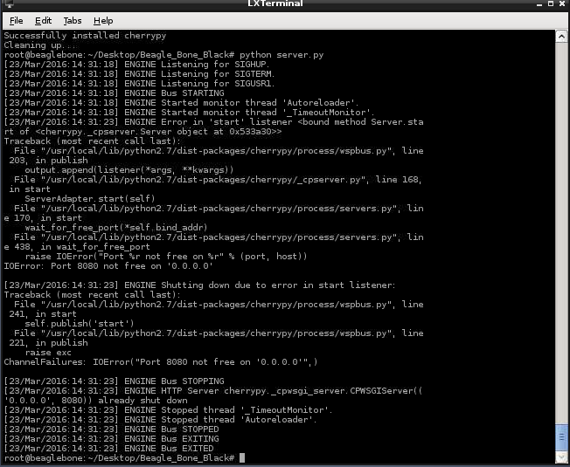

The port is already shut down

1. To fix that just run this command “fuser –k 8080/tcp” and then “python server.py”
2. Now from any computer or mobile connected to the same network open <http://10.1.5.188:8080>

Ofcourse replace the 10.1.5.188 with the ip you got in step 9 part one

Now the server is running Congratulation :)

## 6- Setting up the serial communication

1. Run this command “dmesg | grep tty” the output will look like that

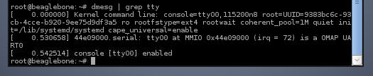

1. What we want is this name “ttyO0” open the server.py and in the line of “ser = serial.Serial(‘/dev/ttyO0’)”

Replace ttyO0 with the value you get

1. Get the value of your virtual COM port from the device manager in your computer in my case it was COM5

And right click properties to get the baud rate and other settings

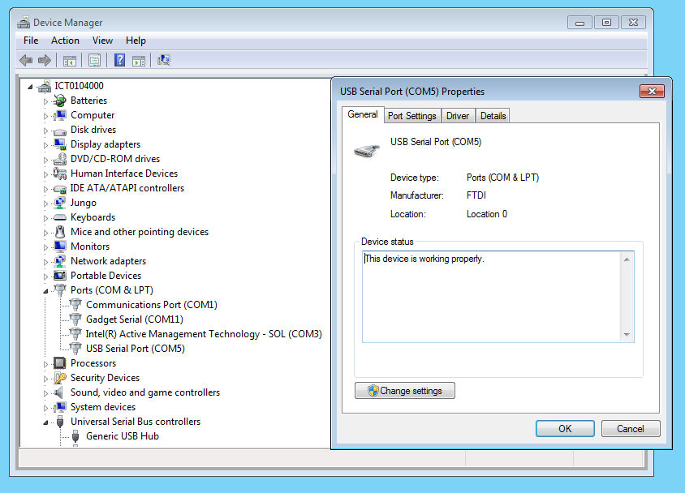

1. Connect the wires as in this picture

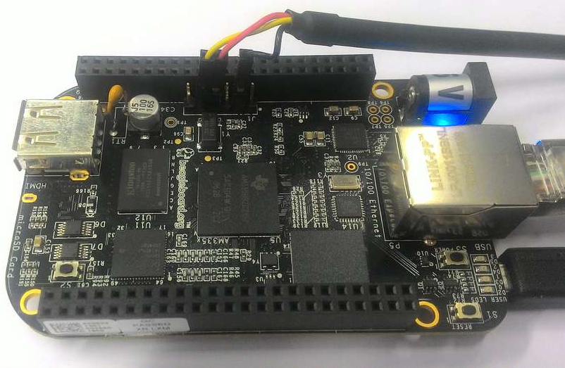

1. Now run putty with the com setting and you are ready to transmit and receive

