idonmapper
v0.01

User Manual

Software Purpose

This is a free-to-use and free-to-modify graphical application to enable the creation of hexagonal mind maps as described by Anthony Hodgson in his 'Hexagons for Systems Thinking' paper. Mind maps can act as useful revision aids for students, for exploring a domain of knoweledge and as a project planning tool.

Creating concept maps with idonmapper is very easy. Entering your ideas via a simple text field places them appear inside coloured hexagons on a virtual 'whiteboard', where they can be re-arranged, edited and removed like in any modern file manager. Hexagons are automatically aligned and can be moved and acted upon in groups, to save you time and help you focus on the task at hand.

Additionally, the application uses the power of Google Sets as a 'suggestion engine', which finds related concepts to include in your maps, thus speeding up process. Generated maps may be saved or loaded to an XML file, and can also be exported as images to PostScript.

Software License

Copyright Sean Talbot 2010.

This is free software: you can redistribute it and/or modify it under the terms of the GNU General Public License as published by the Free Software Foundation, either version 3 of the License, or (at your option) any later version. idonmapper is distributed in the hope that it will be useful, but WITHOUT ANY WARRANTY; without even the implied warranty of MERCHANTABILITY or FITNESS FOR A PARTICULAR PURPOSE. See the GNU General Public License for more details.

You should have received a copy of the GNU General Public License along with idonmapper. If not, see http://www.gnu.org/licenses/

The GNU GENERAL PUBLIC LICENSE, Version 3 should be present at

.../docs/license.txt

Hardware Requirements

This software was developed and tested on a PC with the following specs:

- Intel Pentium 4 2.8ghz 32-bit CPU
- 1gb of RAM
- nVidia 7600se 512mb graphics card

however, it should perform perfectly well on similar 32- or 64 bit processors with at least 512mb of RAM.

Software Requirements

The program requires that the Java Runtime Environment 1.6 or higher is installed. If you are unsure if your system already has this, you can enter
java

into the command line to see if it is recognized. If so you can try

java -version

to see if you have a compatible version installed.

If not, please download and install Java from

http://www.java.com/en/download/manual.jsp

and select the options for your operating system.

Running the program

The program may be run in the following ways

- compiling from the java source and running manually;

- running from the pre-compiled class files;

- via the executable .jar file (recommended).

Please note that it is necessary to download third-party jar files for any of the above options chosen, unless the software was downloaded directly from the github project page, in which case you can safely skip the next section.

Obtaining the third-party jar files

This (stable) version of the program relies on the following third-party jar files which must by present in the lib folder in order for it to compile and run:

NOTE these can all be downloaded easily via the project page on the web site Github.com:

http://github.com/beltsonata/idonmapper/tree/master/idonmapper_stable/lib/

Alternatively, they can be downloaded individually from:

Jar | URL
jxlayer.jar | https://jxlayer.dev.java.net/bin/jxlayer.jar
swingx-1.6.1.jar | https://swingx.dev.java.net/servlets/ProjectDocumentList?folderID=12289&expandFolder=12289&folderID=6868
jericho-html-3.1.jar | http://sourceforge.net/projects/jerichohtml/files/jericho-html/3.1/jericho-html-3.1.zip/download
miglayout-3.7.2.jar | http://www.migcalendar.com/miglayout/versions/3.7.2/miglayout-3.7.2.jar
xmlgraphics-commons-1.4.jar | http://www.mirrorservice.org/sites/ftp.apache.org/xmlgraphics/commons/binaries/xmlgraphics-commons-1.4-bin.tar.gz

Compiling from source

*Please make sure the above jar files have been located and placed in the 'lib' directory before continuing.*

There should exist a file ('compile.sh' for Linux/Max, 'compile.bat' on Windows) containing the command to compile the program in the base folder. This can be executed from the command line (DOS prompt 'cmd.exe' in Windows) by using

cd [PATH]

to move to the idonmapper_stable directory, followed by entering the name of the file. The file may first need to be made
executable on Linux / Macintosh using

chmod +x [FILE NAME]

If the file is missing, then the following command will compile the software

On Linux/Mac

javac -cp :lib/miglayout-3.7.2.jar:lib/jericho-html-3.1.jar:lib/jxlayer.jar:lib/swingx-1.6.1.jar:lib/xmlgraphics-commons-1.4.jar: idonmapper/*.java

[without spaces, on a single line]

On Windows

javac -cp ;lib/miglayout-3.7.2.jar;lib/jericho-html-3.1.jar;lib/jxlayer.jar;lib/swingx-1.6.1.jar;lib/xmlgraphics-commons-1.4.jar; idonmapper/*.java

[without spaces, on a single line]

Running the compiled classes

*Please make sure the above jar files are placed in the 'lib' directory before continuing.*

There should be a file (use 'run.sh' for Linux/Max, 'run.bat' on Windows) containing a command to run
the program. This can be executed from the command line (DOS prompt 'cmd.exe' in Windows) by using

cd [PATH]

to move to the idonmapper_stable directory, followed by entering the name of the file. The file may first need to be made executable on Linux / Macintosh and derivative operating systems using

chmod +x [FILE NAME]

If the file is missing, then please enter the following commands to compile the software for your operating system.

On Linux/Mac

java -cp :lib/miglayout-3.7.2.jar:lib/jericho-html-3.1.jar:lib/jxlayer.jar:lib/swingx-1.6.1.jar:lib/xmlgraphics-commons-1.4.jar: idonmapper.Start

[without spaces, on a single line]

On Windows

java -cp ;lib/miglayout-3.7.2.jar;lib/jericho-html-3.1.jar;lib/jxlayer.jar;lib/swingx-1.6.1.jar;lib/xmlgraphics-commons-1.4.jar; idonmapper.Start

[without spaces, on a single line]

Creating a jar from the compiled classes

You may wish to create a jar out of source files that you have edited or added to the progam yourself. There should be two files present in the directory:

jar-stable
manifest-stable

jar-stable contains a template command to create a jar based upon the contents of the idonmapper and idonmapper/Event source directories. Note that this and the manifest-stable file may need editing if you need to include any other classes / jars.

Running the jar file

*Please make sure the above jar files are placed in the 'lib' directory before continuing.*

There should be a file named idonmapper.jar file in the base directory of the application.

The file may need to be made executable on Linux / Macintosh using

chmod +x idonmapper.jar

The file may then be executed by double clicking or by entering its name on the command line.
Using the Application

Once the application has loaded, you should find yourself presented with the following window:
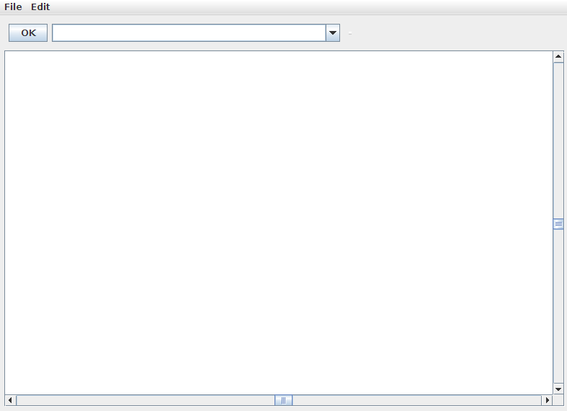

Notice how this is split into three distinct parts:

- Menu Bar – this is at the top of the window and holds the 'File' and 'Edit' menus. These contain similar in operation to their name-sakes in desktop-publishing and text-editing applications like Microsoft Word and Notepad.

- Input Panel - this is the area at the top of the window consisting of an 'OK' button, text-field and an arrow button. This is used for entering your ideas so that they appear written inside hexagons underneath.

- Hexagon Panel - this is the large white panel area with scroll-bars. This is where concepts will appear, inside coloured hexagons, when they have been entered through the Input Panel.

Application Usage Example

To illustrate how the components work, take the following example: let us suppose we are interested in creating a map about different species of animals. We might start by entering a couple of bird species we know by typing them into the text field on the Input Panel.

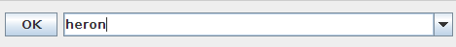

Pressing enter or clicking on OK sends this concept to the Hexagon Panel:

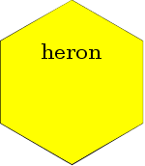

Typing and entering another places by the last one, if there is space:

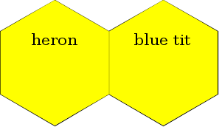

Whilst starting to type your next idea, you notice that a menu has dropped down with it inside:

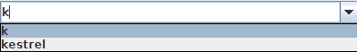

This is a suggestion retrieved by Google Sets, based upon one or more of your previous concepts. By highlighting the suggestion in the drop-down menu with the arrow keys, or by clicking it, you can send it straight to the Hexagon Panel like you would if you entering a search term or URL in a web browser:

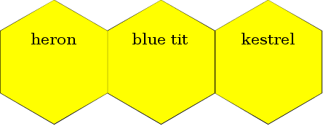

Let us suppose you next add some separate, unrelated species onto your map:

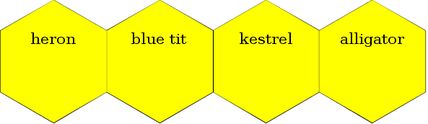

You may wish to move it, which you can do by dragging and dropping it to a new position, just like you would move a file to a directory in a file-manager:

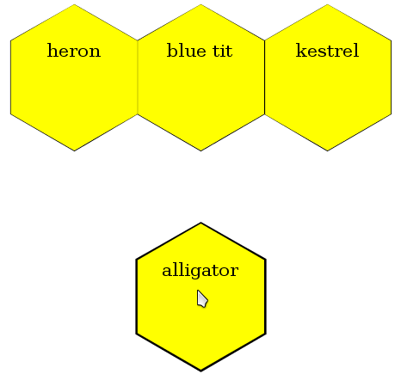

Notice here that the concept is snapped to a certain position when it is dropped. This is so that overlaps do not occur when developing your map.

You may wish to distinguish the concept more, by changing its colour.

This involves first selecting its hexagon, which can be done by clicking on it. A selected hexagon-concept has a thicker edge than non-selected ones so you can tell them apart easily.




Selected Not-selected

If there are several concepts you want to select, you do this by dragging a rectangle over them, starting from an unoccupied place:

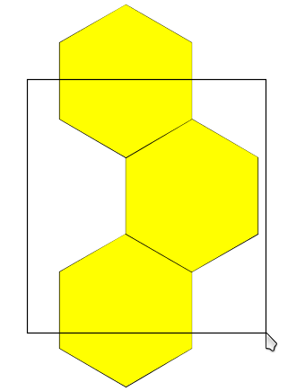

You can also select many concepts one at a time, by holding the Ctrl key when clicking on them:

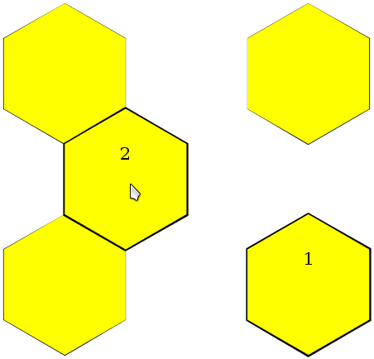

The numbers here represent the order in which the concepts were clicked. By substituting Shift for Ctrl, all of the concepts clicked on in the above picture that are linked to it are selected too:

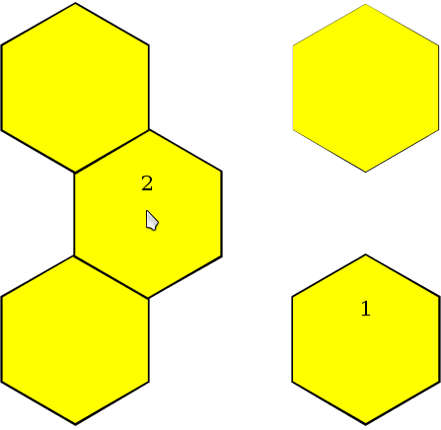

If you keep holding Ctrl or Shift, you can drag-select other concepts as well.

Once selected, one or more hexagons can have their colour altered, by pressing one of the following keys, where the key is the first letter of the associated colour:

- Red
- Orange
- Yellow
- Blue
- Green
- Purple

Let us say you press the 'R' key to make the selected concepts red:

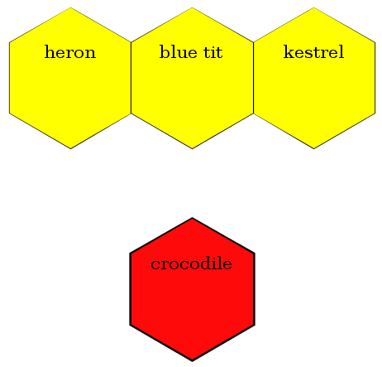

You might also want to move the concepts around.

If you only want to move one, you just drag and drop it where you like. For more than one, you select the concepts to move first, then drag them to where you want.

Don't worry if you drop them in the wrong place. Concepts will be aligned as they were before, in a place nearby that isn't occupied:

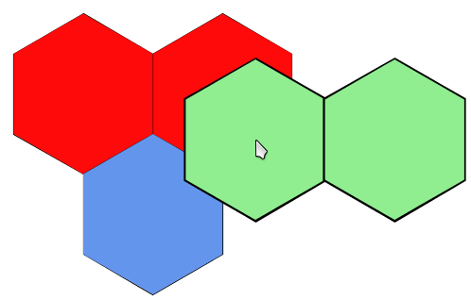
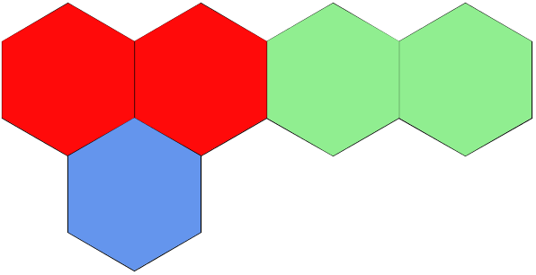

→

If you want to move concepts out of the current viewing area, the window will scroll to where you move them.

Editing Concepts

Now, let us imagine for your next concept that you accidentally typed a few wrong characters into the Input Panel:



You can edit the contents of any concept by double clicking on it:

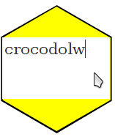

Notice how the inside concept goes white to show you which concept you are editing.

You can select the text inside with the mouse, as you might in a text editor.

When you have finished, press Enter or click away from the concept to save it.

Deleting Concepts

You might realize you do not want all of the concepts you have placed on the panel. Once selected, you can remove them using the Delete key on the keyboard:

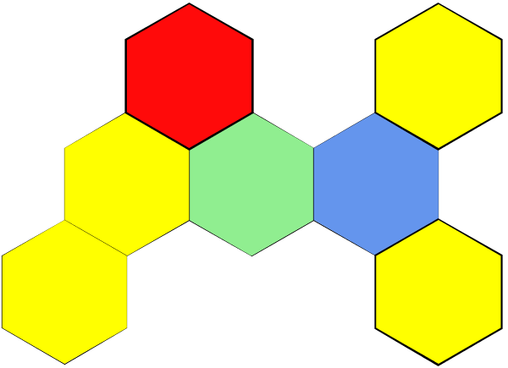

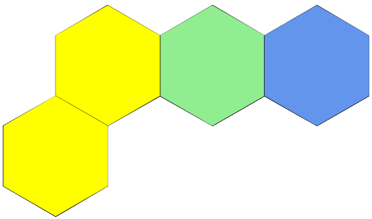

→

Next, we shall examine the Edit menu. You can access it by left-clicking on it:

The Edit Menu

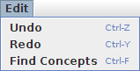

Notice that each of the functions has a key-combination following it. This is the function's keyboard short-cut which you can use instead of having to open the menu, to save you time.

Undo

If you make a mistake when moving, editing or changing the colour of your concepts, you can select Undo to 'step back' to the previous state of your map.

Redo

If you accidentally select Undo, you can use Redo to restore the previous state.

Find Concepts

When working on a large map, you may lose track of where concepts are. Selecting Find Concepts will display a small window in the centre of the Hexagon Panel:

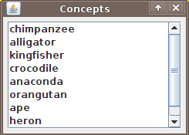

Clicking on any concept listed inside will move the view area so that it is visible. To return to the Hexagon Panel, just click on the Find Concepts' window's X close button

Middle-mouse scrolling

In addition to this, if your mouse has a middle button, you can use this for navigating the Hexagon Panel.

Middle-clicking or middle-pressing on any unoccupied area of the Hexagon Panel will change the mouse cursor image:



Moving the mouse will scroll the Hexagon Panel in the desired direction until you either let go of the mouse button or press another one.

Next, we shall examine the File menu. Again, you can access it by left-clicking on it:

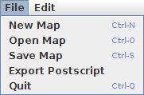

Notice that each function, except Export Postscript, has a common keyboard short-cut associated with it.

New Map

This allows you to create a new concept map. If there is an unsaved map in the Hexagon Panel you will prompted to save it.

Open Map

Select this to load a map you have previously saved. Like New Map, if you have an unsaved map already open, you will be prompted to save it.

When opening a map, a new window containing a view of files and directories on your computer will appear:

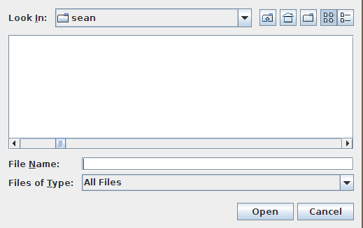

Use this to navigate your computer and locate the map file you wish to open.

Save Map

Select this to save a map you are working on. You will be prompted to find a location to save your map, using the same window as when opening a map.

Use this to navigate your computer and find a suitable place to save your map. Give the file a memorable name so that you can find it easily.

If the file already exists, you will be asked whether or not it should be overwritten.

Export Postscript

You can use this to export your entire map into a PostScript image file which you can view and edit in another application, such as GIMP or ghostscript.

The same rules apply to exporting PostScript as saving a map.

Quit

Select this to leave the application. If you have any unsaved data on the Hexagon Panel, you will be prompted to save your map.

Troubleshooting

Q: Why can't I change the size / colours of the hexagons / text?
A: This has not been implemented yet.

Q: The program crashed, or behaved strangely!
A: Please try to reproduce exactly the steps you took to create the anomaly. Please also visit the following URL to see if the issue has been documented (or fixed). If so inclined, please select 'Create Issue' if it does not already exist in the database:

http://github.com/beltsonata/idonmapper/issues

Alternatively, please email the author at

sean.talbot@gmail.com

or via the github.com project page

http://github.com/beltsonata/idonmapper

Q: Why doesn't the program have feature X?
A: The author has probably either not thought of doing it or hasn't managed to implement it yet. Please contact the author or create a new issue at the github.com project page as described above.

