**CMSC 201 Project 6**

Name: Ayesa Akhter

**Project: working with JUnit**

**Test Plan**

|  |  |  |  |  |
| --- | --- | --- | --- | --- |
| Cases | Input | Expected Output | Actual Output | Did Test Pass? |
| Case 1 | Run StringTest.java and verify that all test cases are passing | All test cases pass | All test cases pass | Y |
| Case 2 | Run  PrimeNumberMethodTest.java and verify that all test cases are passing | All test cases pass | All test cases pass | Y |

**Screenshots related to Test Plan**

**Case 1:**

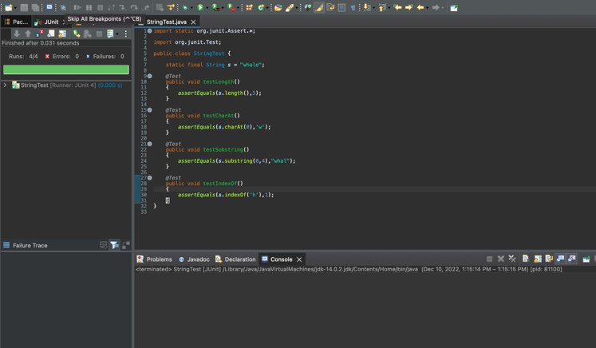

**Case 2:**

**Project 6 part 1 screenshots:**

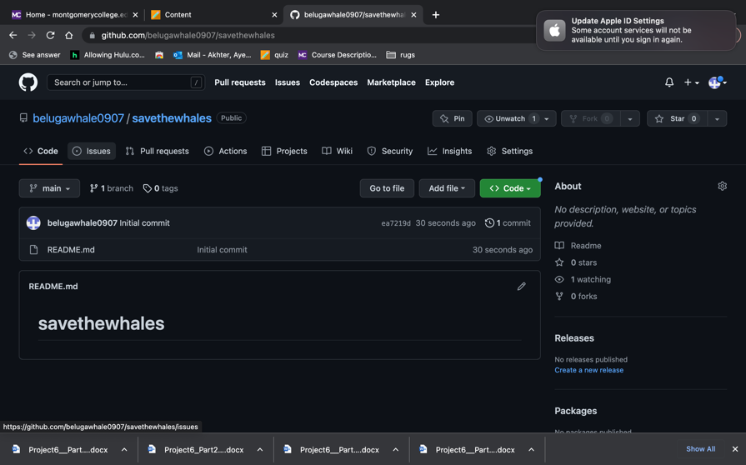

**Check List**

|  |  |  |  |
| --- | --- | --- | --- |
| **#** |  | **Y/N** | **Comments** |
|  | **Source java files** | **Y** |  |
|  | **Compressed files:** | **Y** |  |
|  | FirstInitialLastName_Project6_Moss.zip | **Y** |  |
|  | FirstInitialLastName_Project6Completed.zip | **Y** |  |
|  | **Program compiles** | **Y** |  |
|  | **Program runs** | **Y** |  |
|  | **Checklist is completed and included in the Documentation** | **Y** |  |
|  | **Documentation file:** | **Y** |  |
|  | **Screenshots based** | **Y** |  |
|  | **Lessons Learned** | **Y** |  |

**Lessons Learned:**

In this lesson I used Junit to test different methods. This is my first time using a test class and learning about test methods. I also created a GitHub account and learned about source control repositories.