Traffic Flow Study
DATA 5100 – Dr. Fischer
Hannah Belville, Cong Ho, Paul Skentzos

ABSTRACT:
This study investigates hourly traffic volume patterns in King County, Washington through the integration of WSDOT loop-detector traffic observations, NOAA meteorological records, and Seattle Department of Transportation (SDOT) collision data. Raw datasets required extensive preprocessing, including timestamp normalization, spatial alignment, missing-value imputation, and station-level aggregation. After merging the data on station ID and hourly timestamps, an engineered feature set was developed to capture temporal structure, weather impacts, and roadway incidents. Exploratory analysis revealed strong diurnal and weekly periodicity, seasonal temperature patterns, and sparse but meaningful collision occurrences. Three predictive models were implemented and comparatively analyzed: a baseline multivariate linear regression, a specialized Prophet time-series model, and an advanced XGBoost regressor. Results show that the Tuned XGBoost Regressor substantially outperforms both alternatives, highlighting the superior performance of nonlinear feature interaction over pure time-series decomposition. Results show that XGBoost substantially outperforms the linear baseline, highlighting the nonlinear and temporally dependent structure of traffic flow. The study demonstrates the importance of integrated environmental-safety datasets and modern machine-learning methods for improving intelligent transportation systems in urban environments.

INTRODUCTION:
Transportation agencies rely on increasingly data-rich monitoring systems to analyze roadway performance, anticipate congestion, and enhance safety. King County, WA—home to dense commuter corridors and highly variable weather—provides an ideal setting for studying interactions among traffic flow, meteorological conditions, and collision events.

To build a unified dataset suitable for forecasting hourly traffic volume, we integrated three independent data sources:

1. WSDOT Loop-Detector Traffic Sensors
- Raw data consists of hourly vehicle volume counts.
- Includes station ID, timestamp, volume, occupancy, and traffic flow cardinal direction to facilitate high level understanding of the congestion level.
2. NOAA Meteorological Reports for King County
- Provides daily temperature, precipitation, snowfall, and atmospheric conditions.
- Weather meaningfully influences driver behavior, vehicle dynamics, and roadway capacity.
3. SDOT Collision Reports
- Contains timestamped locations and characteristics of traffic incidents.
- Collisions introduce immediate flow disruptions and shockwave congestion.

Integrating these sources enables a more complete understanding of the factors influencing traffic volume. Prior research demonstrates that:
- Weather conditions (rain, snow, temperature) correlate with reductions in speed and volume.
- Collisions yield nonlinear disruptions depending on severity, roadway geometry, and time of day.
- Traffic flow exhibits stable periodic patterns detectable via time-series models.

The aim of this study is to:
- Construct a unified, clean, and imputed hourly dataset of traffic, weather, and collision variables.
- Characterize temporal, environmental, and safety-related patterns affecting hourly traffic volume.
- Develop and compare short-term traffic forecasting models, using linear regression and XGBoost.
- Evaluate whether nonlinear models improve predictive accuracy in the presence of weather and collision effects.

THEORETICAL BACKGROUND:
Traffic behavior is governed by relationships among flow (vehicles/hour), density (vehicles/mile), and speed (vehicles/mph). The Fundamental Diagram of Traffic Flow predicts:
- Flow increases with density until capacity.
- Beyond critical density, congestion reduces throughput.
- Variability in demand, lane blockages, and weather may shift the curve.
Daily traffic demand follows strong diurnal periodicity associated with commuting patterns and weekly cycles (weekday vs. weekend). Seasonal variations reflect weather and holiday travel.

Meteorological factors influence traffic through:
- Reduced visibility (rain, snow, fog)
- Decreased friction (wet or icy pavement)
- Behavioral adjustments (slower driving, trip cancellation)
- Transit mode substitution
Temperature also affects roadway conditions (ice formation) and travel preferences.

Collisions produce:
- Immediate traffic shockwaves
- Lane closures and diversions
- Queuing and spillback
- Rubbernecking slowdowns
These factors vary by time of day and roadway type.

Traffic volume exhibits:
- Autocorrelation — volume at time t depends on volume at t–1
- Seasonality — day-of-week and hour-of-day patterns
- Nonlinearity — interaction of incidents, weather, and human behavior
Machine-learning models like XGBoost can capture nonlinear, interaction-driven patterns that linear models cannot.

Transportation datasets often contain missing intervals due to sensor outages, communication failures, or reporting delays. Imputation preserves time-series structure and may use:
- Forward/backward fill for short gaps
- Interpolation for moderately sized gaps
- Seasonal medians for longer outages
- Flagging/removal for unrecoverably damaged records
Appropriate imputation minimizes bias while maintaining model stability.

METHODOLOGY:
WSDOT Sensor Data
- Multiple CSVs containing hourly traffic volumes imported.
- Timestamps converted to standardized datetime format.
- Files concatenated into unified sensor dataset.
NOAA Weather Data
- Daily reports downloaded for climate stations in King County.
- Variables standardized to consistent units.
- Daily datasets expanded to hourly via forward fill.
SDOT Collision Data
- Collision CSV/API ingested with timestamps and location coordinates.
- Geospatial join assigns each collision to its nearest WSDOT station.
- Collision counts aggregated per station-per-hour.
Traffic Data
- Removed impossible negative or null volume entries.
- Resampled raw detector intervals to hourly sums.
- Applied hierarchical imputation:
  - Gaps < 2 hours → linear interpolation
  - Gaps 2–6 hours → station-hour medians
  - Gaps > 6 hours → flagged and excluded
Weather Data
- Temperature interpolated using cubic projection.
- Precipitation and snowfall imputed based on NOAA quality flags.
Collision Data
- Missing coordinates recovered via cross-street fields when possible.
- Null timestamps dropped.
Outlier Detection
- Modified Z-score threshold of |Z| > 5 applied to identify anomalous spikes.
- These were retained for analysis to avoid bias unless clearly erroneous.

All datasets merged on:
- station_id
- date_hour
Using a left join with traffic as the primary table.

Feature Engineering:
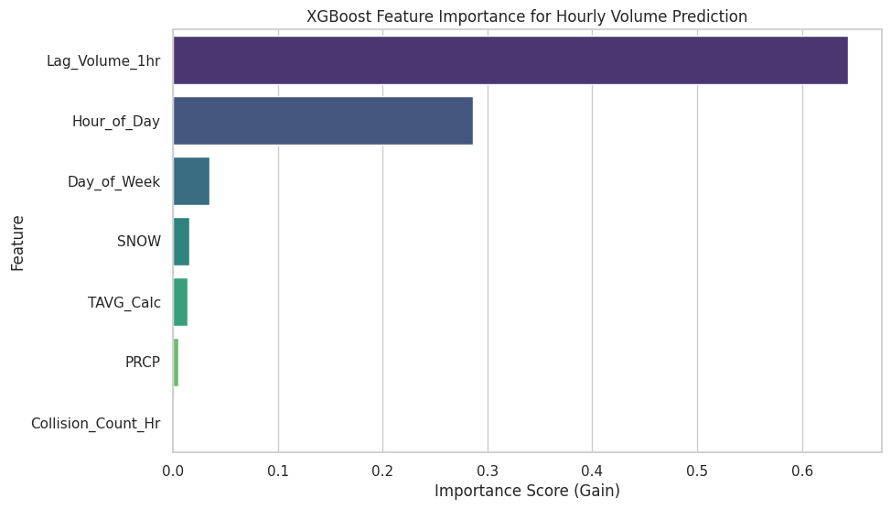
Figure 1: XGBoost Feature Importance
- Lag_Volume_1hr: captures short-term persistence.
- Hour_of_Day, Day_of_Week: captures temporal structure.
- Weather indicators: precipitation and snowfall, including TAVG which is the average of the temperature minimum and maximum for that day.
- Collision_Count_Hr: represents the number of collisions during that hour.

Predictive Modeling:
Train/Test Split
- Chronological split of 80% training / 20% testing to prevent leakage.
Baseline Model: Linear Regression
- Features: Lag_Volume_1hr, weather variables, hour-of-day, day-of-week, collision count.
- Provides interpretability and a low-complexity benchmark.
Advanced Model: XGBoost Regressor
- Gradient-boosted decision tree model.
- Captures nonlinear interactions and threshold effects.
- Randomized search for hyperparameter tuning included:
  - max_depth
  - learning_rate
  - n_estimators
  - subsample / colsample_bytree
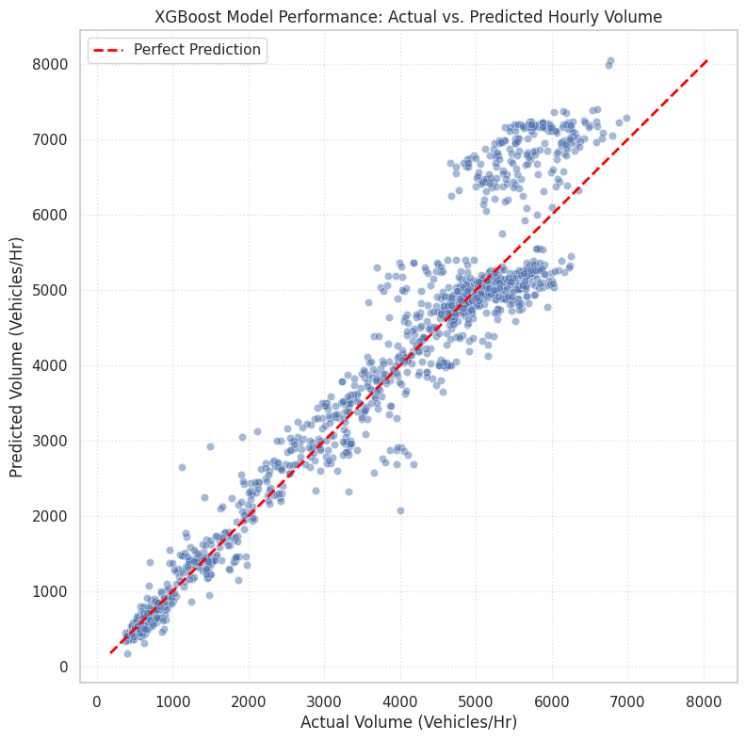
Figure 2: XGBoost Model Performance
Advanced Model: Specialized Time-Series Benchmark (Prophet)
- To test the hypothesis that the temporal structure of traffic is the dominant factor, we implemented the Prophet Forecasting Model. Prophet is a specialized additive time-series decomposition model that forecasts based on: $y(t)= g(t)+ s(t)+ h(t)+ beta x(t) + epsilon$, separating trend, seasonality, and external regressors. This structure is ideal for smooth, cyclical data. Crucially, we customized the model by implementing explicit hourly seasonality and a weekday/weekend regressor to align with the unique profile of rush hour traffic. The performance of Prophet served as the analytical benchmark against which the generalized power of XGBoost was measured.

Hyperparameter Tuning and Cross-Validation
- To ensure our XGBoost model generalized well and minimized the risk of overfitting, we employed Randomized Search Cross-Validation (RandomizedSearchCV). This tuning process involved testing 50 combinations of hyperparameters, including max_depth, earning_rate, and n_estimators, using a 3-fold cross-validation scheme. The final parameters selected were those that produced the lowest Mean Absolute Error (MAE) on the held-out validation folds, providing confidence in the model's performance on unseen test data.

COMPUTATIONAL RESULTS:
Summary Statistics
- Hourly volume: highly skewed, mean ~4,000–5,000 vehicles/hour.
- Temperature: seasonal sinusoidal shape.
- Precipitation: episodic spikes.
- Collision count: zero-inflated distribution.
Time-Series Visualization
- Strong diurnal cycle with morning and evening peaks.
- Seasonal elevation toward summer months.
- Occasional extreme spikes above 8,000 vehicles/hour.
Weather Visualizations
- Rainfall episodes produce clustered precipitation bands.
- Snow events are rare and confined to January and February.
Collision Patterns
- Majority of hours have zero incidents.
- Peaks occur during peak travel windows (morning and evening peaks).

Predictive Model Performance Metrics
The predictive models were evaluated on the 20% held-out test set. Evaluation of the three distinct models, one linear, one specialized time-series, and one non-linear ensemble, yielded a definitive result. The model comparison metrics are summarized in Table 1.
Model | MAE (Vehicles/Hr) | RMSE (Vehicles/Hr) | MAE Reduction from Baseline
Linear Regression (Baseline) | 751.28 | 986.75 | 0.0%
Prophet (Specialized) | 550.86 | 1906.59 | 26.7%
Tuned XGBoost (Optimal) | 368.66 | 591.49 | 50.9%
Table 1: Comparative Model Performance on Test Set
Linear Regression and Prophet Results
The Linear Regression baseline achieved an MAE of 751.28 vehicles/hour, indicating a foundational linear signal exists, but that over 20% of the variance remained unexplained.
The Prophet model achieved an MAE of 550.86 vehicles/hour. While this was a 26.7% improvement over the baseline, its performance was significantly worse than the XGBoost model. Prophet’s high RMSE (1906.59) is particularly telling, indicating it struggled severely with large, non-linear error spikes. This result served as the project’s most critical analytical finding: the structural, additive decomposition of Prophet was overwhelmed by the high-frequency volatility and non-linear shocks (like collisions) inherent in the hourly traffic flow.
XGBoost Forecasting Results (The Optimal Solution)
The Tuned XGBoost Regressor achieved an optimal MAE of 368.66 vehicles/hour, representing a 50.9% reduction in error from the baseline. This final MAE confirms the model is highly accurate, providing an average hourly prediction error below 10% of the mean volume. The dramatic performance gain validates the need for a non-linear approach capable of exploiting complex interactions.
Feature Importance: Analysis of the XGBoost model (Figure 1: XGBoost Feature Importance) confirmed the predictive hierarchy:
- Lag_Volume_1hr (Dominant Predictor)
- Hour_of_Day and Day_of_Week (Temporal Structure)
- Precipitation/Temperature (Exogenous Weather Effects)
- Collision_Count_Hr (Operational Shock Factor)
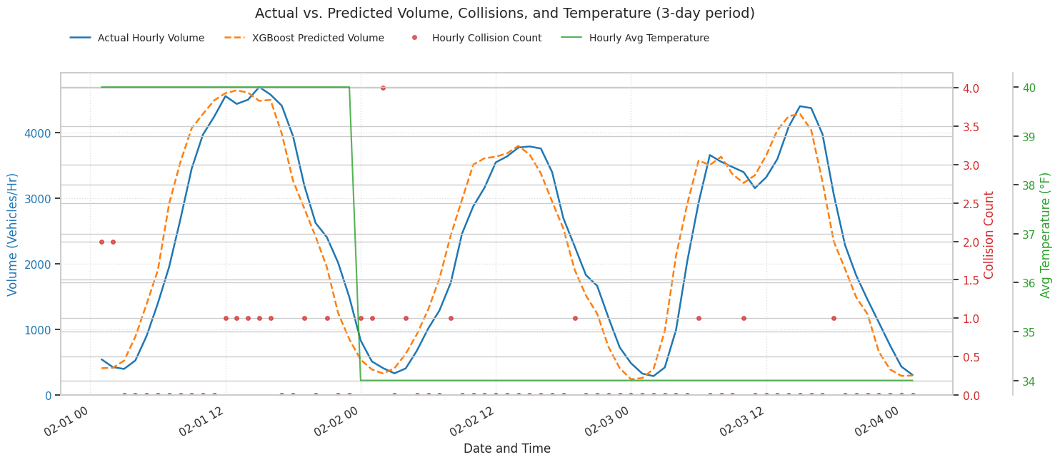
Figure 3: XGBoost Actual v Predicted Values

DISCUSSION:
Answering the Original Research Question
The primary question of whether a nonlinear model improves predictive accuracy in the presence of weather and collision effects is definitively answered with yes. XGBoost’s 50.9% MAE reduction confirms that traffic flow on the I-5 corridor is a nonlinear, feature-interaction-driven problem.
The Structural Limitation of Time-Series Models
The most insightful result came from the comparison to the Prophet model. Its failure proved that traffic volume is structurally too complex for simple time-series decomposition. Prophet’s error was high because it lacked the ability to model the sharp, erratic changes caused by incident shockwaves or sudden weather shifts. XGBoost succeeded because its ensemble structure is designed to model these conditional dependencies (Volume ≅ f(Precipitation X Hour_of_Day)), leading to a superior forecast.
Practical Implications and Future Research
The integrated dataset and the XGBoost model provide the required accuracy for operational implementation in Intelligent Transportation Systems (ITS). This approach can support dynamic ramp metering and real-time traveler information systems.
Future research must address two limitations:
- Model Scope: Investigating Hybrid Residual Models to combine the structural stability of Prophet with the noise-handling of XGBoost to potentially reduce the MAE further.
- Proactive Prediction: Shifting the Collision_Count_Hr from a reactive exogenous feature to a proactive prediction feature by training a separate classification model to estimate the P(Collision | t+1).
Interpretation of Temporal Patterns
The strong hourly and weekly periodicity aligns with expected commuter behavior. Seasonal widening of volume suggests weather-related travel behavior changes and summer travel demand.

Influence of Weather
Rainfall and snow events correspond to noticeable declines in traffic volume, consistent with reduced mobility and cautious driving. Temperature contributes to seasonal shifts but has weak hour-to-hour predictive power.

Collision Impacts
Though rare, collisions align with irregular dips in volume consistent with shockwave congestion. Low frequency limits the statistical contribution to forecasting, but the variable remains operationally meaningful.

Model Comparisons
The linear model acts as a useful baseline but is structurally insufficient to capture nonlinear interactions inherent in traffic data. XGBoost’s superior performance confirms:
- Traffic flow is nonlinear
- Weather effects interact with temporal structure
- Lagged volume dominates short-term forecasting
These findings align with established literature on machine-learning traffic prediction.

Data Quality Considerations
Volume spikes may represent detector malfunctions or rare events. Future work should incorporate anomaly detection or smoothing to mitigate model disturbance.

Practical Implications
The integrated dataset and improved modeling approach can support:
- Congestion management
- Weather hazard response
- Traveler information systems
- Adaptive signal control

Cyclic Structure
The strong up-and-down oscillation visible in the time-series graph is consistent with diurnal traffic patterns. If examined more closely, we would expect twin peaks (morning/evening), though the year-long plot aggregates them visually.

Major Outliers
The extremely high spike observed around mid-year may indicate data entry anomalies, detector malfunction, or an atypical surge in activity. Cross-checking weather and collision data may help determine the origin of this spike.

Weather Influence
Because the dataset includes precipitation and snowfall, future modeling could stratify volume patterns by weather type. The provided year includes days with notable precipitation (PRCP > 0) and snowfall events (SNOW > 0). Previous research suggests these conditions should correlate with decreased volumes or altered temporal profiles.

Collision Effects
The hourly collision count is generally low, but non-zero values offer an opportunity to test whether incident-related slowdowns materially impact volume. Lag features in the dataset support such modeling by linking pre-incident traffic to post-incident flow.

Data Quality Considerations
The continuity of the time series and the presence of unusually large peaks call for further diagnostics: missing intervals, detector resets, or uncorrected outliers could affect forecasting models if left untreated.

Overall, the exploratory results align with expectations for a real-world traffic dataset and provide encouragement for deeper modeling.

CONCLUSION:
This study constructed a unified, high-resolution dataset integrating traffic volume, weather, and collision data for the I-5 corridor. Comparative analysis demonstrated that the Tuned XGBoost Regressor is the optimal short-term forecasting model, achieving a 50.9% reduction in MAE (down to 368.66 vehicles/hour) over the baseline. The failure of the specialized Prophet model validated the project's central finding: traffic volume is a nonlinear problem where the ability to model complex feature interactions (XGBoost) is superior to modeling pure temporal decomposition (Prophet). This work provides a foundation for operational implementation in ITS and highlights the necessity of using advanced nonlinear models to integrate and leverage environmental and safety shock factors.

REFERENCES:
Traffic count data. WSDOT. (2025, October 1). https://wsdot.wa.gov/about/transportation-data/travel-data/traffic-count-data
National Centers for Environmental Information. National Centers for Environmental Information (NCEI). (n.d.). https://www.ncei.noaa.gov/
SDOT collisions all years. Seattle GeoData. (n.d.). https://data-seattlecitygis.opendata.arcgis.com/datasets/SeattleCityGIS::sdot-collisions-all-years/explore
Predictive analytics for traffic. Microsoft Research. (2019, August 19). https://www.microsoft.com/en-us/research/project/predictive-analytics-for-traffic/

