Run Command:

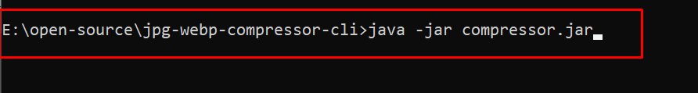

Application Will ask for folder path like this:

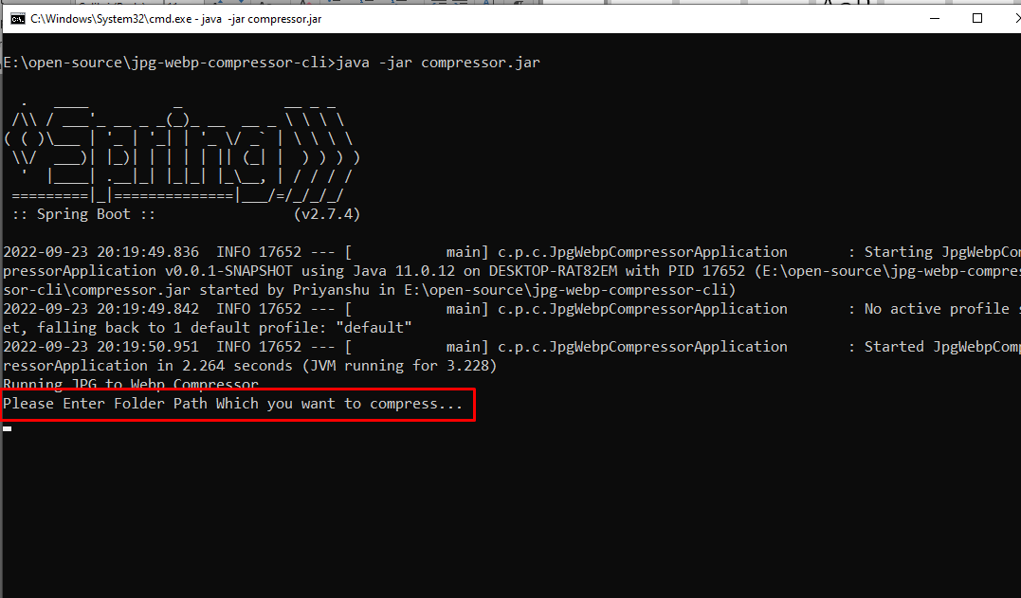

Provide Folder Path and Hit Enter:

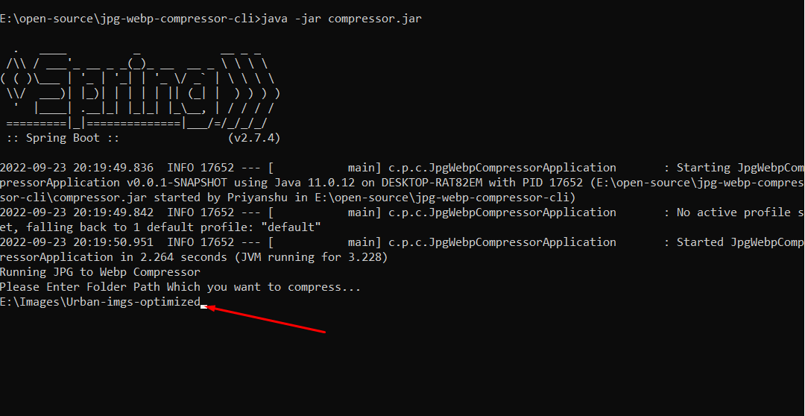

Conversion will be completed shortly.

