

AI Essentials: Theory and Applications
Topic of the project work: «Emotion Classification
Using a Custom CNN»
Made by Bolatova Akbota
Group: AAI-2502M
Link: https://github.com/belron/aiefinalwork

Content

Project Report 2
1. Introduction 3
2. Dataset 3
2.1 Preprocessing и Augmentation 4
3. Methodology 4
4. Results 7
5. Conclusion 8
Appendix 9

Project Report

Introduction
The goal of the project is to develop a convolutional neural network (CNN) from scratch for automatic classification of human facial expressions into seven emotions: anger, contempt, disgust, fear, happiness, sadness, and surprise. The task is challenging due to variability in facial appearance (lighting conditions, head pose, expression intensity, demographic differences) and the heterogeneity of available datasets. In this project, we train a custom model without using any pretrained networks, aiming to obtain a reliable classifier and to analyze its errors and behavior.

Dataset
Source: an image dataset for facial emotion recognition (the Facial Emotion Recognition Faces Dataset on Kaggle).
Description: images of people displaying seven emotions, with demographic diversity (gender, age, ethnicity). The dataset has several limitations, including class imbalance, partially incomplete labels, and different numbers of samples across classes.
Split: the data was divided into train/validation/test sets in proportions 70% / 15% / 15%. The split was performed per class to preserve class distribution in each subset. (The code includes a procedure that, for each class folder, randomly shuffles the files and copies them into OUT_DIR / {train, val, test} / class_name.)

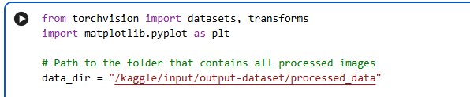
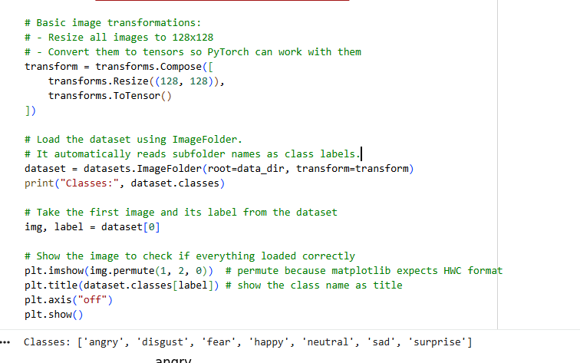

2.1 Preprocessing и Augmentation
All images were converted to grayscale (1 channel) and resized to 128×128. For training, data augmentation was applied, including random horizontal flips, small random rotations of ±10°, conversion to tensor format, and pixel normalization to the range [-1, 1]. For validation and test sets, the same preprocessing steps were used but without augmentation (only grayscale conversion, resizing, tensor conversion, and normalization). Since the classes are imbalanced, class weights were calculated based on the number of samples in the training set. These weights were passed to nn.CrossEntropyLoss(weight=class_weights, label_smoothing=0.05), which encourages the model to pay more attention to rare classes and reduces its tendency to ignore minority categori

Methodology
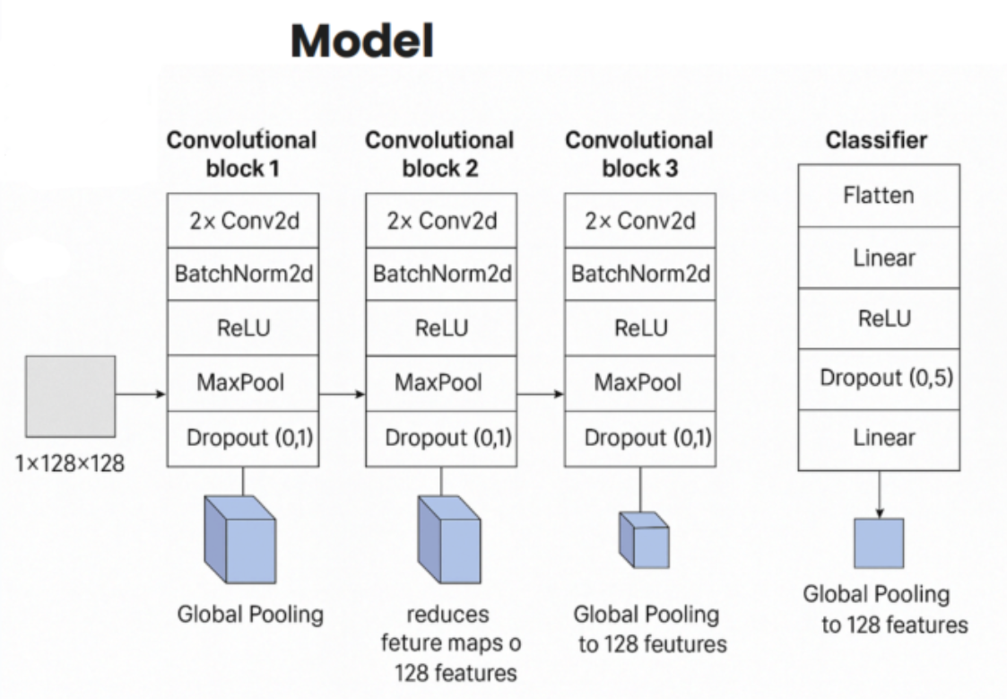

The model architecture (EmotionCNN) takes a 1-channel 128×128 image as input. It consists of three convolutional blocks, each containing: Conv2d → BatchNorm → ReLU, Conv2d → BatchNorm → ReLU, MaxPool2d(2×2), and Dropout(0.1), with channel growth from 1 → 32 → 64 → 128. A global pooling layer (AdaptiveAvgPool2d(1)) is followed by the classifier: Flatten → Linear(128,128) → ReLU → Dropout(0.5) → Linear(128, num_classes). The loss function is CrossEntropyLoss(weight=class_weights, label_smoothing=0.05), optimized using AdamW (lr=5e-4, weight_decay=1e-4), with a ReduceLROnPlateau scheduler (factor=0.5, patience=3) and early stopping after 7 epochs without improvement in validation loss. Training ran for up to 30 epochs, saving the best weights based on minimum validation loss. Metrics tracked include loss and accuracy for training and validation sets, with final accuracy and loss measured on the test set.

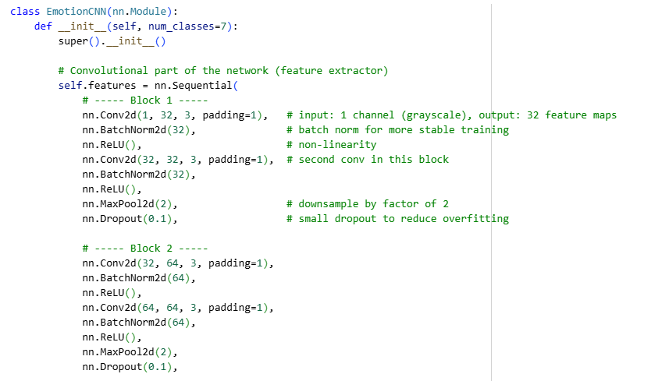
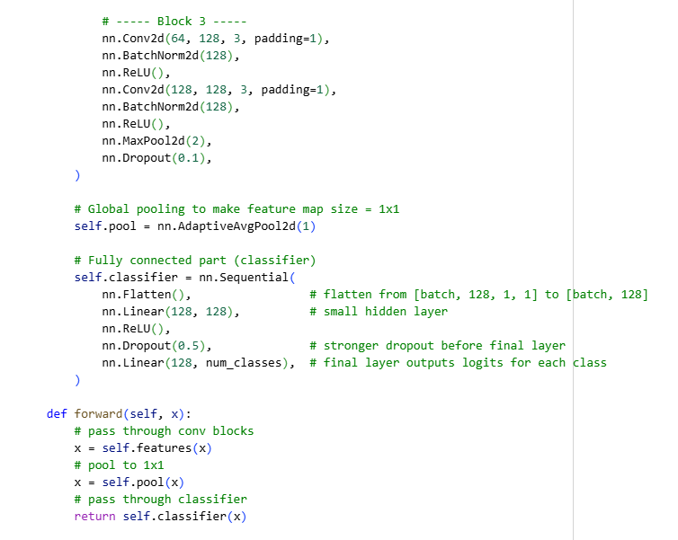

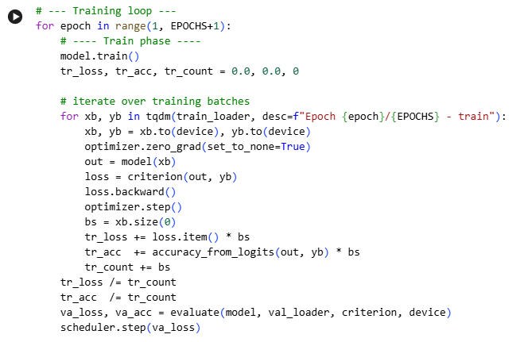

Results
The model achieved a test accuracy of 0.6349 (63.49%). A confusion matrix was used to analyze errors, showing which classes were most frequently confused (e.g., fear ↔ surprise, sadness ↔ neutral/disgust when a neutral class is present). Loss and accuracy curves revealed differences between training and validation sets, indicating some overfitting (train loss lower than validation loss; train accuracy higher than validation accuracy). For each emotion, the most confident correct predictions were selected based on softmax probabilities to visually assess recognition quality. Key observations include the importance of class balance—using class weights improved performance for rare classes, though some imbalance still affects metrics. Data augmentation was limited to simple transformations (flip, rotation); more aggressive augmentation (brightness/contrast adjustments, shifts, noise) could improve robustness. The model is relatively compact, and the observed partial overfitting could be mitigated by tuning weight decay, increasing dropout, or adding more training data. Most classification errors occur between emotions with similar expressions, such as fear vs. surprise and sadness vs. neutral/disgust in some datasets.
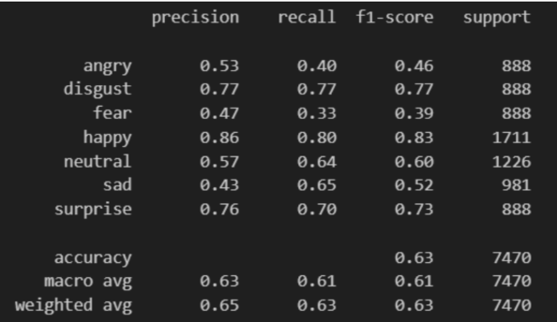

Conclusion
The CNN developed from scratch demonstrated the feasibility of the approach, achieving a final test accuracy of approximately 63.5% across seven emotion classes. This result provides a reasonable baseline for a model trained on a single dataset without pretraining. The main limitations—class imbalance and limited augmentation diversity—highlight clear directions for improvement: expanding and enriching the dataset, applying stronger data augmentation, and exploring more powerful architectures or regularization techniques.

Appendix

